

ADM 2304 – Application of Stat Methods in Business
Assignment 1 – Summer 2019

1. [10 marks] Organizers of a fishing tournament believe that the lake holds a sizable
population of largemouth bass. They assume that the weights of these fish have a model
that’s skewed to the right with a mean of 3.5 pounds and a standard deviation of 2.32 pounds.
a. Explain why you can’t determine the probability that a largemouth bass randomly
selected from the lake weighs over 3 pounds.
We can’t determine the probability of the largemouth bass randomly selected from the lake that will weigh over 3 pounds because we know the distribution is a skewed distribution and not a normal distribution
b. Each contestant catches five fish each day. Can you determine the probability that
someone’s catch averages over 3 pounds? Explain.
Since it is a skewed distribution, we can’t determine the probability that someone’s catches will average over 3 pounds. Central limit theorem can’t be applied to this problem because the sample size is too small.
c. The 12 contestants competing each caught the limit of five fish. What’s the standard
deviation of the mean weight of the 60 fish caught?
Since the sample size for this problem is 60, we can use the central limit theorem for the skewed distribution.
Standard deviation $=SD\left(\overline{y}\right)$
$$SD\left(\overline{y}\right)= \frac{σ}{\sqrt{n}} \\ =\frac{2.32}{\sqrt{60}} \\ =\frac{2.32}{\sqrt{7.7459}} \\ =0.2995$$The SD of the 60 fishes is 0.2995

d. Would you be surprised if the mean weight of the 60 fish caught in the competition
was more than 4.5 pounds?
Using the rule of 68-95-99.7, we can verify that it would happen 2.5% of the time. Therefore it would be surprising if the mean of the fish was more than 4.5 pounds.

2. [10 marks] Ipsos-Reid asked 900 Canadian adults (assume half men and half women)
whether they approve of using illegal or unauthorized online methods to access online music.
In their responses, 12% of men said they completely approve, whereas the corresponding
percentage for women was 6%.
a. Construct a 90% confidence interval for the percentage of Canadian adult men who
completely approve of using illegal or unauthorized online methods to access online
music and interpret what this interval means. State your assumptions clearly and check
the conditions.
90% confidence interval
$$\hat{p}±1.645×\sqrt{\frac{\hat{p}\left(1-\hat{p}\right)}{n}} \\ =0.12±1.645×\sqrt{\frac{0.12\left(1-0.88\right)}{900}} \\ =(0.1022, 0.1378)$$
90% confidence interval for men = (10.22%, 13.78%)
We are 90% confident that the percentage of Canadian men who completely approve of using unauthorized online methods to access online music lies between 10.22% and 13.78%
b. Considering a 99% confidence interval, is there any difference between the proportions
of men and women on this issue?
99% confidence interval
$$\left(\hat{p}1-\hat{p}2\right)±zc×\sqrt{PQ\left(\frac{1}{n1}+\frac{1}{n2}\right)} \\ =\left(0.12-0.06\right)±2.58×\sqrt{0.09×0.91\left(\frac{1}{900}+\frac{1}{900}\right)}$$
= (0.0254,0.0948)
Since the confidence interval does not contain zero, there is enough evidence to conclude that there is a difference between the proportions of men and women on this issue.
c. Using hypothesis test, show if the proportions of men and women is equal at 1% alpha
level?
Null and alternate hypothesis
H0= p1=p2
Ha= p1≠p2

T-stat
$$z=\hat{p}1-\hat{p}2/\sqrt{PQ\left(\frac{1}{n1}+\frac{1}{n2}\right)}$$
Where
$$P=\frac{n1\hat{p}1+n2\hat{p}2}{n1+n2}$$
=0.09
Q=0.91
Z=4.45
The critical value of z at 1% level =2.58
Since z>zc we reject H0
At 1% level, there is enough evidence to conclude that proportion of men and women are not equal.
d. Suppose Ipsos-Reid had interviewed 2000 Canadian adults. How much narrower
would the confidence interval in (a) be? Give your answer as a percentage of the
answer in (a).
For sample size 2000
Margin of error =0.0119 compared to margin of error =0.0178 for a sample size of 900
Confidence interval would be narrower by 32.91%
e. The population of Ontario is 10 times as large as the population of Manitoba. Should
we survey 10 times as many people in Ontario as in Manitoba in order for the
confidence intervals on our results to be of similar width in the two provinces?

3. [10 marks] Production managers on an assembly line must monitor the output to be sure
that the level of defective products remains small. They periodically inspect a random sample
of the items produced. If they find a significant increase in the proportion of items that must
be rejected, they’ll halt the assembly process until the problem can be identified and repaired.
- Write null and alternative hypotheses for this problem.
Null and alternative hypotheses
H0=p < 0H0​:p<0
Ha=p > 0Ha​:p>0

- What are the Type I and Type II errors in this context?
Type 1 error occurs when rejecting the null hypothesis when it is true, the probability of wrongly detecting the increase in proportion of items that must be rejected when the proportion is large.

Type 2 error occurs when failing rejecting the null hypothesis when it is false, the probability of correctly detecting the increase in proportion of items that must be rejected when proportion is large
- Which type of error would the factory owner consider more serious?
Type 1 error is more serious to the factory owner because it rejects the fact that there is no defects
- Which type of error might customers consider more serious?
Type 2 error is more serious to the customers because it rejects the fact that there are defects.
4. [10 marks] The sodium content of twenty 300-gram boxes of organic cornflakes was
determined. The data (in milligrams) are as follows:
131.15, 130.69, 130.91, 129.54, 129.64, 128.77, 130.72, 128.33, 128.24, 129.65, 130.14, 129.29,
128.71, 129.00, 129.39, 130.42, 129.53, 130.12, 129.78, 130.92.
(a) Can you support a claim that mean sodium content of this brand of cornflakes differs from
130 milligrams? Use α = 0.05. Solve this part using critical values (without software), and also
find the P-value by software.
(b) Check by software that sodium content is nearly normally distributed.
The normal probability plot provides good support that the data is normally distributed.
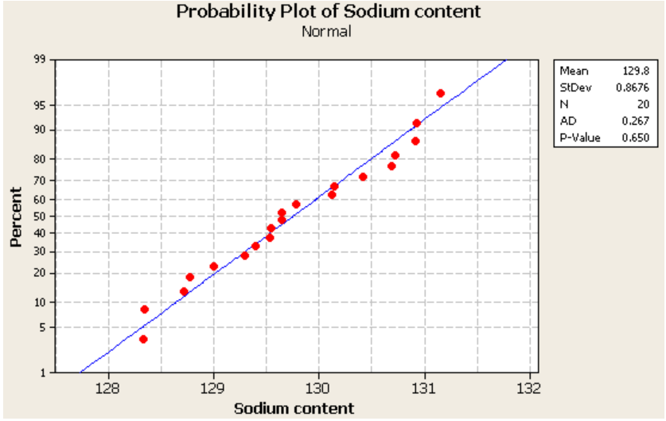
(c) Compute the power of the test if the true mean sodium content is 130.5 milligrams.
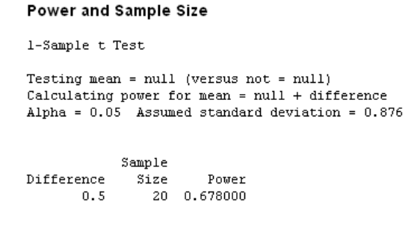

7. Personal Ethics Statement
Individual Assignment: By signing this Statement, I am attesting to the fact that I have reviewed the entirety of my attached work and that I have applied all the appropriate rules of quotation and referencing in use at the Telfer School of Management at the University of Ottawa, as well as adhered to the fraud policies outlined in the Academic Regulations in the University’s Undergraduate Studies Calendar. Academic Fraud Webpage
______________________________ May 29 2019______________
Signature Date
Leopardi, Anthony 8477846
Last Name (print), First Name (print) Student Number

