AS101 Module 1

Lesson 1:
Our Place in the Universe
- CERN – European organization that operates the largest particle physics lab in the world
- 1.5 x 10^8 km is defined as 1 Astronomical Unit (AU) or 150 million km
- The milky way galaxy is 100 000 ly in diameter with 100 billion stars

The Cosmic Calendar
- 13.8 billion years since the Big Bang
- MILKY WAY IS ONE OF THE OLDEST GALAXIES

Seeing Stars, Patterns in the Night Sky
- With the naked eye we can see as many as 3000 stars, all of them are a part of the Milky Way Galaxy
- Stars lie at different distances from Earth
  - They move in different directions and are spread out in all three dimensions of the plane (above, on, and below)

Precession
- Earth’s rotational axis is pointed toward Polaris, the North Star
  - 2000 years the axis didn’t point anywhere specifically, and 2000 years from now it won’t either
  - This is due to the precession of the axis
- The processional period for Earth is about 26 000 years, on a 23.4º tilt

The Night Sky and Its Motions
- The Earth is rotating from west to east in front of the Sun, giving up both day and night
- What you see in the sky depends where you are on Earth. Canadians see constellations and stars that Australians never see and visa-versa
- Astronomers measure distances across the sky as angles in units of degrees, arc minutes and arc seconds
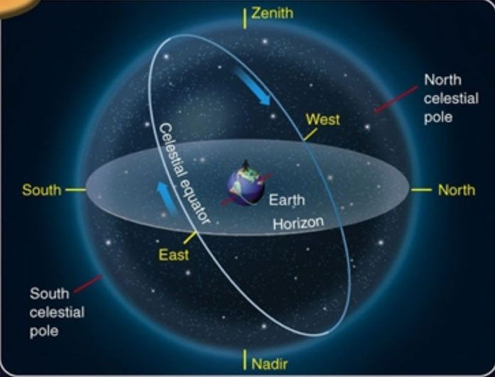
- Zenith: the point in the sky directly overhead
- Nadir: the point in the sky directly below on other side of celestial sphere
- Celestial Equator: an extension of the Earth’s equator onto the celestial sphere, due east to due west, through zenith
- Meridian: line going from due north, through your zenith and finishing due south. It always cuts the celestial equator at a right angle
- North Celestial Point: coincides w Earth’s rotational North Pole, northern point of celestial sphere
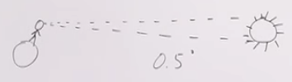
Angular Measurements
- Refer to size of objects (or separation of two objects) by the angle they subtend in degrees
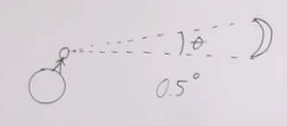
- Angular distance is the angle made by the two lines emanating from the observer's eye or vantage point to the two outer edges of the object (Top and bottom of object to make up an angle
- Angular degrees are subdivided into arc minutes (60' in one degree); an arc minute is further subdivided into 60 arc seconds (").

Stellar Motions
- the "turning of the sky" looks different depending on your latitude on Earth
- the star patterns shift as the Earth orbits the Sun gradually, not overnight

Lesson 2:
The Cycle of the Sun
- The Sun moves eastwards relative to distant stars, east to west each day
- Seasons are a result of the changes in the amount of solar energy received by the northern and southern hemispheres
- The earth is tilted at 23.4º which causes seasons to occur
  - This is why the southern and northern hemisphere experience opposite seasons
  - During Canadian summer the Earth’s northern hemisphere is tilted towards the sun, whereas the southern hemisphere is tilted away from the sun, meaning they experience winter

Daily Path of the Sun
- The location of the Sun depends on multiple factors
  - Time of day
  - Time of year
  - Your location
- Rises in the east, arcs through the sky and sets in the west
  - Sunset and sunrise times vary throughout the year as the earth rotates around the sun
- NOTE: earth completes a revolution around the sun in a year, and earth completes a revolution on its own axis to complete a day
- The Sun’s path does not change every day, but it does gradually over time
  - From summer solstice to winter solstice, the Sun’s path is moving slowly southward from your zenith
  - From winter to summer solstice its path is moving just a little more northward each day
- If you are…
  - Standing at the equator on March 21, the Sun’s path is coinciding with the celestial equator
  - Standing and it is June 21 (summer solstice) the Sun follows the 23.4 latitude line, this is known as the Tropic of Cancer
  - rise north of due east, cross your meridian at your zenith and set north of due west
    - Repeated after June 21, south of the celestial equator reaching most southward path on December 21 at the Tropic of Capricorn

Looney Tunes: The Moon
- Takes a month to complete orbit around Earth
- Distance of orbit varies
- Orbital period is 29.5 days
  - Sidereal period (time for one revolution relative to stars) is a little over 27 days

Phases of the Moon
- New moon exactly when it is between the earth and sun, the backside of the moon gets illuminated so we can’t see it
- New moon rises early in the morning (6 am) and sets in the evening (6pm)
- Full moon takes 14.5 days (rises in evening, sets at dawn)
- New moon, Waxing Crescent, First Quarter, Waxing Gibbous, Full moon, Waning Gibbous, Last Quarter, and finally Waning Crescent

Eclipses
- There should be two eclipses every month
  - Each new moon should be a solar eclipse (moon blocks out the sunlight at high noon for a period of time)
  - Lunar eclipse at full moon (Earth blocks out Sun’s light at midnight)
- ^ This does not happen because the moon’s orbit is inclined at about 5º to ecliptic plane
  - Means it is usually above or below the plane
  - It crosses at points called nodes where and eclipse is possible
  - The paths of sun, earth, and moon must line up and it must be a full or new moon

- Lunar Eclipse Types
- Penumbral
  - Most common
  - Moon passes through only the penumbra, so sunlight is only partially blocked
  - Moon darkens slightly
- Partial
  - Part of the moon passes through the umbra while the rest passes through the penumbra
  - Part of the moon is completely dark while the rest is only slightly dark
- Total
  - Moon passes entirely through the umbra
  - Result is the moon is completely dark during the eclipse

Solar Eclipse
- Happens when the moon is in between the earth and sun
- The earth passes through the moon’s shadow
- The nodes must be aligned, and it must be a new moon
- Types of Solar Eclipses
- Total
  - Moon is relatively close to the Earth in its orbit and moons umbra touches small area of the Earth’s surface
  - Sun is entirely blocked out
- Partial
  - Surround the small area of totality lies a larger area falling inside the moon’s penumbral shadow
  - Only partially blocked out sun
- Annular
  - Occurs when the moon is relatively far from earth and the moons umbra may not reach the earth’s surface at all
  - All of the sun blocked out except a ring of sunlight around moon disk

Eclipse Cycles
- Eclipses occur almost every 6 months (173 days)
- Cycle of both lunar and solar eclipses occurs over a period of about 18 years, 11.3 days known as the saros cycle

Planet Wanderings: Planet Watching
- “My Very Educated Mother Just Served Us Nachos”

  - Mercury
  - Venus
  - Earth
  - Mars
  - Jupiter
  - Saturn
  - Uranus
  - Neptune
- The planets move eastward relative to the stars
- Retrograde is when the planets appear to change direction and move westward relative to stars
- As the inner planet catches up to and passes the outer, slower-moving planet, the outer planet "appears" to move backwards in the sky.

Stellar Parallax
- Looking at an object, close your eyes. First one eye then the next. The lateral shift in the object’s position relative to the background is called parallax.
- Stellar parallax occurs when observing nearby star from two vantage points
  - When earth is at one extreme, and its opposite extreme
  - Star appears to shift laterally relative to the background of stars behind it
- Allows us to measure distances to nearby stars and provides evidence that the earth revolves around the Sun
- Seen through telescope, not naked eye

Lesson 3:

Celestial Coordinates
- In the sky latitude is declination and longitude are right ascension
- Declination is expressed in degrees, arcminutes, and arcseconds north (+) or south (-) of the celestial equator
- The degrees refer to the size of the angle between a line from the centre of the earth out to the particular location on the celestial sphere
  - Any point on celestial equator has a declination of 0º while the north pole has a declination of +90º
  - Right Ascension is expressed in hours, minutes, and seconds from 0-24 hours
  - The celestial coordinates of stars remain constant because they are so far
  - The 0 h for RA is the longitudinal line that runs through the spring equinox (middle of earth vertically)

Timekeeping
- Timekeeping by Day
  - Local meridian is imaginary line ending at north and south celestial poles that cuts through the zenith
  - Length of time between successive passes of the sun across the local meridian is called a solar day
  - Another way to measure the length of a day is the measure the time it takes any star to make successive passes across the local meridian which we call a sidereal day (23 hours 56 minutes)
- Timekeeping by Month
  - Lunar phase’s cycle which is about 29.5 solar days
  - Known is a synodic month
- Timekeeping by Year
  - Time required for Earth to complete an orbit around the sun (365.25 days) kno2n as a revolution
  - Sidereal year is time taken for complete orbit relative to stars whereas the time between successive spring or autumnal equinoxes’ is called a tropical year
  - Sidereal year is longer by 20 mins compared to tropical year
- When the sun is right on the meridian it is noon
- Average solar day differs because of earth’s 23.4 tilt

Calendars
- Tropical year is about 365.25 days
- Julius Caesar: Every 4 years the extra .25 adds up and a leap year happens to account for that time. Short by 11 minutes tho
- Pope Gregory XIII: Georgian calendar with slight variation to make it even more proper

