Acid Base Titrations Lab

CHM1311
Prof: Darrin Richeson
TA name: Yuchu Dou
Date: November 16, 2018
Introduction
According to Svante Arrhenius, a Swedish chemist from 1850 to 1927, an Arrhenius Acid is defined by a chemical compound that increases concentration of hydronium ions (H₃O⁺)
when dissolved in water. It can also be referred to as a “hydrogen ion donor”. On the contrary, an Arrhenius base is a substance that increases the concentration of hydroxide ion (OH⁻) when placed in water, also referred to as “hydroxide ion donors”. Thus, if you were to take any acid, such as hydrochloric acid, and combine it with water, the result would be as seen below, where hydronium ion can be found as a product :
HCL + H₂O H₃O⁺ + Cl⁻
Similarly, if you were to take a base like sodium hydroxide (NaOH), which is used in this experiment, and dissolve it in water, the hydroxide ion would separate from NaOH. The resulting chemical reaction would appear as the following:
NaOH Na⁺ + OH⁻
Acids are further grouped according to the number of hydrogen ions that can be donated. While monoprotic acids can only donate one hydrogen ion, polyprotic acids can donate two or more.

Purpose
The purpose of this experiment is to determine the concentration of an unknown acid by conducting a titration experiment. If the solution is highly concentrated, then there is a greater ratio of acid or base in the water with respect to water, and vise versa. Equivalence point and endpoint are essential factors when preforming a titration experiment, where the closer the numbers are, the better. An indictor, Phenolphathalein, will be used to determine the endpoint in this experiment, which will leave a light pink color in the solution.

References:
Fred Scaffidi. “Acid/Base Concept.” 16 Sept. 2011
< www.tc.gc.ca/eng/canutec/articles-acid-445.htm. >
Virginia Department of Education. Science Enhanced Scope and Sequence-Chemistry. (2012)

Materials and Apparatus

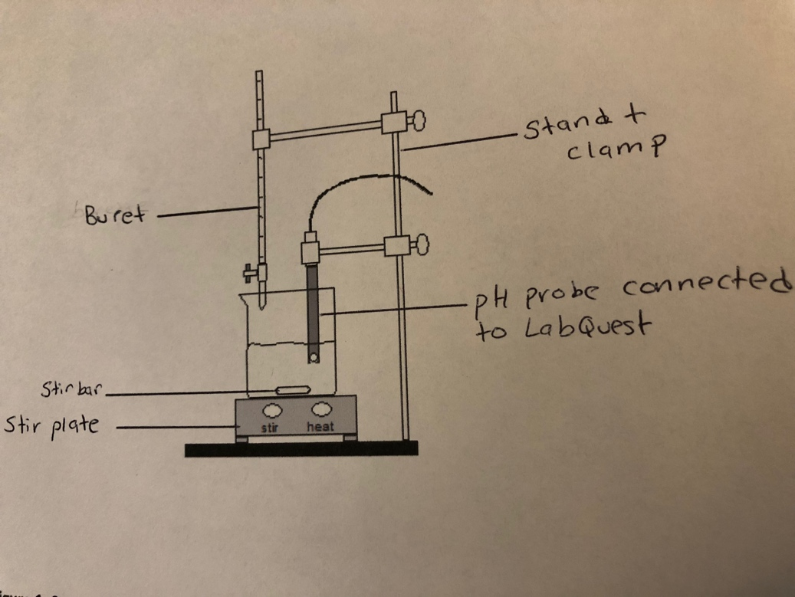

Figure 1: Set up of the titration experiment
Equipment:
- 400 ml beaker

- 50 ml beaker
- 10 ml graduated cylinder
- distilled water
- LabQuest 2 device
- Plastic buret
- Glass buret
- Universal clamp

- Double buret clamp
- Funnel
- pH probe
- stirrer
- stir plate
Chemicals:
- 6 mol/L NaOH
- Phenolphalein indicator
- 0.1M HCL (monoprotic acid)
- Diprotic Unknown Acid Solution

Safety Measures
- As mentioned in the Lab manual, acids and bases included diluted solutions are corrosive so handle with care. If acid or base is spilled, make sure to clean it up immediately so it is not mistaken for water.
- Hydrochloric acid is a very strong acid, do not inhale
- Do not consume any solutions in the lab
- If any solution comes into contact with skin, thoroughly and immediately rinse with cold water for approximately 15 minutes
- Wear safety goggles and appropriate lab wear at all times.
Procedure
Refer to Lab Manuel for the procedure of this experiment.

(Lab Manual. “Oh How Bitter A Thing It Is….” Acid Base Titration. Pg. 79-82)

Raw Data
Standard Solution
Run 1 Graph:

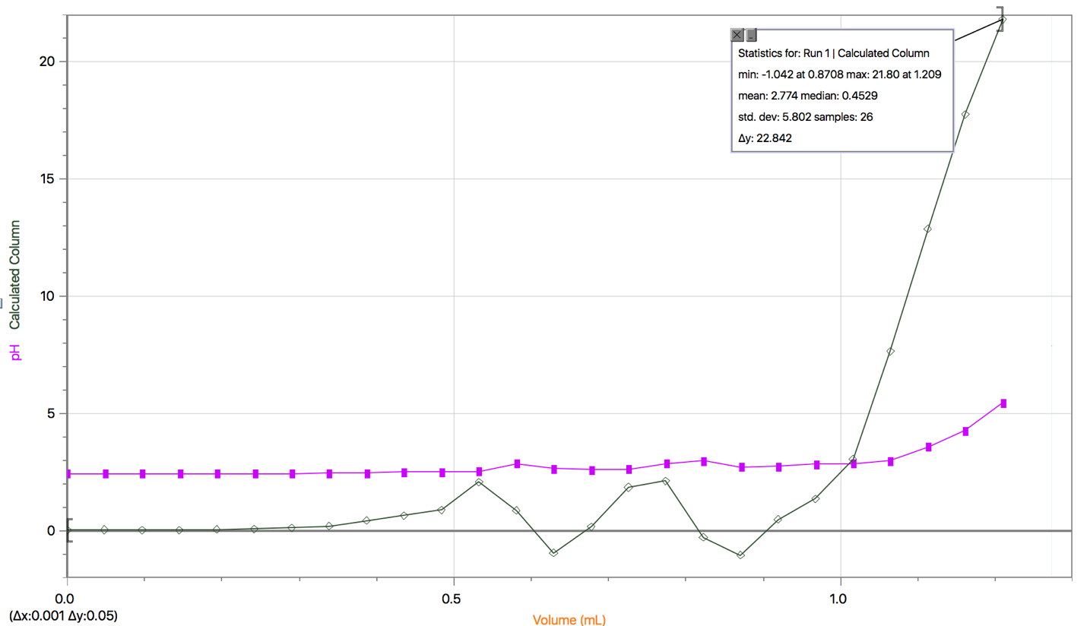

Run 2:
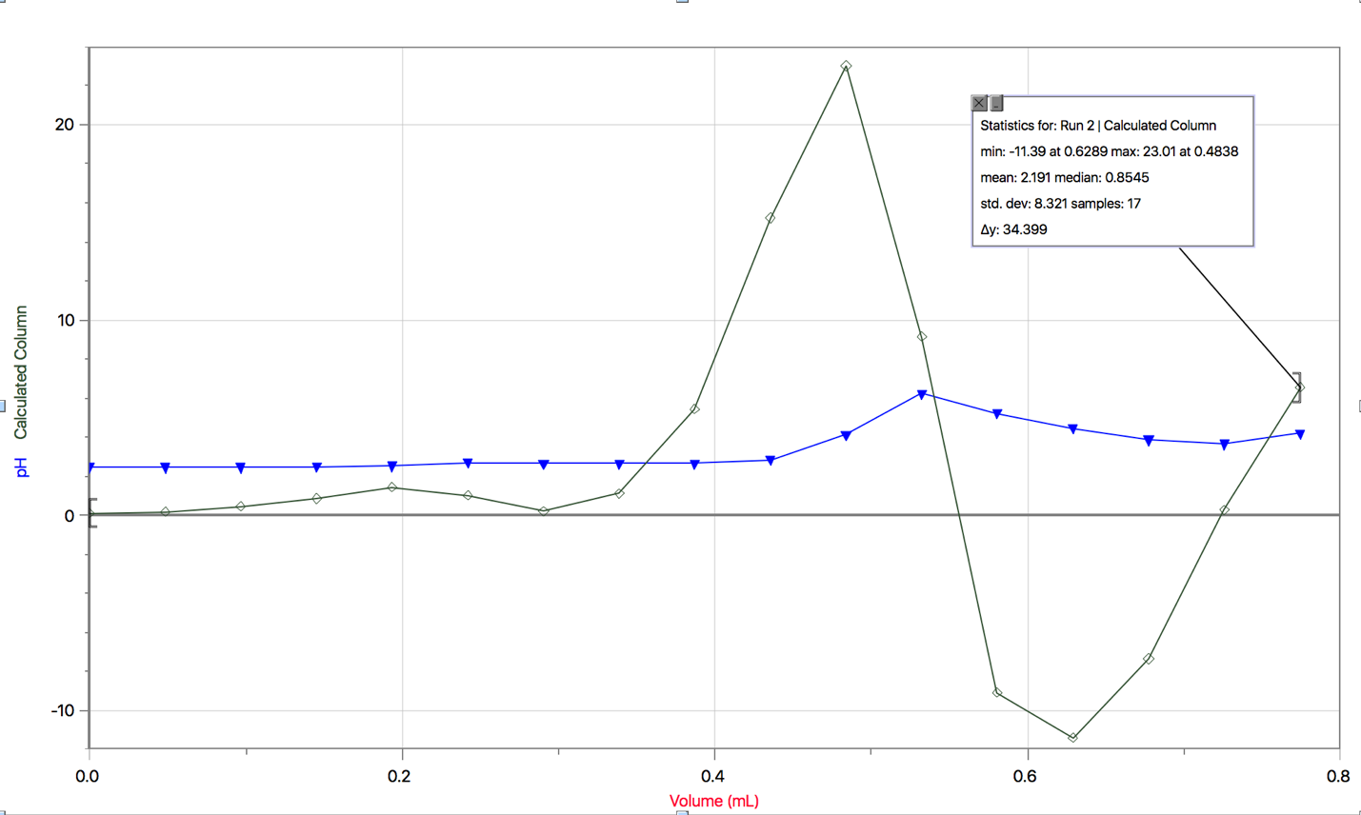

Run 3:
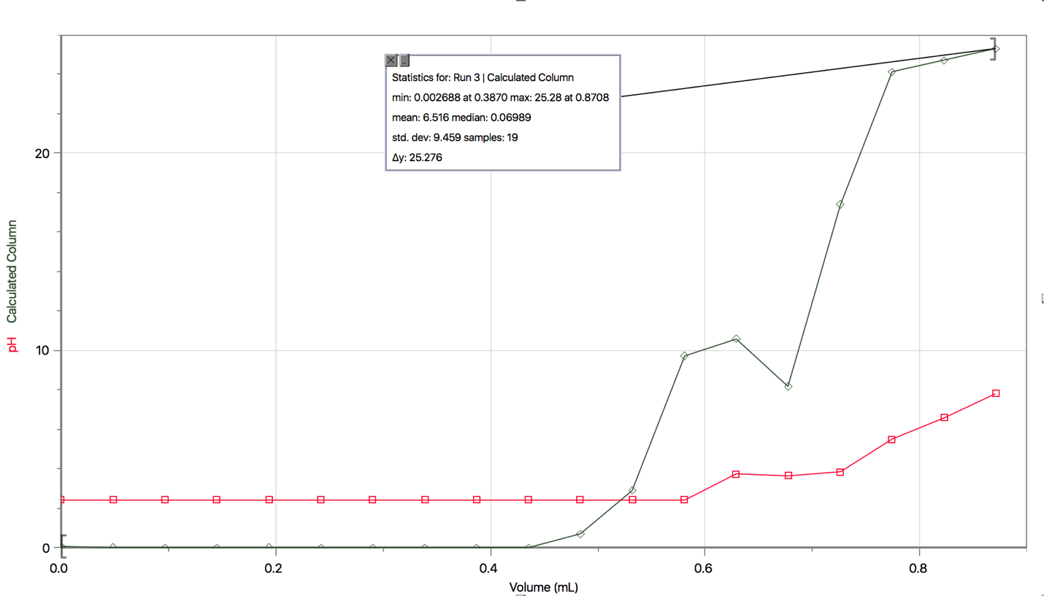

Diprotic Solution

Run 1:

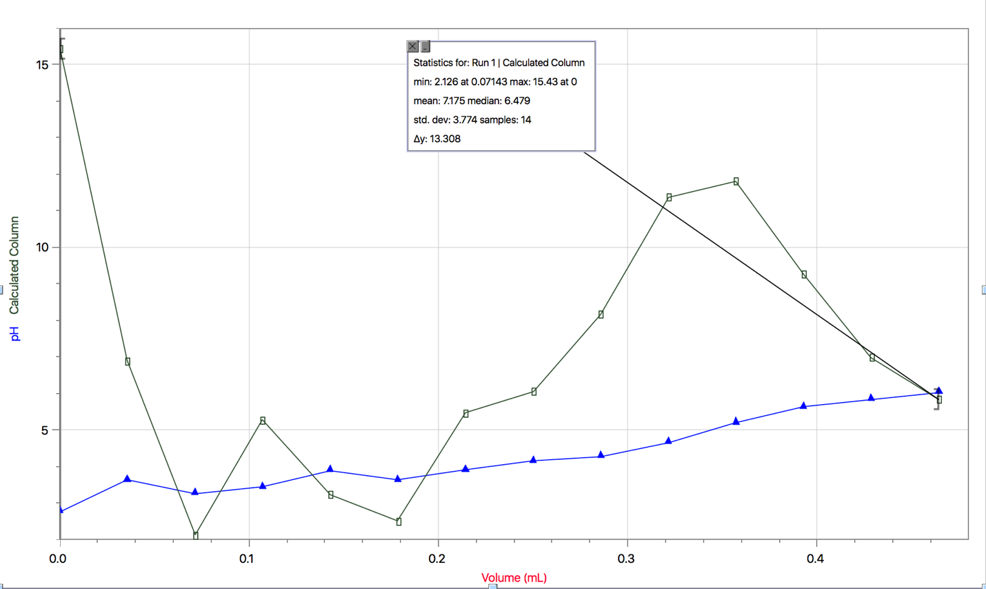

Run 2:

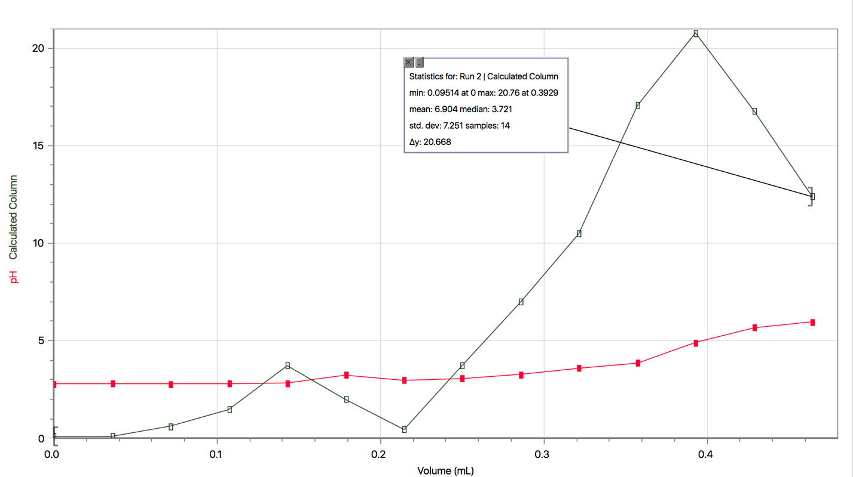

Run 3: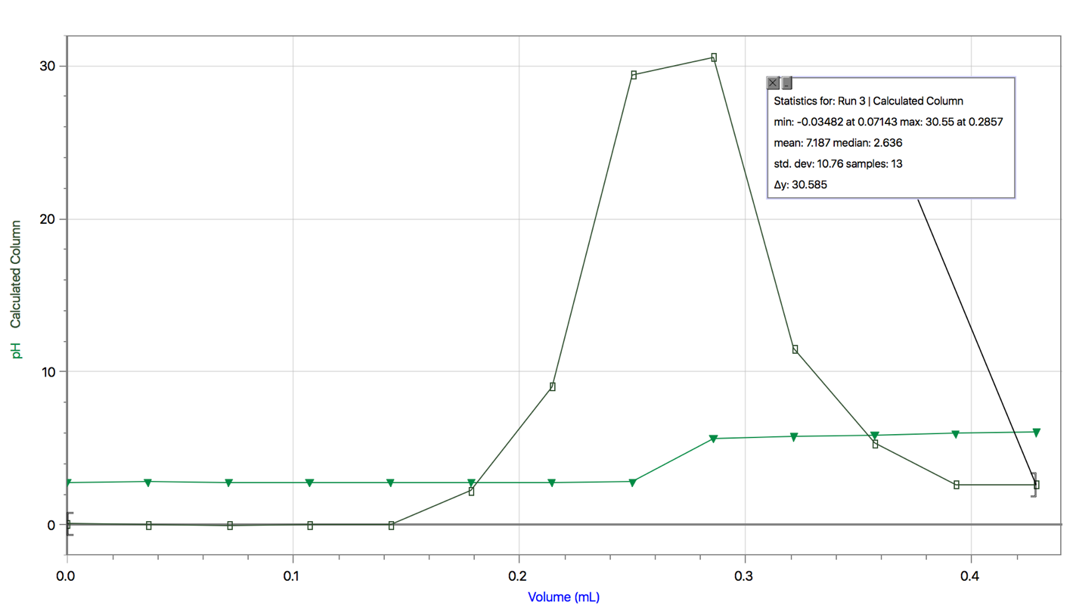

Calculations

1.C₁V₁= C₂V₂

Initial concentration of NaOH (C₁) = 6 mol/L
Initial volume of NaOH (V₁) = 10 ml = 0.010 L
Total Volume (V₂) = 130 ml = 0.13 L

Therefore:

(6 mol/L) (0.010L) = C₂ (0.130 L)

C₂ = 0.06 mol / 0.13 L

C₂ = 0.46 mol/L

Concentration of NaOH solution used in the experiment = 0.46 mol/L

2. Equivalence point of titration with standard solution:

Equivalence point for run 1 = 1.209
Equivalence point for run 2 = 0.4838
Equivalence point for run 3 = 0.8708

Average Equivalence point = (1.209 + 0.4838 + 0.8708)/3
= 0.854 ml

Exact concentration of NaOH (C₂):

C₁V₁= C₂V₂

Initial concentration for standard acid (C₁) = 0.1 mol/L HCl
Exact volume for HCl (V₁) = 10 ml = 0.010 L
Volume of base determined from logger pro (V₂) = 0.854

Thus: ( 0.1 mol/L HCl) (0.010L) = C₂ (0.000854L)
C₂ = 0.001/ 0.000854
= 1.171 mol/L

3. C₁V₁= C₂V₂
(1.171) (0.010L) = C₂ (0.000854L)
C₂ = 0.01171/ 0.000854
= 13.71 mol/L
Discussion
- No it does not matter what volume of concentrated NaOH you use in the beginning because the concentration stays the same throughout.
- The NaOH is going to be consumed so it is important to know what the concentration of NaOH is in the beginning
- The volumes at equivalence determined by Logger Pro was the same as the volumes which we observed the color change.

- Sources of Error - The main source of error in this experiment, or in titration experiments in general is the endpoint error. This is because the human eye itself cannot determine what the endpoint of the titration really is. This effects the experiment because excess titrant may have been added, resulting in a greater concentration of acid.

- At 0 ml of added base, species present is just H₂A, because there is no reaction taking place yet
- First equivalence point: H₂A + NaOH ⟷ NaHA + H₂O. This is because all of the hydrogen ions have reacted with sodium hydroxide, which is the base used in this experiment.
- At midway to the second equivalence point, the species are: NaHA +NaOH ⟷Na₂A + H₂O.
- At the second equivalence point: H₂A + 2NaOH ⟷ Na₂X + 2 H₂O. At this point, there are twice as many hydrogen ions than before because the hydrogen ions from both reactions reacted.

Conclusion
Thus, it is evident that the concentration of an unknown acid can be found using a titration experiment. In this experiment, the concentration of the diprotic acid was 13.7 mol/L.

Sources:

Fred Scaffidi. “Acid/Base Concept.” 16 Sept. 2011
< www.tc.gc.ca/eng/canutec/articles-acid-445.htm. >

Manitoba Education
< https://www.edu.gov.mb.ca/k12/cur/science/found/gr12_chem/topic5.pdf>

Lab Manual. “Oh How Bitter A Thing It Is….” Acid Base Titration

Vernier Lab Quest. Titration of Diprotic Acid.
<http://www2.vernier.com/sample_labs/CWV-25-COMP-titration_diprotic_acid.pdf>

Virginia Department of Education. Science Enhanced Scope and Sequence-Chemistry. (2012)

Volumetric Glassware,
<www.webassign.net/question_assets/ncsugenchem102labv1/lab_9/manual.html.>

Lab Data:


