Validation of Gas Laws: Charles Law and Boyles Law

CHM1311
Prof: Daren Richeson
TA name: Yuchu Dou
Date: September 27, 2018
Introduction

Gasses are impacted by three main factors including changes in temperature, pressure and volume, and the relationship between these factors can be defined by the Ideal Gas Law Equation: PV= nRT
- Pressure (P)
- Volume (V)
- number of moles of gas (n)
- universal gas constant (R)
- temperature (T)
An ideal gas is characterized as one with gas particles that are small, equally sized, far apart, and without any volume or intermolecular forces to allow attraction or repulsion to one another. As indicated in the lab manual, in reality, these terms are difficult to satisfy, since they require low pressure and high temperature conditions, allowing for less intermolecular forces to exist between gas molecules. However, if these conditions are manipulated to an increase in pressure or lowered temperature, a shift from the concept of ideality can be examined, since real gasses do have intermolecular forces between molecules as well as a volume.

Purpose:
While the Ideal gas law is driven from Charles’ Law, Boyle’s law, and Gay- Lussac’s Law, this experiment will solely work to verify Charles’ Law and Boyle’s Law. As mentioned in the lab manual, Charles Law examines the relationship between temperature and volume of a gas at a constant pressure and states they are directly proportional, while Boyle’s law investigates the inverse relationship between the pressure and the volume of a confined gas. Charles’ Law will be verified using two different temperatures and Boyle’s Law will require trapping a gas at various volumes in a 20mL syringe that is connected to a Gas Pressure Sensor to record the changes in pressure.

Reference:
Tenny KM, Cooper JS. Ideal Gas Behavior. [Updated 2018 Sep 20]. In: StatPearls [Internet]. Treasure Island (FL): StatPearls Publishing; 2018 Jan

Chart 1: Variables for Charles’ Lab Experiment
Variables | Impact on Investigation | Controlling/Changing/ Measuring Each Variable
Independent Variable  Temperature (K) | In order to verify Charles’ law and the relationship between temperature and volume, two different temperatures need to be used:  - Temperature of boiling water  - Temperature of ice bath | The temperature of the gas in the Erlenmeyer flask will be determined by measuring the temperature of the boiling water in the beaker that the flask is submerged in, and the temperature of the ice bath. It will be measured in degrees Celsius, and will be converted to Kalvin afterwards.
Dependent Variable  Volume (ml) | According to Charles’ law, the volume will change depending on the temperature being tested. | The volume will be measured in a graduated cylinder, and the meniscus will be read at eye level in order to accurately obtain the volume.
Controlled Variables  - Pressure (kPa)  - Amount of gas | Pressure needs to be constant in order to examine the relationship between temperature and volume. If the pressure is not equalized to constant atmospheric pressure, then Charles’ law is no longer applicable, as pressure is no longer a constant variable. Instead, it would apply the combined gas law as the relationship between all three variables is being determined.  There will be a constant amount of gas in the Erlenmeyer flask. | Pressure is constant at atmospheric pressure.  The amount of gas will be the amount of gas that fills the 150 ml flask.

Chart 2: Variables for Boyle’s Law Experiment
Variables | Impact on Investigation | Controlling/Changing/ Measuring Each Variable
Independent Variable  Volume (ml) | In order to verify Boyle’s law and the relationship between pressure and volume, different volumes have to be tested. | 8 different volumes will be used, measured in a 20 mL plastic syringe. The volume will start at 16 mL and will be decreased by increments of 1 mL until the measurement on the syringe reads 9 mL.
Dependent Variable  Pressure (kPa) | According to Boyle’s law, the pressure will behave inversely to volume. Thus, change in pressure depends on the volume being tested. | The pressure (kPa) will be recorded using a gas pressure sensor and Lab quest. After doing the experiment, the volume and pressure obtained will be used for calculations such as the Boyle’s Law constant.
Controlled Variables  Temperature (K) | Temperature needs to be constant in order to examine the relationship between pressure and volume. If the temperature is not constant, then Boyle’s Law is no longer applicable. Instead, it would apply the combined gas law as the relationship between all three variables is being determined. | Temperature remains constant at room temperature. It will be assumed that room temperature will be the same throughout the duration of the experiment.

Materials and Apparatus:

Charles’ Law experiment

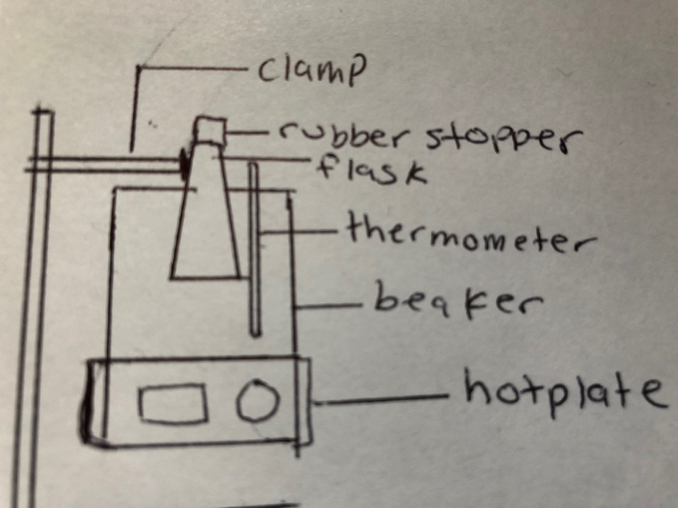
Figure 1: Charles Law apparatus. The Erlenmeyer flask should be as low as possible in the beaker, however, should not come in contact with the sides or the bottom of the beaker.

- 125ml Erlenmeyer flask
- 600 ml beaker
- Rubber Stopper
- Thermometer
- Ice Bath
- Extension Clamp

Boyles Law experiment

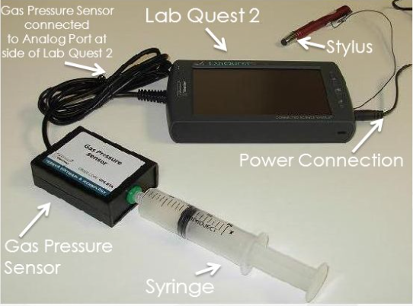
Figure 2: Boyle’s Law Apparatus

- Lab quest 2
- Vernier Gas Pressure Sensor
- 20 mL Syringe
Safety Precautions

After the water is boiled, do not touch both hotplate and Erlenmeyer flask as they are both hot. Use extension clamp in order to move the Erlenmeyer flask into the ice bath. If any of these hot materials come in contact with skin, wash hand immediately with cold water. Wear safety glasses and appropriate lab wear.

Procedure

Verification of Charles’ Law:

The procedure for this part of the experiment is the same as described in the Lab manual, however, the steps included below are the one’s that were slightly modified:
- Turn on the hotplate and heat the boiling. Monitor the temperature of the water in the beaker. Once the water is boiling, allow the Erlenmeyer to remain in the boiling water.
- Using a thermometer, determine the temperature of the water. Place a figure over the hole on the stopper and remove the Erlenmeyer from the hot water by disconnecting the extension clamp from the clamp holder. Do not touch the Erlenmeyer flask directly as it is hot.
As seen above, the main modification made was to step 6, simply because the lab did not have a digital thermometer which could fit inside the rubber stopper of the Erlenmeyer flask. Thus, the water of the boiled water was measured, and it was assumed that the temperature of the air inside the Erlenmeyer flask was equivalent to the temperature of the boiled water.

Verification of Boyle’s Law

- Prepare your air sample by moving the plunger of the 20mL syringe to the 16mL mark.
- After preparing your air sample, connect the 20 mL syringe to the valve of the Gas Pressure Sensor, and connect the the Gas Pressure Sensor to your Lab quest 2.
- Set up Lab quest as described in the lab manual in step two of the “How to Use the Equipment” section, and remember to add 0.8mL to each of your volume readings on the syringe since there is 0.8 mL of space inside the pressure sensor. Also, press “keep” button on Lab Quest only once the pressure on the screen becomes relatively stable.
- Start collecting your data, writing down the pressure for the volume at essentially 16.8 mL.
- Next, decrease the volume by moving the plunger of the syringe to 15.0 ml, and record the pressure when it is stable.
- Continue in this manner until you have measured the pressure in the syringe by decreasing the volume 1 mL at a time up until 9.0 ml. As stated in the lab manual, after the final pressure is recorded for 9.0 ml, move the plunger back to the original volume of 16.0 mL and decide which pressure reading at the original volume to keep.
- Stop data collection and view the plotted points on the graph. Remove the data point for the original volume which you do not want to keep (instructions on how to do this are explained in step 4 of the lab manual).
- Next, choose a line of best fit, or a curve fit, which ever is a better match for your graph, and save and transfer your data to your USB. Repeat steps 1-8 to conduct at least one more trial.
- The data collection and the information gathered was used to calculate a Boyle’s Law constant and develop an equation for Boyle’s Law.
Raw Data

Table 1: Charles Law

 | Trial 1 | Trial 2
T₁ - Temperature of boiled water (K) | 101°C + 273 = 374K | 375
T₂ -Temperature of ice bath (K) | 278 | 279
V₁- Volume in beaker (L) | 147 ml/1000 = 0.147 L | 0.151
V_{cw}- Volume of Graduated Cylinder (L) | 0.0251 | 0.038

Table 2: Boyle’s Law

Volume (ml) | Pressure (kPa)
 | Trial 1 | Trial 2
16.8 | 103.83 | 102.48
15.8 | 108.81 | 110.29
14.8 | 117.74 | 115.28
13.8 | 123.84 | 125.94
12.8 | 130.99 | 133.79
11.8 | 134.38 | 144.39
10.8 | 159.87 | 160.19
9.8 | 171.51 | 173.75

Qualitative Observations

Charles’ Law:
- While performing the Charles Law procedure, small bubbles began to form around 4 minutes after heating the water in the beaker on the hot plate set at high temperature
- At around 6-7 minutes, big bubbles began to form, indicating that the temperature inside the flask reached approximately boiling temperature (100 Degrees Celsius)
- When the flask was placed into the ice bath, water almost immediately entered the flask

Boyles’ Law:
- While conducting Boyle’s law, as we continued to decrease the volume of gas in the syringe by increments of 1ml, it became more and more difficult to hold the syringe in place
- At around 11.8 ml, the pressure pushing back against the plunger of the syringe was a lot more prevalent that the increments before
- At our last increment, 9.8 ml, the pressure pushing back felt the greatest of all the previous

Processing Data and Discussion

Graph 1: The relationship between pressure and volume in the first trial, obtained by decreasing the volume by increments pf 1 ml each time.

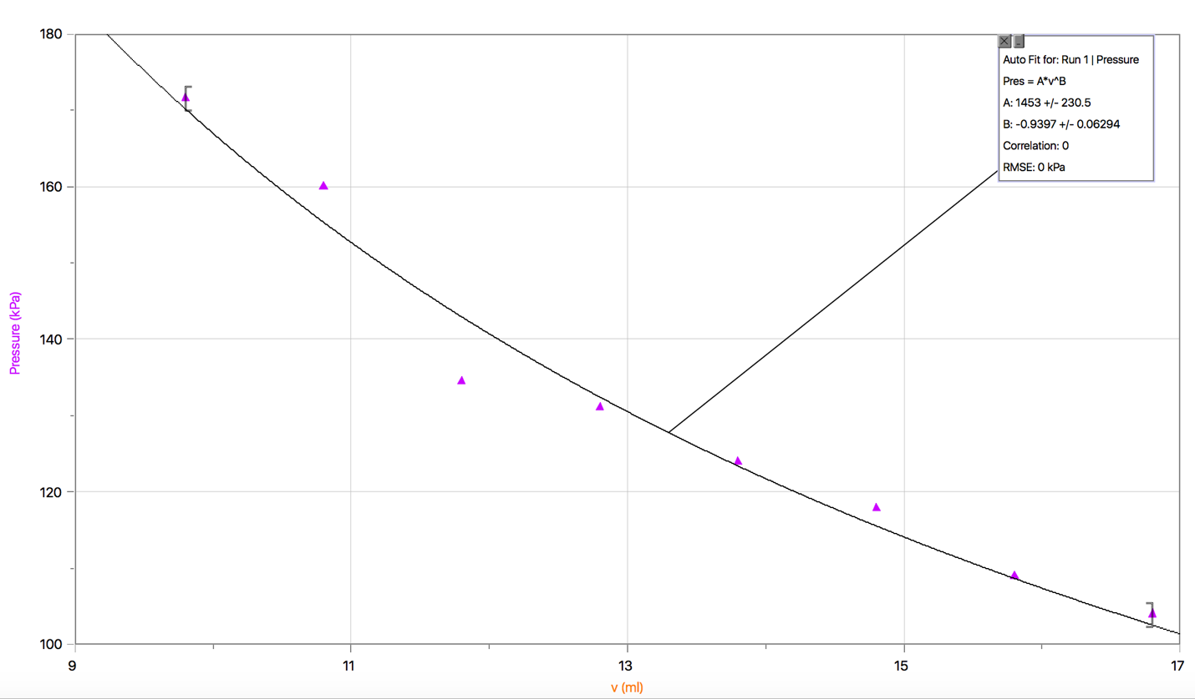

Graph 2: The relationship between pressure and volume in the second trial, obtained by decreasing the volume by increments pf 1 ml each time.
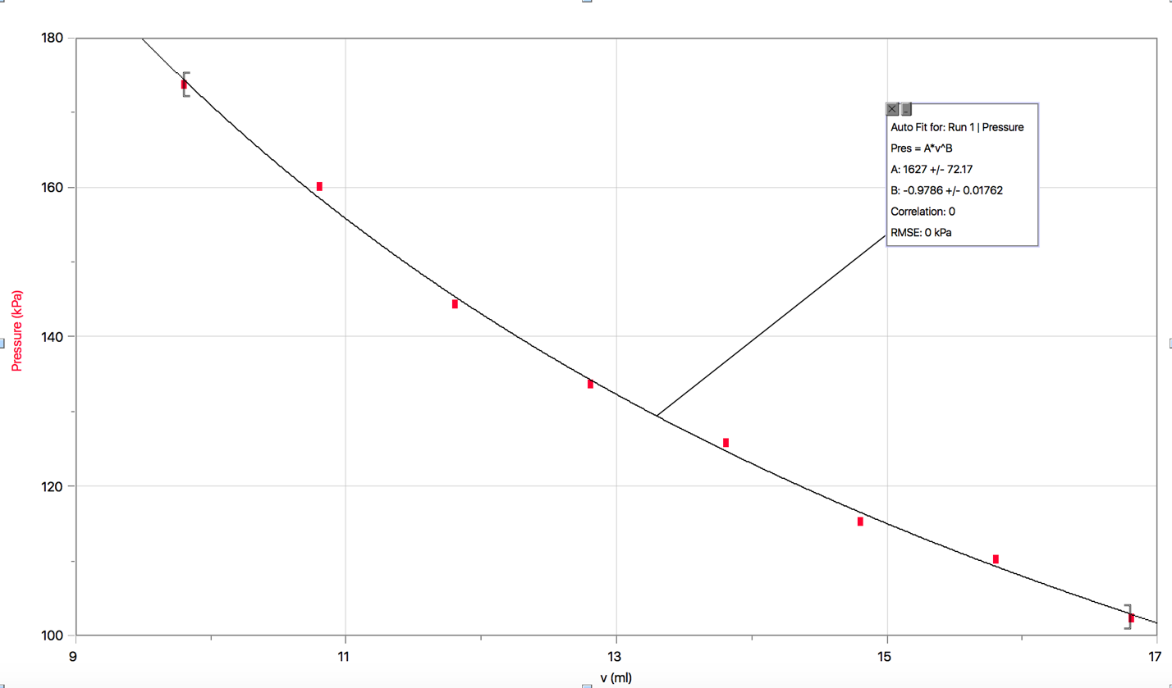

From the graphs above, with data derived from Table 2, it is evident that volume and pressure are inversely related. As the volume decreases from 16.8 ml by increments of 1 ml, the pressure continues to increase. This can be explained by applying Boyle’s Law. Boyle’s Law states that with conditions of constant temperature, a decrease in volume causes molecules of gas to be compressed and pushed closer together in a shrinking space, intern causing the pressure to build up. Thus, this supports the purpose of the experiment and verifies Boyle’s Law. However, looking at the graphs, it is noticeable that there is not a linear line of best fit, and instead, it is curved. This is important because it links back to the idea that the behavior of real gasses is not ideal.
In addition, the curve in graph 1 and graph 2 appear to be very similar, however there are a few discrepancies or random errors in the first trial. For example, the point at 10.8ml and 11.8 ml do not seem to fit the the curve of best fit as well as the other points in the graph or the points in graph 2.

Charles’ Law (refer to questions in lab manual)

- V₁= 0.147 ml
T₂= 374 K
- V₂ (volume of the gas at T₂ for trial 1) = V_{cw} – V₁
= 0.147 L – 0.0251 L
= 0.1219 L
- Charles Law = V₁/T₁ = V₂/T₂ (using values from trial one)
= 0.147 L / 374 K = 0.1219 L / 278 K
= 3.93 x E-4 = 4.3 x E-4

- Table 3: Average of variables using data from both trials

T₁ | 373.5 K
T₂ | 278.5 K
V₁ | 0.149 L
V₂ | 0.117 L

Sample Calculation to Calculate Averages
T₁ = (Trial 1 T₁ + Trial 2 T₁) / 2
= (374 + 373) / 2
= 373.5 K
Charles Law = V₁/T₁ = V₂/T₂ (using average values from table cndn)
= 0.149 L / 373.5 K = 0.117 L / 278.5 K
=3.99 x E-4 = 4.20x E-4

Although the numbers above are not completely equal to each other, similar to question 3, they are relatively close with a difference of 2.1 x E-5. This is to be expected because of sources of error, and the idea that gasses do not act ideally under variations of temperature, volume, or pressure.

- Percent Error Calculation

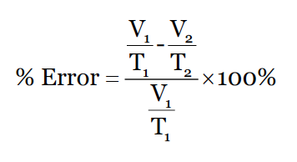
=$\frac{\left(\frac{0.149 L}{373.5 K}\right) - \left(\frac{0.117 L}{278.5 K}\right)}{\frac{0.149 L}{373.5 K}} X 100\%$

= $\frac{\left(3.989 X E-4\right) - (4.200 X E-4)}{(3.989 X E-4)}$ X 100%

$=- 5.714 \%$

Since the percent error does not equal zero, it is evident that the data collected is not fully in accord with Charles’ law. This result was predictable as it fulfills the idea that gasses are not ideal.

Boyle’s Law (refer to lab manual for questions)

- Determining the Rate Constant (k)

K = PV

=(Average of K=PV in Trial 1) + (Average of K= PV in Trial 1)
2
= 1.6981 + 1.7187
2
= 1.71 kPa / L

Sample Calculation : Average of k=PV in Trial 1

(15.8 ml x 106.81 kPa) + (14.8 x 117.74) + (13.8 x 123.84) + (12.8 x 130.99 ) + (11.8 x k= 134.38) + (10.8 x 159.87 ) + (9.8 x 171.51 )

8
k = 1698.1045 ml x 1000
k = 1.70 L

- Looking at the calculations in question 1, the equation that can be developed from this is: P₁V₁ = k = P₂V₂

P₁V₁ refers to average pressure x volume in trial 1 and P₂V₂ refers to average pressure x volume in trial 2. From the previous question, we can sub in the values for these variables to get:

1.70 kPa/L = 1.71 kPa/L = 1.72 kPa/L

Just like in the equation to verify Charles’ law, the values are extremely close with a difference of only 0.01 kPa/L. In this case, due to the close nature and difference of only one decimal, this may just be a random error that must have occurred during the experimental procedure.

- In the procedure we were instructed to note down the value of the first and last measurements at the same mark on the syringe. We did this for the second trial, where 101.69 was the last measurement at 16.8 ml, and 102.48 was the original value. Because the values are relatively close, both would appear to be fine on the graphed data. The purpose of this is mainly to ensure accuracy of the data collected.
- Boyle’s law requires certain conditions be met for other gas variables, the main one being temperature. As described in the variables chart, temperature is kept constant in order to directly examine the relationship between pressure and volume. If the temperature is not constant, then Boyle’s Law is no longer applicable as the combined gas law would be more appropriate. However, there is no actual way in order to keep temperature constant, instead, we just made the assumption that the room temperature will stay constant throughout the experiment.

Sources of Error and Suggestions for Improvement

It must be noted that only two trials were conducted for both of these experiments. The most impactful suggestion for improvement would include conducting more trials, which could be used to obtain an overall average, leading to a more accurate result.

Charles’ Law Experiment:

Error in timing the boiling or cooling process-
In this experiment, the assumption was made that the temperature in the flask was equivalent to the temperature of the boiled water or that of the ice bath. However, this could lead to error because if not enough time was given for the temperature inside the flask to equal that of the boiled water or ice bath, inaccurate temperature could be recorded. Similarly, if the Erlenmeyer flask was allocated too much time to boil, and not enough cooling time or vise versa, incorrect data for temperatures could once again be recoded.
In order to avoid this, the flask should be constantly monitored especially when bubbles begin to form in the water, in order to prevent it from heating for too long. In addition, time could be set appropriately as a constant variable.

Escaping Gas-
While transferring the Erlenmeyer flask into the ice bath, it was essential to keeping the hole in the rubber stopper firmly closed using your figure so that gas could not escape. However, since the flask is very hot, skin contact with it can cause your hand to shift slightly, allowing air to escape. Similarly, when removing the flask out of the ice bath while keeping a figure over the hole, sensitivity to the cold could also cause discomfort and cause your figure to move slightly, leading to inaccurate data collection.

Incorrect Volume -
When pouring the water obtained in the Erlenmeyer flask from the ice bath into a graduated cylinder, drops stuck to the outside of the flask could have entered the cylinder. This would slightly increase the volume, leading to an error in the data collection of the volume.
To avoid this situation, the tip of the flask should be placed directly on the tip of the graduated cylinder. This way, droplets from the outer surface of the flask have a lower chance of entering the graduated cylinder.

Equalizing Water Level –
When the flask is raised in the ice bath, the total pressure in the flask becomes equalized to the atmospheric pressure. However, if this step is not done correctly, then the pressure is not equalized and Charles’ law is no longer applicable since pressure is no longer a constant variable.

Boyle’s Law Experiment:
Inaccurate Reading of Syringe-
As mentioned in the observations, as we continued to decrease the volume of gas in the syringe by increments of 1ml, it became more and more difficult to hold the syringe in place. This is because the molecules of gas were being compressed and pushed closer together in a shrinking space, intern causing the pressure to build up and push back against the plunger of the syringe. This caused trouble because it would slightly cause changes in the volume being recorded. As the volume was being interrupted, it further impacted the pressure as we had to wait for the pressure being measured on Lab quest to become somewhat stable. Once the pressure appeared stable and the pressure was submitted, we noticed that within that movement of clicking the button, the pressure submitted was slightly different from when we clicked the button because the grip on the syringe may have slightly shifted and changed the volume, causing the data to have error.
In order to avoid unwanted fluctuations in volume, a more defined syringe with lockable positions could be used so that it is not only easier to view, but can also withstand the pressure being exerted back to provide a more accurate volume and pressure reading.

Lab quest Data logger
One of the main issues with Lab quest was that it automatically rounds to two decimal places, causing a slight inaccuracy in the pressure being recorded and within the other calculations that required this data.

Conclusion

As depicted in the data tables and graphs, this lab successfully verifies Charles’ Law and Boyle’s Law. For Charles’ Law, we can use the data tables to understand that volume and temperature are proportionately related, whereas the graphs for Boyle’s law indicate that pressure and volume are indirectly related. As volume decreases, pressure increases and vise versa. However, from the calculations, the idea of ideal gasses can be viewed as strictly a theoretical concept.

Extension of Experiment
An extension to this lab could be to verify Gay-Lussac’s Law, examining the relationship between pressure and temperature.

Raw Data

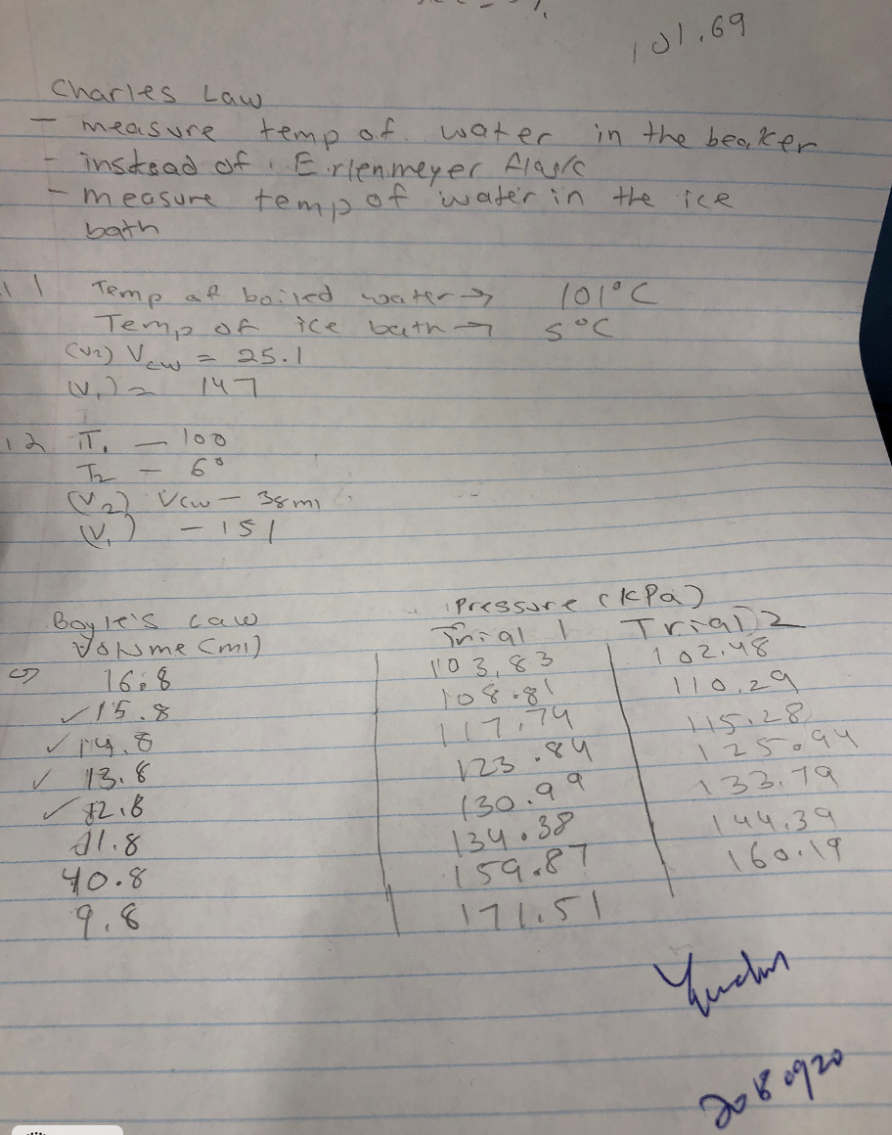

Works Cited

- T.S. Eliot, “Verification of Gas Laws”. Lab Manual
- Tenny KM, Cooper JS. Ideal Gas Behavior. [Updated 2018 Sep 20]. In: StatPearls [Internet]. Treasure Island (FL): StatPearls Publishing; 2018 Jan

Image obtained from:
Slideplayer. “Exploring Boyle’s Law using Vernier Equipment”. 2018

