Chapter 1: The Scientific Method:
  - Definition of Science:
- Science: A coherent body of knowledge related to certain categories of facts, objects or phenomena obeying laws that are verifiable through experimental methods
- Scientific inquiry aims to acquire new knowledge.
- Two approaches:
  - Description-based: (e.g. describing nature)
  - Hypothesis-based: (e.g. explaining nature)

  - The Scientific Method:
- 1.2.1 Inductive reasoning (linked to a descriptive-based approach):
  - Making a generalization often based on numerous specific observations
  - Particular -> general
  - Examples:
    - Seeing people outside of a class, and guessing that there will be a class happening
    - Looking outside in the morning, seeing the Sun and saying that it will be a nice day
  - Problem with this: probable that something could be wrong
- 1.2.2 Deductive reasoning (linked to a hypothesis-based approach):
  - Involves stating a hypothesis and drawing conclusions (after experimentation or observation) from this hypothesis
  - General -> Particular
  - Examples:
    - Seeing people outside of a class and guessing that there will be a class happening. Verifying it by going inside and looking.
    - Doesn’t stop after making the statement, needs further testing and verifying their statement.
- 1.2.3 The Scientific Process:
  - Observation: this orange is sweet
  - Generalization: All oranges are sweet
  - All scientific inquiry starts with one or multiple observations.
  - Subsequently, the scientific process must be implemented.
  - We need to see something before we make a statement
  - Inductive statement: “the fish died because of a lack of oxygen/poisoning.” – sounds more appealing to the media
  - A real scientist would say “I don’t know why this occurred. I need to do some tests.”
  - Scientific hypotheses must be verifiable, refutable, reproducible
  - Hypothesis that can be manipulated and tested
  - Make sure that you can repeat the experiment
  - If you can’t obtain those results again, something is wrong
  - 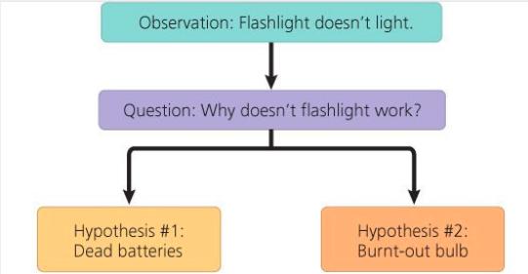
  - From a hypothesis, you can make a prediction.
  - Predictions must be testable and give a clear result
    - If… then... statement
  - Hypothesis can be falsified or not falsified (theories)
  - We can never prove that a hypothesis is the scientific truth
  - Scientists don’t say they have the truth, you can never say that a hypothesis is the scientific truth
  - If it is a real strong hypothesis (repeated several times), then it becomes a theory
    - E.g Evolution
  - There is always the possibility that something isn’t the truth
  - 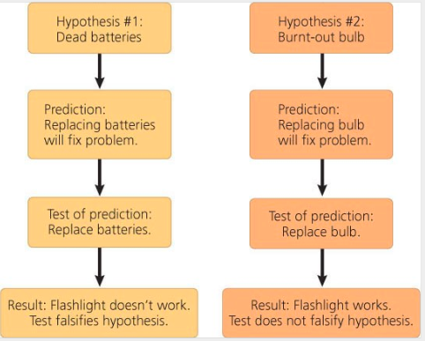
  - Observation: This orange is sweet
  - Hypothesis: All oranges are sweet
  - Prediction: If I taste all kinds of oranges, then they will always be sweet
  - Tests: tasting all kinds of oranges.
    - Traveled to Madagascar: tasted a very sour orange
      - Hypothesis is now falsified
  - Modify your hypothesis if refuted: “All oranges are sweet except for the Madagascar orange.”
  - 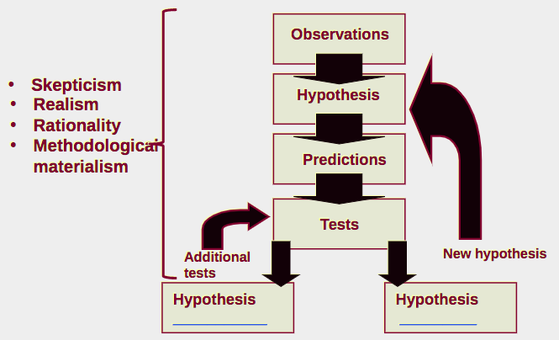
  - The objective is not to confirm your hypothesis, the objective is to falsify your hypothesis
  - 4 Clauses:
    - If you don’t follow them, then it isn’t science
  - Contract between science and knowledge (or the ability to know)
    - Initial skepticism on facts:
      - We ask honest questions on facts and hypothesis (tangible/real things) and we always retest what has been found
      - We can never finalize research and say that we have the truth, some hypothesis has never been falsified, we have to assume that they are close to the truth and build on that
        - E.g Darwin’s Theory of Evolution
      - This is our weakest point when we deal with media and politics, seems like our weakness
    - Realism:
      - The world is older and exists independently from my perception of it (the realm of ideas does not have the priority over the real world)
      - Imagine that when you are born, you are a clean slate. You build your ideas based on your surroundings (parents, community, etc.) filling the empty slate of your mind. When you do science, you need to focus on the real world. Only see the real world, not any preconceived ideas that you have (NO BIAS)
    - Rationality:
      - Logic: demonstrations from a scientist must be the result of coherent steps.
      - Parsimony: methodological principle which states that acceptable theories are hypothetically the most economical in assumptions (fewest steps)
      - Basically, the process of just explaining (tests and retests) what your question is, what you are going to find, how you are going to do that, and how you are going to test is.
    - Methodological materialism:
      - All that is experimentally accessible in the real world is material or has material origin
      - You cannot explain something in science with a supernatural explanation (i.e. aliens)
      - Your explanation has to be testable
  - If you follow these four clauses, you are doing science.
- Crop circles: no explanation (no one knew where they came from). Caused people to be skeptical. People assumed Martians until two guys stepped up 7 years later and took responsibility for the crop circles.
- Monarch butterflies and the Viceroy:
  - Monarch:
    - Breed in our regions, consumes milkweed
    - Toxic due to the milkweed they eat
    - Birds eat one, learn that they are toxic and won’t try to eat them again
    - Colour – warning – says “I’m toxic, don’t eat me”
  - Viceroy:
    - Looks like the monarch, however not even from the same genus (not sister species)
    - Colouration similar to the monarch
    - Hypothesis: Batesian Mimicry
      - Some species evolve colour of toxic species even though they are not toxic (protection)
      - Other species go through this (snakes, insects, moths)
      - Likely one individual of viceroy had this colouring; the trait was favoured, and it evolved (natural selection)
    - Viceroy is actually as toxic as the monarch (found through testing: had a bird eat just the body of both the monarch and viceroy with the wings cut off, the bird spat both out)
    - Mullerian Mimicry:
      - Species that are toxic tend to look alike to send a stronger signal of toxicity to predators
  - Point: The need to review and test theories – it is good to revisit things and ensure that they are real.
  - Camouflage in the environment:
    - Odd field mouse: several populations that have adapted to their environment. Colouration is really important to survival in their environment
      - Beach – creamy white colouration to match the sand
      - Inland – brownish to match the dirt
    - Hypothesis: in this species, fur colouration patterns has evolved as camouflage in their native environments
    - Predictions: If mice have a colouration that does not match their habitat, then they will be preyed on more heavily than the native, well-matched mice.
    - Test:
      - Plasticine mice spray-painted in beach or inland colours.
      - Spread both colour models (control and experimental) in equal numbers in both habitats
      - Count the signs of attack - different colour attacked more
    - Results: Hypothesis was not falsified – colouration is important to survival in both environments
  - Case study: Introduction of fish in Gatineau Park:
    - The introduction of species has an impact on fish biodiversity.
    - In Canada, the « value » of a lake is often linked with the quality of recreational fishing.
    - The introduction of species for recreational fishing are frequent to enhance the « value » of a lake.
    - Fish species for recreational fishing are often piscivores (they
prey on other fish species, usually smaller)
    - The impacts of piscivorous fish introductions on indigenous
species have been the subject of few studies.
    - Gatineau Park has dozens of small lakes where species were
introduced for recreational fishing.
    - Observation: small lakes in which recreational fishing species (piscivores) have been introduced do not have schools of small fish near shore
    - Sample are: Gatineau Park – the introduction of piscivores species in 20 small lakes (less than 60 hectares) at the beginning of the 20th century (experimental group).
      - There are still about 25 small lakes without piscivores species (control group)
    - Hypothesis: The introduction of piscivore fish species in small lakes would result in a decline in the numbers of smaller species present
    - Prediction: in small lakes from the same region, if lakes contain introduced piscivorous species then they will have fewer smaller fish species than lakes without the piscivores
    - Testing the prediction: determine the number of fish species in both types of lakes (catch and release – count the number of individuals in each lake every 2-3 days). A comparative analysis of fish species diversity in a region with small lakes with and without introduced piscivores. Spent 2 summers gathering data, putting it all together and analyzing.
    - Results: Lakes without introduced piscivorous fish species have significantly more (50%) small-sized fish species than lakes where they were introduced
    - Recommendation: no piscivorous species introduction in Gatineau Park lakes to preserve the park’s biodiversity
Conclusion:
- In this chapter, we have established the definition of science, and the validity of the scientific method/process
- A valid scientific process needs to respect the 4 clauses of the contract between the acquisition of knowledge and science
  - Breaking one of the clauses invalidates the contract before the acquisition of knowledge does not correspond to an objective search for the scientific truth (which we can never say we have attained). Thus, the knowledge acquisition process in this instance is faulty and corrupted.
Chapter 2: Evolutionary Thinking Before Darwin:
*See handout

Chapter 3: Charles Darwin and Evolution:
3.1 Charles Darwin: Education and Family:
- Born February 12th, 1809
- Father was a doctor
- Mother was from the Wedgewood family (porcelain)
  - Darwin was in the higher class
- Married (1838) to his cousin Emma Wedgwood (1808 – 1896)
  - Meant some of his kids were more at risk to genetic diseases (no genetic variation)
- Had 10 children
- Stops his studies in and takes a more serious interest in religion (Cambridge).
  - Prerequisite to become a pastor: Bachelor of Arts
- Developed an interest in nature: taxidermy, insect collecting, botany, etc.

3.2 The Voyage on the Beagle:
- In 1831, he leaves on the Beagle, a ship commissioned by the British government to do the cartography of the coast of South America
  - The boat was leaving for 2 years to collect specimens and do the cartography of the continent
- Darwin was invited on board as the companion of the captain Fitzroy but quickly became the naturalist of the voyage.
  - They hired Darwin to be the captain’s companion at dinner due to the fact that he was in the higher class.
- He travels the world and spends most of his time on land to sample the fauna and flora and to study South American geology
  - The vision of the trip by Darwin was that they would go from city to city and organize an expedition inland where they collect specimens then map out the area. They bring the specimens to the boat, put them in a preservative and analyse the findings. After this trip, he wrote a book about it. He was interested in how everything worked.
- The trip is planned for two years, lasted 5 years
- During the voyage, two books had an impact on Darwin
  - William Paley (1743-1805): “Theology, or evidences of the existence and attributes of the deity.”
    - Paley is the father of the Theology of Nature. This theology advocated that harmony and design in nature are indicators of the existence and the acts of God (today = intelligent design).
  - Charles Lyell: “Principles of Geology.”
    - Darwin began his expedition thinking like a good protestant: believing in the Great Flood and Cuvier’s catastrophism
    - When he returned five years later, he was in total agreement with Lyell and Hutton’s principle of uniformity

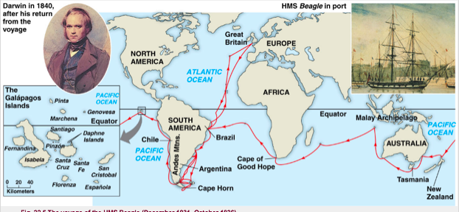
- The very distinct fauna of South America had a profound effect on Darwin:
  - Why do the fauna and flora of Africa, Europe, Australia and South America have relatively few species in common?
  - Why are the animals and plants of the temperate zones of South America resemble the species living in the tropical zones of South America but not the species in temperate Europe?
  - Why are the mammal fossils of South America absent from the current fauna (e.g. Giant Sloth)? Why do these fossils show the resemblance with current species found only in South America (e.g. Three-toed Sloth)?
  - Fauna on the Galápagos Islands surprises Darwin
    - The fauna on the Islands is unique. Why?
    - Why does it show resemblance with species on the American continent?
      - E.g Galápagos Sea lions closely related to the California sea lion
    - Why so much shell variability in Tortoises in the Galápagos? Every island has a different shell.
    - The finches of the Islands.
      - Why so much morphological variability in one group? These birds all have the same body, just different beaks. The beak varies on what the bird eats.
      - Why does each island, in most cases, have their own species? own species?
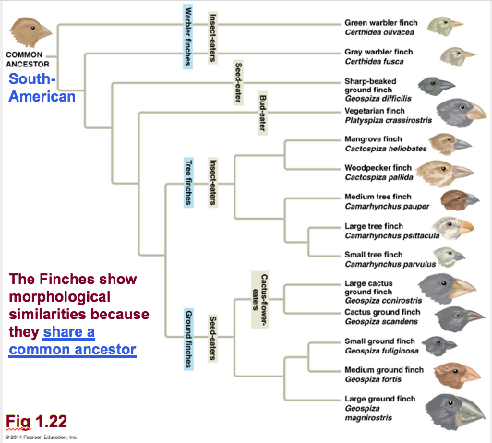
3.3 Evolution and Natural Selection:
- In 1837, we find in Darwin’s notes the first mention that species show resemblance to each other because they share a common ancestor (not a common environment).
  - Rejects the fixity (no change) of species and accepts the concept of descent with modifications (evolution).
  - Very materialistic view of life that is in contradiction to the religious dogma of the time
  - Rejects Lamarck’s evolutionary mechanism (environmental determinism)
- Then, he begins the search for an evolutionary mechanism
- If species look alike, it’s probably because they share a common ancestor. This explains why some species look alike, this explains why there is some variety in the beaks, this explains why the tortoise look alike,
- The notion of fossil and importance of fossils:
  - Fossils have the key to understanding evolution.
    - These 3 species (Rock hyrax, Dugong, African elephant) belong to the same group – they share a common ancestor and common features
- 99% of species that have lived on Earth are extinct
- Most of the evolutionary branches finish in a dead-end (extinction).
- In 1838, Darwin read “An essay on the principle of population” written by the economist Thomas R. Malthus who was interested in the human evolution
- This reading became one of the main sources that inspired him to formulate his famous theory on natural selection
- In his book “An essay on the principle of population (1798)”, Malthus wrote that:
  - Every human population tends to increase geometrically (exponentially), whereas the available resources to feed these populations increase arithmetically (a lot slower).
  - 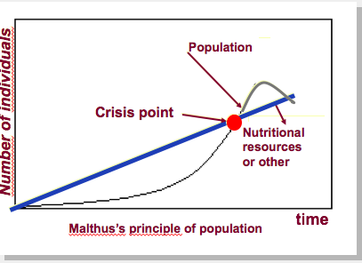
  - The human population increases faster than its capacity to feed itself. This leads to crisis (famine, sickness, war, etc.) and eventually to a substantial reduction in population size
  - Crisis point = population too large to be able to take care of themselves, exceed the available resources
  - When the crisis point occurs, there are winners and losers. People will die until out of the crisis point
  - Darwin used this concept for his natural selection
  - Malthus seemed to try to use this as some sort of human population deterrent
  - Darwin’s first observation: all species can produce more offspring than their environment can sustain and many of this offspring fail to survive and reproduce
    - An example of this is the maple tree and its samaras. It produces many seed, but not all will end up growing up into a tree. Some won’t survive. It’s all about winners and losers, you can’t control the birth-rate, you can easily exceed your resources and then competition will occur
    - Another example is the Puffball and its spore cloud. It releases a lot more offspring than the number that will survive
    - A final example is the Ocean Sunfish. In her lifetime, the female Ocean Sunfish will release almost 30 million eggs. Many of these will not survive or mature due to the fact that resources in order to survive.
  - Darwin’s Second observation: Members of a population often vary in their inherited traits
    - There has to be a genetic basis for it to be inherited. Darwin didn’t know about this.
      - Example: Ladybugs. The number of dots varies in each bug on a genetic basis. The shell colouring also varies with each species
    - The reality of variability in a generation became really important. It’s the key on how to understand how evolution works
    - He knew that there were traits that were passed from generation to generation. These are the more favourable traits (like colouring, speed, etc.) – Natural selection
  - Darwin made two inferences:
    - Individuals whose inherited traits give them a higher probability of surviving and reproducing in a given environment tend to leave more offspring than other individuals
    - From generation to generation, this unequal capacity of survive and reproduce (differential reproductive success) results in an accumulation of favourable traits in a population
    - This is natural selection. It enables the emergence of adaptations
      - Example: Model fishes. Inside this population, there is genetic variability – the colour varies. These are inherited traits, which is very important (ensure that you add this to your answer on a test, some characteristics are not inherited. If they are not inherited, then they won’t be passed on) in this pool of genetic variability. There is a predator (duck) that attacks the prey and chooses the fish that is more distinct to their environment. Most of the fish that will be attacked will be the ones with the greatest contrast to their background. What natural selection suggests is that after a few generations, more fish will have the same colour as the background as they are more able to survive and reproduce. This trait is more important, it is favoured for natural selection. The trait is more abundant in the next generation.
      - Second example: water conditions change, background colour changes. Ducks still attack the fish with the greatest contrast to their background. The selective pressure changes, new colour becomes more abundant as it is easier for it to survive.
    - Selective Pressure: any phenomena which alters the behavior and fitness of living organisms within a given environment. It is the driving force of evolution and natural selection.
  - It is a letter from Alfred Russel Wallace (1823-1913), received in 1853, that forced Darwin to publicly release his ideas.
  - Wallace had come to the same conclusions as Darwin concerning the theory of natural selection by observing the fauna of Indonesia
  - Thus, it was 23 years after his voyage on the Beagle that Darwin publicly released his views on the evolution of species
  - On the same day, in 1858, Darwin and Wallace presented a resume of their ideas on natural selection to the Linnaean Society of London
  - In 1859, Darwin published the first edition of his book “On the Origin of Species.” This book became an instant bestseller and created great controversy
  - The 6th and last edition of his book, published in 1872, contains a chapter dedicated to the most important arguments against his theory. Most of these arguments came from his creationist colleagues
  - This is the most important book in natural history written – he provided tons of examples of natural selection and inherited traits and such. He provided contrast, explains things through natural laws, does not involve religion in his ideas
  - Important notions linked with natural selection:
    - Individuals do not evolve, populations evolve
    - Only hereditary traits are subject to natural selection
      - If you are talking about traits that are acquired during the lifetime of an individual, or non-genetic traits, they will not be passed down (not subject to natural selection)
    - For evolution to occur, we need genetic variability.
      - Darwin said that genetic variability is the source of evolution
      - Cheetah has no genetic variability. If their environment would change, they’d all be ‘losers’ and extinction is likely. They are unable to adapt to change
    - Natural selection corresponds to a differential reproductive success within a population from generation to generation
    - With time, natural selection enables individuals to become better adapted to their environment
      - Survival of the fittest is not an accurate description
    - Environmental factors vary in time and space. Thus, the selective forces are variable.
      - Deer – size varies depending on their environment. Smaller when they get to Costa Rica, selective pressure varies in space, varies in time (we have seasons, Costa Rica doesn’t)
    - Traits in populations will change and can modify the species
      - E.g. less selective pressure for us to have a strong jaw to consume meat, now that we have tools, and use fire to cook our meat to make it easier to consume (evolution within a species that results in a change of shape)
  - For Darwin, this mechanism is valid because:
    - It respects the principle of uniformity of Lyell and Hutton
    - The results of natural selection are visible in nature
    - The mechanism can be verified on current populations (e.g. artificial selection)
    - It is a materialistic concept (no need for divine intervention)
      - The mechanism is not random. Natural selection enables individuals that are better adapted to their environment to become more abundant than those who are not (differential reproductive success)
      - Not a quest for perfection (evolution is not a directed process). It does not lead to the appearance of “perfect” traits. Organisms only adapt to their environment
    - Only ultimate goal is to have your genes be more represented in the next generation
  - Artificial selection is finalized because the goals, fixed well in advance, precedes the causes. The end result can be obtained in a few generations
    - Example: Suppose that you want a certain dog trait, you choose dogs with this trait and breed them together until you achieve puppies with this trait (FINALIZED) you can reach your end goal
    - Example: Wild mustard was bred selectively to make more traits more abundant (e.g. selection for leaves led to Kale)
  - Natural selection is not finalized. It can take a long time for changes to occur (geological time scale)
    - Example: moths. Peppered moths are found everywhere. There are two morphs: grey and dark. These have predators (some species of birds). This experiment was made in the 1900’s where the main source of energy was coal. The environment was dark and sooty as a result. It provided many dark things for the month to live on. If you are a light (grey moth) you are more visible, and the birds will eat you. In dirty cities, the proportion of dark moths was a lot more prominent than that of the light moths. In the countryside, the trees are grey, and the light moths are more able to camouflage so they are less likely to be eaten. There are more grey moths as a result. In the 1950’s, the cities were more cleaned up and the ultimate consequence logically would be that the dark moth population would shrink as they are unable to hide. There are still some alive, but there is just a significantly smaller amount compared to the grey moth.
    - Example 2: Birds. Every summer, UCLA goes to catch birds in the Galapagos. They are able to measure them, and they know the pedigree of the birds. This is good if you know the morphology of the parents, you are more likely to know the genetic basis of the trait. Population of this bird went down when the drought occurred, as it ate seeds. This was measured based on the size of the beak. If the beak is bigger, you can eat bigger seeds, if it is smaller, you are restricted to smaller seeds. When the drought occurred, they realized that the population that remained were the ones with the larger beaks, as the only food that remained was the larger seeds.
    - Example 3: Adaptation to altitude. When Francois Chapleau travelled to the Himalayas, he found the altitude very hard to walk up, he is used to a lower altitude. On the first day at a higher altitude, he was very sick and not well adapted. The people who lived in that area, were used to the altitude and did not have these side effects. Francois Chapleau had to walk really slow to not get out of breath and couldn’t go faster without getting affected by the altitude. The guide, who was used to the altitude was running up and down the mountain, not getting affected at all. He has a genetic adaptation to not be affected by the altitude. Over 2000m, the partial pressure of O₂ is insufficient for normal saturation of hemoglobin for a traveller in high altitudes. As a result, they get short of breath and altitude sickness. This is due to the physiological response (acclimatization, this is not genetic): After a few days at high altitude, the body compensates the low partial pressure of oxygen by increasing the concentration of red blood cells in our blood. This presents some serious health risks: thrombosis, pulmonary edema, etc. This is because your body may not be used to this sort of adaption. Some people cannot handle this concentration of RBC.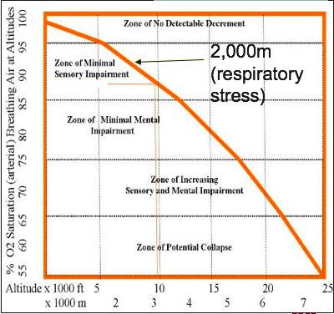
    - How did this evolve: It can be hypothesized that more than 22,000 years ago, in the lowlands of Asia, there was a population who mostly did not have the genetic traits allowing them to live and reproduce at high altitudes, however some individuals had a mutation that allowed them. Because of this, when the population moved up to the higher altitude (3,500 m) they were able to survive at the higher altitude
    - By generation 50, they made up half of the population in the higher altitude, compared to the 25% they made up at the first generation. By generation 500, they made up 75% of the population up in the higher altitude. Now, 1000 generations later, they make up 90% of the population at the higher altitude.
    - Many regions in high altitudes were independently colonized by humans. On the Qinghai-Tibet Plateau, human adaptation to high altitudes differs from the Andes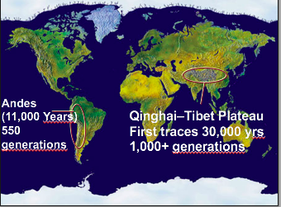
    - Adaptations:
      - Andes – increase in hemoglobin concentration (RBC)
      - Qinghai-Tibet Plateau – deeper breath, larger pulmonary capacity and increased blood flow.
    - Natural selection keeps the individuals with the genetic traits that allow adaptation to high altitudes. This means that individuals that have the mutation are at an advantage for survival and reproduction (produce more offspring like them)
    - Due to the acclimatization that Francois Chapleau had, he was able to run his next few marathons easier, due to the higher RBC count, his body was able to transport oxygen easier. Unfortunately, this adaption didn’t last too long in the lower altitudes
  - In the three cases (moths, finches, and humans), the hereditary traits that give a reproductive advantage (i.e. adaptation) to individuals in a population will be favoured. Thus, from generation to generation, there will be a higher percentage of individuals carrying the adaptation. This is natural selection. It’s Darwin’s descent with modification. It’s evolution
  - These adaptations can sometimes redefine a species and, in certain circumstances, define a new species.

3.4 Proof of Evolution: Homology
- Descent with modification theory (theory of evolution) explains the resemblance between certain traits even if the functions are different
  - Homologous structures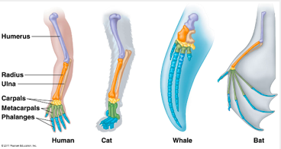
    - A dolphin’s flipper, bird’s wing, cat’s leg, and the human arm are all considered homologous structures. Whereas human beings have bones such as the humerus, ulna, radius, wrist bones, and fingers, these features appear as similar bones in form in the other animals. Bats, whales, and many other have very similar homologous structures, demonstrating that these creatures all had a common ancestor.
  - 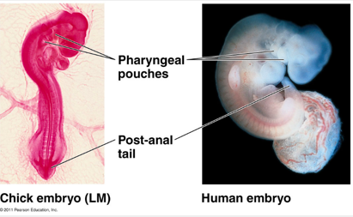
    - Comparative embryology: by comparing two species embryos, we are able to see some homologous structures that may disappear after some development such as the post-anal tail and the pharyngeal pouches.
  - 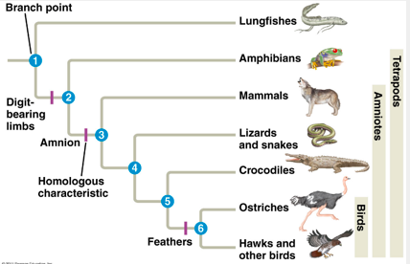
    - Homologous structures = purple dashes
    - The challenge of evolutionists is to put the homologous structures at the correct spot on the evolutionary tree
    - Evolution isn’t linear, it is branched
- Fossils:
  - Evolution of the horse:
    - In this first picture, it shows the evolution as linear. The horse began as a small, fox sized creature with many toes to accommodate life spent walking on the soft, moist ground of the forest. It had simpler teeth which made it easier to eat the leaves it typically consumed. As it progressed, the horse moved to more of a prairie environment, the leg got simpler (hooves) and the teeth got more complex as it began to eat grass. The legs got longer to be able to outrun predators, and the teeth became a lot more durable as when animals graze, they tend to consume a lot of sand along with their grass.
    - The real picture demonstrates the evolution more accurately many species were alive at the same time, not just one at a time like the linear depiction suggests.
    - 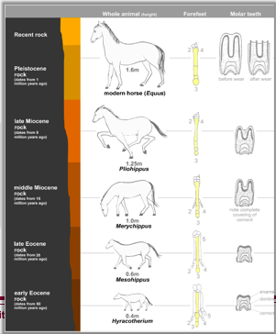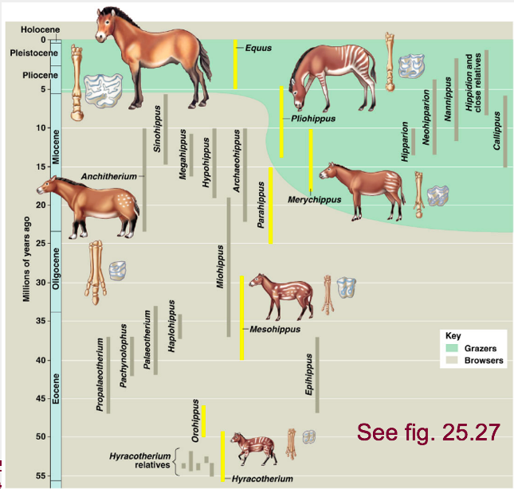
    - Pakicetus: When we look at the whale’s ancestors, we see a quadropedic creature that shares features with the whale, but also other mammals like the hippopotamus. It is obvious that the whale and the hippo do not resemble. Among living species, the closest species to whales are the hippopotamus. There is a distinct gap between them, that is being filled with the discovery of fossils. These fossils show a body that is more adapted to the aquatic life rather than on land. We analyze the structure of the bones, like the Pakicetus ankle bond. It resembles many ankles of the dog, pigs and such. This is an example of the relationship. It seems like Pakicetus (or their descendants) became very adapted to water (as we see the hind leg progressively disappear in each species). By the end of the chain (whale), the only part that remains is the pelvic girdle. This leads us to the following question: why does the whale still have the pelvic girdle? They have no hind leg, but the presence of this structure is found in all of their fossils, (e.g. blue whale at the museum). This is what we refer to as a vestigial structure. The presence of this bone suggests that an ancestor of the whale had limbs, but progressively left due to lack of function.
  - Vestigial structure: Anatomic structure that has lost almost of its initial function, this is the evidence of evolution (nature of the structure).
    - Example: Nictitating membrane (third eyelid)
      - Little piece of flesh in the corner of our eye. Very functional structure in some vertebrates. Membrane that can slide from the corner of the eye that can protect the eye while they are moving. (e.g. birds when they fly). Crocodiles have this when they swim under water. Yet humans have the knob of flesh that serves no function. It’s presence has no real function, but our ancestors probably had a good use for it (indication that the structure at least once had a good function)
    - Example: appendix
      - Found attached to the ceacum (long intestine). Finger Length attachment that tends to get inflamed and we typically need to get it removed. Why do we have one? If you look at a herbivorous animal, their ceacum is huge. It contains lots of bacteria and microorganisms, site of digestion in plant material. We don’t have the enzymes to break down plant material, but horses and such do. They need a large ceacum to breakdown their food. In us, its presence indicates that we once had a large appendix in order to facilitate digestion. We have lost the need for it, so now we just have the remnant of it. Serves no more function. (you are able to get your appendix removed without loss of digestive function) Indication of common ancestor.
      - Example: goose bumps and hair. Goosebumps (also known as goose pimples in the UK) are the bumps on a person's skin at the base of body hairs which may involuntarily develop when a person is cold or experiences strong emotions such as fear, euphoria or sexual arousal. The formation of goosebumps in humans under stress is considered to be a vestigial reflex; and its function in other apes is to raise the body's hair, and would have made our human ancestors appear larger to scare off predators or to increase the amount of air trapped in the fur to make it more insulating.
      - Hiccups: A heritage from fishes and amphibians. A hiccup (also spelled hiccough) is an involuntary contraction (myoclonic jerk) of the diaphragm that may repeat several times per minute. The hiccup is an involuntary action involving a reflex arc.^{[1]} Once triggered, the reflex causes a strong contraction of the diaphragm followed about 0.25 second later by closure of the vocal cords, which results in the classic "hic" sound. Amphibians such as tadpoles gulp air and water across their gills via a rather simple motor reflex akin to mammalian hiccuping. The motor pathways that enable hiccuping form early during fetal development, before the motor pathways that enable normal lung ventilation form. Thus, the hiccup is evolutionarily antecedent to modern lung respiration.
        - The hiccup is basically is basically a pinch of the phrenic nerve which is a nerve that runs through the body from the cervical vertebrae to the diaphragm
        - This nerve is an efficient path to the gills in fish but it is not an efficient pathway to the diaphragm in humans which is why it is a vestigial structure.
        - It would be more useful in humans if it ran from the thoracic lumbar
  - Discovery of a fossil in the wrong place in the geological archives would be sufficient to refute our concept of evolution.



