Physical Determinates of Health
Thursday September 5th, 2019

Defining health- Medical definition
Normal physical state- being whole/ free from mental/physical pain or disease for parts of body to carry proper fiction
World Health Organization (WHO)-
1948- health is a state of complete physical/mental/social well-being and not merely the absence of disease/infirmity
1986-positive concept emphasizing person resources & physical capacities

3 Broad Concepts of Health
- Medical (traditional)
- Behavioural (lifestyle)- looks at behaviour risk factors ie. Smoking, drinking
- Socio-Environmental (structural)- Poverty and wage gap

Medical Concept of Health
Problems being defined in terms of disease categories or physiological risk factors
- Physiological deviation from the norm (CVD, AIDS, Diabetes….)
Drug therapy and surgical intervention used to help

Language of Anatomy & Physiology
Anatomy
- Study of structure of an organism and the relationship of its parts
- Dissection- how anatomists learn about body
- Concerned on shape, size, position, structure, blood supply and innervation of an organ
Physiology
- Study of the function of living organisms and parts
- Dynamic science
- Requires active experimentation to understand
Homeostasis
- Self-regulating process where biological system maintain stability while adjusting to conditions that are optimal for survival
- Receptors relay change to control center sends out stimulus to effectors react effectors respond
- Afferent- towards control center
- Efferent- taking from control center
- Examples: body temp, pH, hydration, blood pressure and energy balance

Disease
- Lack of ease
- Physiological disturbance that threatens well being
- Abnormalities in body structure/function
- Associated with dysfunction of the body’s normal homeostatic process
- Pathology: scientific study of disease. patho= disease
- Diagnosed by…
- Signs- objective abnormality that can be seen/measured by someone other than the patient
- Symptoms- subjective abnormalities felt only by patient=
- Syndrome: collection of different signs and symptoms w/ a common cause that presents a distinct picture of pathological condition. A disease
- Acute disease- sudden and short
- Chronic disease- develops slowly, and last long
- Etiology- study of all factors involved in causing a disease
- Idiopathic- unknown/undetermined cause of a disease
- Communicable/infectious diseases can be transmitted from 1 individual to another

Structural Levels of Organization in the Body
The cell
- Smallest living structural units organization of various chemicals
- Many shapes and sizes and function (100 trillion)
- 3 main parts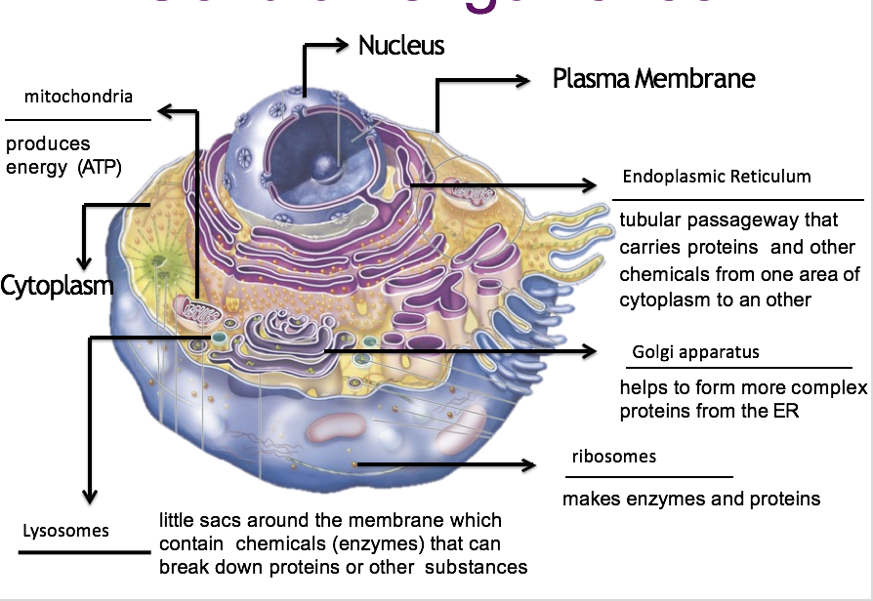
- Plasma membrane- boundary (phospholipids)
- Cytoplasm- holds organelles in place and allows movements
- Nucleus- double membrane, control center of organelles
- Mitochondria- produces energy, has its own DNA- power house
- endoplasmic reticulum- tubular passageway that carries protein and chemicals from one area of cytoplasm to another
a. Enzymes- promotes chemical reactions, attaches to ER
b. ER- moves tings around the cell
c. Rough ER- studded with ribosomes
- Smooth ER- no ribosomes
- Golgi apparatus- helps to form more complex protein from ER
- GA- sends out vesical that is carrying protein to exit
- Lysosomes- little sacs around membrane that contains chemicals that break down proteins or other substances

Tissue
Organization of similar cells that preform a common function
- Epithelial- covers the body and many of its parts. Packed close together and form a sheet. No blood vessels
- connective- most abundant, in skin membrane, muscles, bones, nerves and internal organs. Thin delicate, has a matrix (blood, cartilage)
- muscle- allows movement, contracts. Skeletal- voluntary cardiac and smooth- involuntary
- nervous- rapid communication between structures, control body functions

Organs
- organization of different kinds of tissue that preform specific function

Organ system
- Organization of different kinds of organs that together preform some complex function

Anatomical Position
- Standing erect
- Feet apart
- Arms at side
- Palms forward

Anatomical directions
- Superior
- Towards head
- Upper
- above
- Inferior
- Towards feet
- Lower
- Below
- Right and left (in terms of subject)
- Anterior
- Front
- In front of
- Posterior
- Back
- In behind of
- Medial
- Towards midline
- Lateral
- Away from midline
- Towards side of structure
- Proximal
- Towards
- nearest trunk
- Nearest part of origin
- Distal
- Away from
- Farthest from trunk
- Farthest from a structure point of origin
- Superficial
- Near body surface
- Deep
- Farther away from the body surface

Planes or body sections
- Sagittal plane
- Lengthwise plane
- Divides structure into left or right
- Midsagittal plane
- Divides body into 2 equal parts
- Frontal (Coronal) plane
- Lengthwise that divides a structure into anterior and posterior
- Transverse plane
- Horizontal divides upper and lower

Body cavities
2 major cavities
- Ventral- towards front
- Thoracic cavity
- Mediastinum- heart
- Pleural cavities- lungs
- Abdominopelvic cavity
- Abdominal- digestive organs
- Pelvic- reproductive and bladder
- Dorsal- towards the back
- Cranial
- Contains brain
- Spinal
- Contain spinal cord

