Kristy Ng
30005073
Hephaestus’ Role in the Iliad
The Great Impacts of an Outcast
Though Hephaestus does not have many appearances in Homer’s Iliad compared to other Olympians, he plays a subtle but significant role in the epic poem. He may be considered the outsider or outcast of the gods, but his limited appearance still allows his divine attributes to be seen and appreciated. As the intelligent but lame divine smith and the god of fire, Hephaestus is the calming voice amongst the Olympians. He is also responsible for a great deal of the success of the Achaeans in the Iliad, especially for Achilles. Through his actions and attributes, the reader is also able to see the dualism that Hephaestus establishes, a reoccurring theme in the Iliad and in Greek mythology.
Towards the end of Book 1 of the Iliad, the jealous Hera was quarrelling with Zeus after she had seen him secretly plotting with Thetis. Zeus was trying to put an end to the argument by threatening Hera, which frightened her. Hephaestus was the only god who stepped in during the conflict. As the calming voice of the Olympians, he comforted his mother and pointed out that it “will be a disastrous matter and not endurable if [they] are to quarrel for the sake of mortals and bring brawling among the gods” (Hom., Il. 1: 573-575). Hephaestus’ intelligence realized the quarrel was not worth the gods’ energy, especially against the mighty Zeus who had once thrown Hephaestus in which he “landed in Lemnos, and there was not much life left in [him]” (1, 593). One of the reasons for Hephaestus’ maltreatment from Zeus and even Hera once he was birthed was because he was “marked as an outsider” (Buxton 84) due to his lameness. His earlier years were hard after being thrown out by his mother, and was constantly the “butt of [the gods’] rough humour” (Buxton 84). However, through hard work and determination, he had since regained respect from the immortals and had acquired great intelligence from past experiences. It is here where the reader first witnesses Hephaestus’ intellect and unimpulsive problem-solving skills by calming Hera, relieving the tension amongst the immortals, and stopping a violent fight from erupting too early on in the Iliad between the Olympians, which could have driven the entire plot into another direction. Instead, they feasted happily until the end of the first Book.
Hephaestus’ next appearance was in Book 18. The Achaeans and Trojans had been fighting for quite some time, and Patroklos, Achilles’ closest friend, had died in a battle while wearing Achilles’ armor. Thetis, the mother of Achilles, thus begged for help from Hephaestus because her son needed protection if he wanted to return to battle. Hephaestus’ calming voice reappeared to comfort Thetis, telling her “not [to] fear” (18, 463). As the god of fire and divine smith, he used his powers to build beautiful armor for Achilles that was able to protect and save the hero during the rest of his battles in the Iliad. Achilles’ most famous piece of armor is his shield. The shield was described to have five different layers, all of which were to represent the realms of the universe. Human civilization was represented with “two cities of mortal men” (18, 490-491). Both cities had their moments of happiness and “light-hearted innocence” (18, 567), but they were also filled with evil and “treachery” (18, 526). The imagery on the shield depicts a contrast between the “idealized expectations of humanity with a much harsher, grimmer reality” (Broder 4). Hephaestus’ intelligence and observant characteristic from being an outsider shined through once more since he was able to see the greater picture by pointing out the dark side and imperfections of humanity, unlike some gods or goddesses, like Thetis, who only wanted to see the universe as an “ideological fantasy” (Smith 197). Hephaestus not only contributed to the success of Achilles by making his armor, he also provided the Iliad with a much deeper meaning hidden in the shield he created.
Upon receiving the new armor, Achilles fighted ruthlessly against the Trojans, piling river Scamandros with corpses. The river fought Achilles, forcing Hera to call upon Hephaestus to “set on them an inhuman fire” (342), saving Achilles from the river. As the god of fire, he was able to help Achilles once more with his divine powers. In Book 21, Hephaestus is allowing the plot to move forward by saving Achilles so that he can find Hector and kill him.
In Greek mythology and in the Iliad, there is a common theme of dualism. Hephaestus is no exception, he himself has a role in the Iliad in which he is used to implement this theme into the poem. As the god of fire, he uses his divine power to craft with metals, hence his title as the smith god. However, Hephaestus’ name also means volcano, he had also used his powers to “burn [the river] with fire” (365). Hephaestus thus establishes the duality of fire that is able to build and destroy at the same time. Hephaestus possesses a sort of duality within himself as well: beauty versus ugliness. He is often described as ugly or “imperfect” (Buxton 84), especially due to his lameness, yet he is able to produce such beautiful works of art, like his home he had built that was “imperishable, starry, and shining among the immortals” (18, 370).
As the outsider of the gods of Olympus, Hephaestus manages to play a small but impactful part in the Iliad. With his divine powers and attributes, he is able to advance the plot by helping Achilles under multiple circumstances which ultimately give the Achaeans the upper hand against the Trojans. In addition, without his comforting voice and rational thinking that were put into use right from the very beginning of the poem, the Iliad may have had a different ending. But most importantly, Hephaestus serves an even greater purpose in the Iliad, he gives the epic poem an underlying insight on human civilization with Achilles’ shield and brings forth the duality and complexity that is present in everyday life. (Word Count: 1021)

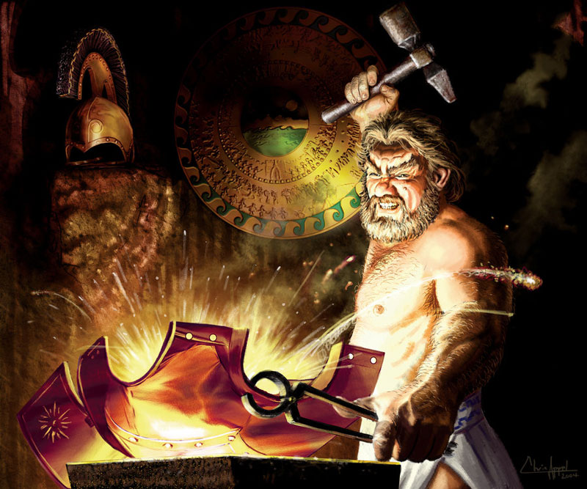
Hephaestus forger armor for Achilles by Chris Appel, 2005

This image depicts Hephaestus’ most famous contribution to the Iliad. As the smith god and the god of fire, Hephaestus builds the armor of Achilles. Hung up in the background is the infamous shield. The five layers are shown with intricate details, including the river of Oceanus on the outer rim. Behind these details, holds the underlying message and truth about humanity. Hephaestus is wearing an unattractive expression on his face, which contrasts from the beautiful, shiny armor he is creating in order to bring forth the dualism he possesses. It is also seen that he is working very hard, and it is with his hardworking characteristic that allowed him to “earn [the gods’] respect, thanks to his unrivalled mastery of the arts of metal and fire” (Buxton 84).

Works Cited
Appel, C., Armor of Hephaestus. Triking Games, 2005. http://www.topillustrations.com/chrisappel/portfolio/The-Armor-of-Achilles/id=180/.
Broder, M. The Shield of Achilles. ProQuest LLC., 2012.
Buxton, Richard. The Complete World of Greek Mythology. Thames and Hudson, 2007.
Lattimore, Richmond, translator. The Iliad of Homer. By Homer. The University of Chicago Press, 2011.
Smith, Stan. Epic Logos: On Last Looking Into Several Homers. Boydell & Brewer Inc., 2001.

Personal Ethics Agreement Concerning University Assignments
I submit this assignment and I confirm that I have taken knowledge of and respected the regulations on Academic Fraud on http://www.uottawa.ca/vice-president-academic/academic-integrity. I attest that this work conforms to the rules on academic integrity of the University of Ottawa.
_______________________________ _________________ ________________________
Student Name Student number Date

Buxton 84
Buxton 84
Broder 4
Buxton 218

