Work Sheet – Experiment 1

Experiment Title:
Verification of Gas Laws
Author(s) Name(s):
Hope Avramidis
Oreoluwa Adeleke
Submitting Author’s Partner:
Oreoluwa Adeleke
TA (Demonstrator)’s Name:
Eliza-Jayne Boisvert
Date Experiment Performed:
Tuesday, September 17, 2019
Date Experiment Submitted:
Tuesday, September 24, 2019
Attach here (if required, indicate the appropriate document(s)):

Medical or other Acceptable Document: _____
Change of Lab Day Form: _____
Change of Lab Section Form: _____
Late Pass: _____

Procedure – Charles’ Law:
As outlined in the manual (Venkateswaran, 2019).
Procedure – Boyle’s Law:
First, the pressure was chosen as the variable dependent on the volume of air inside the syringe. Next, a 20 mL syringe and a Gas Pressure Sensor (GPS) were obtained and attached to each other, then to the LabQuest2 device. The syringe was adjusted so that the plunger marked 20 mL, as the GPS had 0.80 mL of air inside, 0.80 mL of air was added to the volume values at each interval. Therefore, 20.8 was recorded as the initial volume on the LabQuest2 device and in each lab partner’s lab notebook. The plunger was then pushed in 2.00 mL, and the pressure was recorded at the new volume of 18.8 mL. This step was repeated six more times until the last recorded volume reached 10.8 mL. A second trial was made. Finally, the materials used were returned.
Discussion:
Table 1. The values of temperature and volume recorded throughout the experiment.
T1 (temperature of the air in boiling water bath in C) | 100°C
T2 (temperature of the air in ice water bath in C) | 19°C
V1 (volume occupied by the air at T1 in mL) | 156 mL
V_{cw} (volume of ice-bath water) | 24 mL
V2** (volume occupied by the air at T2 in ml) | 132 mL
**Note: This value was calculated using the experimental data; the work can be shown in Table 2 below.
Charles’ Law
Charles’ law states that a sample of a gas at constant pressure, a change in temperature results in a proportional change in volume (Petty 1995). In this experiment the air in the Erlenmeyer’s flask is used to verify Charles’ law. In this case, volume was decided as the dependant variable and temperature being the independent variable. Volume is dependent on the temperature due to the fact that as the temperature increases the gas expands and as the temperature decreases the gas contracts. Before starting the experiment, the air in the Erlenmeyer flask was recorded at room temperature as V1 =156v mL, once the Erlenmeyer mask was submerged into the boiling water the temperature of the air in the flask was recorded as T1 = 100◦C.

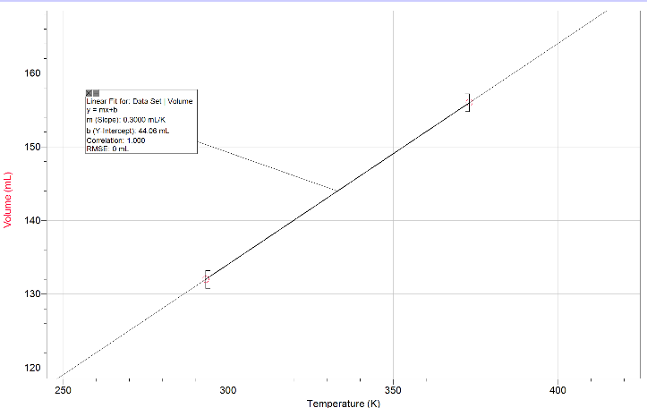
In order to find the correct calculation for Charles’ Law, 273.15 was added to the temperature converting it to 373.15 Kelvins (refer to Table 3). The volume of the air in the flask of the second temperature was recorded as V2= 132mL. The temperature of the air in the flask when cooled in the ice water was T2= 19◦C. 273.15 was added to the temperature converting it to 292.15 Kelvins. Once the variables were plugged into the Charles’ law equation (refer to Table 4), the value of V1/T1 came to a total of 0.418 ml/K and the value of V2/T2 came to a total of 0.452 mL/K. The results of V1/T1 and of V2/T2 were relatively distant from each other which, should not be the case as the experiment was done in closed system allowing the pressure to be constant throughout the experiment which means the two ratios must be relatively close or equal to each other. In this experiment there could have been possibilities of errors that could have influenced the results, a plausible error could have been the Erlenmeyer mask not being raised correctly when submerge into the ice water bath. If it’s done incorrectly the atmospheric pressure and the pressure from the flask are not equalized, causing a change in pressure which results to Charles’ Law no longer applying as it states that pressure must be constant. Another plausible error could have been an error in the timing for allowing the temperature change inside the flask to equal the temperature outside the flask. If timed incorrectly the temperature of the air inside the flask may not have achieved the right temperature influencing the results. The percentage error calculated was 8.13% meaning that our results were not precise.
Graph 1. A linear representation of the relationship between the recorded measurements of volume and temperature

Boyle’s Law
In this experiment, the pressure was decided as the variable dependent on the volume of air based on the following property of ideal gases. Pressure exerted by ideal gases is created by the collision of particles within a confined container; decreasing the amount of confined space causes the particles to collide more often which increases the pressure (Herbst, 2013). Consequently, the number of particle-collisions depends on the amount of confined space (Ball, D. W., & Key, J. A., 2014). The temperature must remain constant for the law to be applicable because changes in temperature can increase or decrease the kinetic energy of the particles, which is a factor that also affects the pressure exerted by the gas (Ball, D. W., & Key, J. A., 2014). Boyle’s law states that the product of a pressure exerted by a gas and its corresponding volume generate a constant; this rule is applicable to the data collected during this experiment. For example, the first trial produced the constant of 1906.3 (refer to Table 5). The constants for each trial, rounding to two significant digits, draw near the number 1900. The relationship between the volume of air in the syringe and the pressure it exerted verify Boyle’s law because the values from each trial produce constants relatively similar to each other. A factor that could have affected the accuracy of the data is that the temperature was only assumed to be constant, not controlled, therefore, the temperature could have changed throughout the experiment and affected the net kinetic energy of the gas particles. Another factor to be considered is the accuracy of the volume measurement. The more the volume interval decreased, the harder it became to hold a secure position on the syringe’s plunger due to the increase in pressure. This could have slightly altered the readings of pressure and volume, skewing the data and calculations associated with Boyle’s law. Despite the opportunities for errors, the graphical representation (refer to Graph 2) of the raw data from the experiment accurately described the proportional relationship between the volume of gas and the pressure it exerted; as the volume decreased, the pressure increased. Two trials of this experiment were performed to validate the data from the first trial. Moreover, the data of both trials were very similar and only varied a difference of a few decimal places. The closeness of the values from both trials allows for the prediction that the data collected is accurate.

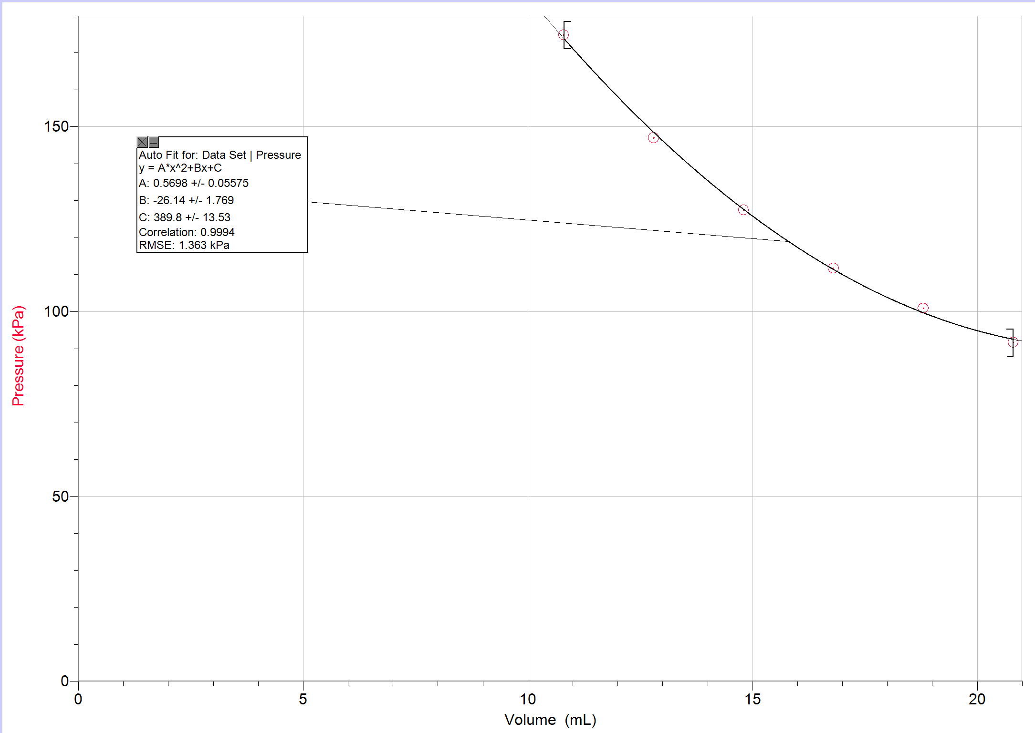
Conclusion:
Graph 2. Starting with a volume of 20.8 mL and decreasing by a 2.0 mL interval, the pressure increased significantly with each interval.

In conclusion, the results of the ratios from Charles’ Law experiment should have been similar in theory however, due to some human errors the results were different. The Boyle’s law experiment verified that the volume of a gas at a fixed temperature is inversely proportional to the pressure.
Reference(s):
- Ball, D. W., & Key, J. A. (2014, September 16). Introductory Chemistry – 1st Canadian Edition.
- Charles' Law of Gases: A Simple Experimental Demonstration, Chem. Educ.1995723257 John T. Petty March 1, 1995
- Herbst D. P. (2013). “The effects of pressure on gases in solution: possible insights to improve microbubble filtration for extracorporeal circulation”. The journal of extra-corporeal technology, 45(2), 94–106.
- “What in the World ISN’T Chemistry”, General Chemistry Laboratory Manual, Dr. Rashmi Venkateswaran, 2019

Appendix:
Raw Data, Charles’ Law:
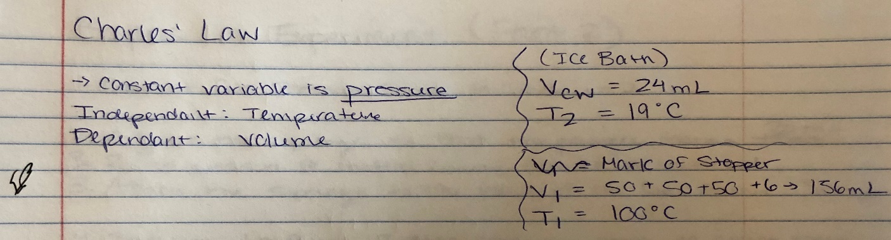
Figure 1. Image of raw data for the Charles’ Law experiment, showing temperature as the independent variable, volume as the dependent variable, and measurements of volumes and temperatures needed to verify Charles’ Law.

Sample Calculations, Charles’ Law
Table 2. V₂ was calculated by subtracting the volume of water from the ice bath from the initial volume.
Equation[1]: | $$V_{2}= V_{1}-V_{cw}$$
Calculation: | $$V_{2}= V_{1}-V_{cw}$$  $$V_{2}=156 mL-24 mL$$  $$V_{2}= 132 mL$$

Table 3. Sample calculation of the conversion of T₁ in Celsius to Kelvin
Equation [2]: | T_{K} = T₁+ 273.15 K
Calculation: | $$T_{K(1)}= 100°+273.15 K$$  $$T_{K(1)}=373.15 K$$
Table 4. Sample calculation of Charles’ Law, displaying the proportional relationship between the values of volume and temperature.
Equation [3]: | $$\frac{V_{1}}{T_{1}}= \frac{V_{2}}{T_{2}}$$
Calculation: | $$\frac{156 mL}{373.15 K}= \frac{132 mL}{292.15 K}$$  $$0.418≠0.452$$

Table 5. Percent error calculation comparing two volume and temperature proportions.
Equation [4]: | $$\frac{\left|\left(\frac{V_{1}}{T_{1}}\right)- \left(\frac{V_{2}}{T_{2}}\right)\right|}{\left(\frac{V_{1}}{T_{1}}\right)} ×100$$
Calculation: | $\frac{\left|0.418-0.452\right|}{0.418} ×100=$ 8.13% Error

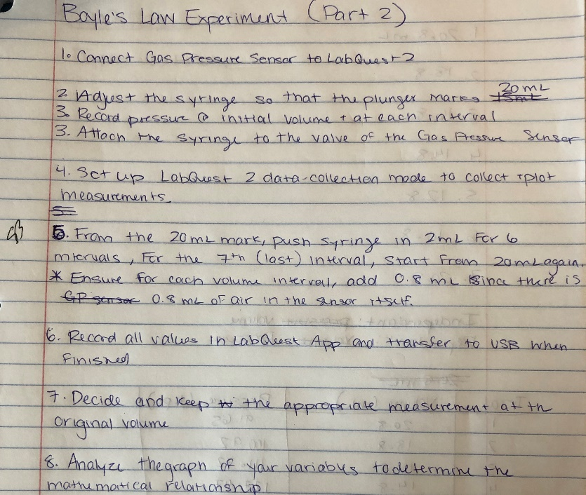
Raw Data, Boyle’s Law:
Figure 2. An image depicting the rough draft of the procedure for Boyle’s Law.

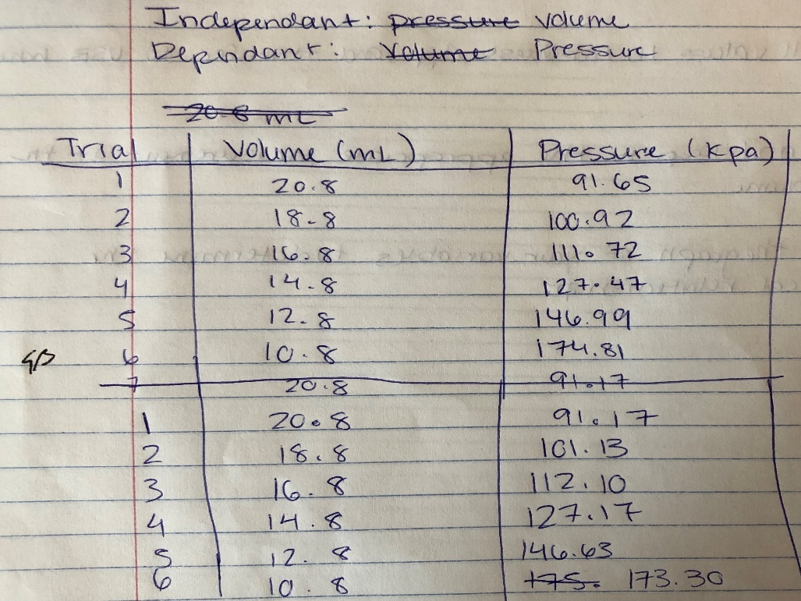
Figure 3. An image depicting the data collected while measuring the volumes of air at intervals decreasing by 2.0 mL and their associated pressure.

Additional Data, Boyle’s Law
Table 5. Measurements of the pressure (in kilopascals) and the volume (in millilitres) for each of the two trials performed, as well as the averages of values from both trials.
Trial 1 |  |  | Trial 2 |  |  | PV=k
Volume (mL) | Pressure  (kPa) |  | Volume (mL) | Pressure (kPa) |  | Calculated Constant
20.8 | 91.65 |  | 20.8 | 91.17 |  | 1906.3
18.8 | 100.92 |  | 18.8 | 101.13 |  | 1897.3
16.8 | 111.72 |  | 16.8 | 112.10 |  | 1876.9
14.8 | 127.47 |  | 14.8 | 127.17 |  | 1886.6
12.8 | 146.99 |  | 12.8 | 146.63 |  | 1881.5
10.8 | 174.81 |  | 10.8 | 173.30 |  | 1887.9

Sample Calculations, Boyle’s Law
Table 6. Sample calculations of the total volume, due to there being 0.8 mL of space inside in the pressure sensor.
Equation [5]: | Volume readings (mL) + 0.8 mL = Total volume (mL)
Calculation: | - 20 mL + 0.8 mL = 20.8 mL
Table 7. Sample calculations of the volume multiplied by the temperature, yielding the constant (k).
Equation [6]: | PV = k
Calculation: | (91.65 kPa)(20.8 mL) = 1906.32

