In Focus assignment

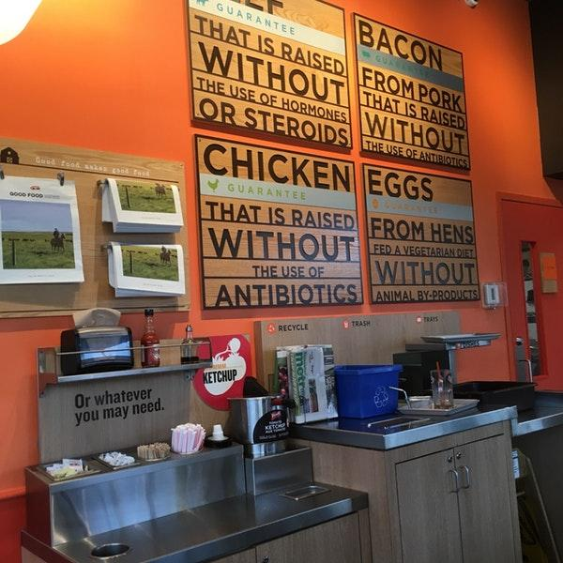
A&W is a Canadian fast-food chain that believes in providing quality food without the use of harmful substances such as steroids, antibiotics, and hormones. They can’t stress this enough from multiple television ads to stores littered with posters and plaques. First of all, their production campaign benefits the company economically because providing food without harmful substances acts as a marketing strategy. This strategy attracts customers because people like to know what they’re eating and A&W ensures that all products are safe to eat. Also, it displays they care for the health of their customers and animals. For instance, A&W raises cattle completely grass fed without the use of harmful hormones and steroids ensuring that cattle only receive healthy antibiotics if needed for health reasons. Their method of raising cattle and other animals such as chicken and pig, preparing for the production of their food displays that the company is not just ethical but as well caring.


Bridgehead coffee is an Ottawa based coffee shop that buys and sells fair-trade products to their customers. Fair-trade has a major economic impact on small communities and farmers because fair-trade systems provide new tools and equipment to use, environmental protection, as well as steady profits from the sales of their products. According to fairtrade.org, protection includes “energy and greenhouse gas emission reduction, soil and water quality, pest management, biodiversity protection, prohibition of genetically modified organisms and harmful chemicals and waste management.” To ensure fair-trade farmers receive steady profits the fair-trade minimum guarantees minimum profits for sales of fair-trade products. Bridgehead coffee buys fair-trade local organic products to help improve less developed communities economically and environmentally as well as performing ethical practices regarding the environment. Rather than purchasing non-fair trade coffee beans which can have all sorts of harmful to the environment substances such as pesticides, Bridgehead deals with locally produced fair-trade coffee.

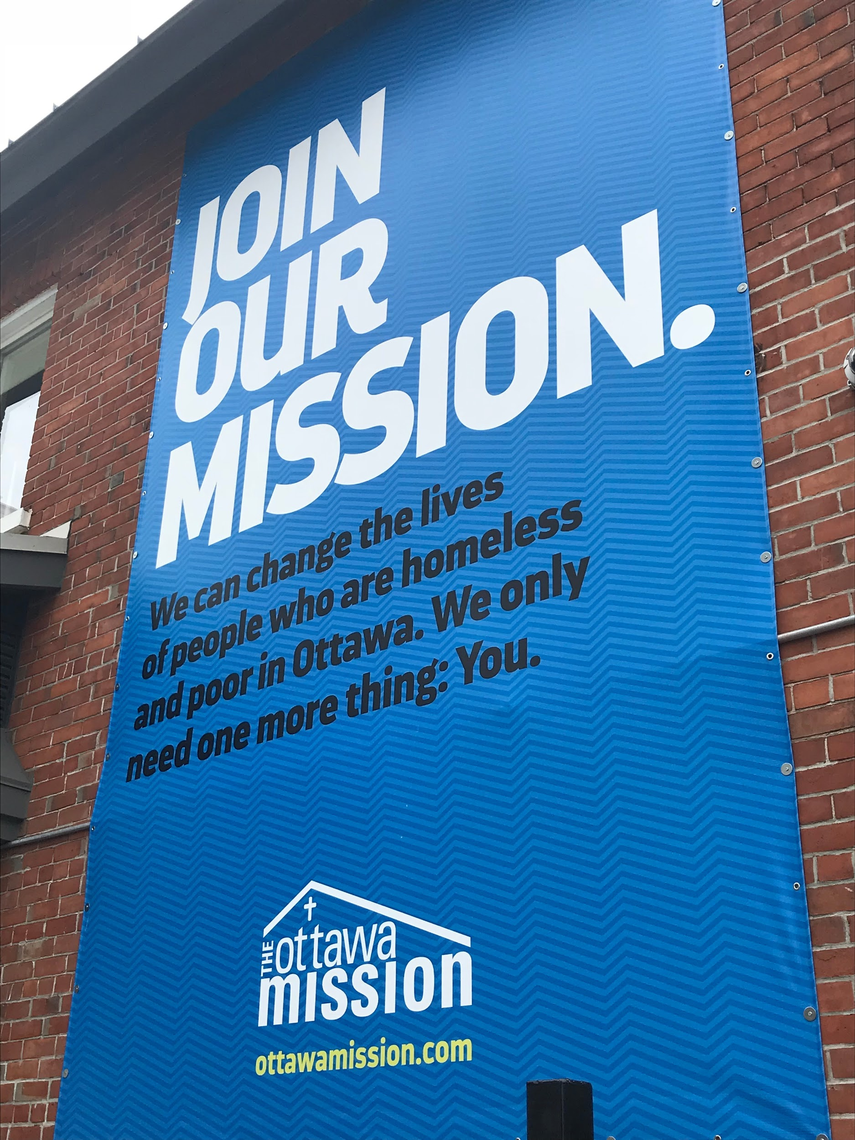
The Ottawa Mission has been serving the homeless and hungry since 1906. The mission is a homeless shelter that provides warm food, clothes, health services, and a place to stay for countless people in need. The mission affects the social environment as well as the economic aspect of the community. Their intentions are to bring everyone together as a community to help homeless and people in need of care. Economically, the Mission provides economical growth from their hard work and assistance on attempting to balance the community.

