EDUC 240 LESSON 2
Chapter 1 READING
Example
Lindsay Moran - CIA Officer
Physical Training
- Army physical fitness test
- Defensive driving
- Paramilitary training
- Boating
- Hand to hand combat
- Jump school (jumps out of an airplane)

Definitions
Human Resource Management
- Strategic approach to the management of employees
- Objective = recruit, motivate, develop and retain employee performance
Performance Management
- Process of establishing performance expectations
- Design of interventions and programs to improve
- Monitor success
Training
- Acquisition of knowledge, skills… to improve performance
- Plan effort done by a company to facilitate their employees’
- This has immediate impact
Development
- Acquisition of knowledge, skills, and abilities required to perform a future job
- So it prepares the employees

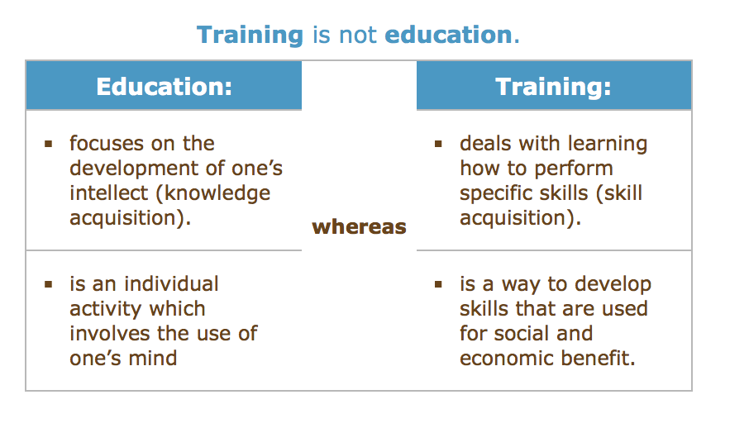
Dr. Haccoun
Education
- Education is a lifelong process - delivered many ways (classes, tv…)
- Broad term = everything that involves us learning
Development
- Long process = sequential process
Training
- Specific things (I will now be trained on how to use PowerPoint)

Dr. Schmid
Education
- A whole series of core competencies that will be useful overtime
- All the things we cover in primary and secondary school
Training
- Focused
- Specific things
A lot of the learning occurs not by design but our environment - self-assessment
Informal learning encourages development!

Engagement resolves to leaning that they retain over a long period of time!

The Benefits of Training and Development
Dr. Haccoun
- Prepare you for the current job and the next job
Dr. Schmid
- Core of modern society (knowledge based economy)
- Development of knowledge and training is critical for individuals participating in society
- So it's essential to know how things work and why
- An individual derives satisfaction from how well they do
- A lot of factors come in to play … what kind of feedback is the client giving
- Do we perform less well cause of colleagues

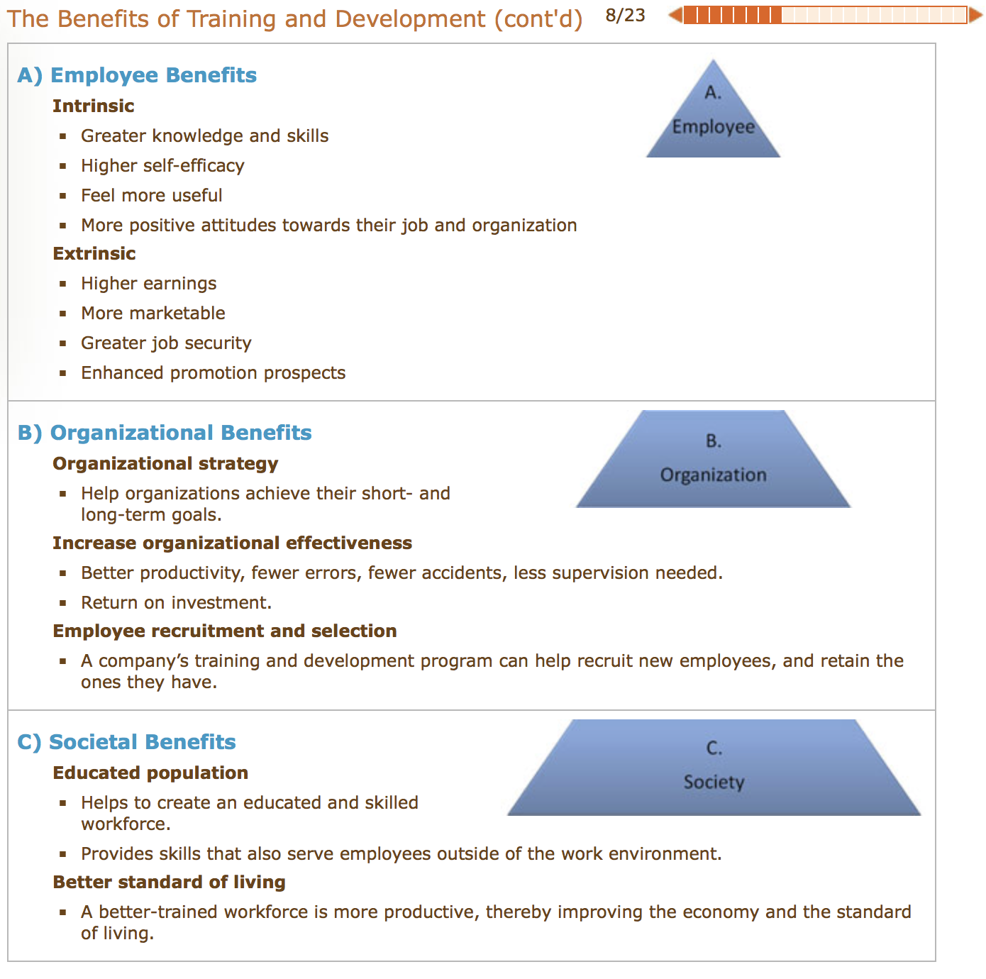

Unemployment Rate in Canada
- In 2008 we had a big unemployment rate = the government was like oh no
- Ratio derived by the # of people that are seeking work vs the ones that are quitting
- So it might drop because people don’t want to work
- So in case there weren’t enough people in jobs, there’s higher demand in training so people can reach other positions in their workforce

What is driving T & D in Canada and Quebec these days?
- Globalization = competing with other countries
- Our economy is shifting like service = montreal being bilingual
- We have to be able to serve the demands = the ability to compete = behave creatively in your jobs = putting skills in different ways

How are we faring compared to the rest of the world
- Not well
- We don’t spend as much as the US or Europeans
- We don’t focus on it like that

Quebec’s 1% Law
Introduced in 1995 to catalyze the stagnant workplace training sector. Company’s were required to invest at least 1% of their money to their employee training.

Because of that Quebec had the fastest growth rate in Canada in workplace training with an increase of 6%

Dr. Haccoun
- Required organization that had payrolls of over 1 million they had to spend 1% and if they didn’t they lose it!
- If they spend more in training is it profitable? No there’s very little difference with organizations that spend very little and very much.
- One must be careful, doesn’t mean if we spend more we do better.

Employers Reluctance to Training Investment
- Leads to insecure employers because they don’t think it will do good
- Employers are concerned about employees taking advantage of them

An interrelated system of HR practices and policies which typically includes:  - rigorous recruitment and selection procedures  - performance-contingent incentive compensation  - performance management  - a commitment to employee involvement  - extensive training and development programs | Workplace training is not an independent activity.  - It is influenced by a broader organizational and environmental context, and a human resource system.

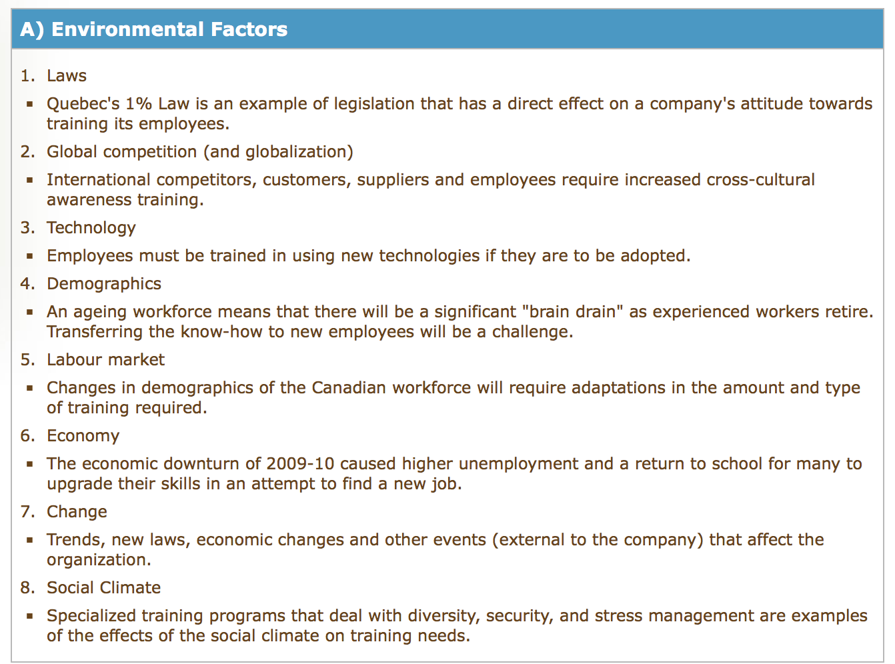
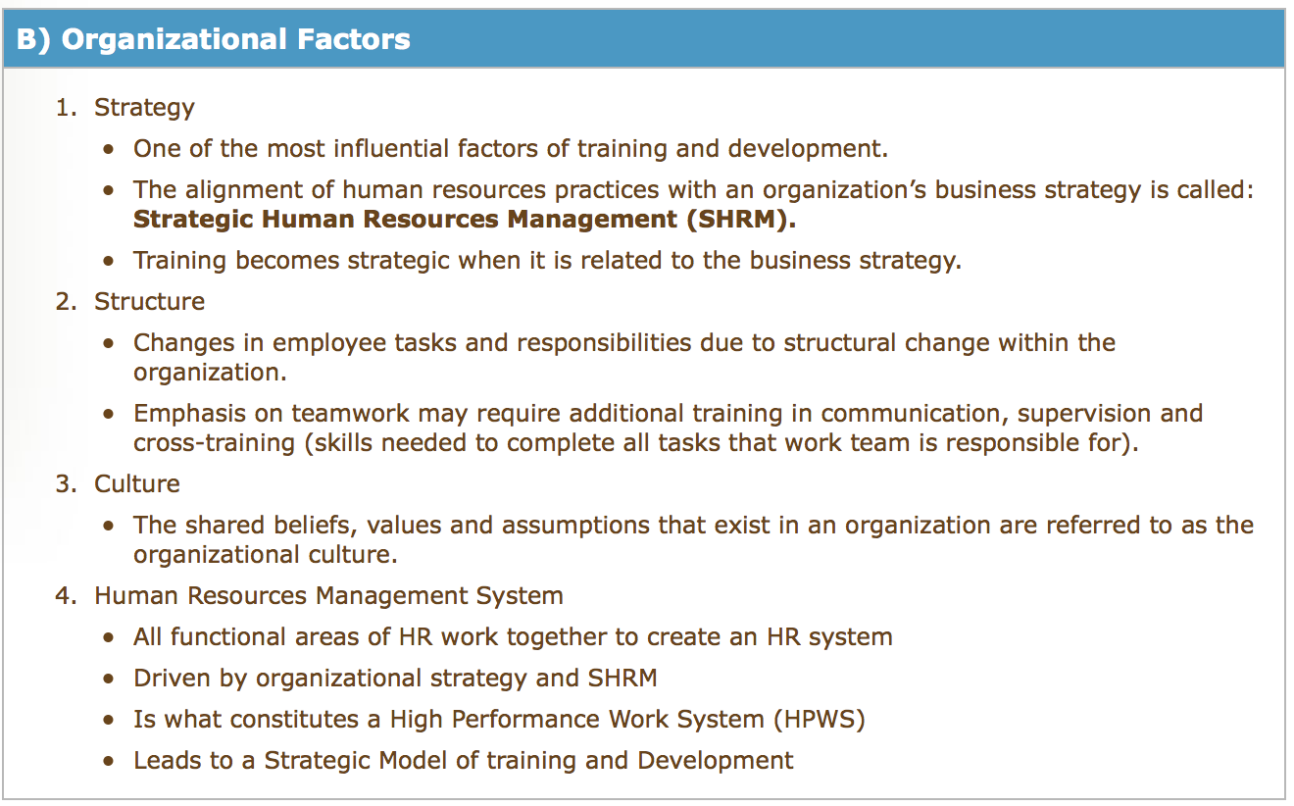
ADDIE process :
  - Analyze the situation (learners, content, resources, environment).
  - Design the instruction (objectives, method).
  - Develop the learning material (content, multimedia, resources).
  - Implement the training (face-to-face, online, blended delivery).
  - Evaluate the outcome (make changes if necessary).
- Cyclic process

SHRM describes the alignment of human resources practices with an organization’s business strategy

To fully understand the concepts covered in this lesson it is important to have acquired a solid background on a number of key points such as:

- Training and development has benefits for the employee, the organization, as well as society as a whole.
- Overall, Canadian businesses have not fared well in the training of their employees.
- Demographic shifts in the Canadian workforce, in addition to other environmental and organizational factors, will increase reliance on training.
- The government of Quebec introduced special legislation to penalize companies that did not invest in the training and development of its employees (the “1% Law”).
- Training and development works in the context of a larger system (HPWS).
- The instructional systems design (ISD) model is a systemic approach to the creation of training and development practices.

