Chandler (theory of organizational success)

Major Claim: Successful firms capitalize on economies of scale and scope, create functional management structures, invest in research and development and grow through related diversification.

Economies of Scale: Large plants produce products at a much lower cost because the cost per unit of production drops as the volume of output rises (The more you produce the cheaper the per unit cost of products are, as fixed costs are divided over more units). Selling to other companies lowers cost of production as well.

Ex. If a shoe factory produces 10,000 shoes per day, its cost per shoe is less than if it produces 1,000 per day.

Economies of Scope: Large plants are more efficient as they can use many of the same raw/semi finished materials and intermediate production processes to make different products. (more products using similar inputs)

Ex. A paint factory can also produce sealant, gloss, and varnish - they have the infrastructure already in place

Cost advantages of Economies of Scale and Scope can only be exploited if:
- Flow of materials is constant
- Investment in the creation of national and international marketing and distribution organizations is made
- Recruitment of lower and middle managers (to coordinate flow of products through production and distribution)
- Recruitment of top managers (to coordinate operations and plan for the future)

First Mover: First company that makes necessary investment to dominate industry
- Being first mover is really import = large advantage, competitors are always playing catch-up
- Opportunity to make first-mover investment short-lived, once opportunity is lost its hard for company to become competitive

Growth: Bigger is better (growth super important to chandler)
- Companies grow horizontally (combining with competitors) and vertically (buying suppliers and distributors)
- Long term growth based on geographical expansion (economies of scale) and moves into related products (economies of scope)
- Companies should try to act entrepreneurial (stay small and focused, as size not always an asset)
- Companies that grow by buying other companies in unrelated industries (unrelated diversification) in which they lack knowledge will not succeed.
- Unrelated diversification leads to separation of top and middle management due to top management lack of knowledge/experience with divisions + decision overload = Dysfunctional divisions and management hierarchy
- Successful growth will result form related diversification and investment in economies of scale

Companies that do not invest in R&D and organizational capabilities cannot succeed in the long term

Stock market ownership patterns = divided ownership, difficult to make decisions, and need for updates frequently
- Leads to short term thinking just to focus on keeping stock price up

Greiner

Major Claim: Organizational growth through phases of evolution and revolution based on age and size of organization

Age Of Organization
- Lifespan of organization
- Organizational practices change throughout life span
- Management problems are rooted at certain times throughout lifespan
- Passage of time = managerial attitudes become rigid/ difficult to change
Size of Organization
- Company’s problems change depending on size
Stages of Evolution
- Prolonged growth = evolutionary period
- 4-8 years in length
Stages of Revolution
- Period of turbulence between evolution period = revolution period
- Results in change in management practices (practices change as company grows)
- Task of management to find new practices to manage next evolutionary period
Growth Rate of Industry
- Rapidly expanding industry = quick evolutionary periods
- Slow growing industry = longer evolutionary period
- Poor market environment = revolutions more difficult to resolve

Five Phases of Growth

Evolutionary Phase 1: Creativity
Characteristics:
- Emphasis is on creating both a product and a market.
- Founders are technically or entrepreneurially oriented,disdain management activities; energies absorbed entirely in making/selling a new product.
- Communication frequent and informal.
- Long hours of work rewarded by modest salaries and promise of ownership benefits.
- Activities determined by marketplace feedback; management acts as the customer reacts.

Revolution 1: Crisis of leadership
Causes:
- Individualistic and creative activities essential for the company to get off the ground, but as the company grows, business knowledge required (about the efficiencies of manufacturing).
- Large number of employees can’t be managed through informal communication
- New employees not motivated by dedication to the product or organization.
- Additional capital must be secured, new accounting procedures for financial control.
- Founders burdened with unwanted management responsibilities. Long for the ‘good old days’, still trying to act as they did in the past = conflicts between leaders

Solution: Locate and install a strong business manager who has the necessary knowledge and skill to introduce new business techniques, is acceptable to the founders, and who can pull the organization together.

Evolution 2: Direction
Period of sustained growth under able and directive leadership.
Characteristics:
- organization structure to separate manufacturing from marketing activities, job specialization.
- Accounting systems for inventory and purchasing.
- Incentives, budgets, and work standards
- Formal and impersonal communication .
- Manager/key supervisors responsible for direction, while lower-level supervisors = functional specialists, not autonomous decision-making managers.

Revolution 2: Crisis of Autonomy
Causes:
- New directive techniques inappropriate for controlling larger, diverse, and complex organization
- Lower-level employees restricted by centralized hierarchy
- Employees have more knowledge about markets and machinery than top management
- Torn between following procedures and taking initiative.
- Demands for greater autonomy of lower-level managers.

Solution: Greater delegation (Entrusting tasks to others), autonomy to low-level managers

Evolution 3: Delegation
Successful application of a decentralized organization structure.
Characteristics:
- Greater responsibility to low-level managers of plants and market territories.
- Profit centers (generate own earnings based on their results) and bonuses used to stimulate motivation.
- Top executives manage by exception, based on periodic reports from the field.
- Management concentrates on making new acquisitions
- Communication from the top is infrequent
- Gaining expansion through heightened motivation at lower levels.
- Decentralized managers able to penetrate larger markets, respond faster to customers, and develop new products.

Revolution 3: Crisis of Control
Causes:
- Top executives feel they are losing control over a highly diversified field operation.
- Autonomous field managers prefer to run their own shows without coordinating plans, money, technology, and manpower with the rest of the organization.
- Top management attempt to regain control

Solution: Use of special coordination techniques.

Evolution Phase 4: Coordination
Use of formal systems for achieving greater coordination and by top executives taking responsibility for the initiation and administration of these new systems.
Characteristics:
- Decentralized units merged into product groups.
- Formal planning procedures established, and intensively reviewed.
- HR personnel hired to initiate company-wide programs of control and review for line managers.
- Capital expenditure weighted and given out across organization. Each product group treated as an investment center (return on invested capital is important criterion used in allocating funds)
- Technical functions (data processing) centralized at headquarters; daily operating decisions are decentralized.
- Stock options and companywide profit sharing.
- Growth through efficient allocation of limited resources.
- Managers have decision-making responsibility, justify their actions more carefully
- ‘Watchdog’ audience at headquarters

Revolution 4: Red-Tape Crisis
Causes: The organization has become too large and complex to be managed through formal programs and rigid systems.
- Lack of confidence builds between line and staff, between headquarters and the field; leads to resentment.
- Large number of systems and programs begins to exceed its utility
- Ex. Line managers resent heavy HR direction from those who are not familiar with local conditions. HR people complain about uncooperative/uninformed line managers.
- Criticism of bureaucratic paper system.
- Procedures take precedence over problem solving, and innovation is dampened.

Solution: Collaboration

Evolution Phase 5: Collaboration
- Emphasizes strong interpersonal collaboration.
- Emphasizes greater spontaneity in management action through teams and the skillful confrontation of interpersonal differences.
- Builds around a more flexible and behavioral approach to management.
Characteristics:
- Focus on quick problem-solving quickly through teamwork.
- Teams combined across functions to handle specific tasks.
- Headquarters HR reduced in number, reassigned, and combined in interdisciplinary teams to consult with, not to direct, field units.
- Matrix-type structure to assemble teams for right situations.
- Formal systems simplified and combined into Multipurpose systems.
- Frequent senior Manager conferences to focus on major issues.
- Educational programs to train managers in behavioral skills for better teamwork and conflict resolution.
- Real-time information systems integrated into daily decision making.
- Team-based reward/compensation.

Revolution 5: ?
Most present companies in Collaboration phase, the outcome is unknown
Other claims
- Management need to be aware of which phase they are in, so they know when it is time for change and what solution to use
- Can’t avoid revolution as they are needed for growth
- Revolution can only end with specific new solution that can’t be repeated for the next phase
- Growth isn't inevitable - badly run companies, or bad ideas, might not grow
- Top managers whose style is a bad fit should step down
- Organizations can skip phases (through being bought out by larger company)
- Solution to revolution will be cause of next revolution

Barney
Major Claims:
- A firm will have a sustained competitive advantage if its resources and capabilities are valuable, rare, inimitable and organized in a way that allows it to exploit potential opportunities.
- A firm will be successful if it has resources with the right attributes and characteristics.
- Analyze not only competitive environment, but internal strengths and weaknesses
- Internal attributes (strengths and weaknesses aka resources and capabilities) = source of competitive advantage

Firms Resources and Capabilities
- Financial: debt, equity, retained earnings, etc.
- Physical: machines, manufacturing facilities, base of operations
- Human: Experience, knowledge, judgement, risk taking, wisdom
- Organizational: History, relationships, trust, culture, formal reporting structure, management control system, compensation policies

Four Important Questions about resources and capabilities (VRIO Framework)

Question of Value
- Does a firm’s resources and capabilities add value by enabling it to exploit opportunities and/or neutralize threats?
- Change in competitive environment
  - Change in consumer taste, industry structure, tech can change value of resources
  - Firm must constantly evaluate value of resources to determine how strengths can be used in new ways to make them valuable again

Question of Rareness
- How many competing firms already possess these valuable resources and capabilities?
- If firm’s resources are both valuable and rare = temporary competitive advantage
- Common resources still needed for firm’s survival

Question of Imitability
- Do firms without a resource or capability face a cost disadvantage in obtaining it compared to firms that already possess it?
- Two ways of imitation
  - Duplication: Building same kinds of resources as another firm
  - Substitution: Substitute some resources for others, giving some strategic implications at no extra cost will lead to competitive parity (firms are equal)

Reasons for cost disadvantage when imitating
- Importance of history
  - As firm evolves it picks up skills, abilities, resources that are unique to them reflecting their path through history
  - Valuable and rare resources acquired or developed through unique historical circumstances can be costly to imitate, and thus a source of sustained competitive advantage
  - EX. Caterpillar given contract to supply Allies in WW2, giving them government funding and a global supply network
- Importance of numerous small decisions
  - Firm’s competitive advantage depends on numerous small decisions through which firm’s resources are developed and exploited
  - Small decisions are invisible to other firms making them hard to imitate
- Importance of Socially Complex Resources
  - Resources based on organizational phenomena (company’s culture, relationships, friendships, teamwork, reputation, trust)
  - Very difficult to imitate

Question of Organization
- Is a firm organized to exploit the full competitive potential of its resources and capabilities?
- Components of firm’s organization: Formal reporting structure, management control systems, compensation policies = complementary resources
- Complementary resources have limited ability to generate advantage in isolation, but in combination with other resources and capabilities leads to full competitive advantage

VRIO in a nutshell
Valuable | Rare | Inimitable | Organized | Competitive Implication
No | No | No | No | Disadvantage - no one wants or needs your product
Yes | No | No | No | Parity - you are equal to other firms
Yes | Yes | No | No | Temporary advantage - others will catch up
Yes | Yes | Yes | Yes | Sustained advantage - others won’t catch up

Collins and Porras
Major Claim: Companies that remain successful overtime have fixed core values and core purpose, and business strategies that endlessly adapt ( Great companies know what should and shouldn't change)
- VISION provides guidance about what CORE to preserve, and what FUTURE to stimulate progress toward.
- Vision consists of Core ideology and envisioned future

Core Ideology: what we stand for and why we exist (unchanging)
- Defines enduring character of company, consistent identity
- Enduring source of guidance/ inspiration for company
- Glue that holds company together through time
- Consistent identity of the organization
- Consists of core values and core purpose

Core Values:
- Beliefs about what is important, small set of timeless guiding principles.
- Essential and enduring tenets, that are non-negotiable
- Company should not change core values, companies keep them even if they became a competitive disadvantage.
- Intrinsic value to those in company
- Require no external justification
- Companies usually have 3-5.

How to pick who to represent core values?
Mars Group: Scenario of 5-7 people who would be sent to another planet to recreate best attributes of firm. People chosen always embody fully core values of company
Questions of enduring core values:
- Can you envision value 100 yr from now being valid as they are today?
- Would you hold core values even if they become a disadvantage?
- If you were to start a new company what core values would you use?

Core Purpose: (reason for existing)
- Organization’s reason for being (soul of organization)
- Idealistic motivation for doing companies work
- Should last for 100 years, not be a specific goal
- Purpose like a guiding star, forever pursued but never attained
- Does not change, but inspires change (companies never stop changing/progressing)
- Not a goal or business strategy, little to do with shareholder wealth
- If everyone at the company suddenly became millionaires overnight, the core purpose is the reason they would continue to work there, even if they didn’t need the money

Methods for identifying purpose
Five Whys: Start with descriptive statement “we make X products”, then ask why five times
Ask Mars group if they could retire why would they stay
If company ceased to exist, What would last? Why is it important for company to continue?

“Discovering” core ideology
- You do not create or set core ideology, you discover it
- Description of what actually exists, not just what we wish existed
- Needs to be meaningful and inspirational only to people inside the organization
- Find people who are predisposed to share the organization’s core values and purpose
- Expressed differently overtime, but keeps same idea
- If it's not core change it!

Envisioned Future: What we aspire to become, to achieve (requires significant change and progress)
- Requires certain level of confidence/commitment
- Consists of BHAG and vivid description

Vision Level BHAG ( Big, Hairy, Audacious Goal):
- Difficult goal company wants to achieve 10-30 years in the future
- Clear and compelling, unifying focal point, catalyst for team spirit
- Clear finish line
- Engages people, is tangible, energizing, highly focused, easy to comprehend
- Not a sure bet (50-70% probability of success)
Categories of BHAG
- Target BHAG: ex. Become a $125 million company by year 2000 (Walmart, 1999)
- Common Enemy BHAG: ex. Crush Adidas (Nike 1960s)
- Role Model BHAG: ex. Become the Nike of cycling industry (Giro Sports Design)
- Internal Transformation BHAG: ex Transform company from defense contractor to best diversified high-tech company in the world (Rockwell)
Vivid Description
- Vibrant, vivid, specific description of what it will be like to achieve BHAG
- Translating words into an image, painting a picture to make it more tangible to people
- Imagined optimal future.
- It motivates employees, because they work towards achieving the BHAG and making the vision a reality.

Herzberg

Major Claim: Factors that provide motivation and job satisfaction are independent to the factors that bring job dissatisfaction.

- Motivating with KITA: audience anxious for quick, straight forward formula for moving people
  - Surest way of getting someone to do something is to administer a Kick In The Ass (KITA)
Negative Physical KITA(Push Factor)
- Physical discipline
- 3 Drawbacks:
  - Inelegant
  - Contradicts image of benevolence of organization
  - Results in negative feedback (fighting back)
Negative Psychological KITA(Push Factor)
- Advantages over negative physical KITA:
  - Cruelty invisible
  - Reduced chance of negative feedback
  - # of psychological pains infinite, possibilities of KITA increased
  - System can accomplish dirty work of higher ups
  - Person who practices KITA gets an ego boost
  - No tangible evidence
- EX. Taking something away from someone
Positive KITA (Pull Factor)
- Employees given reward for doing something (reward, incentive, status, etc.)
- Examples of Positive KITA
  - Reducing time spent at work
  - Fringe Benefits
  - Spiraling Wages
  - Human relations training
  - Sensitivity training
  - Communications
  - Two-way communications
  - Job Participation
  - Employees Counselling
Myths About Motivation
- KITA is not motivation, but short-term movement
- If I kick you, you move; but, to move again I must kick you again
- Person’s battery can be continuously charged with KITA, but they are only motivated when they have their own power generator

Hygiene vs Motivators
Two-way Theory of Motivation
- Factors involved in producing job satisfaction (motivation) are separate from factors that cause job dissatisfaction
- Opposite of job satisfaction is not job dissatisfaction, but no job satisfaction (and vice-versa)
Hygiene (Extrinsic)
- Stemming from humankind’s animal nature, biological needs and pain avoidance
- Needed to ensure employees do not become dissatisfied.
- Do not lead to motivation, but without them there is possibility for dissatisfaction
- EX. Company policy and administration, supervision, Interpersonal relationships (supervisor, peers, subordinates), work conditions, salary, personal life, status, security
Motivators (Intrinsic)
- Relates to unique human characteristic, ability to achieve, psychological growth
- Job content is stimuli for growth
- Needed to motivate an employee into higher motivation (primary cause of job satisfaction)
- EX. Achievement, recognition, work itself, responsibility, advancement, growth
Combining Hygiene and Motivators
- High Hygiene and High Motivators
  - Ideal situation where employees are highly motivated and have few complaints
- High Hygiene and Low Motivators
  - Employees have few complaints but are not motivated (Job see as paycheck)
- Low Hygiene and High Motivators
  - Employees are motivated but have lots of complaints (job is exciting and challenging, but salaries and work conditions are poor)
- Low Hygiene and Low Motivators
  - Unmotivated employees with lots of complaints (worse situation)
Job enlargement
Horizontal
- Widening the range of jobs at the same level in the organization and adding them to the existing job - little motivation
Vertical
- More tasks with responsibility & authority needed to complete the task - Employees gain an enhanced sense of responsibility and achievement, along with new opportunities to learn and grow
Job Loading
Horizontal Job Loading
- Adding tasks to a job but not responsibility
- Increases the meaninglessness of the job
Vertical Job Loading
- Adding meaningful tasks that will lead to growth
- Additional tasks the permit growth and provide motivating factors
- EX.
  - Removing some controls while retaining accountability
  - Increasing accountability for own work
  - More difficult tasks introduced
  - Giving person complete unit of work
  - Specialized Tasks
  - Job Freedom
Job Rotation
- Rotation between staff positions to alleviate monotony and provide fresh job challenge

Change should bring job level up to challenge equal with skill level hired
People with higher skill get promoted
Jobs might need to be enriched again
Not all jobs can be enriched, not all need to be enriched

Mintzberg
Major claim: Managers role of planning, organizing, coordinating and controlling is a myth. A manager's role is characterized by interpersonal roles, informational roles, and decision roles.

Folklore and Facts About Managerial Work

Folklore 1: The manager is a reflective, systematic planner.
Fact 1: Managers work at an unrelenting pace, activities are characterized by brevity, variety, and discontinuity,they are strongly oriented to action and dislike reflective activities.

Folklore 2: Effective managers do not have regular duties to perform
Fact 2: Managerial work involves performing a number of regular duties, including ritual and ceremony, negotiations, and processing of soft information that links the organization with its environment.

Folklore 3: The senior manager needs aggregated information, which a formal management information system best provides.
Fact 3: Managers strongly favor verbal media, telephone calls and meetings, over documents.

Folklore 4: Management is a science and a profession.
Fact 4: The managers’ programs (to schedule time, process information, make decisions) are locked deep inside their brains.

- A manager's job is a mix of regular & non-programmed jobs
- A manager is both generalist and specialist
- A manager relies on all information but prefers orally transmitted information
- A manager performs many activities characterized by brevity, variety and fragmentation
- Management is more of an art than a science
- It is always becoming more complex

Back to Basic Description of Managerial Work
- Managers are given formal authority over an organizational unit. From formal authority comes status, which leads to various interpersonal relations, and from these comes access to information. Information, in turn, enables the manager to make decisions and strategies for the unit.
- Manager’s job can be organized and described in terms of various manager roles

Interpersonal roles (managing people)
Arises directly from status from given authority
Figurehead role: Managers must perform ceremonial duties
- Duties may sometimes be routine without any important decision making
- Important for smooth functioning of organization
Leader role: Managers are responsible for the work of the people in their unit
- Direct leadership: Hiring, training of staff
- Indirect leadership: motivation and encouragement of employees, aligning individual need with goals of organization
- Leadership determines how much potential power from authority will be realized
Liaison role: Managers make contacts outside the vertical chain of command
- Spend as much time with peers and others outside their units as they do with subordinates (many contacts: suppliers, associates, peers, etc.)

Informational roles (Managing information)
Manager is nerve center of organizational unit, knows more than subordinates due to network of contacts (staff members and liaison contacts)
Processing info key part of manager’s job, communication is their work
Monitor role: Managers constantly scan environment for info, receives unsolicited info from liaison contacts and subordinates
- Most info gathered through soft info (gossip, hearsay, speculation)
Disseminator role: Managers pass privileged info directly to subordinates who otherwise wouldn’t have access to the info
- If subordinates lack ease of contact, manager may pass info from one to the other
Spokesperson role: Managers send info to people outside the unit (represents unit)
- Speeches, contact with suppliers, etc.
- Must satisfy and inform influential people who control organizational unit

Decision roles (Managing through action)
Manager plays important role in decision-making system, know all the info to make decisions, can commit unit to courses of action, etc.
Entrepreneur role: Managers seek to improve the unit and adapt to changing environment
- Development projects emerge as series of small decisions and actions over time
- Executives maintain inventory over projects through development, start new projects and discard old ones
Disturbance Handler role: Managers involuntarily respond to pressures caused by change beyond their control
- Pressures are to severe to be ignored, manager must act
- Large amount of time spent taken to respond to high-pressure disturbances
- Good managers cannot anticipate all consequences of their actions
Resource Allocator role: Managers responsible for deciding who will get what
- Most important resource to allocate is manager’s time
- Manager must also design unit’s structure (how work is divided and coordinated), authorize important decisions
- Must consider impact of each complex decision on organizational (feasibility, costs, strategies, timing, etc.)
Negotiator role: Managers spend considerable time in negotiations
- Negotiations integral part of manager’s job as only they have the information and authority for real-time negotiations

Integrated Job
- Ten managerial roles cannot be separated (no role can be pulled out and leave job intact)
  - Ex. A manager without liaison contacts lack external communication; therefore, managers cannot make informed decisions or relay info to subordinates
- Team management has problems due to the fact that managerial roles cannot be split up (difficulty with informational roles as they cannot be split up as all info needed to make a decision)

French and Raven

Major Claim: The bases of social power are a theory by French and Raven that identifies 5 bases or sources of social organization power.

Range of power: power based on context, location. Use of power out of range leads to reduction of power. Reference power has largest range.
- Ex. Teacher has power in the classroom, but no power over you outside of the classroom. If they attempt to exert their power outside the classroom they are outside their range of power; that may diminish their power in the classroom.

Bases of social power
Relationship between the person (P) and the other exerting the power (O)

5 bases of social power

- Reward power
  - power whose basis is the ability to reward.
  - strength of the reward power of O over P increases with the magnitude of the rewards which P perceives that O can mediate for him.
  - Reward power depends on O's ability to administer positive valences and to remove or decrease negative valences.
- Coercive Power
  - based on one’s perception that the other has the ability to mediate punishments on him
  - leads to dependent change also; and the degree of dependence varies with the level of observability of P's conformity
- Legitimate Power
  - based on one’s perception that the other has a legitimate right to prescribe behaviour for him
  - From office: person that has a higher position than you has legitimate power over you
  - From culture: Elders revered in some cultures, men have power over woman in some cultures; have legitimate power over them
  - From social structure: Police officers, judges, etc. have been given legitimate power due to their position
- Referent Power
  - based on one’s identification with the other
  - P wants to be like O, admires them, and desires to be closely associated to them
  - O influences P; however they are both unaware of this influence
  - Stronger the identification the stronger the referent power
- Expert Power
  - based on one’s perception that the other has some special knowledge or expertise

Kaplan and Norton (Balanced Scorecard)

Major Claim: Balanced scorecard is a strategic planning and management system to align business activities to the vision and strategy of the organization, and monitor organization performance against strategic goals.
- Organization measurement system affects the behaviour of managers and employees
- Traditional financial accounting measures worked well in the past but are not enough in the present
- Manager’s should not have to choose between financial and operational measures
- No single measure can provide enough info to provide clear performance target a focus on critical areas
  - Managers need balanced presentation of financial and operational measures
Balanced Scorecard
- Set of measures that give fast and comprehensive view of business
  - Financial measures: Results of actions already taken (current performance)
  - Operational measures: Customer satisfaction, internal processes, innovation and improvements activities (future performance)
- Managing an organization requires being able to view performance in several areas simultaneously
- Scorecard minimizes information overload by limiting number of measures
- Forces managers to focus on critical measures
- Scorecard shows how results are achieved
- Scorecard brings dispersed elements of company’s agenda into a single report
- Scorecard guards against suboptimization
  - Shows if improvements in one area leads to expenses in another area
- Scorecard way to clarify, simplify, operationalize vision of organization
Four Important Perspectives of Business (answer to 4 questions)
- How do customers see us? (consumer perspective)
- What must we excel at? (internal perspective)
- Can we continue to improve and create value? (innovation and learning perspective)
- How do we look to shareholders? (financial perspective)
Customer Perspective
- Four Categories of Customer Concerns (try to set goals for each and translate them into measures)
  - Time (lead time: time required to meet consumer needs)
  - Quality (defect level of incoming products, measure of on-time delivery, accuracy)
  - Performance and Service (how products create value for consumer)
  - Cost (remain sensitive to costs of production)
- Forces manager to think from consumer perspective
Internal Business Perspective
- Measures of what company must do internally to meet its customers expectations
- Internal measures stem from processes that have greatest customer satisfaction
  - Cycle time, Quality, Employee Skills, Productivity
- They should decide which processes and competencies they must excel at and create measures for them
Innovation and Learning Perspective
- Competition requires companies to continuously improve existing products and develop new ones
- Ability to improve innovate and learn ties into company value
- Specific improvement goals to existing processes
Financial Perspective
- Measures indicate whether strategy is contributing to bottom-line improvement
- Goals = profitability, growth, shareholder value
- Measured by cash flow, sales growth, income, etc.
- Financial measures criticized for being backward-looking focused

Example of Scorecard Perspective
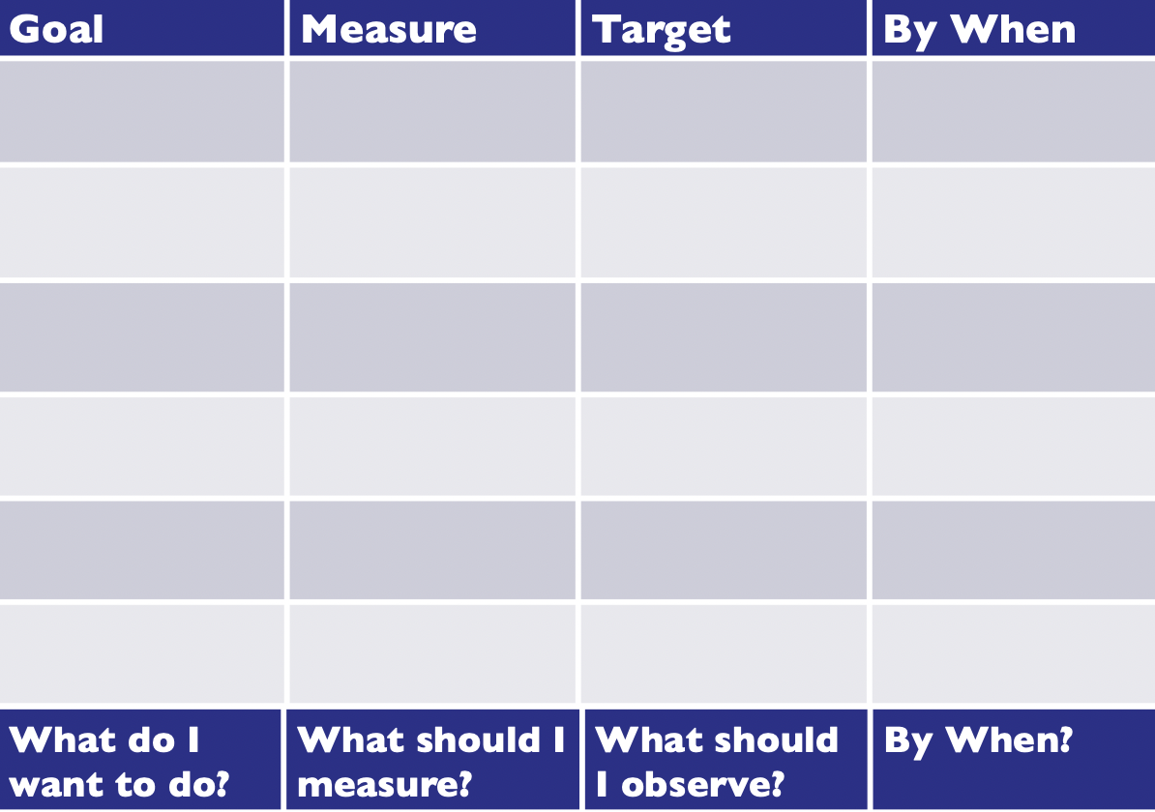
Order of perspectives: Customer, Internal, Innovation, Financial
- Goals have to link to one another
EX. Megabus
- Customer
  - Goal: Customers want to leave on time/follow schedule
  - Measure: Departure times
  - Target: Improve leaving time by 20%
  - When: Within 1 year
- Internal
  - Goal: Reduce Breakdown (Buses might be late due to breakdowns)
  - Measure: Breakdown rates
  - Target: Decrease breakdowns by 10%
  - When: Within 7 months
- Innovation
  - Goal: Creating more double-decker buses (equals less buses on road, less possibility to break down)
  - Measure: Number of double-decker buses produced
  - Target: Increase number of double-decker buses produced by 15%
  - When: Within 5 months
- Financial
  - Goal: Increase revenue
  - Measure: Yearly revenue
  - Target: Increase revenue by 17%
  - When: By year end

Handy: The Sigmoid Curve (continually innovating)

Major Claim: Businesses proceed in a series of up-and-down curves. The secret to success is to realize when things are doing well and change your strategy, rather than keep doing what has worked in the past.

Sigmoid Curve
- S-shaped curve that demonstrates the story of life itself
  - In business context = product life-cycle, organizations rise and fall
- Curves are continuing to shrink due to accelerating pace of change
- Secret to continuous growth is to start new curve before the first one dies out
- Right place to start second curve is Point A (where time, resources to get new curve through initial explorations before dip in first curve)
- Not obvious when time for change has come as at Point A everything is going well/would be dumb to change something successful
  - Due to this change is only pushed for in face of disaster at Point B on the first curve
- At Point B it requires mighty effort to bring them up to second curve
  - Resources and energy are depleted, hard to return to peak performance
- Can get back to second curve from Point B by bringing in the new people at the top
- Second curve (new product/strategy/operations) has to be different form the old
- People who led the first curve will not lead the second curve
  - Responsibility of first leaders is to keep first curve going long enough to support the early stages of second curve (difficult to give up successful firm)
  - New ideas have to coexist with old until the second curve is up and running
- The shaded area represents a time of change and great confusion (groups of people with different sets of ideas are competing for future of company)
  - Struggle of what to keep from the past, while experimenting with the new
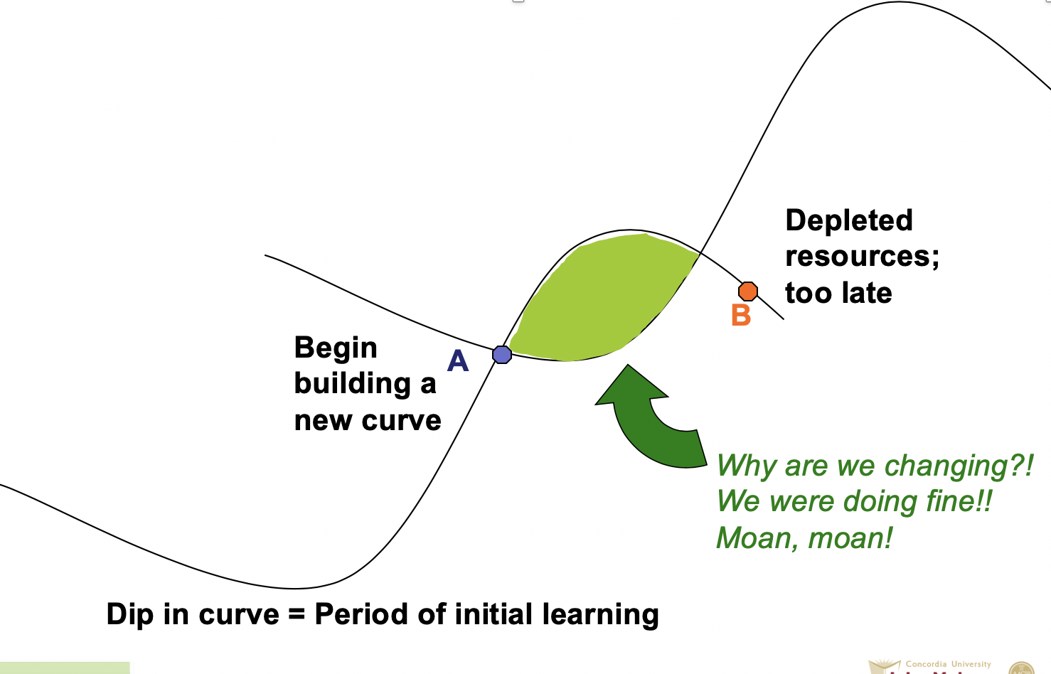

Paradox of time: By the time you know where you ought to go, it’s too late to go there
- Easy to explain things when looking backward, we think that we can predict them going forward
Discipline of the Second Curve
- Impossible to know here you are on the first curve until it is too late
- Discipline of Second Curve = Always assume you are near Point A and start preparing the second curve
  - Organizations should assume present strategies will be replaced in 2-3 yrs
- Nothing wrong with planning for second curve too early,(exploratory phase)
- Forces the challenging of assumption and development of possible alternatives
  - Keeps one skeptical, curious, inventive
- Four stages of discovery:
  - Questions
  - Ideas, possibilities, hypotheses
  - Tentative + experimental testing of hypotheses
  - Review of experiments
- Let go of the past, create new life while building on the old one

Curvilinear Logic
- Everything has ups and downs, nothing last nor was there forever
- Paradox of Success: Things that make you successful rarely keep you successful
- Means starting life over, more difficult as you get older
  - That is why curvilinear thinking is left to next-gen, who have clearer view of where first curve is going and what second curve might look like
- Kaizen
- Don’t abandon first curve too early, second curve needs time and resources that first curve provides
Fertilizing Second Curve Thinking
- Second curve thinking comes naturally from second-gen, but they need permission and encouragement to challenge the way things are (new ideas coexisting with old)
  - Attempt to build something new into the existing fabric of the organization
- Future is for next-gen; present is for current leaders
- Commitment is needed to endure early dip of second curve, and live with first curve while the second one develops
- To manage the paradox you need to live it and analyze it (outsiders can’t help with the problem)

Tannenbaum and Schmidt

Major Claim: The continuum of leadership provide a framework for managers who are torn on how democratic or autocratic to be. The continuum ranges from manager-centered leadership, where managers use authority to make decisions and announce them, to subordinate-centered leadership, where subordinates have freedom to decide, within the limits defined by their supervisors.

New Problem
- How the modern manager can be "democratic" in his relations with subordinates and at the same time maintain the necessary authority and control in the organization for which he is responsible?
New Need
- Managers not quite sure how to behave; torn between exerting "strong" leadership and "permissive" leadership.

Continuum/Range of Behaviour

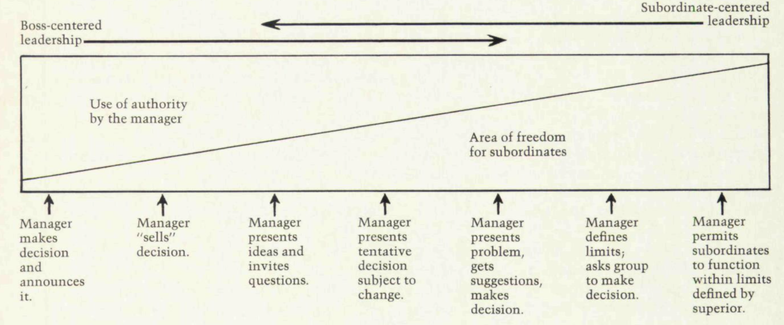

- Continuum of possible leadership behavior available to a manager.
- Each type of action is related to the degree of authority used by the boss and to the amount of freedom available to his subordinates in reaching decisions.
- Extreme left characterize the manager with high degree of control; extreme right characterize the manager who releases a high degree of control

- Manager makes decision and announces it
  - Manager identifies problem, consider alternative solutions, chooses one of them, and then announces his decision to subordinates for implementation
  - No opportunity for subordinates to participate in decision
- Manager “sells” decision
  - Manager still identifies the problem and comes to a decision
  - Recognizes possibility of resistance and tries to persuade subordinates to accept
- Manager presents ideas and invites questions
  - Manager still identifies the problem and comes to a decision
  - Seeks acceptance and provides opportunity for subordinates to ask questions to get explanations on manager’s thinking and intentions
- Manager presents a tentative decision subject to change
  - Manager still identifies the problem and comes to a tentative decision
  - Permits subordinates to have some influence over decision as they can provide their opinions
  - Manager still makes final decision
- Manager presents problem, gets suggestions, and then makes a final decision
  - Up to this point the manager already had a decision when presenting to the group
  - Manager identifies the problem
  - Subordinates now get a chance to suggest solutions, increasing the manager’s possible solution
  - Manager still makes the final decision
- Manager defines the limits and request the group to make a decision
  - Manager identifies the problem to be solved and the boundaries in which the decision can be made
  - Right to make decisions is passed along to the group
- Manager permits subordinates to function within limits defined by superior
  - Subordinates identify and diagnose the problem, develop alternative solutions, and decide on one of the solutions (degree of extreme freedom)
  - Only limits directly imposed on the group by the organization are those specified by the superior of the team's boss
  - If the manager participates in the decision-making process, he attempts to do so with no more authority

Deciding how to lead

Forces in the manager
- Manager’s behaviour in any given instance will be influenced greatly by the many forces operating within his own personality

- Value system
  - Strength of conviction of questions like the following will tend to move the manager form one side of the continuum to the other:
    - How convinced is he that the official that is being payed to assume responsibility should personally carry the burden of decision making?
    - How strongly does he feel that individuals should have a share in making the decisions which affect them?
  - Behaviour also influenced by importance attached to organizational efficiency, personal growth of subordinates, and company profits
- Confidence in subordinates
  - Managers likely to consider knowledge and competence of subordinates, with respect to the problem
  - Who is best qualified to deal with this problem?
  - Manager may have more confidence in their capabilities than their subordinates
- Own Leadership Inclinations
  - Some managers more comfortable and natural directive leaders
  - Other managers more comfortable in a team role, sharing functions with their subordinates
- Feelings of Security in Uncertain Situation
  - Releasing control over decision-making process reduces predictability of outcome
  - Tolerance for ambiguity

Forces in the Subordinate
- Manager also considers forces affecting subordinates behaviour (personality, expectations of boss)
- Managers permit subordinates greater freedom if following conditions exist:
  - If subordinates have high needs for independence
  - If subordinates have readiness to assume responsibility for decision making
  - If they have a high tolerance for ambiguity (uncertainty)
  - If the are interested in the problem and feel that it is important
  - If they understand and identify with organization’s goals
  - If they have the necessary knowledge and experience to deal with problem
  - If they learned to expect the share in decision making
- Manager will be more authoritative if above conditions are not met

Forces in the Situation
- Characteristics of the general situation will also affect manager’s behaviour (critical environmental pressures)
- Type of organization
  - Organizations have values and traditions which influence behaviour of employees (Deviating from generally accepted is likely to create problems )
  - Values and traditions communicated through: job descriptions, policy, public statements by top executives
  - Employee participation influence by sizing of working units, geographical distribution, intra-organizational security to attain company goals
- Group Effectiveness
  - Consider how effective members work together as a unit
- Problem Itself
  - Nature of the problem may determine what degree of authority should be delegated by the manager to his subordinates
- Pressure of Time
  - The more the manager feels the need for an immediate decision, the more difficult it is to involve other people (Crisis/Crash programming lead managers to use high degree of authority)
  - When time pressure is less intense, much easier to bring subordinates in on decision-making process
- Long-run strategy
  - In the long-run, strategy can shift to large-scale strategy, forces become variables over which the manager has some control
  - gain new insights or skills for himself, supply training for individual subordinates, and provide participative experiences for his employee group.
- Attaining Objectives
  - What does the manager what to accomplish will determine leadership style

