“DO I DARE DISTURB THE UNIVERSE?” Lab Report

7
Date Submitted: Sept. 28, 2017

Introduction:
Gases are one of the fundamental states of matter; they are composed of billion of atoms that can collide with one another. Gases are variable volume and variable shape meaning they can adapt both their shape and volume to fit into the desired container. Due to that ability they can be affected by changes in volume, pressure and temperature. Ideal gases have such small and far apart particles that they don’t take up any volume and will not attract or repeal one another. In real life gases don’t act “ideal” and so the concept of ideal gas was created in order for us to predict how real gasses would behave.
The ideal gas law is defines by the following equation:
PV = nRT [1]
P stands for pressure of the gas in kPa, V stands for the volume taken up by the gas in mL, n stands for the number of moles in the gas, R is the gas constant (8.31J/K⋅mol) and T stands for the temperature of the gas in Kelvin.

If the equation above is rearranged to isolate pressure, it reveals how volume and pressure are inversely proportional. This inverse relationship between volume and pressure at a constant temperature is known as Boyle’s Law. Boyle’s Law states that if a fixed amount of gas were trapped in a container, changing the containers volume would change the pressure made by the gas. However it’s important that the temperature of the gas inside the container remains the same. The equation for Boyle's law can be defined by:
PV = k [2]
P Stands for the pressure of a gas in kPa, V stands for the volume of the gas in mL, and k is the Boyle’s Law Constant.
The propose of this experiment is to investigate the relationship between the pressure and volume of a confined gas. In this experiment a 20 mL plastic syringe that is connected to a Gas Pressure Sensor and Lab Quest is used to record the correlation between the pressure of the trapped air at different volumes.

Materials and Apparatus:
- One, 20 mL Syringe
- Gas Pressure Sensor
- LabQuest

Procedure:
Step 1: Connect the Gas Pressure Sensor to LabQuest
Step 2: Push the plunger of the 20mL syringe to 11 mL.
Step 3: Connect the syringe to the valve of the Gas Pressure Sensor. (Turn the syringe halfway to lock it. Over tightening will result in breaking the equipment.)
Step 4: Set up your LabQuest, by selecting the mode and entering the name of your variables.
Step 5: After the pressure stabilizes, record the results.
Step 6: Bring the plunger of the syringe to different volume and record the pressure.
Step 7: Repeat for six different volumes.
Step 8: Repeat all the steps above for two more trials.
Data and Observations:
Table 1: Trials 1, 2 and 3 of the pressures of a confined gas measured at various volumes

Volume  mL | Pressure  kPa |  |  | Average volume  mL | Average Pressure kPa
 | Trial 1 | Trial 2 | Trial 3
5 | 205.37 | 202.75 | 205.27 | 5 | 204.46
8 | 137.42 | 133.38 | 125.35 | 8 | 132.05
11 | 102.16 | 101.32 | 102.16 | 11 | 101.88
14 | 81.69 | 80.94 | 83.56 | 14 | 82.06
17 | 68.24 | 66.75 | 68.82 | 17 | 67.94
20 | 58.28 | 57.12 | 58.91 | 20 | 58.10

Figure 1: Graph of volume (mL) vs. pressure (kPa) of a confined gas, Trial 1
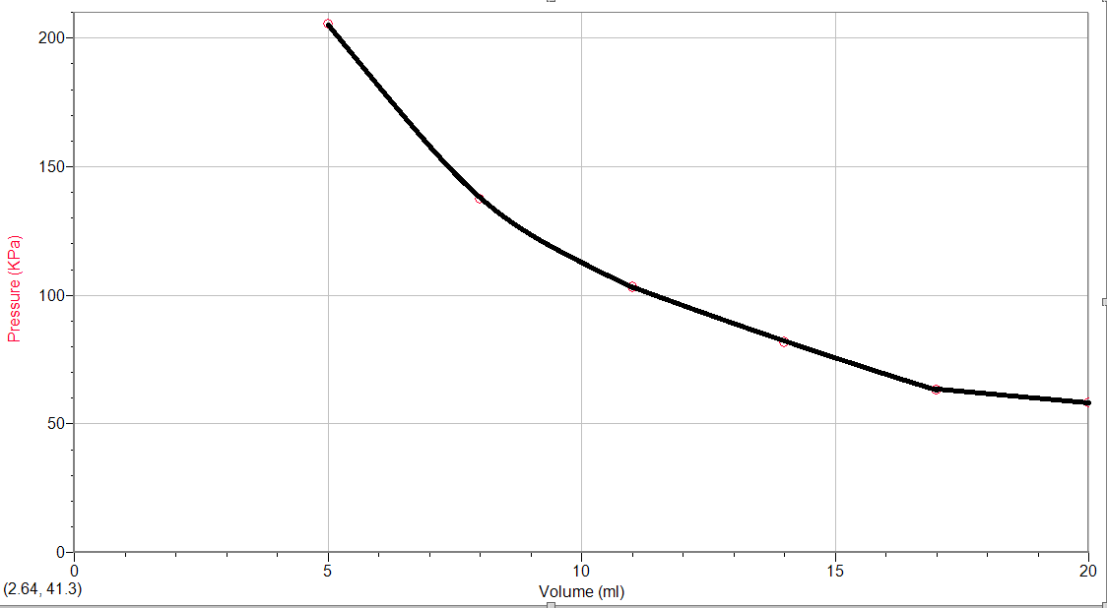

Figure 2: Graph of volume (mL) vs. pressure (kPa) of a confined gas, Trial 2
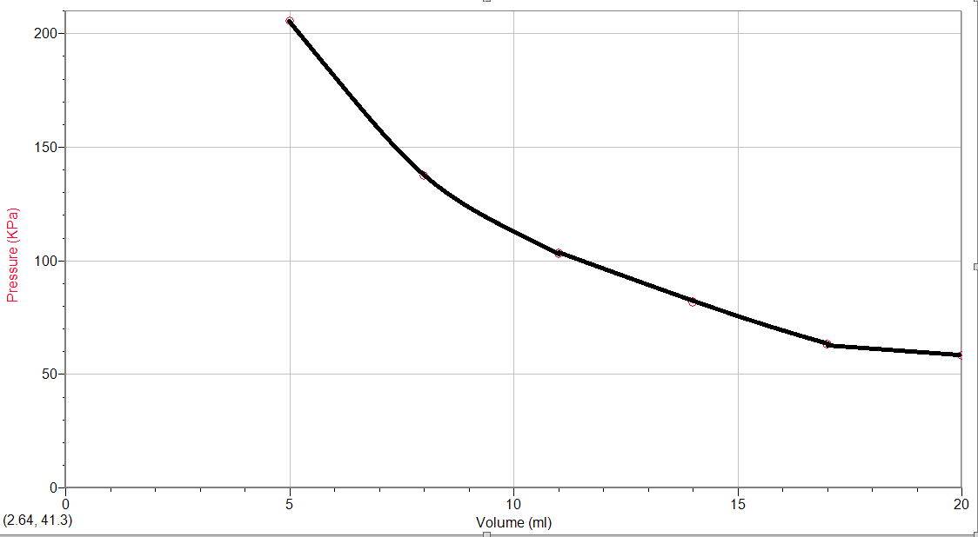

Figure 3: Graph of volume (mL) vs. pressure (kPa) of a confined gas, Trial 3

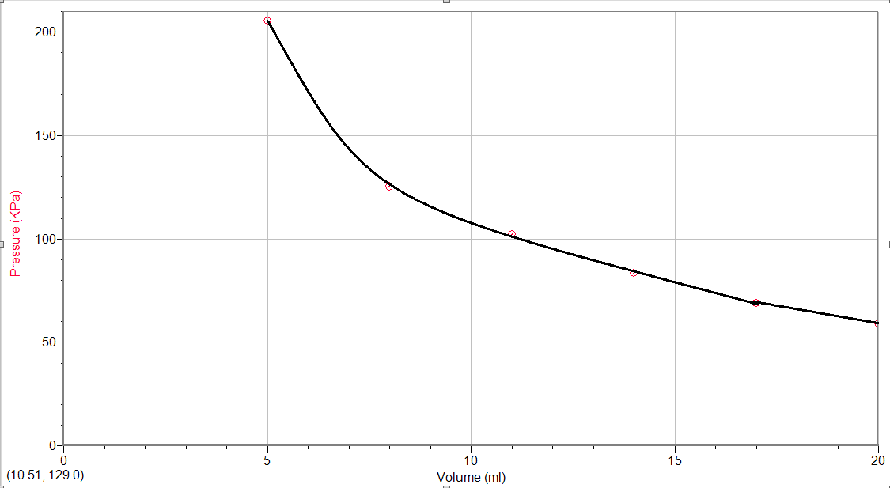

Data Analysis:
- Boyle’s law states that the volume of a confined gas is inversely proportional to its pressure at a constant temperature. Referring to equation [1]. In order to find Boyle’s Law Constant, k, we need to substitute our volume and our pressure and get our constant. This was done using the average pressure and average volume in table 1.
PV=k P(KPa) V(ml)
5 x 204.46=1022.30
8 x 132.05=1056.40
11 x 101.88=1120.68
14 x 82.06=1156.40
17 x 67.94=1154.98
20 x 58.10=1162.00
(1022.30+1056.40+1120.68+1156.40+1154.98+1162.00)/6=1112.13

- The relationship that is illustrated by Boyle’s law is that the volume of a confined gas at a specific temperature is inversely proportional to its pressure. When looking at this mathematically we can refer to equation 2. For a gas, at a constant temperature, the product (pressure*volume) is a constant.
(Pressure)(volume)=constant
PV=1112.13

- Its very important to take multiple readings of the dependant variable for the same value of the independent variable, By doing so the chances of making an error would decrease. Taking multiple readings allows for a better estimation of the results and decreases the uncertainty in the readings. For example by referring to trial 1 and 3 from Table 1. It’s noticeable that at volume 8 mL there’s a big gap between trial 1 and 3. And if we had not done three trials, the average answer would have been way off. This demonstrates that there can still be errors; one is the accuracy of the 20 mL syringe. The syringe is very small and hard to control, to get the exact volume that you desire is hard.

- Boyle’s law requires specific conditions to be met for other gas variables. These variables are temperature of the gas and the number of moles of the gas. We took temperature into consideration and in order to ensure that the temperature of the syringe remained constant, between every measurement we let the syringe cool down for up to a minute. This way if our hands had warmed up the syringe, which would then warm up the gas inside, would have time to cool down. We didn’t take the number of moles into consideration; we assumed that it would be constant. I think ensuring that the two variables remain constant is important since it would have had an effect on the Boyle's Law constant itself. There was no method of checking if the number of moles were constant, therefore errors would be inevitable for the lab.

- Refer to Figures number 1, 2 and 3.

Discussion:
According to the data and the values that were collected and calculated in this lab, the experiment was accurate. The results demonstrate that Boyle’s law is in fact valid. The volume of a confined gas at a specific temperature and number of moles is inversely proportional to its pressure. When looking Table 1, it's noticeable that as the volume increases the pressure decreases and vice versa. However the relationship between the volume and pressure is not linear, it’s quadratic. Referring to figures 1, 2 and 3.

Conclusion:
The volume of a confined gas at a specific temperature and a specific number of moles is inversely proportional to its pressure.

References:

“DO I DARE DISTURB THE UNIVERSE?” (n.d). Retrieved September 20, 2017, from https://uottawa.brightspace.com/d2l/le/content/42104/viewContent/1388250/View

“Estimating uncertainty from multiple measurements”,Retrieved September 25, 2017, from
https://www2.southeastern.edu/Academics/Faculty/rallain/plab193/labinfo/Error_Analysis/08_Multiple_Measurements.html

L. (2017, August 28). 10.9: Real Gases - Deviations from Ideal Behavior. Retrieved September 25, 2017, from
https://chem.libretexts.org/Textbook_Maps/General_Chemistry_Textbook_Maps/Map%3A_Chemistry%3A_The_Central_Science_(Brown_et_al.)/10%3A_Gases/10.9%3A_Real_Gases_-_Deviations_from_Ideal_Behavior

“Pressure and volume relationship of a gas” Retrieved September 25, 2017, from
www.passmyexams.co.uk

Proof of Data:


