CHAPTER 1: DISCOVERING YOUR PERSONAL RHYTHM FOR HEALTHY LIVING
What is Health?
HEALTH AND SICKNESS: DEFINED BY EXTREMES
Prior to Late 1800s – Health viewed as absence of disease, healthy if person was not suffering life threatening illness.
Late 1800s & early 1900 discovered victims of microorganisms contaminating environment.
HEALTH: MORE THAN NOT BEING SICK
Mortality – death rate
Morbidity – illness rate
World Health Organization, WHO (1947) – defined health as a complete physical, mental, & social well-being not merely absence of disease/infirmity.
Health dynamic, ever-changing process of trying to reach individual potential in physical, social, intellectual, occupational, emotional, environmental, & spiritual dimension.
HEALTH AS WELLNESS: PUTTING QUALITY INTO YEARS
Wellness dynamic ever-changing process in which a person attempts to reach his/her potential in each of health’s components.
Physical Health body shape, size, sensory acuity, susceptibility to disease & disorder, body functions, recuperative ability.
- Perform daily activity & task
- Restrictive alcohol, smoking, fixed dietary intake, healthcare
Social Health capacity of satisfying interpersonal relationship, interaction s, adaptations to various social situations
- Communication skills other daily activities
- Make choices regarding social activities, better communicator (listener/speaker)
Intellectual Health ability to think clearly, reason objectively, analyze critically, effective use of brain power.
- Learn from success and failure, responsible decisions, think before you act, manage time well
Occupational Health satisfaction received for career or stage of career development, maintaining balance between work & leisure
Emotional Health feeling of self-esteem, self-confidence, self-efficiency, trust, love
- Learn to express feelings or emotions effectively, limit your worrying, receptive to change
Spiritual Health provides meaning, purpose, transcendence, connectedness and energy
- Particularly religion, higher entity, peace with natural belief
HEALTH PROMOTION: HELPING YOUR STAY HEALTHY
Health promotion various efforts aimed at encouraging individuals and communities to make healthier choices.
- Requires educational, organizational, environmental, political, and financial support to build positive health attitudes and behaviour
The Healthy Living Strategy takes a population health approach, recognizing that sustainable changes in individual behaviours are difficult to achieve without addressing living/working conditions.
- Recognizing linkage between lifestyle choices and surrounding social, economic, and environmental influences
- Healthy Living Targets healthy eating, physical activity, healthy weight
PREVENTION: THE KEY TO FUTURE HEALTH
Primary Prevention actions designed to reduce the chances of a health issue arising, or perhaps to delay the ages at which it occurs.
- Examples, school breakfast programs, The Good Food Box
Secondary Prevention intervention early in the development of a health problem to reduce symptoms or to halt or at the least delay its progression.
- Modifying dietary intake and physical activity
Tertiary Prevention treatment or rehabilitation efforts aimed at limiting the effect of a disease
- Chemotherapy, radiation, coronary bypass surgery
Sex Difference
Androcentricity refers to viewing the world form a male perspective.
Overgeneralization occurs when a study explores issues for one sex and generalizes the findings to both sexes.
Sex Insensitivity means overlooking sex a s an important variable.
Double standards “evaluation, treatment or measurement of identical behaviours, traits or situations by different means”
1996 – a policy in clinical traits states products likely to be used by woman are to be tested on women.
Mid 1990s – any significant amount of research was conducted on the causes, treatment, social, psychological concerns of women

Improve Your Health
BENEFITS OF ACHIEVEING OPTIMAL HEALTH
The following reasons explain why you should focus on health:
- Greater energy levels and increase capacity for and interest in having fun
- Stronger immune system enhances ability to fight infections (flu and common cold)
- Improves self-confidence, self-concept, self-esteem, self-efficacy
- Enhances relationships w other due to better communication and “quality” time
- Better sleep, increased ability to handle physical and mental reactions to stress
- Improving cardiovascular functioning, positive outlook
PREPARING FOR BEHAVIOUR CHANGE
Mark Twain said, “habit is habit, and not to be flung out the window by anyone, but coaxed downstairs a step at a time.”
Changing your attitude and behaviours into healthier ones is time-consuming and difficult process.
FACTORS INFLUENCING BEHAVIOUR CHANGE
Figure 1.4 Factors that influence Your Behaviour-Change Decision
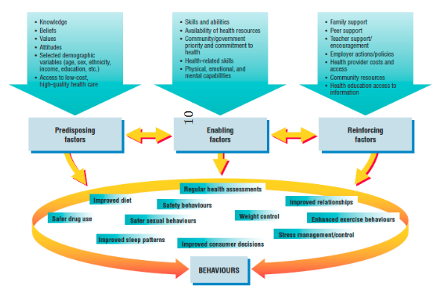
PREDISPOSING FACTORS
Predisposed to certain attitudes and behaviours including age, sex, ethnicity, income, family, education, environment, and access to health.
Impact from family and friend the way you grew up.
ENABLING FACTOR
Skills or abilities, physical, mental, and intellectual capabilities and resources to accessible facilities that make health decisions more convenient or difficult.
Positive enablers allow for you to carry out your intent, negative enablers do the opposite.
REINFORCING FACTORS
Refers to support and encourage or discourage the come from significant others, influence you towards positive or negative behaviours include;
- money, popularity, support and appreciation from friends and family interest and enthusiasm for what you are doing.
- Punishing yourself and rewarding yourself for following through with your intent
- Accepting small failures and setbacks
- Motivation combines with common sense, commitment, realistic understanding best combination
STAGES OF CHANGE, TRANSTHEORTIECAL MODEL
Transtheoretical model created by Prochaska and DiClemente (1983) developed from smoking cessations and drug/alcohol addiction research
Stages of Change Model asks:
- Are you ready for change?
- Where are you in terms of readiness to change?
Precontemplation - no intention now for changing, unaware for the need of change, attempted but have failed/ given up
Strategies for Change – improving knowledge by reading or making tactful suggestions
Contemplation – recognition for need of change due to impact from significant others, access to information or increased knowledge.
Strategies for Change – awareness of benefits, rewards, think of course of action
Preparation – coming up with a plan to help them within the action stage, focusing on what needs to be changed.
Strategies for Change – simple guidelines, available resources, written plan, identifying barriers
Action – making the change and following the plan prepared, engaging in social support, buddy system.
Maintenance – attention to detail and long-term commitment, not slipping back into unwanted behaviours that will allow relapse.
Termination – when the behaviour becomes ingrained new habit (pat of daily living)
Relapse – fixing your plan to ensure that relapse does not occur once again.
YOUR BELIEFS AND ATTITUDES
Belief is an appraisal of the relationship between some object, action, or idea
- outcome of direct experience or secondhand experiences or knowledge conveyed by others.
Attitude is a relatively stable set of beliefs, feeling, and behavioral tendencies in relation to something or someone.
DO BELIEFS AND ATTITUDE INFLUENCE BEHAVOURS?
Figure 1.5 Health Belief Model
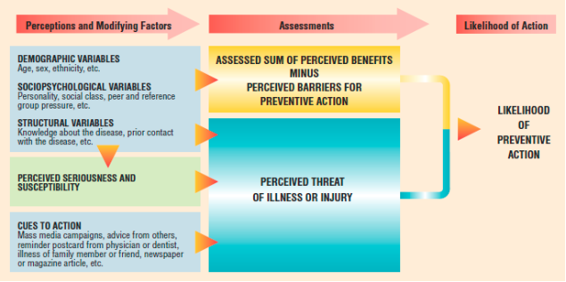
The following model explains how our beliefs about our health may influence our attitudes and behaviour regarding our health.
PERCEIVED SERIOUSNESS OF THE HEALTH PROBLEM – the severity of the medical/social consequence if health problem was left untreated.
PRECEIVED SUSCEPTABILITY TO THE HEALTH PROBLEM – your personal perspective of how likely you believe you are to developing health problems, more likely to act.
CUES TO ACTION – reminded or told of potential health risk > chance of taking preventative actions.
- DEMOGRAPHIC VARIABLES – age, sex, ethnicity, cultural background
- SOCIOPSYCHOLOGICAL VARIABLES – personality traits, social class, social pressure
- STRUCTURAL VARIABLES – knowledge, prior contact w health issues
YOUR INTENTIONS TO CHANGE
Theory of Reasoned Action – model for explaining the importance of our intentions regarding our behaviours.
Consistent and powerful attitudes about action, influence by others to act will > intention of doing so verbalizing your commitment to action.
SIGNIFICANT OTHERS AS CHANGE AGENTS
FAMILY – family norms allow for positive behaviours to be learnt breeding more healthy habits.
THE INFLENCE OF OTHERS – your attitude towards the behaviour, your level of perceived behavioral control, your subjective norms.
- Intention are powerful indicators of successful behaviour change,
  - Attitude towards behaviour (e.g. developing strong intentions to exercise)
  - Controlled behaviours (e.g. affordable gym with acceptable times motivation ↑)
  - Subjective norms (e.g. encouragement from friends)
BEHAVIOUR CHANGE TECHNIQUES
SHAPING: DEVELOPING NEW BEHAVIOURS IN SMALL STEPS
Shaping, using a series of smaller steps to achieve goal gradually. Whatever the desired behaviour change, shaping involves:
- Starting slowly, preventing/limiting stress, realistic & achievable
- Flexible/adaptable, ready to change original plan
- Refusing to skip steps until last has been mastered, rewarding yourself
VISUALIZING: THE IMAGINED REHERSAL practicing a skill or behaviour through mental imagination
MODELLING learning specific behaviours by watching others preform them (e.g. presentation skills)
CONTROLLIN THE SITUATION
Situational inducement – attempts to influence a behaviour by using situation and occasions structured to exert control over the behaviour.
REINFORECEMENT
Positive reinforcement – presenting something positive following a behaviour being reinforced.
CONSUMEABLE REINFORCERS edibles, reinforcers not affecting your plans.
ACTIVE REINFORCERS enjoyable activities such as runs, swimming, vacations
MANIPULATIVE REINFORCERS such as better grades for doing extra credit
POSSESSIONAL REINFORCERS tangible rewards (e.g. dress, laptops, etc.)
SOCIAL REINFORCERS loving looks, affectionate hugs, and praises.
CHANGING SELF-TALK
RATIONAL-EMOTIVE THERAPHY
Behaviour change is based in close connections between yourself and your feelings. Form of cognitive behaviour therapy action orientated. Taught to identify, challenge, and replace self-defense thoughts and beliefs.
MEICHENBAUM’S SELF-INSTRCITONAL METHODS
Encouraged to give self-instruction and positive affirmations instead of self-defeating thoughts. Stress inoculation in extreme stressors prior to event and practicing coping techniques.
MAKING BEHAVIOUR CHANGE
SELF-ASSESSMENT: ANTECHEDENTS AND CONSEQUECNCES
Antecedents are the setting events for a behaviour; they cue or stimulate a person to act in certain ways. Antecedents can be physical events, thoughts, emotions, or the actions of other people.
Consequences result of behaviour – affect repetition of behaviour - physical events, thoughts, emotions, or the actions of other people.
ANALYZING THE BEHAVIOURS YOU WANT TO CHANGE
You can analyze behaviour using the following:
- Frequency
- Duration
- Seriousness
- Basis for the Problem Behaviour
- Antecedents
DECISION MAKING: CHOICES FOR CHANGE
D – Decide in advance what the problem is.
E – Explore the alternatives
C – Consider the consequences
I – Identify your values.
D – decide to take action.
E – Evaluate the consequences

CHAPTER 2: PROMOTING AND PRESERVING YOUR PSYCHOLOGICAL HEALTH
Defining Psychosocial Health
Psychosocial Health (Mental Health) – the intellectual, emotional, social, and spiritual dimensions of health.
PSYCHOSOCIALLY HEALTHY PEOPLE EXPRESS THE FOLLOWING CHARACTERISTIC:
- They feel good about themselves.
- They feel comfortable with others.
- They control tension and anxiety.
- They are able to meet the demands of life.
- They curb hate and guilt.
- They choose a positive outlook.
- They enrich the lives of others.
- They cherish the things that make them smile.
- They value diversity.
Intellectual Health: The Thinking You
Intellectual Health – The “thinking” part of psychosocial health – includes values, attitudes and beliefs.
- Enjoys life, the environment, and the people in it.
- People tend to be creative to learn, to try new things, and to take risks, cope well with personal and professional stress.
- Thinking and communicating rationally allows for them to move forwards in their life.
Deterioration of intellectual health lead to sharp decline in rational thinking, increasing distorted perceptions, cynical and distrustful, volatile mood swing, isolation from others.
Emotional Health: The Feeling You
Emotional Health – the “feeling” part of psychosocial health, the “feeling” reactions to life.
Emotions – intensified feelings or complex patterns of feelings we experience.
Typically, emotions are described as the interplay of four components: Psychological arousal, feelings, cognitive (thinking) processes, and behavioral reactions.
Four basic types of emotions
- Emotions resulting from harm, loss, or threats.
- Emotions resulting from benefits or rewards.
- Borderline emotions, such as hope, compassion.
- More complex emotions such as grief, disappointment, bewilderment, curiosity.

Social Health: Interactions with Others
Social Bonds – degree and nature of interpersonal contacts.
Social Supports – structural and expressive aspects of social interactions.
Prejudice – a negative evaluation of an entire group of people usually based on unfavorable and often mistaken ideas about the group.
Two Important Factors:
PRESENCE OF STRONG SOCIAL BONDS. – social bonds usually provide six major functions: intimacy, feelings of belonging to or integration with a group, opportunities for giving and receiving nurturance, reassurance of your worth, assistance and guidance, advice.
PRESENCE OF KEY SOCIAL SUPPORTS. – bringing positive benefits to individuals, expressive (emotional support, encouragement), structural (housing, money).
Spiritual Health: An Inner Quest for Well-Being
Interconnectedness: a web of connections, including your relationship to yourself, to others, and to a larger meaning or purpose in life.
Mindfulness – awareness and acceptance of the reality of the present moment.
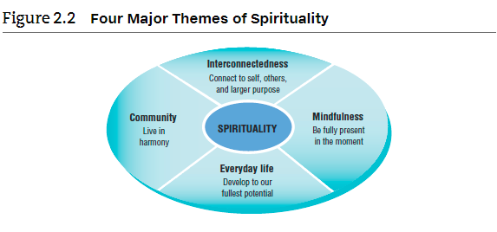
INTERCONNECTEDNESS – sense of belonging and connecting with yourself and others with larger. meaning to life.
MINDFULNESS – live in the now.
SPIRITUALITY AS PART OF DAILY LIFE – ongoing process of growth fostering faith, hope, and love.
LIVING IN HARMONEY WITH YOUR COMMUNITY – values an extension of your beliefs about the world and your attitude towards life.
Strategies for Finding Your Spiritual Side
VOLUNTEER – connected with others and reaching out to help others.
TAKE TIME TO REFLECT – setting time aside to reflect on oneself, relieve tension, seek answers to problems or experiences.
GETTING INVOLVED IN SERVICE LEARNING – same things as volunteering.
Factors Influencing Psychological Health
Table 2.1 Psychosocial Health Tips
Daydream | Imagine yourself in a dream location, breathing slowly and deeply, comforting environment.
“Collect” Positive Emotional Moments | Recalling times when you experienced pleasure, comfort, tenderness, confidence / positive emotions. May have items (special).
Learn Ways to Cope with Negative Thoughts | Learn to interrupt negative thoughts not block them, don’t let them over take, try distracting yourself or comforting yourself if it cannot be solved immediately.
Do One Thing at a Time | Be present, do one thing at a time, do not multitask. Get rid of distractions by devices and stop making mental “to do” list.
Make Your Meals a Special Time | Get rid of distraction and enjoy your meal with others or by yourself.
Be Physically Active | Regular physical activity improves psychological well-being and reduce depression/anxiety loneliness, new people with common goal.
Enjoy Hobbies | Free of pressure of everyday tasks, keeps brain active.
Set Personal Goals | Short-term, mid-length or long-term goals, high significance or low significance.
Keep a Journal (Or Even Talk to The Wall) | Express yourself to gain perspective, release tension, boost body’s resistance to illness.
Share Humor | Share something that makes you smile or laughs with others.
Volunteer | Help someone in greater need, widen opportunities, social network adds new dimension to your life.
Treat Yourself Well | Pay attention to your own needs and wants, trust your gut instinct, eat healthy and be physically active.
Do something you’ve been putting off, give yourself rewards, wear clothes that make you feel good about yourself, spend time with people, learn something new every day.
External Influences
Influences from the Family
- The healthy nurturing that occurs within a family are responsible for what the children learn to be more well-adjusted, productive adults.
- Children raised in dysfunctional families in which negative behaviours (violence, abuse) is present may have harder time adapting to life.
  - Unconditional love and lack of trust often confused and psychologically bruised

Influences of the Wider Environment
- Children raised in an environment where rampant and safety safety (?) increased risk of psychosocial health issues drugs, crime, violent acts, School failures, unemployment
- Protecting factors, one or more positive role model / high level of self-esteem can help children grow up healthy and well-adjusted.
Internal Influences
Some factors include your traits, hormonal functioning, physical health status, level of physical fitness, and select elements of mental and emotional health.
Self-Efficacy and Self-Esteem
Self-Efficacy – belief in your ability to perform a task successfully.
Self-Esteem – your sense of self-respect or self-worth.
Personal Control – belief that your effort can and do influence situations and interactions with others.
Learned Helplessness VS. Learned Optimism
When continual failure occurs, you may develop pattern of responding learned helplessness.
Learned Helplessness society’s tendency towards victimology rather than accepting responsibility for ones actions.
Learned Helplessness – an attitude of giving up and not trying because of past failure.
Countering learned helplessness – learned optimism, when you assess what has happened in life and block negative thoughts replacing them with positive thoughts.
Learned Optimism – pattern of responding that focuses on the positive, because you choose to view each situation positively and with a sense of hope.
Personality
Personality is a mixture of characteristics, hereditary, environmental, cultural, and exceptional factors.
EXTROVERSION. Ability to adapt to a social situation and demonstrate assertiveness as well as power or interpersonal involvement.
AGREEABLENESS. The ability to conform, likable, and demonstrate friendly compliance & love.
OPENNESS TO EXPERIENCE. Willingness to demonstrate curiosity and independence.
EMOTIONAL STABILITY. Maintain control of your feelings.
CONSCIENTIOUSNESS.

