Economics 201 Sample Midterm

Multiple Choice
Identify the letter of the choice that best completes the statement or answers the question.

1. When a society cannot produce all the goods and services people wish to have it is said that the economy is
experiencing
a.
scarcity.
b.
communism.
c.
externalities.
d.
market failure.

2. Daniel decides to spend the last two hours of the night before his economics exam studying instead of
sleeping. For Daniel, his tradeoff would be
a.
nothing, since no dollar value can be put on sleep.
b.
nothing, since studying would be more beneficial than sleep.
c.
the six hours of sleep he could have had if he had gone to bed before midnight.
d.
the two hours of rest he would have gotten.

3. Which of the following best defines efficiency?
a.
absolute fairness
b.
equal distribution
c.
minimum waste
d.
consumer sovereignty

4. When government policies such as the welfare system try to help the most needy members of society, it
a.
increases equity and reduces efficiency.
b.
reduces charitable contributions in an economy.
c.
increases the productivity of the needy in the society.
d.
causes market failure to occur.

Economics 201 Sample Midterm

Multiple Choice
Identify the letter of the choice that best completes the statement or answers the question.

1. When a society cannot produce all the goods and services people wish to have it is said that the economy is
experiencing
a.
scarcity.
b.
communism.
c.
externalities.
d.
market failure.

2. Daniel decides to spend the last two hours of the night before his economics exam studying instead of
sleeping. For Daniel, his tradeoff would be
a.
nothing, since no dollar value can be put on sleep.
b.
nothing, since studying would be more beneficial than sleep.
c.
the six hours of sleep he could have had if he had gone to bed before midnight.
d.
the two hours of rest he would have gotten.

3. Which of the following best defines efficiency?
a.
absolute fairness
b.
equal distribution
c.
minimum waste
d.
consumer sovereignty

4. When government policies such as the welfare system try to help the most needy members of society, it
a.
increases equity and reduces efficiency.
b.
reduces charitable contributions in an economy.
c.
increases the productivity of the needy in the society.
d.
causes market failure to occur.

Economics 201 Sample Midterm

Multiple Choice
Identify the letter of the choice that best completes the statement or answers the question.

1. When a society cannot produce all the goods and services people wish to have it is said that the economy is
experiencing
a.
scarcity.
b.
communism.
c.
externalities.
d.
market failure.

2. Daniel decides to spend the last two hours of the night before his economics exam studying instead of
sleeping. For Daniel, his tradeoff would be
a.
nothing, since no dollar value can be put on sleep.
b.
nothing, since studying would be more beneficial than sleep.
c.
the six hours of sleep he could have had if he had gone to bed before midnight.
d.
the two hours of rest he would have gotten.

3. Which of the following best defines efficiency?
a.
absolute fairness
b.
equal distribution
c.
minimum waste
d.
consumer sovereignty

4. When government policies such as the welfare system try to help the most needy members of society, it
a.
increases equity and reduces efficiency.
b.
reduces charitable contributions in an economy.
c.
increases the productivity of the needy in the society.
d.
causes market failure to occur.

Economics 201 Sample Midterm

Multiple Choice
Identify the letter of the choice that best completes the statement or answers the question.

1. When a society cannot produce all the goods and services people wish to have it is said that the economy is
experiencing
a.
scarcity.
b.
communism.
c.
externalities.
d.
market failure.

2. Daniel decides to spend the last two hours of the night before his economics exam studying instead of
sleeping. For Daniel, his tradeoff would be
a.
nothing, since no dollar value can be put on sleep.
b.
nothing, since studying would be more beneficial than sleep.
c.
the six hours of sleep he could have had if he had gone to bed before midnight.
d.
the two hours of rest he would have gotten.

3. Which of the following best defines efficiency?
a.
absolute fairness
b.
equal distribution
c.
minimum waste
d.
consumer sovereignty

4. When government policies such as the welfare system try to help the most needy members of society, it
a.
increases equity and reduces efficiency.
b.
reduces charitable contributions in an economy.
c.
increases the productivity of the needy in the society.
d.
causes market failure to occur.
Multiple Choice
Identify the letter of the choice that best completes the statement or answers the question.
Multiple Choice
Identify the letter of the choice that best completes the statement or answers the question.
Multiple Choice
Identify the letter of the choice that best completes the statement or answers the question.
Multiple Choice
Identify the letter of the choice that best completes the statement or answers the question.
Multiple Choice
Identify the letter of the choice that best completes the statement or answers the question.
Economics 201 Midterm
Multiple Choice
Identify the letter of the choice that best completes the statement or answers the question.
1. When a society cannot produce all the goods and services people wish to have it is said that the economy is
experiencing
a.
scarcity.
b.
communism.
c.
externalities.
d.
market failure.

2. Daniel decides to spend the last two hours of the night before his economics exam studying instead of
sleeping. For Daniel, his tradeoff would be
a.
nothing, since no dollar value can be put on sleep.
b.
nothing, since studying would be more beneficial than sleep.
c.
the six hours of sleep he could have had if he had gone to bed before midnight.
d.
the two hours of rest he would have gotten.

3. Which of the following best defines efficiency?
a.
absolute fairness
b.
equal distribution
c.
minimum waste
d.
consumer sovereignty

4. When government policies such as the welfare system try to help the most needy members of society, it
a.
increases equity and reduces efficiency.
b.
reduces charitable contributions in an economy.
c.
increases the productivity of the needy in the society.
d.
causes market failure to occur.
1. When a society cannot produce all the goods and services people wish to have it is said that the economy is
experiencing
a.
scarcity.
b.
communism.
c.
externalities.
d.
market failure.

2. Daniel decides to spend the last two hours of the night before his economics exam studying instead of
sleeping. For Daniel, his tradeoff would be
a.
nothing, since no dollar value can be put on sleep.
b.
nothing, since studying would be more beneficial than sleep.
c.
the six hours of sleep he could have had if he had gone to bed before midnight.
d.
the two hours of rest he would have gotten.

3. Which of the following best defines efficiency?
a.
absolute fairness
b.
equal distribution
c.
minimum waste
d.
consumer sovereignty

4. When government policies such as the welfare system try to help the most needy members of society, it
a.
increases equity and reduces efficiency.
b.
reduces charitable contributions in an economy.
c.
increases the productivity of the needy in the society.
d.
causes market failure to occur.

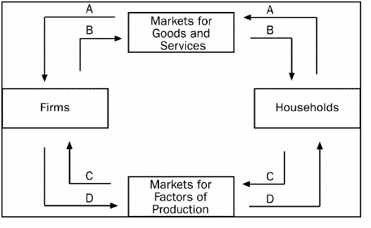

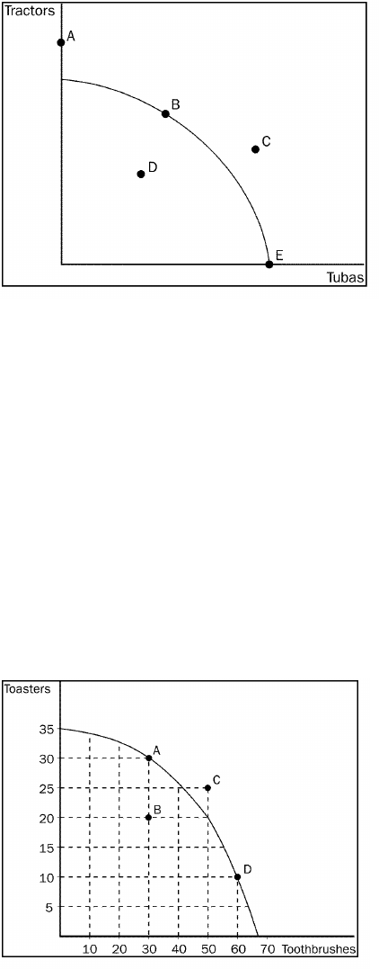
11. Refer to Figure 2-3. The economy CANNOT produce at which point or points?
a.
A
b.
C
c.
A, C
d.
A, C, D,
12. Refer to Figure 2-3. Which point or points are efficient?
a.
B, E
b.
A, B, E
c.
D
d.
C
Figure 2-4
13. Refer to Figure 2-4. The opportunity cost to the economy of getting 30 additional toothbrushes by moving
from point A to point D is
a.
10 toasters.
b.
15 toasters.
c.
20 toasters.
d.
25 toasters.
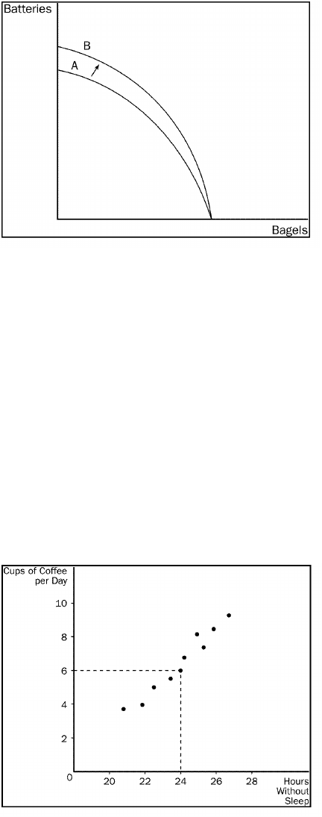
Figure 2-5
14. Refer to Figure 2-5. The shift of the frontier from A to B was most likely caused by which of the following?
a.
technological improvement in the production of batteries
b.
more labour available in the economy
c.
a general technological breakthrough
d.
more capital available in the economy
15. Microeconomics is the study of
a.
the behaviour of consumers.
b.
how individual households and firms make decisions.
c.
how government affects the economy.
d.
how the economy as a whole works.
Figure 2-9
16. Refer to Figure 2-9. Cups of coffee per day and the hours that someone can go without sleep have
a.
a positive correlation.
b.
a negative correlation.

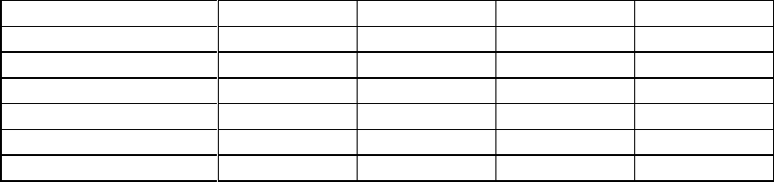
22. You lose your job and as a result, you buy fewer mystery books. This shows that you consider mystery books
to be a/an
a.
normal good.
b.
inferior good.
c.
luxury good.
d.
complementary good.
23. If goods A and B are complements, an increase in the price of A will result in
a.
more of good A sold.
b.
more of good B sold.
c.
less of good B sold.
d.
no difference in the quantity sold of either good.
Table 4-1
The table shows individual demand schedules for a market.
Price of the Good
Aaron
Angela
Austin
Alyssa
$0.00
20
16
10
8
0.50
18
12
6
6
1.00
14
10
2
5
1.50
12
8
0
4
2.00
6
6
0
2
2.50
0
4
0
0
24. Refer to Table 4-1. When the price of the good is $1.00, the quantity demanded in this market would be
a.
42 units.
b.
31 units.
c.
24 units.
d.
14 units.
25. A very hot summer in Atlanta will cause the demand for lemonade to
a.
shift to the left.
b.
shift to the right.
c.
remain stable but we would move down the curve.
d.
remain stable but we would move up the curve.
26. Fewer sellers in the market causes
a.
the supply curve to shift to the left.
b.
the supply curve to shift to the right.
c.
a movement up a stationary supply curve.
d.
a movement down a stationary supply curve.
27. An advance in production technology will
a.
increase a firm's costs.
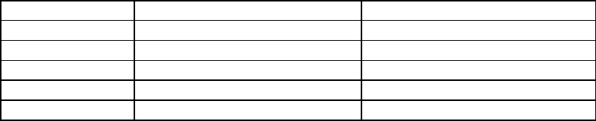
b.
allow firms to raise the price of their product.
c.
shift the supply curve to the right.
d.
Both a and b are correct.
28. Workers at a bicycle assembly plant currently make minimum wage. If the federal government increases the
minimum wage by $1.00 an hour it is likely that the
a.
demand for bicycle assembly workers will increase.
b.
supply of bicycles will shift to the right.
c.
supply of bicycles will shift to the left.

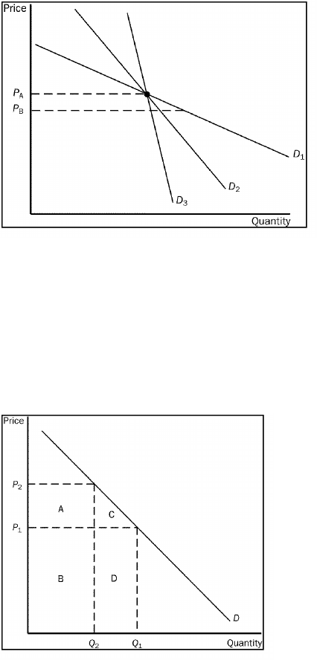
38. Refer to Figure 5-4. As price falls from P
A
to P
B
, which demand curve is least elastic?
a.
D
1
b.
D
2
c.
D
3
d.
All of the above are equally elastic.
Figure 5-7
39. Refer to Figure 5-7. Total revenue at P2 would be represented by area(s)
a.
B + D
b.
A + B
c.
C + D
d.
D
40. The local pizza restaurant makes such great bread sticks that consumers do not respond much to a change in
the price. If the owner is only interested in increasing revenue, he should
a.
lower the price of the bread sticks.
b.
leave the price of the bread sticks alone.
c.
raise the price of the bread sticks.
d.
reduce costs.

