BIO 3303 Midterm 2 notes
Lecture 7 sensory physiology
- Sensory physiology division
- Introduction to Sensory Physiology
- Chemoreception (olfaction and gustation)
- Mechanoreceptors
- Hearing
- Photoreception and vision
- Thermoreception, and Magnetoreception
- Hypothesis: Sensory access to prey lead to resource partitioning
  - Natterer's bat (Myotis nattereri) hunt by echolocation
  - Bechstein's bat (Myotis bechsteinii) hunt by sound alone
  - What makes up a community
  - Katydid back sensor that is being hunt and runs away, perceives echolocation. It evolved with bats
- Sensory physiology the study of how sensory stimuli are transduced by sensory receptors and processed by the nervous system.
  - Integration of these:

- Sensory system: sense organ + afferent sensory neuron + area of brain to which these neurons project e.g. Visual system: eyes, optic nerve, brain areas concerned with processing visual info
- Sense organ: receptor cells + accessory non-neural tissues. e.g. Eye
- Sensory receptors: cell that is specialized to detect incoming sensory stimuli e.g. Rods and cones
- Receptor proteins: proteins on membranes of sensory receptors (cell) specialized to detect incoming sensory signals e.g. opsin
- Classification of sensory receptors
  - Human-centered classification of senses that we consciously use (first developed by Aristotle >2000 years ago). 5 senses
  - Based on location:
    - Exteroceptors: detect stimuli occurring on the outside of the body e.g. Pressure, temperature, etc.
Types of stimulus | Sensory receptor
Chemical | Chemoreceptors
Mechanical | mechanoreceptors
Light | photoreceptors
Temperature | thermoreceptors
Magnetic fields | magnetoreceptors
Electrical fields | electroreceptors
    - Interceptors: detect stimuli occurring inside the body e.g. Blood pressure, blood oxygen
  - There are receptors that allow homeostasis.
  - Based on stimulus modality (type of stimulus it detects)
    - Stimulus: form of external energy to which a receptor responds

- Sensory receptors:
  - Most receptors have a preferred stimulus modality → adequate stimulus. e.g. rods and cones = light
  - Enough stimulus energy can overcome specialization. e.g. enough pressure on eye = light signal
  - Some receptors sensitive to multiple modalities → polymodal receptors. e.g. Ampullae of Lorenzini (shark nose): electricity, touch and temperature. e.g. Nociceptors (humans and other animals): detect strong stimuli of temperature, pressure, chemicals, among others→detection of pain
- Steps in sensory reception
- Reception of the stimulus
- Transduction of the stimulus (usually with amplification): stimulus converted into changes in membrane potential (electrical signal)
- Transmission of the signal to the integrating centre
- Perception of the stimulus at the integrating centre
Types of sensory receptors
  - Sensory neuron (sensory receptor neuron)
  - Is an afferent neuron
  - Stimulus leads to a type of graded potential called: “generator potential” and AP generated at trigger zone if threshold reached
  - Epithelial sensory receptor cell
  - Graded potential called: “receptor potential”
  - Releases neurotransmitter causing graded potentials and APs in an associated primary afferent neuron
- Stimulus encoding, problems of sensory encoding:
  - Different types of stimulus of varying intensity and duration from different places, but only one signal in nervous system: the action potential
- How APs encode for these?
- Modality (type of stimulus)
  - Most receptors are maximally sensitive to 1 type of stimulus
  - (adequate stimulus)
  - In general, same types of sensory receptors synapse with the same afferent neuron.
  - “Labeled-line Theory” (1850’s Johannes Müller)
  - Modality based on receptor type and afferent neuron
  - Requires high degree of receptor specificity
  - Each receptor is for one stimulus. If the receptor responds to multiple stimuli the brain needs to know what stimulus it was.
  - Similarities across modality
  - stimulus parameters encoded by AP rate and pattern
  - Also, modality-specific differences Highly specific transduction mechanisms
  - Frequency determined by AP
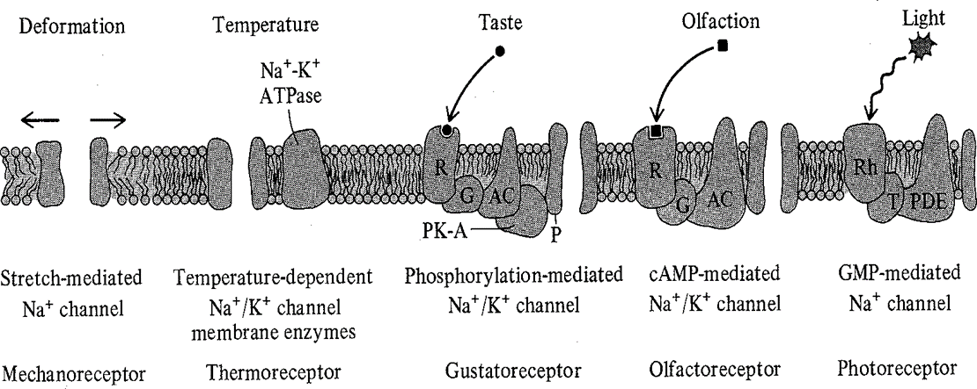
  - Chemoreception: Taste, smell (olfaction), ECF composition
  - Mechanoreception: Stretch receptors, Hearing (Audition), Balance (Proprioception), BP
  - Photoreception: Sight and visual processing
  - →Detection (receptor protein complex), signal transduction and amplification (enzyme cascade), receptor channel activation
  - Encoding stimulus modality:
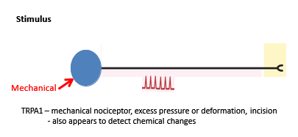
    - Polymodal receptors: how can they encode more than one modality?
      - Temporal pattern of Aps
        - Different frequencies are detected by the brain as different stimulus
      - “Cross-fiber” coding: Several neurons in close proximity with differing sensitivities. Compare relative intensity.
      - 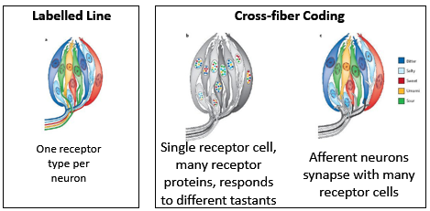
      - A single nerve brings multiple signals from neurosensory cells. Each color for each nerve. Colours represent receptor proteins
- Intensity
  - APs are all-or-none electrical events of same magnitude
  - Graded (receptor/generator) potentials vary in magnitude and affect rate of APs
  - stimulus intensity coded through changes in frequency of Aps
  - 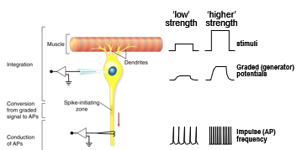
  - Stimulus can activate one or many receptor cells
  - Large stimulus activates larger number of receptor cells e.g. strong mechanical force, or high amplitude (loud) sound = large deformation
- Stimulus response relationship EXAM QUESTION
  - Dynamic range: range of intensities over which stimuli are encoded by receptor cells
  - Below threshold intensity, the receptor fails to initiate APs (stimulus too weak = no response)
  - Any of the steps in sensory transduction can set the top of the dynamic range.
  - receptor proteins saturated
  - all ion channels have opened or closed
  - Membrane potential change maxes out (i.e. reaches equilibrium potential of ion)
  - Maximum rate of release of neurotransmitters
  - Maximum frequency of APs in afferent neuron (set by refractory periods, dynamic range 1000-fold)
  - Depending on receptors it will have different dynamic range. Stimulus starts threshold intensity. Receptor saturation: it can’t send Aps any faster. Range is critical because the receptor will only work on that range.
  - Different receptors with varying dynamic range
    - Receptor A detect broad range of stimulus intensities, but has low power to discriminate among different intensities
    - Receptor B detect narrow range; but provide fine discrimination within that range
  - Range fractionation: Group of receptors, each sensitive to a different range, work together to provide finer discrimination across a wider range of intensities
    - Population code: intensity coded through the behavior of the population (multiple) of sensory receptors
    - Usually there is much more overlap than shown
    - Responses integrated in upstream neurons and processing centers
  - Range fractionation extend the dynamic range and increases sensory discrimination
  - We use different receptors that have different ranges, so what you do is have specialists and put them together and you get very good at having the sensitivity over a bigger range. With the concept of additivity range fractionation
  - Logarithmic encoding:
    - Some receptors encode stimulus intensity logarithmically:
    - Discrimination of stimulus: fine at low intensities coarse at high intensities e.g. Candle light in dark room vs bright room
  - Fechner's law states that subjective sensation is proportional to the logarithm of the stimulus intensity. The way we perceive stimuli.
  - Weber-Fechner relationship: logarithmic relationship between actual and perceived stimulus intensity (e.g. brightness and weight)
- Location
  - Receptive Field: region of sensory surface that, when stimulated, generates a response in the primary afferent neuron
    - Neurons with small receptive fields provide more precise localization of stimulus (greater acuity)
    - Populations of neurons with overlapping receptive fields improves ability to locate stimuli
    - Population coding: information about stimulus encoded in pattern of firing of multiple neurons
    - ** two-point discrimination test. Neuron density
  - Lateral inhibition increases contrast between signals from neurons at the center of the stimulus and neurons on the edge, allowing further discrimination
    - Strong stimulus at center (B) causes skin to bend in receptive fields of adjacent neurons (A and C)
    - Neuron B release lots of Nt which stimulates lateral interneurons
    - Lateral interneurons release inhibitory Nt, preventing release of Nt in A and C.
    - Lets the peripheral system and it tells the system the stimuli are in the middle.
    - It basically cleans the system for you to discriminate where the stimulus is coming from. Simplifies signal so that the integrating system is not overwhelmed.
  - Contrast enhancement
    - Lateral inhibition crucial for photoreceptor receptive field organization and visual processing
    - Enhances contrast for improved detection of edges and gradients
    - Squares example with the grey
- Duration
  - Tonic receptors: fire APs as long as the stimulus continues
  - → convey information about how long the stimulus lasts
  - Receptor adaptation: AP frequency declines even when the stimulus
  - intensity is maintained at a constant level
  - Phasic receptors: fire APs only when the stimulus begins (adapt quickly) → convey information about changes in stimulus but not duration Eg Pacinian corpuscle:
    - Mechanoreceptor, sensitive only to changes in pressure
    - Phasic response due to peripheral filtering from lamellae (accessory structure)
    - Lamellae (“onion skin”) separated with fluid act as a filter: fluid redistributes, relieving initial distortion of sensory terminal
    - If lamellae removed: Pacinian corpuscle act more as a tonic receptor.→ Other mechanisms of adaptation depend on changes in the neuronal membrane or channels
  - Tonic If there is a signal on is depolarized and sending ap
  - Phasic when there's change it sends about if there's not then it doesn’t send anything

