BIO1130: Lecture 2 – Chapter 1: The Scientific Method
CHAPTER 1: The Scientific Method
  - Introduction and definition of science
  - The Scientific Method
    - Inductive Reasoning
    - Deductive Reasoning
    - Scientific Process + Case Studies
  - Conclusion

1.1 Introduction and definition of Science
- Science: the intellectual and practical activity encompassing the systematic study of the structure and behavior of the physical and natural world through observation and experiment
  - Science is evidence based
- Biology: The science of how life works
- Scientific inquiry: the diverse ways in which scientists study the natural world and propose explanations based on the evidence derived from their work
- Two approaches:
  - Description-based (ex: describing nature)
  - Hypothesis-based (ex: explaining nature)
1.2 The Scientific Method
1.2.1 Inductive reasoning (linked to a descriptive-based approach):
- Generalization based on numerous observations
- Particular General
1.2.2 Deductive reasoning (linked to a hypothesis-based approach):
- Stating a hypothesis and then making conclusions (after experimentation or observation) from hypothesis
- General Particular
  - Testing general thinking (hypothesis) = then closer to truth
- Scientific hypotheses must be verifiable, refutable, reproducible

- Observation: Flashlight doesn’t light
  - Question: Why doesn’t flashlight work?
    - Hypothesis 1: Dead batteries
      - Prediction: Replacing batteries will fix problem
        - Test of prediction: Replace batteries
          - Results: Flashlight doesn’t work Test falsifies hypothesis
    - Hypothesis 2: Burnt-out bulb
      - Prediction: Replacing bulb with fix problem
        - Test Prediction: Replace bulb
          - Result: Flashing works. Test does not falsift hypothesis
- From hypothesis you can make a PREDICTION
- Predictions must be testable and give a clear result
  - If …. Then …. Statement
- Hypothesis can be falsified or not falsified
- We can never prove that a hypothesis is the scientific truth
  - Maybe the bulb was never burnt, it wasn’t screwed properly
- I f a hypothesis has survived multiple falsification attempts = THEORY
The case of dead fishes of Gatineau:
- After proper necropsies of fishes
  - Cause of death: Gas bubble disease cause by the outflow of a hydro-electric dam on the river
    - Gas is super saturated => gets in fish and causes death
Not refuted refuted
- Not all knowledge is science

- A contract between science and knowledge (or the ability to know)
  - Initial skepticism on facts
    - Ask honest questions on facts and hypothesis
    - Re-test what has been found
  - Realism
    - The world is older and exists independently from my perception of it
    - Test reality, not ideas
    - Requires neutrality
  - Rationality
    - Logic: demonstrations from a scientist must be the result of coherent steps
      - All process; hypothesis, tested, claim falsified or not …
    - Parsimony: methodological principle which states that acceptable theories are hypothetically the most economical in assumptions
      - Many hypothesis to explain a hypothesis: go with less complicated one, simplest solution
  - Methodological materialism
    - Materialistic type
    - All that is experimentally accessible in the real world is material or has a material origin
      - No extra force or made up thing
      - No evidence of credibility – need to test hypotheses

- Crop Circle enigma (ex: of Parsimony)
  - 1970s – geometric figure that would appear at night (no one knows who did them)
  - People thought they were made by aliens, extraterrestrials
    - Studies done on DNA - said there was radiation
  - After 2 yrs, 2 people confessed how they did them at night
    - Simplest explanation: people did it at night

1.2.3 Scientific Process:
- Mimicry (Batesian)
  - Monarchs: only feed on milkweed
    - Viceroy: non toxic looks very similar, same patterns, but viceroy are smaller
    - Monarch : toxic
    - However similar coloration
  - Non toxic (Viceroy) species, adapts to toxic species’ (Monarch) coloration as a mean of protection predator won’t feed on non toxic bc looks like toxic butterfly
  - THEN … new case studies show that Viceroy are actually toxic now called Mullerian, not Batesian (Mullerian = Toxic & toxic)
    - Batesian = (non-toxic species looks like toxic species)
    - Therefore, hypothesis NEED TO BE TESTED AGAIN (revise hypothesis)

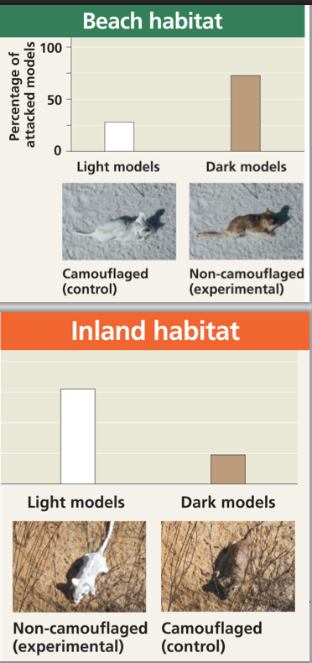
Case Study: Fur colouration in Peromyscus polionotus, the oldfield mouse
- Florida – mouse is white (beach population)
- Inland population – mouse is brown (bends with trees and soil)
- Hypothesis: In this species, fur colouration patterns has evolved as camouflage in their native environments
- Prediction: If mice have a colouration that does not match their habitat, then they will be preyed on more heavily than the native, well-matched mice
- Test: Put white mouse in inland and brown mice in beach (opposite native environments)
  - Plasticine mice sprayed-painted in beach or inland colours
  - Spread both colors models (control and experimental) in equal numbers in both habitats.
  - Count signs of attacks
  - See if predators attack experimental mouse
    - Monitor attacks and looks at result
  - Tested hypothesis: mice that camouflage with habitat are more likely to survive
Case study: Introduction of fish in Gatineau Park
- The introduction of species for recreational l fishing are frequent to enhance the “value” of a lake
- The impact of piscivorous fish introductions on indigenous species have been the subject of studies
- Observation: Small Lakes in which recreational fishing specie (piscivores) have been introduced do not have schools of small fish near store.
  - Thinking: Potential prey fishes were lower
- Sample Area: Gatineau Park
  - Introduction of piscivores species in 20 small lakes (less than 60 hectares) at the beginning of the 20th century (experimental group)
  - About 25 small lakes without piscivores species (control group)
- Hypothesis: Introduction of piscivore fish species in small lakes would result in a decline in the numbers o f smaller species
  - Think about predator – if u have a species that doesn’t get big susceptible to credation small fish would be the ones to disappear first
- Prediction: In small lakes from the same region, if lakes contain introduced piscivorous species then they will have fewer smaller fish species than lakes without the piscivores
- Testing the prediction: Determine the number of fish species in both types of lakes.
  - A comparative analysis of fish species diversity in a region with small lakes with and without introducing piscivores
- Results: Lakes without introduced piscivorous fish species have significantly more (50%) small-sized fish species than lakes with introduced piscivores
- Recommendation: No piscivorous species introduction in Gatineau Park lakes to preserve the park’s biodiversity
CONCLUSION:
- A valid scientific process needs to respect the clauses of the contract between the acquisition of knowledge and science
  - Breaking one of the clauses invalidates the contract because the acquisition of knowledge is not associated with an objective search for the scientific truth (which we can never say we have obtained)

