Comm 305[Managerial Accounting] Notes
9/5/19

Chapter Outline
1. Explain the distinguishing features of Managerial Accounting
2. Identify the three broad functions of management and the role of management accounts in an organizational structure.
3. Explain the importance of business ethics
4. Identify changes and trends in Managerial Accounting.

Terms:
Managerial Accounting: Also called Management Accounting, is a field of accounting that provides economic and financial information for managers and other internal users.

Comparing financial and managerial accounting
Feature | Financial accounting | Managerial accounting
Primary users of reports | External users, shareholders, creditors, and regulators | Internal users: officers and managers (CFO)
Types and Frequency of reports | · Financial statements  · Quarterly and annually | · Internal reports  · As frequently as needed
Purpose of reports | General-purpose | Special-purpose for specific decisions
Content of reports | · Pertains to business as a whole  · Highly aggregated(condensed)  · Limited to double-entry accounting and cost data  · Generally accepted accounting principles | · Pertains to sub-units of the business  · Very Detailed  · Extends beyond double-entry accounting to any relevant data  · Standard is relevance to decisions
Verification process | Audited by CPA (Chartered Professional Accountant) | No independent audits

Managerial Accounting Duties:
Ø Determine product costs.
Ø Responsible for evaluating how well the company is employing its resources.
Ø When the company makes critical strategic decisions, managerial accountants serve as team members alongside personnel from production, marketing, and engineering.

Managerial accountants’ responsibilities can be classified into three broad functions, Planning, Directing, Controlling, in performing these functions managers make decisions that have a significant impact on the organization.

Planning:
Requires management to look ahead and establish objectives. These objectives are often diverse; maximizing short-term profits and market share, maintaining a commitment to environmental protection, and contributing to social programs. For example, Hewlett-Packard, to gain a stronger foothold in the computer industry, greatly reduced its prices to compete with Dell. A key objective of management is to add Value to the business under its control. Value is usually measured by the trading price of the company’s shares and by the potential selling price of the company.

Directing;
Involves coordinating a company’s diverse activities and human resources to produce a smoothly running operation. This includes implementing planned objectives and providing necessary incentives to motivate employees. For example, manufactures such as General Motors of Canada, Magna international, and Dare Foods must coordinate their purchasing, manufacturing, warehousing, and selling. Service corporations such as Air Canada, TELUS, and CGI must coordinate their scheduling, sales, service, and acquisitions of equipment and supplies. Directing also involves selecting executives, appointing managers and supervisors, and hiring and training employees.

Controlling:
Is the process of keeping the company’s activities on track. In controlling operations, managers determine whether planned goals are being achieved. When there are deviations from target objectives, mangers must decide what changes are needed to get back on track. Scandals at companies like Nortel Networks and Hollinger attest to the fact that companies must have adequate controls to ensure that the company develops and distributes accurate information. [CONTROLLING-NOTE] A smart manager in a small operation can make personal observations, ask good questions, and know how to evaluate the answers. But using this approach in a large organization would result in chaos. Imagine the president of the company Current Designs trying to determine whether planned objectives are being met without some record of what has happened and what is expected to occur. Thus, large business typically uses a formal system of evaluation. These systems include such features as budgets, responsibility centers, and performance evaluation reports, all of which are features of managerial accounting.

Decision-Making:
is not a separate management function, rather, it is the outcome of the exercise of good judgement in Planning, Directing, and Controlling.
Organizational-Structures
In order to assist in carrying out management functions, most companies prepare Organizational-Charts that show the interrelationships of activities and the delegation of authority and responsibility within the company. Below is a typical organization chart showing the delegation of responsibility.

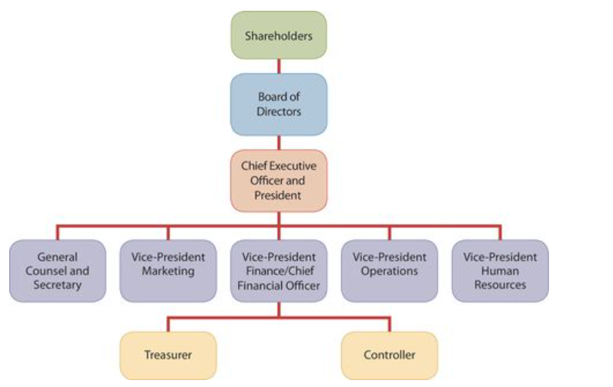

Analysis of the Organization Chart:
Shareholders own the corporation, but they manage it indirectly through a Board of Directors. The board formulates the operating policies for the company or organization. The board also selects officers, such as a president and one or more vice-presidents, to execute policy and perform daily management functions.

Chief Executive Officer has overall responsibility for managing the business. Obviously, even in a small business, in order to accomplish organizational objectives, the company relies on the delegation of responsibilities. As the organization chart shows, the CEO delegates responsibility to other officers. Each member of the organization has a clearly defined role to play.

Responsibilities within the company are frequently classified as either line or staff positions. Employees with line positions are directly involved in the company’s main revenue-generating operating activities. Examples of line positions would be the vice-president of operations, vice-president of marketing, plant managers, supervisors, and production personnel. Employees with staff positions are involved in activities that support the efforts of the line employees. In firms like General Motors or Petro-Canada (Part of Suncor Energy), employees in the finance, legal, and human resources departments have staff positions.

Chief Financial Officer is responsible for all the accounting and finance issues the company faces. The CFO is supported by the Controller and the Treasurer. The controller’s responsibilities include 1. Maintaining the accounting records; 2. Maintaining an adequate system of internal control; and 3. Preparing Financial statements, tax returns, and internal reports. The Treasurer has custody of the corporation’s funds and is responsible for maintaining the company’s cash position.
[NOTE] Also serving the CFO are the Internal-Audit-Staff. The Audits staff’s responsibilities include reviewing the reliability and integrity of the financial information provided by the controller and treasurer. Audit staff members also ensure that internal control systems are functioning properly to safeguard corporate assets. In addition, they investigate compliance with policies and regulations, and, in many companies, they determine whether resources are being used in the most economical and efficient fashion.

[MEMORIZE] Managers activities are classified into 3 broad categories PLANNING, DIRECTING, CONTROLLING.
· Planning: requires managers to look ahead to establish objectives
· Directing: involves coordinating a company’s diverse activities and human resources to produce a smooth-running operation.
· Controlling: is keeping the company’s activities on track.

t's rooted in the IMA's ethical principles of honesty, fairness, objectivity, and responsibility. The statement describes specific requirements for management accountants to heed according to the IMA's four standards: competence, confidentiality, integrity, and credibility.

Explaining the Importance of Business Ethics:

All employees in an organization are expected to act ethically in their business activities. Given the importance of ethical behavior to corporations and their owners (Shareholders) an increasing number of organizations provide codes of business ethics for their employees. Despite these efforts, recent business scandals have resulted in massive investment losses and large employee layoffs. A recent survey of fraud by international accounting firm KPMG reported a 13% increase in instances of corporate fraud compared with five years earlier. It noted that, while employee fraud (such things as expense account abuse, payroll fraud, and theft of assets) represented 60% of all instances of fraud, financial reporting fraud (The intentional misstatement of financial reports) was the most costly to companies. That should not be surprising given the long list of companies, such as Nortel, Enron, Global Crossing, and WorldCom, that have engaged in or been accused of engaging in massive financial frauds, which have led to huge financial losses and thousands of lost jobs.

In January 2004, the Ontario Securities Commission (OSC), in conjunction with the Canadian Securities Administrators, introduced regulations governing the composition and duties of audit committees, as well as their members’ behaviour. The new regulations were also adopted by all provincial and territorial securities regulators, except for British Columbia's. “The rules are as robust as parallel rules required by the U.S. Sarbanes-Oxley legislation, but address unique Canadian concerns,” said OSC chair David Brown.1 (Weygandt, 12/2017, p. 9)

[NOTES]
Creating proper incentives: Companies like BCE (Owners of Bell Canada), CGI, Motorola, IBM, and Nike use complex systems to control and evaluate the actions of managers. They dedicate substantial resources to monitor and effectively evaluate the actions of employees. Unfortunately, these systems and controls sometimes unwittingly create incentives for mangers to take unethical actions. For example, companies prepare budgets to provide direction. Because the budget is also used as an evaluation tool, some mangers try to play a “game” by using budgetary slack; that is, they build some slack into the budget by underestimating their division’s predicted performance so that it will be easier to meet their performance targets. On the other hand, if the budget is set at unattainable levels, mangers sometime take unethical actions to meet the targets in order to receive higher compensation or, in some cases, to keep their jobs.

In response to corporate scandals in 2001 and 2002, the U.S. Congress enacted legislation to help prevent lapses in internal control. This legislation, referred to as the Sarbanes-Oxley Act of 2002 (SOX), had important implications of the financial community. One result of SOX was the clarification of top management’s responsibility for the company’s financial statements. CEOs and CFOs must now certify that the financial statements give a fair presentation of the company’s operating results and its financial condition. In addition, top mangers must certify that the company maintains and adequate system of internal controls to safeguard the company’s assets and ensure accurate financial reports.
To increase the likelihood of compliance with the rules that are part of the new legislation, the law substantially increases the penalties for misconduct. Another result of the SOX is that companies now pay more attention to the composition of the board of directors. In particular, members of the audit committee of the board of directors must all be entirely independent (that is, non-employees) and at least one must be a financial expert.

Answers to Questions: Chapter 2

Q. What is the Relevant Range?
- The Relevant Range is “the range that the company expects to operate in during a year.”

Q. Mixed Costs consist of a ?
- A Variable Cost Element and a Fixed Cost Element

Q. A cost that remains the same per unit at every level of activity is called a ?
- Variable Cost

Q. The following data pertain to acitivity and electricity costs for two recent years

 | Year 1 | Year 2
Acitivity levels in units | 12,000 | 8,000
Electricity costs | $15,000 | $12,000

Using the high-low method, what is the variable cost per unit for electricty?
- .75$ a unit
  - Formula for variable cost per unit using the HIgh-low method is Change in total costs / Change in Activity levels = Variable cost per unit
    - 3000/4000= .75

Babar Inc. manufactures electronic parts. Its managers are analyzing its monthly maintenance costs to determine the best way to budget these costs in the future. They have collected the following data for the last 6 months.

Month | Machine hours | Maintenance costs
January | 30,000 | $62,000
Feb | 40,000 | $74,500
March | 37,500 | $65,900
April | 39,000 | $68,750
May | 42,300 | $74,000
June | 35,000 | $64,500

Using the High-low method and the Babar inc. data above, calculate the variable maintenance cost per machine hour.
- .976$/hr highest productivity 42,300 (May) lowest productivity 30,000 (Jan)
  - 42,300-30,000 = 12,300 units $74,000-$62,000= $12,000 12,000/12,300=.976

Q. Kendra Corporation’s total utility costs during the past year were $1,200 during its highest month and $600 during its lowest month. These costs corresponded to 10,000 units of production during the high month and 2,000 units during the low month. What are the fixed and variable components of its utility costs using the high-low method?
- Cost change 1200-600=600 product change 10000-2000=8000
  - 600/8000= .075
    - Now to find fixed costs 10,000 units * .075 = 750, 1200-750= 450fixed
    - Cont. 2000*.075= 150 600-150 =450 fixed
    - So the variable Cost is .075 and the fixed cost is 450.

Q. In a manufacturer’s balance sheet, three inventories may be reported: (1) raw materials, (2) work in process, and (3) finished goods. In what sequence do these inventories generally appear on a balance sheet?
- In the order of liquidity 3, 2, 1

Q.For the year, Redder Company has Cost of Goods Manufactured of $600,000, beginning Finished Goods Inventory of $200,000, and ending Finished Goods Inventory of $250,000. The Cost of Goods Sold is
- COG MAN. + Beginning Finished Goods Inventory - Ending Finished Goods
  - 600,000 + 200,000 - 250,000 = 550,000

Q. A Cost of Goods Manufactured schedule shows beginning and ending inventories for
- Raw materials and work in progress only.

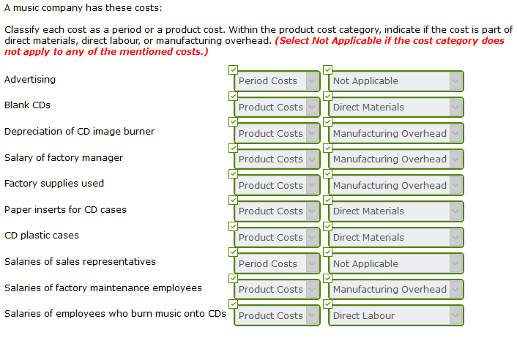

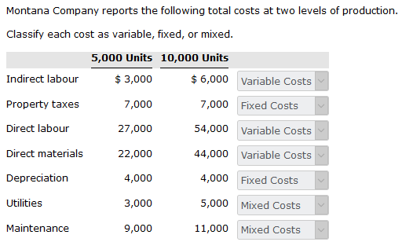

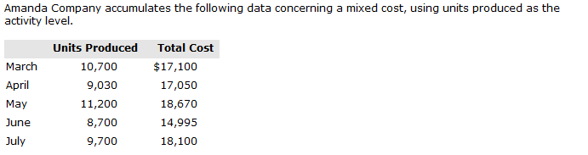
- First step find the variable cost using high low method
  - 3675 / 2500 = 1.47
- Next find the fixed prices
  - 18670-16464 = 2206 14995-12789= 2206
- Estimate the total cost if the company produces 8600 units.
  - 8600 units cannot be calculated because its outside of the relevant range 8700-11200 units

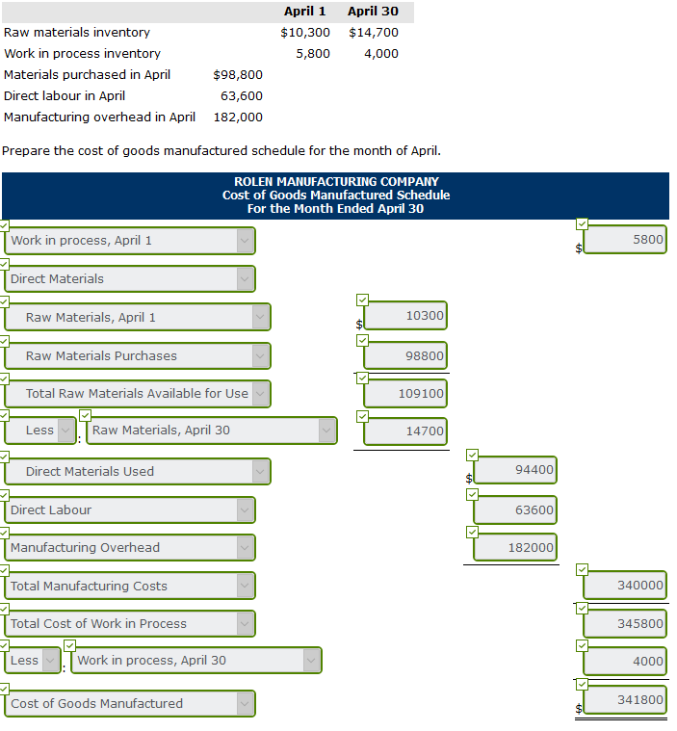

- Determining and controlling the cost of materials, labor, and overhead.
- The relationship between costs and profits.
- How managers use cost information to make various decisions.
- Understanding the variety of cost concepts and how changes in the level of business activity affect these costs.
  - Explaining various managerial cost concepts that are useful in planning, directing, and controlling. Presenting cost flows and the process of cost accumulation in a manufacturing environment.

Example: Goldcorp [Canadian gold producer]:
Vancouver-based Goldcorp is one of the worlds biggest gold producers. Because gold is a commodity—in other words, the market determines the price, which can fluctuate widely based on supply and demand—Goldcorp must control its costs in order to make a profit.
Goldcorp’s primary product is gold, which is mined at its four mines in Canada, and six mines in Mexico, Central America, and South America. The process of extracting gold from the ore—rocks that contain materials—is machinery and labor intensive. For example, at Goldcorp’s mine at Red Lake, in norther Ontario, the gold is deep under the surface and must be extracted underground, which is more expensive than surface mining. It takes one tonne of ore to recover and average of just 45 grams (1.4 ounces) of gold. Goldcorp has used innovative mining techniques to increase efficiency, including using larger trucks and a portable diamond-headed drill on a jumbo carrier. The Red Lake mine has two mill processing facilities, which use various techniques to recover gold from the ore, including crushing, grinding, and leaching (converting the gold to a water-soluble substance using cyanide and other methods).
In 2016, Goldcorp announced what its board chair Ian Telfer called, “an ambitious five-year 20/20/20 plan.” Over five years, the company aims to increase its gold reserves (deposits) by 20%, to 50million ounces. It also wants to boost gold production by 20%, to about 3 million ounces a year. At the same time, it wants to decrease its, “All-in sustaining costs” (or AISC) by 20% per ounce, to about $700 per ounce in year five. (AISC were $856 per ounce for the year ended December 31, 2016.) AISC include total production cash costs, which Goldcorp feels represents the total costs of producing gold from current operations, including administration, exploration, and evaluation, and capital expenditures. AISC is a non-GAAP financial performance measure used in the gold mining industry.
To help drive down costs, Goldcorp underwent “a significant restructuring to decentralize the organization and drive accountability down to the mine site level,” Mr. Telfer said. That included reducing the size of its executive and head office staff, which saved the company $50 million in 2016. In addition, improvements at the company’s Cerro Negro mine in Argentina cut costs by $65 million that year. Goldcorp’s goal is to reduce company-wide costs by about $250 million per year.
Mr. Telfer said that Goldcorp’s 20/20/20 plan will help it weather volatility in the industry. “After years of cost-cutting and underinvestment, our industry is experiencing shrinking gold production and gold reserves and a likely increase in unit costs. We believe Goldcorp’s 20/20/20 plan will position the company for sustained outperformance.”

Learning Objectives:
- Define the three classes of manufacturing costs and differentiate between product costs and period costs.
  - Review
    - Manufacturing costs
    - Prime costs and conversion costs
    - Product versus period costs
    - Cost concepts
- Explain variable, fixed, and mixed costs and the relevant range.
  - Review
    - Variable costs
    - Fixed costs
    - Relevant range
    - Mixed costs
- Apply the high-low method to determine the components of mixed costs
  - Practice High-Low Method
- Demonstrate how to calculate the cost of goods manufactured and prepare financial statements for a manufacturer.
  - Review
    - Income Statement
    - Balance Sheet

Learning Objective 1: Managerial Cost Concepts,
In order for managers at companies like Goldcorp to plan, direct, and control operations effectively, they need good information. One very important type of information is related to costs. Managers should ask questions such as the following
- What costs are involved in making a product or providing a service?
- If we decrease production volume, will costs decrease?
- What impact will automation have on total costs?
- How can we best control costs

In order to answer these questions, managers need reliable and relevant cost information. We now explain and illustrate the various cost categories that management uses. But first, what does cost mean? Accountants define cost as an economic resource given up or forgone to accomplish a particular objective. What does cost object mean? A Cost Object is anything for which we want to calculate a cost, such as a product (soft drink), a product line, a service, or a process for which cost information is measured and accumulated. Management accountants use different systems, or classifications, to develop cost information.

Manufacturing Costs:
Manufacturing consists of activies and processes that convert raw materials into finished goods. In contrast, merchandising sells goods in the same form in which they are purchased. Manufacturing costs are typically classified as shown in the Illustration Below

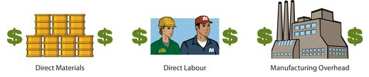

Direct Materials

To obtain the materials that will be converted into the finished product, the manufacturer acquires raw materials. Raw Materials are the basic materials and parts used in the manufacturing process. For example, auto manufacturers such as General Motors of Canada, Honda Canada, and Ford Motor Co. of Canada use steel, plastics, and tires as raw materials in making cars.
Raw materials that can be physically and directly associated with the finished product during the manufacturing process are called Direct Materials. Examples include flour in the baking of bread, syrup in the bottling of soft drinks, and steel in the making of automobiles. In the feature example, the direct material for Goldcorp is Ore.
However, some raw materials cannot be easily associated with the finished product. These are called indirect materials. Indirect materials have one of two characteristics.
- They do not physically become part of the finished product, such as lubricants and polishing compounds.
- They cannot be easily traced because their physical association with the finished product is too small in terms of cost, such as sandpaper and glue.
(Companies account for indirect materials as part of the manufacturing overhead)

Direct Labor

The work of factory employees that can be physically and directly associated with converting raw materials into finished goods is called Direct Labor. Bottlers at Cott Corporation and bakers at McCain Foods are employees whose activities are usually classified as direct labor. But some work of factory employees cannot be easily associated with the finished product. This work is called indirect labor. Indirect Labor has one of two characteristics.
- It is the work of factory employees that has no physical association with the finished product
- It is work for which it is impractical to trace costs to the goods produced. Examples include wages of maintenance people, timekeepers, and supervisors. Like Indirect materials, Indirect labor is classified as manufacturing overhead.

Manufacturing Overhead

Manufacturing Overhead consists of costs that are indirectly associated with the manufacture of the finished product. These costs may also be manufacturing costs that cannot be classified as direct materials or direct labor. Manufacturing overhead includes indirect materials, indirect labor, depreciation on factory buildings and machines, insurance, taxes, and maintenance on factory facilities. [Alternative Terminology: Terms such as factory overhead, indirect manufacturing costs, and burden are sometimes used instead of manufacturing overhead.
One study found the following magnitudes of the three different product costs as a percentage of the total product cost: direct materials 54% direct labor 13% and manufacturing overhead 33%. Note that the direct labor component is the smallest. This component of product cost is dropping substantially because of automation. Companies are working hard to increase productivity by decreasing labor. In some companies, direct labor has become as little as 5% of the total cost.
Allocating materials and labor costs to specific products is fairly straightforward. Good record keeping can tell a company how much plastic is used in making each type of gear, or how many hours of a factory labor are used to assemble a part. But allocating overhead costs to specific products presents problems. How much of the purchasing agent’s salary is attributable to the hundreds of different products made in the same plant? What about the grease that keeps the machines humming, or the computers that make sure employees get paid on time? Boiled down to its simplest form, the question becomes: Which products involve which costs? In subsequent chapters, we show various methods of allocating overhead to products.

Prime Costs and Conversion Costs

Prime Costs and Conversion Costs are two other terms that mangers and accountants use in manufacturing accounting systems. As shown in the Illustration below, Prime Costs are the sum of all direct materials costs and direct labor costs. These are all direct manufacturing costs. Conversion costs are the sum of all direct labor costs and manufacturing overhead costs, which together are the costs of converting raw materials into a final product.
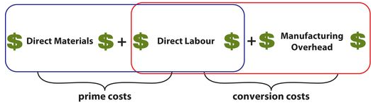

Product versus Period Costs

Each of the manufacturing cost components (Direct Materials, Direct Labor, and Manufacturing Overhead) are product costs. As the term suggests, product costs are costs that are a necessary and integral part of producing the finished product. Companies record product costs, when incurred, as inventory. Under the matching principle, these costs do not become expenses until the company sells the finished goods inventory. At that point, the company records the expense as a cost of goods sold.
[Alternative Terminology: Product costs are also called Inventoriable Costs]

Period Costs are costs that are matched with the revenue of a specific time period rather than included as part of the cost of a saleable product. These are non-manufacturing costs. Period costs include selling and administrative expenses. They are deducted from revenues in the period in which they are incurred, in order to determine net income. The illustration below shows the difference between product costs and period costs.
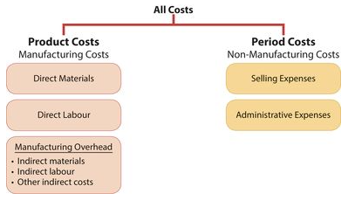
[NOTE] An unethical manger may choose to inflate the company’s earnings by improperly including period costs (such as selling and administrative expenses not related to production) in the ending inventory balances.
Product Costing for Manufacturing Companies
You will learn a number of cost concepts in this chapter. Because many of these concepts are new, we provide here an extended example for review. Suppose you started your own snowboard factory, Terrain Park Boards. Think that’s impossible? Burton Snowboards was started by Jake Burton Carpenter when he was only 23 years old. Jake intiailly experimented with 100 different protoype designs before settling on a final design. Then Jake, along with two relatives and a friend, started making 50 boards per day. Unfortunately, while they made a lot of boards in their first year, they were oly able to sell 300 of them. To get by during those early years, Jake taught tennis and bartended to pay the bills.
Here are some of the costs that your snowboard factory would incur:
- The materials cost of each snowboard (wood cores, fiberglass, resins, metal screw holes, metal edges, and ink) is $30.
- The labor costs (for example, to trim and shape each board using jigsaws and band saws) are $40.
- Depreciation on the factory building and equipment (for example, presses, grinding machines, and lacquer machines) used to make the snowboards is $25,000 per year.
- Property taxes on the factory building (where the snowboards are made) are $6,000 per year.
- Advertising costs (mostly online and catalogue) are $30,000 per year.
- Sales commission related to snowboard sales are $20 per snowboard.
- Salaries for maintenance employees are $45,000 per year.
- The plant manger’s salary is $70,000
- The cost of shipping is $8 per snowboard.
[Refer to the table below on how Terrain Park Boards would assign these manufacturing and costs]
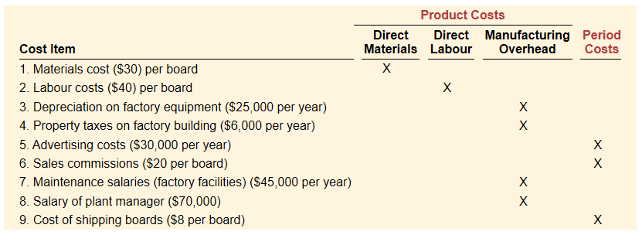
Total Manufacturing costs are the sum of the product costs—Direct materials, direct labor, and manufacturing overhead. If Terrain Park Boards produces 10,000 snowboards the first year, the total manufacturing costs would be $846,000, as shown below.
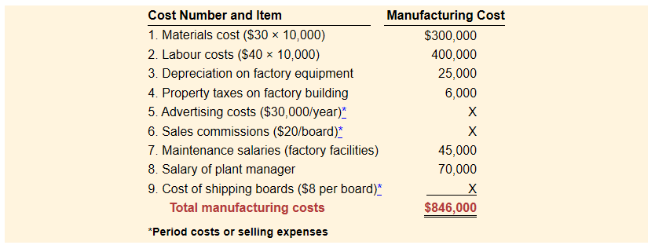
Calculation of total manufacturing costs:
Knowing the total manufacturing costs, Terrain Park Boards can calculate the manufacturing cost per unit. Assuming 10,000 unites, the cost to produce one snowboard is $84.60 ($840,000/10,000 units).
Product costing for service industries:
Chapter 2 focuses on product costs for manufacturers. But as stated in Chapter 1 the Canadian and U.S. economies, in general, have shifted towards an emphasis on providing services, rather than on producing goods. Today more than 50% of North American workers are employed by service companies. Airlines, marketing agencies, cable television companies, and restaurants are just a few examples of service companies. How do service companies differ from manufacturing companies when it comes to product costing? One good way to differentiate these two types of companies is by how quickly the product is used or consumed by the customer. Services are consumed immediately. For example, when a restaurant produces a meal, that meal is not put in inventory, but is instead consumed immediately. An airline uses special equipment to provide its product, but again, the output of that equipment is consumed immediately by the customer in the form of a flight. And a marketing agency performs services for its clients that are immediately consumed by the customer in the form of a marketing plan. For a manufacturing company, such as Bombardier, there is often a long lead time before its product (such as an airplane) is used or consumed by the customer.
In presenting our initial examples, we used manufacturing companies because accounting for the manufacturing environment requires the use of the broad range of accounts. That is, the accounts used by service companies represent a subset of those used by manufactures because service companies are not producing inventory. The restaurant, the airline and the marketing agency discussed above do not produce inventoriable products. However, just like a manufacturer, each needs to keep track of the costs of its services in order to know whether it is generating a profit. A successful restaurateur needs to know the cost of each offering on the menu, an airline needs to know the cost of flight service to each destination, and a marketing agency needs to know the cost to develop a marketing plan. Thus, the techniques shown in this chapter to accumulate manufacturing costs to determine manufacturing inventory are equally useful for determine the costs of providing services.

