Lesson 2
HR management: manage employees by motivating and doing a bunch of shit. They plan the training so the employees have the knowledge necessary to work and they decide who is necessary to keep
Performance management: manage the employees work and expectations. They design interventions n shit when they don’t meet expectations
Training: acquisition of knowledge and skills for individuals
Development: acquiring knowledge to perform jobs in the future. The knowledge is necessary for future jobs.
Training is not education because training focuses on specific skills required for a job, while education grows your intellect.

Performance management process:
- Manager sets goals for the employees
- Employee receives feedback based on the goals set
- Performance evaluation is the next step
- employee development: long term plan used to make employees improve based off their evaluation and goals. This is a design/program

Training is beneficial for Organization
- Strategy: it’s important for employees to have the abilities required to meet the organizations performance expectations
- Effectiveness: with training less errors are made, less supervision is required and a bunch of other reasons which all lead to higher productivity, better revenues which is better for the company
- It also attracts employees
Training is beneficial for employees
- Intrinsic benefits: they get smarter and increase self- efficacy
- Extrinsic benefits:higher earning due to higher knowledge
Training is beneficial for society
- More educated society
- Better economy and higher standard of living

Demographics in Canada
- Canada is an under investor in terms of training
- Baby boomers leaving work force creates a void
- This is because Canadian organizations view training as a cost rather than an investment. During difficult times they minimize training costs.
- conclusion: Canada is not investing enough in training
1% law in Quebec: you have to spend 1% of your profits on training if you make over 1M a year.
- This obvs increased training
- Quebec is now the province with the most training

Context of training
- Training bond: a contract that states that the organization will pay for the employee’s training if he stays with them for a certain amount of time
- This is done because often employers lack confidence of training because they think they’re going to leave and go offer services elsewhere
EOHT OR THOE upside down
High performance work system: environment effects the organization which effect HR and affects training and development.
This means a change in environment causes a change in organization, which causes a change in HR management which causes a change in training design and development
For example if there is higher technology that allows for better production the environment changed. This causes the goals of the organization to change and Human Resources has to change the training and development. Therefore this must be active and ready for change.

Strategic human resource management: alignment of HR strategy and business strategy.
Strategic training and development: alignment of HR training needs and programs of the organizations strategy and objectives. Basically HR bases there training based off the organizations objectives.

Strategic model of training
Business strategy: plan for achieving missions
SHRM: strategic human resource management
Learning and training strategy
Training and development programs
Basically the reaction goes like this
BHLT (cest usain bolt avec un h au lieu du o)
- The business has a strategy and since HRM strategy is aligned with business strategy this causes HRM strategy to change. If HRM strategy changes then learning and training strategy will change since HRM strategy must allign with training strategy. Obviously training strategy has a major impact on the training and development programs.

structure refers to a change in the tasks an employee has due to structural changes within the organization.
Organizational Culture: shared beliefs and values of the organization

ADDIE process= ISD model which is spoken about later: Analyze situation, Design instructions, Develop learning material, Implement training, Evaluate outcomes.
This is basically the ISD model
The A refers to needs analysis
D refers to making objectives
The second D refers to content
The I refers to methods
The E refers to evaluation
Lesson 3
Organizational learning: process of creating and sharing knowledge.
- Focuses on the systems used to distribute learning Continuous learning

Learning organization: an organization that creates and shares knowledge, and uses new info to modify behaviour and improve effectiveness.
To become a learning organization you need PBMTS.
Personal mastery: people have to be open to learning from other as well as be open to teach others
Building a shared vision: an agreed upon future vision for an organization
Mental Models: images people have about the world
Team Learning: people need to be able to learn together
Systems thinking: viewing organization as a whole
PBMTS
Accept that you have to teach others and be open to others, build a shared vision for the organization, have similar mental models, use team learning, systems thinking, think as the organization.
Principles of a learning organization
- Everybody is a learner
- People learn from each other
- Learning leads to change
- Continuous and informal learning
- Learning is an investment
- Experimentation is valued and important
- Failure is tolerated if it leads to improvement

Four pillars of learning
- Vision: clear vision of the organization’s goals
- Culture: a learning organization has a supportive culture with risk taking and shit
- Learning dynamic and systems: seek solution to problem through systemic view
- Knowledge management: systems and processes to support capture of knowledge.
Knowledge: Sum of what is known
Explicit knowledge: things you can buy or trade that are of intellectual property
Tacit knowledge: known only by the individual, and not necessarily the organization. Its mostly defined as things you just know how to do and can’t explain to others

Intellectual capital: Organization’s knowledge, experience relationships e.t.c. it is the organization’s most valued asset
4 type of intellectual capital HRSR. Human=brain renewal= patent Strucutre=communication relationship= relationship with suppliers
Human capital: skills of employees
Renewal capital: intellectual property (patents)
Structural capital: systems that allow employees to communicate
Relationship capital: organization’s relationship with suppliers.

Knowledge management: sharing knowledge of how to do things to avoid solving the same problem and wasting time.

Remember : AIDUER, process of knowledge
Acquire knowledge—> interpret knowledge—> spread/disseminate knowledge—>use knowledge—> evaluate—> retain knowledge
- Knowledge acquisition: environment scanning, formal learning or informal learning.
- Formal learning = training and development
- Highly structure and controlled by organization
- Informal learning : learning when your not in an environment that’s goal is learning, therefore is uncontrolled and dependent on the learner
- knowledge interpretation depends on mental models, which impact how we understand the world
- Knowledge dissemination: use knowledge sharing which is defined as helping other to solve problems and develop ideas.
- Use of knowledge: how, where and who should be using the knowledge
- Evaluation: value of the knowledge
- Knowledge retention: the way in which knowledge is stored so it can easily be retrieved.
- It uses knowledge repositories which allows to retrieve knowledge and is encouraged to be used
organizational learning and training
Training is an important element of learning
Learning organizations train the most
Lesson 4
Learning: process of acquiring knowledge and causes a change in behaviour
Learning outcomes have 5 general categories VICMA
- Verbal Information: facts, principles
- Intellectual skills: procedures (procedural learning)
- Cognitive strategies: application of information
- Motor skills: coordination and execution of movement
- Attitudes: preferences

To learn a skill
- Declarative knowledge: learn the knowledge/ facts. This is verbal info
- Knowledge compilation: integrate task into sequences
- Procedural knowledge: learner has mastered the task
Example: to read
- Learn the alphabet
- Recognizing words become automatic
- Comprehension increases and you’re know a master reader

Learning styles: how an individual learns and process information
you can learn information through
- concrete experience
- Abstract conceptualization
- Reflective observation
- Active experimentation

Converging learning style= thinking and doing
Diverging= feeling and watching
Assimilating= thinking and watch
accomodating= feeling and doing

Learning theories
- Conditioning theory: learning occurs through reinforcement. Stimulus occurs, behaviour is enforced and strengthens the likelihood it happens again
- shaping: reinforcement of each step till process is mastered
- chaining: reinforcement of entire task
- Generalization: conditioned task is applied in different environments then which it was learnt
social cognitive theory: OSS (observe, self efficacy, self management)
a. Observation: learning by watching others
B. Self efficacy: people thoughts on what they are able to do
c. Self management: managing own behaviour through a series of internal processes, and setting performance goals
Adult learning theory:
Andragogy: adult oriented approach that takes into account the differences between teaching adult and kids. Takes into account learning experiences
Pedagogy: teaching the way we teach kids
Teaching adults is different because they are more independent and understand the intrinsic value of learning and also have previous experiences which make it easier.

Motivation: degree of persistence effort one directs toward a goal
Extrinsic motivation: motivation comes from the outside, external environment
Intrinsic motivation: motivation comes from inside, to better yourself, stems between a worker and a task
Theories of motivation:
- Need theories
- Needs are physiological and psychological desires
- Needs are motivational since people are motivated to do things that satisfy there desires.
- Maslow hierarchy of needs
- ERG theory: motivation defence on the existence (safety) needs, relatedness (belonging) and growth (self actualization) needs.
- Difference between the two is that you don’t need to do the higher level in order to achieve motivation, basically ERG theory said you do any of these and you increase motivation, while Maslow was like you have to do it in order.
- Process theories:
- Expectancy theory: motivation comes from expectancy, instrumentality and valence.
- Goal setting theory: goals are motivational and lead to strategies to develop your goal. This theory says it requires commitment and specific goals’
- Goal orientation includes. Master goals: process oriented focus on learning. Performance goals: focus on achievement and performance

Training motivation= motivation to learn: learning directed behaviour
Locus of control: people’s belief if there behaviour is controlled internally or externally
Achievement motivation: desire to perform challenging task
Consciousness: the degree of responsibleness someone is.
All the things learnt and discuss above affect learning and retention
Job attitudes, cognitive ability, self efficacy, training motivation, personality characteristics and training affect learning and retention.

Chapter 5
Transfer of training: Generalization + Maintenance.
Generalization: application of learned material (during training) on the job
Maintenance: application over a period of time (the same thing as generalization but repeated)
Transfer of training has 3 levels
- Positive: trainess effectively apply learnt material
- Zero: trainees do not apply the material they learnt
- Negative: they perform worse after training

There are 4 different types of transfer training
- Near: applying new learning to situations very similar to those in training
- Far: applying new learning which are very different to the material learnt during training
- Horizontal: transfer across different setting at the same level
- Vertical: transfer from trainee level to organizational level (same material but on harder level)

MODEL (training inputstraining outputs (learning and retention) conditions of training (generalization and maintenance )
This model basically shows that the training inputs are what the outputs depend on which impacts the generalization and maintenance at the end
There are 3 factors for the training inputs
- Trainee characteristics: cognitive ability, self-efficacy, personality (relating to the self)
- Training design: active practice and conditions of learning (ill explain it better next chapter)
- Work environment : having good environment pre and post training (pre: signals regarding important of training, post: support provided to trainees)
Transfer of training activities before training
- Management: decide who should attend, do trainability tests, increase motivation to learn (blablabla)
- Trainer: APPLY ISD, make sure supervisors, and trainees know objectives and benefits, and learn there expectations
- Trainees: find out about objectives before going, prep for program.
Transfer of training activities during
- Management: speak about importance of the program and participate
- Trainer: explain principles well and provide examples, and tips on how to have a good transfer of training.
- Trainee: enter program with positive attitude and participate in training program.
Transfer of training activities after training
- Management: ensure trainees are doing okay, reinforce them
- Trainer: conduct field visits where you observe the training, and offer booster sessions
- Trainees: use new knowledge, meet with supervisor to discuss transfer
Relapse prevention: develop coping skills in case of relapse
Self management: perform steps to manage transfer behaviour, and performance maintenance
Goal setting: set specific goals
Goal setting intervention: teach trainees about the goal setting process
Booster sessions: review of material
Model extended: the training and transfer of training affects learning and retention. This affects individual performance, which impacts organizational effectiveness.
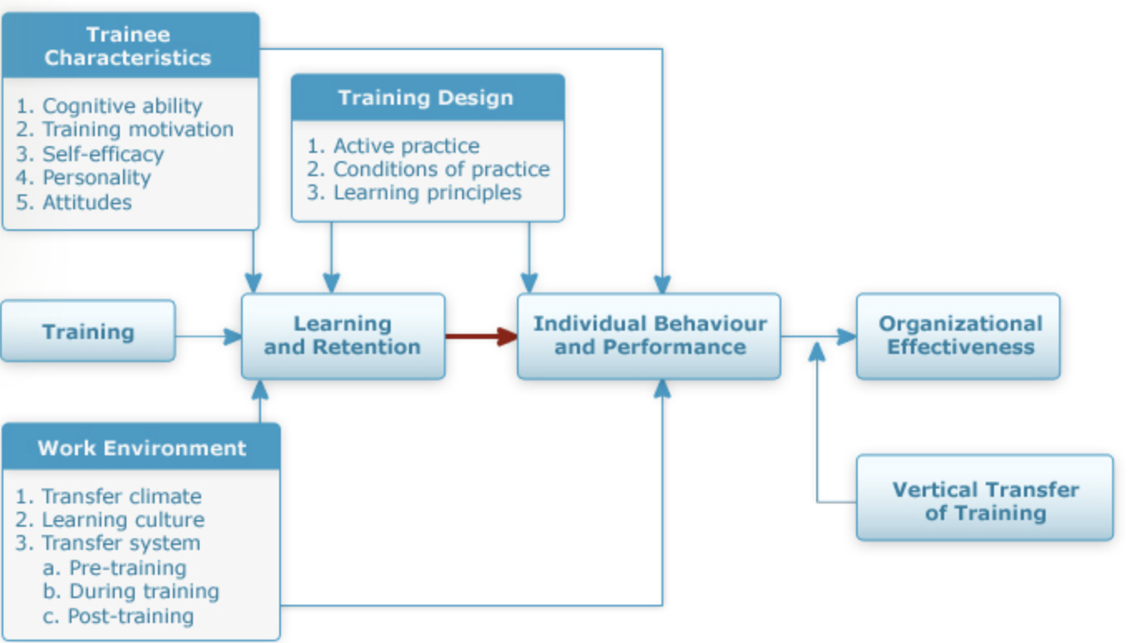

Conclusion:
Transfer of training is a serious problem because it is difficult to measure how effective the transfer is, and there are lots of potential barriers.
- Trainig inputs all impact the transfer of training
Transfer can be effected by the 3 stakeholders (management, trainer and trainees) before, during and after training
Transfer system combines: human and organizational factors to model the effectiveness of training.
( The Learning System Transfer Inventory (LTSI) can be used to assess this system)

Chapter 6
Needs analysis/ needs assessment : serves to identify the gaps in what results are desired and which are obtained
Steps, remember CISD
- Concerns: an issue that captured your attention
- importance is it central to the effectiveness of the organization
- consult stakeholders: involve stakeholders about the issue
- data collection: collect info from the 3 levels (organizaiton, task, employee)

Needs analysis outcome: gives you information about performance gaps and helps you make a plan to adjust

Organizational analysis: study of entire organization in terms of SERO
- Strategy: organisation’s missions, goals and objectives. Strategic training: aligning the goals of the organization to the training needs
- Environment: new technologies, competitors and a bunch of other environmental shits can affect the need and content of a training program
- Resource analysis: identifying which resources are abailable in an organization (money, time, expertise)
- Organizational context climate: collective attituded of employees towards the work. Training transfer climate: charcarcteristics which can improve of worsen the job transfer. Learning culture: culture where members of organization believe learning is a part of work.

Task analysis : process of obtaining information about a job by determining the tasks and knowledge required for the tasks.
Task is considered the smallest unit of a job you can study
6 steps IDRSAP (I love DR smith after porn)
- Identify target job= which job causes the problem
- Description of the job= learn about each task that is included in the job
- Develop rating scales about each tasks frequency
- Survey a sample= give ppl the rating scales and see what they say
- Analyze the information= analyze your survey
- Provide feedback on results

Cognitive task analysis : procedure which focuses on understanding the mental processes to perform a task.
It’s different from task analysis since in describes mental and cognitive activities
Team task analysis: analysis of the task+ analysis of team based competencies (knowledge, skills, attitudes) associated with the tasks
Differs from task analysis since it studies knowledge and skills from a group perspective.
Person analysis: studying employee behavior to see whether performance meets standards
3 steps
DGS
- Define desired performance
- Determine gap between desired and actual
- Identify obstacle and how to surpass them
Basically you want to determine desired performance, the find the gaps and see how to surpass them.
4 different types of barriers to effective performance
- Human: example:lack of knowledge/ skills
- Technical: example: lack of tool, bad job design
- Information: example: lack of performance measurments, ill defined goals
- Structural: overlapping roles, lack of control
There are 9 methods for needs analysis methods
- Observation
- Questionares
- Key consultation
- Print media
- Interviews
- Group discussion
- Tests
- Records and reports
- Work samples

Sources for needs analysis MCCE
You can get your info from these 4 mothafuckas
- Managers and employees
- Customers
- Computer based analysis
- Experts in the field

Problems with needs analysis: time consuming , expensive, lack of importance from managers perspective, inability to conduct a needs analysis

Conclusion
- Needs analysis is required to have a good design and development of training
- Has the 4 main steps CISD
- The outcome/results may tell you the solution is non-intructional
- If the solution is instructional, you can learn how to fix the training design
- A poorly done needs analysis impedes training program
- Use organization, task and person analysis for optimal results (I think, but im chucking tbh)
- The more variety in the sources the better it will be

Chapter 7 Design
Design is defined as: the purpose of creating some new thing of practical utility, involves, exploring an ill defined situation and solving a problem.
Depending on the situation it could be defined as: inventing, systematic planning, devise a plan, to create, to have as a goal

Basic beliefs of design
- Design is a problem solving discipline
- No two problems are the same
- One of the main reasons to define a problem is to identify the constraints associated, which helps find a solution
- There is no perfect solution

Instructional design (ISD) is a system of procedures which uses research and allows you to have educational training programs which are consistent and reliable. It is active ( constantly monitored), iterative (repeated and refined), creative (allows for many sollutions)

The system consists of elements which are
- Interdependent: we can’t separate the elements
- Synergistic: sum of the parts is bigger then the contribution of a single element
- Dynamic: system is constantly monitoring the environment, and flexible to change in different conditions
- Cybernetic: individual elements must be able to communicate with one another

ISD model is composed of three main phases
- Needs analysis: used to analyze if the training is a viable solution to the problem
- Training design and delivery: to develop and deliver training to trainees
- Training evaluation: assess results of the training and adjustments required

The training design include 4 components OCMP
- Training objectives/ learning of performance objectives: statement of what trainees are expected to be able to do after the training program.
- Objectives are specific and they dictate the design of training. They are also used to evaluate the training later on.
- They are important for the 3 stakeholders (trainers, trainees, managers)
- Training objectives include 5 key elements
- Who performs the behaviour
- What is the actual behaviour
- Where is the behaviour demonstrated
- What is the behaviour demonstrated
- What standard will it be judged by
- Follow SMART design (specific, measurable, attainable, relevant, time- framed)
- Performance: specific words about what they should do and the tasks required
- Conditions: where they should do it and with what tools n shit
- Criterion: acceptable level of performance

- Training content: training can either be internal (the company makes it’s own training) or external (uses a company that is already experts in training to do so).
- training objectives determine the content of training
- content should identify performance gaps (like in needs analysis)
- new legislation should be reflected in the new content learnt ( dumb)
- consult with subject matter expert to make proper content (dumb)

Advantages of packaged programs (external): high quality, immediate delivery, less expensive
Industry specific programs: option to customize, non generic content meaning very industry specific.
Factors to consider which training you should get
- cost
- human resources
- time
- who needs the training and what is the benefit
Request for proposal / RFP : document that outlines potential vednors/ companies to an organization needs (basically il cherche un offer/ deal)
- Training methods (off the job, on the job and blended training)
- Off the job= classroom
- On the job= coaching
- Blended: combination of both approaches
- Learning principles: what the designer uses to bring the training obejctives, content and methods together.
- Uses learning theories, and design techniques to do so

Active practice
Practice: rehearsal of a task/ knowledge in order to become better at a task.
Active practice: providing trainees with opportunities to practice a task
- Therefore active practice is integrated in a course design
Prepractice strategies, before training program AMAGPP
- Attention advice: information about the task process that can helpe them perform a task
- Metacognitive strategies: thinking out loud, asking question, guide own learning performance
- Advance organizers: activities that help training intergrate the info they learnt during training
- Goal orientation: refer to the type of goal set during the training
- Preparatory info: providing trainees information on how to prep
- Pre-practice briefs: sessions where roles are established prior to a team practice
Conditions of Practice strategies during training
- Massed versus distributed practice: is training spread out or a one time fish
- Whole versus part learning: training materials are all presented at once or a part at a time
- Overlearning: repeated behavior till it becomes reflexive/ automatic
- Task sequencing: training material is divided and organized
- Feedback of results: providing trainees with feedback about there performance

Routine expertise: training people by making training them in similar situations, however this is not always sufficient for complex jobs
Adaptive expertise: ability to use knowledge skills across a range of tasks
Active learning: the trainees are active participants of their own learning experience

Intergrating errors into learning and training
Error training: training that explicitly allows trainees to make errors while performing a task
Error avoidant training: explicitly avoids errors while learning to perform a task
Error management instructions: statements that emphasize the positive function of errors

Error training is advantageous since it develops thoughtful strategies for trainees, greater practice and exploration.

The lesson plan: blueprint that outlines the training program as a sequence of activities.
They are important because: ensure training is directed toward solving real problems, enhance credibility of training, smoother operation during training
Lesson plan cover pages should include: training objectives, time allocation and location, training materials.
Gagne’s nine events are elements that should be contained in every program to ensure its effective
- Gain attention (interest the trainees)
- Describe the objectives
- Stimulate recall of prior knowledge
- Present material to be learned
- Provide guidance for learning
- Elicit performance practice
- Provide informative feedback
- Assess performance
- Enhance retention and transfer

This is probably useless but
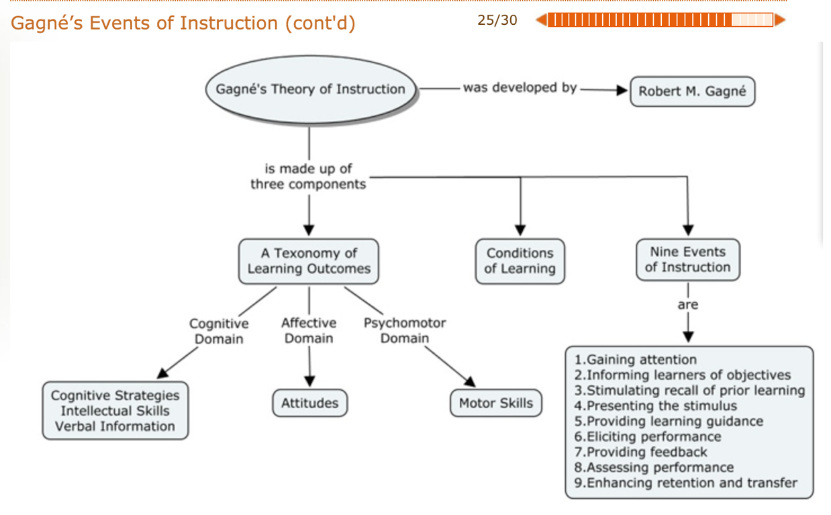
Universal design: involves the design of products which can be used by anyone and does not required adaptation or specialized design.
- This is good for accessibility, flexibility , clear instructions
- Equitable use (useful for diverse abilities): provide the same guidelines to everyone, provide privacy and security for all
- Flexibility in use ( accommodates a wide range of preferences): provide choice in which methods to use allowing for better accommodation based of what one is trying to do
- Simple and intuitive use( easy to understand): eliminate unnecessary complexity and accommodate a wide range of people due to how easy it is
- Perceptible information (design communicates information that is necessary regardless of the abilities of the user): provide essential info basically.
- Tolerance for error: minimizes error and negative consequences
- Low physical effort: can be used efficiently with minimum fatigue
- Size and space for approach and use: provides appropriate size space…

Conclusion
- Training objectives guide the design of instruction (from the needs analysis)
- Training objectives should address performance, condition and criterion
- Training can be a internal or external and both have advantages and disadvantages
- Request for proposal systems is important to find training and development services
- Active practice is a method to use what is learned to the context instantly after learning / during training
- Certain conditions can improve learning and retention such as advance organizers, metacognitive strategies of attention advice
- There are a bunch of practice conditions that can improve learning and retention such as massed versus distributed learning, task sequencing, overlearning whole vs partial learning
- Error training offers an environment where trainees can make mistakes with low actual consequences
- Employing principles of UD has benefits to all participants

Chapter 8 off the job training
Off the job training: instructional methods that are used off the job
Instructional methods: techniques used to stimulate learning
- Lecture method: trainer organizes content and presents it orally
- Adv: lots of info in a short time, and everyone gets the same message
- Dis: not effective to develop skills, forced passive learning, does not adjust per trainee
- Audio-visual: lectures can be supplemented with audio-visual methods (PP, videos,)
- Adv: illustrates behavior and highlights key points
- Dis: tendency to emphasize style over substance+ cost increases with use
- Discussion: leader facilitates analysis of a problem
- Discussions serve to helps members recognize what they don’t know but should, opportunity for members to get answers to there questions, good advice, sharing ideas, learning about the other
- Case study: analyze and solve problems based on real situation
- Objective: introduce realism, teach how to make decision and creativity, deal with a variety of problems
- Requirement: must be able to analyze the material and need time to do so
- Styles: cases can be presented in a variety of ways including single problem vs multiple situations.
- Case incident: studies a part of an organization’s problem for analysis
- Adv: short and concentrates on 1 topic
- Dis: lack of background info about the organization, can be problematic for people with limited work experience
- Behaviour modeling: trainees observe and attempt to replicate behaviour.
- Based off : Observing, rehearsal, reinforcement , tranfer
- This method is good for learning skills and behaviours but you don’t actually learn info
- Role play (like josh and talia do and then talia pulls out the tutsi)
- Includes: Development enactement debriefing
- Development= preparing the role
- Games: activities with structured competition where the trainees learn specific skills
- Focus on problem solving and make learning interesting
- However, weak relation to training objectives, not sure what they were suppose to learn
- Stimulations: operating models designed to represent reality
- Simplifies situations and is often use if real life training can be dangerous
- Allows for good feedback and is realistic but its also expensive
- Fidelity: the similarity to the real life situations.
- physical fidelity is how similar are the physical aspect of the stimulation to the actual job.
- psychological fidelity refers to the similarity of psychological conditions
- Action learning: completes an activity and analyzes their own action to improve performance. Typically obtains feedback from a small set of individuals
- Tests theories in the real world and identifies real problems while finding solutions to them which may be easier to find while completing the action.

To analyze which method is best:
- The more involved the trainee the more hell remember for the transfer
- Does it achieve training objectives
- Blended learning is the most effective (mixing methods together)
- When picking which method you should consider (training objectives, cost, on job application, trainer skills)

Chapter 9 on the job training (OJT)
- Trainees receiver instruction and training in there work environment
- Most common in trade industry
- Useful for small buisnesses and is the most common however needs to be well planned

- Job instruction training: systematic approach to OJT
- 4 steps PIPF
- Preparation: develop a strategy that fits the trainee and determine what he already knows
- Instruction: explaining the tasks, and showing trainee how to perform the task.
- Performance: trainess performs the task under guidance who provides feedback and reinforcment
- Follow up: trainer monitors performance and provides feedback, and slowly tappers off instruction to allows employee to gain confidence and skill
- For a successful job instruction training it should be intergrated with another training and should be managed similarly to other types.
- Trainers must be carefully chosen
- Performance aids: devices that help an employee perform his job.
- Signs, prompts, flash cards
- Proper training design identifies key information that must be retained vs useless info you use once a year
- Job rotation: trainees are exposed to multiple jobs within an organization
- Serves to learn a variety of skills required for current and future jobs
- Benefits: improved knowledge, higher job satisfaction and salary
- However this technique should only be one component of training, should be supplemented with other forms of off the job training
- Apprenticeship programs: training for skilled trades that combine OJT and class
- On the job component teaches requisite= hand on skills
- Classroom teaches theory and design
- Regulated through government and labour industry
- Government and industry make provide ways to achieve this (paying for class, getting payed for on job training)
- Coaching: seasoned ( with a lot of experience) employee works close with another employee to build skills and develop insight.
- Good to train social skills (interpersonal, communication, leadership)
- There needs to be a set of objectives before the training begins, and the work environment is training laboratory (IDK wtf this means but ye)
- You begin with setting goals at the beginning. Then once you have your goals you make a long term plan. Then the employee performs the tasks and follows the plan and reports back to the coach.
- Techniques include: job rotation, special project assignment, schedule of reprensentation
- Issues include: coach must be selected based on motivation and ability, performance of the coach should be integrated into performance management
- Mentoring: senior member of an organization takes personal interest in junior member
- Mentor: experience individual who provides coaching to junior
- Offers career support and psychological support
- Passes on wisdom from older people
- Structure mentoring relationship and offer benefits to mentors

Comparison between on and off the job
Advantage Off the job: large number of trainess can be trained at once, and a variety of methods are available
Disadvantage off the job training: expensive, differes from the workplace so challenges with transfer
Advantage On the job: low cost, good application on the job
Disadvantage on the job: potential for damage to actual work equipment, slowdown of production since workers are busy training, potential danger.

Conclusion: know the 4 steps for on the job training instruction

Chapter 10
Technology-based training involves the use of technology to develop, deliver and manage courses or learning content.
Examples such as: online classes, Teleconference, Videoconference
4-types of Training Delivery Methods
- Computer-Based Training (CBT)
- e-Learning (Electronic Learning)
- Electronic Performance Support System (EPSS): A computer-based system that provides information, advice, and learning experience on the job to improve performance.
- Videoconferencing
The past decade has seen a significant growth in e-Learning in Canadian because: Evolution of digital technologies, Globalization and the knowledge-based economy/society, Increased accessibility and affordability of high-speed networks and Increased availability and more tech savvy consumers.
Modes of e-learning:
- Instructor led learning (synchronous) (sage on the stage)
- Self-directed learning (asynchronous taining) (guide on the side)
There are many myths of e-learning such as it takes more time than traditional methods, don’t need to be scheduled in advance, all learners are motivated, but we know this is not always true.
Advantages for trainees:
Can learn outside workplace, work at own pace, built in guidance system, provides privacy, opportunity for review.
Advantages for organisations:
All trainees receive the same training, can work with large numbers, track performance, increased efficiency and strategic.
Disadvantages for trainees:
Less intrapersonal connections (isolation), online degrees not always seen as equal, immediate feedback is removed.
Disadvantages for organizations:
resistance to this training, cost to develop, lack of control of context, ineffective for certain types of learning, loss of non verbal cues.
Effectiveness: majority conclude that e-learning is not more affective than regular learning. For less complex material it is found to be better. Drop out rates although have been higher in online courses.
Strategies for make e-learning affective:
Develop job-focused curriculum, Support learners, make learning interactive, Monitor and report results, Offer support material, Evaluate, Prepare learners, Enhance the course, Prepare managers, Identify future training needs.
For information to be retained must have active practice, conditions of practice, experiential and interactive
And might want to include games, role plays and simulations.

Chapter 11: training evaluation
What is training evaluation? The process of assessing worthiness and effectiveness of training programs, staff.
Involves the analysis of data collected, Objective and subjective information is collected.
Why Conduct Training Evaluations? Identify what should be trained, Determine the cost, Diagnose the strengths and weaknesses.
Barriers to Training Evaluation
Barriers fall into two categories:
Pragmatic: Requires time (loss of production) to organize the collection of the data and specialized knowledge to properly analyze and interpret it.
Political: Pressure from administration to justify the costs, potential to reveal ineffectiveness of training, conflict of interest (may require added resources to get external audit).
Evaluations may be distinguished from each other in 2 ways:
- The date gathered and analyzed: trainee perceptions, info about work environment, assessing forces that operate during training
- The purpose of Evaluation refers to the types of training evaluations
- Formative evaluations: provides date about the aspects of training
- Summative evaluations: provides date about effectiveness
- Descriptive evaluations: provides info that describes trainee after training
- Casual evaluations: describes if training caused one’s post training behaviour
Training models:
4 levels of training evaluation: (Kirkpatrick) (most use level 1)
Level 1 reactions: trainee’s perceptions of the training, method: smiley sheets
Level 2 learning: trainees’ acquisition of the program, method: before and after assessments
Level 3 behaviours: extent that skills are applied in job, method: observation and interviews over time
Level 4 results: the affect on the business, method: expenses, revenues, sales…
COMA model (Improves on Kirkpatrick’s model): Cognitive, Organizational environment, Motivation, Attitudes.
Decision-Based Evaluation Model:
Model that specifies the target, focus, and methods
Identifying the target of the evaluation General to any evaluation goals Flexibility: guided by target of evaluation
The Learning Transfer System Inventory (LTSI) (Holtens)
This inventory contains all the variables from COMA, plus additional ones such as: learner readiness, resistance/openness to change, and opportunity to use learning.
Training evaluation variables:
Reactions: affective reactions: trainees likes and dislikes, Utility reactions: measures usefulness of training
Learning: Declarative learning: acquisition of facts, procedural learning: organization of facts
Behaviours: measured by Self-reports, Observations, Production indicators.
Motivations: Motivation to learn, Motivation to apply the skill on the job
Self-efficacy: beliefs trainees have about being able to perform what they learnt
Perceived/anticipated support: perceived report: degree of help they received, anticipated report: expected support
Organizational perceptions: There are 2 scales to measure perceptions: Transfer climate: set of 8 cues in questionnaire. Continuous learning culture: assessed with questionnaire of 10 cues.
Cues include: Goal cues: Social cues, Task and structural cues, Positive feedback, Negative feedback, Punishment, No feedback, Self-control
Organizational results: Hard data: measured. Soft Data: perception of judgment. Return on expectations: Measurement The manner in which the data collection is organized and how the data will be analyzed.
All data collection designs compare the trained person to something.
-Non-experimental designs: Comparison is made to a standard and not to another group of (untrained) people.
-Experimental designs: Trained group is compared to another group that does not receive the training and when the assignment of people to the training group and the non-training group is random.
-Quasi-experimental designs: Trained group is compared to another group that does not receive the training, but of a training program’s ability to meet managerial expectations.

Chapter 12:
There are 5 categories of cost for training programs:
- Direct cost: directly linked costs; trainer, equipment rental, rent of space.
- Indirect costs: costs that helped support the training; preparation, marketing.
- Development costs: Costs that are related to the design of a training program; development of materials, evaluations.
- Overhead costs: Costs incurred by the training department not associated with a program; heating, lighting, maintenance
- Trainee compensation: cost to pay trainee’s who are being trained by the company.

Cost Analysis Worksheets (Costing Sheets) help identify the cost and allow you to compare to other training programs, and helps identify cheapest options.
Calculating the cost benefit of training:
Cost-effectiveness evaluation: Comparing the costs ($) to the benefits ($)
Cost-benefit evaluation: comparing the costs ($) to the benefits in non monetary terms.
Net benefit: The estimated value of resources over the costs.
Benefit-cost ratio (BCR): The benefits divided by the costs.
Return on Investment (ROI): A comparison of costs and benefits
More on the ROI:
The 2 factors needed for calculation: 1) The full cost of training program ($) 2) the benefits of program ($)
There are 5 steps in order to convert the measures into monetary value:
Step 1: focus on 1 single unit, ex: employee behaviour
Step 2: determine a value, ex: units sold
Step 3: calculate change in performance
Step 4: obtain an annual amount
Step 5: determine annual value.
Break-even analysis: Finding the value at which benefits equal costs and utility is equal to zero
Increasing ones credibility of their estimates:
- Take a conservative approach 2) use credible and reliable sources 3) Explain approaches and assumptions 4) Results must appear realistic 5) Use hard data.

Chapter 13: list of different types of training
- Orientation training: introduce new employees to organization, usually done internally by HR
- Essential skill training: trainees are taught essential skills to work. many essential skills are literacy skills= ability to understand information.
- technical skills training: teach specific job skills that all employees need to do their job.
- Information technology training: training programs that focus on using computers, or computer systems
- Computer software training: teach you how to use specific software, is an example of information technology training
- Health and safety training: trains employees to work safely and recognize hazards in the work place. They are also taught how to act in case of accidents
- Workplace hazardous materials information systems: legislation to ensure that workers across Canada are aware of hazards and emergency procedures
- total quality management training: programs that involve team training and using tools to solve problem.
- Total quality management: ensures continual improvement in the quality of the products form the organization
- Team training: programs that are designed to improve the functioning and effectiveness of teams through communication. Basically it improves communication between teams
- Sales training: programs designed to improve sales professionals
- Customer service training: provides employees with interpersonal and service skills to improve interaction with customers
- Sexual harassment training: design to educated people about sexual harassment
- Sexual harassment is defined as unwelcome sexual advances, requests for sexual favour or any type of harassment which involves sexual shit.
- Ethics training: teaches programs about organizational values, ethical policies and how to make ethical decisions
- Diversity training: training programs focuses on differences between individuals and there backgrounds
- Cross-cultural training: prepare employees for working and living in different cultures and help them interact with people from different backgrounds

lesson 14
Management: the process of getting things done efficiently
Roles of managers are interpersonal, decisional and informational and they function of control organize and plan and all act as leader
Management development: complex process by which people learn to perform managerial roles.
- Training managers shows to be more costly of other training
Leadership development: having leadership behaviours the shape the organization and encourage people to surpass obstacles
Management development vs employee development
- Managers work through others and therefore work on interpersonal skills
- Different training designs
- Management development is longitudinal and an incompetent manager can severely affect the success of organization.

Managerial roles
Interpersonal: relationships managers develop with others. Therefore the manager is a leader since he helps others overcome their obstacles.
Informational role: managers monitor the environment and informs the unit of any change.
Decisional role: the manager must make decisions and allocates resources based off what is needed.

Managerial functions: COP, controlling organizing and planning. They monitor towards a goal (control). They allocate resources (organize) and they decide what should be done and how (planning)

Skills: actions that are performed that lead to an outcome (managing time, verbal communication, managing. Conflict)
5 sets of skills SMEIS
- Self awareness: understanding oneself
- Self- control: regulate emotion
- Motivation: channeling emotion to pursuit goal
- Empathy: reading other people’s emotions
- Interpersonal skills: ability to interact

Management development programs need to include
- initial Skills assessment: identify where people are
- Skill acquisition/learning: learning the basic principle with the specific skill of interest
- Skill practice: develop procedural learning
- Skill application on the job: applying learned principle in job situations

Management skills fall under 3 categories
- Conceptual skills: problem solving
- Technical skills: using excel
- Interpersonal skills: communication

Methods of management development
- Experiential learning: learning experiences where the trainee actually has to do the job sketch. Like stimulations, role play
- Management education: acquisition of managerial knowledge
- Management training: program designed to make managerial skills
- On the job management development: programs designed to provide individuals with managerial practice but on the job

Coaching: we spoke about this before, but its good to have goals for coaching. coaches are best when they get the manager to develop motivation, capabilities, insight.

