Chapter 1: Markets and Prices Cost of Production
  - The Themes of Microeconomics
- Microeconomics Branch of economics that deals with the behavior of individual economic units—consumers, firms, workers, and investors—as well as the markets that these units comprise.
  - The purpose is to explain how consumers can best allocate their limited incomes to the various goods and services
- Macroeconomics Branch of economics that deals with aggregate economic variables, such as the level and growth rate of national output, interest rates, unemployment, and inflation.

Trade-offs
- Consumers
  - Trade-offs in the purchase of more of some goods for less of others
  - Trade-off between current consumption and future consumption
    - Income split between diff products, savings, investment, e.t.c
- Workers
  - Trade-offs in their choice of employment
  - Trade-off between labor and leisure
- Firms
  - Trade-offs in what to produce
  - Trade-offs in the resources to use in production

Prices and Markets
- Trade-offs are based on the prices faced by consumers, workers, or firms.
  - Also, based on the preferences (utility) of consumers, workers or firms
  - If my utility is not high enough, we will switch our consumption. This happens when products are substitutes
  - Prices and preferences will affect how you allocate your limited resources
- In a centrally planned economy, prices are set by the government.
- In a market economy, prices are determined by the interactions of consumers, workers, and firms in markets—collections of buyers and sellers that together determine the price of a good.

Theories and Models
- Like any science, economics is concerned with the explanations of observed phenomena and predictions based on theories developed from a set of assumptions.
- A model is a mathematical representation, based on economic theory, of a firm, a market, or some other entity.
- Statistics and econometrics let us measure the accuracy of our predictions.
- When evaluating a theory, it is important to keep in mind that it is invariably imperfect and has limited success in making predictions.

Positive versus Normative Analysis
- Positive questions deal with explanation and prediction, normative questions with what ought to be.
- positive analysis Analysis describing relationships of cause and effect.
  - Positive analysis is central to microeconomics.
- normative analysis Analysis examining questions of what ought to be.
  - Normative analysis is often supplemented by value judgments. When value judgments are involved, microeconomics cannot tell us what the best policy is. However, it can clarify the trade-offs and thereby help to illuminate the issues and sharpen the debate.

  - What is a market?
- Market: Collection of buyers and sellers that, through their actual or potential interactions, determines the price of a product or set of products.
  - Where buyers and sellers reach an agreement on Market Clearing Price aka Market equilibrium; Qs = Qd, If Qs > Qd – surplus of inventory, producers wanna get rid of extra units and will reduce the price of product; If Qd > Qs – shortage of inventory, vice versa.
- Market definition: Determination of the buyers, sellers, and range of products that should be included in a particular market.
- Arbitrage: Practice of buying at a low price at one location and selling at a higher price in another.

Competitive versus Noncompetitive Markets
- Perfectly competitive market: Market with many buyers and sellers, so that no single buyer or seller has a significant impact on price.
  - not several buyers and sellers. It’s MANY.
- Many other markets are competitive enough to be treated as if they were perfectly competitive.
- Other markets containing a small number of producers may still be treated as competitive for purposes of analysis.
- Some markets contain many producers but are noncompetitive; that is, individual firms can jointly affect the price.

Market Price
- market price Price prevailing in a competitive market.
- In markets that are not perfectly competitive, different firms might charge different prices for the same product.
- The market prices of most goods will fluctuate over time, and for many goods the fluctuations can be rapid. This is particularly true for goods sold in competitive markets.

Market Definition – The Extent of a Market
- Extent of a market Boundaries of a market, both geographical and in terms of range of products produced and sold within it.
- For some goods, it makes sense to talk about a market only in terms of very restrictive geographic boundaries.
- We must also think carefully about the range of products to include in a market.
- Market definition is important for two reasons:
  - A company must understand who its actual and potential competitors are for the various products that it sells or might sell in the future.
  - Market definition can be important for public policy decisions.
Example 1.2
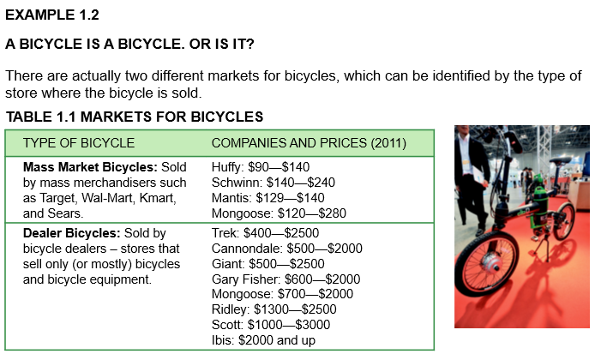

  - Real vs Nominal Prices
- Nominal price: Absolute price of a good, unadjusted for inflation.
  - Also called absolute price/current dollar price
- Real price: Price of a good relative to an aggregate measure of prices; price adjusted for inflation.
  - Also called constant dollar price
  - Prices that take into consideration increasing rate of inflation
  - We are interested in this
- Consumer Price Index Measure of the aggregate price level.
  - Nominal prices of a basket of goods
- Producer Price Index Measure of the aggregate price level for intermediate products and wholesale goods.

Example 1.3
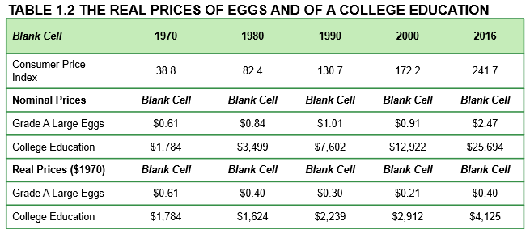
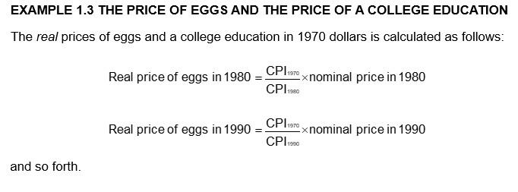
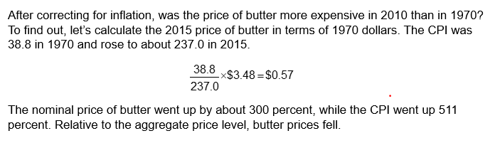
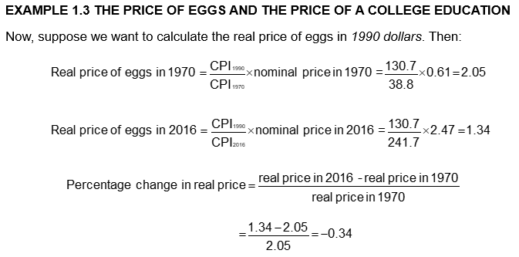

Example 1.4
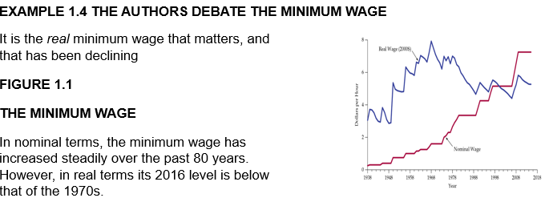

Example 1.5


