Psy3101
Lecture 1
Why should we study death?

Death is no enemy of life; it restores our sense of the value of living. Illness restores the sense of proportion that is lost when we take life for granted. To learn about value and proportion we need to honor illness, and ultimately to honor death.

Definitions of Death

- Early Standards
- Typically through heart or lung functioning
- i.e., Feel for pulse, listen for breathing, & mirror test for condensation
- Initially death was the lost of function to breath and function

- Was good until technology developed
- Cannot check for pulse if doing a heart transplant
- Cannot test for breathing if doing lung transplant
- Or if using a respirator to continue life support

- 1960s the push towards a more definitive definition for legal and medical concerns

- ‘Total Brain’ Standard
- Death of the entire brain of a person (incorporate the new advances of technology)
- Irreversible cessation of circulatory and respiratory functions (without any help you still wont breathe), or
- Irreversible cessation of all functions of the entire brain, including the brain stem, is dead
- Adopted by the American Bar Association and American Medical Association (AMA) (what we consider death now)

- ‘Higher Brain’ Standards
- “Death is the irreversible loss of what is essentially significant to the nature of man”
- -Robert Veatch
- Death to certain parts of the brain ” (what makes us human and what makes us different than a plant: consciousness, personality
- Key functions originate in the cerebral hemispheres, therefore when this part of the brain dies that counts as death of the person
- Relates to the application of theory of mind – “each of us is essentially a mind”
- Ex: people with alzheimers are dead based on “higher brain’ standards

- Social death: behaving as if the person is physically dead when the body has not died (social death because they are being excluded (socially isolated) by their closed one… could be purposeful or they could just have no one in their lives)
- Often refers to socially marginalized older person (ex: very old, frail isolated senior (in care), racial minority, the poor,)

- Physical death can proceed social death (or vice versa)
- In some cultures they have elaborate funerals and may not have the funeral for up to a year later and therefore death is not considered until the funeral has happened

- We also often keep the dead alive in our minds, memories, or rituals
- Imagine them as living
- Could have conversations with them in our minds (or even talk to them out-loud)
- Engage in rituals to bring the dead and the living together

Changes in Death

- Mainly deaths were found in infancy and early childhood (Since the 1950’s we can see many changes in: )
- Vaccinations
- Chemotherapy
- Antibiotics
- Child care
- Education (many more have high school education)

- Now death is in old age from chronic disease (rather than from measles, and young diseases)

- Better Health, Science, & higher GDP (longer life span and longer life expectancy
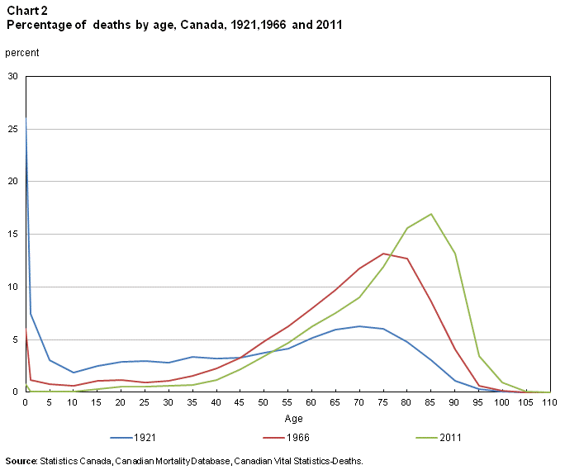 How we die and when we die is changing.
Life Expectancy & Average Age

- Average Life Expectancy: an estimate of the average number of years members of a group of people are projected to live
- e.g., Canada is 80 yrs of age for male and 84 for female (lower for men than women)

- Death Rates: numbers of deaths among members of a given population group divided by the total number of those in the group
- e.g., In 2016 death rate in Canada was 7.5 per 1000

Median age has gone up and so has our Life expectancy

Canadian Death Stats

- 1950
- Men: 1831 deaths per 100,000
- Women: 1475.6 per 100,000 (women are dying less)
- Life expectancy ~ 68

- Leading causes of death…
- Heart disease
- Stroke

- 2012/2015
- Men: 843.4 deaths per 100,000
- Women: 580.3 per 100,000
- Life expectancy ~ 82
- Men: 79.7; Women 83.9

- Leading causes of death…
- Cancer
- Heart Disease
- Sex differences
- Men: Accidents (leading cause of death in men)
- Women : Stroke

Men vs. Women (World Stats)

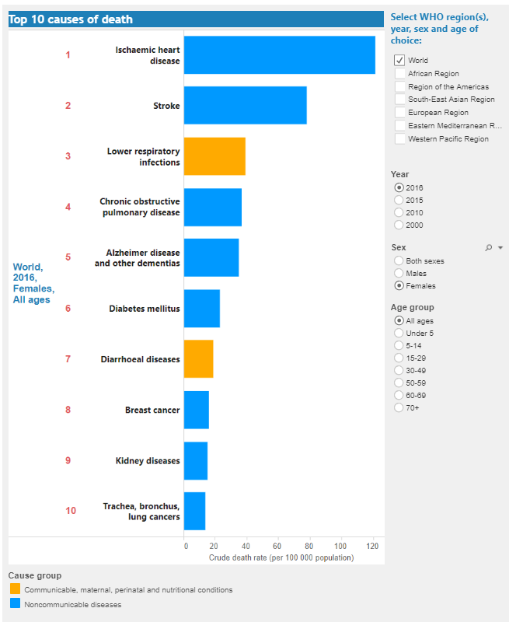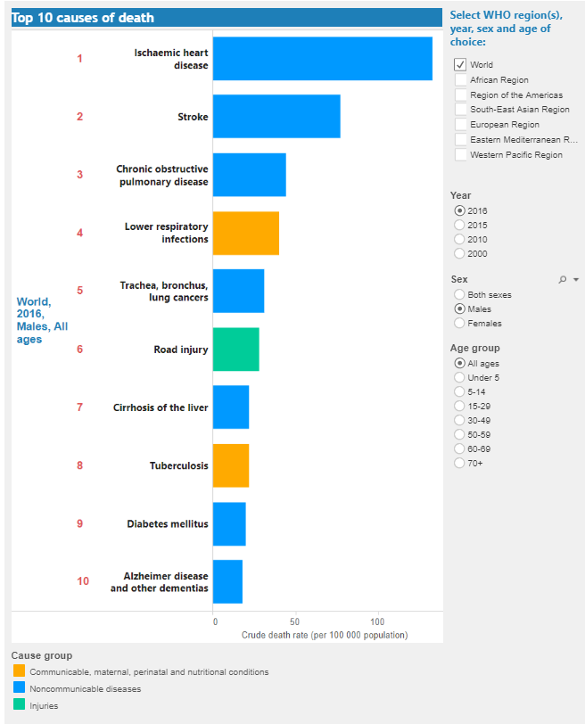

- Death due to dementia has doubled between 2000 and 2016.

Death Rates

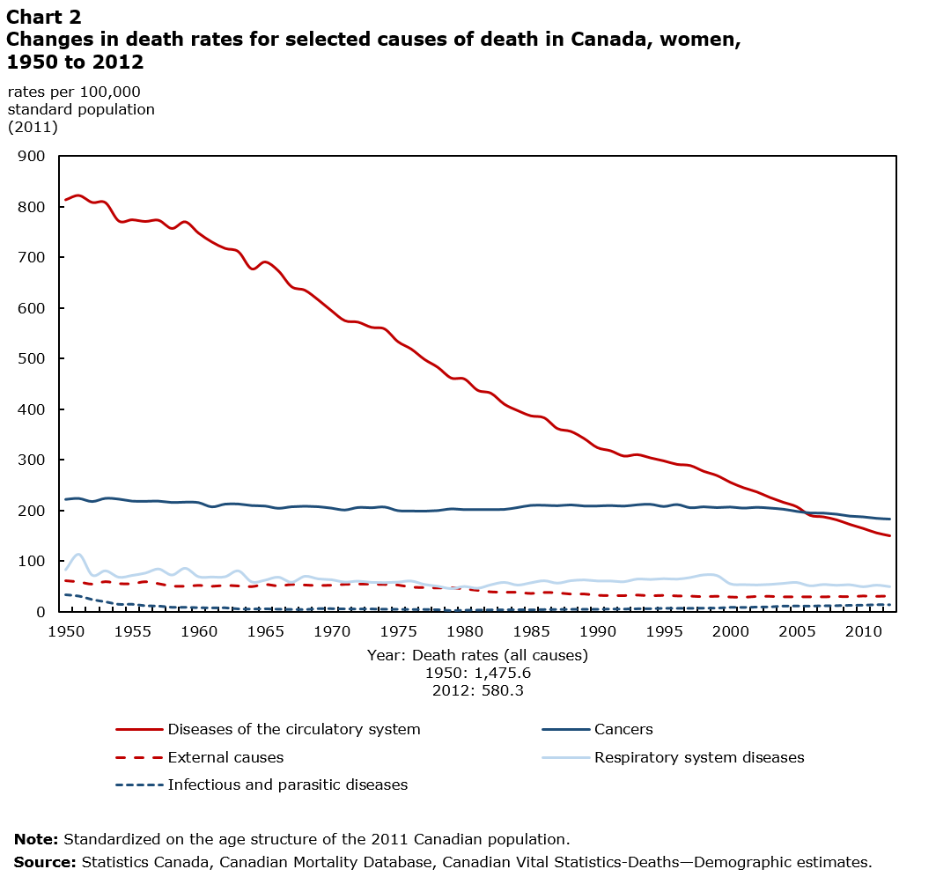

How is death viewed?

- Death is a part of life – but is viewed as taboo B/C its inconceivable for us to imagine an actual ending of our own life
- Death has always been viewed as bad, and is a universal fear
- Ancient Hebrews (considered the body of a dead person as unclean)
- Early Americans (shooting arrows into the air to clear the evil spirits)
- Current military funerals (shoot bullets into the air to clear the evil spirits)

- Death Anxiety: concerns or worries related to death in some way

Fearing Death

- To try to overcome fear of death some people:
- Turn to religion (usually older individuals, those in long term care or on their death bed)
- Purpose to suffering (they will be able to be reborn or go to heaven)
- Offers peace and acceptance
- Believing in an afterlife helps relive pain in those suffering

- Try to postpone it as much as possible
- To ACTUALLY overcome it need to contemplate the possibility (and reality) of our own inevitable death (through the use of machine, life support, computers, being frozen)

Dying Trajectories

- Sudden death: only happens in 10% of cases. It’s an accident. Ex: car accident, work injury.
- Terminal illness: cancer, less and less in older age. (Usually occurs in those under 18 years of age.
- Organ failure: predictable time of death due to decline of health. Ex: kidney failure.
- Frailty: Slow ambiguous decline of health, no predictable time of death, progressive often in older individuals. (Most common ways to die)

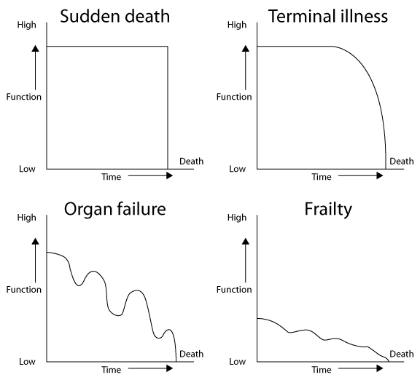
Studying Death

- No matter of race, religion, or area of living death is something that effects everyone

- There have been many different views explaining the nature of death
- From nothing after death (being buried or cremated), to being in Heaven or purgatory, or even reincarnation

- Despite death being something we all experience it is different for everyone

So why talk about it

- It affects us all
- Finding out what we think comes after death (helps lessen stress and anxiety about period of death and what comes after)
- What we would want done for us
- Practical Reasons
- Preparation of funerals, wills, etc..
- Knowing what our loved ones want
- Learning what grief is and how to cope with death (when a father dies: women tend to drink more while men recollect on the good times/memories)

- Death challenges our moral and ethical codes:
- Legal system is grappling with the issue of medical assistance in dying
- Health care system is dealing with the issue of long-term care (many long term care facilities are full so many are sent to a hospital)
- Families have to cope with hospitals, long-term care facilities

- Death confronts us with our own choices:
- Do we want to die at home or in an institution
- To continue or to end treatment
- To get medical assistance in dying or to continue with illness
- To get burial, cremation, or freezing

Goals of Education on Death, Dying and Bereavement

- Enrich Personal Lives
- Inform and guide individuals in their personal transactions with society (makes us aware of services and options we have)
- Help prepare individuals for their public roles as citizens
- Help prepare and support individuals in their professional and vocational roles
- Enhance the ability of individuals to communicate effectively about death-related topics

Definitions

- Early Death Standards: Typically through heart or lung functioning
- i.e., Feel for pulse, listen for breathing, & mirror test for condensation

- Total Brain Death: Irreversible cessation of circulatory and respiratory functions, or irreversible cessation of all functions of the entire brain, including the brain stem

- Higher Brain Death: Death to certain parts of the brain; key functions originate in the cerebral hemispheres, therefore when this part of the brain dies that counts as death of the person (ex: Alzheimer's)

- Death Rates: numbers of deaths among members of a given population group divided by the total number of those in the group

- Death Anxiety: concerns or worries related to death in some way

- Average Life Expectancy: an estimate of the average number of years members of a group of people are projected to live

- Social death: the perception or behaviour of others that indicates that they perceive or treat a person as if physically dead when the physical body has not yet died.

- Trajectory of dying: the pattern or cause of dying over time. For example, a sudden death or a slow decline, terminal illness, organ failure and frailty

