CALCULUS 1001A ASSIGNMENT #1

Table of Contents
Page 57 – Section 1.5 3
Page 71 – section 1.6 3
Page A32 – Appendix D 5
Enlarged $tanx=1$ graph with intervals $[0, 2π]$ 7

Page 57 – Section 1.5
$$22. Find the exponential function f\left(x\right)=Ca^{x} whose graph is given.$$
Since the point $\left(1,\frac{4}{3}\right)$ and $(-1, 3)$ lie on the graph,
$$f\left(x\right)=Ca^{x}$$
$\frac{4}{3}=Ca^{1}$
$\frac{4}{3}=Ca$
$and,$
$$f\left(x\right)=Ca^{x}$$
$3=Ca^{-1}$
$3=\frac{C}{a}$
$then,$
$\left(\frac{C}{a}\right)\left(Ca\right)=C^{2}$
$C=\sqrt{\left(\frac{4}{3}\right)\left(3\right)}$
$C=\sqrt{4}$
$C=±2$
$$thus,$$
$\left\{\begin{aligned}a=\frac{2}{3} when C=2 \\ a=-\frac{2}{3} when C=-2\end{aligned}\right.$
$$So, the two possible equations are:$$
$\left\{\begin{aligned}f(x)=2 {\left(\frac{2}{3}\right)}^{x} \\ f\left(x\right)=-2 {\left(-\frac{2}{3}\right)}^{x} \end{aligned}\right.$
However, the function needs to decrease neatly from left to right like the one pictured, so
$f\left(x\right)=2 {\left(\frac{2}{3}\right)}^{x}$
$$∴f\left(x\right)=2 {\left(\frac{2}{3}\right)}^{x}$$

Page 71 – section 1.6
$$52. Solve the equations for x.$$
- $\ln\left(x^{2}-1\right)=3$
$ln\left(x^{2}- 1\right)= 3$
$$ln((x-1)(x+1)) = 3$$
$$\ln\left(x-1\right)+\ln\left(x+1\right)= 3$$
$e^{ln\left(x-1\right) + ln\left(x+1\right)} = e^{3}$
$$\left(e^{ln\left(x-1\right)}\right)\left(e^{ln\left(x+1\right)}\right)= e^{3}$$
$$(x-1)(x+1) = e^{3}$$
${ x}^{2}-1 = e^{3}$
$$∴ x=±\sqrt{e^{3}+1}$$

$$x=±\sqrt{e^{3}+1}$$

- $e^{2x}- 3e^{x} + 2= 0$

$${ e}^{2x}- 3e^{x} + 2= 0$$
$\frac{3±\sqrt{9 -(4)(1)(2)}}{2}=e^{x}$
$e^{x}=\frac{3±1}{2}$
$$so,$$
$\ln\left(e^{x}\right)=x$ $or$ $\ln\left(e^{x}\right)=x$
$x=ln\left(\frac{3+1}{2}\right)$ $x=\ln\left(\frac{3-1}{2}\right)$
$$x=\ln\left(2\right) x=0$$
$thus,$
$$\left\{\begin{aligned} x=\ln\left(2\right)when e^{x}=\frac{3+1}{2} \\ x=0 when e^{x}=\frac{3-1}{2}\end{aligned}\right.$$

$$68. Find the exact value of each expression.$$
- $tan⁡(\sec^{-1}{4})$
$$n$$
$$y$$
$$1$$
$$4$$
$\cos\left(n\right)=\frac{1}{4}; sec(n) = 4$
$$thus,$$
$\sec^{-1}{(4)}= n$ $Angle=n (radians)$
$$and,$$
$$\tan\left(\sec^{-1}\left(4\right)\right)=\tan\left(n\right)$$
$$=\frac{y}{4}$$

$By the Pythagorean theorem,$
$$∴ tan(\sec^{-1}{(4)}) = \sqrt{15}$$

$$y = \sqrt{4^{2} - 1^{2}}$$
$$= \sqrt{15}$$
$$so,$$
$$tan(\sec^{-1}{(4)}) = \sqrt{15}$$

- $\sin\left(2\sin^{-1}\left(\frac{3}{5}\right)\right)$
$Let the angle x be equal to 2\sin^{-1}\left(\frac{3}{5}\right)$
$$x$$
$$3$$
$$4$$
$$5$$
$so that$,
$\sin\left(x\right) =\frac{3}{5};$ $\sin^{-1}\left(\frac{3}{5}\right)= x$
$\sin\left(2\sin^{-1}\left(\frac{3}{5}\right)\right)=\sin\left(2x\right)$
$=2\sin\left(x\right)\cos\left(x\right)$
$= 2\left(\frac{3}{5}\right)\left(\frac{4}{5}\right)$
$=\frac{24}{25}$
$∴\sin\left(2\sin^{-1}\left(\frac{3}{5}\right)\right)=\frac{24}{25}$

$72. Simplify the expression→ cos(2\tan^{-1}{(x)})$.

$\cos\left(2\tan^{-1}\left(x\right)\right) = 2cos^{2} \left(\tan^{-1}\left(x\right)\right)-1$
$In a right triangle with angle n$
$n = \tan^{-1}\left(x\right)$
$$opp = x and adj = 1$$
$\cos\left(n\right)=\frac{1}{\sqrt{x^{2}+1}}$
$$∴ \cos\left(2\tan^{-1}\left(x\right)\right)=\left(1-x^{2}\right)\left(1+x^{2}\right)$$

$\cos\left(2\tan^{-1}\left(x\right)\right)= 2{\left(\frac{1}{\sqrt{x^{2}+1}}\right)}^{2} – 1$
$$= \left(1-x^{2}\right)\left(1+x^{2}\right)$$

Page A32 – Appendix D
$32. Find the remaining trigonometric ratios for\cos{(x)}=-\frac{1}{3}$
$$-1$$
$$3$$
$$θ$$
$$-2\sqrt{2}$$
$→ Let x be equal to angle θ$
$$θ$$
$$2\sqrt{2}$$
$$-1$$
$$3$$
$$On the unit circle, cos\left(θ\right)=\frac{x}{r}$$
$$so,$$
$\frac{x}{r} = -\frac{1}{3}$
$$Since r must be positive,$$
$x = -1$
$$and$$
$r = 3$
$$Then,$$
$y= -2\sqrt{2}$
$$so,$$
$\sin{x}=\frac{y}{r}$
$=-\frac{2\sqrt{2}}{3}$

$\cos{x=}\frac{x}{r}$
$=-\frac{1}{3}$

$\cos{x=}\frac{x}{r}$
$=-\frac{1}{3}$
$\tan{θ=}\frac{y}{x}$
$$=2\sqrt{2}$$

$\tan{θ=}\frac{y}{x}$
$$=2\sqrt{2}$$
$\sec{x=\frac{r}{x}}$
$=-3$
$\csc{x=\frac{y}{r}}$
$=-\frac{3}{2\sqrt{2}}$

$\csc{x=\frac{y}{r}}$
$=\frac{1}{2\sqrt{2}}$

$$68.find all values of x in the intervals \left[0, 2π\right] that satisfy the equation |tan(x)|= 1$$
$\left|\tan\left(x\right)\right| = 1$
$\left|\frac{sin\left(x\right)}{cos\left(x\right)}\right| = 1$
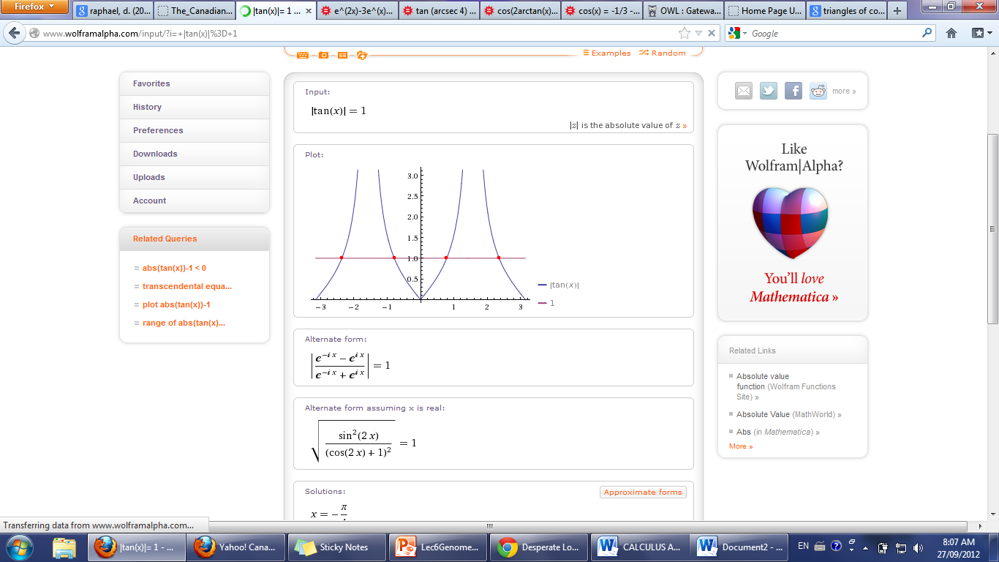
$\sin{(x)} = ±\cos{(x)}$

Graph 1: $\left|tan\left(x\right)\right|= 1$ with intervals $\left[-π, π\right]$

$$So, |tan(x)|=1 with intervals [0, 2π] should look like:$$
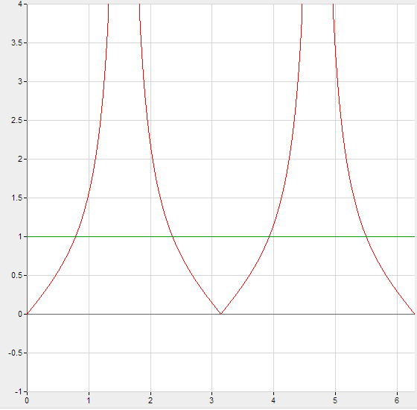
Graph 2: $\left|tan\left(x\right)\right|=1$ with intervals $\left[0, 2π\right]$

$Thus, it can be noted that,$
$\frac{y}{r} = -\frac{x}{r}$
$$then,$$
$y=-r$
$$so,$$
$x=\frac{π}{4},\frac{3π}{4}$, $\frac{5π}{4},\frac{7π}{4}$

$\frac{y}{r}=±\frac{x}{r}$
$$or if,$$

$If$,
$\frac{y}{r} =\frac{x}{r}$
$$Then,$$
$$y = x$$

$∴x=\frac{π}{4},\frac{3π}{4}$, $\frac{5π}{4},\frac{7π}{4}$

Enlarged $\left|tan\left(x\right)\right|=1$ graph with intervals $\left[0, 2π\right]$

GRAPH 2: $\left|tan\left(x\right)\right|=1$ with intervals $\left[0, 2π\right]$

