AHSC 260
Program Mission > Organizational Needs > Community Needs > Individual needs
SAMPLE NEEDS ASSESSMENT QUESTIONS:

Program Mission: Do courses and educational programs for parenting skills meet our mission statement criteria?
Organizational Needs: What qualifications do our staff have/need to provide a parenting skills course?
Community needs: Are your children in the community in danger?
Individual needs: Would you be willing to participate in a course about best parenting practices?
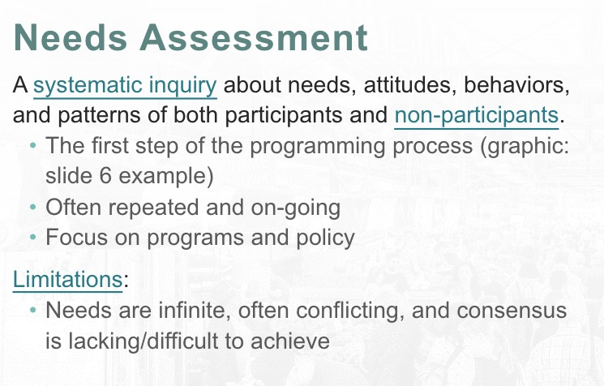
Systematic Inquiry: When conducting a systematic inq, the difference between attitudes and behaviours has implications we should understand.
- Attitude: A belief that manifests itself
- behaviours: the actions people take
Why Non-Participants?
Why bother with non-participants?
- We need to understand people who should participate in our program but do not.
- Altering barriers makes it more accessible to those who are unable to participate in the program.
Limitations
Example: If we are running a community center with limited budget and space, but we have clients with all types of needs, those clients are competing for our resources.
Identify Limitations.
Program Director at community centre, faces many people with needs but has a limited budget, how do you approach?

Need: Things that we cannot live without, such as food, shelter, love & affection.
Want: Culturally learned, influenced by trends
Intention: Commitment to engage in specific actions
Concept of Need: Determining needs is difficult
Needs assessment helps reduce bias and I.D diff types of needs
ONGOING because people’s needs change. Social conditions change, and communities change.

Four Need Types
Normative Needs: Focus on established guide lines that should be maintained. I.e Family falling below the poverty line, we use systems like food stamps, rent control, tuition assistance.
Comparative Needs: Compare and Contrast services and facilities between two similar things.
I.e One town offers an art class, the neighboring town wants a similar art class
Perceived Needs: “thinking” I have a need, but don’t do anything about it.
I.e person with eating disorder thinks they need to be on a diet and lose more weight
Expressed Needs: Said or done something to express needs. Asking for help.

Ponsioen’s Theory of Needs: Society (Community/Organization/program) is responsible to meet the basic survival needs of its members.
- Required to identify a threshold, below which no one should fall
- Needs exist when people fall below the established threshold

Maslow: Lower levels must be achieved before going to the next level
Levels are: Phys/Safety/Love/Esteem/Self-Act
Why are we doing a Needs assessment?
Solve a Problem, better understand complaints, Make sure we’re providing programs people need

What information do we want? Demographic info, Opinions
How do we collect information? Interview group or solo? Surveys?
Where is this data coming from? Identify areas with the most relevant users and non-users
When to gather the data? Identify times when relevant users are active, and identify different times.
Who will collect the data? Identify from users and non users for accurate info.
Who will use the data? Identify who will use the data to better curate questions and data gathering tools.

THREE REASONS FOR NEEDS ASSESSMENT
**Each needs assessment should be focused and should only include relevant questions that are in line with the answers you are seeking. Even within these topical areas you might have very focused questions. **
Program Management, Service Orientation and Desire for Quality
Program Management: Manage Duplication: Is the prog unique or is there competition?
Address safety: Are we managing our programs at a good level of care?
Prioritize: Have we allocated the proper resources, scheduling?
Dev & Meet the individual goals: Why are people in our programs?
Service Orientation: Constituent Input: ask participants about the service, and ideas for improvement.
Solicit New Ideas from current, past participants or external conduct an external needs assessment and proxy programs similar to your program and “pinch” their good ideas.
Inclusion: Include a variety of people who have competing needs.
Meet the real needs of people: cant ignore the data, responding to it means meeting their needs.
Desire for Quality: Professional commitment? Is the organization promoting professionalism? Are they accredited? The staff, are they professional, and have been accredited?
Resource allocation: Staff, money, space
Increase Profits: Not to increase costs but to use profits efficiently NON-FOR-PROFIT Can make a profit. The money goes back into the company to better themselves.
Accountability: Trained staff, appropriate allocated resources, good budgeting, we are accountable.
Constituent Data of Users and non-users: Demographic, Involvement, Needs/Skills, Attitude beliefs values, preferences/opinions/intentions.
Quantitative Question example: “What is your age? How old are you?”
Data Gathering (external inventory):

Operationalize:
3 types of data: Constituent data: Demographic data
QUANTITATIVE QUESTIONS FOR CONSTITUENT DATA: Martial status? How old?
External Inventory Data (collecting data from other inventories)
Internal Inventory data collecting data from/for/about your program
Two Sources of Data
People (primary source)
Advantage: Building relationships, able to follow up, getting relevant info.
Disadvantage: people have conflicting needs, time consuming, expensive, bias for the needs assessment.
Records (secondary)
Advantage: Less time consuming, expensive, chance for bias
Disadvantage: Data may not be current, data may relate to a diff cohort.

People as resources: Comment cards/Surveys are QUANTITATIVE
Observations are QUALITATIVE
Open Meetings (Internal Inventory)
Reliability: The degree of consistency that a needs assessment instrument or procedure demonstrates over time.
Validity: The quality that allows the needs assessment instrument or procedure to discover what it is intended to discover.
ONLY COLLECT DATA YOU NEED AND ARE GOING TO USE

L2
_________________________________________

Evaluation Activities: The first evaluation activity is the Needs Assessment, where we find out if there is a need for a program, identify the needs, and determine if similar programs exist elsewhere or whether there are gaps in services
The second evaluation activity is Assessing Program Theory, or looking at the program’s concept and design (Rossi et al., 2004)
The third evaluation activity is Assessing Program Process, where we look at day-today program delivery and management, measure client satisfaction, develop a client profile, and see if the program has reached the target population (Rossi et al., 2004).
The fourth evaluation activity is Assessing Impact, or seeing if the program is achieving its goals or having an impact with the intended target group.
The fifth evaluation activity in the continuum is the Efficiency Assessment, or the cost of a program. An efficiency assessment can tell us how to allocate valuable resources, what the cost-benefit ratio is, or whether the program is costeffective (i.e. do the costs of the program justify the effects?)

5 components to Program Logic Model (PLM) is a tool often used in program development and program evaluation as a way to assess program theory.

1. Barriers and resources that could limit or enable the delivery of a program. Resources could be staff time, money, equipment and interpersonal networks, while barriers could be policies or laws, attitudes and geography (i.e., not an accessible program).
2. Activities, which could include a product, service or infrastructure.
3. Outputs: the quantification of activities, e.g.: program participation rates or number of products sold.
4. Outcomes: measured in immediate or intermediate time range, such as individual changes in awareness, knowledge, attitudes or behaviour.
5. Impacts, or long-term results from the program. Impacts are often thought of as system, societal or policy level changes.
4 types of evaluation: Program, Staff, Outcome, Goal-Objective

Goals are measurable
Program Evaluation
1) Integral part of programming
2) Part of the planning cycle
3) Considered prior to program implementation
4) Systematic-defined steps/tasks
5) Judges value/worth of the program
6) Determines if mission (goals) are being met
7) Informs decision mak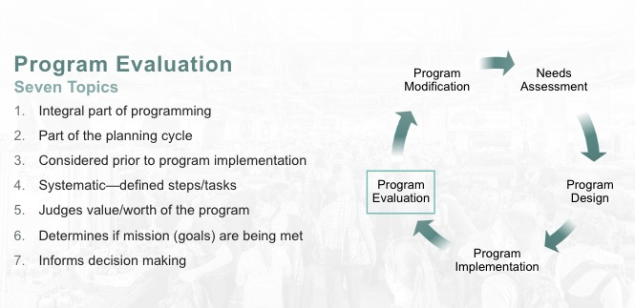
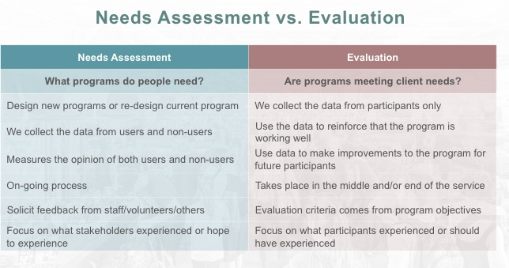
EVALUATION
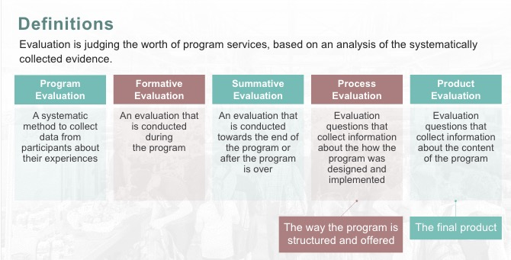
4 Types of Evaluation:
Summative: Formative:
- Conducted at the end of a program - Conducted during a program delivery
- informs future offerings - Continuous/on-going
- Used to adjust program
- Occurs both formally / informally
Process:
- Evaluates “how it was done, how it was going”
- Concerned with Effectiveness & efficiency
- Was the teacher polite?
- Was the atmosphere welcoming?
- Did you feel the instructor explained all the difficult topics?

Product:
- Evaluates “what was offered” (outcomes, or the end product)
- Did the participants get the benefits that the program promised?
Benefits of Evaluation:
Improve Programs: If something should be stopped, changed to improve
Increased participant satisfaction: Evaluation involves participants in decision making by seeking input
Eliminate detrimental elements: I.e; poor staff, poor maintenance, program delivery
Address risk management/safety issues: Constant monitoring of staff performance and equipment supports a risk management plan.
Determine if goals are met: Mission, values, objectives
Improved Decision making, justify expenditure, Explain/Learn from success/failures, comply with standards, maintain professional practice.
Nine steps of Evaluation:
Purpose: Judge the value of a program.
Audience: Variety of people. (Participants, Stakeholders, Supervisors, Attendance Rec, test scores)
Process: What technique will we use to collect data?
A) What part of the program should we evaluate?
B) We need to develop or borrow tools that allow us to collect un-biased data (qualitative/quantitative)
C) We need to recruit people to participate in the evaluation

Issues: Identify what needs to be evaluated.
This is difficult because what we think is important might not be important to the participants.
issues are NOT static.
How well is the program delivering the services?
Evidence: What evidence should be collected?
Many types of evidence can be used to evaluations; Descriptions by personnel on the impact of the program, Cost benefits, program outcomes, program objectives, participant opinions.
Data Gathering: How is the evidence to be collected? Focus groups, questionnaires, interviews, rating scales, observations, analysis of records.
Analysis: Once collected, the data needs to be analyzed to determine what they say about the program.
Resources: What resources do you need to design, conduct, analyze and report the evaluation?
Reporting: Different kind of reports, seasonal, testimonials, statistics
Aspects of Evaluation:
Evaluation is always considered early in the program planning cycle. We measure progress toward a plan and impact against our objectives.
PROGRAM EVALUATION: Provides feedback on progress, success and challenges. The results are used to improve the prog at the start of a new prog cycle.
Formative Evaluation: Middle of the prog. Allows programmer to “fix” what is not working so participants are satisfied. Design the formative evaluation questions and decide when you will give the eval to participants
Summative Evaluation: End of program. Assess effectiveness and impact. This data WILL NOT help participants who take the time to complete the summative eval, because they have completed the program. It helps future participants.
Quantitative Data: Helps us understand large numbers of evaluations easily but the data is often shallow
Qualitative Data: helps us understand in-depth details, but usually it is designed for small numbers of people
Participatory Evaluation: Is an eval that involves all the stakeholders in a project – those directly affected by it or by carrying it out. (Prof feels that participatory evaluation is a needs assessment, not a program eval.)
Which Questions should we ask?
Are we reading those we intended to reach?
Are we reaching them in the way we intended
Is our timetable correct?
Are all of the objectives being accomplished?
Have we reduced bias as much as possible?
Data Collection Methods:
Questionnaires, surveys, checklists
Overall Purpose Advantages Challenges/Disadvantages
Questionnaires, Surveys, Checklists | When needed to quickly/easily get lots of info in a non-threatening way | Can be anonymous/confidential, inexpensive to, administer, lots of data | Wording can be bias, might need more detailed information, ability to perform statistical analysis,
Interviews | We want to fully understand someones impressions or experiences | Get full range and depth of info, develop relationship with client, can be flexible with them | Takes much time, hard to analyze and compare, costly, interviewer can be bias
Documentation review | Impression of how program operates without interrupting program. | Get comprehensive and historical info, doesn’t interrupt program or routine, info exists, few biases | Often takes time, information may be incomplete, need to be quiet clear about what looking for, not flexible means to what already exists
Observation | Gather accurate ino about how a prog operates | View operations of a program as they are occurring, can adapt to events as they occur | Can be difficult to interpret seen behaviours, complete to categorize, influence behaviours
Focus group | Explore topic in depth through discussion, about reactions to an experience or suggestion, understanding | Able to collect in-depth impressions, effeient way to get much range and depth of info. | Hard to analyze responses, need good facilitator for safety and closure, difficult to schedule
Case studies | Fully understand or depict clients experiences in a program | Fully depicts client’s experience in program input, process, results  Powerful means to portray program outsiders | Usually time consuming to collect ,organize and describe  Represents depth of info, rather breadth
Triangulation: using multiple tools, techniques and participants for a strong evaluation
Lesson 3
Two Research Tools
Quantitative tools: Quantitative methods include structured methods to collect data and most often employ statistical manipulation of the data. Some common forms of qualitative research might include questionnaires, face-to-face surveys, online questions. The data collected is manipulated using statistical analysis to learn about the participants, patterns, behaviours and to identify correlations between diff variables.
Qualitative tools: Qualitative methods include unstructured or semi-structured methods to collect data. Some common forms of qualitative research might include: Focus groups, participatory research, interviews and phenomenology. The data collected is often manipulated (categorized) to help identify themes, concepts, issues that the research participants have experienced or identified.
Mixed Methods: Program planner would use the most appropriate research tools and combine the data to get the best possible data to support their needs assessment. First a general questionnaire can be distributed to participants. Based on the results of the questionnaire the program planner can use the data to structure a focus group. Second, the prog planner organizes a focus group to better understand why the participants responded so positively/negatively to the questionnaire. This would provider deeper understanding about
the program of the participants.
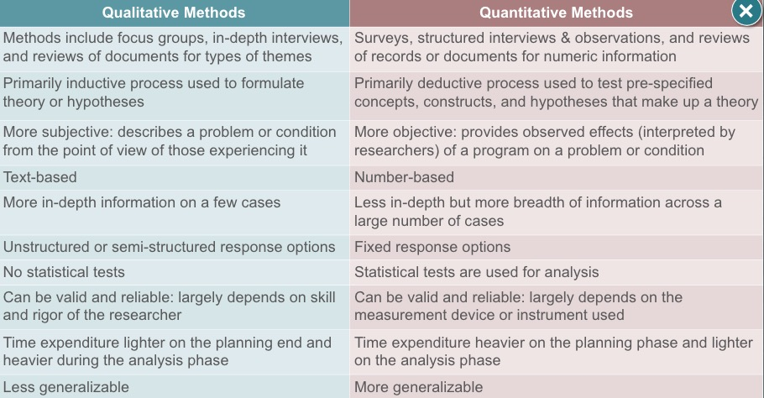
Definitions
Qualitative Research: Primarily exploratory research. It’s used to gain an understanding of underlying reasons, opinions, and motivations. It provides insights into the problem or helps to develop ideas or hypotheses.
Quantitative Data: Measures of values or counts and are expressed as numbers. Quantitative data is data about number values. (how many, how much, how often)
Qualitative Data: Measures of “types” of and may be represented by a name, symbol or number code.
Mixed Methods: is a research methodology for conducting research that involves collecting, analyzing and integrating quantitative (experiments, surveys) and qualitative (focus groups, interviews) research
Bias: Is a prejudice in a favor of or against one thing, person, or group, compared with another usually in a way considered to be unfair.
Human Ethics Considerations
When conducting a needs assessment or program evaluation, we are not doing research in the traditional sense. – We circumvent the need to get approval to conduct research involving human subjects.
Case Study: A comprehensive methods to record diff detailed consideration related to the development of a particular person, group or situation over a period of time.
Ethnographic Study: Methods used to better understand groups or individuals, through observations/interviews
Focus group: In-depth interview or participatory process from a small group of people to gather beliefs or ideas. Often times the members of the group influence the content and direction while the facilitator responds or records the data. NEEDS TO BE STRATIFIED
Sociometry: The study and measurement of relationships within a group of people.
Qualitative Observation: Done by evaluator, goal is to see the program through eyes of participant. Notes behaviours, relationships. >video, notes, audio recording
*Each observation requires analysis to reduce bias and to ensure that the observation is reflective of the reality to the stakeholders.

4 Types of Qualitative Interviews
Informal Interview (conversation): Informal settings can get people to share more information.
Interview Guided approach: Topics to be covered are predetermined, sequence of questions are based on the flow of the interview.
Standardized Open-Ended interview: Each person is asked the same questions with the same wording in the same order. Regardless of the answer, interviewer asks the next question.
reduces bias, helps ensure regardless of relationship between interview and interviewer, all the questions are asked an answered.
Close-ended qualitative interview: An oral survey where the respondents select answers from among predetermined choices. A lot like survey with close-ended questions, difference is this is an interview.
Quantitative Tools
Questionnaire design for quantitative tools: Choose appropriate survey questions
make the questions clear, make it easy for participants to partake, make the answer choices clear and distinct.
I.E Face to face, online, mail, self-guided.

Types of questions
Close-ended questions (forced choice): Ask a specific question and provide all the possible answer choices so participants can select the best answer.
Dichotomous Questions (special forced choice design): Has only 2 possible answer choices “yes” or “no” or True/False.
Likert-type questions: Uses a scale
Open ended questions: Write freely
Double Barreled questions: Avoid asking two questions in the same sentence. CAN CONFUSE THE PARTICIPANT AND MAKE ANSWERING DIFFICULT
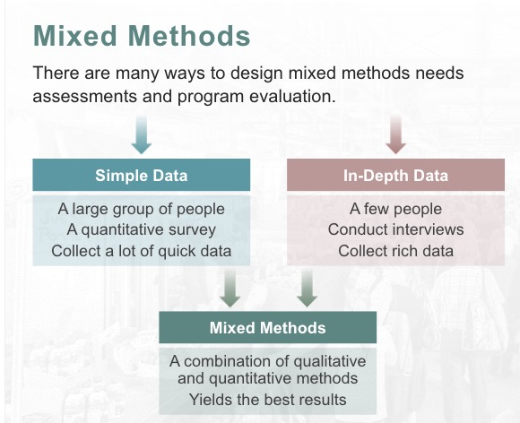

Lesson 4
Logic Model: A logic model presents a picture of how your effort or initiative is supposed to work. It explains why your strategy is a good solution to the problem at hand.
an example a mentoring program in a community where the high-school dropout rate is very high. We'll call this program "On Track."

“All models are wrong”, they are unique to situations under which they were developed. Using one outweighs not using one.

Efficiency & effectiveness
Efficiency: Ratio of outputs to inputs
Effectiveness: The achievement of client outcomes
Program: A prearranged set of activities designed to achieve a stated set of goals

Definitions:
Agency: Plan in advance to establish goals/objectives / provider clear definitions of services and results
Client Requests: Must be categorized, clients are directed into services that offer the best possibility of meeting their needs and resolving their problems

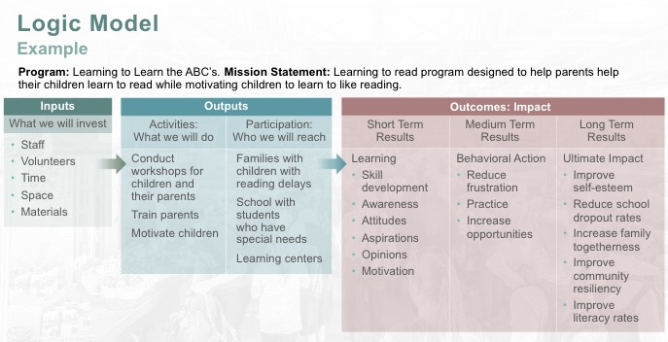
Benefits driven model
Benefits for the individual : Physical, emotional, Cognitive
Benefits for the community: Economic, Environmental, improved quality of life
Why use the benefits driven model?
Easy to adapt for any program, simple terminology, can be explained in writing or graphically, easy to add or remove elements of the program without removing other elements, Ideas can overla having multiple benefits.

Symbolic Interaction Theory: WALKED IN THE FOOTSTEPS OF HER PARTICIPANTS. People attach meanings to their interactions (environment/others)
Programmers must “walk in the footsteps” of the participants for insight. (Perceptions/interpretations) This plays a large role in shaping the nature of an experience**this helps programmers be trusted by participants, since they share similar experiences**
SMART model (useful for health promotion)
Phase 1: Preliminary Planning, I.D a health problem, Develop general goals, outline how you will evaluate the outcome, guess program costs and potential income.
Phase 2: Consumer Analysis, I.D the target population, Explain formative eval tools, define needs/wants/preferences, Dev program ideas
Phase 3: Market Analysis, Establish promotional needs, conduct an environmental scan to I.D competitors and potential collaborators
Phase 4: Channel Analysis Identify how you can communicate your message, how can you set-up your program to maximize outcomes
Phase 5: Develop material and pre-test, Develop the program activities based on earlier phases, pilot the test and refine the program
Phase 6: Implementation communicate with partners and I.D roles, Document the procedures to create a road map or manual to re-use, Evaluate timelines for pre-program tasks and progam activities, Refine the program so that it is efficient and effective
Phase 7: Evaluation, Assess the degree to which the program is impacting the population, evaluate the short, immediate and long-term impacts, Evaluate changes within the population.
THIS LAST CONCEPT IS MORE OF A NEEDS ASSESSMENT THAN PROGRAM EVALUATION

Grassroots Design: Builds community groups from scratch, typically by people who have no program planning credentials, they respond to an identified need.

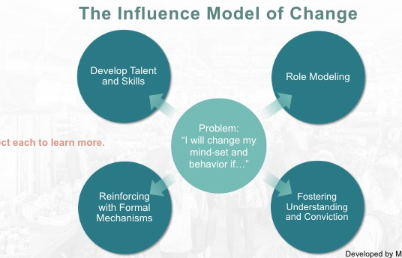
Develop Talent & skills: Our brains remain malleable into adulthood.
Role Modeling: People mimic individual and groups who surround them
Reinforcing w/ formal mechanisms: Associations and consequences shape behaviour
Fostering understanding & conviction: People seek congruence between their beliefs and actions.

Lesson 5
(VMOSA)
Vision, Mission, Objectives, Strategies, and Action Plans
Vision = The Dream. Mission = What/Why. Objectives = How much of what will be accomplished by when. Strategies = The How. Action Plan = What change will happen.

Vision Statement = a dream.
Mission statement = precise goals.
It’s important to make Objectives as they must be Specific, Measurable, Achievable, Relevant, Timed and Challenging.

What is Not-For-Profit Organization?
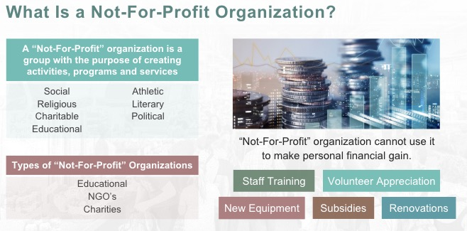
Advantages to incorporating your not-for-profit: Distinct legal entity, Limited Liability, Perceptual Continuation, Governmental Aid
Reflective Programs: A program reflects the community or population being served.
- When designing a program, we need to be cognizant of the social mores*
- *The essential or characterstic customs and conventions of a community. I.e; “an offense against social mores”
- Synonyms: Customs, conventions, ways, way of life, traditions, practice, habits.

Values Theory: Terminal Values: Life without inner & outer conflict. “zen”
Universal Prosocial: Equality, world peace.
Mature accomplishment: a sense of accomplishment, social recognition, self-respect, wisdom
Positive affiliation: True freindship, mature love
Individual self-definition: An exciting life, freedom

Instrumental Values: The preferred methods of behaviour and characteristics valued for their ability to help achieve desired end-states (terminal values)
Self-Direction competence: Broad minded, independent, courageous, imaginative
Restrictive conformity: Police, clean, ambitious, capable
Pro-social concern: forgiving, helpful, responsible, honest
People will have different values in different situations

Articulating the program
Communicate the purpose of your programs once you identify the core values.
Values we identify help shape the mission statement and vision for the program, based on the mission we dev specific goals, objectives help operational the goals by adding a unit of measurement, all of these converge into a program plan.

Program vision and mission
Vision statements should be short and sweet, not long and wordy
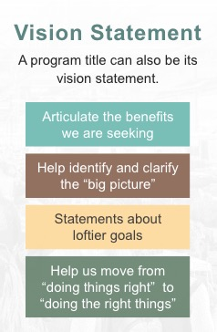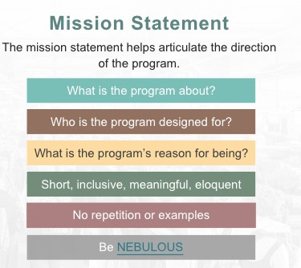
Nebulous: Mission statement should avoid concrete examples and can change the program’s focus.
Program Goals
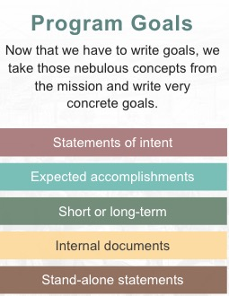 Relationship between a relationship and a goal: Goals are specific, mission statement is nebulous. MISSION STATEMENT ARE END RESULTS, goals are attributes of the program

Creating objectives: these are written for each goal.
We need to be able to measure these objectives such as Time (in counseling or at the gym), Habits (study skills, number of alcoholic drinks per week)
Formal scales and tests (Academic performance, maximum heart rate, psycho-social scales)
SMART objectives Specific, Measurable, Achievable, Relevant, Time-bound

Lesson 6 Design Fundamentals
Three Program Reference Points:
Pre-Program: All the work you need to do before the program starts
Program: Problem solving and leading the program
Post Program: The important work after the program ends, like clean-up, evaluation and debriefing.
Pre-Program tasks
Order of tasks
Fund raising > Needs assessment > Budgeting > Hiring > Staff Training > Facility Development > Promotion > Registration
Organizational Charts
Important tool to:
Keep organized, identify priorities, manage resources, hold staff/volunteers accountable, I.D interdependency of program tasks, determine the critical timeline to accomplish tasks

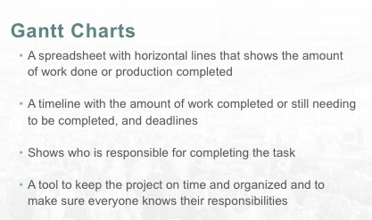

Group Discussion
Give everyone the opportunity to have a voice
Allow a variety of ideas
Open the channels of communication
types of discussion groups
Board of directors, Staff, Volunteers, Teachers, Healthcare professionals, community activists – some might overlap.
When do you lead a discussion?
Start of something new, when issues can no longer be ignored, when groups need unity due to discourse, when groups rally for a common cause.

Six steps in the facilitation cycle
1) Introduction: Give members time to settle down, ask people what they have on their agenda, 2) Gathering: Set the agenda with input from participants
3) Selecting: With the participants, decide which topics will have priority
4) Handling: Deal with the topics, do the work or make decisions
5) Planning: I.D the tasks that need to be completed (next steps), set target dates and assign tasks to people
6) Conclusion: What worked well and what needs to be improved? Celebrate your groups milestones so they are motivated.

How to lead a group discussion
Setting the tone: Design choices with lay out and procedure.
Welcoming space
Establish ground rules: Guidelines to keep the topic on track, talking rules
Bring materials: Food, paperwork, Office supplies
Setting an Agenda: encourage ideas, define the problem
Communicating with members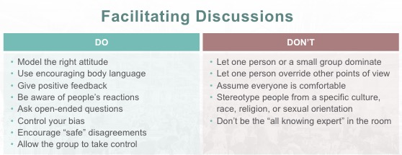
Facilitation
Facilitators should know their group that they’re going to work with. Their likes/dislikes/past experiences. Special needs or skills.
Leadership in leisure
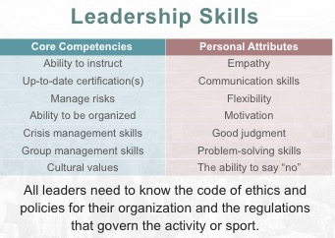

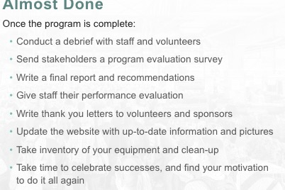
Debriefing
Sometimes called a post-mortem. Sharing the how and why
Rose Metaphor: Rose: What went well, Bud: what did we learn, Thorn: what went wrong
Debriefing tools
set a time frame, set the agenda, learn, no finger pointing, just the facts, create an actionable to-do list, invite a third party. Share results no the discussion.
Don’t include clients in the debrief

Lesson 7: Facilitating Leadership Styles
Facilitation: Make an action or process easier, help a group or person meet their goals
Leadership: Lead a group of people or an organization

Three principles of facilitation:
1) Draw out opinions & Ideas
2) Focus on HOW and WHAT
3) Never take sides

Facilitation skills: Good planning, Keep Members Involved, Leadership Opportunities, increased skills, good communication, resolved conflicts, help people achieve goals

Being a good facilitator: Understand goals, keep group/agenda moving forward, involving everyone, decisions are democratic

Planning a good process: Check for the climate (the tone is correct), The Environment (the room) is appropriate, Logistics (Anything else is needed) and Room arrangements

Leadership Styles:
Transactional Leadership: best for deadlines, maintain group dynamics, rewards increase efforts. Carrot & Stick
- Works within existing boundaries
- Results Driven
- Strict Boundaries
- Evaluate performance regularly
- Efficiency and effectiveness

Transformational Leadership: Motivate staff, build expectations,
- Future conscious
- Enthuse employees
- Vision & Values
- Lead by example
- Inspire team
Leadership Styles
Authoritarian: Pure exercise of power
Transactional: Political Scheming
Relational: Using Relationships
Authentic: Setting an example
Laissez-Faire: lazy boss
Democratic: Sharing power
Transformational: Charisma
Path-Goal: Involving followers in the goal

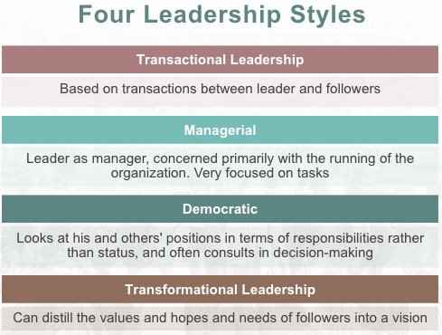
Person-First Language puts the person before the label or disability.

Lesson 8: Program Promotion
Promotion:
> Keeps the product in the minds of the customer
> Helps stimulate a demand for the product
> Involves ongoing advertising and publicity

Marketing:
> Usually focused on one product or service
- Inbound marketing; market research to find out what groups of potential clients exist, what their needs are, which of those needs you can meet & How to meet them
- Outbound marketing; includes promoting a product through continued advertising, promotions, public relations, sales

Advertising: Information given
Promotion: Demonstration of product
Publicity: Execute an example for attention, publicity
Public Relations: Having a figurehead mention the product
Program Life Cycle: Determined by volume of participants and time.
Introduction: Inform and Educate prospects about the program.
Growth & Maturity: Rate of growth slows, but the context of the program is richer.
Decline/end: Phase out promotional efforts
Saturation: No new growth, number of participants is stable. Imminent decline. Repeat participants. Focus on keeping current clients satisfied and stop taking on new clients
Revitalisation: remodeled program
Decline: When enrollment begins to fall, choose to let the prog die, petrify, or revitalize.
Petrification: Program exists, not doing great but not bad either.

4 P’s of promotion
Promotion: Inform, educate, persuade, remind
Place: (where to put promotional materials) Schools, letters sent home, lunch rooms
Price: How much participants need to pay for the program or service
Product: The tools you will choose to help promote

Trends are long lasting, fad’s carry the trend for a short while.

Not-For-Profit marketing:

Lesson 9 Program Budget

3 Steps of this topic
1) Undertanding how “trends” impact budgets
2) Understanding budgets and why/how they are used
3) Applying a formula to calculate the budget

Trends:
Risk Management: high risk programs need more management
- More insurance
- Better staff training/certification
- More Back-up plans
Increased competition: Means 1 of 2 things
- Competitors that offers same services for cheaper, so you lower your rates
- You can increase your rates to improve the quality of your service
Mission-Driven & Benefits Orientated
- Focus on your mission statement (even if they cant pay fees, let them participate)
Do more with less
Contracting services:
- Increases expenses, improves quality
Expanded definition of costs: Don’t fully train volunteers save time and money

Needs assessment helps understand these things

How to understand budgets:
Planning & forecasting (What tools do we need?)
Communicates priorities (What is a priority that we need to cover?)
Allocates resources (How can we share what we have?)
Builds organizational consensus (Staff that understands the budget, can promote program)
Records past priorities (What was done prior)
Commits to a course of action (tells staff what to focus on)
Controls expenditures (The limits of the budget)
Monitors spending & Revenue (observe the budget over time)
Brings programs to reality

Budget application:

Calculating costs: A cost budget to control outflow of money

Calculating income: An income budget to predict the income and track the money that is coming into the program. This might be through reg fees, donations, etc

Total Cost is the sum of Indirect/Direct/Variable costs

Indirect (Overhead) costs: Admin salaries, Office equipment
Direct costs: Fixed that may be traced back to a program – Instructor salaries, facility rent, program promotion, equipment

Variable costs: Directly attributed to a specific program & that vary proportionately with changes in volume.
Supplies, equipment, program staff

Total Costs:

Line-Item budget:
- Commonly used: It’s a budget in which the individual financial statement, items are grouped by costs centre or by departments.
- Compares past financial data with current or future estimated figures
- Difficult to establish the first time (no data, a lot of estimating)
- Easy to update annually with incremental adjustments based on previous budgets
- Income and expenses should balance

Program Line-Item
Detailed budget for a single program
Program reports to their supervisor with their budget and the supervisor then accounts for all other programs to make one universal budget.

Agency Line-Item
General budget for all programs in an agency
Asks program directors for their budget, the Executives then consolidate all the program budgets from each program

Operating budget
Compare and contrast two years and their numbers

Statement of Financial Position
Data provides an overview of the financial health of the organization. It must be balanced

Calculating income:
Variable costs are direct ( fixed) costs are subsidized
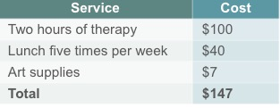
Partial Overhead Costs: Participants pays part of the costs of the program but less than the actual cost. (Insurance, electricity, usually something not tangible)
Full cost recovery: Charge full registration fees to cover all expenses to the program.

Corporate Structure:
Difference between for profit and not-for-profit
For Profit:
- The owners can choose what to do with the profits
- All profits can be taken by the owner
- May use the business to generate additional income
- Cannot qualify for grants
- Does not get the same advantages as non-profits
Not-For-profit:
- Allows to make a profit, related to the core business
- Any profit is re-invested back into the program/agency
- Receives special tax treatment
- Able to apply for grants
- May or may not be a charitable organization
Why NFP needs a profit: To reinvest in itself to expand on services and facilities

Ingenuity Gap: Gap between escalading need for solutions to problems and our inadequate supply of solutions
OR
The pace of the severity of problems + we need more ingenuity = the gap

Global Issues: Climate change, Weapons, Corruption etc
2 Types of ingenuity
Technical Ingenuity: Our ideas help us meet our physical needs. Transportation, health etc
Social Ingenuity: Schools, businesses for equity and innovation between people
Solving the ingenuity gap:
1) be aware
2) Meet the real needs of people

