Week 12: Continental Ice & Past Glaciations
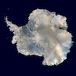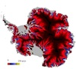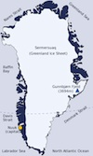
Modern ice sheets
Glaciers Developed on Continental Surfaces
- When ice accumulates on relatively flat areas, it forms an ice dome around the zone maximum glacier ice accumulation
  - The ice flows outwards from the centre of the dome in a radial pattern
  - The central part of the dome will accumulate more snow every year than can be melted. This is called the accumulation zone
  - The outer fringe of the dome accumulates less snow than is melted annually. This is called the ablation zone.
  - If the ice dome is neither growing or shrinking, the amount of melt occurring in the ablation zone equals the accumulation there plus the volume of ice flowing in from the accumulation zone

Depositional Features
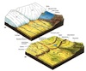
Strahler diagram of depositional landforms
- Deposition occurs:
  - During transport by ice at the base of the glacier (“basal till” or “lodgement till”)
  - During melting of the ice (“ablation till”)
  - Following transport by water in the ice, and downstream of the glacier(“stratified drift”)
- Tills: these are generally unsorted, and composed of sediments ranging fromclay to boulders. They have no internal layering,
- Stratified drift: these are well sorted sediments, often laid down in layers by rivers or in small ice-contact lakes.
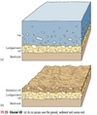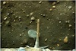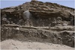
- Landforms
  - Ground moraine: an even blanket of to 10’s of metres thick covering the ground (also called till plains)
  - Terminal moraine: as for alpine glaciers, these mark the location of the ice front. They record the maximum extent of a glacier ice sheet
  - Recessional moraine: if the ice sheet retreats from the maximum extent and then deposits another moraine at the edge of the ice, it is called a recessional moraine.
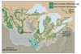
  - Drumlins: composed of till deposited under the ice
    - Streamlined, indicating ice flow direction
    - Have a steep, up-ice face, elongated tail pointing in direction of flow
    - Occur in groups or “swarms"
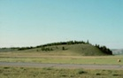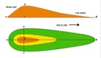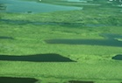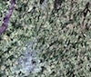
  - Outwash plains: these are large fluvial deposits (like floodplains) that form from water and sediment down valley from a glacier/ice sheet
    - If ice blocks are incorporated in the deposit, they will eventuallymelt, leaving a hole (“kettle”)
    - If the kettle depression intersects the local water table, then a kettle lake forms
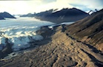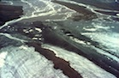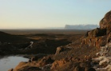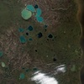
  - Kame: forms when sediment is deposited on the ice surface and is subsequently lowered onto the landscape as the glacier or ice sheet melts away.
  - Eskers: these are the channel bed deposits of rivers running through andunder glacier ice.
    - Rivers form tunnels beneath and through the ice sheet (or alpine glacier)
    - The rivers carry sediment, some of which remains in the tunnel
    - When the ice sheet melts, the river sediments in the tunnel are leftdraped over the landscape, where they form networks of sinuous ridges mapping out the subglacial drainage system
    - Eskers are often used for road beds because they tend to be well-drained and elevated above the landscape.
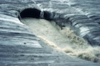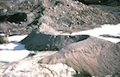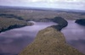

Ice Sheets of the Past and Present
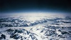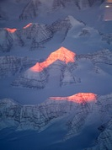
Greenland
Antarctica
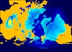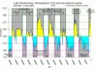
Ice ages and the Last Glacial Maximum
- Currently ice sheets exist at the northern and southern extreme latitudes (rather than at high altitudes)
  - They may be 1000’s of metres thick (e.g. Antarctica, Greenland)
  - In the past, ice sheets have spread out over the continents (as a result of systematic climatic cooling)
- Advancing ice sheets: “glaciation”
- Retreating ice sheets: “deglaciation”
- Period between subsequent glaciations: “interglacial” period

Causes of Ice Ages
Among other factors, the largest contribution to the variation in the Earth's climate and the reason for the ice ages of the past are the Milankovich Cycles. These are variations in the earth's orbit and axis of rotation that result in variations in the amount of solar radiation that reaches the Earth.
- Eccentricity of the Earth's orbit - Period of about 100,000 years
- Obliquity of the axial tilt - variations in the tilt of the axis between about 22 and 24 degrees with a period of 41,000 years.
- Precession of the equinoxes - wobble of the Earth's axis much like a top when it begins to lose its momentum. This has a period of 19-26000 years.
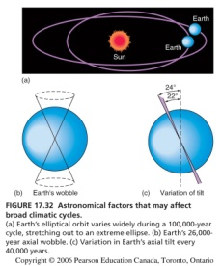
Milankovich Cycles
Past Glaciations
- In the past ~2.6 million years, there have been at least 12 cycles of glaciation anddeglaciation
- We do not know much about most of these glaciations
- We do know more about the last major glaciation, called the Wisconsinan glaciation, as the record from the last advance has not been wiped out by subsequent advances

- Wisconsinan Glaciation [The Last Glacial Maximum @ 25,000 yrs B.P.]
  - Ice advanced over much of North America (Europe also covered by ice sheets around the same time)
  - In central Canada, the Laurentide Ice Sheet extended out of Hudson’s Bayinto the USA
  - In western Canada, the Cordilleran Ice Sheet grew together from a large number of alpine glaciers in the Coast and Rocky Mountains
  - The maximum ice extent of the Cordilleran Ice Sheet was reached at around 18,000 years ago, at which time Vancouver was under 2000 m of ice
  - Global sea level during the time of maximum ice extent was about 125 mlower than today, so that the continental shelf was exposed.
  - The weight of these large ice sheets caused the crust beneath to bedepressed. In the Vancouver Region, the land was depressed more than 250 m. below its current level, so that relative sea level was higher than today, even though global sea levels were lower.
  - Once the ice sheets retreated, the land rebounded isostatically. Isostatic rebound was rapid at first, then slowed. Isostatic rebound from the Laurentide Ice Sheet is ongoing today.
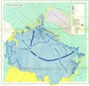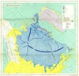
Laurentide ice sheet
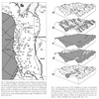
Cordilleran ice sheet

Periglacial Processes
PERIGLACIAL: This is a ten-dollar word referring to the climate andgeomorphology of cold regions. Periglacial regions are defined by a mean annual temperature that is less than -1 degree Celsius. Here, freeze-thaw related processes are very important, producing surface features seen only in these extremely cold environments. Periglacial regions often exist along the margins of past and present ice sheets. They are are also often associated with the occurrence of PERMAFROST.
PERMAFROST: material below the ground surface that has remained continuously below 0°C for at least 2 years. In the coldest parts of the word, there is permafrostalmost everywhere beneath the land surface, which is referred to as continuous permafrost. As one moves toward the equators away from the continuous permafrost zone, the permafrost becomes thinner and only forms where conditions are favorable. This is referred to as the discontinuous permafrost zone.
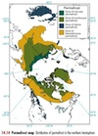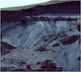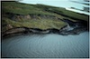

Permafrost and the Active Layer
In some cases, there is very little water in the soil, and permafrost is really nothing more than cold dirt, cemented together to some degree by whatever water is found in the soil matrix. This is called DRY PERMAFROST
Where there is abundant water in the soil, we get WET PERMAFROST, which may include thick layers of pure ice.
At the surface, the soil temperature varies with the temperature of the air masses above it, becoming very cold in the winter and relatively warm (above 0° C!) in the summer.
- Result: permafrost is not found at the surface anywhere!
- At some depth below the surface, the overlying soil acts as insulation, preventing large changes in the soil temperature (it is less cold in the winter, less warm in the summer)
- Where the insulation of the overlying soil prevents the temperature from rising above 0o C, the soil remains permanently frozen, and we have the top of the permafrost
- The zone above the top of the permafrost will freeze in winter and melt in summer. Here is where all the cool freeze-thaw processes occur, and this is called the ACTIVE LAYER
- The bottom of the permafrost occurs where geothermal heat raises the T above 0° C (this may be as deep as 600 m)
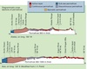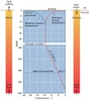

Ice Wedges
One common surface feature in Periglacial regions is the ice wedge. It is avertically oriented wedge-shaped body of pure ice (called massive ice, in technical jargon) that is widest at the boundary between the active layer and the permafrostand narrowest at its deepest point.
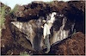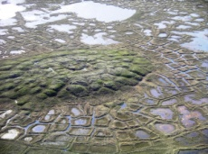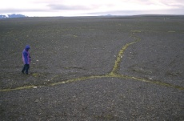
How Ice Wedges Form
- Although ice initially expands when it freezes, ice-rich soil will start to contract (to shrink) as the temperature becomes very, very cold
- As a result, the soil mass cracks in the same way as mud does when it dries. THESE CRACKS FORM IN THE DEAD OF WINTER
- We call the pattern of the cracks as seen from above “polygonal cracking”, since the cracks are arranged in a roughly polygonal pattern (straight sections that form irregular pentagons, hexagons etc.)
- These cracks extend (propagate) into the permafrost. The depth to which they propagate depends on how cold it is, and how much contraction occurs in the soil
- IN THE SUMMER, the active layer thaws (the permafrost does NOT), and water is released, some of which flows down into the cracks in the permafrost, where it freezes, initiating the ice wedge.
- In the NEXT cold winter, freezing temperatures will cause a crack to form in more or less the same place, and another layer of ice will be added to the ice wedge.
- Over time, a thick wedge forms, and the individual ice layers can be used to count the number of cold winters (sort of like tree rings)

Pingos
Pingos are ice-cored mounds that may rise as much as 60 to 70 meters above abroad, flat plain that consists of silt and sand-rich soils (usually laid down by a river). They are produced when a lake drains or fills with sediment, and the TALIKbeneath the lake freezes.
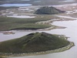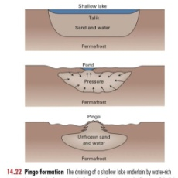
A Talik is simply a word describing a hole in the permafrost that occurs beneath a lake. Lakes are very good insulators, and keep the ground beneath them warm enough that permafrost does not form there.

How Pingos Form
- We start with a lake, beneath which we find a talik
- If the lake is drained or otherwise dries up, it loses its ability to insulate the ground, and the permafrost adjacent to the talik expands
- Once the bottom of the talik is closed off by expansion of the permafrost, the system becomes essentially sealed off, and water can only exit towards the surface
- The soil in the talik is saturated, sot that when it freezes, expansion (water à ice) forces some of the water upwards under pressure
- Since permafrost expansion is most likely to occur during winter, the water forced upward will freeze again near the surface, forming an ice lens.
- The formation of the ice lens forces the soil on top of it upwards, creating a dome
- This process of: (i) permafrost expansion, (ii) the forcing of pressurized watertoward the surface, (iii) refreezing and (iv) doming of the overlying soil, will continue until the entire talik is transformed into permafrost, creating the pingo.

Patterned Ground
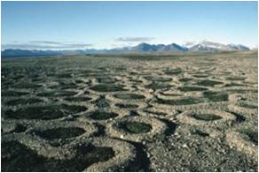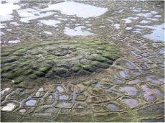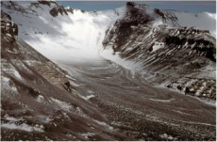

Loess
LOESS (where the dust goes): there are regions of the Earth where windblown dustsettles out, forming thick blankets of silt (and minor fine sand and clay) draped over the landscape. These deposits are incredibly productive in terms of agricultural food production, because the infiltration capacity of silt is high enough to prevent the soils from becoming saturated, but the soil retains enough moisture to support vegetation growth.
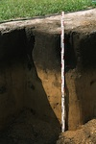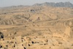
Loess deposits
SOURCES: the source of dust needs to be large for loess deposits to form and isderived from mainly unvegetated land surfaces. There are a wide range of dust sources, but there are two main ones:
- Deserts: dust can be derived from deflation surfaces in desert environments. The largest and deepest deposits of loess are found west of the Gobi Desert in China and are derived from dust storms in the Gobi Desert. These deposits can be a100 m deep or more
- Deglaciation: as the large continental glaciers retreated, they left behindunvegetated surfaces with abundant fine sediment on glacial outwash plains andablation till. These sources were active only briefly during deglaciation, and the sources of dust became vegetated, turning off the loess deposition process. Significant loess deposits derived from this source were laid down in the north-central United States just below the glacial limit, and eastern Europe and Asia(again south of the glacial limit)

