Week 10: Fluvial Landforms

Alluvial Deposits
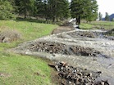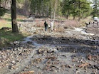
- Sediment is transported from erosional sources to depositional sinks
- Deposits of sediment transported by a stream are referred to as “alluvium” (which are typically well sorted)
- Alluvium differs from sedimentary rocks in that alluvium is unconsolidated
Importance: alluvium contains placer deposits (gold, platinum); it is used asaggregate for construction, the deposits are oftencenters for human development, including agriculture, transportation routes and communication corridors
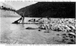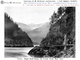
Our Focus: depositional landforms and processes shaping them

Introduction to Alluvial Landforms
Within the stream channel we find bars, pools and riffles.

Bars
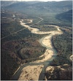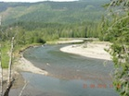
- Accumulations of sediment within the stream channel, usually along the marginsof the channel
- The main flow of the river diverts around the bars…the deepest and fastest part of the channel is called the thalweg

Pools and Riffles
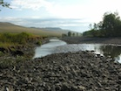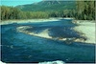
- If we travel down the thalweg, we encounter alternating sections of deep, slow flow, usually right beside the center of a bar and shallow rapid flow near thedownstream end of a bar
- The slow flowing deep areas adjacent to the bars are called pools
- The rapid flowing shallow zones near the end of a bar are called riffles
The channel itself is often developed within some sort of larger alluvial depositlaid down over thousands of years. These larger deposits can also be considered to be landforms. Included in this category are:
- Floodplains: broad, flat deposits of alluvium that extend from valley wall to valley wall. The upper surface of a floodplain is at the same elevation as the peak flow water level in the channel, such that floodplains are inundated during flood events (hence the name!). They are composed of sediment transported and depositedby the river running though the valley.
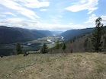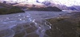
- Terraces: Discontinuous, flat-topped features similar to floodplains. They are in fact remnants of former floodplains developed at a higher elevation. There may be multiple terraces within a valley, representing a series of former floodplain surfaces.
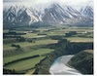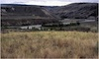
- Fans: Cone-shaped, relatively steep alluvial deposits that occur where a stream channel emerges from a steep, confined valley onto a broader, flatter surface. These are basically short, strangely shaped floodplains.
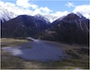

Graded Channel Response
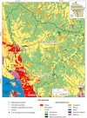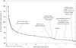
Halfway Creek Watershed and Longitudinal Profile (a watershed at grade)

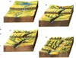
Stream grade diagram from Strahler
The kinds of landforms found depend on how the sediment supply relates to the channel transport capacity, and the relation of the stream to the valley sides
- Sediment supply: the volume of material input from the hillslopes and recruited by the stream channel in a specified time interval [volume/unit time]
- Transport capacity: the volume of material that a stream is capable of transporting in the same interval of time [volume/unit time]
Over time, river systems reach an equilibrium or steady state where the channelslope is adjusted to transport the sediment supply. Channels that have adjusted their local slopes everywhere to reach this equilibrium are called graded channels

How Stream Gradation Works
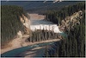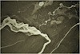
A non-graded stream, Eastern BC
When the channel slope is to high, local erosion will occur, increasing the localsediment supplyand at the same time lowering the local slope.
When the slope is too low, local deposition will occur, decreasing the sediment supply and increasing the local slope.
Local adjustments interact throughout the drainage network to establish a “graded condition” relative to the “base level”
- Base level: this is the lowest point in the drainage network, and usually is the mean sea level for rivers entering the ocean or the typical lake water level for rivers entering lakes
- Nickpoints (as known as knickpoints) are discontinuities in the stream channel profile caused by a change in lithology (more and less resistant strata), or a sudden lowering of the base level due to tectonics, climate change (e.g., lowering of sea level or lake level) or reengineering of streams (e.g., dam removal).Nickpoints will tend to propagate upstream until the channel profile reaches a new, graded condition relative to the change.

Confined Alluvial Systems
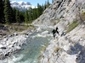
Porcupine Creek Canyon, Kananaskis
In confined systems, the valley sides constrict the stream channel so that theshape and location of the channel and its landforms is controlled by geologic structure. Confined systems are found in upper parts of a drainage basin inmountainous environments. They may or be at grade, but are not necessarily so.
Landforms in the channel: lateral bars along the inner part of bends (pools andriffles may be present, but are sometimes poorly developed or absent).
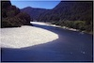
LATERAL BARS in Buller River, NZ
- Usually, the channel banks are composed of bedrock
- There is normally only one main channel (only one thalweg)

Stable Floodplain Systems
Where the valley sides are further apart, the channel has room to deposit afloodplain and develop a more complete assemblage of fluvial landforms.
- These systems are almost always at-grade, and are considered to be STABLE, EQUILIBRIUM river channels
- The stream channel (bed and banks) is developed entirely within the alluviumcontained in the floodplain.
- Since the floodplain was formed by the river, and the river is developed within the floodplain, the river can be said to be “self-formed”
Channel Appearance: these streams often meander back and forth across theirfloodplains, and are called meandering rivers
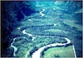
Meandering river
- Landforms in the channel: point & lateral bars, pools, and riffles
- Landforms on the floodplain: levees, oxbows, and backswamps
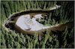
POINT BAR in Beaverfoot River, BC
Wandering rivers (meandering on the edge)

Other Key Concepts for Meandering Streams
Floodplain Turnover: one full cycle of floodplain erosion and re-depositionproduced by a single sweep of meanders across the floodplain
Meander Dynamics: meanders migrate laterally across the floodplain and downthe river valley
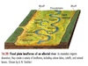
Meandering floodplain diagram from Strahler
Avulsions: occasionally a river jumps out of its banks andcuts a new channel into the floodplain, leaving old channel scars on the floodplain (e.g. oxbow lakes)
Processes Occurring During Flooding:
- When water floods out of the stream channel and onto the floodplain, it slows down and the suspended sediment is deposited
- This produces levees of silt and sand and backswamps further way from the channel

Agrading Floodplain Systems
When sediment supply is greater than the transport capacity of a stream, a netincrease in the volume of material in the floodplain must occur
- This imbalance causes the level of the floodplain surface to rise
- The increase in floodplain elevation will be greatest closer to the source (i.e. at theupstream end of the floodplain) resulting in an increase in the slope of the floodplain surface
- The system is unbalanced (it is NOT at grade), and the individual channelsfrequently become filled with sediment, causing avulsions, and producingmultiple channels on the floodplain
- The multiple channels divide and re-combine, giving the channel a braided appearance: these channels are called braided channels
- By increasing the slope, the stream velocity is increased, and so is the channeltransport capacity. This is an attempt to re-grade by increasing the transport capacity and re-establish equilibrium
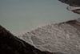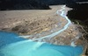
Braided channel at River Mouth
Landforms:
- In the stream channel: mid-channel & lateral bars, pools and riffles
- On the floodplain: multiple channels produced by avulsions
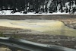
MID-CHANNEL BARS
Final Points:
- The sediment in braided streams tends to be coarser and the channel slopestend to be higher than meandering streams
- These channels are only found in areas with a relatively high sediment supply
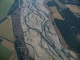
Braided channel, Waimakarirri river, NZ

Degrading Floodplain Systems
When the channel transport capacity becomes larger than the sediment supply,degradation occurs and the floodplain surface drops in elevation and the channelincises into the former floodplain
These systems are not at-grade, but the changes in the landforms that develop under these conditions represent an attempt to re-grade by reducing the transport capacity. This is achieved by:
- Eroding the channel bed: the channel becomes lower, which reduces the channel slope, reduces the stream velocity and therefore reduces the transport capacity
- Increasing the sediment supply: the channel picks up sediment from the former floodplain, increasing the sediment supply to downstream parts of the channel
Dominant landform: terraces, which are eroded remnants of former floodplain surfaces
- Multiple cycles of meander migration across the floodplain may leave multiple terraces at different elevations (oldest terrace = highest, youngest terrace = lowest)
- Paired terraces: formed at same elevation on both sides of the river valley, representing the same floodplain surface (equal ages)
- Unpaired terraces: terraces on opposite sides of the valley are at different elevations…each terrace represents a different floodplain elevation and therefore a different time period in the history of the river
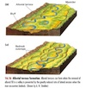
Terraced floodplain diagram from Strahler

Causes of Degration
- A decrease in sediment supply due to changes in land use, changes in climate or other factors that affect weathering, mass movement and fluvial erosion upstream.
- A reduction in the base level due to a falling sea level (this increases the channel slope and therefore the transport capacity)
- An increase in relative surface elevation due to tectonic uplift(this also increases the channel slope and transport capacity)
Terraces generated by falling base level/rising land surface
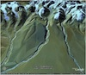
Terraces generated by supply reduction
Degradation also occurs following dam removal, a local and sudden reduction in the base level, as seen in the video of the Condit Dam removal on October 26, 2011:
Explosive Breach of Condit Dam from Andy Maser on Vimeo.

Other Alluvial Landforms
Alluvial Fan: these form where there is a sudden change in transport capacity(usually as a result of a change in confinement), which produces rapid deposition.
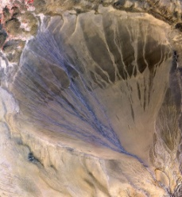
- They are composed of coarse sediments (usually gravel toboulders with sand mixed in).
- They are moderately steep (about 1 to 4 degrees).
- They may be subject to debris flows, in which case the landform is composed of both alluvial material (from the river) and colluvial material (from the debris flow)
Delta: These occur where a river flows into a body of standing water, which results in rapid deposition of the alluvial sediment (like fans). (Oceans, lakes)
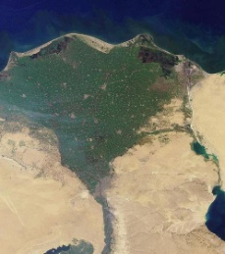
- The sediment found in deltas may be as coarse as gravelwhere steep channels flow into lakes, but are usuallycomposed of sand and finer material.
- They are very low angle landforms on top, but have steep fronts that prograde out into the water body, producing foresetbedding.

