Laboratory 1. Polytene Chromosomes and Gene Mapping

Klaudia Baumann (300017769)
BIO2133 A01

Pre-lab Reflection:
In this lab, we are expected to describe and understand what polyteny is, observe the physiological and features and arrangements of polytene chromosomes (eg. Banding patterns, swelling, etc). We will also observe the result of heat shocking and understand that it causes puffing of the chromosomes, which allows us to see the chromosomes more easily.

Achievements:
It is expected that the salivary glands from the larvae will be isolated, followed by staining of the polytene chromosomes. There will be both a heat shocked preparation and a non heat shocked preparation. These two preparations will be observed and compared to distinguish between the puffing and the control chromosomes. Lastly, there will be digital images taken of both heat shock and non heat shock polytene chromosomes, and the chromosomal length is to be measured.

In-lab Reflection:
In the lab we were able to properly dissect larvae using tools provided and used those dissections to observe and asses polytene chromosomes. We familiarized ourselves with microscopes and the different settings that could be manipulated in order to get clearer images. The hardest part for me during the lab was the dissection itself as it was hard to isolate the salivary glands cleanly. I found it very difficult to grab hold of the larvae with the tweezers since they were very small and squirmy. The easiest part of the lab was preparing the slide and staining the chromosomes.

Results:
It was observed that there was a big difference between heat shock chromosomes and room temperature chromosomes. The light and dark bands of the polytene chromosomes were also observed under the microscope.

PART 1 Preparation of polytene chromosomes from the salivary glands of 3rd instar larvae of Drosophila virilis

Insert your two photos for each of the two treatments without and with heat shocking along with a brief descriptive caption. A brief caption should indicate the content (polytene chromosomes), the origin (salivary glands of 3rd instar larvae of Drosophila virilis) as well as the magnification (400X). Write your captions as clearly and concisely as possible; avoid including unnecessary details.

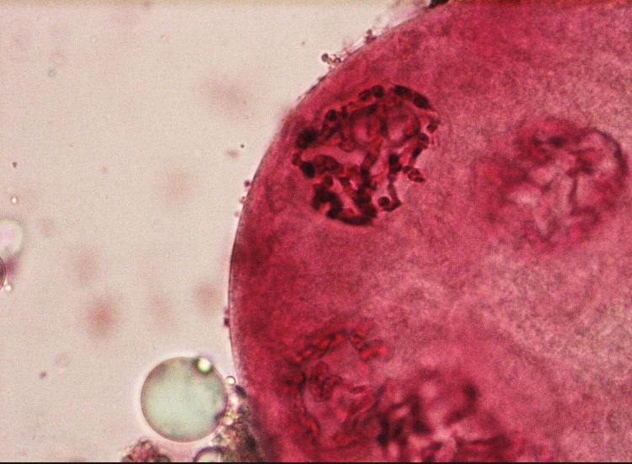
1a)

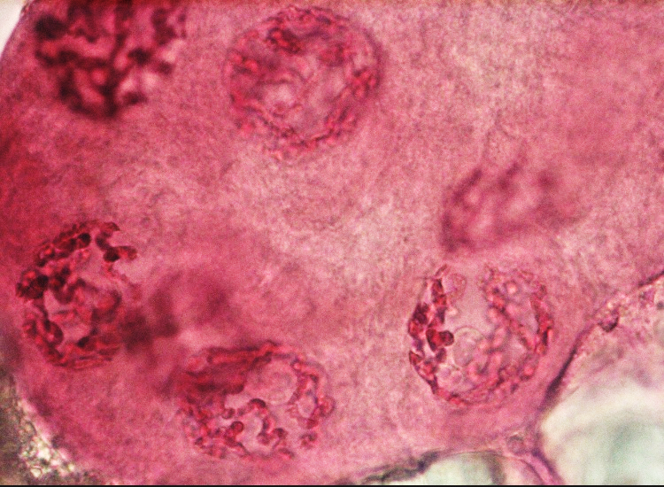
1b)

Figure 1 a, b. Polytene chromosomes of the salivary glands of a Drosophila virilis 3rd instar lavae incubated at 37ºC for 40 minutes and then incubated at room temperature for 10 minutes. Image is at 400x magnification using a compound microscope and aceto-orcein stain.

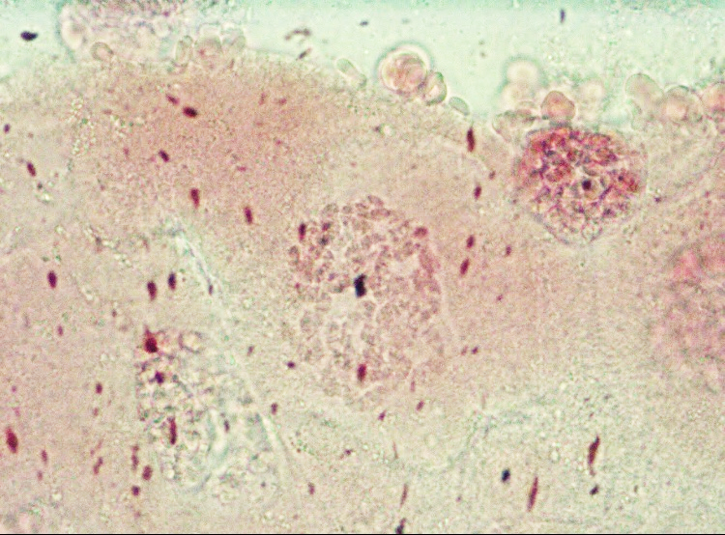
2a)
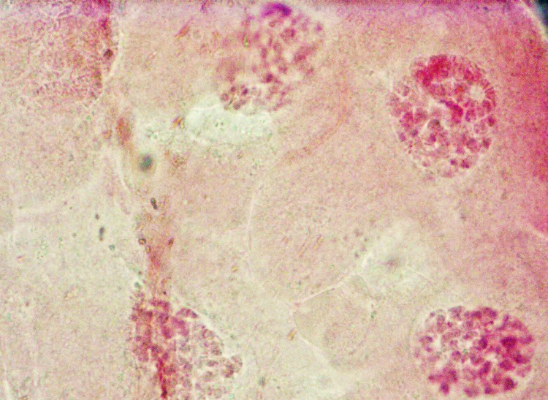
2b)

Figure 2 a, b. Polytene chromosomes of the salivary glands of a Drosophila virilis 3rd instar lavae at room temperature. Image is at 400x magnification using a compound microscope and aceto-orcein stain.

Are there some visible differences you can observe between your two temperature treatments? If yes, what are they? Should there be more puffs in the treatment at 37 °C compared to the one at 25 °C?

Yes there would be a visual difference observed between the room temperature and incubated salivary glands. The increase in temperature during incubation causes an increase in DNA production in the salivary glands, causing an increase in puffing. Sine there will be more puffing in the incubated salivary glands, they will appear larger than the ones at room temperature.

Are the polytene chromosomes physically interconnected? If yes, describe the structure you see.

Polytene chromosomes are physically connected and appear as clumps in the nuclei. This clump that is seen is called the chromocenter.

What is the ploidy of your polytene chromosomes? Justify your answer.

Polytene chromosomes are poly ploidy. There is an increased amount of gene content, and a larger amount of sister chromatids together than normal. This process is called endoreplication (where mitosis does not occur) and allows the larvae to grow much faster with increased genetic material.

Measurement of polytene chromosomes

Paste below your ‘best’ microscope photo of one of your preparation of polytene chromosomes. Estimate the length of a representative chromosome assuming that it could be linearized. Keep in mind that your photo most illustrates a mass of chromosomes attached at the chromocenter as illustrated in figure 1.

Insert your microscope photo and calculations and explain your reasoning.
Length of picture: 7.7cm
Field of view at 400x: 0.175mm
Actual size of object = ((actual size of FOV)/(on screen size of FOV))* on screen size of object
= (0.175mm/7.7cm)*(1.3cm *2)
= 0.0591mm
= 59100nm

Estimate the relative expansion of your prepared polytene chromosomes by comparing its packing ratio to a reference of 2x10⁴ base pairs/nm for an interphase human chromosome (this reference was calculated based on data obtained from Am J Hum Genet, 2002). To estimate this ratio, you will first need to establish the average chromosome length (# DNA base pairs) in Drosophila virilis. This can be done by referring to the Genome Data Viewer database of Drosophila melanogaster to calculate the mean length of its chromosomes – one can reasonably assume that both ‘sister’ fruit fly species have chromosomes of comparable sizes. You can then estimate the ratio of DNA base pairs/nm in your preparation of polytene chromosomes by dividing the mean number of base pairs per chromosomes over the linear chromosomal length measured in the previous question. Finally compare the ratio value of your preparation of polytene chromosomes to the one of interphase human chromosomes to deduce the fold expansion of chromosomes in the salivary glands of D. virilis. Can you now explain why one can directly observe polytene chromosomes under a conventional light microscope?

Chromosome | Base Pairs
X | 24Mbp
2L | 24Mbp
2R | 25Mbp
3L | 28Mbp
3R | 32Mbp
4 | 1.3Mbp
MT | 20Kbp = 0.02Mbp
Therefore the average number of base pairs per chromosome is 19.19 Mbp = 19,190,000 bp.
Packing ratio = DNA base pair/ length in nm
= 19190000 bp per chromosome/59100nm
= 324.70 base pair/nm

Ratio of DNA bp in my preparation:
19,190,000/324.7 = 59,100.7

Ratio of D. virsilis polytene chromosomes to human interphase chromosomes:
59,100.7:20,000

Based on these numbers, the human chromosomes are more folded. Even though the polytene chromosomes are less folded, they are still folded enough to be seen under a conventional light microscope. They clump and form a mass that makes them more easily visible.

Post-lab Reflection:
Polytene chromosomes experience puffing as a result of heat shock (increasing temperature). The chromocenters (interconnection of chromosomes due to a mass of centromeres) of the polytene chromosomes were also observed under the microscope.
I believe that every learning outcome was achieved and understood as I followed the lab outline as well as used knowledge from in class to perform all tasks. I found the lab itself (dissection, slide preparation, and microscope portion) very fun and exciting, but the worksheet aspect and pre-lab quiz are more boring and stressful.

