Week 8: Hillslopes

Mass Movement: Introduction
MASS MOVEMENT (or MASS WASTING): is the spontaneous downhill movement ofsoil, regolith, and rock under the influence of gravity. Mass movements occur when the force of gravity tending to pull regolith downhill becomes greater than the frictionand cohesion tending to hold it in place.
Why are we interested in mass movements?
- ECONOMIC IMPACT : Mass movements are one of the most destructive geological hazards in Canada. (e.g. annual costs related to landslides in Canada are ~ $70 million; in Japan, they are ~ $5.5 billion)
- HUMAN FATALITIES1: Average number of deaths per year are significant: Canada (5/year); USA (25-50/year); Japan (170/year); Nepal (186/year). Some striking examples:
  - 1920, Gansu Province in China, Magnitude 8.5 earthquake causes numerous mudflows in an area of 50,000 km2 , killing ~180,000 people
  - 1933, Tajikistan: Magnitude 7.5 earthquake causes a rock slide that buries several villages & farms, killing ~18,000 people
  - 1965, British Columbia: no obvious trigger, large landslide that buried Hwy 3 to a depth of ~80 m, killing 4 people
  - 1985, Columbia: volcanic eruption melts snow & ice, causing lahars that destroy the town of Armero, killing ~23,000 people
  - 1999, Venezuela: about 1 meter of rain in under 3 days produces numerous landslides & debris flows along the coast, destroying 8000 houses, 700 apartment buildings and damaging infrastructure, killing ~30,000 people
Statistics from Landslides: Processes, Prediction and Land Use, by R.C. Sidle and H. Ochiai (2006)
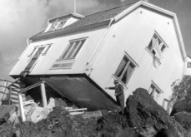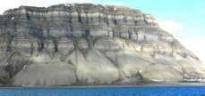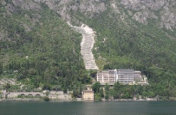

Gravity, Slope Angle & The Factor of Safety
- Mass movements occur on slopes, since gravity acting on a flat plane produces only friction. As the slope angle increases, the component of the gravitational forcethat produces friction declines, and the component of the gravitational force tending to produce movement (called the shear stress) increases
- Slopes can be defined as strips of land inclined from the horizontal
- If you try and pile dry sand on a beach the grains will flow downward until equilibrium is reached. The steepness of the slope that results when loose sandcomes to rest depends on the size and texture of the grains; this slope is called the angle of repose.
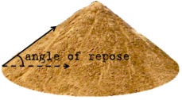
- This angle represents a balance between driving andresisting forces. To asses the stability of a slope we look at it factor of safety (FS)

  - The slope is stable when FS is above 1, and is unstable when FS falls below 1
- The driving force in mass movements is gravity, acting parallel to the slope, which is called the shear stress. The steeper the slope, the higher the shear stress and the more susceptible the material is to failing.
- The resisting force is composed of the friction generated by the gravity force as well as the “stickiness” of the material itself, called cohesion.
  - True cohesion is produced by attraction of sediment particles (primarilyclay) to each other
  - Apparent cohesion is produced by the binding effect of vegetation roots &capillary tension in unsaturated wet sediment (think of a sand castle)
- Together, friction & cohesion represent the strength of the material

Mass Movement Classification
- The type of mass movement is classified based on: (1) material type; (2) water content; (3) rate of failure; and (4) types of movement
- Material type can be described as either rock, soil, or debris
- Water content (in combination with material type) determines whether a soil can behave as a solid, plastic of liquid. It also contributes to the weight of a soil column, and hence the magnitude of the gravity force.

Rates of Movement
- Rapid: greater than 1.5 m/s (6 km/hr), which includes what we will call rockfall, debris flows, mud flows {e.g. Frank Slide, Alberta: 28 m/s (100 km/hr); Elm, Switzerland: 80 m/s (288 km/hr)}
- Moderate: 1.5 m/day to 1.5 m/month, which includes failures called earthflows
- Slow: 1.5 m/month to less than 60 mm/yr, which includes creep, and slumps

Types of Movement
- Fall
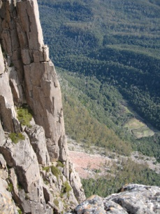
  - A fall involves movement best described as a “free vertical drop”, where the failing mass is seldom in contact with the ground surface. This is typical of failures along steep and/or overhanging cliffs
- Topple
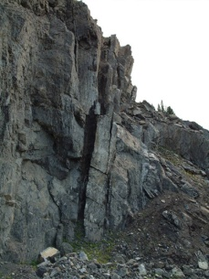
  - Think of the urban myth of cow tipping. That is a topple. It involves a rotation where the bottom of the blockremains stationary, but the top moves laterally and, ultimately, downwards.
- Slide
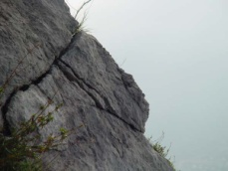
  - This involves the movement of material along a well defined failure plane. The material is in contact with the failure plane more-or-less continuously. Slides can betranslational & rotational, depending on the rock type.
- Flow
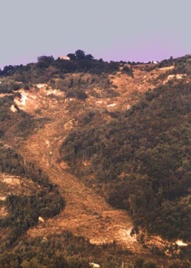
  - Movement of material (usually soil or debris) as a liquidor a plastic. Flows behave like rivers of mud, and often occur in steep, mountainous stream channels

Types of Mass Movements: Part A - Falls and Slides
- Rockfalls usually start with the detachment of rock from a steep slope. The material then descends mainly through the air by falling, bouncing, or rolling. Movement rate is usually in the rapid category.
  - Material: rock and debris
  - Water Content: dry
  - Typically, rockfalls occur on cliff faces, and produce talus cones or talus slopes at the base of the cliff, where the material comes to rest. The angle of the talus slope is the angle of repose for the failed material.
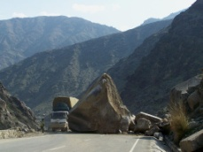
- Translational slides involve the rapid movement of rock (or debris) along a planar failure surface. The failure plane is often found along bedding planes insedimentary rocks or along exfoliation sheets in igneous and metamorphic rocks.
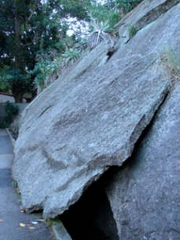
  - This kind of failure is often triggered by earthquakes, though sometimes there is no definable trigger for the failures. The material may be wet or dry when failure occurs.
  - The material that fails quickly disintegrates as it moves, forming a blocky rubble that accumulates downslopeof the initial failure. Since the velocities that the failing material can reach are in excess of 100 km/hr, they often “runout” a long distance from the original failure, coming to rest at slopes well below the angle of repose.
- Rotational Slides involve the slower failure of a weak rock mass along a curved failure plane that cuts across the bedding planes of sedimentary rocks. These failures are most common in clay-rich sedimentary rocks (shales).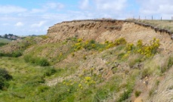
  - The upper part of these failures rotate back into the slope, and the toe of the failure bulges outwards at the bottom. Sometimes, multiple failure planes will develop, giving the upper part of the failure a distinct,stair-case shape.
  - Movement along the failure plane(s) can continue for months or evenyears before a factor of safety > 1.0 is reestablished and the slope becomes stable.

Types of Mass Movements: Part B - Flows
SLIDES VS. FLOWS: The water content in the soil & regolith when it starts movingdetermines if the mass movement is best described as a fall or slide (which havelow water content) or as some kind of flow (high water content). At the extreme end of the spectrum with very high water content, it makes more sense to treat the mixture as simply a fluid (termed stream flow)
DIFFERENT KINDS OF FLOWS: The material properties of the soil & regolithdetermine the rate at which a flow moves, how long a flow can remain active, and the hazard of the flow to people & infrastructure
Overview of Flow Types: We will consider, in turn the following kinds of flows:
- Earth flows in “normal” clay (slow, deep and long lasting)
- Earth flows in “quick” clay (moderately fast, relatively deep and short duration)
- Debris flows (includes mudflows & debris floods from table 15.10, S & S): these are particularly important in wet mountainous environments.
- Soil Creep (which turns out not be a true flow at all…)
- Earth flows in “normal” clay tend to move relatively slowly, as a plastic materialfor a period of several hours or days, but may fail numerous times at the same location over a prolonged long period (decades). They always have a failure planethat is convex upwards .
  - Earth flows only occur in cohesive materials that can retain lots of water, and are restricted to clay-rich soils. They are also restricted to fairly humid climates where soils can and do become saturated.
  - Movement occurs when the factor of safety (FS) along the failure planefalls below 1 (FS <1), and continues until the failing material reaches a stable configuration – a process that may take hours or days
the reason for this is beyond the scope of this course, but it is related to the fact that clay has bothfrictional strength and cohesive strength …sand which has no cohesion always fails along planar (straight)surfaces
  - An earth flow has an identifiable set of features:
      - A nearly vertical headscarp marking the upper extent of the failure
      - A slump zone where the soil surface is highly disturbed &often lower than surrounding areas
      - A bulging, distorted deposit at the toe of the failure (in what may be called the flowage zone) where the failed material has moved out on top of the undisturbed soil surface, burying it
      - Multiple headscarps & depositional toes indicate repeated failures over a long period of time (decades)
- Earth flows in “quick” clay tend to move relatively quickly, for a shorter period oftime. Quick clays can be transformed almost instantaneously from a cohesivesolid to almost a pure liquid, which results in a faster flow velocity, and flows thatmove much further from their source.
  - Quick clays essentially lose both their cohesive and their frictionalstrength when they start to fail.
  - The underlying explanation for this extreme behaviour is the very high porosity and water content in quick clays.
  - They are thought to have been deposited in a saltwater environment, which results in a “house of cards” internal structure for the clay minerals, where as much as 60 to 80% of the “soil” can be water!
  - When some sort of physical shock (an earthquake, for example) disruptsthe house of cards, it collapses, producing a liquid that is only about 20 to 40% solid material. This failed material will push against adjacentmaterial, causing the structure to collapse there as well, and the failure grows…quickly!
  - These kinds of failures often occur repeatedly in the same environment, but not often at the same place, since all of the failed material isevacuated.
  - The evidence remaining behind is simply the failure scar, with little depositional evidence (the flowage zone turns into stream flow and runs much farther downstream).
- Mud flows & debris flows are the most common & hazardous mass movement process in mountainous environments, particularly in humid climates. They have the highest water contents of all the common failure times we will discuss.
  - They can involve a wide range of materials
    - If they consist primarily of clay, silt & sand, they are often calledmudflows (these are common in more arid environments, like the mountains in Arizona & California)
    - If they include vegetation (trees, shrubs), and a very wide range of grain sizes (boulders → clay) we call them debris flows (these are the dominant types in the mountains near Vancouver)
  - Both mud flows and debris flows ARE CONFINED WITHIN THE STREAM CHANNEL NETWORK! That is, they begin in the upper parts of the drainage basin and move both water & sediment further down the stream channel network, often demolishing bridges & other structures they encounter along the way!
  - They are most frequently triggered by a DEBRIS SLIDE or sometimes a SNOW AVALANCHE on the hillslopes adjacent to the stream channel thatstrikes the stream channel, liquefying the channel bed and triggering the flow
  - The location where a debris flow starts is called the “initiation” zone. Initiation zones are steep, with stream channel gradients between 30 and 45 degrees
  - As the debris flow moves down the stream channel IT GROWS! by erodingthe channel bed and banks, often SCOURING the channel down to bedrock.
    - The location where the debris flow scours the bed is called the “transport & erosion” zone. The channel gradients here are about 15 degrees, and these zones can be kilometers in length
    - Debris flow velocities in this zone range from about 3 to 20 meters per second…the fastest humans (e.g. a young Ben Johnson) can move at speeds of about 10 meters per second, so don’t get caught in the transport zone during a debris flow!
    - The only signs of deposition in the transport zone are bouldery deposits along the margins of the flow called Levees.
  - When the debris flow reaches the parts of the stream channel that are less steep (say about 10 degrees), all of the material begins to deposit rathersuddenly.
  - This is often associated with the emergence of the stream that has the debris flows out into a larger, wider stream valley. As a consequence, the stream channel is often no longer confined, and the debris flow deposits spread out laterally, forming a debris flow fan which a gradient of between about 6 and 10 degrees.
LAHARS: These are a special case of exceptionally large debris flowsassociated with strato volcanoes. They are triggered by volcanic eruptions (that may very quickly melt the snow and ice cover on the volcano), and the associatedground tremors. Due to their size and energy, they often move very long distancesfrom the volcano and can do unbelievable damage to surrounding areas that one would otherwise guess to be safe from debris flows.
- Soil creep is a very slow, gradual process that is thought to be at work on all inclined, soil covered surfaces. There are in fact a number of different processes that give rise to soil creep, but we will focus only on the dominant one in northern climates – ice crystal growth.
  - Ice crystals grow within a soil when the temperature falls below 0 degrees and when water is available to form ice.
  - One kind of ice crystal that is particularly common is called needle ice. It grows perpendicular to the ground surface, and is capable of lifting small soil particles upwards. If the ground surface is inclined, this producesboth a vertical and a horizontal displacement.
  - When the temperature rises and the ice melts, the particle then returns back to the ground, but this time it moves in a purely vertical direction. Theresult is a small, net horizontal displacement down the slope.
    - The rate of soil creep depends on how many freeze thaw cyclesoccur in a given period of time
    - It also depends on how steep the slope is.
  - The effects can be seen in things like tilted fence posts.

Induced Mass Movements
There are a number of ways in which humans affect mass movement processes,accelerating them beyond their natural range or causing them in areas that would otherwise be stable. The following are some examples of typical effects in British Columbia.
Road cuts: forest roads are often constructed using materials found on-site. Typically, material is carved out of a hillslope upslope from the desired road centerline and placed down slope of the road centerline. This is called “half-bench” construction, and can lead to instability in the slopes above and below the road.
Land fill: Often, houses are developed near the top of terraces. In order to have a larger, flatter back yard, fill material is trucked in and deposited near the top of the terrace slope. This material is quite likely to fail if it becomes saturated. Also, theconstruction of a house near the edge of the terrace may also contribute to the potential for failure for the original material and the fill material.
Drainage disruption: Where roads intercept water flowing through the subsurface(SSF) and route it down road ditches, it sometimes ends up saturating an area of a hillslope that would otherwise not be saturated, causing failures. If the terrain is steep, these failures may reach the stream channel network and cause debris flows that may affect much larger areas.

