
CHEMISTRY EXPERIMENT - 3
Aishwarya Pramudi Suresh, 300083747
CHM1311 - Z01
Teacher Assistant: Luana Porto


16TH OCTOBER,2018
DEPARTMENT OF CHEMISTRY
University of Ottawa

INTRODUCTION
Equilibrium
Chemical equilibrium is achieved by a system when the rate at which the forward reaction taking place equals the rate of the backward reaction. This, however, does not mean that the concentration of the reactant to equal to the concentration of the products of the reaction. The amounts of reactants and products remain constant. This is called a dynamic equilibrium as it is in a constant state of flux. This happens in reversible reactions, when a chemical reaction does not go to completion but reaches an equilibrium.
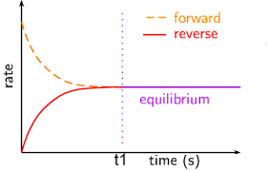
For any aqueous reaction, a reaction constant “K” can be derived through the following formula:
For a general chemical reaction occurring in a solution,
aA + bB ⇄ cC + dD
K_{eq} , the equilibrium constant can be given by the following expression:
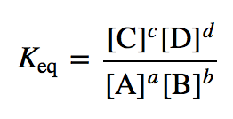
This expression relates the amounts of reactants and products at equilibrium for a chemical reaction. Every chemical reaction has a unique K value and depending on what (products or the reactants) the reaction favors, the equilibrium constant value can differ.
Le Chatelier’s Principle
In the case of a dynamic system, if the conditions are disturbed, the position of equilibrium moves to counteract the change to res-establish the state of equilibrium. If a chemical reaction at equilibrium faces a change in concentration, pressure or temperature of either the product or the reactant, the system will respond in such a manner which will nullify the effect of this change on the system.
Concept of Acid-Base dissociation
In the case of acid- base dissociations, the species which dissociates completely is termed strong. This means that the reaction proceeds completely to one particular side. Acids which dissociate completely are term strong acids while bases which dissociate completely are know as strong bases. On the contrary, acids and bases which undergo partial dissociation in an aqueous solution are known as weak acids and bases.
The strength of an acid or a base can be determined by the acid-base dissociation constant. For an acid, an acid dissociation constant can be derived from the aqueous reaction involving an acid. The same applies for a base. For example, in the reaction
HA_{(aq)} + H₂O_{(l)} ⇌ H₃O⁺_{(aq)} + A_{(aq)}⁻
the equilibrium constant for the dissociation is
K_{a} = [H₃O⁺][A⁻] / [H₂O][HA]
Acid-base dissociation constants are based on the amount of OH⁻ and H⁺ ions present. The larger the acid dissociation constant, the greater the amount of H⁺ ions in the solution at equilibrium. Similarly, the same applies for bases. However, instead of H⁺ ions, OH⁻ ions are measured. A greater measure of OH⁻ ions at equilibrium indicates a stronger base and a higher base-dissociation constant.
For example, in the reaction
B_{(aq)} + H₂O_{(l)} ⇌ BH_{(aq)}⁺ + OH_{(aq)}⁻
The equilibrium constant is given by the following expression:
K_{b} = K[H₂O] = [BH⁺] / [OH⁻][B]
The pH of a substance depends on the varying concentrations of H⁺ ions and OH⁻ ions present in a particular aqueous substance. The concentrations of H⁺ ions and OH⁻ ions vary drastically and therefore, defined using a logarithmic scale known as the pH scale. The formula for finding the pH of a substance is given by :
pH = -log₁₀[H⁺]
Indicators
The pH of a solution is determined using pH indicators. Acid- bas e indicators change color as their pH is lowered or increased. They are usually weak acids or bases. A general indicator is denoted by the following formula Hln. This ionizes in the following manner
HIn_{(aq)} ⇌ H_{(aq)}⁺ + In_{(aq)}⁻
The equilibrium constant for this reaction is expressed as K_{ai}, where K_{ai} =
[H⁺][ln⁻] / [Hln]
Therefore, when H⁺ ions are greater than 10 K_{ai}, then the color of ln⁻ dominates the indicator solution. However, when the H⁺ ion concentration is lesser than K_{ai}, then the color of Hln will dominate.
Buffers in the human Body
The human body requires a very ideal pH condition of 7.34 to 7.45. Large deviations from this range might lead to the death of the individual. A buffer system is present in the body which stabilizes the pH of the body to optimum conditions when there are fluctuations from the ideality. A buffer consists of an acid and its conjugate base in adequate amounts.
In the human body, a buffer system is seen in the blood which works with the respiratory system and the urinary system.
The main chemical buffer present in the body is the one involving carbonic acid as an acid in the buffer. In the blood, H₂CO₃ is in equilibrium with the hydrogen carbonate ion, HCO₃⁻ . The overall buffer reaction equation can be given as the following:
2H₂O_{(l)} + CO_{2(g)} ⇌ H₂CO_{3(aq)} + H₂O_{(l)} ⇌ HCO_{3(aq)}⁻ + H₃O⁺_{(aq)}
this buffer system is couple to the respiratory system as carbon dioxide is formed in this reaction and needs to be exhaled out of the system. The higher concentration of bicarbonate ions neutralize the acids which are produced as a result of the buffer reaction.
This experiment tests the effect of hyperventilation and hypoventilation. During hyperventilation, rapid breathing occurs. As a high amount of carbon dioxide is leaving the body at a high rate, the buffer system responds in a way so that it can replenish the lost carbon dioxide. The equilibrium therefore shifts to the left to produce more CO₂. In the case hypoventilation, breathing is shallow and at a slow rate. In such a case, the individual is not exhaling the required amount of CO₂ and therefore, the equilibrium shifts to the right to consume the excess CO₂ present in the body.
MATERIALS REQUIRED
As prescribed in the lab manual on BrightSpace ("VIOLENT FIRES SOON BURN OUT THEMSELVES SMALL SHOW'RS LAST LONG, BUT SUDDEN STORMS ARE SHORT" EQUILIBRIA; experiment 3,p 21)
PROCEDURE
As prescribed in the lab manual on BrightSpace ("VIOLENT FIRES SOON BURN OUT THEMSELVES SMALL SHOW'RS LAST LONG, BUT SUDDEN STORMS ARE SHORT" EQUILIBRIA; experiment 3,p 22-23)
OBSERVATIONS/ DISCUSSION
PART I – EQUILIBRIUM SHIFT
- CuSO₄ is a very light blue color when added to the clean test tube
- This light color is due to the presence of Cu²⁺ ion in the solution. This is also called cupric ion
- When 1 drop of concentrated NH₃ was added dropwise, the color of the solution changed rapidly to a dark shade of blue within 5 drops of concentrated NH₃
- The change to a darker shade of blue was due to the formation of complex copper ammonia ion. The blue became darker with further addition of NH₃. Therefore, the ion responsible for this change is Cu(NH₃)₄²⁺.
Cu²⁺_{(aq)} + 4 NH_{3(aq)} ⇌Cu(NH₃)₄²⁺_{(aq)}
- The NH₃ is a weak base, containing hydroxide ions, leads to the formation of copper(II) hydroxide first. Upon adding more NH₃, the copper(II) hydroxide forms a complex copper ammonia compound.
- After adding 10 drops 1mol/L HCl, there was no visible color change that was noticed. This is because the acid was able to neutralize the alkaline ammonia and causing the reaction to shift to the left. This process regenerates copper (II) ions. This process would only increase the Cu²⁺ concentration in the solution and therefore, there is no noticeable change in color.
- By repeating step 2, the solution only turned a darker shade of blue. By repeating step 3, there was no change observed. The solution remained a dark shade of blue.
- Copper sulphate is a blue color which is due to the light energy being used to excite the copper atoms.
- I expected the color of blue to darken further with the addition of HCl as there is production copper (II) ions. However, this was not observed.

PART II – MULTIPLE EQUILIBRIA
- Na₂CO₃ is a white anhydrous powder
- When 0.5mL of 0.01mol/L AgNO₃ was added to the sodium carbonate, an opaque precipitate was formed which turned the solution into a thick milky concoction.
- The precipitate which was formed is silver carbonate (Ag₂CO₃), turning the solution a milky color. Apart from Ag₂CO₃, sodium nitrate was also formed as a result of the reaction (NaNO₃). The change in color of the solution is caused by a displacement reaction as CO₃²⁻ displaces the NO₃⁻ ion. Therefore, the change in color is caused by the CO₃²⁻ ions.

2AgNO_{3(aq)} + Na₂CO_{3(aq)} ⇌ Ag₂CO_{3(s)} + 2NaNO_{3(aq)}

- When 6mol/L of HNO₃ (a clear solution with a very strong acidic odor) was added to the milky solution, the solution turned clear and transparent and there was no trace of the precipitate. This reaction produces AgNO₃ as the main product. H₂CO₃ is also one of the products which gives the solution the transparent color. This is not a reversible process as all the Ag₂CO₃ was used up as the precipitate no longer persisted. The follo-wing is the chemistry behind this reaction:
2H⁺_{(aq)} + CO₃²⁻_{(aq)} ⇌ H₂CO_{3(aq)} → H₂O_{(l)} + CO_{2(g)}
- When 0.1 mol/L of HCl was added to clear and transparent solution dropwise, the solution turned to a thick, cloudy and milky white solution and formed a precipitate which sedimented at the bottom of the test tube. the HCl, in this case, would dissociate in the aqueous solution to for H⁺ and Cl⁻ ions. The Cl⁻ ions react with the silver ions to form AgCl which is the white precipitate that was observed in the test tube. The following chemical reaction explains this process:
Ag⁺_{(aq)} + Cl⁻_{(aq)} ⇌ AgCl_{(s)}
- When concentrated NH₃ was added to this solution (a clear solution with a very strong odor) , the solution started to slowly become clear again. At a certain point, after adding 7-8 drops of NH₃, the solution split into two components, forming two layers. The bottom layer was clearer than the layer on top. This is due to the reaction between the Ag⁺ ions and NH₃. The bottom half of the test tube, which was clear, evidently reacted with the NH₃ to form [Ag(NH₃)₂]⁺. The milky portion of the solution was formed due to the dissociation of AgCl and the lack of NH₃ to react with all the Ag⁺ ions. The following reaction explains this:
Ag⁺_{(aq)} + 2NH_{3(aq)} ⇌ [Ag(NH₃)₂]⁺_{(aq)}
- When 0.1mol/L of KI was added to the solution, a precipitate was formed which is AgI according to the equation:
Ag⁺_{(aq)} + I⁻_{(aq)} ⇌ AgI_{(s)}
The Ag⁺ ion reacts to give this precipitate. This reaction will shift to the left to re-establish the equilibrium as it causes the dissociation of [Ag(NH₃)₂]⁺_{(aq)}
- When 0.1 mol/L of Na₂S is added to the solution drop-wise, a precipitate is formed again which is solid silver sulfide in this case (Ag₂S). This is as a result of reacting with Ag⁺ ions from AgI. This is explained through the following chemical reaction:
2Ag⁺_{(aq)} + S²⁻_{(aq)} ⇌ Ag₂S_{(s)}
- We observed that new equilibria were formed every time a new reactant was introduced to the solution in this part.
PART III: BUFFERS
- After creating a vortex in the water and inserting the pH probe, the pH of the water was recorded after a few minutes. The pH was recorded to be 6.45. The expected pH of water is 7, as it is thought to be neutral. However, when water comes in contact with air, the CO₂ present in the air dissolves in it to form carbonic acid. This might be a reason for the lower pH of the water.
- After adding 2.5g of sodium hydrogen carbonate, the solution was foggy for a few seconds. After completely dissolving, the pH was recorded to be 8.16. As a result of dissociation of Sodium bicarbonate in water, OH⁻ is produced as one of the products. This contributes to the alkalinity of the solution and therefore, increases the pH value of the solution.
- When 30mL of 0.1mol/L HCl was added to the solution, bubbles slowly started to form and float up to the surface of the solution. The stirring rate was increased and the production bubbles increased as well. The pH was recorded to be 7.23. The reaction between HCl and NaHCO₃ produces NaCl and HCO₃. However, HCO₃ is highly unstable and therefore, it breaks up into CO₂ and H₂O which is explained by the formation of bubbles. The acid has therefore been added to neutralize the solution and shift the equilibrium to the right in favor if the products.
- After adding 10mL of 0.85% lactic acid to the beaker, the pH decreased by a small amount. However, the bubbles continued to liberate. The pH was recorded to be 7.13. The pH did not reduce by a great extent as lactic acid is a weak acid. This drop in pH is also contributed by the production of dilute HCl This stimulates lactic acidosis in the body. The following is the chemical reaction:
NaCl_{(aq)} + HC₃H₅O_{3(aq)} → C₃H₅NaO_{3(aq)} + HCl_{(aq)}
- The rate of stirring was increased. There was no change observed and the pH remain constant at 7.14. However, the rate at which the bubbles escaped also increased. These bubbles are pockets of carbon dioxide. Increase in rate of stirring increased the outflow of CO₂. Therefore, in this case, the rate of the forward reaction was increased by increasing the kinetic energy of the particles. This shifted the equilibrium to the right, in favor of the products.
- After adding more NaHCO₃ there is an increase in the pH of the solution. The pH of the solution is now 7.23. the salt complete dissolves and eventually, the solution becomes clear. The increase in pH is due to the increase in the concentration of the CO₃ ²⁻ ions present in the solution. The lactate ion here is oxidized to form bicarbonate ion. Therefore, the equilibrium shifts in favor of the bicarbonate ions.
- After adding more NaHCO₃, there is a further increase in the pH of the solution which is now 7.32. This is because the equilibrium further shifts to the side which favors the production of bicarbonate ions which therefore increases the pH of the substance further on.
- When the dry ice was added to the solution, a drastic change in pH was not observed. The pH of the solution remained constant at 7.32. The dry ice slowly started to dissolve into the mixture.
- After adding the NH₄Cl to the solution, the production of a lot of bubbles were observed which came up to the surface of the solution. This is due to the production of carbon dioxide as a by-product of the reaction.
- The fluctuations in the pH denote that there were fluctuations in the formation of acids and bases in the solution.
END OF THE LAB REPORT QUESTIONS
- a) HCl is a very strong acid and it would dissociate completely if it was added. This means that the blood pH levels would drop drastically which is not a favorable condition for blood. Therefore, ammonium ion is used as an acid source in this case.
b) NH₄Cl is a compound where the anion does not act as a base. Due to this, the NH⁼₄ is able to act as an acid. This is not seen in other compounds of ammonia such as NH₄NO₃ or NH₄I.

- when acid is added to the beaker, there was an evident decrease in the pH of the solution. This id due to the dissociation reactions and the production of H⁺ ions in the solution. The following is the general equation for an acid dissociation:
HA_{(aq)} + H₂O_{(l)} ⇌ H₃O⁺_{(aq)} + A_{(aq)}⁻

- The increase acidity of the blood hinders the ability of hemoglobin to carry oxygen. This is due to the fact that the hemoglobin is bound to carbon dioxide which is transported to the respiratory system to be exhaled out of the system. Since carbon dioxide is already bound to the hemoglobin, it hinders the uptake of oxygen by the hemoglobin as a respiratory gas is already bound to the hemoglobin.
- the solution to the right is darker in color. This is due to the drop in pH level, the blood buffer system undergoes a reaction to produce CO₂ gas which gives the blood the dark color. The equilibria of the buffer system shifts to the right, favoring the production of carbon dioxide in the blood.
- the pH of the solution should rise as CO₂ leaves the soda solution as it is stirred vigorously. This is because every time the soda is stirred, it comes in contact with the air and the surrounding. This increases the rate at which carbon dioxide is diffused to the surroundings. The escaping of CO₂ will lead to the increase in the pH of the flat soda
- when chicken pant, they are exhaling carbon dioxide at a very fast rate. This means that an increased amount of carbon dioxide leaves the body. As more carbon dioxide exits the body, the blood pH of the chicken is subject to rise. Due to this, the equilibrium will shift to the left and re-postion itself and there will be a reduction in the carbonic acid content in the blood of the chicken. Egg shell requires carbonate ions to synthesize hard calcium carbonate shells. Since carbonic acid is a reactant leading to the production of carbonate ions, the reduction in carbonic acid in the body will lead to the formation eggshells which have a small concentration of carbonate ions. This makes the shell brittle and break out.
CONCLUSION
Equilibria is established by the reaction system when the equilibrium of the system is disturbed by reacting in an opposite manner. The experiments which were undertaken shed light on this ability of a reaction system as described by the Le Chatelier’s principle. The recreation of the buffer system of the human body in the lab showed a rough working of the buffer system in the blood which gave an idea of the working of the buffer system.

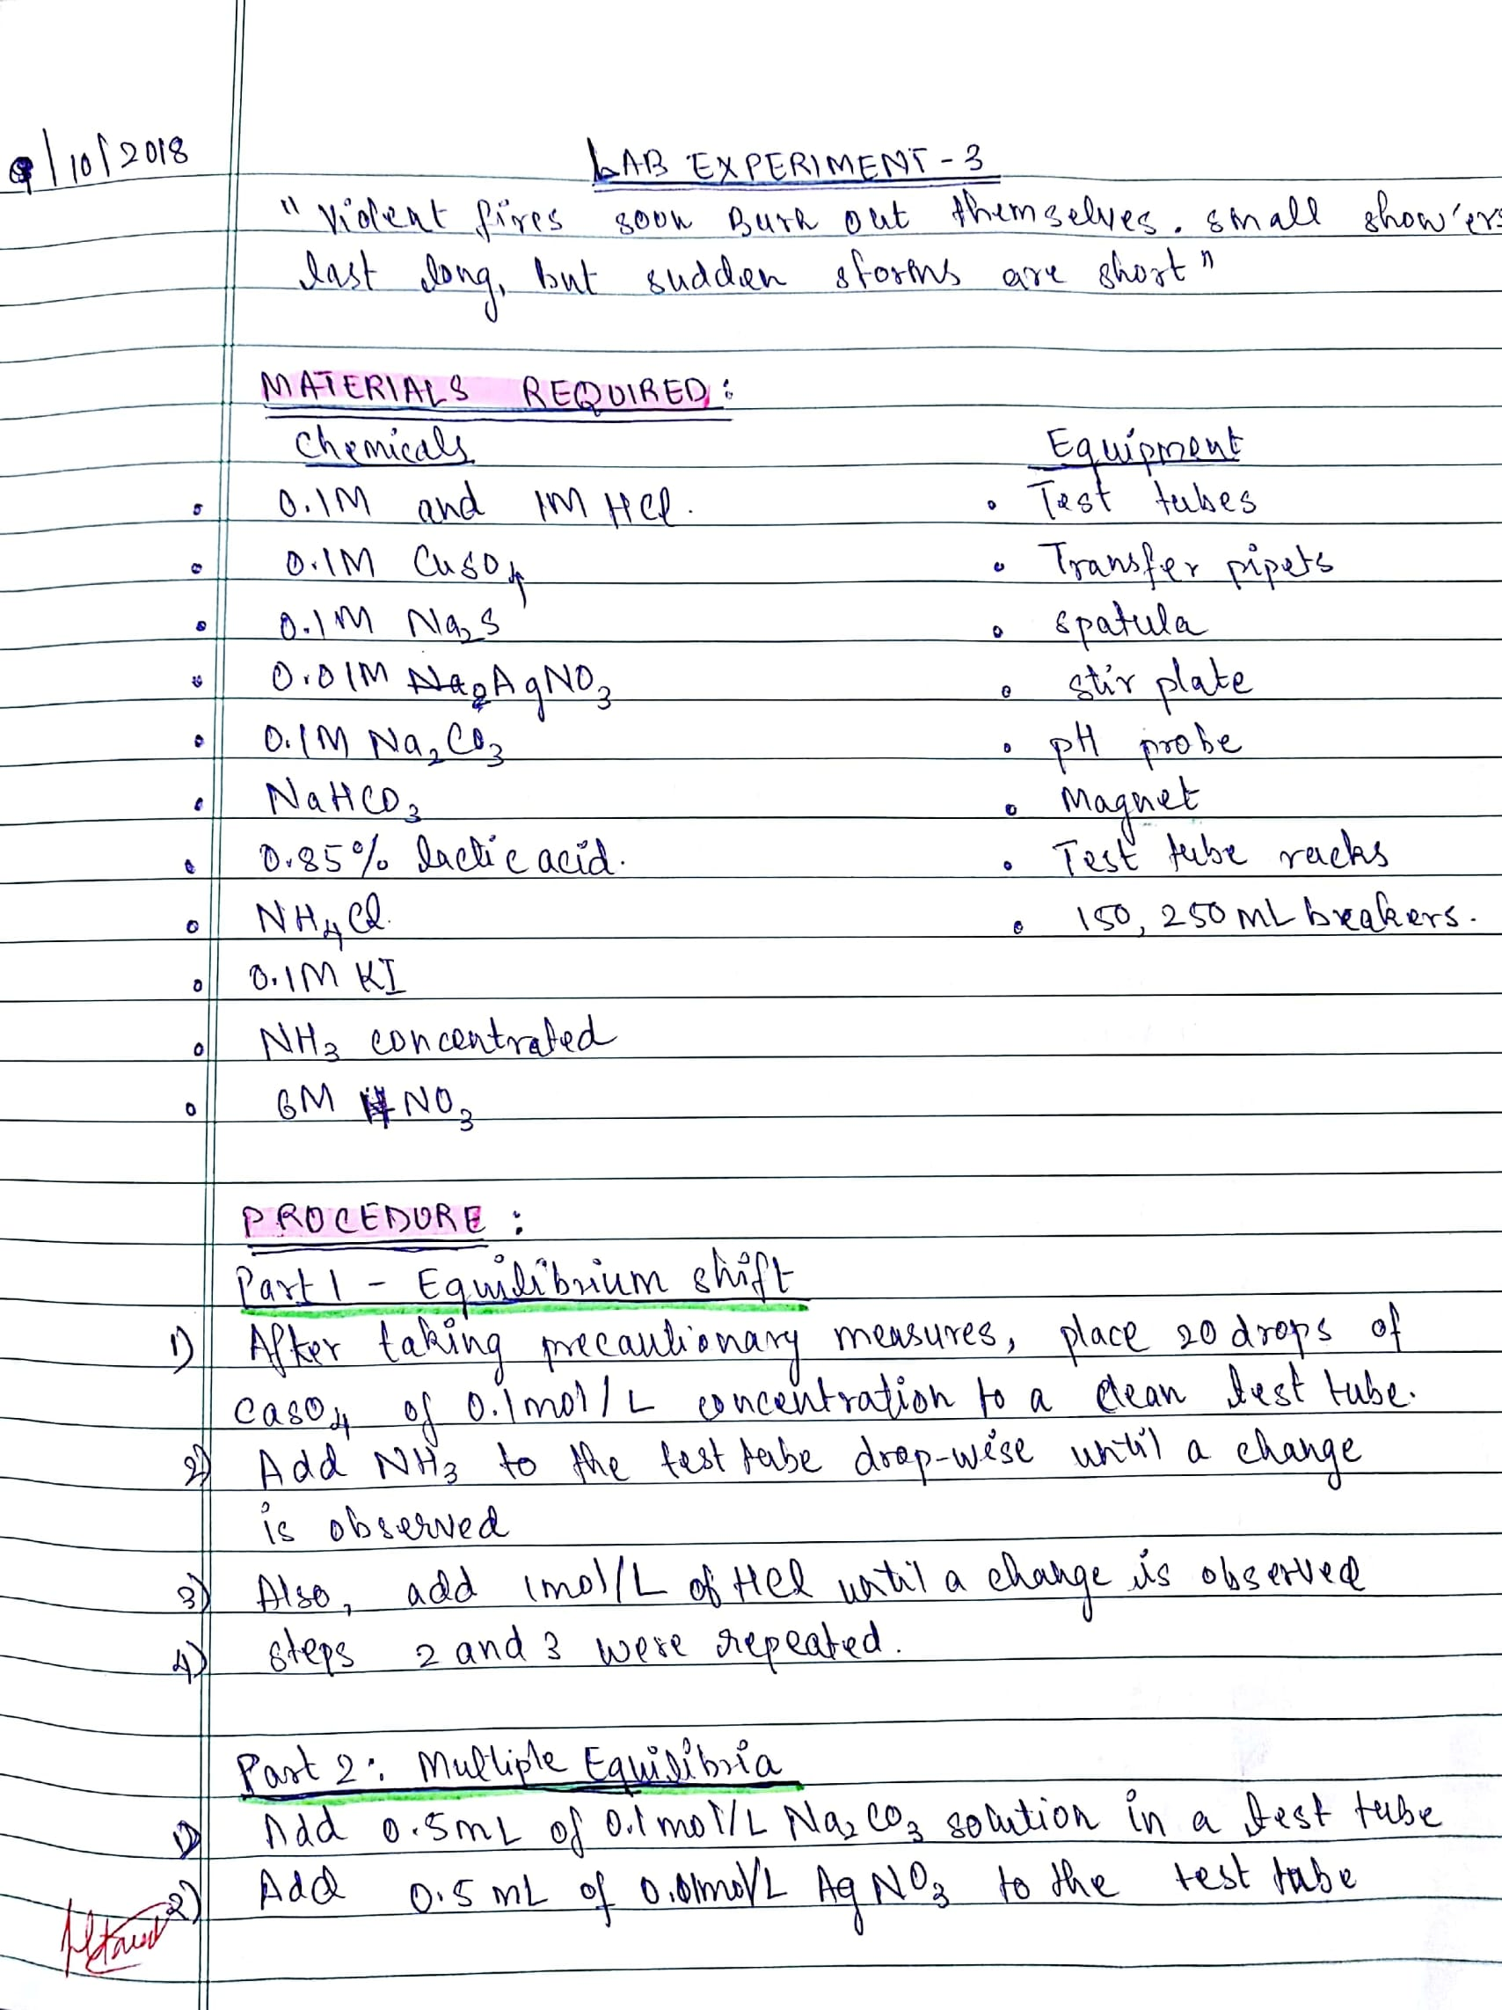
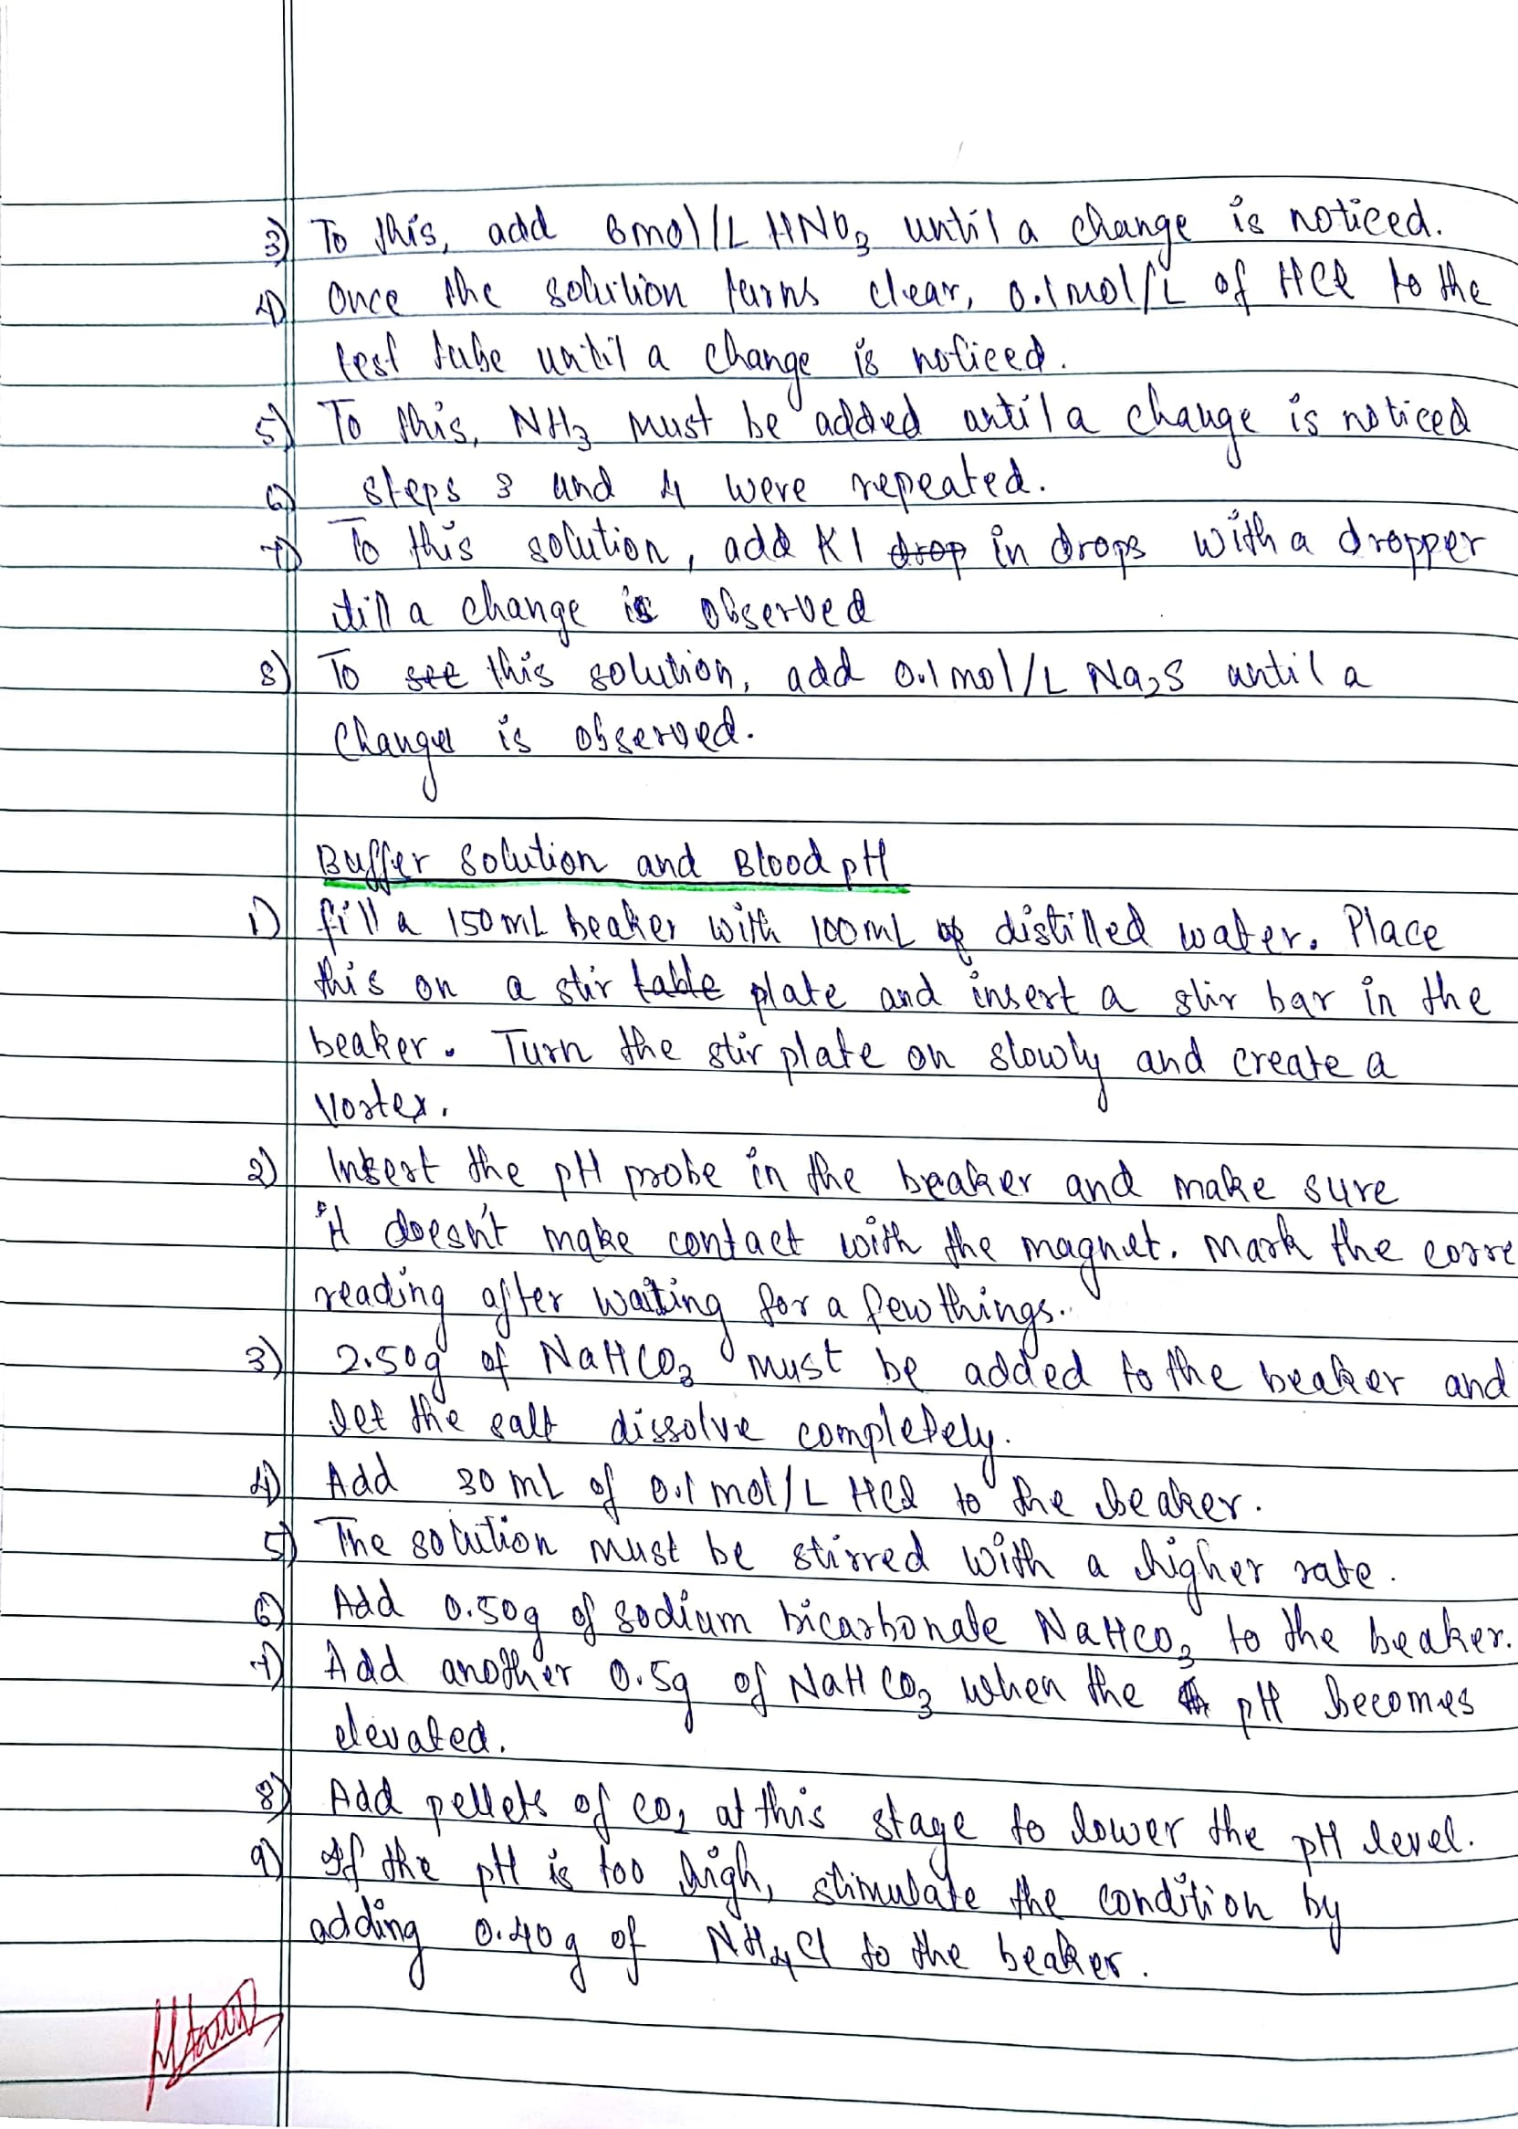
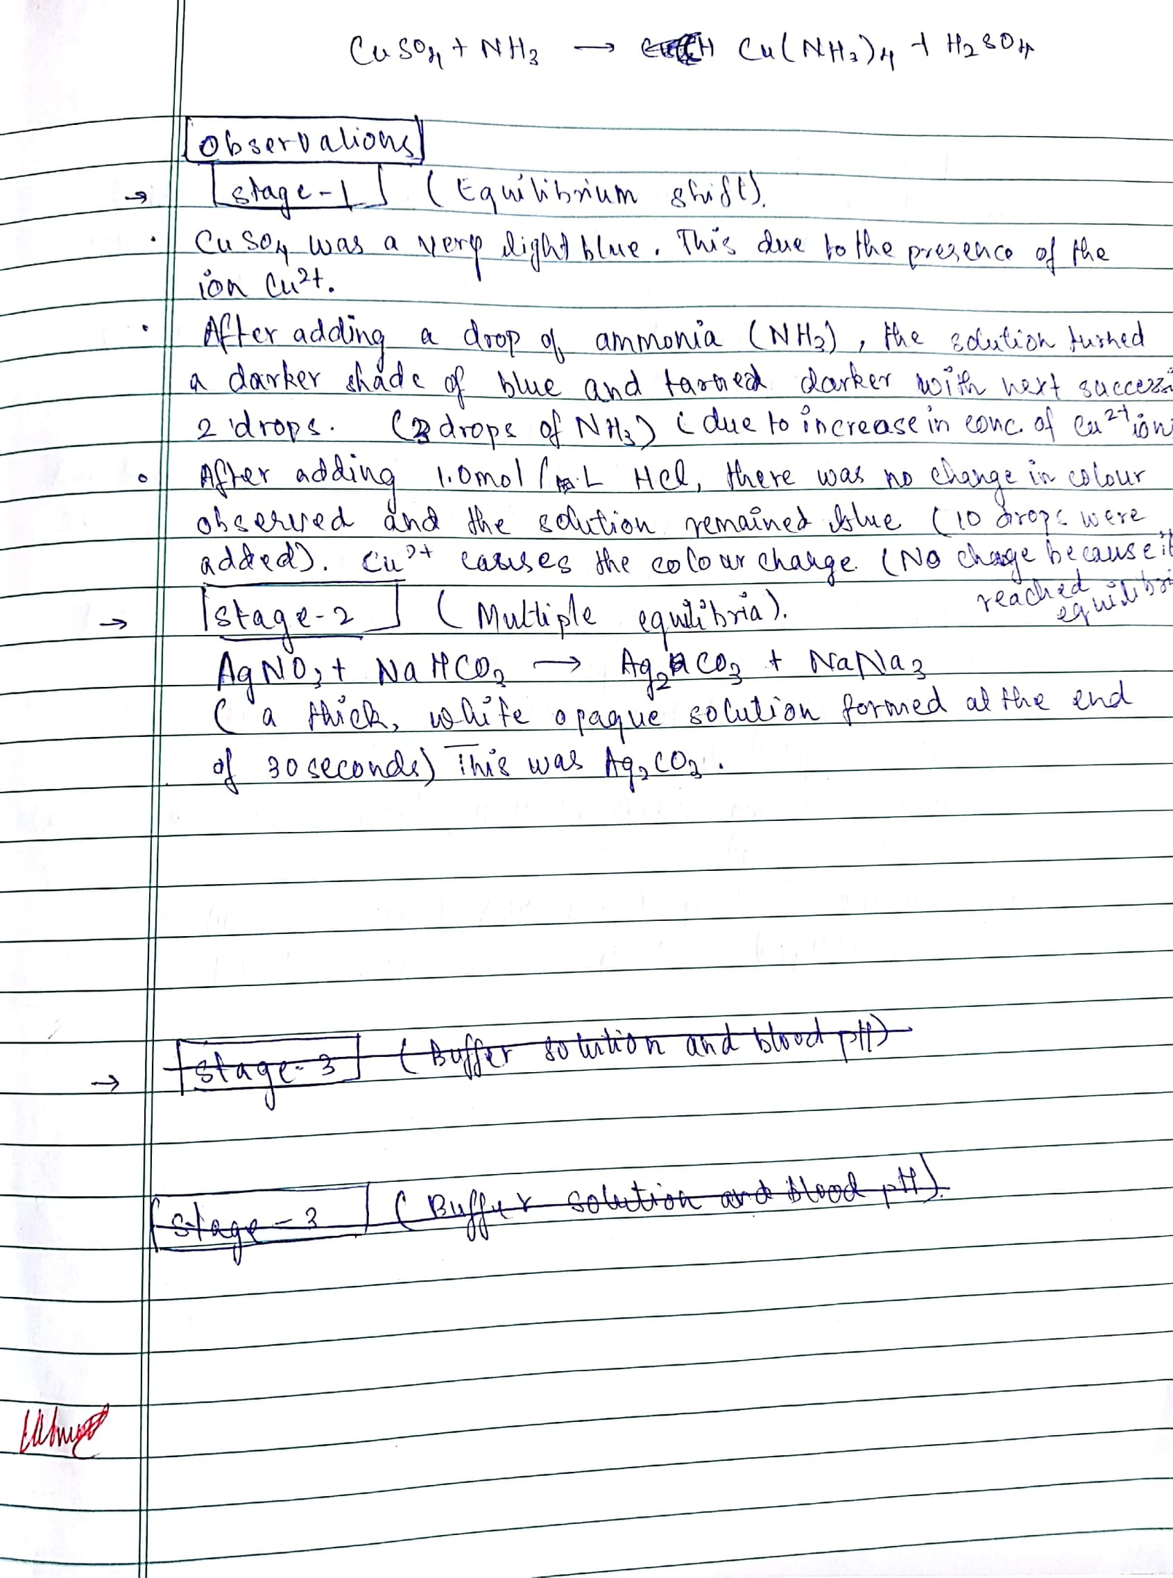
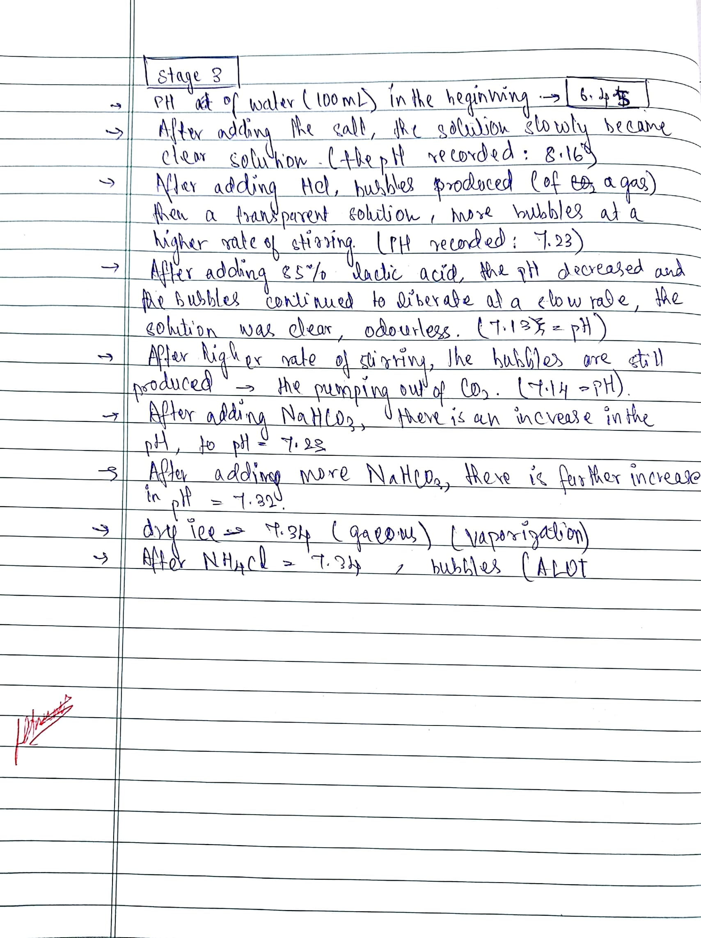

“What Is Chemical Equilibrium?” What Is Chemical Equilibrium? | Chemical Equilibrium | Siyavula, www.siyavula.com/read/science/grade-12/chemical-equilibrium/08-chemical-equilibrium-01.
Lesson 4 Equilibrium - Interpreting Equilibrium Graphs. www.dynamicscience.com.au/tester/solutions1/chemistry/equilibrium/Lesson 3- equilibriumgraphs.pdf.
Libretexts. “Principles of Chemical Equilibrium.” Chemistry LibreTexts, Libretexts, 21 July 2016, chem.libretexts.org/Textbook_Maps/Physical_and_Theoretical_Chemistry_Textbook_Maps/Supplemental_Modules_(Physical_and_Theoretical_Chemistry)/Equilibria/Chemical_Equilibria/Principles_of_Chemical_Equilibria/Principles_of_Chemical_Equilibrium.
"VIOLENT FIRES SOON BURN OUT THEMSELVES SMALL SHOW'RS LAST LONG, BUT SUDDEN STORMS ARE SHORT" EQUILIBRIA; experiment 3,p 14-27
Le Chatelier's Principle, www.chemguide.co.uk/physical/equilibria/lechatelier.html.
Libretexts. “16: Acids and Bases.” Chemistry LibreTexts, Libretexts, 13 Dec. 2016, chem.libretexts.org/Textbook_Maps/General_Chemistry/Map:_A_Molecular_Approach_(Tro)/16:_Acids_and_Bases.
Helmenstine, Anne Marie, and Helmenstine. “What You Need to Know to Calculate PH.” ThoughtCo, www.thoughtco.com/how-to-calculate-ph-quick-review-606089.
“AcidBase.” Indicators, sciborg.uwaterloo.ca/~cchieh/cact/c123/indicator.html.
"VIOLENT FIRES SOON BURN OUT THEMSELVES SMALL SHOW'RS LAST LONG, BUT SUDDEN STORMS ARE SHORT" EQUILIBRIA; experiment 3,p 14-27

