
chemistry Experiment -2
Aishwarya Pramudi Suresh, 300083747
Teacher Assistant: Luana Porto
CHM1311 – Z01


2nd October, 2018
Department of chemistry
University of Ottawa.

INTRODUCTION
Standard Heat of Formation
“Standard heat of formation refers to the enthalpy change required to form one mole of a compound from its constituent elements at standard temperature and pressure”. The SI unit of Standard heat of formation is kJ/mol.
Standard heat of formation can be negative or positive. When there is loss of heat from the system of reaction to the surrounding, it is an exothermic reaction and it is denoted with a negative sign. However, when there is heat taken into the system, then it is an endothermic reaction and it is denoted with a positive sign.
Hess’s Law
According to Hess’s Law, the total enthalpy of a particular reaction is the sum of all enthalpies at intermediate stages and steps. This law aids in finding the total enthalpy of even the most complex reaction systems.
An example of Hess’s Law has been demonstrated below (from the prelab exercise)
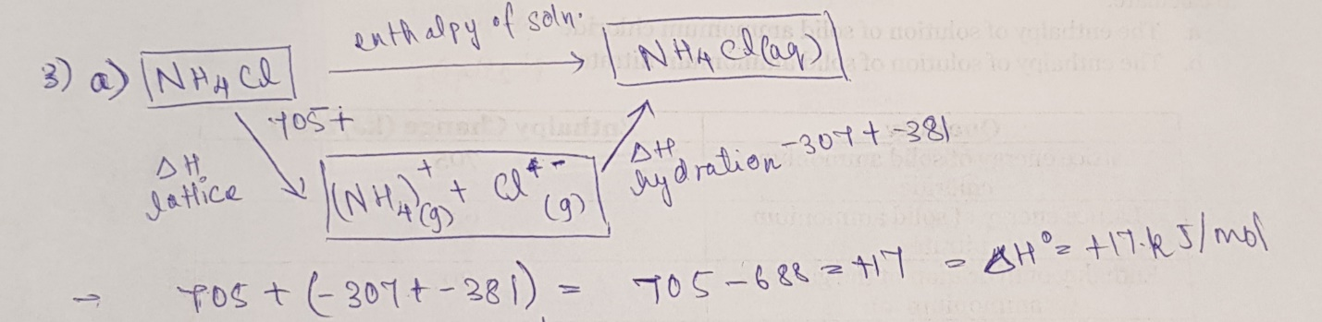
How can we measure enthalpy change in a particular reaction system?
A calorimeter can be used to measure the change in thermal enthalpy of a particular reaction system. A simple calorimeter can be constructed by placing a tin can within a Styrofoam container. The amount of thermal enthalpy required to increase the temperature by one degree for one gram of a particular substance is the Specific heat capacity of that substance. The specific heat capacity gives an idea as to how much thermal energy is required to raise the temperature by a degree. The energy required to change the temperature of a substance can be modelled in the following equation:
$$Q=mcΔT$$
Here, $c$ refers to the specific heat capacity, $m$ refers to the mass of the substance and $ΔT$ refers to the change in the temperature. In a simple calorimeter, the reaction between a salt and water is an endothermic reaction which takes place between the tin can and the Styrofoam container. In this case, the enthalpy taken in for the reaction is the enthalpy lost by the substance within the tin can. Enthalpy of Solution
“The enthalpy change of solution is the enthalpy change when 1 mole of an ionic substance dissolves in water to give a solution of infinite dilution.”
The enthalpy of the solution is also known as the enthalpy of dissolution in the case of an aqueous solution. The enthalpy of dissolution is the summation of lattice dissociation enthalpy and hydration enthalpy. The heat enthalpy evolved as a result of the breaking of one mole of a crystal lattice substance is the lattice dissociation enthalpy. When new bonds are made between the ions and water molecules, the energy released as a result of this bond formation is the hydration enthalpy. This is true to gaseous ions.
The following equation can be used to calculate the enthalpy of solution:
$$ΔH=\frac{Q}{n}=\frac{-mCΔT}{n}$$
Where $"n$” is the moles of the salt required, $m$ is the mass of the solution, $C$is the specific heat capacity of the solution $ΔT$ is the change in temperature.
MATERIALS REQUIRED
- 100cm³ Measuring Cylinder
- A Styrofoam container
- A tin can
- Spatula
- Temperature Probe connected to LabQuest
- Adequate supply of Ammonium Chloride (NH₄Cl)
- Sheet of paper or beaker
- Electrical balance
- A timer
PROCEDURE
- Precautionary measurements were taken before the lab began. We made sure to equip ourselves with lab coat and safety goggles.
- After this, we measured 100mL of distilled water in a measuring flask and transferred the water to the Styrofoam container
- Using the same measuring flask, we measured 100mL of water and transferred the water to the tin can. The water will be perceived as the drink.
- As inferred from the Pre-lab exercise, the standard heat of formation of Ammonium chloride is +17 kJ/mol. Using this value, the amount of Ammonium chloride required for the experiment was deduced using the formula $Q=mcΔT$. As a result of calculations, the mass of Ammonium Chloride was deduced as 6.5grams.
- Using an electrical balance and a beaker, 6.5grams of Ammonium Chloride was measured.
- Carefully, the Ammonium Chloride was added to the 100cm³ of water in the Styrofoam container.
- A temperature probe which is connected to the LabQuest, was placed in the water within the tin can.
- Using a timer, the reaction was left to progress for 5 minutes and the temperature after 5 minutes was recorded.
- The temperature of the water was recorded with every successive addition of 6.5grams of Ammonium Chloride.
- This process was repeated for 4 trials.

OBSERVATIONS and RAW DATA
- With every successive increase in the addition of the ammonium chloride, the temperature was noticeably declining.
- We observed that the rate at which the temperature decreased was greater when the reaction solution was stirred vigorously. Stirring the reaction solution ensured that a greater number of salt particles are dissolved.
- The initials temperature was recorded to be 22.8⁰C
Table 1: The temperature corresponding to each successive increase in mass of NH₄Cl
No. of Trials | Mass of NH₄Cl in grams | Temperature in ⁰C
1 | 6.5 | 21.8
2 | 13 | 18.6
3 | 19.5 | 17.4
4 | 26 | 13.8
Figure 1: Digital representation of the raw data on LoggerPro for 4 trials
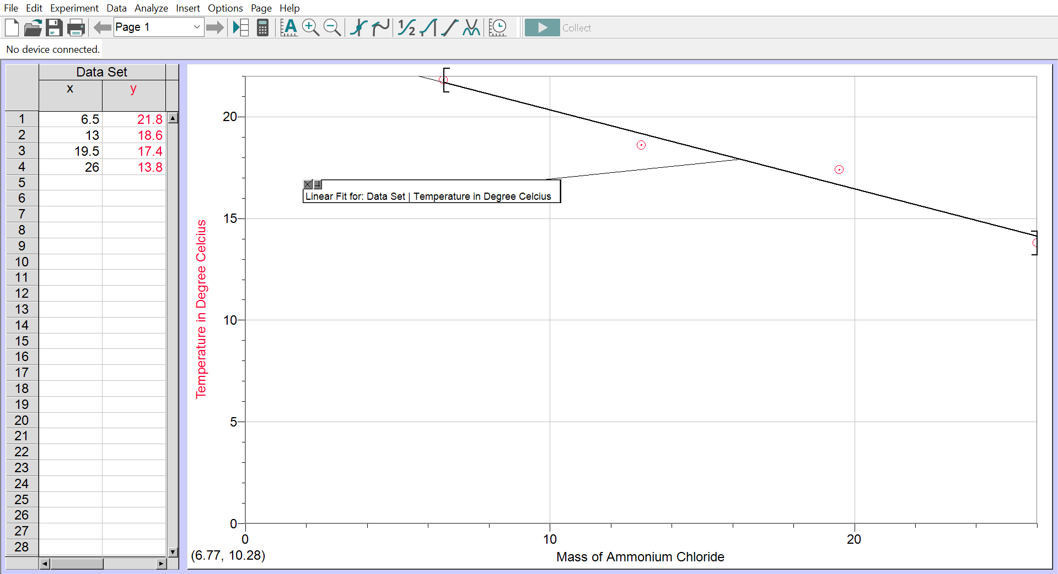
CALCULATIONS
Finding the amount of NH₄Cl required for the experiment:
Using the formula :$Q=mcΔT$
= 100 × 4.18 × 5
= 2090J = 2.09kJ
Using the formula $\frac{Q}{n}$ =
= 2.09/n = 17kJ
n = 0.122
Therefore, the mass of NH₄Cl =
Molar mass of NH₄Cl × moles of NH₄Cl
= 53.491 × 0.122
= 6.5grams of NH₄Cl.
DISCUSSION
- The results clearly show that with an increase in the mass of ammonium chloride added, there is a significant decrease in the temperature of the water within the tin container.
- despite the noticeable negative correlation, the large errors associated with the experimental apparatus should have decreased the accuracy of the results to a great extent.
- The experimental apparatus provides a basic method to decrease the temperature of the water in the tin can.
- while measuring water using the measuring cylinder, due to human error, the accurate value of the water might have not been recorded.
- while measuring the quantity of ammonium chloride using the electrical balance, the precision of the electrical balance was limited to two decimal places. This gives a good idea of how much error is carried forward into the experiment.
- The experimental apparatus is rudimentary. The possibility of the reaction solution interacting with the water within the tin can is very high. This apparatus can be re-modelled such that the water is compartmentalized in a sealed container.
- The apparatus should also be insulated adequately in such a manner so tat the material of the container holding the reaction mixture does not affect the thermodynamics of the system.
CONCLUSION
Therefore, we can say that as the mass of the salt is increased successively, the temperature of the water is subject to decrease due to the endothermic nature of the reaction solution.
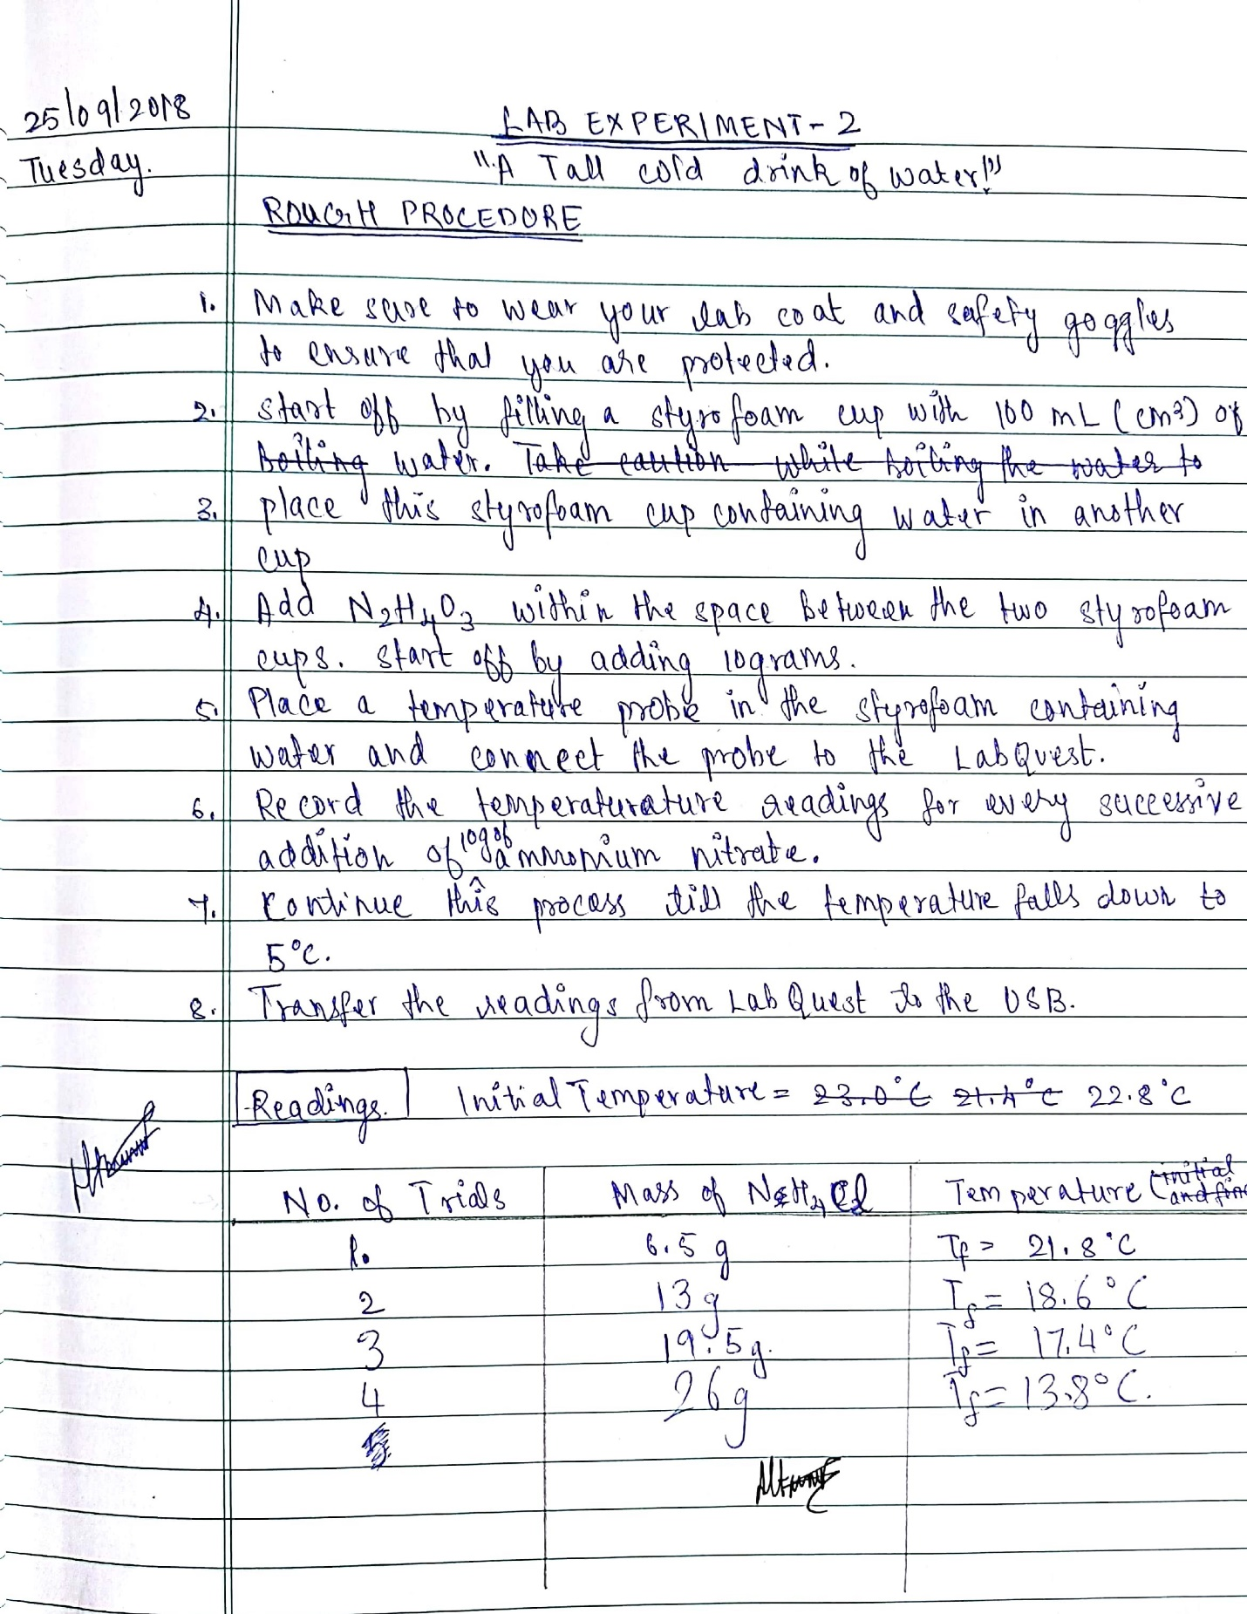
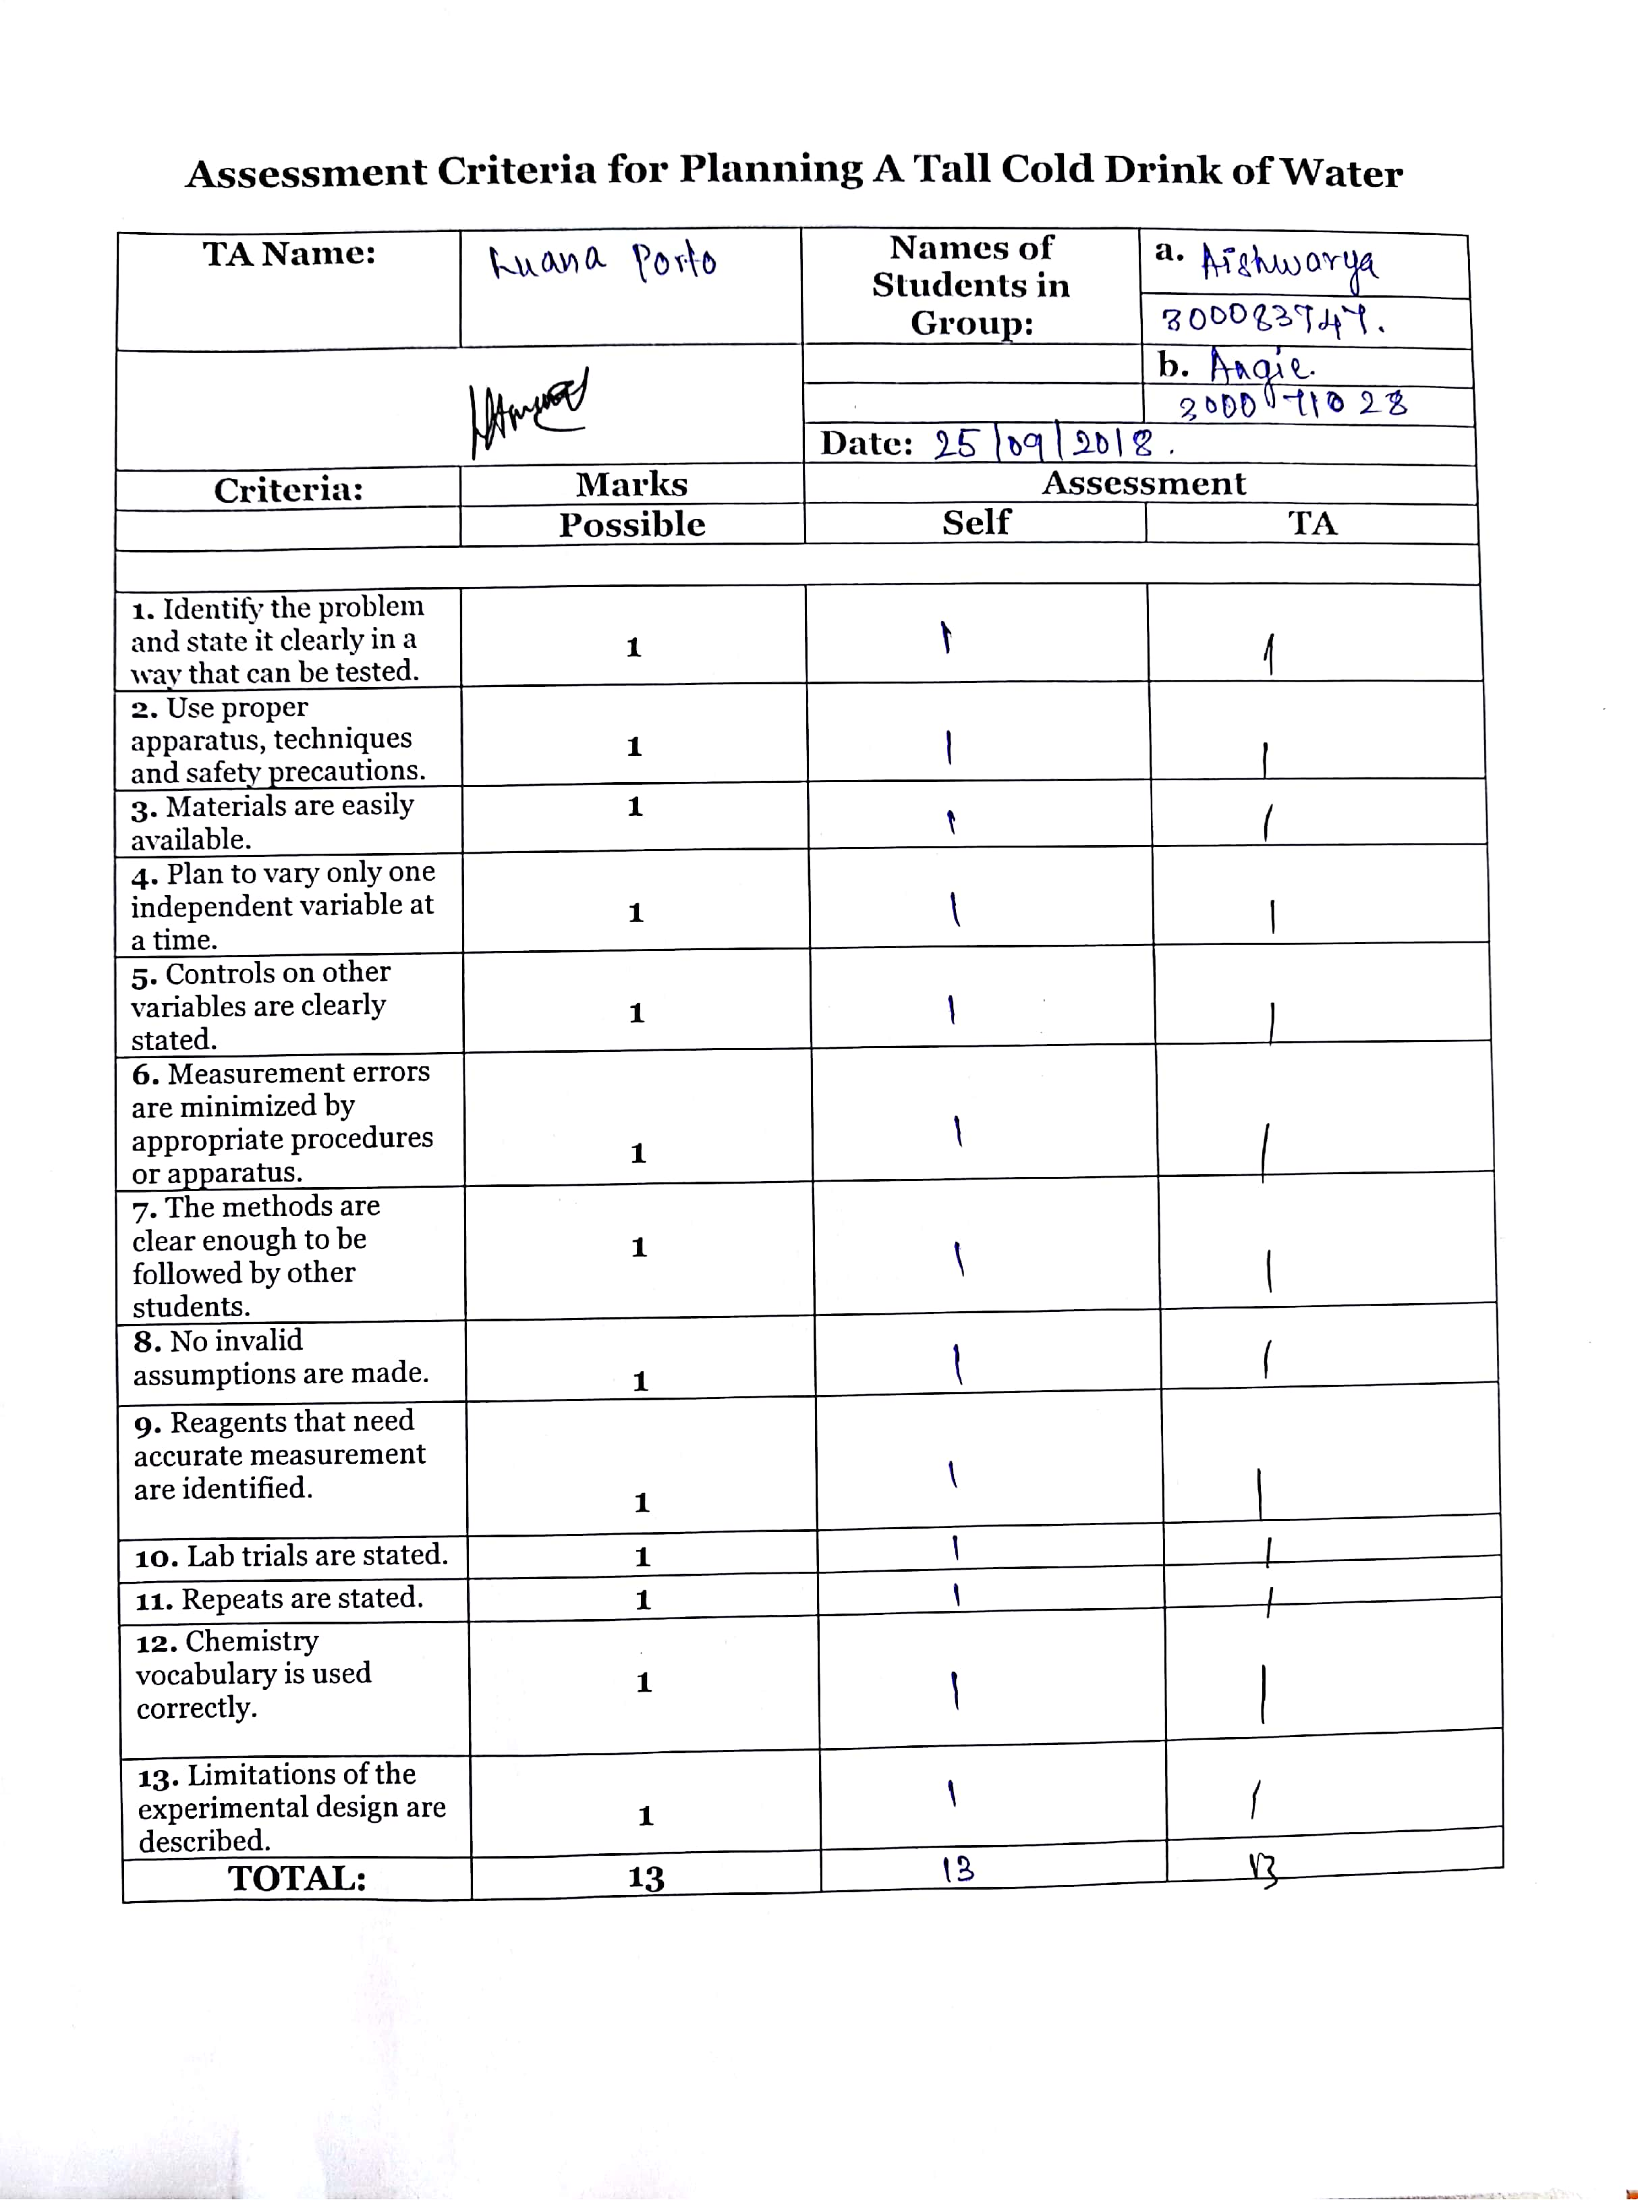
Other References
- Silberberg, M. S., Venkateswaran, R., Lavieri, S., & Amateis, P. (2013). Chemistry: The molecular nature of matter and change. Toronto: McGraw-Hill Ryerson.
- “...BUT A HOT TEMPER LEAPS O’ER A COLD DECREE” ENTHALPY OF VARIOUS REACTIONS., EXPERIMENT 2: A Tall Cold Drink of Water! , p., 27-30.

Intermediate, C. (n.d.). Chemistry for Non-Majors. Retrieved from https://courses.lumenlearning.com/cheminter/chapter/standard-heat-of-formation/
Libretexts. (2016, September 20). Hesss Law. Retrieved from https://chem.libretexts.org/Textbook_Maps/Physical_and_Theoretical_Chemistry_Textbook_Maps/Supplemental_Modules_(Physical_and_Theoretical_Chemistry)/Thermodynamics/Thermodynamic_Cycles/Hesss_Law
Enthalpy of Solution. (n.d.). Retrieved from http://sites.middlebury.edu/chem103lab/2017/01/24/heats-of-reaction/
Enthalpies of solution and hydration. (n.d.). Retrieved from https://www.chemguide.co.uk/physical/energetics/solution.html

