chemistry lab report - 1
Verification of Charles law and Boyle’s law

LAB REPORT BY AISHWARYA SURESH
TEACHER ASSISSTANT: LUANA PORTO

INTRODUCTION
A gas is state of matter of a particular substance or a collection of substances where the particles do not possess a defined volume or shape. They are known to imitate the shape of their container. The concept of ideal gases, developed on the underlying principles introduced by Robert Boyle and Jacques A. C Charles, assumes that the gas particles consume negligible amount of space. They are also assumed to have absolutely no intermolecular forces of attraction. Ideal gases abide by the following ideal gas equation which states that:
PV = nRT,
Where P is pressure (Pa), V is volume (m³/kg), T is Temperature (K), R is the gas constant of a particular gas, and n refers to the number of moles.This theory of ideal gases may hold true for gases when they are present in conditions with optimum temperature and pressure. However, at differing measures of temperature and pressures, the concept of ideal gases does not hold true for real gases. For example, at high pressures and low temperatures, the volume of gas has been observed to decrease. Real gases exhibit such behavior as their intermolecular forces are affected by the changes in temperature and pressure.
Charles Law
The Charles Law establishes a correlation between the temperature and volume of a particular gas or mixture of gases. “If any gas is heated at constant pressure, its volume changes directly as its absolute temperature". The law is represented through the following formula.
$$\frac{V}{T}=\frac{V^{'}}{T^{'}}$$
Where $V$ is the original volume, $T$ is the original Kelvin temperature, $V^{'}$ is the new volume and $T^{'}$is the new temperature in Kelvin.
Boyle’s Law
The Boyle’s Law draws a correlation between the volume and the pressure of a particular gas or mixture of gases. “If a gas is compressed while keeping the temperature constant, the pressure varies inversely with the volume”. The law is presented by the equation
$$V^{'}=V\frac{P}{P^{'}}$$
Where $V^{'}$ is the new volume, $P$ is the original pressure, $P^{'}$ is represents the new pressure and $V$is the original volume.
HYPOTHESES: I hypothesized that a positive correlation between time and volume will be obtained as a result of verification of the Charles Law. I also hypothesized that as a result of the Boyles law verification experiment, a negative correlation between volume and pressure will be obtained.
PROCEDURE: As described in the lab manual
OBSERVATIONS/RAW DATA/RESULTS :
While verifying the Boyle’s law, differences in pressure were felt while maneuvering the syringe to fit different volumes. As we decreased the volume gradually, we could feel the increase in pressure from within the syringe.
Raw data for Charles Law
Table 1. Results of Charles experiment
Condition | Temperature (in ºC) | Volume (cm³)
While boiling | 100 ($T$) | 154.3cm³ ($V$)
While in ice bath | 2.9 ($T^{'}$) | 128.2cm³ ($V^{'}$)

Raw data for Boyles Law
Table 2. Results of Boyles Lay experiment
Trial No | Independent variable (Volume in cm³) | Dependent Variable (Pressure in kPa)
1 | 5.80 | 123.64
2 | 8.80 | 102.25
3 | 10.80 | 102.04
4 | 15.80 | 101.98
5 | 17.80 | 91.03
6 | 20.80 | 77.44

Figure 1. Graph of Pressure against Volume (Screen shot from Logger Pro)
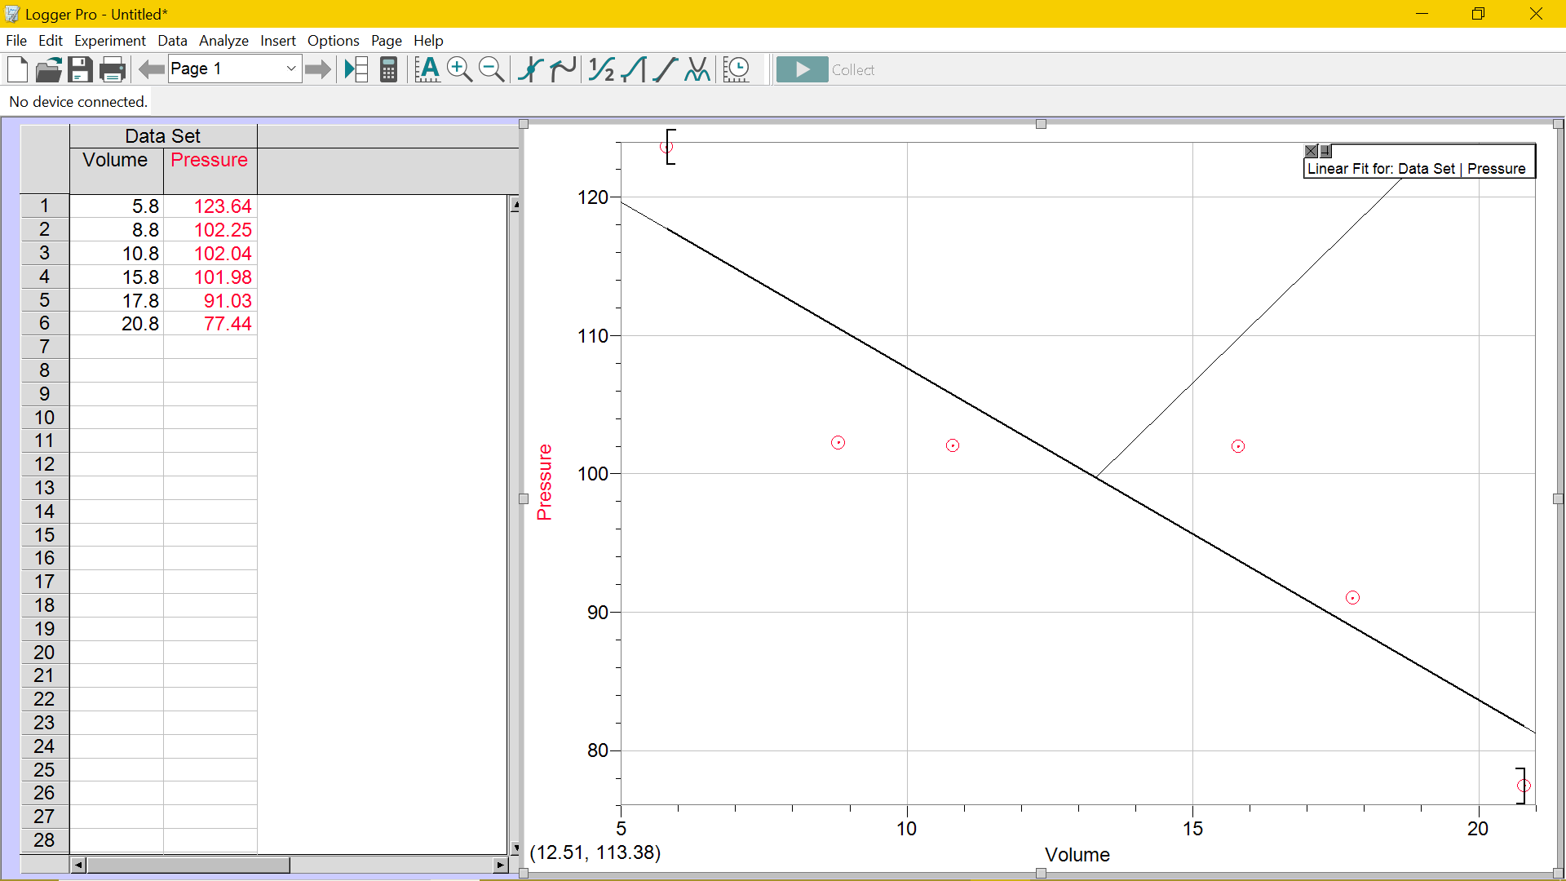
CALCULATIONS
Charles Law:
Calculation of $V^{'}$ = The difference between $V$ and $V$_{cw} ( where $V$_{cw} is the volume of the cold water)
Therefore, $V$-$V$_{cw} = $V^{'}$
= 154.2 – 26
$V^{'}$= 128.2cm³
Boyles Law:
$$V^{'}=V\frac{P}{P^{'}}$$
Taking the first set of readings and second set of readings, we can estimate the value of $P^{'}$ and verify it with the value obtained as a result of the experiment.
If $V$= 5.80cm³ , $P$= 123.64kPa and $V^{'}$= 8.80cm³ , then according to the Boyles law,
$$V^{'}×P^{'}=V×P$$
Therefore, inserting values into the equation,
8.80×$P^{'}$= 5.80×123.64
8.80×$P^{'}$= 717.112
$P^{'}$= 81.49kPa
The experimental value of pressure in trial 2 was 102.25kPa. This difference in theoretical and experimental values can be attributed to errors in experimental procedure.
Identifying the Boyles constant
The Boyles Law constant can be deduced through the following formula=
$$P×V=k$$
Therefore, for example,
Taking the values of the first trial, $P$= 123.64 kPa and $V$= 5.80cm³
= 5.80×123.64
= 717.112
DISCUSSION
The results obtained at the end of the experiment are congruent to the hypothesis that was made in the beginning. The experiment validated both laws successfully. The graph presented above illustrates a negative trend between volume and pressure as hypothesized in the introduction. The Charles experiment was not conducted multiple times and therefore, the lack of multiple trials brings down the accuracy of the result. There were many possible sources of error in the experiment which could have greatly diminished the accuracy of the results obtained. The experiment was subject to many random and human errors. In the Charles’ law verification experiment, the pressure exerted on the gas is assumed to be constant. However, in actuality, we are ignorant to the subtle changes in atmospheric pressure affected by other random variables in the environment. Similarly, in the Boyles’ law verification experiment, the temperature was assumed to be constant.
A major experimental error was noticed in the apparatus of the Charles law verification experiment when $V$ was equated to the volume of the Erlenmeyer flask till the rubber stopper. The volume of the gas would be much lesser in actuality.
Overall, the results confirm that gases deviate from the ideal concept and do exhibit intermolecular forces of attraction.

CONCLUSION
The data points collected for the Charles law indicate that at higher temperatures, the increases (at 100ºC, volume was 154.3cm³). However, at lesser temperatures, the volume of the gas was observed to decrease (at 2.9ºC, volume was 128.2cm³). The data points collected for Boyles law indicate a negative correlation which, according to the Boyles Law, there was a decrease in pressure with the increase in volume.
Figure2. Copy of of Raw data from notebook

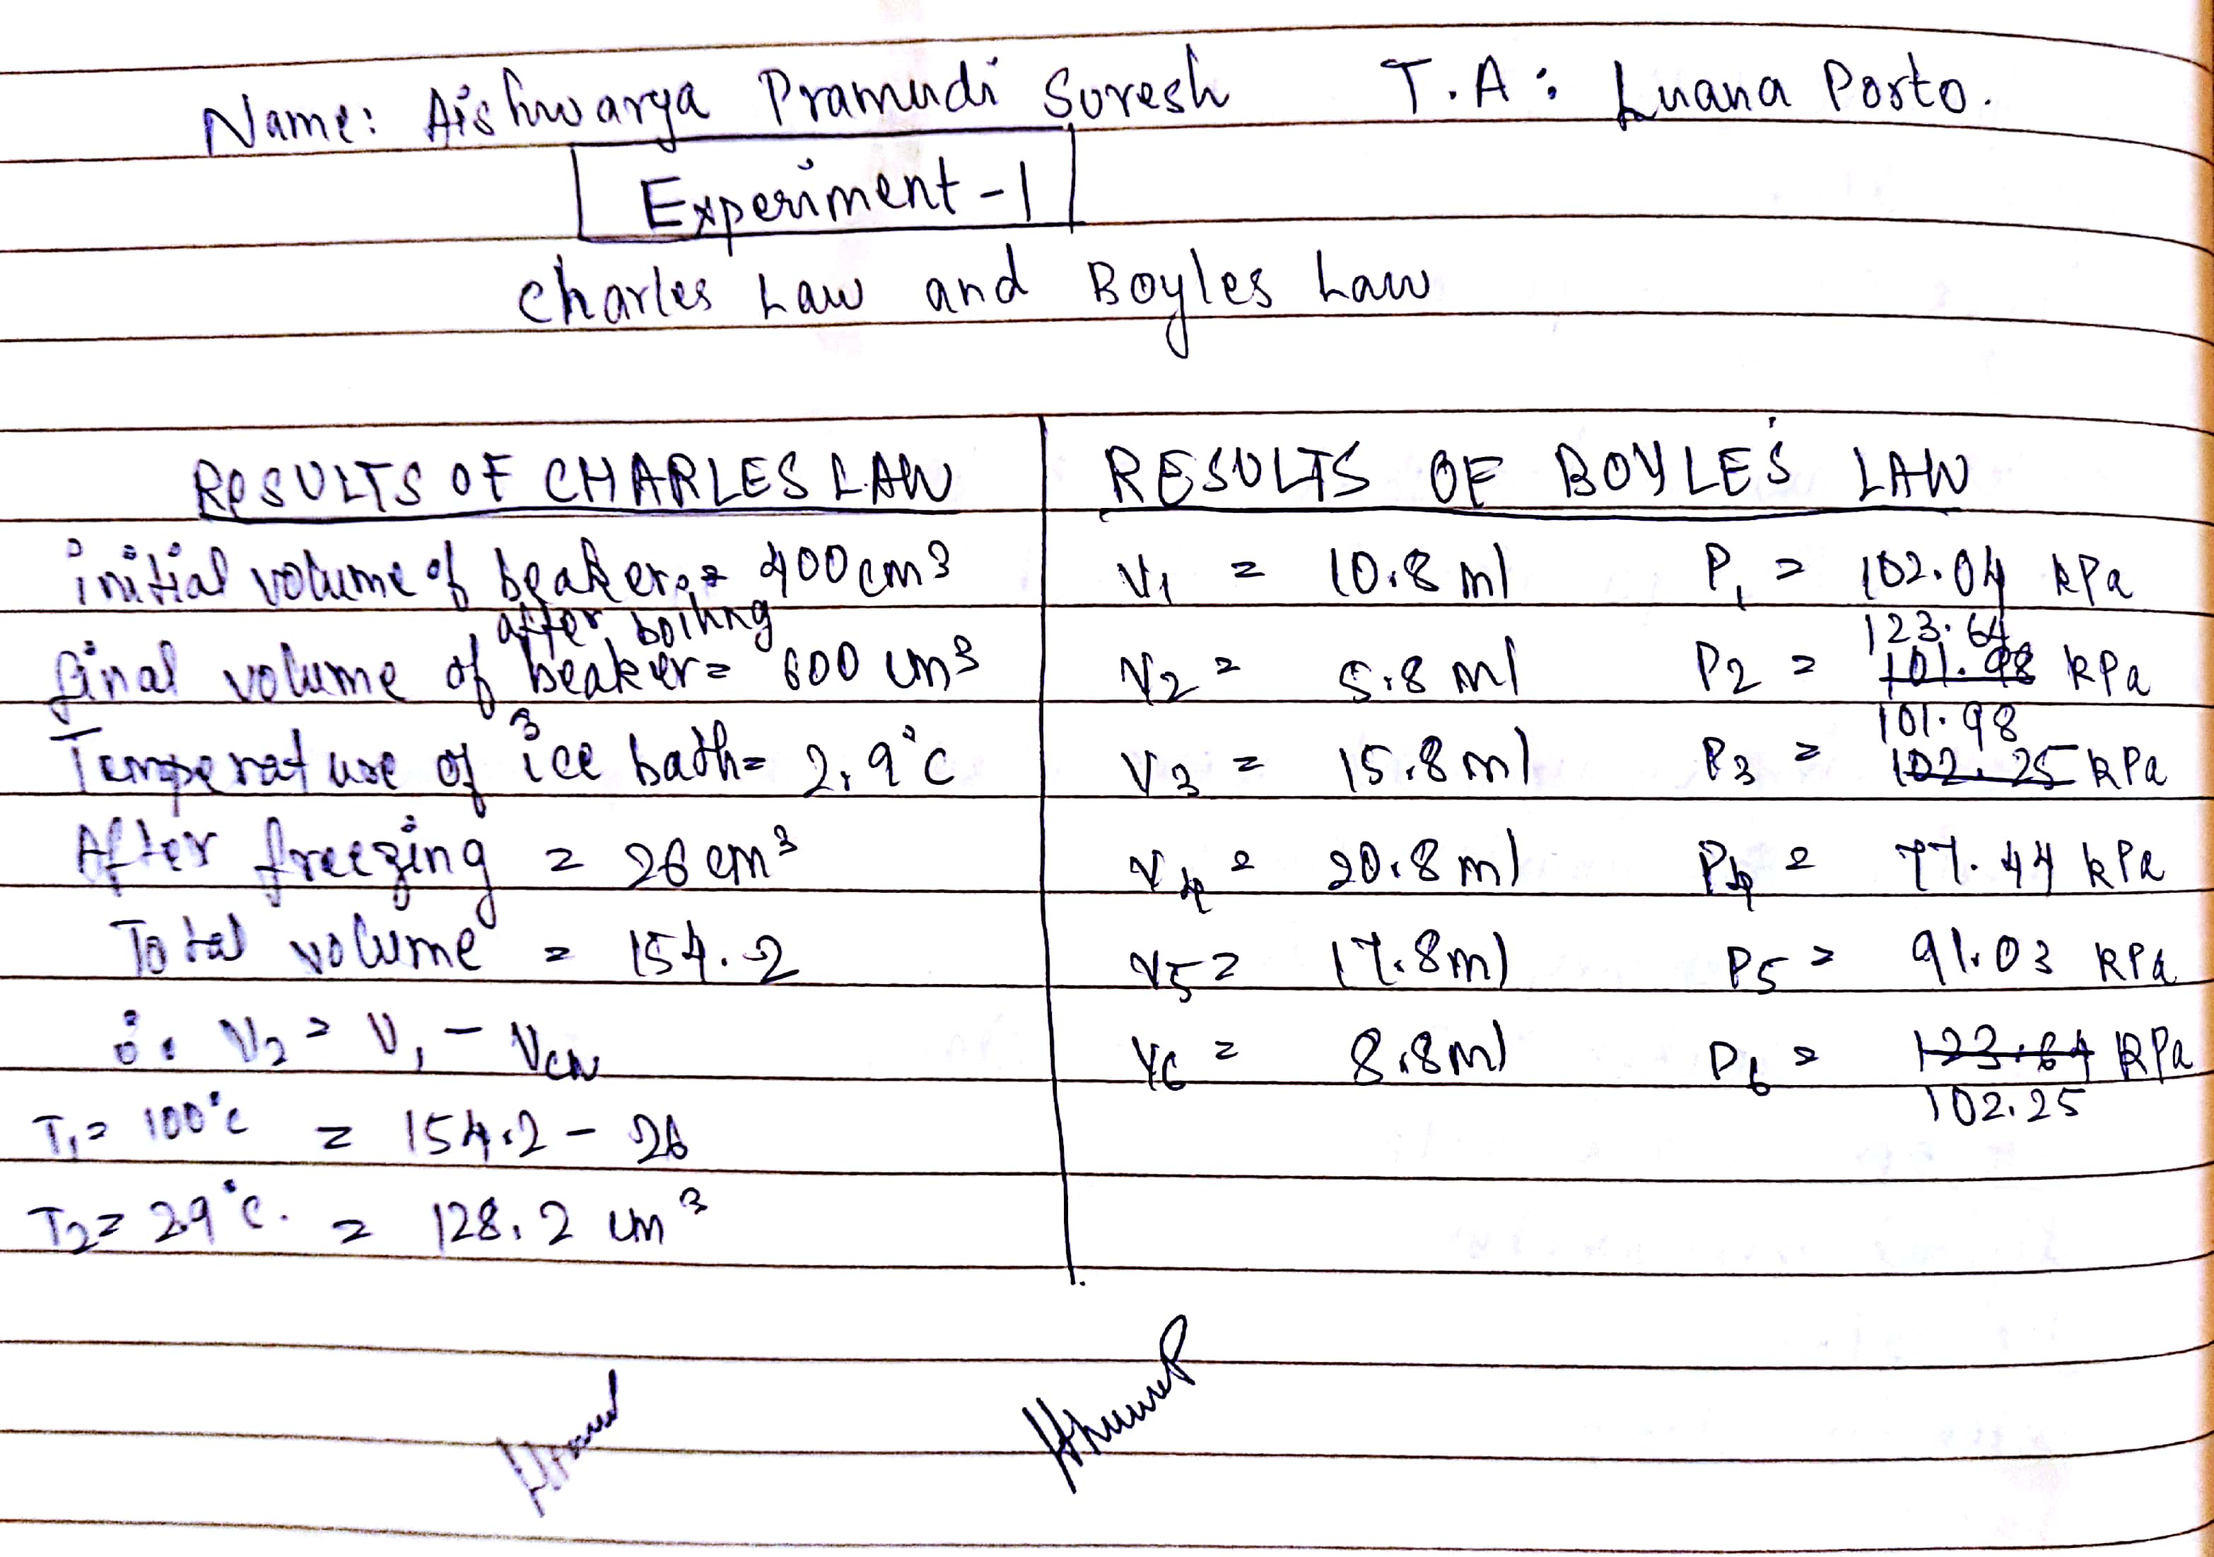

Figure 3. Copy of checklist for the procedure
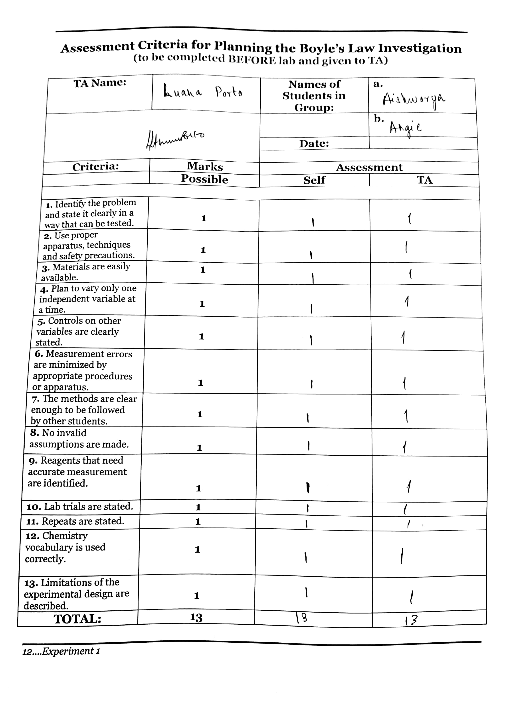

Thirumaleshwar, M. Basic Thermodynamics Software Solutions. Real and Ideal Gases and Gas Mixtures. 1st ed., Dr. M. Thirumaleshwar , 2014.
Libretexts. “10.9: Real Gases - Deviations from Ideal Behavior.” Chemistry LibreTexts, Libretexts, 17 June 2018, chem.libretexts.org/Textbook_Maps/General_Chemistry/Map:_Chemistry_-_The_Central_Science_(Brown_et_al.)/10:_Gases/10.9:_Real_Gases_-_Deviations_from_Ideal_Behavior.
“Development of the Ideal Gas Law.” What Is Anatomy and Physiology?, www.cliffsnotes.com/study-guides/physics/thermodynamics/development-of-the-ideal-gas-law.
“Development of the Ideal Gas Law.” What Is Anatomy and Physiology?, www.cliffsnotes.com/study-guides/physics/thermodynamics/development-of-the-ideal-gas-law.

