Week 7: Weathering

Weathering
Geologic processes (tectonics and volcanism) uplift rock above the mean sea levelof the oceans (called base level).
Denudational processes (landslides, stream erosion) move sediment downwards towards base level.
The intervening step whereby ROCK is transformed into material that can be moved is called weathering.
- The product of weathering in called REGOLITH
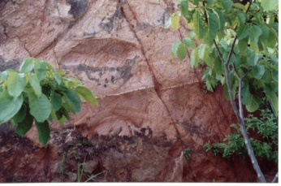
- Chemical reactions can dissolve rock minerals, create new minerals and ultimately weakens the rock. This is called chemical weathering.
- Physical processes can cause the rock to fracture into smaller more easily transported fragments. This is called physical weathering.
- Biologic activity can also weaken rock by enhancing chemical reactions and/orphysically stressing rock bodies, and is sometimes separately referred to asbiological weathering.
- Many kinds of weathering are usually acting at a given location, but we cansometimes identify a dominant weathering process for a characteristicenvironment.
SEDIMENT: Once rock has been weathered, it becomes regolith, and once regolith has been transported by some process, it becomes sediment. We make this distinction because the physical properties (i.e. the strength, grain size, infiltration capacity, etc.) of rock, regolith and sediment are all different and are determined by the processes producing them!

Processes of Physical Weathering
- Unloading
  - Rocks are formed well below the surface of the earth, where they are subject to high pressures and/or temperatures.
  - Erosion and exposure at the surface result in a decrease in temperature and an asymmetric decrease in pressure
  - Think of rock as being like a spring:
    - Where the rock forms, the pressure is high and the spring iscompressed
    - As the material on top of the rock is eroded, the pressure from above is reduced (but not the pressure from below)
    - In order to release the imbalance in the pressures, the rockfractures (more fractures occur the closer a rock mass moves toward the surface)
  - The result of gradual unloading is “sheeting” or “exfoliation”, wherein a rock breaks into a series of sheets parallel to the land surface, producingexfoliation domes
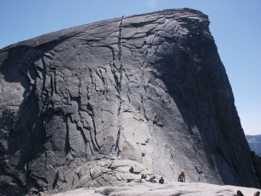
  - Most rocks are fractured to some degree, usually along planes parallel to the surface and also along planes perpendicular to the surface
- Frost Shatter
  - When water freezes to become ice, its volume increases by about 9%!
  - As a result, a crack in rock that is full of water which then freezes will have to expand as well
  - The pressure exerted by the freezing process can be very intense, and is capable of fracturing very hard rock
  - Over many freeze-thaw cycles, a once solid rock mass may be reduced to a pile of shattered, angular rock
  - In very cold (i.e. arctic) environments where there is enough water, this process may be the dominant weathering mechanism
    - Landscapes produced by frost shatter have extensive “block fields” called “felsenmeer”
  - Frost shatteris also very important in mountainous environments that may experience many freeze-thaw cycles in a given year
    - Typically, exposed cliff faces are subject to intense frost shatter, producing angular blocks that fall down the cliff face and accumulate at the base of the cliff
    - Thick accumulations of frost-shatter rock are called talus slopes or sometime scree slopes
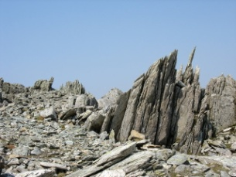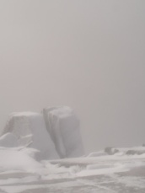
Frost Shatter
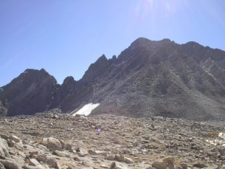
Talus Slopes
- Granular Disintegration
  - In some rocks, individual mineral crystals are physically separated from the intact rock.
  - The product of this grain-by-grain process is a rounded rock mass withsand accumulations at the base
  - There are two processes than can produce granular disintegration
    - The first is the growth of ice in the rock pores, which is basically agrain-scale version of frost shatter
    - The second is the swelling of minerals that absorb water (a process called hydration). Clay minerals swell dramatically when they come in contact with water, which exerts a pressure thatdislodges grains from the rock mass.
  - Granular disintegration is quite common in arid desert regions
- Salt Crystal Growth
  - Salt crystals can also grow in pore spaces, exerting a pressure sufficient todislodge individual gains
  - In this process, salt is moved in solution through the groundwater, towards a surface, where evaporation induces the growth of a salt crystal that ultimately dislodges rock grains
  - This process is common along sea cliffs (supply of salt & water), and produces a characteristic weathering pattern called “tafoni”
- Biological Activity
  - The growth of root systems exploits existing fractures, making them larger,disintegrating the rock mass
  - When trees fall over (due to wind, etc.) their root masses pluck rock andsoil out of the ground, in a process called tree throw. This may be one of the dominant sediment transport mechanisms in the old growth forests of the Pacific Northwest!
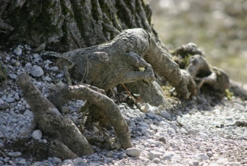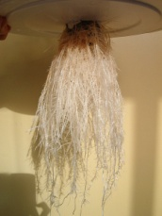
Root Systems

Processes of Chemical Weathering
Various chemical reactions occur when rock arrives at the Earth’s surface. This occurs in large part because the minerals are in equilibrium to the temperatures & pressures at which they formed, but not to the lower temperatures and pressures they experience at the surface.
- The higher the temperature & pressure at which a mineral is formed, the moresusceptible it is to chemical weathering at the surface!
- Chemical weathering also produces new minerals: clays are the most important minerals produced by weathering at the surface
- Solution
  - In this chemical reaction, a solid mineral is dissolved into its constituentions or molecules
  - The solvent is water (H20): water is a dipole (has a positively charged end and a negatively charged end), and thus can “pull apart” molecules
  - Some of the ions produced by solution will recombine to form new,chemically stable molecules
Example:
(1) SiO₂ + H₂0 → Si₄⁺ + 2(O²⁻) + H⁺ + OH⁻ (solution of silica)
(water and silica interact, forming ions (positively & negatively charged particles)
(2)Si⁴⁺ + 4(H⁺) + 4(O²⁻) → H₄SiO₄ (precipitate forms)
(some of the ions interact, forming a new, stable, SOLID molecule)
- Carbonation
  - In this reaction, carbon dioxide (CO₂) combines with water to formcarbonic acid (H₂CO₃).
CO₂ + H₂O → H₂CO₃
  - Carbonic acid becomes an important reagent for some solution reactions
  - Since carbonation can occur in the atmosphere, carbonic acid is readily available at the surface and is an important chemical weathering process
  - Example: Limestone and marble become very soluble in the presence of carbonic acid, and so weather very quickly in CO₂ rich, wet environments(i.e. in humid climates with abundant vegetation)
Calcite + Carbonic Acid → a series of dissolved ions
  - The reaction rates for solution of calcite-rich rocks depend on (a) thesupply of CO2 and (b) the rate of water exchange (which determines how quickly the ions-rich water is replaced by “clean” water)
- Oxidation
  - Metals exposed to oxygen & water with “rust”. This process is generally referred to as oxidation
  - Oxidation involves the development of a new mineral by inserting molecules of oxygen and water into the structure of the metal. (So a block of iron that rusts will end up weighing more than it did before it rusted, though it may be in smaller pieces!)
  - Oxidation occurs very readily for iron, but also affects other metals (such as aluminum)
Fe + H₂O + O₂ → Fe₂O₃3(H₂0) (formation of hydrous iron oxide)
  - It is often the first process to affect a freshly exposed surface, and produces a weathering rind that increases in thickness over time
  - The rate of oxidation depends on (a) the exposed surface area (how fractured is a rock) (b) the availability of O2 and H20, and (c) the acidity of the water source (its pH value)
- Reduction
  - This is the reverse of oxidation (water and oxygen are removed)
  - This occurs in oxygen-deprived environments, like bogs
  - It is less common, but still important
- Hydrolysis
  - In this reaction, the ions found in water (H+ and OH-) are inserted into amolecular structure, disrupting it
    - The acidity of the water determines the concentration of the H+ions (that is, in fact, what acidity is and what pH measures)
    - One of the products of this kind of reaction are clay minerals
Feldspar + acidic water → Kaolinite (a kind of clay) + silicic acid
  - Hydration
    - This refers to the absorption of water molecules into the chemical structure of a mineral
Example: anhydrite (CaSO₄) + water (H₂O) → gypsum (CaS0₄2[H₂0])
    - As discussed in physical weathering, the hydration reaction in clay minerals (a chemical weathering process) exerts a large enoughforce on other mineral grains that they can be broken away from the rock (a physical weathering process called granular disintegration)

General Sequence of Chemical Changes in Minerology
Primary Minerals | → | Secondary Minerals | → | Simple Clays
(feldspars, mica) | → | (clays like illite) | → | (clays like kaolinite)

Clays: these are flat, plate-like minerals composed of sheets of silicates. Whenwater is added to a clay, it can enter the molecular structure between the silicate sheets, causing it to swell in size. Swelling occurs in the secondary clay minerals, but not in the simple clays like Kaolinite (which is what we use to make clay potsand china)

Factors Controlling Rates of Chemical Weathering
- Temperature (as temperature increases, chemical reaction rates, in general,increase: as a result, chemical weathering is most intense near the equator, andleast effective near the poles)
- Available reagents (all chemical reactions require all of the individual ingredients to be present, such as H20, CO2, O2, H+; since water is such an important reagent, humid regions tend to have much higher chemical weathering rates thanarid ones)
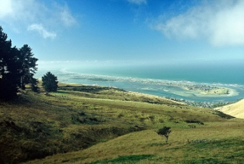
- Evacuation of reaction products (the ions must be removed from the site of weathering if it is to continue; this is achieved primarily as a result of groundwater flow)
- Surface area exposed (the degree to which a rock mass is fractured determines the area over which chemical reactions can occur)
- Mineralogy (the minerals formed deep in the crust, like Olivine, are more susceptible to chemical weathering than minerals formed closer to the surface, like silica and feldspars)

Acid Mine Drainage
This is when sulfur-rich rocks are exposed to air and water at the surface aftermining, it first oxidizes, and then the oxide (which is a solid precipitate) is oftendissolved by water (a solution reaction). The sulfate ion reacts with water to formsulfuric acid (similar to carbonation reaction, but a much more corrosive acid!).
This reaction on its own does not produce a very high concentration of acid in the water. But, when a sulfur-oxidizing bacteria (genus thiobacilli) is added to the mix (which can happen only at the Earth’s surface, where the bacteria can live), the acid production increases exponentially. This has two important effects:
- The acidity of some acid mine drainage is high enough to kill plants, fish andinvertebrates
- The acidity allows various metals to stay dissolved in the water, and the toxicity of the metals affect aquatic ecosystems (dissolved copper is a poison, and so is zinc)
Note: this is a naturally occurring process of chemical weathering, not just an effect produced as a result of mining. When the acid drainage is thought to be from anatural source, we call it Acid Rock Drainage (ARD), and when it is known to come from a mining operation, we call it Acid Mine Drainage (AMD)
This chemical reaction will continue more-or-less indefinitely (it does not go away), and there is still AMD being produced from mines created by the Romans in 476 (AD). In extreme cases, AMD can effectively kill the entire ecosystem of the receiving streams downstream for decades or even centuries.
There are estimated to be between 20 & 50 thousand mines producing significant AMD in the western US today, impacting between 8000 & 16,000 kilometers ofstream channel.
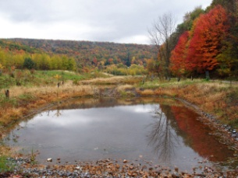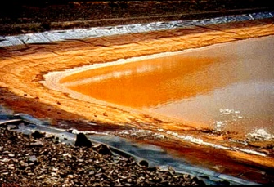
Acid Mine Drainage

