Introduction, Structure, Function, and Cell theory
Chapter 1- The Human Body
Anatomy and physiology provide a framework that helps us understand the human body
1.3 p.8-9
Form (anatomy) Follows Function (physiology)
- Louis Sullivan, architect (circa 1895)
- "Whether it be the sweeping eagle in his flight, or the open apple-blossom, the toiling work-horse, the blithe swan, the branching oak, the winding stream at its base, the drifting clouds, over all the coursing sun, form ever follows function, and this is the law.”
- The shape of a building should relate to its intended function
- Apply this truism to the Anatomy and Physiology of living cells, tissues, and organisms
Two complementary branches of science-anatomy and physiology-provide the concepts that help us to understand the human body.
- Anatomy studies the structure of body parts and their relationships to one another  - Concrete: Structure can be seen, felt, and examined closely. No need to imagine what they look like  - You can memorize | - Physiology concerns the function of the body, in other words, how the body parts work and carry out their life-sustaining functions  - Physiology is explainable only in terms of the underlying anatomy  - You really need to understand

Complementarity of Structure and Function
- Anatomy and physiology are inseparable because the function is dependent on the structure
- Principle of complementarity of structure and function
- Function can be inferred from structure

Scientific Reductionism
- Reductionism: an approach to understanding the nature of complex things by reducing them to the interactions of their parts, or to simple or more fundamental things
- Physiology focuses on events at the cellular/molecular level because the body’s abilities depend of cells which depend on chemical reactions that go on within them
- Gross (macroscopic) anatomy: the study of large body structures visible to the naked eye, such as the heart, lungs, and kidneys
- Microscopic anatomy: structures too small to be seen with the naked eye.
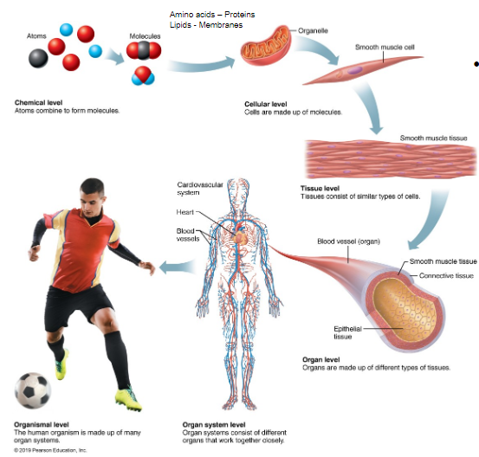
The body’s organization ranges from atoms (smallest units) to the entire organism (largest unit)
Atoms- We are all stardust
- Atoms larger then Li were forged in stars by nuclear fusion (up to Fe)
- Atoms larger than Fe were forced by exploding stars called supernovae

Cells are the Smallest Unit of Life
- Fundamental structural and functional unit
- Smallest unit that can maintain and perpetuate life
- Share common functions but vary widely in size and shape, reflecting their unit functions
- New cells can only come from existing cells
Tissues, Organs, and Organ Systems
- Tissues: Groups of similar cells with common functions
  - 4 types: epithelial, muscle, connective and nervous
- Organs: Discrete structure composed of at least two (usually four) tissue types. Specialized functional center for a specific activity
- Organ systems: Organs that work together to accomplish a common purpose (e.g. Cardiovascular system includes heart and blood vessels)
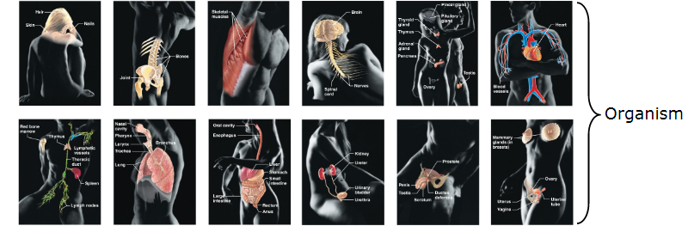
Cells: The living units
The first Eukaryotic Cells
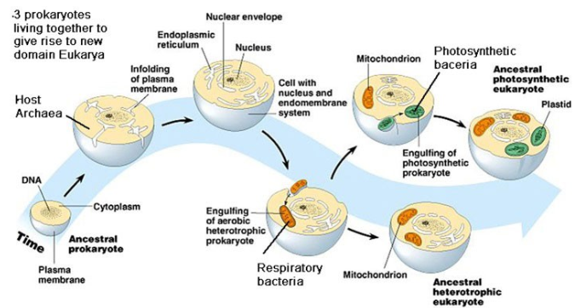
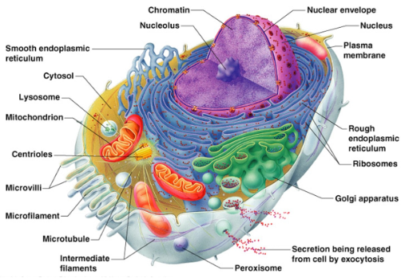
Structure of a generalized cell
- Signal transduction
- Information flow (in-out and out-in)
- Exceedingly complex

Parts of the Cell: Structure and Function


