BIO 1109
Principles of Biology
Questions on the power point slides: KINGDOMS AND DOMAINS
Helping you get ready for the final exam
Preparatory questions are written in red
CHOIX MULTIples
There is none in this pretest. However, at the final exam, true or false questions might be converted into multiple choice questions.
VRAI OU FAUX
1) Halophile means able to release methane : _____
2) Marine algae may be multicellular : _____
3) We use Gram stain to make distinction among Archae: _____
4) No fungilike protists are parasitic: _____
5) Protozoans are related to animals in terms of mode of nutrition: _____
6) Euglenids have a cell wall made of peptidoglycans: _____
7) Chlorophytes are part of Protozoans: _____
8) Ascomycetes and Basidiomycetes have septate hyphae: _____

9) Lycophytes and Pterophytes are seedless plants but they have true roots: _____

10) Frond, rachis and rhizome are typical to a Sphenophyte _____ while the seta and capsule are essentially present in Bryophytes (Mosses) _____
11) The word Spermatophyte is a name given to all plants that produce flowers: _____
12) Gymnosperms have needles as their leaves, while all Angiosperms have reticulate venation: _____
13) In fungi, hyphae is the fundamental element of the body: _____
14) In fungi, nonspetate hyphae are present in Zygomycetes: _____
15) Fungi are autotroph and feed themselves through absorption: _____
16) Wheat stands for a Monocot and apple tree stands for a Eudicot: _____
17) Animals without any true tissues are Radiarians: _____
18) Artiozoans are animals with a bilateral symmetry: _____
19) Artiozoans are divided into three groups according to the presence or not of true tissues: _____
20) Pseudocoelomates are part of Eumetazoans and have a pseudocoelome: _____
21) Osteichthyans and Chondrichthyans are part of Chordata but do not have any backbone: _____
22) See anemones are part of Cnidarians: _____
23) Polip form is tubular body in Hydras: _____
24) All Eumetazoans have a bilateral symmetry: _____
25) Nematodes are part of Annelids : _____
26) Tapeworm is a Cestode: _____
27) Nematodes are flat worms: _____
28) Cephalochordata (Lacelet) and Urochordata (Tunicate) are Chordata, more specifically Prochordata: _____

29) Chordata include Prochordata and Vertebrates: _____

30) Echinoderms are part of Chordata as well as Cephalochordata: _____

figures
Tell the group of organisms each of the following figures stands for.
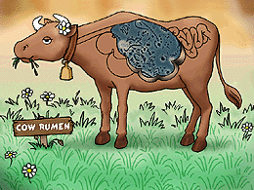
Organisms in a cow’s rumen
Group of organisms :___________________________

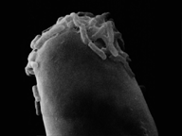Group of organisms : ___________________________
Small rod-shape structures

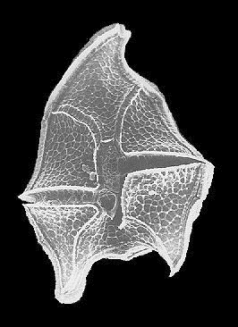 Group of organisms : ___________________________
Group of organisms : ___________________________
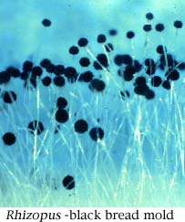 Group of organisms : ___________________________

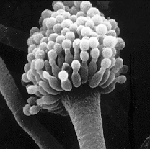 Group of organisms : ___________________________

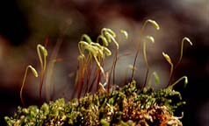 Group of organisms : ___________________________
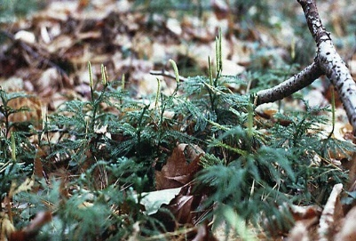 Group of organisms : ___________________________

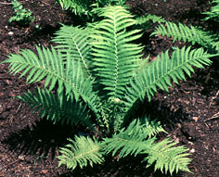 Group of organisms : ___________________________

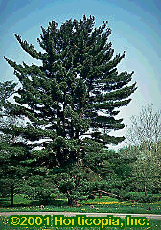 Group of organisms : ___________________________
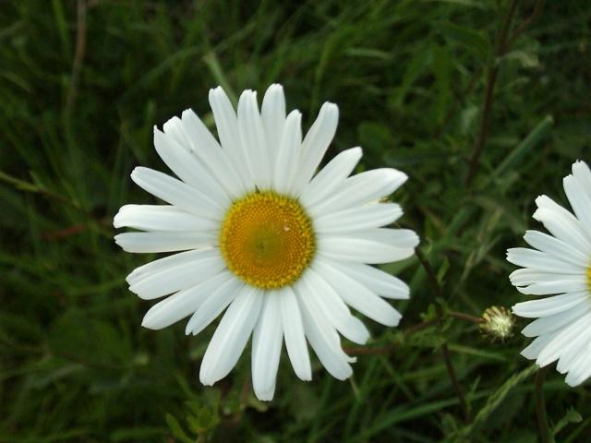 Group of organisms : ___________________________
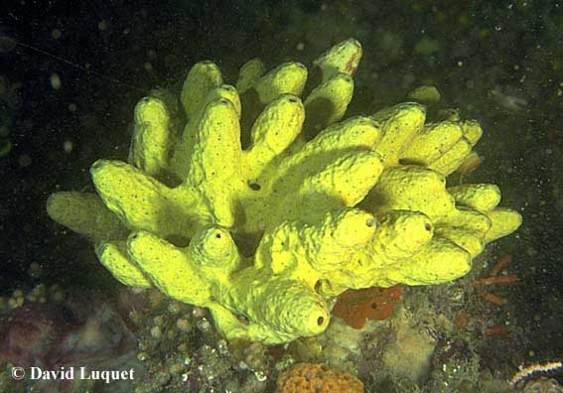 Group of organisms : ___________________________
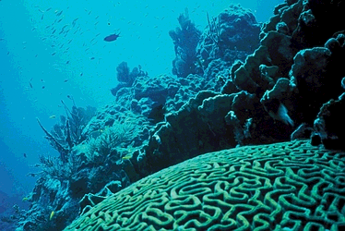 Group of organisms : ___________________________
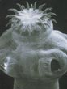 Group of organisms : ___________________________
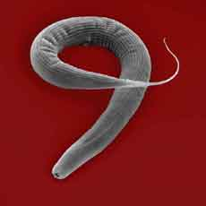 Group of organisms : ___________________________
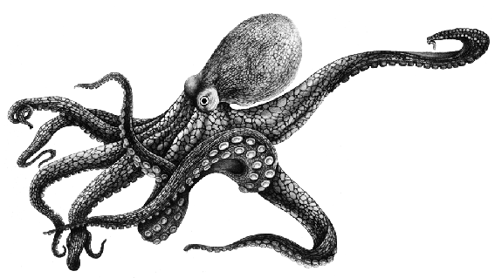 Group of organisms : ___________________________

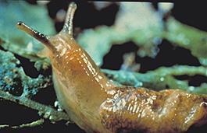 Group of organisms : ___________________________
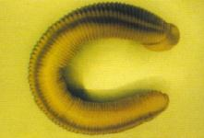 Group of organisms : ___________________________
Group of organisms : ___________________________
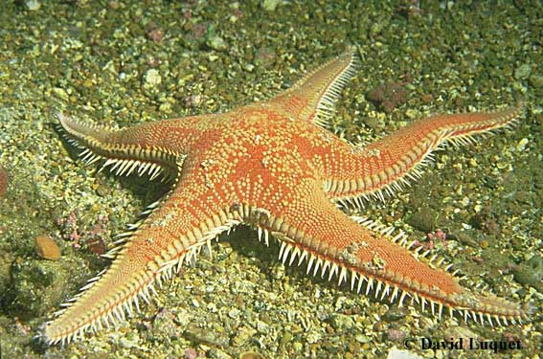 Group of organisms : ___________________________
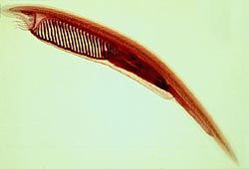 Group of organisms : ___________________________

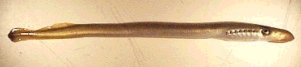
Group of organisms : ___________________________
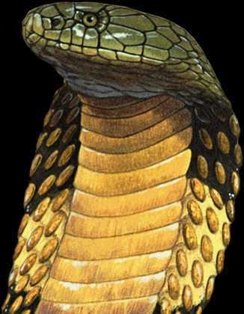 Group of organisms : ___________________________
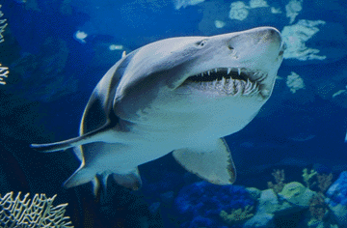 Group of organisms : ___________________________
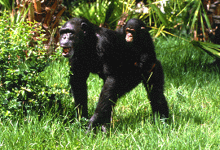 Group of organisms : ___________________________
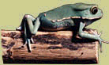 Group of organisms : ___________________________

