Astronomy Dec. 3

Asteroid Belt, comets

Learning about asteroids
- Measure reflected sunlight, infrared for size, albedo
- See how shape varies during rotation, or use radar
- Spectroscopy for composition
- Mass and density be measuring gravity
- Measure orbital parameters like distance from sun, speed of orbit

The asteroid belt & the Trojans
- More elliptical, inclined orbits than planets
- Trojans are farther, darker, harder to study
Near-Earth Asteroids
- Impacts waiting to happen

Asteroids in orbital resonance with Jupiter experience periodic nudges
- Unstable resonance: gaps (Kirkwood)
- Stable resonance: asteroids exist there
- We can actually learn the creation of the asteroid belt and how Jupiter was created

The Kingdom of Jupiter
- Jupiter’s gravity creates stable or unstable orbits
- Stable trapped there (ex. Trojans)
- Unstable asteroid kicked out of the belt

- Disruptions prevented formation of a planet there
- Still happening: occasional collisions, ejections, some sent our way..

Meteoroid: A small to boulder-sized particle of debris in the Solar System
Meteor: The bright trail left by a meteoroid that enters Earth’s atmosphere (aka shooting star or falling star)
Meteorite: A portion of a meteoroid or asteroid that survives its passage through the atmosphere and impact with the ground
Meteorology: Another word for “atmospheric science”. Has only little to do with meteors.

20,000 meteorites have been found, mostly in Antarctica (dark rock, on ice)

Origins of meteorites
- If we saw the meteor, we can determine where it came from (all have been from the asteroid belt)
- We can measure meteorite composition, and have found 2 basic types:
- Primitive: fossils, as old as our Solar System, and unchanged since then
- Processed: A few hundred million years younger, they were part of a larger object that differentiated

Primitive Meteorites
- Stony primitive meteorite:
- Rocky, with shiny metal flakes
- Come from inner asteroid belt, more common on Earth
- Carbon-rich primitive meteorite:
- Born on the outer part of the asteroid belt
- Also rocky, but more dark carbon compounds that could only solidify in outer asteroid belt
- Contain little white spheres called chondrules (chondritic)

Processed meteorites
- Metal sinks to the center, the rock, lighter stuff gets pushed to the top
- The differentiated asteroid could get shattered
- Metal-rich: iron, nickel, etc. like terrestrial cores
- Rocky: came from crust or mantle, similar to lava flows… outer

Some meteorites are pieces of the Moon and Mars
- Composition differs from asteroid fragments
- Cheap (but slow) way to acquire moon & Mars rocks

Halley’s comet n 1066
- Bayeux tapestry
- Comet appearance played a role in the battle of Hastings

Comet Hyakutake (1996)

Comet Hale-Bopp (1997)

Comet Holmes (2007-2008)

Comet McNaught (2007)

Comets
- “comet” = “hair”
- Will be visible for may nights, only gradually moving against the constellations
- Most never have comets, spend their lives in the outer solar system; altered orbits send them into the inner solar system, tail grows
- Comets were seen as omens, until Tycho Brahe proved they were farther than the Moon, Newton proved they orbit the Sun, Halley predicted an orbit

The nucleus of a comet is a “dirty snowball”
- Source of material for comet’s tail: made of hydrogen compounds, complex molecules, organic molecules (origin of life on Earth?)
- Must have formed beyond the frost line, in outer solar system

Comet Halley’s nucleus
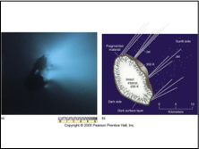
Giotto mission
Less dense than water. So it is partially hollow

The Deep Impact mission studied the nucleus of comet Tempel 1
- Projectile hit surface on July 4, 2005
- Many telescopes studied aftermath of impact

Comets have several kinds of fuzzy stuff associated with them
- Coma: Atmosphere that comes from heated nucleus
- Plasma Tail: Gas escaping from coma, pushed by solar wind. Direction points away from the Sun
- Dust tail: Pushed by photons
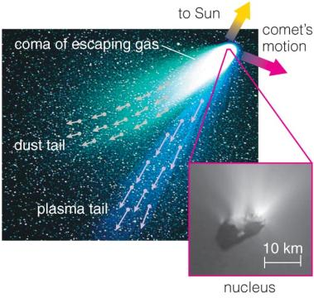

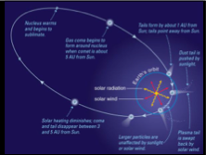

Some Numbers
- Actual comet nuclei normally <20km across
- Escaping gas blasted out at hundred of m/s, dust dragged with it, tails can be 10^8km long
- Plasma tail points away from the sun, swept away by solar wind at hundreds of km/s
- Dust tail pushed not as hard by light, curves back in the direction the comet is coming from
- Comet loses 0.1% of its ice per pass, will be mostly gone after a few hundred orbits

Comets eject dust particles that roughly follow the comet in its orbit

Comet dust trails can cause Meteor Showers many years later!
- Comet may or may not be long gone, but dust still exists
- When Earth crosses the orbit: meteor showers

Meteors in a shower appear to emanate from the same area of sky because of Earth’s motion through space
- Like snow in the windshield when you’re driving in a blizzard

Example: Leonids
- Meteor shower peaks around Nov.17 and sometimes extremely spectacular!
- Noted events: 1833, 1866, 1966
Most meteors (& all meteor showers) originate from comets, but most meteorites originate from asteroids!
- Many more dust particles from comets than from asteroids cross the Earth’s orbit
- Comet material (ices) will not survive passage through atmosphere no meteorites
- Bright flash is the pebble burning up at 70km/s
- Most of the meteorites we find originate from asteroids – rocks and metals can survive!

