Imagine that you are a disembodied spirt that is about to enter a human body and soon after you will find yourself existing on planet earth in the city of Ottawa. You know nothing about your future – you do not know your gender, your genetic or ethnic background, whether you will be intelligent, artistically or musically inclined, your financial situation, nothing. All the same, you want have a good life. What would be the bare necessities for this good life? In other words, what kind of society would you expect the city of Ottawa to be?

John Rawls (1921-2002)

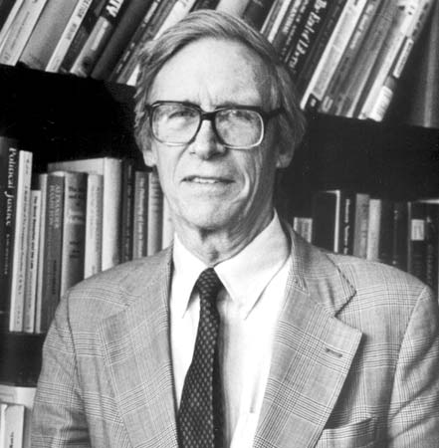

In his highly influential book from 1971, A Theory of Justice, Rawls sets out to explore what a just or fair society is.
As noted by Rawls, justice is the first virtue of social institutions. Accordingly, Rawls seeks a set of principles that can be applied to our institutions enabling us to judge whether these institutions are just or unjust.

Two important principles that Rawls recognizes are:
First: each person is to have an equal right to the most extensive basic liberty compatible with a similar liberty for others
Second, social and economic inequalities are to be arranged so that:
(a) they are to be of the greatest benefit to the least-advantaged members of society.
(b) offices and positions must be open to everyone under conditions of fair equality of opportunity.

To present an argument that any rational individual would choose these principles, Rawls puts forth a thought experiment known as the original position.

In the original position, an individual is behind a veil of ignorance, which entails that the individual knows nothing about him or herself along the lines of intelligence, prosperity strength, gender, ethnicity, socio-economic position in society, and so on.

Individuals in the original position can be thought of as planning their future society. Since the individuals are free and rational, Rawls argues that they will choose a society where no discrimination takes place, and everybody, at minimum, has the bare essentials to survive.

In the original position, behind the veil of ignorance, would one choose a society where women could not become CEOs? Why or why not?

In the original position, behind the veil of ignorance, would one choose a society where people live on the street, a society where homelessness is a fact of existence?

Ethical Issues in International Business

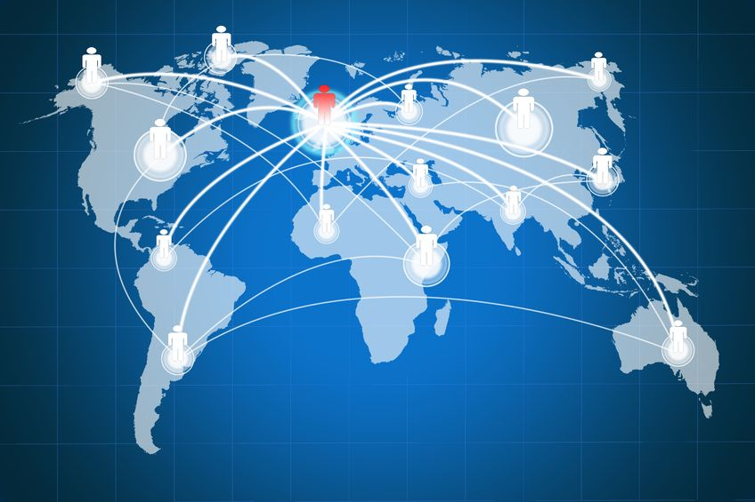

Globalization is the tendency of businesses, technologies, or philosophies to spread throughout the world, or the process of making this happen. The global economy is sometimes referred to as a globality, characterized as a totally interconnected marketplace, unhampered by time zones or national boundaries.
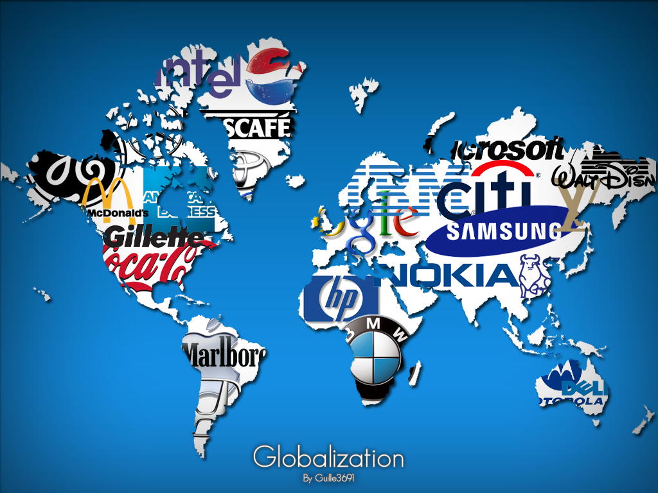

Globalization as Deterritorialization: The idea that social space is no longer wholly mapped in terms of territorial places and borders. Accordingly, corporations as well as NGOs transcend local groupings.

Globalization as Deterritorialization entails that corporations are multinational in nature in that they operate in one or more countries than their home country.

International outsourcing is the practice of a multinational company manufacturing or contracting all or parts of its products abroad.

International outsourcing occurs for the reasons that corporations can be more profitable, as they can take advantage of cheaper labour and labour laws that are more lax in other countries.

As profitable as international outsourcing may be, this practice raises some ethical dilemmas.

Child Labour
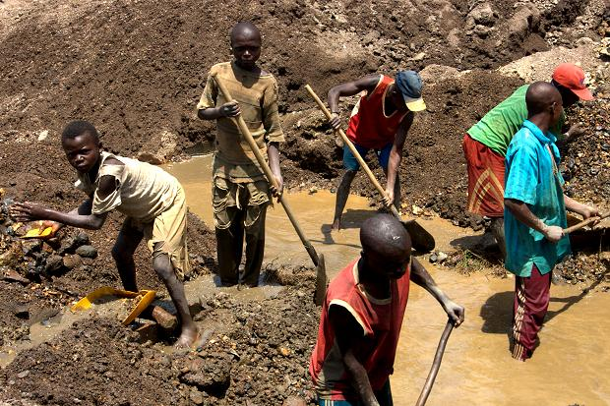

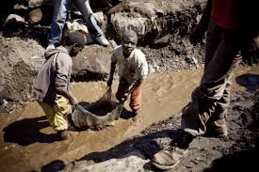

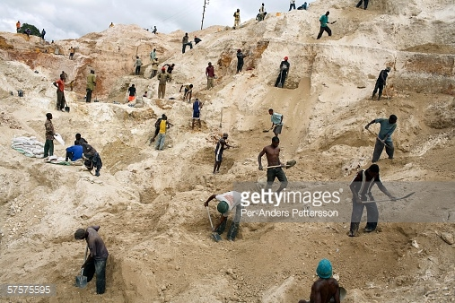

From the International Labor Organization:
- Global number of children in child labour has declined by one third since 2000, from 246 million to 168 million children. More than half of them, 85 million, are in hazardous work (down from 171 million in 2000).

- Asia and the Pacific still has the largest numbers (almost 78 million or 9.3% of child population), but Sub-Saharan Africa continues to be the region with the highest incidence of child labour (59 million, over 21%).

- There are 13 million (8.8%) of children in child labour in Latin America and the Caribbean and in the Middle East and North Africa there are 9.2 million (8.4%).

- Agriculture remains by far the most important sector where child labourers can be found (98 million, or 59%), but the problems are not negligible in services (54 million) and industry (12 million) – mostly in the informal economy.

- Child labour among girls fell by 40% since 2000, compared to 25% for boys.

What is child labour?
Considerable differences exist between the many kinds of work children do. Some are difficult and demanding, others are more hazardous and even morally reprehensible. Children carry out a very wide range of tasks and activities when they work.

Not all work done by children should be classified as child labour that is to be targeted for elimination. Children’s or adolescents’ participation in work that does not affect their health and personal development or interfere with their schooling is generally regarded as being something positive. This includes activities such as helping their parents around the home, assisting in a family business or earning pocket money outside school hours and during school holidays. These kinds of activities contribute to children’s development and to the welfare of their families; they provide them with skills and experience, and help to prepare them to be productive members of society during their adult life.
The term “child labour” is often defined as work that deprives children of their childhood, their potential and their dignity, and that is harmful to physical and mental development.

It refers to work that:
- is mentally, physically, socially or morally dangerous and harmful to children; and
- interferes with their schooling by:
- depriving them of the opportunity to attend school;
- obliging them to leave school prematurely; or
- requiring them to attempt to combine school attendance with excessively long and heavy work.
In its most extreme forms, child labour involves children being enslaved, separated from their families, exposed to serious hazards and illnesses and/or left to fend for themselves on the streets of large cities – often at a very early age. Whether or not particular forms of “work” can be called “child labour” depends on the child’s age, the type and hours of work performed, the conditions under which it is performed and the objectives pursued by individual countries. The answer varies from country to country, as well as among sectors within countries.

The worst forms of child labour
Whilst child labour takes many different forms, a priority is to eliminate without delay the worst forms of child labour as defined by Article 3 of ILO Convention No. 182:
(a) all forms of slavery or practices similar to slavery, such as the sale and trafficking of children, debt bondage and serfdom and forced or compulsory labour, including forced or compulsory recruitment of children for use in armed conflict;
(b) the use, procuring or offering of a child for prostitution, for the production of pornography or for pornographic performances;
(c) the use, procuring or offering of a child for illicit activities, in particular for the production and trafficking of drugs as defined in the relevant international treaties;
(d) work which, by its nature or the circumstances in which it is carried out, is likely to harm the health, safety or morals of children.
Labour that jeopardizes the physical, mental or moral well-being of a child, either because of its nature or because of the conditions in which it is carried out, is known as “hazardous work”.

Questions:

1. Child labour is illegal in Canada and in many other parts of the world, but it is not illegal everywhere. Is it permissible for multinational corporations to employ children as labourers where it is a local custom? Why or why not?

2. Is it permissible to purchase goods made by child labour?

3. Do multinational corporations have a duty to know if one of their subsidiary companies is employing children?

4. It is a major paradox of the digital era that some of the world’s richest, most innovative companies are able to market incredibly sophisticated devices without being required to show where they source raw materials for their components.

Should companies be mandated by law to show where they source their raw material?

Sweatshops

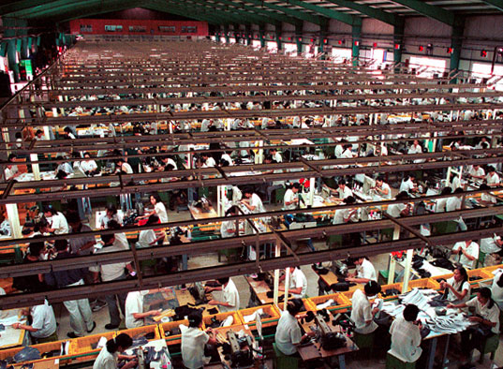

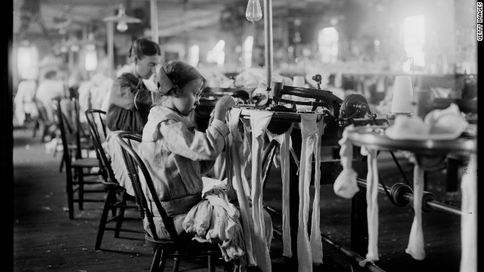

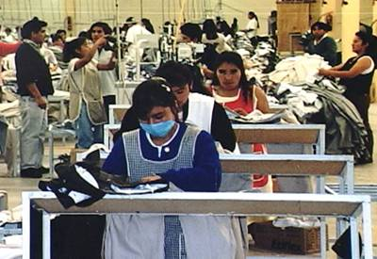

From DOSOMETHING.ORG:

Facts about Sweatshops
- A "sweatshop" is defined by the US Department of Labor as a factory that violates 2 or more labor laws.
- Sweatshops often have poor working conditions, unfair wages, unreasonable hours, child labor, and a lack of benefits for workers. In developing countries, an estimated 168 million children ages 5 to 14 are forced to work.
- America has stronger labor laws than most undeveloped countries, but it is not free of sweatshop conditions. Many labor violations slip under the radar of the US Department of Labor.
- Products that commonly come from sweatshops are garments, cotton, bricks, cocoa, and coffee.
- A study showed that doubling the salary of sweatshop workers would only increase the consumer cost of an item by 1.8%, while consumers would be willing to pay 15% more to know a product did not come from a sweatshop.
- Sweatshops do not alleviate poverty. The people who are forced to work must spend the majority of their paycheck on food for their families to survive.
- Child labor is especially common in agriculture (98 million, or 59% of child laborers work in agriculture), followed by services (54 million) and industry (12 million).
- The majority of child laborers are found in Asia and the Pacific. Sub-Saharan Africa has the highest prevalence, with one in five children in child labor.
- According to one survey, more than 2/3 of US workers experienced at least one pay-related violation in the previous work week. Assuming a full-time, full-year work schedule, workers lose an average of $2,634 annually due to violations.
- Because women make up 85 to 90% of sweatshop workers, some employers force them to take birth control and routine pregnancy tests to avoid supporting maternity leave or providing appropriate health benefits.

Factory collapse in Bangladesh in April 2013:

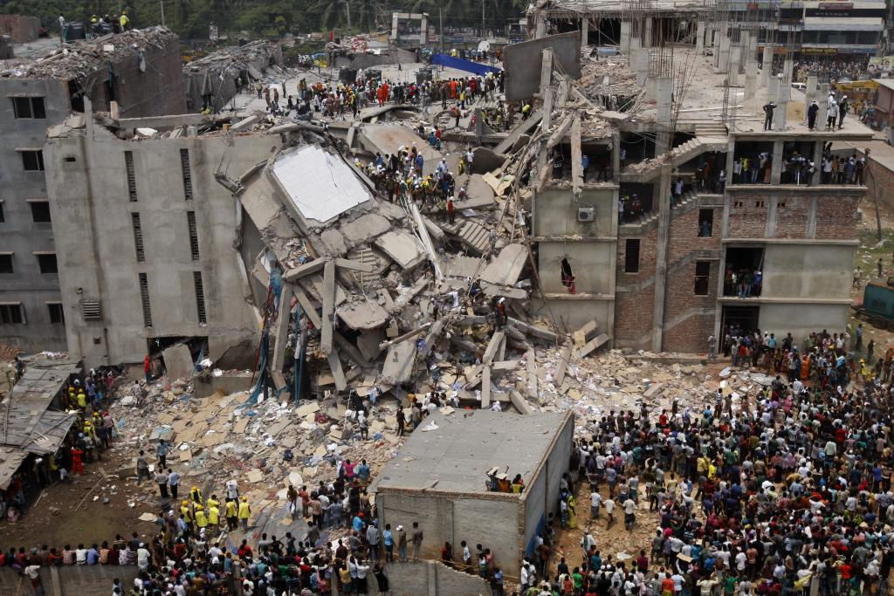

From In Our World: Events and Issues that Shape our Planet
Background: For a small country it is quite impressive that Bangladesh is the No.2 garment exporter in the world (surprise, surprise, China is first) with over 5000 factories and bringing in US$20bn a year. Subsequently, the textile industry is not a major part of the Bangladeshi economy – it is the Bangladeshi economy. Bangladesh enjoys a number of special trade deals with the European Union, the United States, Canada and Australia – a situation where Bangladesh has a vibrant industry and the West accesses some of the cheapest labour in the world. Hence many Bangladeshi garment factories produce clothes for some of the world’s largest clothing retailers. The list includes Wal-Mart (arguably the largest corporation in the world), JC Penny, Gap, K-Mart, Target, Irish textile company Primark, Germany’s Phantom Apparels, Ether Tex and in Australia, Big W, Coles, Portmans, Cotton On and Pacific Brands. Despite widespread condemnation and awareness, sweatshop labour is widely used in Bangladesh and across the world, especially in parts of Asia, Africa and the Americas.
Sweatshop building conditions are well known for being below a tolerable standard. For these mostly female, mostly young workers, spaces are cramped, heavy machinery poses numerous health and safety risks, low ventilation and inadequate air-conditioning make it stifling hot and blocked fire exits, locked doors and barred windows make it nearly impossible to evacuate in an emergency. In actuality, factory fire deaths are the more common form of mass workplace deaths compared to building collapse. Only last year Pakistan endured a loss of 289 people in a factory fire in Karachi. A factory fire in Tarzeen, Bangladesh claimed the lives of 112 people. In both instances exits were either blocked or locked. Furthermore there have been a number of findings from reports that workplace managers have exploited their positions of power in various oppressive ways: violent beatings of workers, the use of fines and coercing sexual favours in exchange for continuation of work.
However what many people don’t realise is that Bangladesh, like many countries with sweatshop labour, does have labour and building laws. However there are only a handful of inspectors for the thousands of factories that operate. Furthermore, bribery and worse, generally lax enforcement make it easy to disregard labour laws and building codes.

The Bangladesh Accord (May 2013):
The Accord is an independent, legally binding agreement between brands and trade unions designed to work towards a safe and healthy Bangladeshi Ready-Made Garment Industry. Our purpose is to enable a working environment in which no worker needs to fear fires, building collapses, or other accidents that could be prevented with reasonable health and safety measures.

Though legally binding, the Bangladesh Accord is not mandatory and most North American retailers did not sign it citing liability concerns.

Should multinational corporations based in North America have to sign accords such as the Bangladesh Accord? If so, who should enforce that these accords are signed, along with enforcing the rules that such accords outline?

Friedman vs. Freeman

In his influential essay from 1970, ‘The Social Responsibility of Business is to Increase Its Profits,’ Milton Friedman concludes by noting:
There is one and only one social responsibility of business–to use its resources and engage in activities designed to increase its profits so long as it stays within the rules of the game, which is to say, engages in open and free competition without deception or fraud.

Let’s concentrate on the one responsibility of business or the corporation that Friedman recognizes – the idea that a corporation should only increase its profits, an idea that seemingly defies conventional wisdom.

Of course we know that in a capitalist society corporations certainly want to be profitable.

But, at the same time, we also know that corporations donate money to charities, the arts, universities, and so on.

Executives for corporations that give money away will often describe such actions as proving that the corporation in question has a social conscious, or is socially responsible.

Yet, Friedman argues that such actions go against the purpose or function of the corporation.

In making such an argument, Friedman notes that with respect to a corporation, the idea of “social responsibility” is a vague idea.

According to Freidman, it makes sense to talk of a person as being socially responsible.

For example, Joe a corporate executive might provide a portion of his income to charities, and in doing so, we can say that Joe is taking a leading part in charitable causes, and we can describe Joe’s actions as socially responsible.

The important thing to note is that an individual such as |Joe can be socially responsible.

In other words, Friedman argues that individuals can be socially responsible.

At the same time, corporations only have one social responsibility – a responsibility which does not relate to giving money away to charity or for that matter, any other cause that does not increase the profits of the corporation.

As argued by Friedman, unlike an individual, a corporation is an “artificial person,” and since a corporation is not a real person, it does not make sense to discuss it as having responsibilities.

As opposed to Milton Friedman, R. Edward Freeman sees the corporation as a having a different purpose.

In his essay, ‘A Stakeholder Theory of the Modern Corporation,’ he advances the idea that corporate executives or managers do not have a sole duty to stockholders, but rather must have a trustworthy relationship to stakeholders.

Stakeholders are groups that have a claim or stake in the firm or corporation, and they include suppliers, customers, owners, employees, the local community, and management.
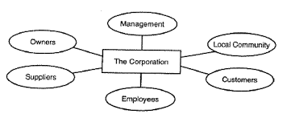

According to Freeman, each of these stakeholders must be treated according to the dictates of the second formulation of Immanuel Kant’s categorical imperative, which tells us:

So act that you use humanity, whether in your own person or in the person of any other, always at the same time as an end, never merely as a means.

In other words, each stakeholder group has a right not to be treated as a means to some end, and the right to determine the future of the corporation in which they have a stake.

For instance, the corporation could not expose the local community to environmental hazards, as in doing so, it would be treating the individuals of the local community as a means (to profits), and not an end (respecting their humanity).

In order to bolster Kant’s categorical imperative in his stakeholder theory (which include suppliers, customers, owners, employees, the local community, and management), Freeman incorporates Rawls’ concepts of the original position and the veil of ignorance.

A multi-national corporation sells a popular patented solvent based adhesive (glue) in countries around the world. This best-selling product has many industrial uses, and is invaluable since it can bond things together that are not possible with water-based glue. As profitable and useful as this glue is, another darker and nefarious side of it has become known. In several impoverished countries this glue has become very popular among children of the street who have taken to sniffing it. Severe sickness and even death have been the results for many of the children who abuse this product. Unfortunately, in the countries where this is a problem, corruption and mismanagement by the governments have hindered any government action towards this problem. Back in the USA the president of this multi-national corporation is reading a letter sent to him by an advocacy group that is imploring him to use his corporation’s resources to address this problem before it becomes widespread.
What would Milton Friedman advise the president of this corporation to do? Discuss. On the other hand, what would R. Edward Freeman advise the president of the corporation to do?

