1. Environmental Ethics
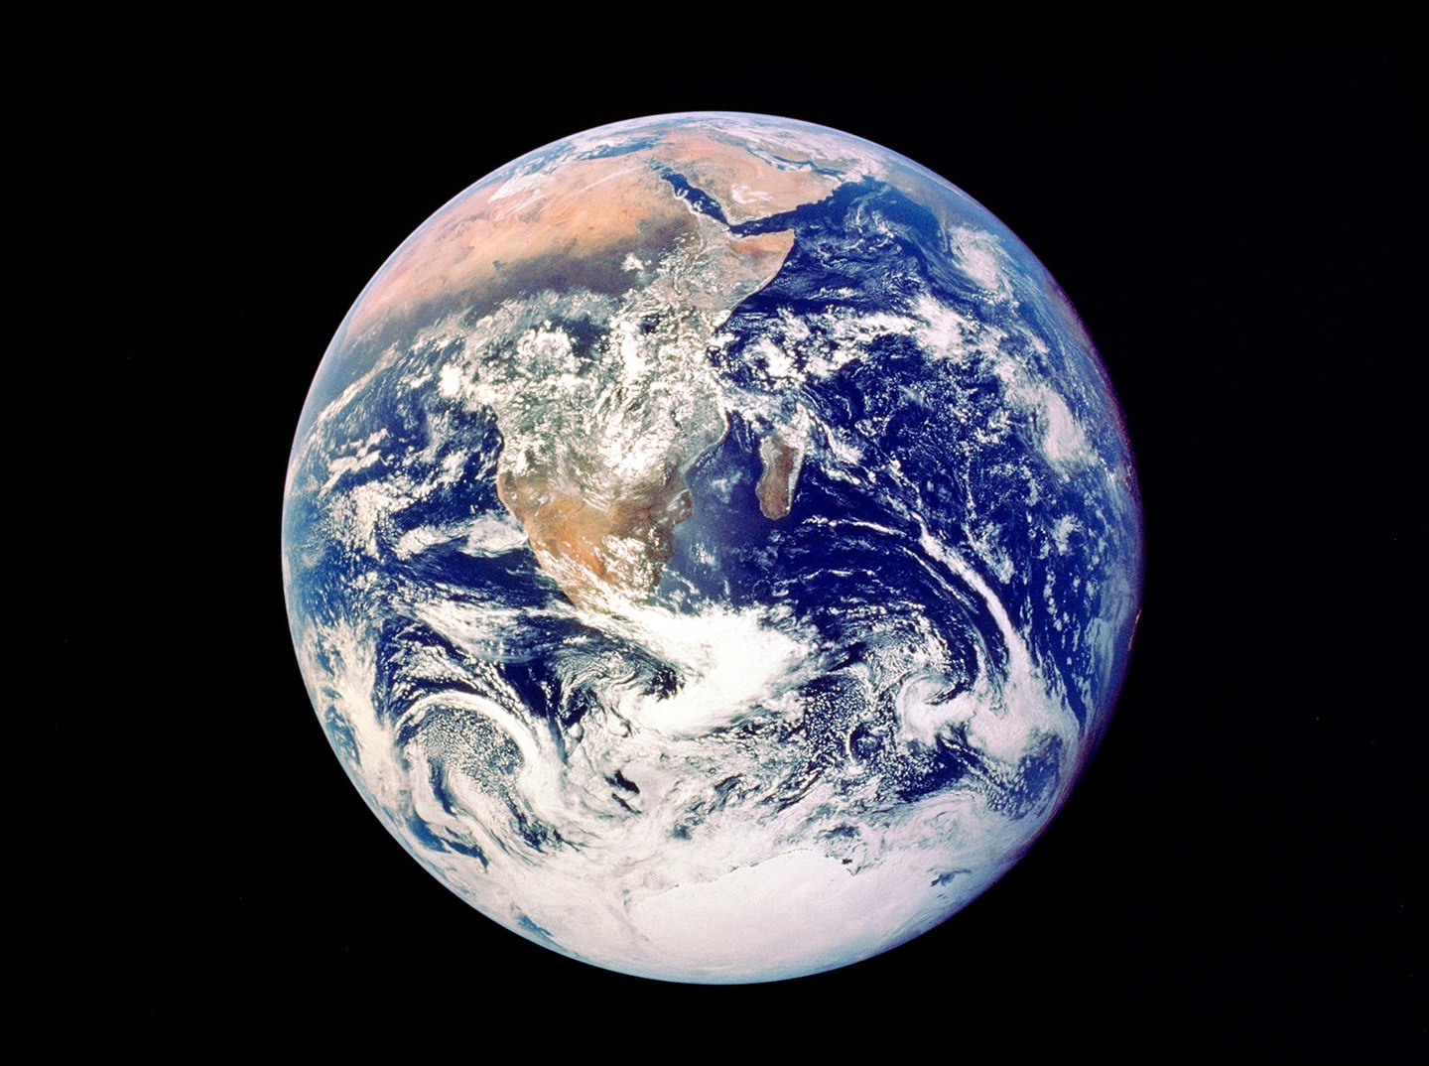
The “Whole Earth” photograph—also known as the “Blue Marble”—was the first to depict the entire planet. Shot in December 1972 by the crew of Apollo 17 (from a distance of 28,000 miles), the picture reveals the Arabian Peninsula, the African continent, and the Antarctic polar ice cap. Over the years, each of the three astronauts aboard the spacecraft—Eugene Cernan, Ron Evans, and Harrison H. Schmitt—claimed to have taken it.
From NASA/Getty Images.

“All my life I’ve been a humanist. But what really put this into focus for me was the day, 44 years ago, when I saw this photograph for the first time: our planet Earth, taken from outer space. I remember being so captivated, thinking about what it must have been like to frame the entire world between two fingers. What a perspective. All the tribulations, the wars, the prejudice—and everything that divides us—simply melt away when you realize that we’re all together on one planet and that every problem should have a solution. As Ella Fitzgerald used to say to me, ‘Tony, we are all here.’ ”

Tony Bennett



Environmental Ethics Questions

A. The Environment and Private Property
A homeowner in Ottawa is tired of mowing his front and back yards, along with keeping the vegetation on his property under control. As a result, he decides to pave his front and back yards.
What would John Locke’s theory of private property tells us about this homeowner’s actions?
Even if this individual has a legal right to pave his front and back yards, would there be anything morally objectionable about his actions?

B. Global Warming
From the AP (Associated Press), September 2013:
WASHINGTON (AP) — Top scientists from a variety of fields say they are about as certain that global warming is a real, man-made threat as they are that cigarettes kill.
They are as sure about climate change as they are about the age of the universe. They say they are more certain about climate change than they are that vitamins make you healthy or that dioxin in Superfund sites is dangerous.
They'll even put a number on how certain they are about climate change. But that number isn't 100 percent. It's 95 percent.
Is global warming a real threat? Does it matter that scientists are not 100 % certain about it?
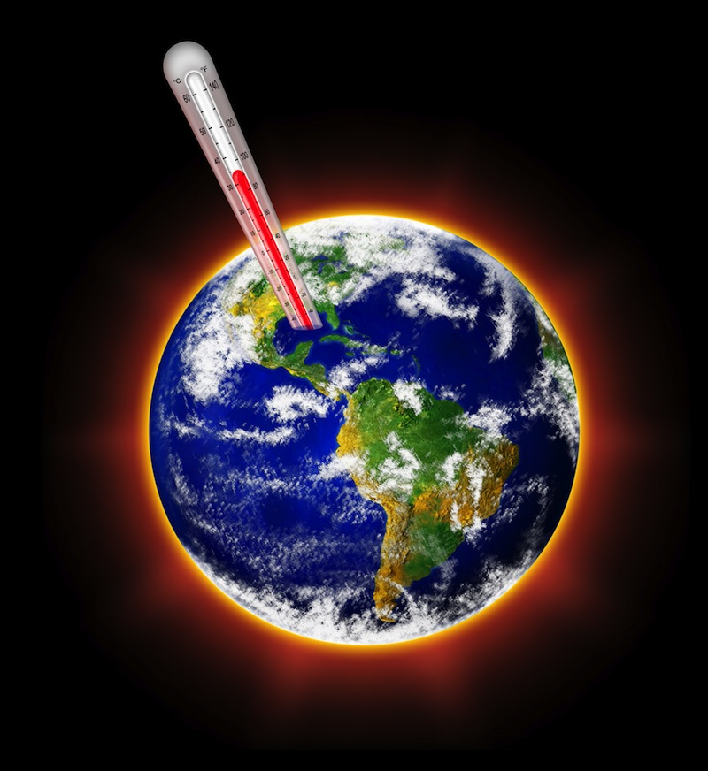

C. Proverbs
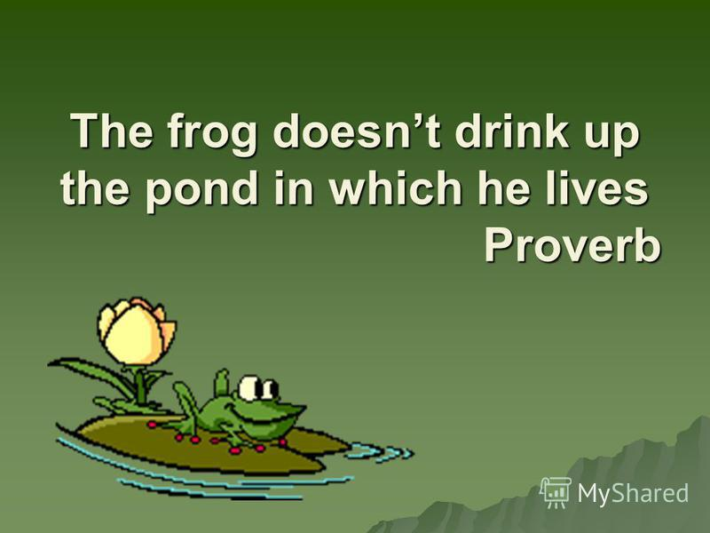

Treat the earth well: It was not given to you by your parents it was loaned to you by your children. We do not inherit the Earth from our Ancestors, we borrow it from our Children.
- Native American Proverb



What is the meaning of each of these proverbs?

D. Humans and the Environment

Humans are part of the environment and not conquerors of it.

-Leopold Aldo (1887-1948), American environmentalist

What is Aldo suggesting?

E. Activism and the Environment
A timber company has been logging trees in the Pacific Northwest for decades. It has done moderately well in replanting where trees have been cut, but it has recently been cutting in an area where some trees are hundreds of years old since the company plans to build roads in this area. An environmental group is determined to prevent this goal. Members of this group have blocked the roads that the company has recently built and also engaged in a practice known as tree spiking. This practice sees iron spikes driven into trees to discourage the use of power saws. Loggers are outraged, because this makes cutting in such areas extremely dangerous. When their saws hit the spikes, they become uncontrollable, and loggers have been injured. Forest rangers have ben marking trees found to be spiked and noted that some spikes are in so far that they are not visible. Eventually, they will be grown over and thus present a hidden danger for years to come. Individuals from this environmental group insist that this is the only way to prevent the short-sightedness destruction of the forests.
Who is right? Why?
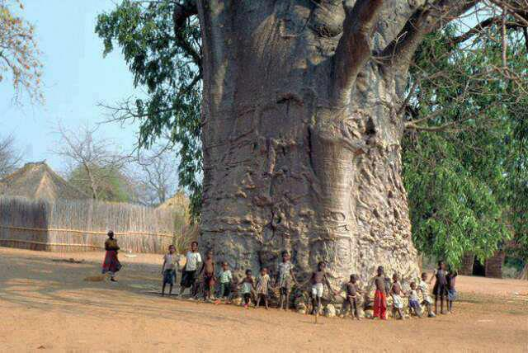
A 2000-year-old tree in South Africa

F. A New Paradigm?
A change in lifestyle could bring healthy pressure to bear on those who wield political, economic and social power. This is what consumer movements accomplish by boycotting certain products. They prove successful in changing the way businesses operate, forcing them to consider their environmental footprint and their patterns of production. When social pressure affects their earnings, businesses clearly have to find ways to produce differently. This shows us the great need for a sense of social responsibility on the part of consumers. “Purchasing is always a moral – and not simply economic – act”. Today, in a word, “the issue of environmental degradation challenges us to examine our lifestyle”.
The Earth Charter asked us to leave behind a period of self-destruction and make a new start, but we have not as yet developed a universal awareness needed to achieve this. Here, I would echo that courageous challenge: “As never before in history, common destiny beckons us to seek a new beginning… Let ours be a time remembered for the awakening of a new reverence for life, the firm resolve to achieve sustainability, the quickening of the struggle for justice and peace, and the joyful celebration of life”.
What exactly is the speaker suggesting with respect to changing our lifestyle? Do you know who the speaker is?

G. Capitalism, Consumerism, and the Environment


Naomi Klein, a Canadian journalist and author, outlined in her book from 2014, This Changes Everything, how a healthy, sustainable biosphere and capitalism are inherently incompatible.

“…. mass consumerism… and the resulting degradation of our environment intrinsic to the process of making things to keep us happy and fulfilled, frightens me. I no longer see my world as delineated by countries, with borders, or language, but as 7 billion humans living off a single, finite planet.”
Canadian Artist, Edward Burtynsky

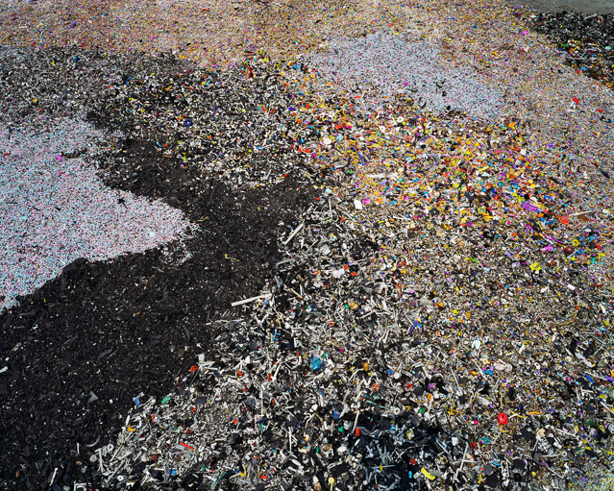
China Recycling #8, Plastic Toy Parts

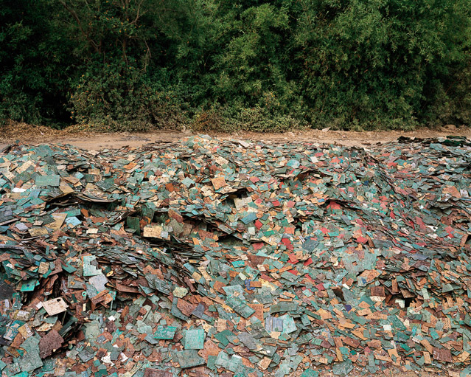
China Recycling #9, Circuit Boards

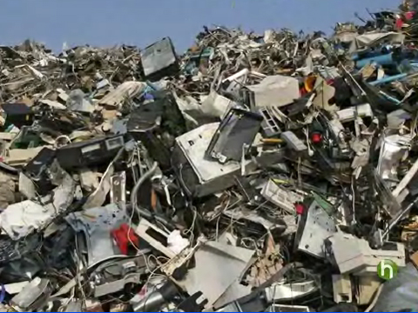
Old Computers, National Geographic

Are, as Klein and Burtynsky suggest, capitalism and consumerism threats to our environment?

H. The Collapse of Civilization?
From The Guardian, March 2014:
A new study partly-sponsored by NASA’s Goddard Space Flight Center has highlighted the prospect that global industrial civilisation could collapse in coming decades due to unsustainable resource exploitation and increasingly unequal wealth distribution.
Noting that warnings of 'collapse' are often seen to be fringe or controversial, the study attempts to make sense of compelling historical data showing that "the process of rise-and-collapse is actually a recurrent cycle found throughout history." Cases of severe civilisational disruption due to "precipitous collapse - often lasting centuries - have been quite common."
By investigating the human-nature dynamics of these past cases of collapse, the project identifies the most salient interrelated factors which explain civilisational decline, and which may help determine the risk of collapse today: namely, Population, Climate, Water, Agriculture, and Energy.
Might we, as the NASA study suggests, be on the verge of seeing civilization collapse?

I. The Legacy of the Industrial Revolution
The Industrial Revolution is a term usually associated with the accelerated pace of economic change, the associated technical and mechanical innovations, and the emergence of mass markets for manufactured goods, beginning in Britain in the last quarter of the eighteenth-century.

During the Industrial Revolution great changes were underway – canals were developed, major railways connecting cities were constructed, the steam engine was developed, powering machines in factories, along with boats and trains.

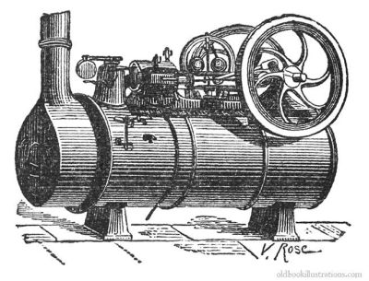

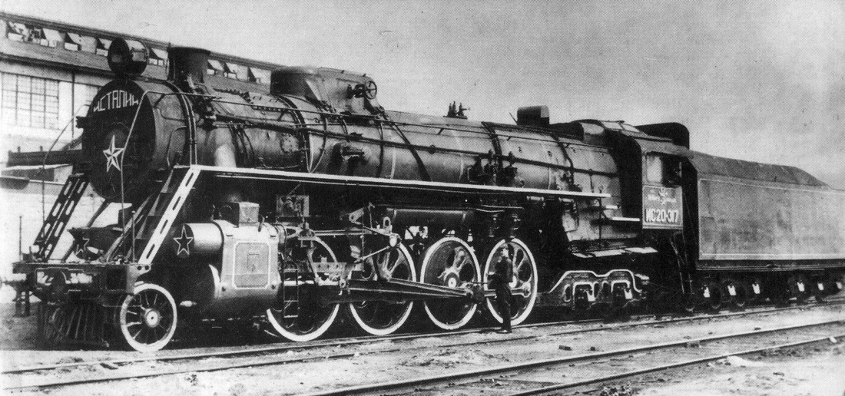

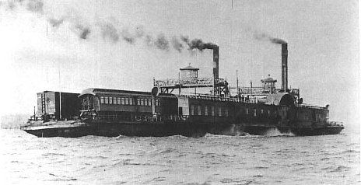


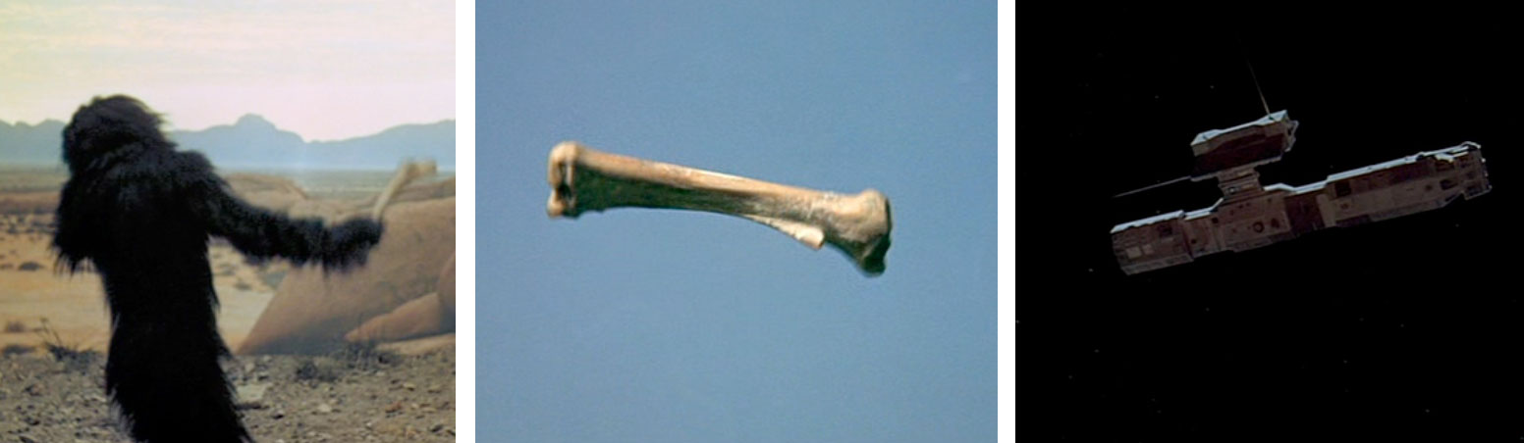



Since the advent of the Industrial Revolution, do you think the activity of humans has greatly impacted the environment in negative ways?

2. The Environment
All too often, we take the definitions of the words we use for granted, and fail to pause for a moment to consider their definition.
Perhaps, the word environment is one such word.
A typical primary definition of the word environment that one might encounter would be something like this –
Environment: the conditions that surround someone or something.

In considering this definition two things immediately come to mind: First, the environment is spatial; it is an area or space that surrounds us. Accordingly, as humans we cannot detach ourselves or escape from the environment.
Second, the environment is a space not just for humans (someone), but other livings things (somethings), and various physical and chemical interactions.
Perhaps, it is best to think of the environment in an organic way in which individuals and things are surrounded by and are interdependent on one another in their very nature.

3. Anthropocentrism
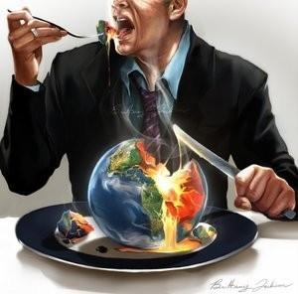

Anthropocentrism: A philosophical viewpoint arguing that human beings are the central or most significant entities in the world. This is a basic belief embedded in many Western religions and philosophies. Anthropocentrism regards humans as separate from and superior to nature and holds that human life has intrinsic value while other entities (including animals, plants, mineral resources, and so on) are resources that may justifiably be exploited for the benefit of humankind.
From the Encyclopaedia Britannica

Anthropocentrism would say that only humans have moral standing, that is, only humans are entities whose existence and fundamental interests have positive moral weight, which means that other humans have duties to constrain themselves in specific ways when dealing with other humans.
The perspective of anthropocentrism tells us that the environment has no value in itself; rather, its value is measured by how it affects humans.
For example, a national park might be instrumentally valuable to us since it is a place of relaxation and beauty.
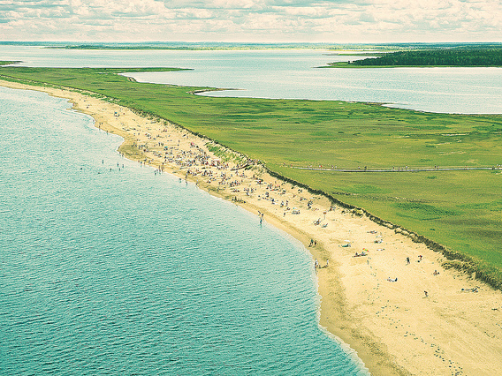
Kouchibouguac National Park, New Brunswick

A forest might be looked upon as being instrumentally valuable as it provides lumber for our buildings.
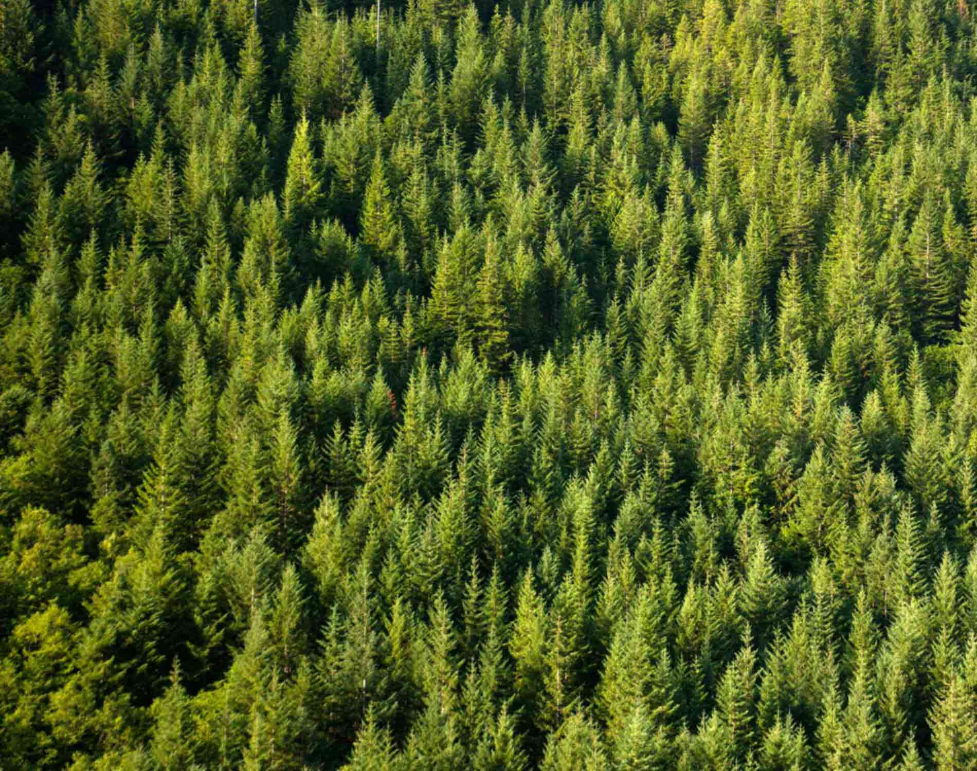
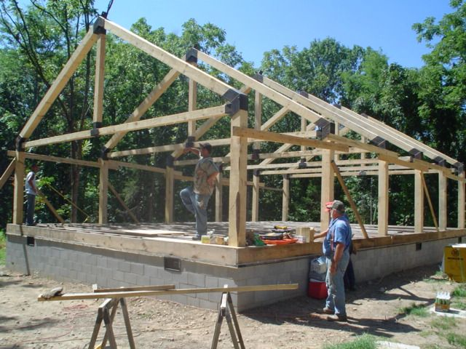

4. Ecocentrism
Ecocentrism is the view that it is simply not just humans that have intrinsic value, but also individual life forms or ecosystems.
There are variations of Ecocentrism, but as one can imagine, this view tells us that we ought to regard nature with admiration and respect, and recognize that nature and natural beings have intrinsic value.
Ecosystem: a system, or a group of interconnected elements, formed by the interaction of a community of organisms with their environment.

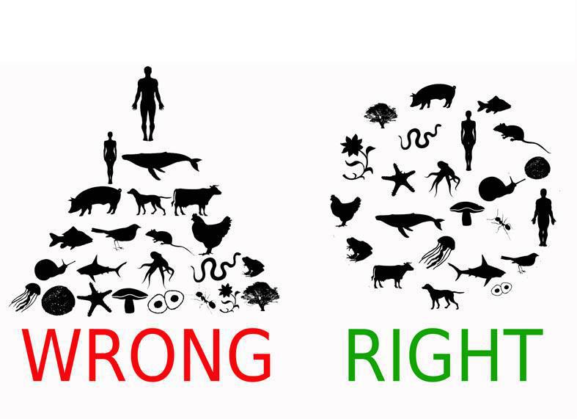

5. Deep Ecology
Deep ecology is contrasted with shallow ecology, which is essentially the same as anthropocentrism.
This term deep ecology was introduced by the Norwegian philosopher and environmentalist, Arne Naess and entails taking a holistic view of nature (emphasizing the importance of the whole and the interdependence of its parts), that is, looking at nature more deeply to identify the root causes of environmental degradation.
Western reductionism, individualism, and consumerism, according to Deep Ecology, are the causes of our environmental problems.
Move away from the reductionist idea that the world is a collection of discrete, isolable things.

6. Biocentrism
Biocentrism is the view that living things can benefit from and be harmed by human actions and that this fact places moral constraints on how we are permitted to treat them, since living things have intrinsic value.

Biocentrism seeks to extend the moral community by calling on humans to rethink their relation with nature.

‘Should Trees Have Standing? Toward Legal Rights for Natural Objects,’ Christopher D. Stone

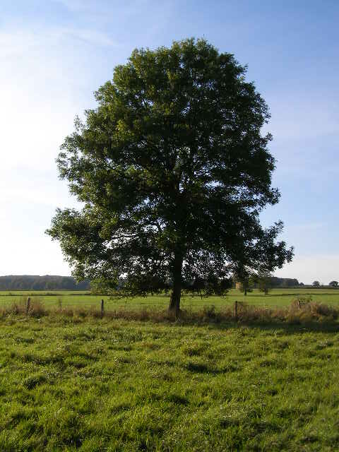

Stone begins his essay by stating:
Throughout legal history, each successive extension of rights to some new entity has been, theretofore, a bit unthinkable.

And he continues:
The fact is that each time there is a movement to confer rights onto some new “entity,” the proposal is bound to seem odd or frightening or laughable.

We can recall that Peter Singer, in ‘All Animals Are Equal,’ informs that one lesson learned from liberation movements is that in the moment it sometimes becomes difficult to point out our latent prejudices.

For example, Singer points out that when Mary Wollstonecraft published her Vindication of the Rights of Women in 1792, her views were widely regarded as absurd, and were parodied as a Vindication of the Rights of Brutes.
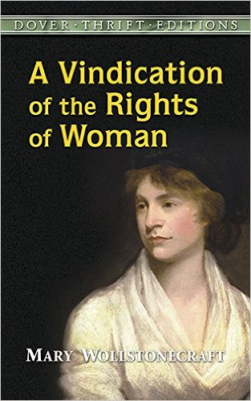
Women’s rights in the eighteenth century were, indeed, laughable.

One of the reasons that Stone provides for a predicament like this is that until something rightless, that is, something without rights, receives its rights, we cannot see it as anything but a thing for the use of us – those who currently hold rights.

For example, without rights women were perhaps seen as a second sex or as the property of men, while slaves, on the other hand, were seen as the property of their owners.

Perhaps, in both cases it can be argued that women and slaves were seen as having only instrumental value, individuals that were of use to those who held sway or power over them.

Nowadays if someone were to put forth a proposal that women should not have equal rights or that slavery as an institution should be reinstated, such proposals would be both frightening and laughable.

Now, we might want asks ourselves: Is it possible that someday down the road natural objects like trees will possess moral standing and have legal rights? Will the day come when the environment is not recognized as being rightless, but, in fact, like you and I, has rights?

It may seem to be a strange proposal, but all the same rights are granted to other nonhuman entities like corporations, states, municipalities, and so on.

As we will see, Stone wants to propose that we give legal rights to forests, oceans, rivers, and other so-called natural objects in the environment.

He qualifies his proposal by explaining that he is not arguing something silly like no one should be allowed to cut down a tree.
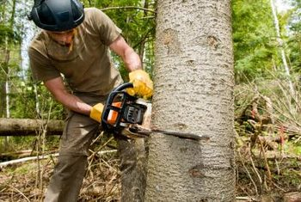

In fact, Stone clarifies that he is not arguing that the environment should have the same rights as humans, or that everything in the environment should have the same rights as every other thing in the environment.

Rather, he argues that the environment should be recognized as what he terms a “holder of legal rights,” which entails the legal recognition that something has worth and dignity on its own.

Stone elaborates that for something to be a “holder of legal rights” these three criteria must be satisfied:
First, the thing can institute legal actions at its behest [A person’s order or command].
Second, that in determining the granting of legal relief, the court must take the injury to it into account.
Third, the relief must run to the benefit of it.

Natural Objects and Rightlessness in Common Law

In order to illustrate how natural objects are without rights in common law, Stone takes the example of the pollution of a stream.

He notes that the stream is without rights, it has no moral or legal standing on its own when it is polluted. It is seen, as are other natural objects, as something for humans to conquer, master, and use. In short, something that just has instrumental value.
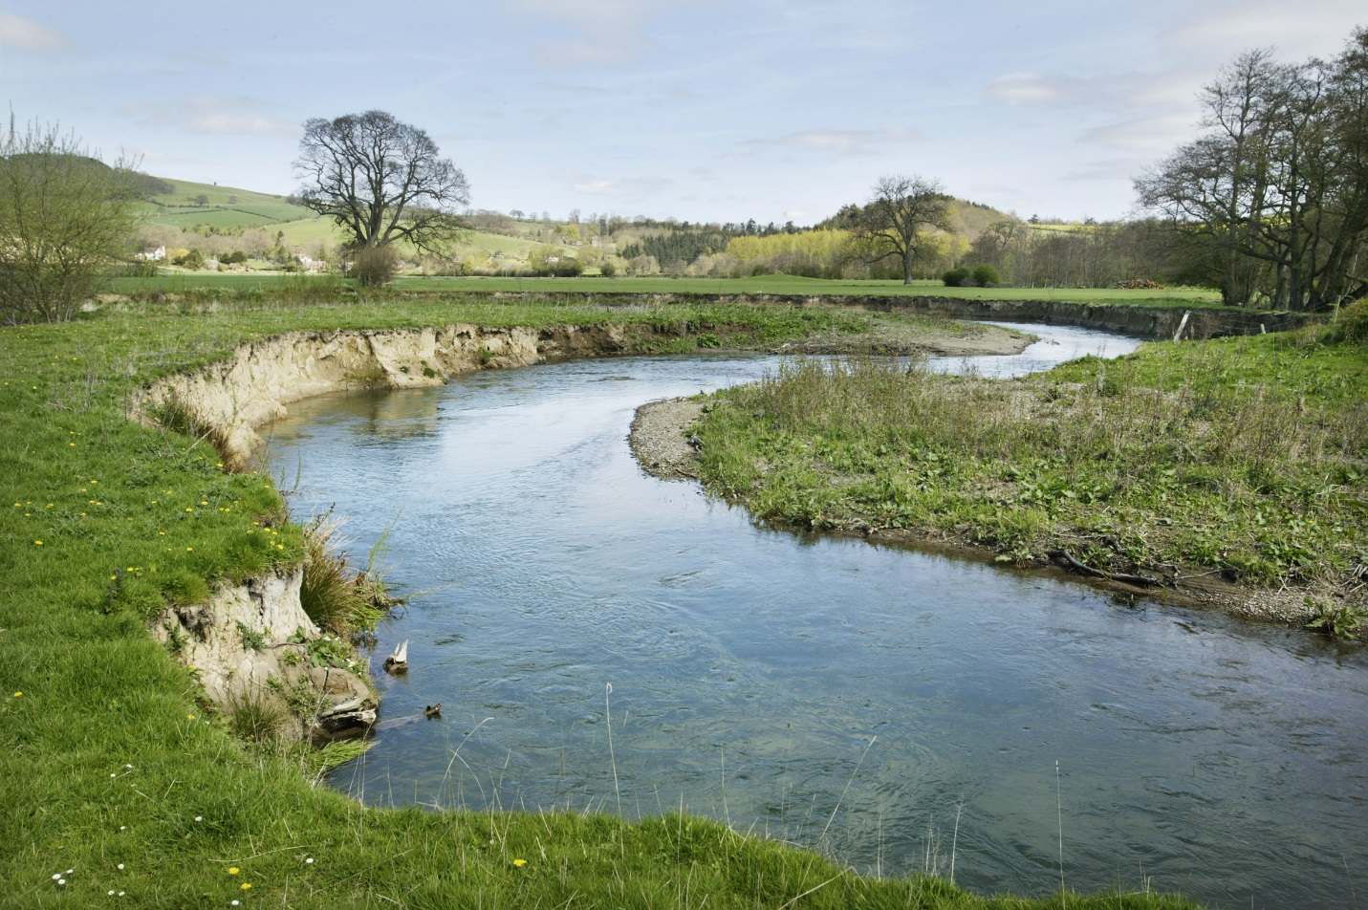

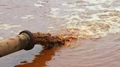
Moreover, it would be typically argued that a stream cannot be really injured nor can it actually benefit from a legal judgement.

And it lacks the three criteria of a rights-holder: “None of the natural objects, whether in common or situated on private land, has any of the three criteria of a rights-holder.”

Towards Natural Objects Having Rights
Stone argues that the fact that streams and forests cannot speak is no excuse to say that they should be without rights, as he notes that institutions that cannot speak like corporations, states, universities, municipalities, all have rights and so too do infants and incompetents.

Stone argues that the legal problems of natural objects should be handled in a similar manner to that of legal incompetents.

Definition of Incompetence (from the Legal Information Institute):
Lack of legal ability to do something, especially to testify or stand trial. Also, known as "incompetency." May be caused by various types of disqualification, inability, or unfitness. Someone who is judged incompetent by means of a formal hearing may have a guardian appointed by the court.

Along these lines, someone who perceives that a natural object is threatened can apply to the court to be a guardian of the environment.

Guardians act on behest of the environment; they raise the pertinent issue on behalf of the environment.

Stone elaborates:

If, for example, the Environmental Defense Fund should have reason to believe that some company's strip mining operations might be irreparably destroying the ecological balance of large tracts of land, it could, under this procedure, apply to the court in which the lands were situated to be appointed guardian. As guardian, it might be given rights of inspection (or visitation) to determine and bring to the court's attention a fuller finding on the land's condition. If there were indications that under the substantive law some redress might be available on the land's behalf, then the guardian wou1d be entitled to raise the land's rights in the land's name, i.e., without having to make the roundabout and often unavailing demonstration, discussed below, that the "rights" of the club's members were being invaded.

As noted, Stone argues that the environment should be recognized as what he terms a “holder of legal rights” and, accordingly, these three criteria must be satisfied:

First, the thing can institute legal actions at its behest [A person’s order or command].
Second, that in determining the granting of legal relief, the court must take the injury to it into account.
Third, the relief must run to the benefit of it.

1) With the example above, a guardian would bring to the court’s attention the potential problem of the strip mining operation by outlining the potential damage or damage already done to the environment. In other words, the guardian would initiate the legal action on behalf of the environment.

2) The court would determine the nature or extent of the injury to the environment by considering a question along these lines: Is the injury or potential injury so great that it would be necessary to issue an edict that would halt the process?

3) If relief is granted, it must be to the benefit of the environment. Also, if damage has been done to the environment, monetary compensation may be awarded to the environment and placed in a trust fund.

