A Prelude to Kant

1. One afternoon while you are walking home your next-door-neighbour quickly passes by you and tells you that he cannot stop to chat since he is on his way home, adding that he is hurrying home for the reason that someone who is in hot pursuit of him wants to harm and/or kill him. You find this strange, but not as odd as when a few moments later a burly and dangerous looking individual approaches you and says that he saw you talking to someone (your next-door neighbour) a few moments ago. This ominous individual asks you this question: Did the individual you were just talking to tell you where he was going?
How would you answer? What would be the morally right thing to do in this situation?

2. On a warm summer day you are walking to work on a bridge across a river when all of a sudden you see a small girl fall into the river and who begins to scream for help as she cannot swim and is being taken away by the current of the river. Do you have a duty to jump in the river and save this small girl?

3. Two individuals decide to meet after work for a drink. Both individuals end up having numerous drinks, and both individuals drive their cars home. Individual A gets home without any problem. Unfortunately, the car of Individual B sways over the centre line and collides with another vehicle sending the driver of the other vehicle to the hospital with critical injuries. Are the intentions of these two individuals any different?

4. An individual who is a known terrorist potentially has information that could thwart a terrorist attack in North America. Getting information from this individual would possibly save the lives of thousands in North America. All the same, after the standard line of questioning, this individual will not confess to any possible information he may know. Would it be morally alright to torture him to get additional information?

1. Kant (1724-1804)
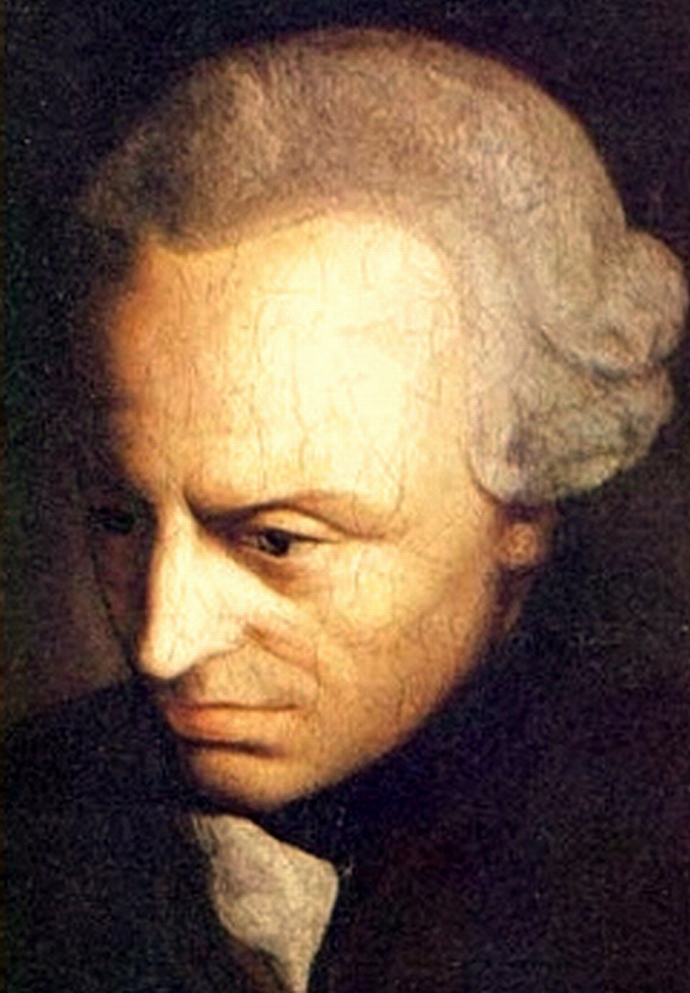

In his essay from 1784, entitled “An Answer to the Question: What is Enlightenment?” Kant writes:
Enlightenment is man’s emergence from his self-imposed immaturity. … This immaturity is self-imposed when its cause lies not in lack of understanding, but in lack of resolve and courage to use it without guidance from another. Sapere Aude! (Dare to know!). “Have courage to use your own understanding!” – that is the motto of the Enlightenment.

In his Critique of Pure Reason, Kant writes:
All of the interests of my reason, speculatively as well as practical, combine in the three following questions:
1. What can I know?
2. What ought I to do?
3. What may I hope?

2. Deontological versus Consequential Moral Theories

In his Groundwork for the Metaphysics of Morals, Kant claims: [Duty] is the necessity of an action from respect for law.



3. Kant’s Groundwork for the Metaphysics of Morals
Kant begins his Groundwork for the Metaphysic of Morals by writing:
It is impossible to think of anything at all in the world, or indeed even beyond it, that could be considered good without limitation except a good will.

4. Hypothetical Imperatives and Categorical Imperatives

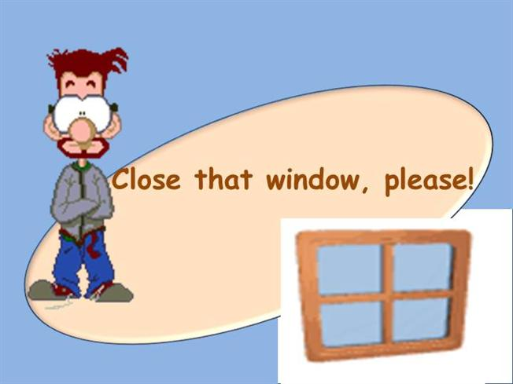

Accordingly, Kant states:
When I think of a hypothetical imperative in general, I do not know beforehand what it will contain; I do not know this until I am given the condition.

The first formulation of the categorical imperative that he provides goes like this:
Act only in accordance with that maxim through which you can at the same time will that it become a universal law.
A variation: Act as though the maxim of your act were to become a universal law of nature.

Kant arrives as another formulation (Formulation 4 in the text) of the categorical imperatives that goes like this –
So act that you use humanity, whether in your own person or in the person of any other, always at the same time as an end, never merely as a means.

