Ahmad Ramadhan 8266814
ADM2304[M]
Antoine Saure
Assignment 1
Feb. 4, 2018

------------------------------------------------ Question 1 --------------------------------------------

- Boxplot comparing the distribution of salaries for 2015 and 2016 graduates
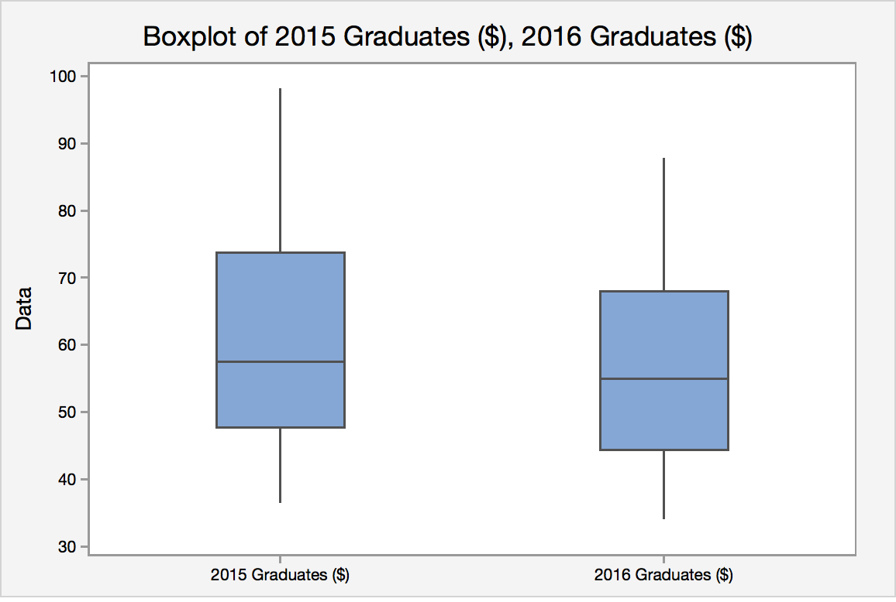

- Mann Whitney Test

Hypothesis
H_{o}: M₁ – M₂ = 0 (The distribution of salaries of 2015 MBA Graduates is equal to 2016 MBA Graduates)
H_{a}: M₁ – M₂ > 0 (The distribution of salaries of 2015 MBA Graduates is higher than 2016 MBA Graduates)

Ranks

2015 Graduates ($) | Rank | 2016 Graduates ($) | Rank
64.9 | 20 | 59.4 | 17
48 | 9 | 74.8 | 24
62.5 | 18 | 55 | 13
58.5 | 16 | 34.2 | 1
56.5 | 15 | 68 | 22
98.1 | 29 | 78.8 | 25
36.6 | 3 | 53.9 | 12
55.5 | 14 | 40.6 | 4
70.7 | 23 | 64.6 | 19
52.9 | 11 | 44.4 | 6
41.6 | 5 | 87.8 | 27
82.7 | 26 | 67.4 | 21
96.8 | 28 | 46.8 | 7
46.9 | 8 | 49.3 | 10
 |  | 36.2 | 2
SUM of Ranks | 225 |  | 210
u_{STAT} Calculation
u₁ = 225 – [(14 x 15)/2]
= 120
u₂ = 210 – [(15 x 16)/2]
= 90
u_{STAT} = 90

u_{CRIT} Calculation
u_{CRIT} = 66 (from “Mann-Whitney u table” using)

Conclusion
u_{STAT} > u_{CRIT}, therefore, we fail to reject the H_{o}. There is no sufficient evidence that the salaries for 2015 graduates is greater than 2016 graduates.

- Mann-Whitney Test Results from Minitab
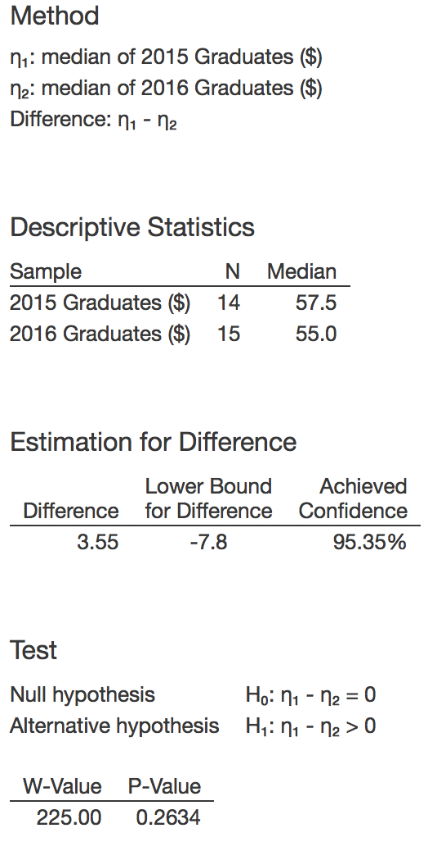

Conclusion
P-Value > alpha (0.2634 > 0.05), we fail to reject the H_{o}. There is no sufficient evidence that the salaries for 2015 graduates is greater than 2016 graduates. Therefore, the result does agree with part (b). Because P-Value > alpha (0.2634 > 0.05), we fail to reject H_{o}. In part (b) we failed to reject H_{o.}

---------------------------------------------Question 2------------------------------------------------

- 2 – Proportions Test (independent)

Hypothesis
H_{o}: p₁ – p₂ = 0 (There is no difference in the proportion of mothers (of children with or without autism) who took parental vitamins three months before pregnancy
H_{a}: p₁ – p₂ ≠ 0 (There is a difference in the proportion of mothers (of children with or without autism) who took parental vitamins three months before pregnancy)

- Calculating Z_{STAT}
Z_{STAT} = [(0.613 – 0.474)]/{SQRT[(0.613 x 0.387)/181] + [0.474 x 0.526)/302]}
= 3.02

Calculating Z_{CRIT}
Z_{CRIT} = 1.96 (from “Z-Table)

Conclusion
Z_{STAT} > Z_{CRIT} (3.02 > 1.96), therefore, we reject H_{o}, there is sufficient evidence that there is a difference in the proportion of mothers (of children with or without autism) who took parental vitamins three months before pregnancy.

- Calculating CI
CI=(0.613 – 0.474) - {1.96 x [SQRT[(0.613 x 0.387)/181] + [(0.474 x 0.526)/302]}
= 0.049
CI=(0.613 – 0.474) + {1.96 x [SQRT[(0.613 x 0.387)/181] + [(0.474 x 0.526)/302]
= 0.23
CI (0.23,0.49)

- The confidence interval does agree with the hypothesis test as the value of 0 (p₁ – p₂ = 0) that we are testing in the hypothesis is not present in the CI. Meaning we reject H_{o} like in the conclusion of the hypothesis test. Yes, it must agree because if the value of 0 was in the CI, our test may not be correct because 0 would be a plausible value and there is a possibility that there is no difference in the proportion of mothers (of children with or without autism) who took parental vitamins three months before pregnancy.

- 2 – Proportions Test (independent) Results from Minitab
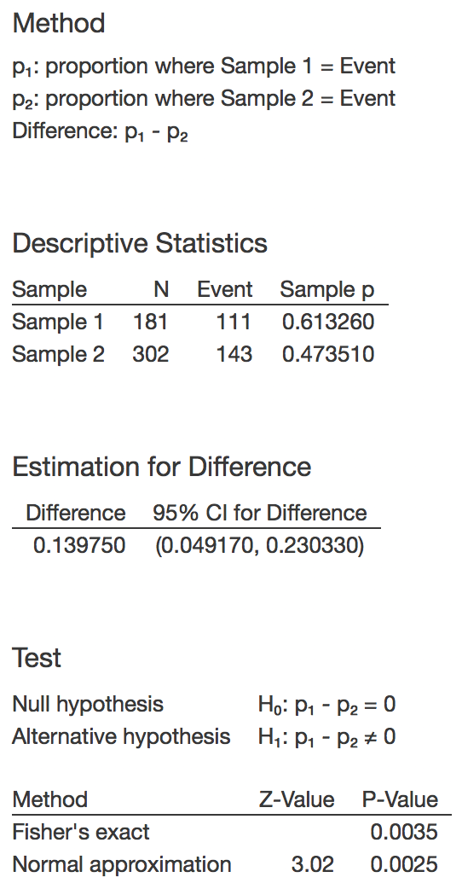

2 – Proportions Test (independent pooled) Results from Minitab
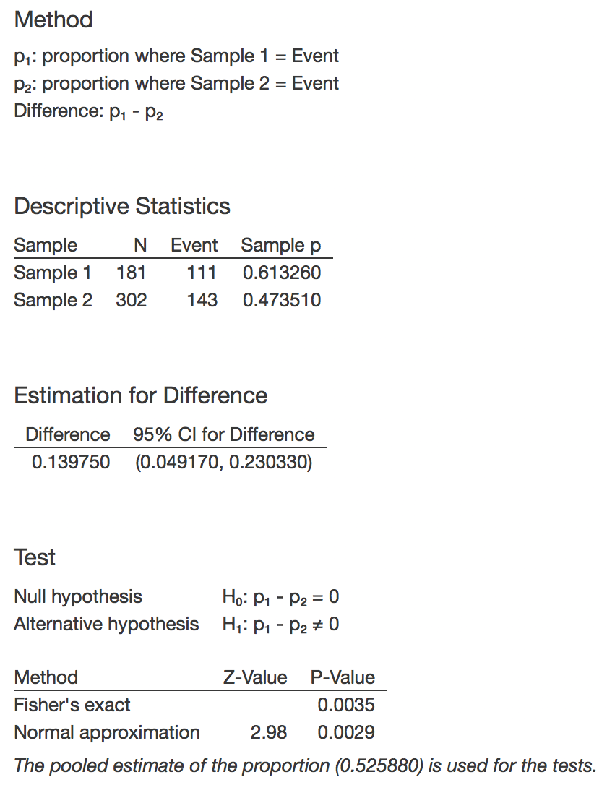

Although the normal approximation Z_{STAT} and P-Value is different in the two examples, the final conclusion and all else remains the same.

- No, I do not agree with this title. As we look at the P-Valued in the test, there is a higher possibility of autism arising when the vitamins are taken. P-Value is 0.613260 when the vitamin is taken and 0.4735 when it is not. A more appropriate article name is “Stats on Prenatal Vitamins vs No Prenatal Vitamins influence on autism”.

---------------------------------------------Question 3------------------------------------------------

- 2 Sample t-test

Hypothesis
H_{o}: u₁ – u₂ = 0 (there is no difference between the average fuel efficiency of cars with manual and automatic transmissions)
H_{a}: u₁ – u₂ ≠ 0 (there is a difference between the average fuel efficiency of cars with manual and automatic transmissions)

Calculating T_{STAT}
T_{STAT} = {16.12 – 19.85}/{SQRT[(3.58²/26) + (4.51²/26)]}
= -3.30

Calculating DF
DF = {[(3.58² /26) + (4.51²/26)]²/{[(3.58²/26/26-1)²] + [(4.51²/26/26-1)²]}
= 47

Calculating T_{CRIT}
T_{CRIT} = 2.012 (Found on T-Table by using DF of 47 and probability of 0.05 on a two-tailed test)

Conclusion
T_{STAT >} T_{CRIT} (3.30 > 2.012), therefore we reject H_{o,} there is sufficient evidence that there is a difference between the average fuel efficiency of cars with manual and automatic transmissions.

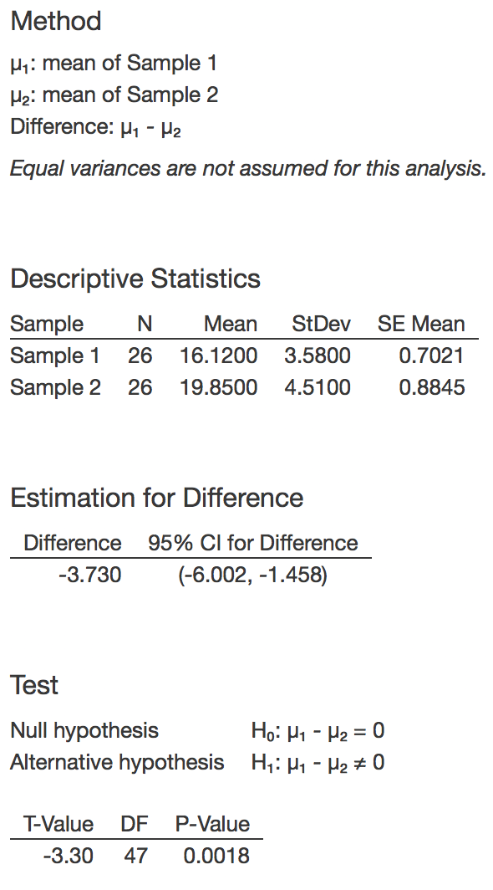
- 2 Sample t-test Results from Minitab

- Confidence Interval
Lower bound = (22.92 – 27.88) - {2.325 x [SQRT(5.29² /26) + (5.01²/26)]}
= -8.396
Upper bound = (22.92 – 27.88) + {2.325 x [SQRT(5.29² /26) + (5.01²/26)]}
= -1.524

The interval mean that the average fuel efficiency of automatic cars is between 1.524 to 8.396 MPG less than manual cars.

- 2 Sample t-test Results from Minitab

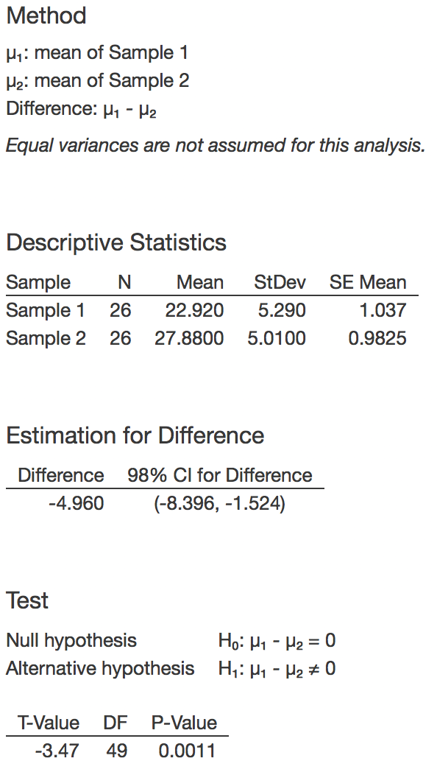

-----------------------------------------------Question 4----------------------------------------------
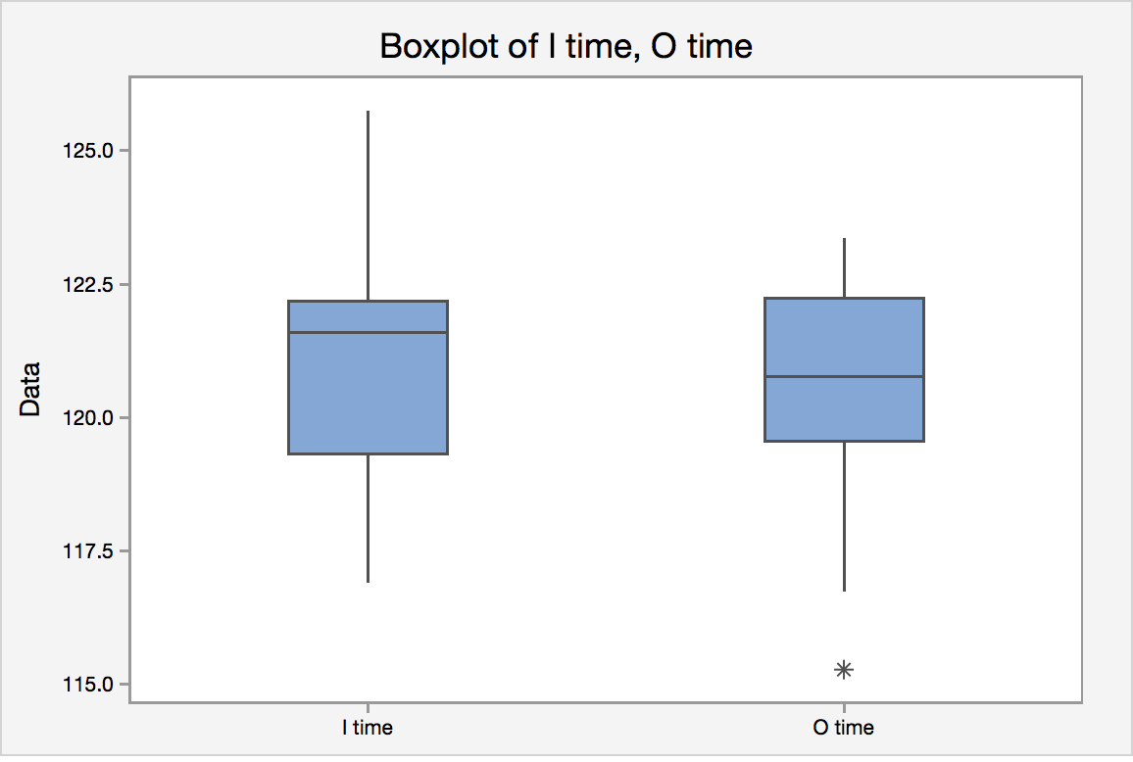

From the boxplot, it is hard to judge whether to inner or outer lane times are
faster, but the median of the outer lane is clearly faster than the inner lane.
Because the data is dependent, I think a boxplot of the differences would be
better suited to compare if there is a difference.

- The speed skating data are matched pairs because we are comparing every inner lane skier with a corresponding outer lane skier. The skiers start at the same time and are being directly compared to each other. As well, the skiers will change from the inner to the outer lane.

- A non-parametric test is more appropriate in this case, the differences of the samples is not normally distributed. We can see that in the histogram below. Therefore, use Wilcoxon Test.
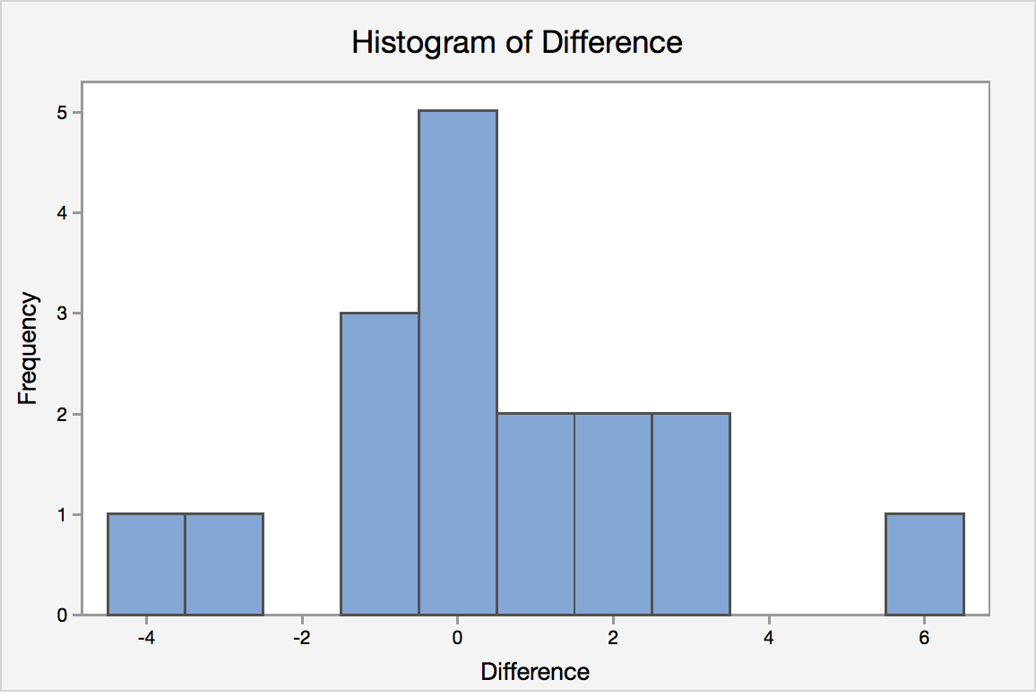

- Paired t-test

Hypothesis
H_{o}: u_{d} = 0 (there is not a significant difference between speed on the inner and outer lanes)
H_{a}: u_{d} ≠ 0 (there is a significant difference between speed on the inner and outer lanes)

Calculating T_{STAT}
T_{STAT} = {0.499}/{2.33/{SQRT[16]}
= 0.88

Calculating DF
DF = 17 - 1
= 16

P-Value
0.3912

Calculating T_{CRIT}
T_{CRIT} = 2.12 (Found on T-Table by using DF of 16 and probability of 0.05 on a two-tailed test)

Conclusion
T_{STAT <} T_{CRIT} (0.88 < 2.12), therefore we fail reject H_{o,} there is no sufficient evidence that there is a significant difference between speed on the inner and outer lanes.

P-Value > alpha (0.3912 > 0.05) therefore we fail reject H_{o,} there is no sufficient evidence that there is a significant difference between speed on the inner and outer lanes.

- Paired t-test Minitab Results

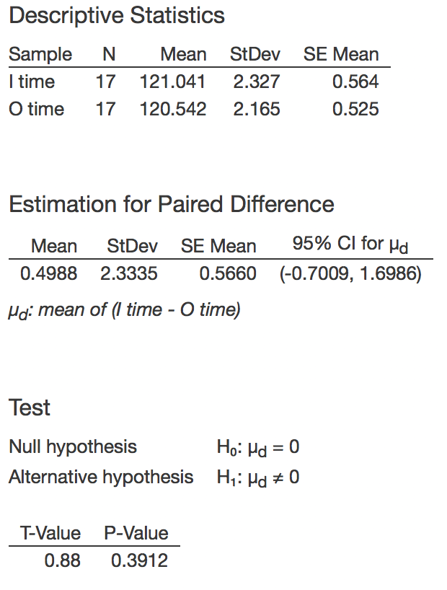

- Wilcoxon Test

Hypothesis
H_{o}: M_{d} = 0
H_{a}: M_{d} ≠ 0

Calculations

I Name | I country | I time | O Name | O country | O time | Difference | Absolute Difference | Ranks of Absolute Difference
ZHANG Xiaolei | China CHN | 125.75 | NEMOTO Nami | Japan JPN | 122.34 | 3.41 | 3.41 | 15
ABRAMOVA Yekaterina | Russian Fed. RUS | 121.63 | LAMB Maria | United States USA | 122.12 | -0.49 | 0.49 | 5
REMPEL Shannon | Canada CAN | 122.24 | NOH Seon Yeong | Korea KOR | 123.35 | -1.11 | 1.11 | 9
LEE Ju-Youn | Korea KOR | 120.85 | TIMMER Marianne | Netherlands NED | 120.45 | 0.40 | 0.40 | 4
ROKITA Anna Natalia | Austria AUT | 122.19 | MARRA Adelia | Italy ITA | 123.07 | -0.88 | 0.88 | 7
YAKSHINA Valentina | Russian Fed. RUS | 122.15 | OPITZ Lucille | Germany GER | 122.75 | -0.60 | 0.60 | 6
BJELKEVIK Hedvig | Norway NOR | 122.16 | HAUGLI Maren | Norway NOR | 121.22 | 0.94 | 0.94 | 8
ISHINO Eriko | Japan JPN | 121.85 | WOJCICKA Katarzyna | Poland POL | 119.96 | 1.89 | 1.89 | 11
RANEY Catherine | United States USA | 121.17 | BJELKEVIK Annette | Norway NOR | 121.03 | 0.14 | 0.14 | 1
OTSU Hiromi | Japan JPN | 124.77 | LOBYSHEVA Yekaterina | Russian Fed. RUS | 118.87 | 5.90 | 5.90 | 17
SIMIONATO Chiara | Italy ITA | 118.76 | JI Jia | China CHN | 121.85 | -3.09 | 3.09 | 14
ANSCHUETZ THOMS Daniela | Germany GER | 119.74 | WANG Fei | China CHN | 120.13 | -0.39 | -0.39 | 3
BARYSHEVA Varvara | Russian Fed. RUS | 121.6 | van DEUTEKOM Paulien | Netherlands NED | 120.15 | 1.45 | 1.45 | 10
GROENEWOLD Renate | Netherlands NED | 119.33 | GROVES Kristina | Canada CAN | 116.74 | 2.59 | 2.59 | 13
RODRIGUEZ Jennifer | United States USA | 119.3 | NESBITT Christine | Canada CAN | 119.15 | 0.15 | 0.15 | 2
FRIESINGER Anni | Germany GER | 117.31 | KLASSEN Cindy | Canada CAN | 115.27 | 2.04 | 2.04 | 12
WUST Ireen | Netherlands NED | 116.9 | TABATA Maki | Japan JPN | 120.77 | -3.87 | 3.87 | 16

Sum of Ranks
T- = 60
T+ = 93
Therefore, W_{STAT} is 60. P-Value is 0.4354. W_{CRIT} is 34.

Conclusion
W_{STAT} > W_{CRIT} (60 > 34), therefore we fail reject H_{o}. There is no sufficient evidence that there is a significant difference between speed on the inner and outer lanes.

- Wilcoxon Test Minitab Results
W-Value: 60
Mean of difference: -1.08
Z-Value: -0.7811
P-Value: 0.4354
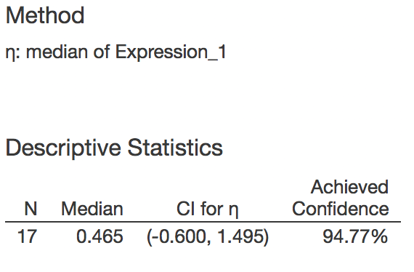

Conclusion
P-Value > alpha (0.4354 > 0.05), therefore we fail to reject H_{o}. There is not sufficient evidence that there is a significant difference between speed on the inner and outer lanes. The conclusion is that the critical value approach does not match the P-Value approach. We fail to reject H_{o} when using the P-Value approach, but we reject H_{o} when using the critical value approach.

- The results from the parametric and non-parametric tests are quite similar when we look at the P-Value. The P-Value for the parametric test is slightly lower at 0.3912, compared to 0.4354 for the non-parametric test. The CI also has a greater range for the parametric test, ranging from -0.7009 to 1.6986 compared -0.6 to 1.495 for the non-parametric test.

