1.1: Why Should I Study Information Systems

Information technology (IT) is any computer-based tool that people use to work with information and to support the information and information-processing needs of an organization.

An information system (IS) collects, processes, stores, analyzes, and disseminates information for a specific purpose.

The MIT Technology Review refers to our generation as Homo conexus. Information technologies are so deeply embedded in your life that your daily routines would be almost unrecognizable to a college student just 20 years ago.
Essentially, you practice continuous computing, surrounded by a movable information network. This network is created by constant co-operation between the digital devices you carry (e.g., laptops, tablets, and smart phones), the wired and wireless networks that you access as you move about, and Web-based tools for finding information and communicating and collaborating with other people.

Why learn about IS? In order to become and informed user, that is, a person knowledgeable about information systems and information technology. Here are some benefits of being an informed user:
- Benefit more from your organization's IT applications because you will understand what is "behind" those applications. That is, what you see on your computer screen is brought to you by your MIS department, which is operating “behind” your screen.
- Second, you will be in a position to enhance the quality of your organization's IT applications with your input.
- Third, even as a new graduate, you will quickly be in a position to recommend—and perhaps help select—the IT applications that your organization will use.
- Fourth, being an informed user will keep you abreast of both new information technologies and rapid developments in existing technologies.
- Fifth, you will understand how using IT can improve your organization's performance and teamwork as well as your own productivity.
- Finally, if you have ideas of becoming an entrepreneur, then being an informed user will help you use IT when you start your own business.

The information systems field includes the people in various organizations who design and build information systems, the people who use those systems, and the people responsible for managing those systems. At the top of the list is the chief information officer (CIO).

Managing Information Resources
Managing IS in modern organizations is a difficult, complex task. This is due to:
- Information systems have enormous strategic value to organizations. Firms rely on them so heavily that if they stop working, the firm cannot function.
- Information systems are very expensive to acquire, operate, and maintain.
- The evolution of the MIS function within the organization. From no computers to computers at every desk. As a result of these developments, the responsibility for managing information resources is now divided between the MIS department and the users.
Generally speaking, the MIS department is responsible for corporate-level and shared resources, and the users are responsible for departmental resources.

In Traditional MIS functions user's come in and provide vital input for two functions: managing systems development and infrastructure planning.

In consultative functions however, the user exercises the primary responsibility for each function, while the MIS department acts as an advisor.

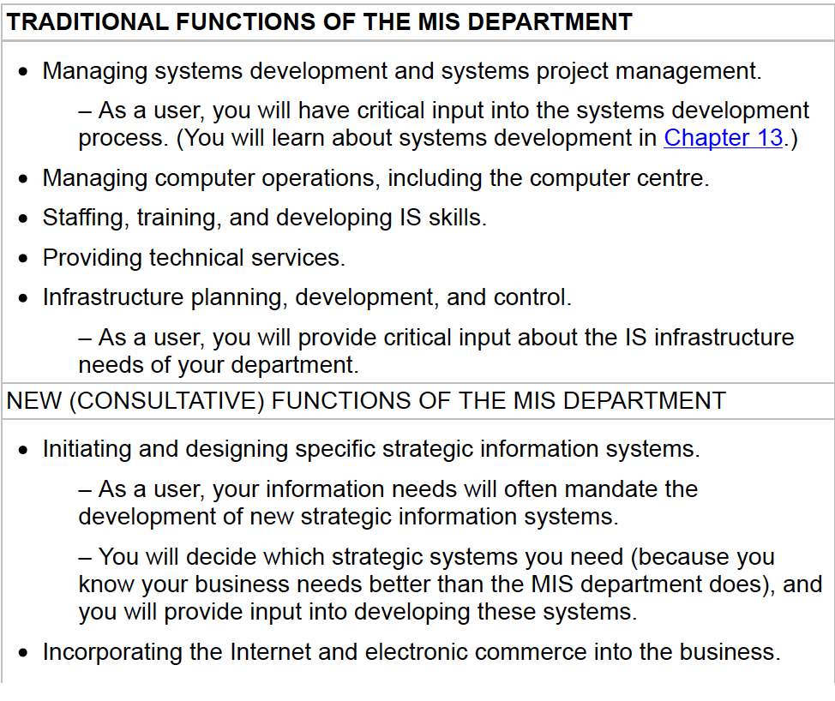

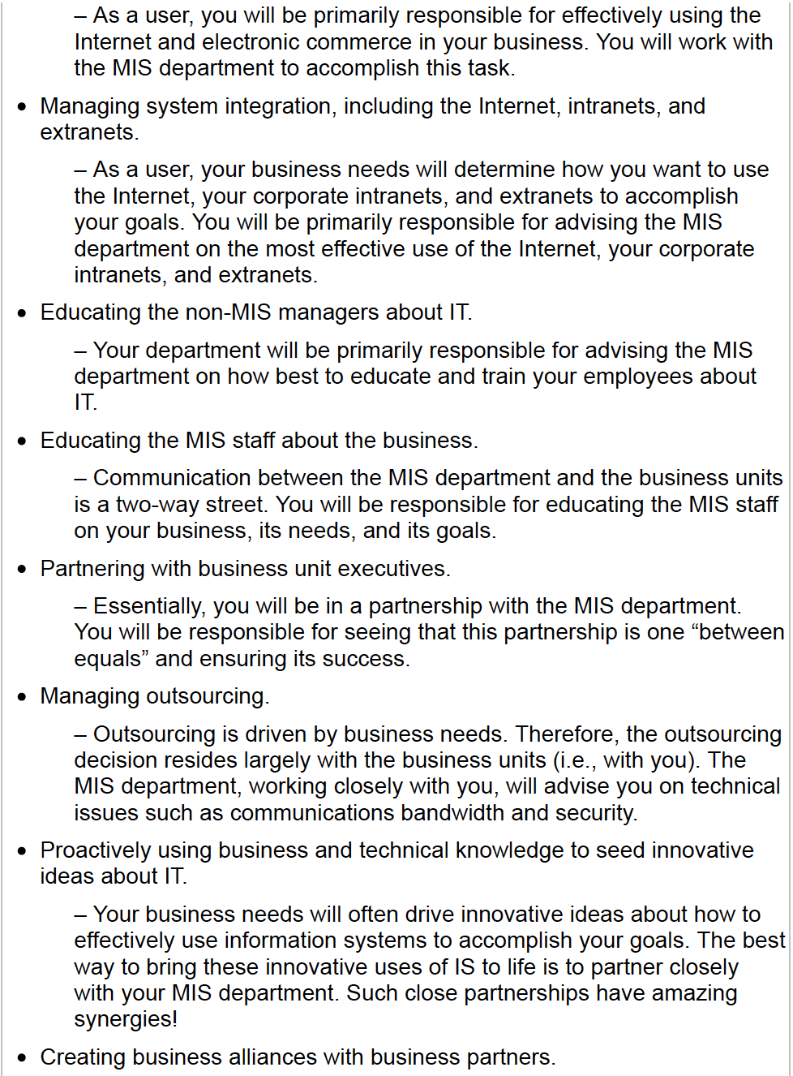

1.2: Overview of Computer-Based Information Systems

Organizations refer to MIS functional area's by several names. Regardless of the name, however, this functional area deals with the planning for—and the development, management, and use of information technology tools to help people perform all the tasks related to information processing and management.

The purpose of information systems has been defined as getting the right information to the right people, at the right time, in the right amount, and in the right format.

Knowledge consists of two things: data and information.

Data items are elementary descriptions of things, events, activities, and transactions that are recorded, classified, and stored but are not organized to convey any specific meaning. They can be numbers, letters, figures, sounds, and images.

Information is data that have been organized so that they have meaning and value to the recipient. The recipient interprets the meaning and draws conclusions and implications from the information.
For example, a grade point average (GPA) by itself is a data item, but a student's name coupled with his or her GPA is information.

Knowledge consists of data and/or information that have been organized and processed to convey understanding, experience, accumulated learning, and expertise as they apply to a current business problem.

A Computer-based information system is an information system that uses computer technology to perform some or all of its intended tasks. The components of computer-based information system are:
- Hardware consists of devices such as the processor, monitor, keyboard,
and printer. Together, these devices accept, process, and display data and
information.
- Software is a program or collection of programs that enable the hardware
to process data.
- A database is a collection of related files or tables containing data.
- A network is a connecting system (wireline or wireless) that permits
different computers to share resources.

Procedures are the instructions for combining the above components to process information and generate the desired output.

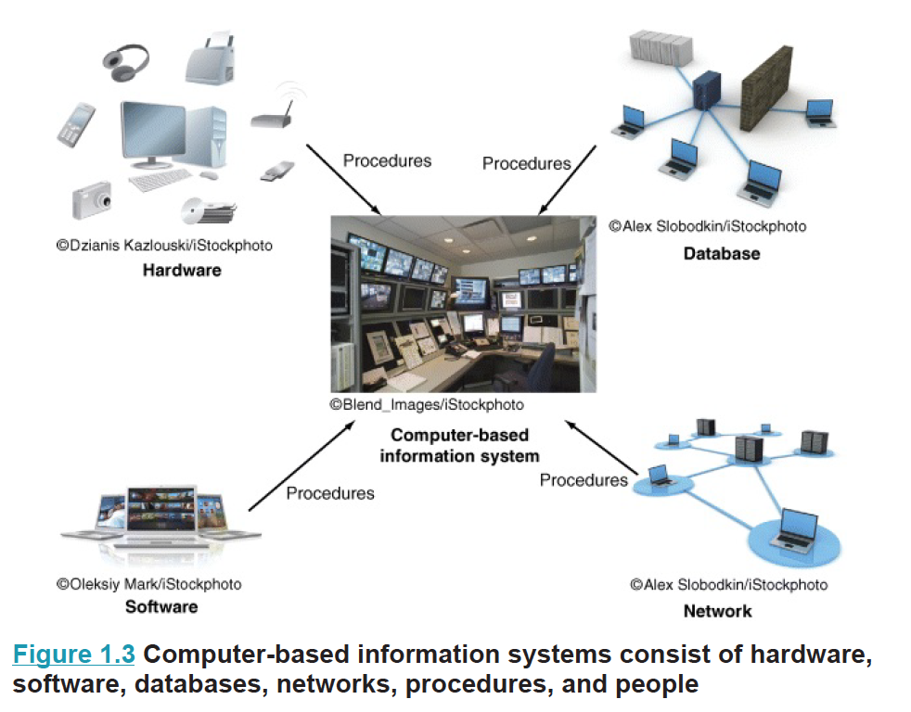

Starting at the bottom of the figure, you see that the IT components of hardware, software, networks (wireline and wireless), and databases form the information technology platform. IT personnel use these components to develop information systems, oversee security and risk, and manage data. These activities cumulatively are called information technology services. The IT components plus IT services compose the organization's information technology infrastructure.
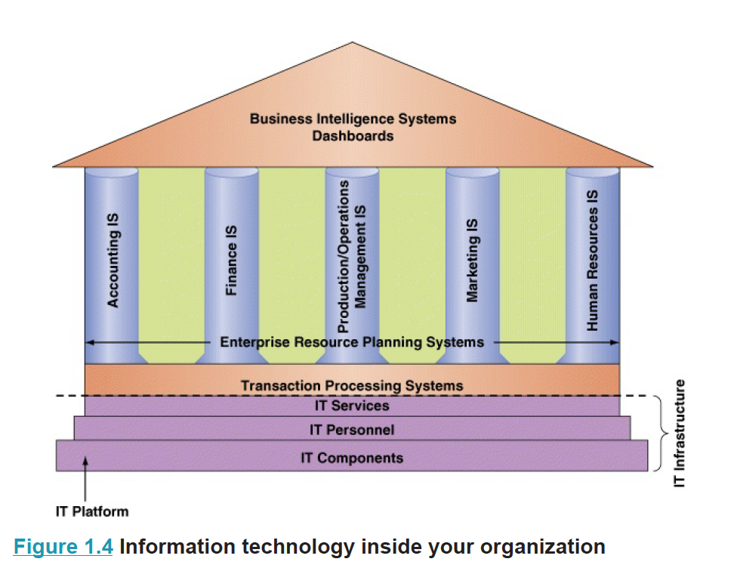

Information systems perform these various tasks via a wide spectrum of applications.
An application (or app) is a computer program designed to support a specific task or business process.

Types of Computer-Based Information Systems

Figure 1.5 shows the different types of information systems that could function among multiple organizations.

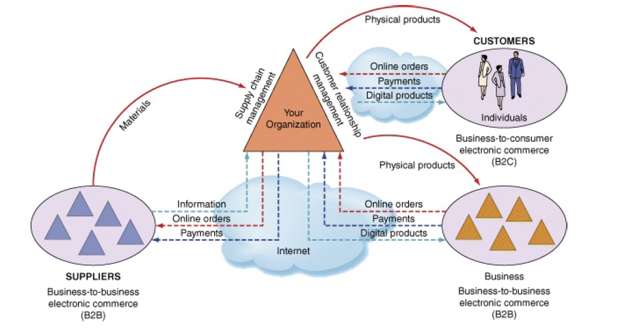

Two information systems that support the entire organization are enterprise resource planning systems and transaction processing systems:

Enterprise resource planning (ERP) systems are designed to correct a lack of communication among the functional area IS's. ERP systems resolve the problem of various functional area IS's not communicating effectively with one another by tightly integrating the functional area IS's via a common database.

A transaction processing system (TPS) supports the monitoring, collection, storage, and processing of data from the organizations basic business transactions, each of which generates data. The information system definition of a transaction is broader: A transaction is anything that changes the firm's database. TPSs are considered critical to the success of any enterprise because they support core operations. Significantly, nearly all ERP systems are also TPSs, but not all TPSs are ERP systems.

Information systems that connect two or more organizations are referred to as interorganizational information systems (IOSs). IOSs support many interorganizational operations, of which supply chain management is the best known. An organization's supply chain is the flow of materials, information, money, and services from suppliers of raw materials through factories and warehouses to the end customers.

Electronic commerce systems are another type of interorganizational information system. These systems enable organizations to conduct transactions, called business-to-business (B2B) electronic commerce, and customers to conduct transactions with businesses, called business-to-consumer (B2C) electronic commerce.

Support for Organizational Employees

- Knowledge workers: professional employees such as financial and marketing analysts, engineers, lawyers, and accountants. All knowledge workers are experts in a particular subject area. Knowledge workers, in turn, act as advisors to middle managers and executives.
- Office automation systems (OASs) typically support the clerical staff, lower and middle managers, and knowledge workers. These employees use OASs to develop documents (word processing and desktop publishing software), schedule resources (electronic calendars), and communicate (email, voice mail, video conferencing, and groupware).
- Business intelligence systems provide computer-based support for complex, nonroutine decisions, primarily for middle managers and knowledge workers. It allows users to perform their own data analysis
- Expert systems (ESs) attempt to duplicate the work of human experts by applying reasoning capabilities, knowledge, and expertise within a specific domain.
- Dashboards are a special form of IS that support all managers of the organization. They provide rapid access to timely information and direct access to structured information in the form of reports.

1.3: How does IT Affect Organizations?

IT Affects Entire Industries

Software tools and Internet-based services enable companies in many industries to launch new software-powered start-ups without investing in new infrastructure or training new employees. In essence, software is affecting every industry, and every organization must prepare for these impacts.

Examples:

- The music industry: Today's dominant music companies are also software companies: for example, Apple's iTunes (www.apple.com/itunes) and Spotify (www.spotify.com). Traditional record labels now exist largely to provide these software companies with content. Meanwhile, the Recording Industry Association of America (RIAA) continues to fight battles over copyright infringement and the illegal download and sharing of digital music files. The equivalent organization in Canada is Music Canada. On its website (http://musiccanada.com/digital-music/) you will find a list of digital music providers in Canada.

- The video industry: Blockbuster—which rented and sold videos and ancillary products through its chain of stores—was the industry leader until it was disrupted by what is now a software company, Netflix (www.netflix.com). In early 2016, Netflix had the largest subscriber base of any video service, with millions of subscribers. Meanwhile, Blockbuster declared bankruptcy in February 2011 and was acquired by satellite television provider Dish Networks a month later. It was announced later that year that all Blockbuster stores would be closed.

- The marketing industry: Today's largest direct marketing companies include Facebook (www.facebook.com), Google (www.google.ca), and Foursquare (www.foursquare.com). All of these companies are using software to disrupt the retail marketing industry.

- Education: University and college graduates owe billions of dollars in student debt, a crippling burden for many recent graduates. UniversityNow (www.unow.com), based in San Francisco, California, was founded to make higher education more accessible to working adults by offering online, self-paced degrees. Two key characteristics distinguish UniversityNow from an increasing number of rivals: (1) very low fees (as little as $2,600, which includes tuition and books for as many courses as students can complete in one year) and (2) fully accredited degrees, from an associate's degree to an MBA.

IT Reduces the Number of Middle Managers

IT makes managers more productive, and it increases the number of employees who can report to a single manager. Thus, IT ultimately decreases the number of managers and experts. It is reasonable to assume, therefore, that in coming years organizations will have fewer managerial levels and fewer staff and line managers.

IT Changes the Manager's Job

IT often provides managers with near-real-time information, meaning that managers have less time to make decisions, making their jobs even more stressful. Fortunately, IT also provides many tools—for example, business analytics applications such as dashboards, search engines, and intranets—to help managers handle the volumes of information they must deal with on an ongoing basis.

Will IT Eliminate Jobs?

Put simply, organizations are responding to today's highly competitive environment by doing more with less. Regardless of your position, then, you consistently will have to add value to your organization and to make certain that your superiors are aware of this value.
As computers continue to advance in terms of intelligence and capabilities, the competitive advantage of replacing people with machines is increasing rapidly. This process frequently leads to layoffs. At the same time, however, IT creates entirely new categories of jobs, such as electronic medical record-keeping and nanotechnology.

IT Affects Employees at Work

Although computers and information systems are generally regarded as agents of “progress,” they can harm individuals' health and safety. To illustrate this point, we consider two issues associated with IT: job stress and long-term use of the keyboard.

Computers can create new employment opportunities for people with disabilities by integrating speech-recognition and vision-recognition capabilities. For example, individuals who cannot type can use a voice operated keyboard, and individuals who cannot travel can work at home.

1.4: Importance of Information Systems to Society

IT Affects Our Quality of Life

IT has significant implications for our quality of life. The workplace can be expanded from the traditional 9-to-5 job at a central location to 24 hours a day at any location. IT can provide employees with flexibility that can significantly improve the quality of leisure time, even if it doesn't increase the total amount of leisure time.

However, IT can place employees on “constant call,” which means they are never truly away from the office, even when they are on vacation.

The Robot Revolution Is Here Now

Once restricted largely to science fiction movies, robots that can perform practical tasks are becoming more common. In fact, “cyberpooches,” “nursebots,” and other mechanical beings may be our companions before we know it. Around the world, quasi-autonomous devices have become increasingly common on factory floors, in hospital corridors, and in farm fields.

Improvements in Health Care

Medical personnel use IT to make better and faster diagnoses and to monitor critically ill patients more accurately. IT has also streamlined the process of researching and developing new drugs. Expert systems now help doctors diagnose diseases, and machine vision is enhancing the work of radiologists. Surgeons use virtual reality to plan complex surgeries. They also employ surgical robots to perform long-distance surgery.

