Psych Lecture Part 2

Lecture #13 – Sensation

Next time: read 150-158

What do Weber fractions tell you about sensation?
Can we perceive subliminal messages?
How does the visual system work?

How do we perceive the world around us?
Psychophysics & psychophysiology

Psychophysics: relation between physical stimulus and psychological response

Fechner: Father of psychophysics
Can determine a just noticeable difference (JND)

Threshold: Value of a stimulus characteristic required to produce some response
Absolute threshold: Lower limit (ie, auditory threshold is 20hz-20khz)
Vision: Candle flame at 50km
Hearing: Tick of a watch at 6m
Taste: Tsp of sugar in 8L water
Smell: 1 drop of perfume in a 6 room apartment
Touch: Wing of a fly falling on cheek from 1cm
Difference threshold: The amount of change necessary for JND

Relation: brightness & perceived brightness, not a 1-1 relation
Weber’s law: Size of difference threshold relative to physical intensity of test is constant: dI/I = C (d=delta)
Ie, if I=50db, and JND is reported at 55db, 5/50=1/10, this is the C value
Predict JND at 100db, dI/100 = 1/10, therefore dl = 10db, new test could be 90 or 110 db
Only works for small changes, not very generalizable

Value of JND is not constant, but the relative difference is constant
Can compare sensitivity of different system, smaller the C, the better
Vision: 1/60 (eagle has 1/200)
Kinesthesis (weight): 1/50
Pain (thermal): 1/30
Audition (mid pitch/moderate loudness): 1/10
Skin pressure: 1/7
Smell (India rubber): 1/4
Taste (salt): 1/3
Therefore vision is the most sensitive

Fechner’s law
Sensation increases with the logarithm of intensity
S = K log I (don’t need to know)
This is more general and cognitively economic

Steven’s power law
S = K long I^{N} (don’t need to know)
More predictive across a variety of sensations

Subliminal perception
Can we perceive stimuli that below threshold?
Is our behaviour affected by subliminal stimuli?

James Vicary (1957)
Claimed 50% increase in popcorn sales
Concern about the use of subliminal “cuts”

William Tapley

In general, there is no evidence that subliminal cuts influence consumer behaviour
BUT, consider Bruce & Valentine (1986) – Priming
Research shows if you show a subliminal cue that relates to the actual picture, response happens 100ms faster

Fitzimons 2008
30 ms exposure to either apple logo or IBM logo, tested creativity

Sensory systems:

1. Accessory structures (for enhancing another structure)
e.g. outer ear improves sound goes in the ear
2. Transduction – receptors
3. Coding
e.g. frequency
4. Interaction
Physiological and psychological

Iris (colored area in your eye) and pupil
Iris (functions like a sphincter) adjust to control size of the pupil to control light intake
Cornea (focuses the light)
Vitreous humor (a jelly that fills the eye)
Retina: light sensitive area at the back of the eye
Fovea: Most sensitive part of the retina (important)
Blind spot: can’t detect image

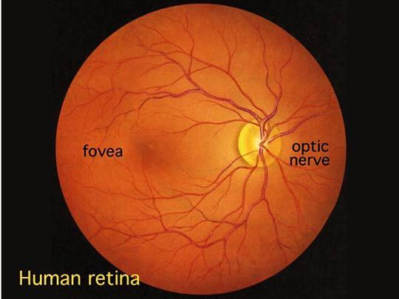
http://www.phys.ufl.edu/~avery/course/3400/vision/retina_picture_live.jpg

Lecture #14 – Visual Processing
Next time read 170-176

How to rods and cones work?
How does the visual system enhance images?
How can we explain phantom spots?

3 distinct cell layers in the retina
-Ganglion cells, on the first outer layer on the retina
-Bipolar cells
-Receptor cells

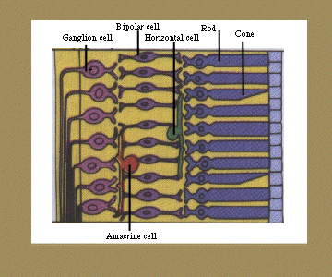

-Horizontal cells and Amacrine cells are inhibitory cells

Then output it to optic nerve

Visual Receptors: Duplex threory
(Per eye) 120 million Rods: Operate at low intensity and sensitive to brightness, none found in the fovea, they only detect monochrome light.
Example: If you look directly at a very weak light source, the fovea straight at it, therefore the rods can’t detect it.
(Per eye) 7 million Cones: Operate at higher intensities, insensitive for brightness,
Concentrated in the fovea
Detects colors

Rods and cones have visual pigments, they are photosensitive (breaks down when hit by light)
Rods: Rhodopsin, breaks down in to 2 other chemicals when hit by light and generate an action potential

Cones: Each breaks down to specific wavelength lights
Chlorolabe: Green
Erythrolabe: Red
Cyanolabe: Blue

Experiments:
1: Dark adaptation: Sit in a dark room, allow pupil to dilate, then flash a strong light and use up all the rhodopsin, then test recovery time, at first, no matter how intense, you can’t detect it, then the intensity gradually drops, and it’s called cone recovery (about 10 min, and measure only directly to use the fovea), and rod recovery takes approx. 30min and makes the eye even more sensitive (measure only by peripheral vision)

Spectral sensitivity

How do you explain phantom spots?
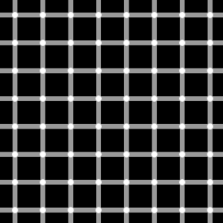

Simultaneous contrast



Single cell recording: (read at home and write notes)
Isolate single retinal ganglion cell
Attach microelectrode record output
Project spot of light on screen and move until output is maximum
This is retinal area served by that ganglion cell
Movement in any direction decreases firing rate
Hitting light at a location on the ganglion cell may inhibit it
Hit the center area, it excites it
Called “on center” and “off surround”
If not hit on center then no effect
Every cell has a receptive field (on and off area)

McCollough Effect

Lecture #15 – Perception

Next time, finish chapter 5

How does lateral inhibition work?
How does the cortex code visual stimuli?
What are the Gestalt rules for perception?

Lateral inhibition: If a receptor cell receive light, and the horizontal cells inhibits the surrounding cells, therefore receptive is created, explains why grey in white background seems darker than in a black background, also explains phantom spots, because there are more surround stimulation than the center, therefore we see dark smudges

Recording from the visual cortex:
Insert recording electrode in a cat (or other animal)
Hubel & Wiesel: Retinal ganglion cells
In the cortex, they don’t respond to dots of light, but instead respond to slits/lines of light
Cortical cells may be orientation specific & motion sensitive /;

Simple cell: Fires to a slit at a particular orientation on a specific retinal location (usually vertical, if the orientation changes, the cell firing rate decreases or stop completely) this is caused by a vertically arranged retinal ganglion cells that are connected to the simple cell, and only vertical lines can hit all the “on center” simultaneously

Complex cell: Moving slits at a particular orientation
Hyper complex cell: Combination of stimulus features, eg a parallelogram
Bug detectors: In frogs, works for dark objects moving randomly in the visual field
Grandmother cells:

Stuff need to know
Color vision:
*Theories of color vision: Trichromatic and opponent process
Color blindness
Also need to know hearing, ie parts of ear, place theory versus frequency theory and hearing loss
General operation of taste, smell and touch

Perception:
How do we understand and interpret the world?
Need to distinguish the figure from the ground

Gestalt approach: Principles of grouping
Similarity: People tends to group similar things together
Proximity: People tends to group close distance things together
Connectedness: Physically connected = psychologically connected
Continuity
Closure: People do not like to see parts, but like to see the whole
Importance of expectation and context

Lecture #16 – Perception II

Next time 191-203

How do we perceive depth?
What happens after we determine distance?
How do we figure out what we are looking at?

Depth Perception:

Binocular cues (2 eyes): Retinal disparity, the 2 eyes are 65mm apart, and the dispersion allows the brain to calculate the relative distance
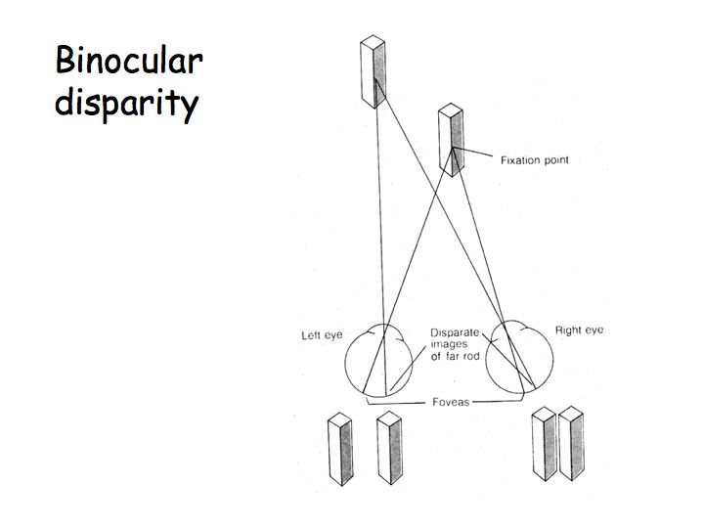

Monocular cues (1 eye): Using brain analysis
Relative size (if both are human, the close one should be larger)
Overlap (image most complete is complete is closest)
Linear perspective (straight lines converge, ie gets smaller in the distance)
Texture gradient (ie in flower field, as you go back to the field, the texture gets denser, therefore it’s further away)

Size constancy: Rescale the size of objects so that they remain constant at any distance, this is learned in the first few months
Many visual illusion reflect inappropriate scaling (ie, the brain uses scaling when not supposed to)
Retinal size pitted against linear perspective

Shape constancy: Ie, a perfect rectangular door is closed, and an open door looks like a trapezoid

How do we recognize and make sense of patterns?

Constructionists: Create meaning from basic elements or features
Feature analysis is a bottom-up process
Register small components and build into larger, meaningful units
Biederman: Recognition by components

Top down processing: Use expectation and features to predict what will happen, example is the jumbled world challenge

Top-down, bottom-up can work together

Perception depends, in part, on attention

Attention is selective: we do not attend to everything; we only sort out relevant material, and filter out the rest
Ie: in a loud party, although you are talking to someone and ignores the background noise, when someone calls your name in the background, you will be aware of it immediately because it is relevant to you

Automatic processing: Behaviour well learning, and not in awareness
Controlled processing: Behaviour poorly learned, much more aware

Lecture #17 – Conciousness

Next time read 204-211

What are the daily rhythms affecting humans?
What is consciousness?
What happens when we sleep?

The stroop effect: Ie, ask a person to tell the color of the word, and read a blue colored word “red”, and say red instead of blue

Circadian rhythms – daily cycles:
Blood pressure
Body temperature
Chemical concentrations
Naturally 25 hour cycle, we artificially compressed it to 24hr

Peak level in late afternoon (best time for physical tasks)

Controlled by SCN: Suprachiasmatic Nucleus
Internal timing mechanism in hypothalamus
Works with pineal gland
Sunlight stimulates SCN, which inhibits the production of melatonin in pineal gland, works by stimulate photosensitive ganglion cells
A chemical called melanopsin is broken down in blue light
Darkness removes inhibition, resulting more melatonin, and we feel tired
Disturbances:

Jet lag & shift work
Phase advance (moving forward, ie fly to west) more difficult than phase delay
Take melatonin supplement:
Appears to safe
Treats phase delay better than advance
Probably works by relieving day time fatigue

Avoid jet lag:
-Hydrate on plane
-Avoid alcohol
-Get up and stretch
-Light meals
-Expose self to sunlight upon survival

Consciousness:

The awareness of the relationship between self and the external world
-Monitoring – keeping track of self
-Controlling and planning

Preconscious level:
Info not currently available, but could be
Ie, what does your parent’s house look like?
“tip-of-tongue” difficulty of pulling from preconscious to conscious, best way to fix it is to stop thinking about it for a while and go back to it later

Subconscious level:
Info not accessible, but it may “leak” out from time to time, called Freudian slips
Freudian slips: unconscious leakage

Freud said: “A happy person never fantasizes, only an unhappy one” in 1908

Fantasizing/daydreaming – Happens average every 90 minutes
Most common one:
1: Failure/success
2: Aggression
3: Sex or romance
4: Guilt
5: Problem solving

Why daydream?
Safety valve: escape from life – relief pressure
Alters mood in positive direction (even if you daydream of failure and aggression)
Low-risk way to deal with problems: imagine reality
Increase arousal

Sleep: During sleep, body begins to shut down
HR, RR, T drops
Minimal muscle activity (so we must lie down, if standing, muscle shuts down and you will fall down)
Decrease in sensitivity to external stimulation
Tested by EEG recordings

Stages of sleep:
Awake, eyes open: Beta waves, high frequency (40 cps) low amp
Alpha wave: 10 cps Very relaxed
Stage 1 sleep – theta waves: 6 cps, amp increases
Stage 2 sleep – Frequency slowing down, but there is a large K complex (sharp drop of activity, followed by sleep spindle) and sleep spindle (high frequency, 12-16 cps)
K complex may be related to restless leg syndrome and epilepsy

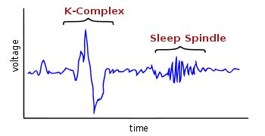

Stage 3 sleep: Delta waves beginning to occur, very slow (1 cps) and large amp waves
Stage 4 sleep: Delta waves begins to dominate

Afterwards, you cycle through the stages, when you are back to stage one, but are still asleep, it is called REM sleep (rapid eye movement)
Pattern goes: 1-2-3-4-3-2-R-2-3-4-3-2-R-2-3…
REM becomes longer each time, and stage 4 disappears
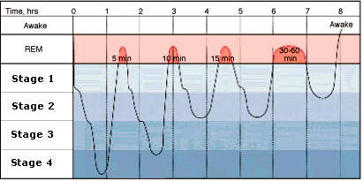
REM sleep has beta and theta waves

Note: If sleep more than 8 hours, the cycle repeats, but with even more REM

We spend more time in REM than stage 4, the reason being

Lecture #18 – Dreaming

Next time finish chap 6 and 235-242
Discussion 2 due at Nov 23rd

Why do we sleep?
What causes sleep disorders?
What do we dream about?

Why do we sleep?
1: Restorative function
Sleep deprivation
Attention lapse and irritability (after 72 hr)
But they can still function with little effect on performance; therefore restorative theory is not a complete explanation
2: Evolutionary Benefits – Webb 1975
Ie, awake at night might be prone to predators
3: Learning and memory:
REM deprived subjects show reduced ability to retain new info (only for REM)
REM could be the stage where you reorganize all the new learned info
4: Mood adjustment (Berry & Webb 1985)
Speed of cycling in to REM correlated with positive mood on following day (ie, faster get in to REM, the better you feel next day)
Also, clinically depressed individuals tend to cycle in REM very quickly (20 min compared to the normal 1.5hr,) could be a self-treat method

Sleep disorders:

Affects 15% of adults

1: Insomnia – most common
Difficulty in getting in or staying asleep
For some people, expectations fall short, ie they sleep for 5hr, but expect 8hr like other people, and they think they have insomnia
Everyone needs different amount of sleep, do not force yourself to sleep strictly 8hrs per day
Situational insomnia – Specific stressor, cured when stressor is gone/dealt with
Chronic insomnia – Possibly circadian rhythm problem
Thermoregulation problem - Failure to lower body temperature, activation remain high & normal sleep cycle fails to develop, therefore people who consume alcohol have high temp, therefore even if they pass out, it is not regular sleeping, treatment is cooling the environment or comsume HOT beverage to stimulate thermoregulation

2: Sleep apnea – Interruption in breathing during sleep
Normal, but people with this disorder do not start breathing again unless they wake up
Severe patients may stop for about 1 minutes, can happen up to hundreds of times per night
Causes:
Obstruction of air passage (loud snoring) easy to fix by machine or surgery
Abnormal brain function
– SID (sudden infant death) could be caused by sleep apnea

3: Narcolepsy – Affect 2-8 %
Person suddenly falls asleep randomly
Get muscle weakness
Begins immediately with REM
Causes:
Abnormal REM cycle timing
Depleted supply of hypocretins (neuropeptides for arousal, wakefulness)
Often triggered by strong emotions

4: Parasomnia – various sleep related problems

Sleepwalking – Affects 15% of children under 16, but rare in adults
Many waking actions performed out of awareness
Occurs in stage 4, not in REM or in a dream
Difficult to wake up
Confused and disoriented
Tends to run in families
Myth: Waking up a sleepwalking person will NOT kill/damage them, but will leave them disoriented and confused, so it’s the best to lead them back to their beds and not wake them up

Sleep talking – Occurs in stage 1-2, rarely in REM, therefore usually not dreaming
Sensitive to external world (ie, may talk back to another person logically, but they will not remember it)

Night terrors: Affects 4% of children
When asleep, child suddenly sits up and screening
Dilated pupils, increased HR, BR and is panicking
This is NOT NIGHTMARE
Occurs in stage 3-4, not associated with dream
Difficult to wake up
Disappears with age

Dreams:

Occurs mostly during REM (80-90%)
2 or more per REM period, 8-10 dreams per night
Duration 1-15 minutes per dream (can occasionally be longer)

Content: Surveyed 1200 students
1: Falling 83%
2: Being pursued 77%
3: School and studies 71%
4: Sex 66%
5: Arriving late 64%
Finding Money
Snakes
Inappropriately dressed
Nude
Failing an exam
Seeing self as dead
Killing someone

Summary: they have familiar setting, real people, monsters are rare
Failure & misfortune outnumber success 3:1
Strong emotions
Overt sexual activity rare (1%)
Can incorporate external events (spray water on a dreamer’s face can make them suddenly dream about water)

Men dream more about: | Women dream more about:
Strangers | Children
Cars | Clothing
Weapon | Jewelry
Acting aggressively | Targets of aggression
Attractive stranger | Significant other

Structure:
Dreams are mostly visual, with some audio components
Mostly in color
Duration directly related to duration of REM
Eye movement related to action
Events unfold in real time (but in fragments so it feels longer in dream)
“Fleeting experiences” Intense but last short
Quickly forgotten

Why do we remember dreams?

Lecture #19 – Dreams and Learning
Next time, read p246-256

Are nightmares common?
Why do we dream?
How do we learn by classical conditioning?

Recall:
Why do we remember some dreams?
They are mostly in the last REM period (longest and most recent, therefore easy to remember)
Reflection of cortical activity
More intensive dreams are easier to remember
Lucid Dreaming - lucidity.com

Nightmares:
Vivid, high anxiety dreams, high emotion and arousal level, easy to wake up
Significant stress correlated with increased frequency, ie if you have more stressors in life, it is easier to have nightmares
In adults, correlated with psychopathology (anxiety), it’s fairly uncommon
More common in children
They might be drug related:
Antidepressants
Beta blockers
Antihypertensive (BP medicines)
Cipro, antihistamines, L-dopa
Withdraw effects

Wood & Bootzin (1990) – Do “healthy” people have nightmares?
Surveyed 220 students and measured frequency of nightmares and anxiety levels by self-reports
Self-report says 9/year, but dream journals may be up to 25/year
Measured anxiety did not affect nightmare frequency

Theories of Dreaming:

Freudian/Psychoanalytic – Dream means everything
Unconscious – Id: Repressed wishes strive for expression
Consciousness - Ego: attempts to control the Id, it wants to sleep, but urges invade consciousness
Censor: Disguises wishes

The content is censored and disguised:
Latent – Actual desire
Manifest – Laundered version (after “cleaned” up by Ego)
But manifest content contains clues…
Symbols where one thing stands for another

Freudian symbols of sexual intercourse:
Climbing a ladder
Staircase
Riding elevator, horse or roller coaster
Crossing a bridge
Walking into a tunnel
Flying in a plane

Freud would say if you dream a lot about these things, you might be repressing sexual desires

Activation-synthesis theory: Dreams are completely meaningless
Dreaming state generator: Periodic firing of pons
Sensory/motor/visceral (emotional) neurons activated
Synthesis: Cortex interprets and integrates the neuron stimulation, making them in a dream
Therefore the dream is only a side effect of random firing neurons
This theory has more scientific support

Is there nothing special about dreaming?
By age 72 – 24 yr. of sleep and 5 yr. dreaming
REM deprivation has not much negative effects

Modular consciousness – Fig 6.18
Dreaming world is much like waking world
Waking world allows for real perceptual input… in dreams we need to construct reality

Read more on:
Drug effects: major categories, ie depressants, stimulants etc
Hypnosis: Theories, ie dissociation

Learning

Behaviorism:
Focus on stimulus & response
Behaviorists are also known as black box psychologists, ie stimulus goes in and response comes out, but we can’t know what’s happening in the middle

Classical/Pavlovian conditioning

Association of neutral stimulus with one that consistently elicits a response

Model:
UCS -> UCR (this is natural, always happens whether learned or not)
Pair CS with UCS
CS -> CR
Pavlov feeds dog meat (UCS), and dog drools (UCR), then he used a bell (CS), ring the bell then give food, after around 20 times, dog drool after hearing bell (CR)

To condition effectively, one must:
1: Attention to CS
-Orienting reflect
2: This model is NOT REPSONSE CONTINGENT (it does not matter what the dog does, ie it can drool, dance, jump etc, as long as it pairs up with the CS)
3: CR =/= UCR, CR is usually weaker than UCR, and they happen in different neurosystem areas

Examples:
1: Walks in the dental office:
UCS: Taking out tooth with drill
UCR: Pain/fear
CS: Dentist
CR: Fear

Example: Classical conditioning of love – Don Byrne: Reinforcement – Affect model

Arousing stimulus (ex: music) -> positive feelings -> positive evaluation (ex: like music) Using neutral stimulus to tie with the music, and we will get the same positive evaluation if we only get the neutral stimulus

May & Hamilton (1980)
Negative, neutral and positive music were played on the background, and asked female students to rate male photographs for attractiveness
The background music made a difference; negative music decreased the attractiveness significantly (8), neutral (9.8) and positive (10)

Practical uses: in fast food restaurants, the background music are proven to be attractive for 10 minutes and begin to be irritating after 15, to make people to buy food but not linger too long

Lecture #20 – Learning II

Next time read p254-258, 265-270

What are the factors that influence conditioning?
What’s the difference between classical and instrumental conditioning?
How is behaviour maintained by its consequences?

Acquisition curves:
Response strength
1: Latency (CS - CR) as trial repeats, decreases. Inverse relationship or negatively accelerated, approaching 0 but never touches
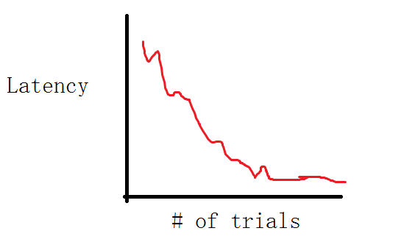
2: Output measure, also negative accelerating
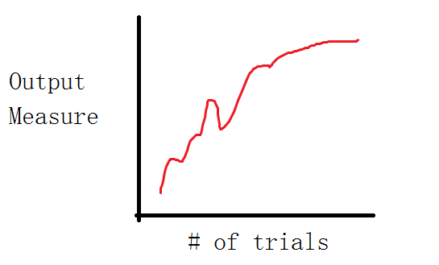
Temporal Contiguity
1: Forward Pairing: CS before UCS, ie ring bell then give food
2: Simultaneous pairing: ie give food and ring ball at same time
3: Backward pairing, CS occurs after UCS

Forward pairing is the most affective, with CS-UCS interval at 0.5 seconds

Higher order conditioning
-Pair primary CS with another neutral stimulus (ie shine light before ring bell befre give food)
Not very effective, CS-UCS bond is no longer reinforced, therefore CR extinguishes
Called CR extinction

Extinction:
-CS no longer presented with UCS
Decrease in response strength
CS loses cue value
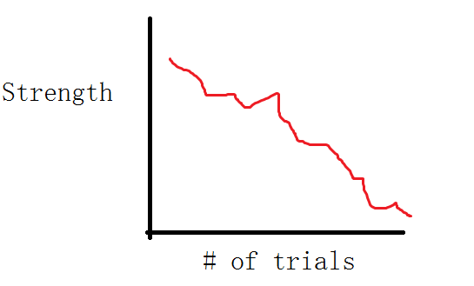
Some extinction trials are very long, such as phobia/fear, takes hundreds or thousands of trials, yet it still presents

1: Index of strength
2: CS-UCS bond not unlearned
“Saving”: Even if extinction happens, if learning the second time, it takes shorter
Spontaneous recovery: Extinction happens, yet CS can trigger CR randomly later

Generalization:
Degree of responding stimuli similar to training stimulus
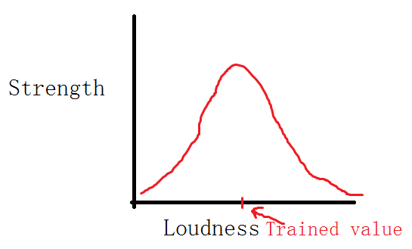
Example: snake phobias, if people are afraid of rattle snakes, they still get scared when looking at pictures, or different types of snakes such as a cobra

Instrumental or Operant conditioning: Thorndike and Skinner:
Association of a stimulus and a response
S – R bond is strengthened by reinforcement – law of effect

1: Stimulus situation -> dominant response (ie cat in the puzzle box would mostly scratch the box, and randomly he pressed the lever)
2: Choose and reinforce some target response (reinforce the lever pressing)
Dominant response changed to lever pressing
This is response contingent: you must make the response yourself

Ie, if they put rat in a T shaped maze, the dominant response is scratching/biting the maze, but if want it to reach a destination, put reward (food) at the end, then the animal would learn to move to the end

Reinforcement/Punishments
Positive reinforcement
Rat presses bar -> get food (reward) -> bar pressing increases
Negative reinforcement -> rat gets shocked, press bar removes shock (stimulus) -> rat presses the bar more
For reinforcement, behaviour ALWAYS INCREASES!
Positive – gives something, negative – takes away something

Positive punishment
Press bar -> gets shock -> bar press decreases
Negative punishment
Press bar -> food is removed -> bar press decreases

Example
 | Reinforcement | Punishment
Positive | Give money | Hitting
Negative | Taking pain medication | Take away money

Taking medication: Stimulus is pain, taking meds takes away pain therefore it’s negative reinforcement

What’s the best?
-Not punishment (ineffective unless it is very specific – swift, consistent, aversive)
-Discrimination training actually works the best (combination of reinforcement and negative punishment together and do it swift, consistent and aversive)

-Acquisition curves (schedules)
-Extinction
-Generalization & discrimination

Higher-order conditioning – much more effective
1: Primary S-R bond still reinforced
To train bird: S (sound) -> R (turn) -> S (light) -> R (peck) -> food
2: Secondary reinforcements
Stimuli that have been associated with primary reinforcers
Ie: Money is secondary, because money itself is useless; we want it to buy actual goods that we enjoy
Ie: Verbal conditioning (appraisal/positive comments)
Study: Ask subjects to say random words, and nod when they say plural words, and then ask them to write an essay, they’ll use more plural words

Lecture #21 – Learning III

Next time: memory, read P242-246, 277-281

Is there more than association to learning?
How important is control to psychological health?
How can conditioning help us to treat psychological disorders?

B.F. Skinner – Notion of operant:
Response-reinforcement bond is critical, response that get reinforced are more ikely to occur
-Shaping – must be slow and use appropriate award

Schedule of Reinforcement:
1: continuous reinforcement (CR)
Reinforce every correct response
2: Fixed ratio (FR)
Reinforce every n^{th} correct response, ie FR5 – reinforce every 5 responses
3: Variable ratio (VR)
Reinforce every n^{th} time on average
Eg: 3,7,5, or 13,1,1 or 4,4,7, but the mean is always 5, so they are all VR5
4: Fixed interval (FI)
Reinforce first correct response after a certain time has elapsed
Eg: FI 1 minute reinforce first correct response after 1 minute
5: Variable interval (VI)
Reinforce first correct response after a certain time has elapsed on average
Eg: 2min, 30s, 30s or 90s, 45s, 45s or 15s, 1min 105 sec, mean is 1min

CR’s response is lowest
Examples:
FR: Piece work
FI: Paycheck
VR: Slot machine
VI: Good jokes in comedy

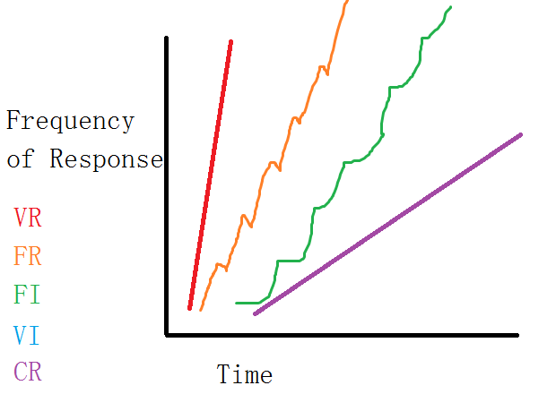

Partial reinforcement effect

Experience with “extinction” maintains responding because reinforcement is unpredictable
Partial better than continuous
VR or VI is most resistant to extinction

Cognitive approach

Learning is not mechanical “stamping in” process
Learning involves formation of cognition, the internal processing of information (thoughts, beliefs, etc.)

Kohler – Insight (guerilla and banana)
Tolman – Cognitive maps (rat and maze)

Traditional S-R approach can’t explain these cases very well

Avoidance learning – Shuttle box:
A box with 2 compartments, you want a dog to jump from one to the other, put electric shock on one part of the floor, and animals jump to other compartment
If place a light that shines 10 seconds before shock, animal learns to walk away when they see the light to avoid the shock

2 factor theory of avoidance

1: classical conditioning
USC (shock) UCR (pain), CS is light
2: Operant conditioning
Termination of light acts as negative reinforcer for the jump response
But… exactly what is this conditioned fear response?

Organisms learns contingency
Given some event, one outcome is more likely to occur than another

 | Pass | Fail
Study | 80% | 20%
No Study | 20% | 80%

 | Shock | No shock
Light | 90% | 10%
No light | 20% | 80%

Animal “expects” shock to occur more often when light is present
The CS (light) allows us to predict that the UCS will occur
Prediction & control

Martin Seligman & Learned helplessness

1 group can escape the shock; other group shock is on both floors

The second group is then exposed to the light, and they did not move even if they know the other side did not have the shock anymore

Animals who previously had no control over their environment learned that there was nothing they could do to stop shock

No contingency between response & reinforcement

Glass & Singer (1972) – Perception of control
Ability to do task with very loud noise distractions, turns out people can do it relatively well even with noise, yet when they are placed in the quiet room for the second task, they mess up
Yet, if they were told they can make the noise stop with a button (the button is actually useless) the illusion of control makes people perform better even though they never use the button

Langer (1975) – Illusion of control
If you have raffle ticket for winning $100, then someone ask you to sell the ticket, the people who handpicked the ticket want more money than those who got randomly generated tickets, even though the ticket winning chance is completely random

Relation to depression
Seligman & Abramson (1988)
Pet therapy & plant therapy

Behaviour therapy
Psychotherapy based on principle of classical or operant conditioning
Problem is viewed as error or “failure” in learning
Cure is to “learn”

Lecture #22 – Memory

Next time read 279-288

How do we remember?
Why do we forget?

Behaviour therapy:
Psychotherapy based on principles of classical or operant conditioning
Problem is viewed as error or “failure” in learning
Cure is to re-learn

Treatment of fear

Simple phobia
Intense, irrational fear of object or situation
Relatively common
Anxiety disorder
Patient is still in touch with reality (they are aware it is irrational but still afraid of it)
Over 200 recognized phobias
Some phobias are easy to deal with, ie fear of wild animals, keep away from zoo or wild, but it can generalize or worsen (ie, may develop in to fear for animals on TV)

Treatment of phobia:

Exposure: Fear viewed as CR, so extinguish by repeated presentation
1: Flooding: patient is continuously presented with fearful object, until it no longer produces a response (not suitable for intense phobia), and it’s hard for patients to do it willingly, therefore not always possible
Eg, put a snake phobia patient in a room of snakes for a few hours
2: Implosion: Patient must continuously imagine fearful situation
Eg, think about being in a room full of snakes
3: Counter-conditioning
Replace CR of dear with a more pleasant response
I: Identify a UCS – UCR (ie patient likes chocolate)
II: Pair the feared object (of low intensity, ie a picture of a small snake) with the positive UCS-UCR
III: Gradually increase intensity of the feared object
IV: Feared object now results in positive CR
4: Systematic desensitization – Wolpe (1958)
I: Train client in muscle relaxation on cue
II: Client imagines fearful situation; receives relaxation cue
III: Imagine more fearful situation, receives cue, if client can relax, move on
IV: Client progress to actual experience (ie holding real snake); receives cue, the final step is called “in vivo desensitization”
5: Aversion therapy
Behaviour maintained because of reinforcement contingency
-Alcohol relaxes body
-Staying in house avoids fear
-Gambling produces a thrill
To change behaviour, change contingency – punishment (swift, severe, constant)
Ie, drinking – illness
It is pretty effective, the drug Anti-abuse, Wiens & Menustir (1983) causes 1 year later, 2/3 people abstinent, 3 years later, still 1/3 left

Memory:

Acquisition: Encoding – Retention, putting info in to memory
Retrieval: Decoding – Getting info out of memory

Recall: Spontaneously generate info
Recognition: Identify info

Information (visual or auditory)
Information -> sensory register -> short term memory (only a few minutes, can prolong by rehearsal) <-> long term memory, output comes from short term

Lecture #23 – Memory II
Exam room: AH gym
Next time read 292-308

How is memory organized?
What exactly is memory?
What evidence is there for different memory systems?

Sensory register

Info held for fraction of a second
Trace fades quickly… ie trying to remember dot patterns on the screen
Visual – Icon
Auditory – Echo
Other registers very poor – ie smell, touch etc

Short term memory (working memory):
Material “held” by rehearsal
No rehearsal – info lost and forgets
Lasts about 20 seconds
Rapidly lost unless we actively do something with it
Very limited capacity: 7 +/- 2 items, and “chunk” helps

Forgetting:
-Decay: Material gets old, fades away over time
-Interference: New material pushes old materials out of the way

Jenkins & Dallenbach (1924)
People learned a 48 word list, and asked to recall them after right away, some are asked later like 1 hr, 5 hr to 8 hr etc…
If people are awake during the 8 hours, they forget most of it
If people sleep for 8 hours after remembering the list, then they can still recall 80% of the information
Shows being awake cause interference

Acoustic coding: ie , a list of 3 word: cook, car, dish or book bar fish. Similar sounds causes more interference

Phonological loop: Auditory
Visual Spatial sketchpad: Images & spatial
Central executive: Directs attention, recall, integration. Located in prefrontal cortex

Long term memory:
-Permanent storage
-Essentially unlimited capacity
-Semantic coding (code by meaning): ie cook car dish (ie cook dish) and more interfered by: chef, auto, plate

How to get info from STM to LTM
-Consolidation – LTP
-Rehearsal
Maintenance (repetition): keep in STM
Active – Organizing

What evidence is there that STM and LTM exist?
-Evidence from cases of brain damage: eg Clive Wearing (can’t remember for more than 2 minutes, but exceptional at playing piano/conducting)
-H.M. (an epilepsy patient, he got hippocampus removed) improved on task, could remember how to do a task, but having no memory of doing the task!
Trish – Must uses post notes every morning to know what is going on (similar to girl in 50 first dates)

Serial position curve: If try to remember a list of letters, people tends to do better on the first few (primacy effect - LTM) and last few ones (regency effect -STM)
If subject is asked to delay 30 seconds before recalling, and prevent rehearsal, last few ones are forgotten, therefore it’s STM, and the first few words gets remembered

Lecture #24 – Memory III

Next time finish chapter 8

How does organization improve memory?
Is eyewitness testimony accurate?
Does mood influence memory?

Memory is ultimately a biochemical event
Learning approach
Semantic network

Memory as a network
Associative networks
Network of linked ideas and concepts, some are closer to others (ie, fire engine and fire are close, but are further to pollution)
Each concept represented by a “node”

Spreading activation:
Activation of one concept leads to activation of other concepts – priming

Importance of organization

Subjective – We impose structure (Hamilton 1980)
Semantic encoding
Recall clustering (Bousfield 1953) – Cluster information to remember better

Cognition & affect

How feeling influence memory
Bower 1981 – Mood congruity : ie, if you are happy when you learn, you will recall more when you are happy and less when you are sad, works opposite way as well

State dependent retrieval Eich et. Al. 1975
Similarly, works with marijuana/alcohol, the same state have the highest recall rate

Cued recall improves recall a lot, shows memory is not lost, but just hidden and therefore unable to recall

Mood influence the kind of info we acquire & retrieve
Seems to be consistent
Eg: Watching a movie while happy, we tend to remember the happier character

Eye witness:
When happening, eye witnesses are in high arousal, but when recalling, they are calm
Memory is not perfect
Shocking events disrupt memory
We reconstruct partial memories
Expectations
False retrieval cues

Loftus Studies: Ask participant to watch a car crash clip

Ask “did you see the broken headlight?” vs “did you see a broken headlight?”
Research shows more people answered yes to the first question

“How fast do you think the cars are when they [smashed/collided/bumped/hit/contacted] each other?
Answer is 40.8 /39.3/38.1/34.0/31.8 respectively

In police lineups to identify suspects, witnesses that given 2 seconds to identify the suspect are more accurate than those who are allowed more time
Accuracy of eye witness (Brigham et. Al. 1982)
Around 50%, increase improves with people in the same race/sex/age etc

Growing old – senile (old) dementia (undoing of the mind) everyone gets it

Alzheimer’s disease:
5% over 65, 20-30% in mid-80’s
50% in mid-80’s if family member has Alzheimer’s

Recent events fade first
Ultimately old memories go and patient becomes “mentally vacant”

Lecture #25 – Memory IV + Exam
Next term, read 315-331
Exam: Dec 12th, 7:00PM, at AH gym

How can we treat Alzheimer’s disease?
How can we improve memory?
What we need to know for exam?

Alzheimer:
Recent events fade first
Ultimately old memories go and patient becomes “mentally vacant”
Could potentially forget who himself is
Bedridden, helpless, terminal in 10 years

Produces severe degeneration of hippocampus and cortex
Association areas of frontal and temporal lobes
Easily observed on autopsy (autopsy is the only 100% accurate way of diagnosis)
Alzheimer’s brains have much wider/deeper folds in the brain cortex, because all the original tissues are gone
Can be detected by PET scans, lower brain activity

Picks: a disease similar to Alzheimer, but happens slower, takes 25-30 years

Nerve degeneration in Ach tracts
Reduction is Ach produces memory loss
NE, SH-5 and DA also involved

Possible Causes:
Chromosome 21 defect (1 in 3)
Buildup of protein causes in plaque and tangles – kills neurons
Also happens in Down’s syndrome
Viral damage to blood-brain barrier
Excess Al, Zn metal poisoning (no proof)

Treatment – No known cures, but to relief the problem:
Nourishment and exercise – stay healthy
“Smart drugs” (nootropics): Slows progression, but does not cure it, eg (Piracetam, Aspirin, Advil, ginseng etc.)
Brain grafting & vaccine (still experimental)

What will help to improve your memory?

Mnemonics – Organizing strategies

1: Keyword methods:
Think of highly visualized image and link it to new concept
Have words “interact”
2: Method of loci
Also uses imagery
Place each item at different location
Also works best with interaction
3: Peg method
Take easy list (ie 1,2,3…)
Use them to hang new information
Ie: 1: brain 2: cell 3: limb …

For reading psych:

Encoding specificity:
Memory is aided when the context at learning is matched by the context at retrieval (state dependent memory)

Comprehend, not memorize
Affect and arousal moderately high
Memory is better for spaced rehearsal
Use multiple coding methods
Use retrieval cues, but watch out for bias recall
Eat blueberries (or other food with antioxidants and vitamin E)

Christmas exam:

75 MC – 15/chapter and 15 lectures

Important points:

5:
-Psychophysics
-Weber’s Law (definitely on exam)
-Visual system (in detail, ie parts of eye, how it works etc)
-Color vision (tri/opp theory)
-Other senses (Understand general function and theory for other function)
-Single cell recording
-Lateral inhibition
-Visual cortex
-Gestalt laws
Depth perception
Size constancy
Perceptual problem solving (bottom up/top down)

6:
Circadian rhythms
Sleep stages
Sleep disorders
Theories of dreaming
Drug – how they work (know types, not individual drugs)
Hypnosis

7:
Classical Conditioning – UCS, UCR, CS, CR
Instrumental/Operant conditioning
Consequences – Reinforcement/punishment
Schedules
Acquisition, extinction etc
Cognitive approach – prediction and control
Observational learning
Biological preparedness
Behaviour modification

8:
3 component model (sensory, registry, LTM, STM etc)
Encoding – Automatic, levels, organization
Types of LTM
Retrieval – Flashbulb, context & mood
Forgetting: decay vs interference, proactive vs retroactive
Memory construction/eye witness testimony
Biology of memory

