Fina 200 Chapter 1

Components of a financial plane :
- Budgeting
- Financing your purchases
- Protecting your assets
- Investing your money
- Planning your retirement and estate

- Budgeting

Budgetting: The process of forecasting future income, expense and saving goals

- Requires you to decide whether spend or save
- Help you estimate how much of your income will be required to cover monthly expenses (Big Savers, Big spenders)

In order to budget, you have to evaluate your financial position (Assets, Liabilities, Net worth= A-L)

Tax Planning: many financial decisions are affected by tax laws; however you can make financial decisions that have the most favorable effect on your after-tax cash flows
Ex of tax: TVA, Income

- Financing

Liquidity: Access to ready cash, including savings and credit, to cover short term cash needs or unexpected expenses
You have to manage your liquidity

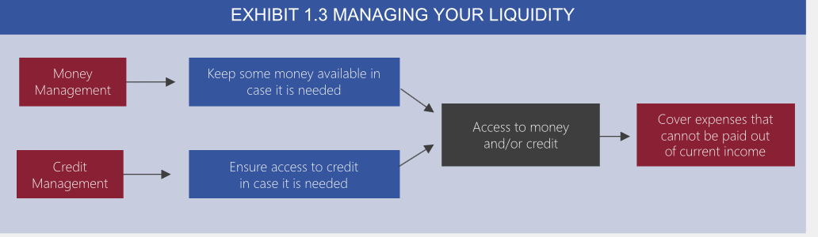

Select a loan with a competitive interest rate
- Protecting

Keep in minds the risk: Exposure to events that can cause a financial loss,
So take decision about whether and how to protect again risk (Risk management)
For instance create an Insurance Planning: determining the types and the amount of insurance needed to protect your assets
It focuses on determining your assurance needs and costs

- Investing

Invest in order to have a return ( Use cash to build wealth)
Ex: Stocks, bonds, real estate
All investment has level of risk

- Planning

Retirement planning: Determining how much money should be set aside each year for retirement and how those found should be invested

Estate Planning: Determining how your wealth, will be distributed before and/or after your death

Developing the financial plan:

- Establish your financial goal (SMART goals)
Specify your goals
Measure your goals
Act on your goals (include specific action steps+
Realistc goals
Timing of goals (Short, Medium, Long)
- Consider your current financial position
- Identify and evaluate alternative plans that could help you achieve your goals
Conservative / Agressive
- Select and implement the best plans to achieve your goal
- Evaluate your financial plan
- Revise your financial plan
Chapter 2
Simple interest
- Interest earned, or paid, is not reinvested

I = P x r x t
I = Interest earned
P = Principal, present value
r = annual rate
t = time

Compound interest

FV= PV(1+i)^t
FV = Future Value of an investment
i = Annual interest rate
t

Chapter 3

- Personal cash flow statement

Personal cash flow statement: A financial statement that measure a person income and expenses.
- Record your expense
- Record your income

Net cash flow: Disposable (after tax) income - expenses

Factors affecting income:
- Stage in your career path
- Type of job
- Number of income Earner in your House hold
Factor affecting cash flow:
- Size of family
- Age
- Personal consumption behavior

II) Budgeting

Budget: A cash flow statement that is based on a forecasted cash flow for a future time period
- Useful to anticipate either cash surpluses or cash deficiencies

Anticipate the cash shortage:
- Small shortage can usually be made up from your checking account or an emergency fund.

Assessing the Accuracy of the Budget:
- Compare predicted cash flows to actual cash flow and take any necessary steps to improve your cash flow.

- Create emergency fund

Alternative budgeting strategies

Envelope method:
- Create separate envelope for each category
- You can spend only the money in the envelope for the assigned category
- Balance can be carried forward

Pay yourself first method
- Arrange an automatic transfer from your checking account to your saving account. ( When you receive your pay check)

III) Personal Balance sheet

Personal Balance sheet: Overall snapshot of your wealth at a specific point in time summarizing you assets less your liabilities to determine your net worth.
- Also called : Net worth statement, Personal Net worth statement

Assets:

Liquid assets: financial assets that can be easily converted into cash without a loss in value

Household assets: Items normally hold by household

Investment:

Stock: certificates representing partial ownership in a firm

Bonds: certificates issued by borrowers Æ

Mutual funds: Investment companies that sell units to individuals and invests the proceed in an overall portfolio of investment instruments such as bonds and stocks.

Real Estate: Holding in rentals property and lands

Liabilities:

Current Liabilities: Personal debts that will be paid in the near future

Long term Liabilities: debts that will be paid over a period longer than one year

Net worth = Value of total assets – Value of total liabilities

Lesson 6: Purchasing Home
Chap 7
Most people pay for a home with a down payment (between 5 and 20 percent) and obtain a mortgage loan to finance their remaining cost.

How much can you afford?

Pre-approval certificates: Provides you with a guideline on how large a mortgage you can afford based on your financial situations
- Provide a mortgage interest rate guarantee
- Mortgage approval is not guarantee

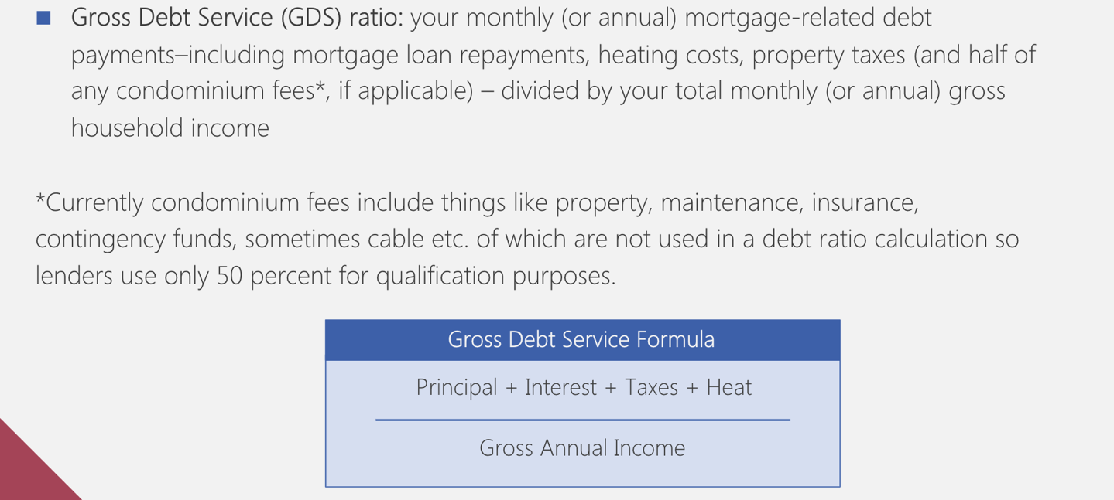

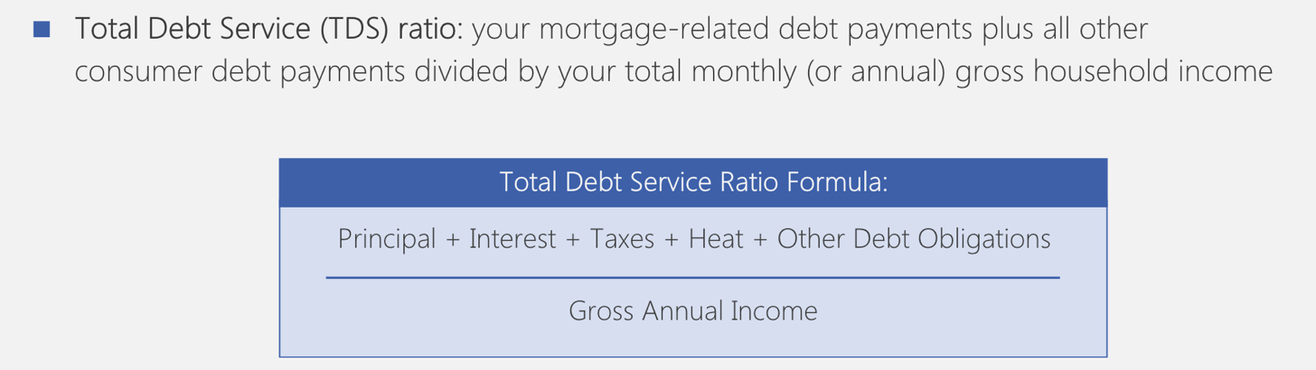

Affordable down payment:

You must maintain some funds for liquidity purposes to cover unanticipated bills and closing cost.

The Home Buyer’s plan (HBP) can help first-time home buyers reach their goals
- Allow each home buyer to ‘’borrow’’ up to 25000$ from their RRSP Registered Retirement Saving Plan
- Allow buyers up to 15 years to payback

Affordable Monthly Mortgage Payment:
- Refer to your cash flow statement
The larger your mortgage payment is:
- The less you can add tom your savings/investment
- The lower your liquidity
- The greater your overall financial risk

Criteria used to select a home:
Price, Location, Maintenance, Insurance, Taxes, Resell Values, Personal preference, School system

Relying on a realtor:
Home seller is responsible for paying a realtor commission
- Traditionally 7% on the first 100’000$ and 3 Percent on the remaining price.
However, you can use Online realtor service
- Multiple Listing Service: An information database of homes available for sale through realtors who are members of the service in Canada.

Negotiating the price

You can negotiate the price and the contract. Contract stipulate the price, and may include conditions such as the completion of home inspection, the move in date, and the approval of a mortgage

Focus on ethics: Disclosing effects

- The law requires disclosure of any defect that may affect the value
- Disclosure is not only legal, but moral
- Failure to disclose can result in a law suit for misrepresentation.

Transactions cost of purchasing a home

Lender bears (carry) the risk that you may default on the loan. Moreover, the down payment provides a cushion in situation where the lenders as to repossess the home and sell it.

Conventional Mortgage: A mortgage where the down payment is at least 20 percent of the home’s appraised value.

High Ratio Mortgage: A mortgage where the down payment is less than 20 percent of the home appraised value.
- Cushion provided by the down payment is lower
- Lenders will ask your mortgaged be insured

Vendor Take Back Mortgage: A mortgage where the lender is the seller of the property

- Buyer makes mortgage payment to the seller
- Property title transfer to the buyer (If the buyer defaults on mortgage payments, the property transfer back to the seller)

Closing costs

Closing costs are the expenses, over and above the price of the property, that buyers and sellers normally incur to complete a real estate transaction.

Home inspection fee: A report on the condition of the home (if it’s a lot you can re-evaluate your decision to purchase)

Appraisal Fee: Use to estimate the value of the home and thus protect the financial institution interest (Real property report, land transfer tax, legal fees and disbursements)

Title Insurance: Protects the insured if it turns out that the real property report is inaccurate

Homeowner Insurance: The lender will request a proof that the buyer has purchased a homeowner’s insurance.

Loan Protection Life and Disability Insurance: Protect the lenders against financial loss as a result of Injury, illness, or death of the borrower.

Mortgage Option

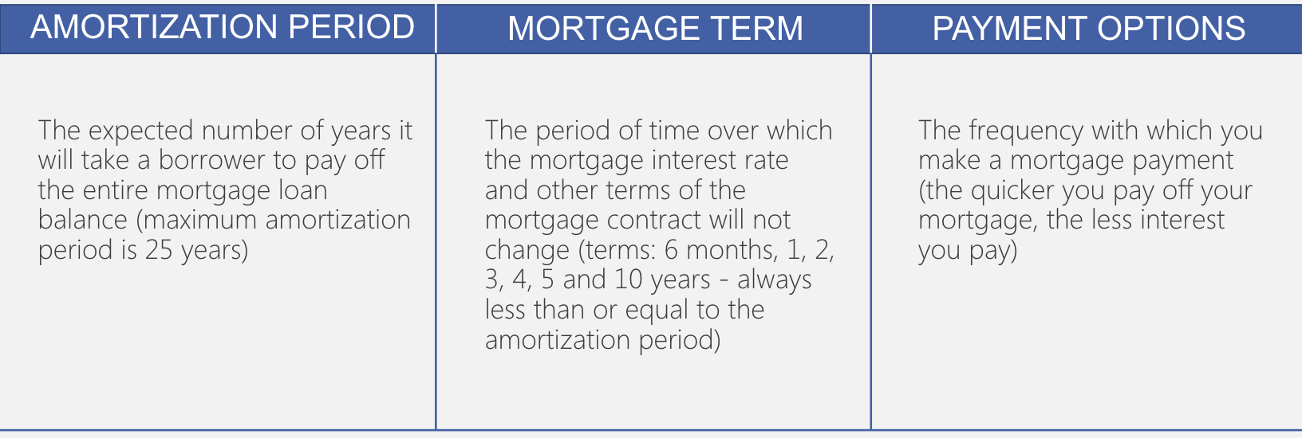

Mortgage Type

Closed mortgage: Restrict your ability to pay off the mortgage balance during the mortgage unless you are willing to pay a financial penalty.
They are however more popular:
- Offer a lower interest rate
- Prepayment privileges: Features that allow borrowers to increase their monthly mortgage payment.

Open Mortgage: Allow you to pay off the mortgage balance at any time during the mortgage term.
Characteristics of a fixed rate-mortgage

Fixed-rate mortgage: a mortgage in which a fixed interest rate is specified for the term of the mortgage.
- Lenders are usually willing to negotiate their posted rates

Amortization Schedule: Disclose the monthly payments.
You will make based on:
- A specific mortgage amounts
- A fixed interest rates
- An amortization periods

Impact of the Mortgage Amount and the Interest Rate on the Monthly Payment
The larger the mortgage amount and the higher the interest rate The larger the mortgage payment.

Impact of the Amortization Period on the Monthly Payment
The longer the amortization period, the lower the monthly payment but the higher the amount of payable over the whole life of the mortgage.

Characteristics of a Variable Mortgage-Rate Mortgage

Variable-Rate Mortgage (VRM): A mortgage where the interest charged on the loan changes in response to movements in specific market-determined interest rate.

- Relatively low initial mortgage over the first year or so.
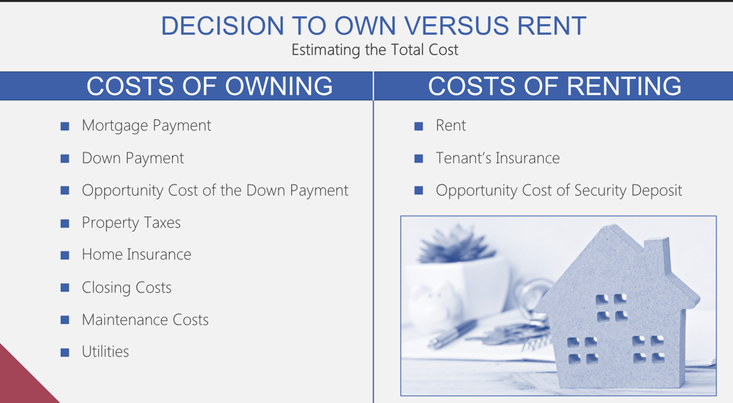

Mortgage Refinancing

Mortgage refinancing: Paying off an existing mortgage with a new mortgage that has lower interest rate.

- You will incur closing costs and prepayment penalties, but the saving on your monthly mort payment may exceed these costs and penalties

Rate modification: (for fixed rates mortgage you can ask to your lenders to allow a “blend and extend’’ Interest rate options.

Refinancing Analysis: Beneficial when a homeowner plan to own the home for a longer period.

LESSON 7: Auto, Homeowner’s, Disability and Life Insurance
Chap 8,9

Auto Insurrance

Auto insurance insures against:
- The legal liability that may arise from causing death or injury to other
- The expense of providing medical to all person touched
- The cost associated with the damage of your automobile
- Can be provided through a government agency or a Private property and casualty (P&C) insurance companies

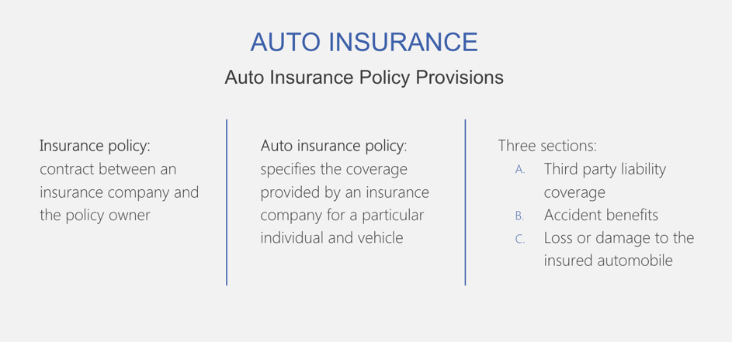

Section A: Third Party Liability Coverage

Third party liability: A legal term that describes the person who have experienced loss that you are responsible for after an at-fault accident.

Bodily injury liability coverage: Protect you against liability associated with injuries you cause to others.
Property damage liability coverage: Protect against losses that result when you damage another person property with his car.
Not your own car

Section B: Accident Benefits

Accident benefits coverage: Insures against the cost of medical care you and passenger in your car. (Funeral benefits, loss of income as a result of death, or total disability and Uninsured Motorist coverage) Coverage is Mandatory

Uninsured Motorist Coverage: insures against the cost of bodily injury when an accident is caused by another driver who is not insured
Also applies for: A hit-and-runner driver, a driver who is fault but whose insurance goes bankrupt.

Section C: Loss or Damage to the insure Automobile

Optional in all province
Collision insurance: Insures against cost of damage to your car resulting from an accident in which the driver of your car is at fault.

Comprehensive coverage: Insures you against the damage to your car that results from something other than a collision, such as floods, theft, fire, hail, explosions, riots, vandalism and various other perils.

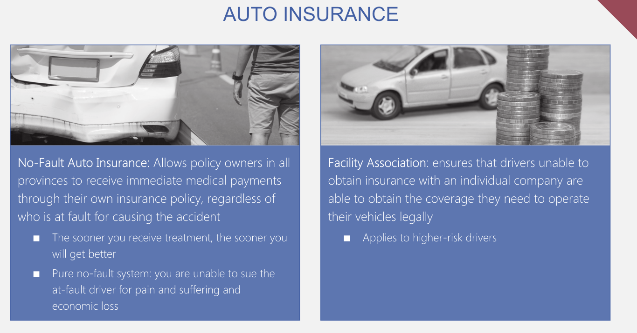

Comparing premiums among insurance companies

Insurance premium: The cost of obtaining insurance
- Can vary substantially among insurance companies
- Some factors affect it (Value of car, driving record, amount of liability coverage…)
If you are in auto accident
- If the other driver is at fault, your insurance should seek damages from the other’s driver insurance.
- If the other driver is at fault, and he doesn’t have any insurance your insurance will accident benefits up to your policy limits. The rest, you will receive benefits from the Motor Vehicle Accident Claim Fund, in your province.

Homeowner’s insurance

Homeowner’s insurance: provide insurance in the event of property damage, theft, or personal third-party liability relating to home ownership.
- Required to get a mortgage

Types of Perils Covered by Homeowner’s Insurance:
- All perils coverage (except those that are specifically excluded by the policy)
- Named perils coverage: Protects the hone and any other structures on the property against only those events named in the policy.

Building (Property damage)

Cash-value policy: Pays you the value of the damaged property after considering its depreciation

Replacement-cost policy: pays you the cost of replacing the damaged property with an item of a similar brand and quality

Minimum Limit: Many insurers require that your homeowner’s insurance policy cover at least 80 percent of the full replacement cost

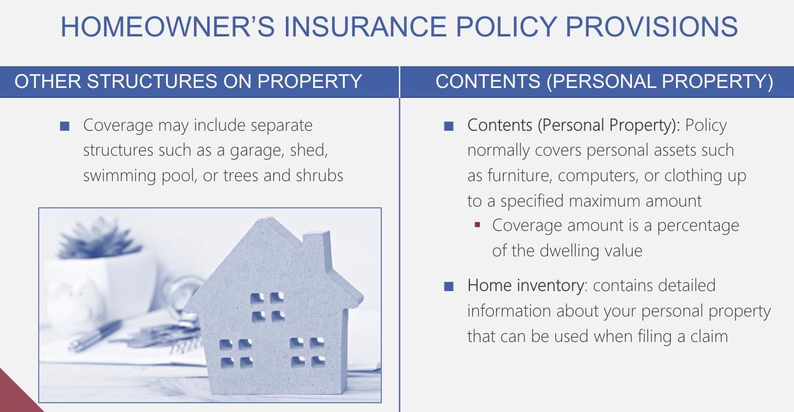

Homeowners Insurance policy limits, exclusion and liabilities

Limits and exclusions

Personal property Replacement Cost Coverage: Provides coverage for personal property at replacement cost rather than actual cash value

Personal Property Floater: An extension of the homeowner’s insurance policy that allows you to itemize your valuables.

Liability

- Specifies coverage in the event that you are sued as the result of something that occurs in your home or on your property.
- Medical payments are covered
- Voluntary property damage is also covered (break the window of ur neighbor)

Factors that affect homeowner’s insurance premiums

- Value of Insured homes
- Deductible
- Location
- Degree of protection
- Discounts
To reduce it use one insurer for all types of insurance

Tenant’s Insurance
Tenant’s insurance: an insurance policy that protects your possessions within a house, condo, or apartment that you are renting
- Also covered liability resulting from injury to a person while on your premises

Umbrella personal liability policy

Umbrella personal liability policy: A supplement to auto and homeowner’s insurance that provides addition personal liability coverage

Useful when you have personal assets that you wish to protect from liability

Disability Insurance

Disability: In general, disability is being unable to work as a result of an injury or an illness.

Disability income insurance: Is monthly insurance benefit paid to you in the event that you are unable to work as a result of an injury or an illness.

Without Disability Insurance, where will the money come from?

Spouse’s Income, Emergency Savings, Investments, RRSPs, Home Equity loan
Own occupation: Policy will provide benefits if you are unable to do the duties required for your occupation, it will also allow you to have another job without reduc of benef

Regular occupation: Policy will provide benefits if you are unable to perform the duties required by your occupation, benefits will be reduced if you find another job.

Any occupation: Policy will provide benefits only if you can’t perform the…that fits your education, and experience.

Waiting period: You become disable but you don’t receive benefits yet.

Benefit Period: The longer the period over which your policy provides you disability income, the more you will pay for disability insurance.

Non-Cancellable provision: Gives you the right to renew the policy each year at the same premium, with no change in benefits.

Renewable provision: Give you the right to renew the policy, with the same benefits.
- Premiums can be increased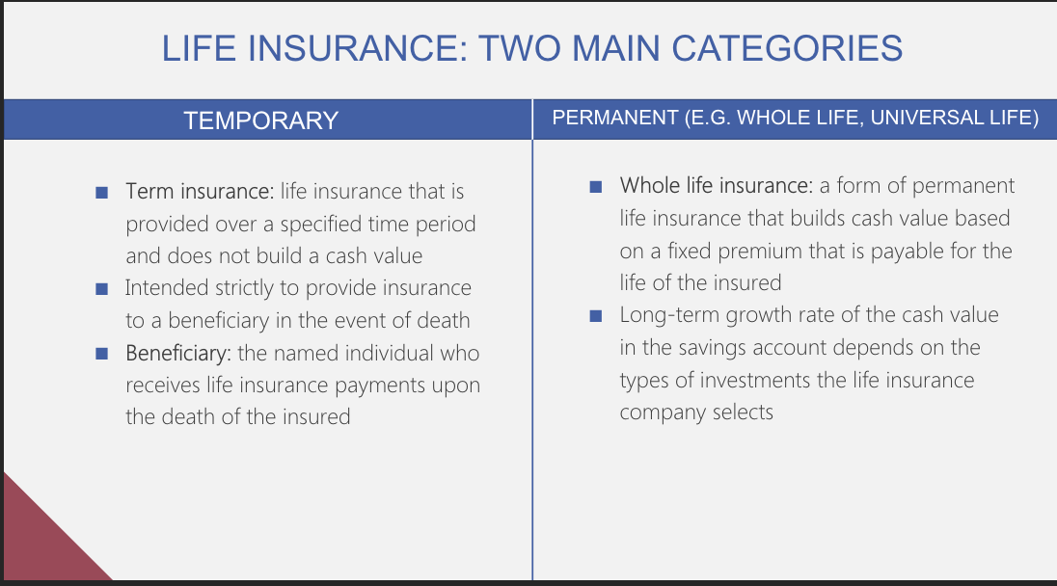
Term Life Insurance
Premiums on Term Insurance:
- Must be paid by the due date, can have a grace period

Factors that raise premiums:
The longer of the term policy, the older of the owner, if is a male, smoker, if ur family have medical record
- Institution Underwrite (the process of evaluating an insurance application)

Focus on Ethics

Medical information bureau: A clearinghouse of medical information that insurers use.

Be Honest and truthful with your insurance company

Creditor Insurance versus personally owned Term Insurance

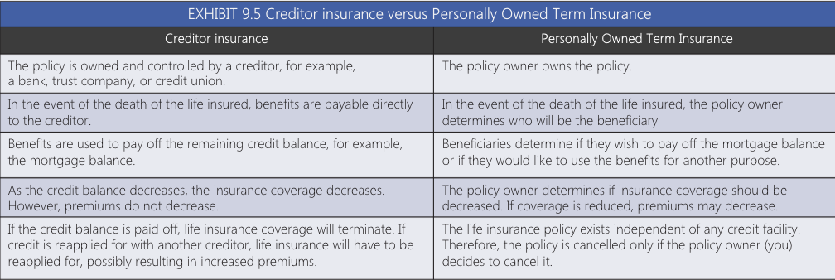

Permanent life insurance: Life insurance that continues to provide insurance for as long as premium are paid.
Divided into two portions:
- Cost of Insurance: The insurance-related expenses incurred by a life insurance company to provide the actual death benefit, sometime reffered to as the pure cost of dying

- Cash Value: The portion of the premium excess of insurance-related and company expenses that is invested by the insurance company on behalf of the policy owner.

Universal Life Insurance

Universal life insurance: A form of permanent life insurance for which you do not pay a fixed premium in which you can invest the cash value portion in a variety of investments
Cost of insurance options:
- Level tem
- Yearly renewable term (YRT)
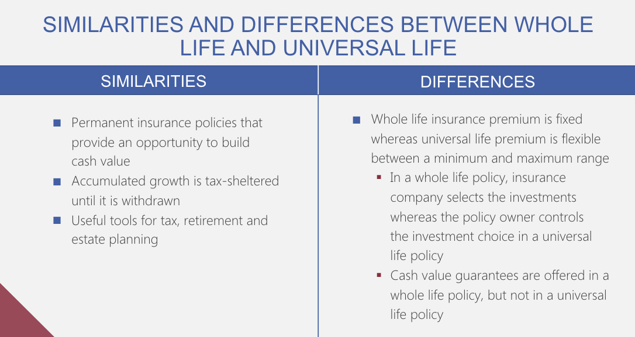
Non-forfeiture options: The options available to a policy owner who would like to discontinue or cancel a policy that has cash value

Term to 100 Insurance: A form of permanent life insurance that does not build cash value. => In most case, the policy owner doesn’t need to pay premiums if he or she live beyond 100 years old.

Classifying life insurance
Participating Policy: A life insurance policy that is eligible to receive policy dividends.

Non-Participating Policy: A life insurance that is not eligible to policy dividedens
- All life insurance policies, with the exception of whole life insurance, are non-participating

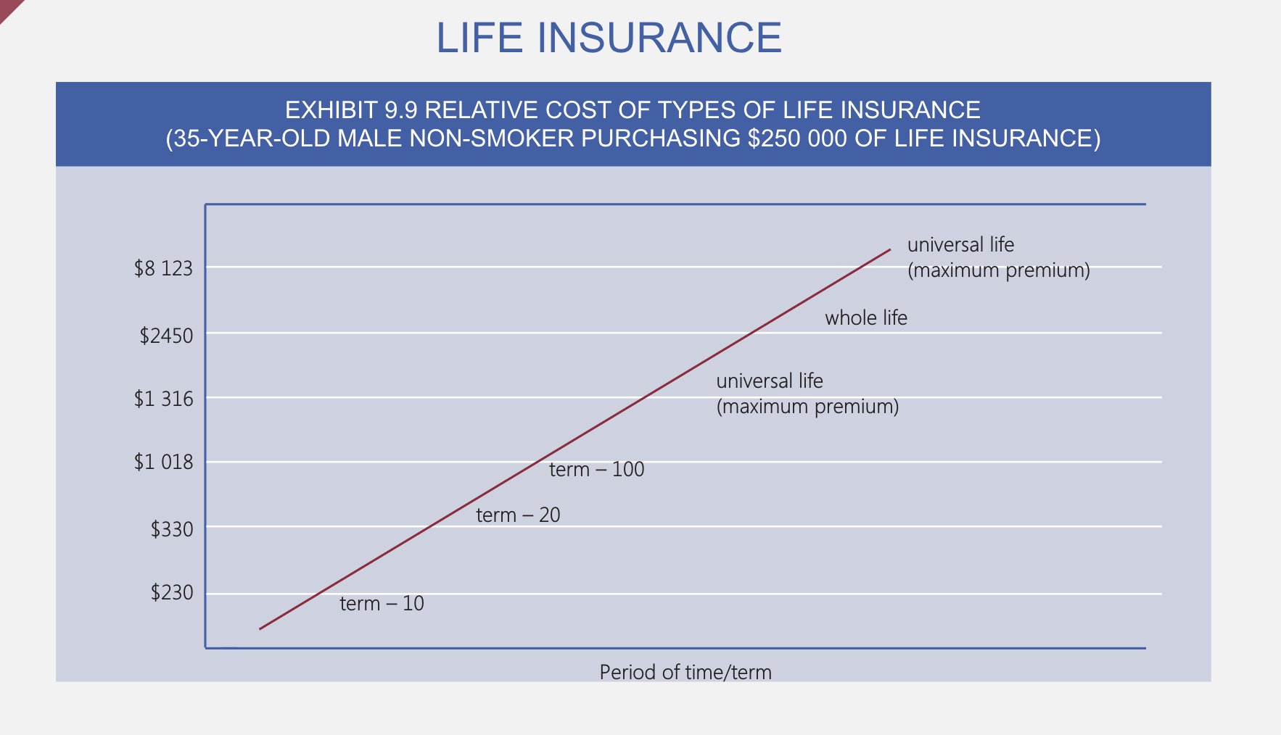

Content of a Life Insurance Policy

Beneficiary:
- Name multiple beneficiaries, that you can change at any time
- Benefits are not subject to probate and related expenses\

Grace Period

Reinstatement: The process of completing a reinstatement application to restor is policy that is in lapse status.
- May be reinstated within 2 years, The policy owner must provide evidence, reinstatement maintain the previous premium

Living Benefits: Benefits that allow the policyholder to receive a portion of death benefits prior to death

Premium Schedule: With a term life policy indicates what the new premium will be when the new premium will be renewed

Loans: You can borrow cash from a policy that accumulates cash value

Suicide Clause: Benefits are not payable if the policy owner commits suicide within two years of the policy effective date

Incontestability Date: The date after which a policy cannot be cancelled because of an accidental misstatement of information

Renewability and Conversion Options

Renewability option: Allows you to renew your policy from another term once the existing term expires.

Conversion option: Allows you to convert your term insurance policy into a whole life policy that will be in effect for the rest of your life.
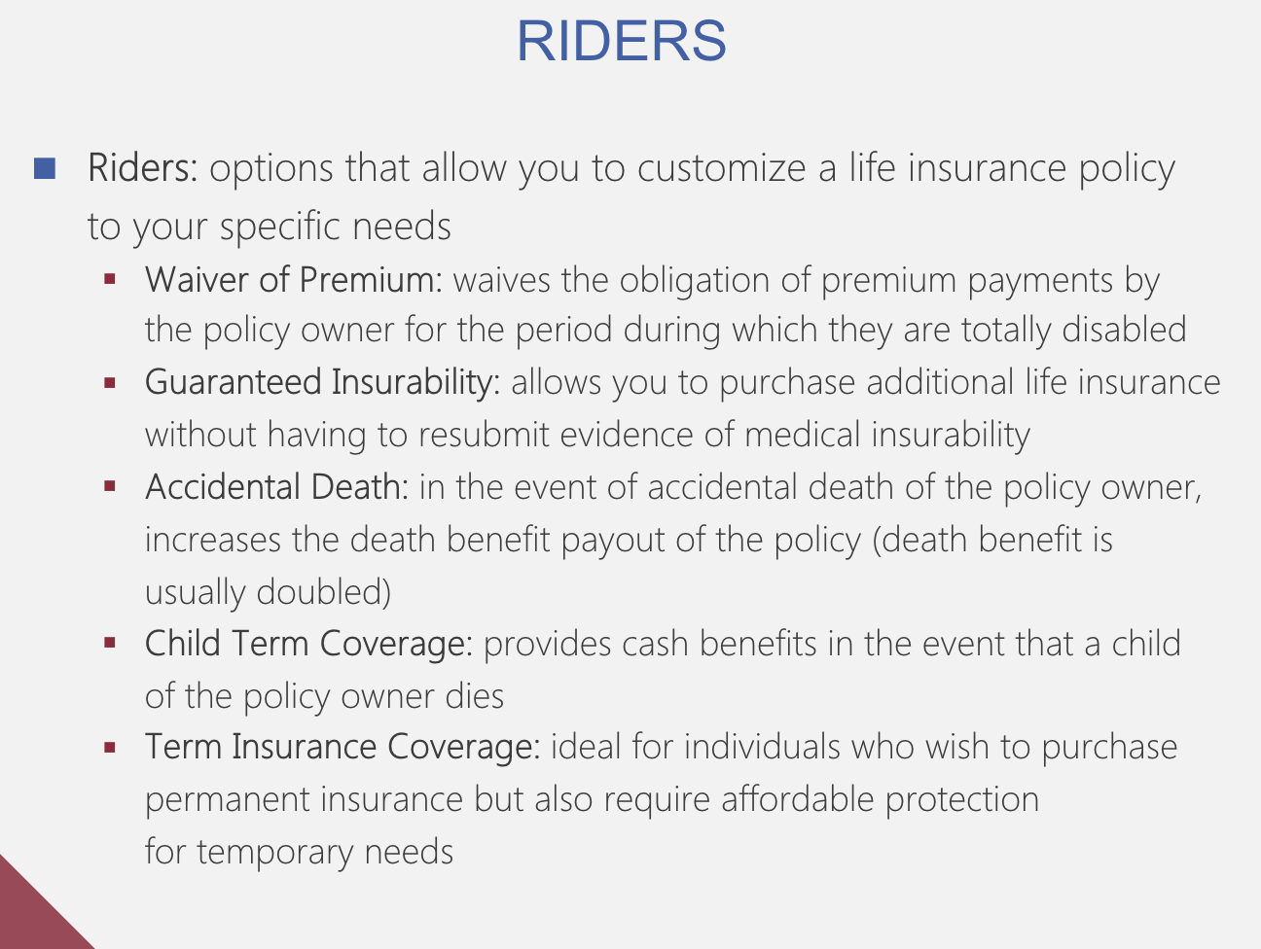

Lesson 8: Investing Fundamentals

- Type of investments

- Money Market

Money Market Securities: are short term assets typically with a maturity of one year or less
- Provide interest Income
- Low level of risk
- Saving alternatives include: term deposit, guaranteed investment cetificates (GICs), Canada Savings Bonds (CSBs)

- Stocks
- Common/Preferred

Common stocks: A certificate issued by a firm to raise funds that represents partial ownership in the firm
Common stock Investors:
- Normally have the right to vote on key issues
- Elect the Board of Directors
- Seek a return on their investment from stock appreciation rather than dividends.

Preferred stock: A certificate issued by a firm to raise funds that entitles shareholders to first priority to receive dividends
Preferred stock Investors:
- Seek the regular income that comes from dividends
- Those Stock aren’t volatile and doesn’t have much potential to increase substantially.

Common stock is issued more frequently than preferred stock
- Primary and secondary stock Markets

Primary market: A market in which newly issued securities are traded

Initial Public Offering: The first offering a firm’s shares to the public

Secondary market: A market in which existing securities are traded

- Return from investing in stocks

Dividend and/or stock price appreciation:
- Firms that pay high dividend tend to be older (firms that have less chance of growth or decrease
- Firms that pay less dividend tend to be younger (have more growth opportunity)

Growth stocks: Shares of firms with substantial growth opportunities
- Offer the prospect of a very large capital gain
- Way more risks, as theu more likely to fail or experience weak performance

Value stocks: Stock of firms that are currently undervalued by the market (for reasons other than the performance of the businesses themselves)

Income stocks: Stocks that provide investors with periodic income in the form of large dividends
- When a firm distributes a large proportion of its earning in dividends it limits its potential growth & his value may decrease

- Bonds

Bonds: long term debt securities issued by government agencies or corporations

Return from investing in bonds:
- In the form of coupon payments and price appreciation
- Desirable for investors who look to generate specific amount of income each year

- Mutual Funds

Mutual Funds: Represent a portfolio (all the assets owned) of investments

Return from Mutual Funds:
- Investor may earn a return from interest income, dividends and/or the price appreciation of the investments in the fund
- Attractive for investors with limited funds and want to invest in a diversified portfolio

- Real Estate

Real Estate: Invest in real estate by buying a home, purchasing rental property, and/or land.

Returns from Real Estate:
- Rent payment
- Selling the property for a capital gain

- Investment Return and Risk

- Investment return

- Measuring the return on your investment.

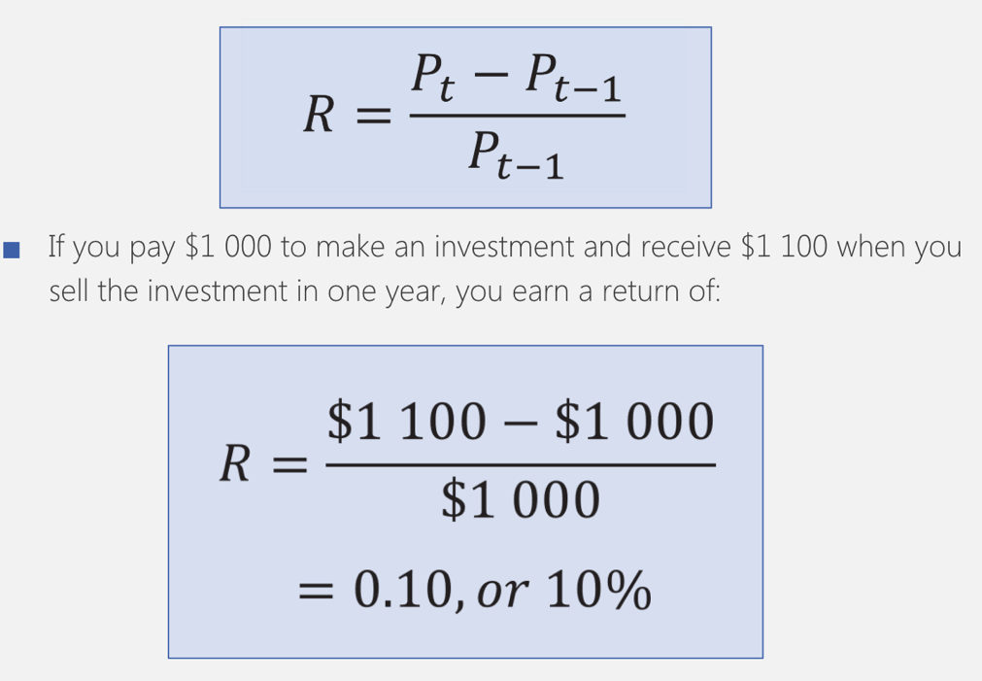

- Incorporating dividend or coupon Payments:

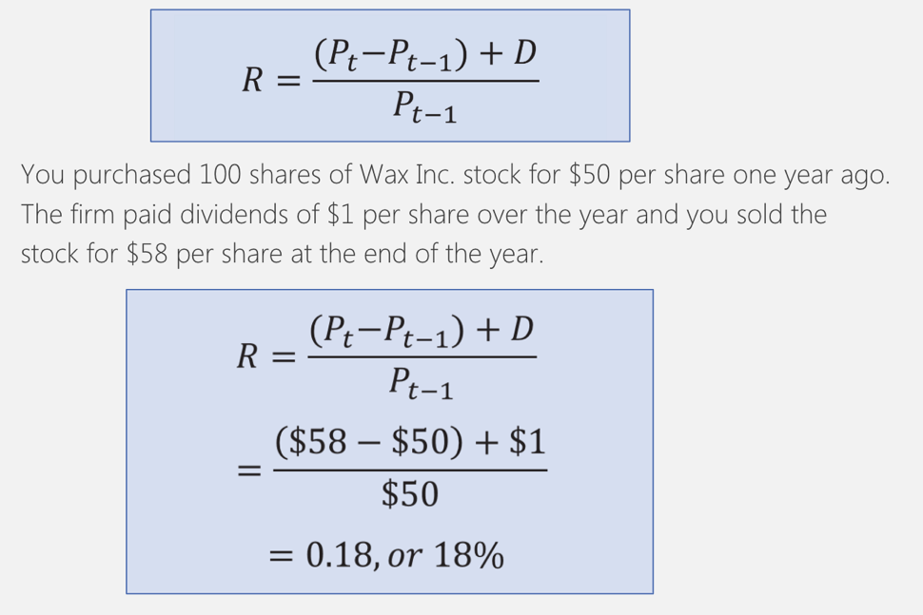
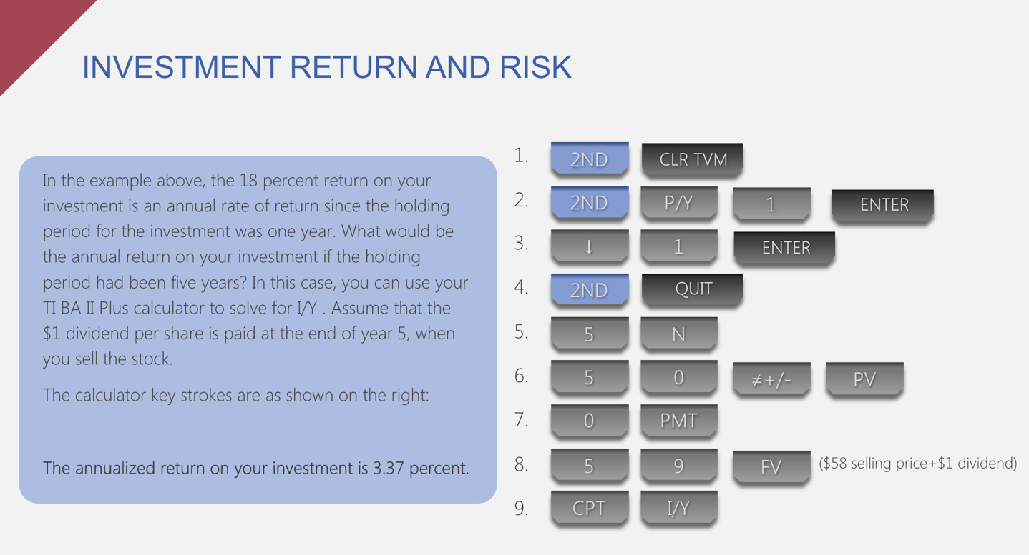

- Differing tax rates: on investment returns

- An investor who receive receives a 1000$ of capital gain or dividend income will pay less tax than an invester who receives 1000$ of interest income
- Individuals who are in the highest marginal tax bracket will pay the most amount of taxes on capital gain

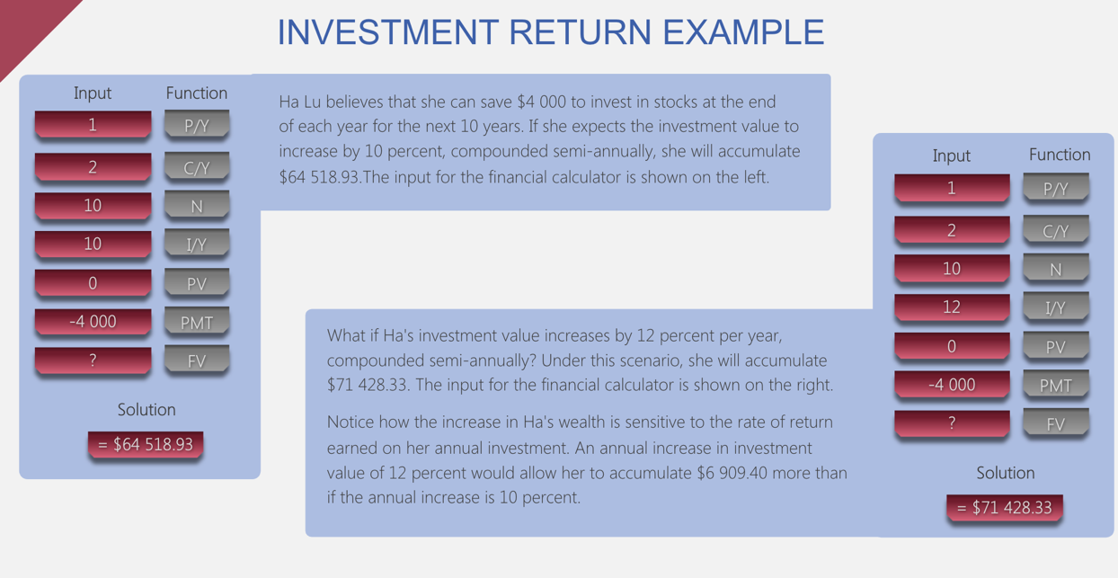
- Risk of investing

Investment risk: Uncertainty associated with an investment

- Investment return is uncertain:
- Stock dividends payments are not guaranteed, and the stocks future price is uncertain
- Bond coupon payments are not guaranteed, and the bonds future price is uncertain when you sell the bond before it matures
- Real estate rental income may not be paid, and the value of real estate is uncertain
- Unsystematic/Systematic risk
Unsystematic risk: Risk that are specific to a company, an industry, or a country
- Diversification and asset location can be used to eliminate, or at least minimize, unsystematic risk

Systematic risk: Risks that affects all companies, industries, and countries
- Risk that can’t be avoid

- Measuring an investment risk

Measuring risk

Range of return: Returns of a specific investment over a given period
Standard deviation: The degree of volatility in the stock’s return over time

Beta: Measures the systematic risk of an investment relative to a benchmark index

A very risky investment will have a relatively wide range of return, a high standard deviation, and a beta much greater than one.

Subjective Measures of risk

- Range returns, standard deviation, and beta are not accurate predictors of the changes in investment price

- The risk of some investments is commonly measured subjectively

- Trade-off between return and risk

Risk Premium: An additional return beyond the risk free rate you can earn from an investment
- Investors expect a higher return for taking additional risk
- The higher the potential risk of an investment, the higher the risk premium

- Return-risk trade off among Stocks, Bonds, Mutual funds…

- Return-risk trade off among Stocks

Initial Public Offering (IPO): The very first time that the stock of a company is offered to the public (Private Held Company => Publicly Traded Company)

- IPOs may offer high returns, but also have risk (Many IPO have performed poorly)
- Individuals investors rarely have access to these investments at the initial price

- Return-risk trade off among Bonds

Bonds of large well known, and successful firms have minimal risk
- Must be willing to accept a lower return on your investment
- High-risk bonds tends to offer higher interest payment
- Return-risk trade off among Bonds

- Mutual funds containing small capitalization companies will be more risky than those that hold large cap

- The primary risk associated with a mutual fund composed of bonds is that the bonds held by the mutual fund could default

- Return-risk trade off among Real Estate

- Renters default on their rent payments
- Property’s value could decline over time

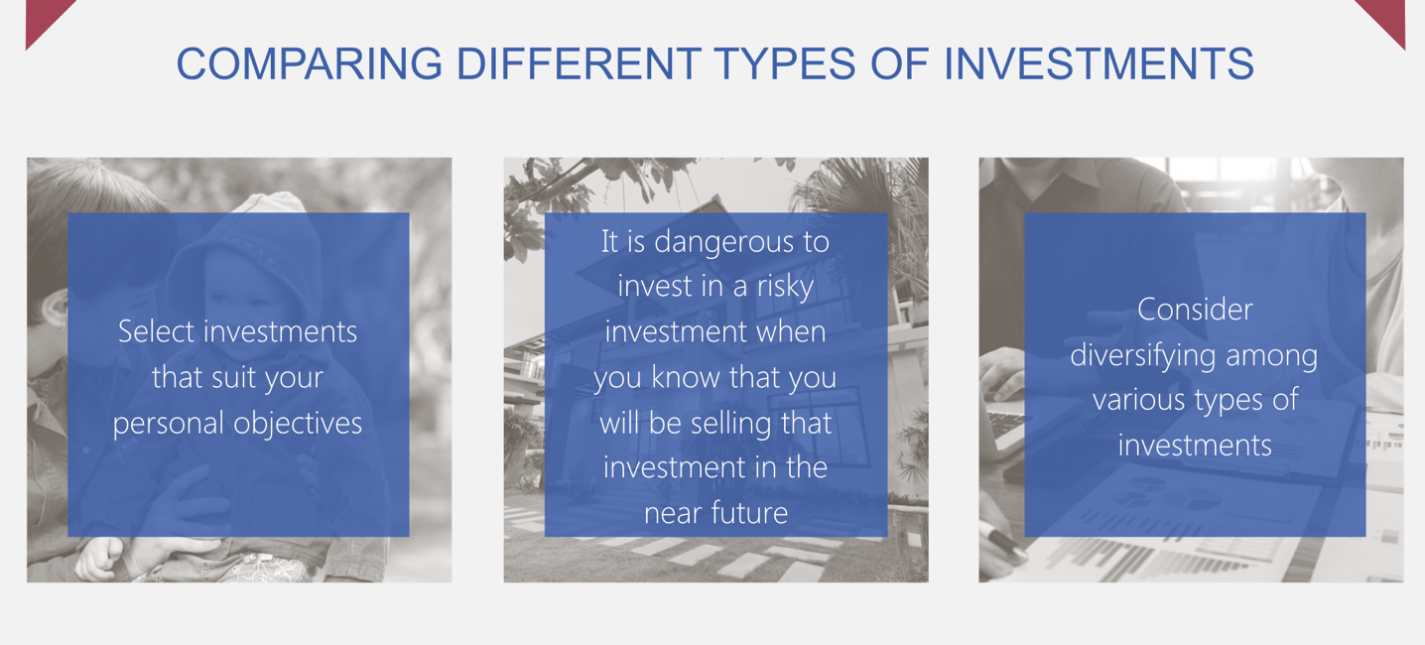

- How diversifications reduce risk

- Benefits of a portfolio diversification

Asset allocation: The process of allocating money across financial assets with the objectives of achieving a desired return while maintaining risk at a tolerable level

- Portfolio Benefits:

- Compare the return on the individual investments, it consists of to the overall portfolio
- Diversification reduces the exposure of your investments to the adverse effects of any individual’s investment
- A portfolio of stocks diversified across industries is less risky than a portfolio of stocks that are all from the same industries

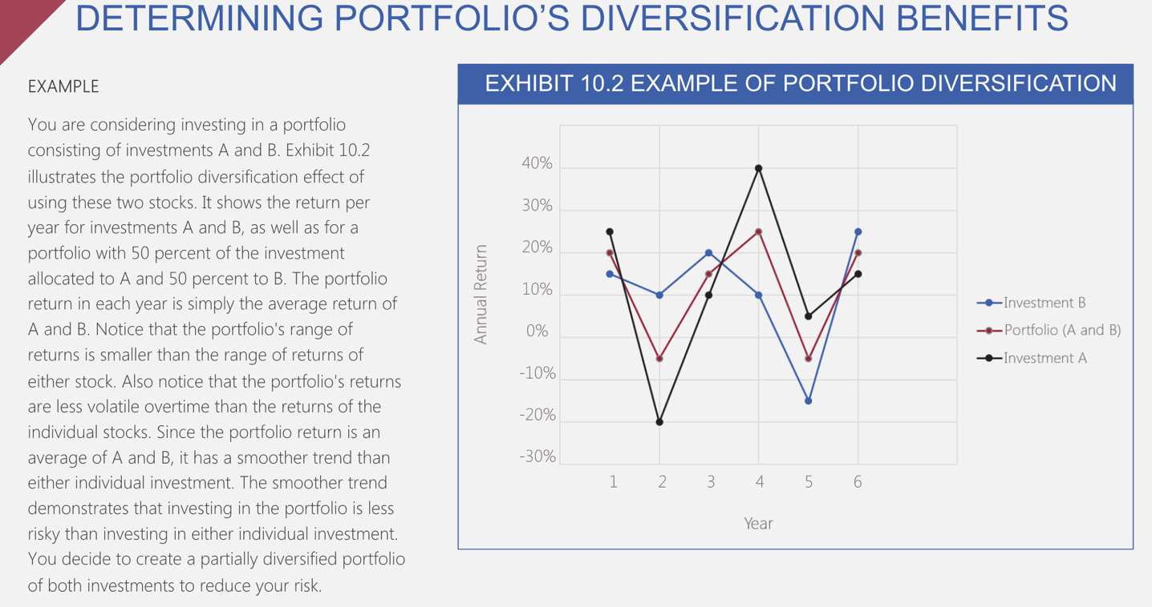

- Factors that influence diversification benefits

- Volatility of each individual investment
The more volatile the returns of individuals investments in a portfolio, the more volatile the portfolio’s returns are over time

- Impact of Correlations (how 2 securities prices move in relation to one another) Among Investments

The volatility of a portfolio’s returns is influenced by:
- The volatility of returns on each indiv investment on the portfolio, and the correlation of the return among investment
- Avoid including investments that exhibit high positive correlation

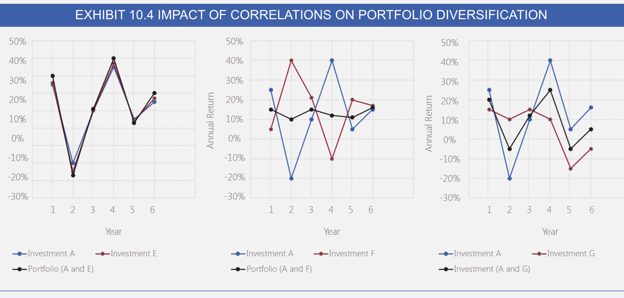

- Strategies for diversification

- Limitations of Industry diversification

- Portfolio can still be very susceptible to general economic conditions
- Diversification will not always prevent losses, but it can limit the losses.

- Diversification of Stocks across Countries (make you less vulnerable to economic conditions)

- Asset Allocation Strategies

Including bond in your portfolio
- Returns are not highly correlated to stocks
- Bond prices are inversely related to interest rates

Including Income Trust Investment in your portfolio
- Income trust: A flow through investment vehicles that generate income and capital gains for investors (fond d’inv)
- Almost 100% of the income generated by the trust assets is ‘’flowed’’ through the investors

- Factors that affect your asset allocations decision

- Your stage in life:
- Investors in the early life stages need easy access to fund so they should invest in safe and liquid securities.

- Investors not needing liquidity might consider investing in securities with high growth potential

- Investors nearing retirement may choose investment that will generate a fixed income

- Your degree of risk tolerance
- Your expectations about economic conditions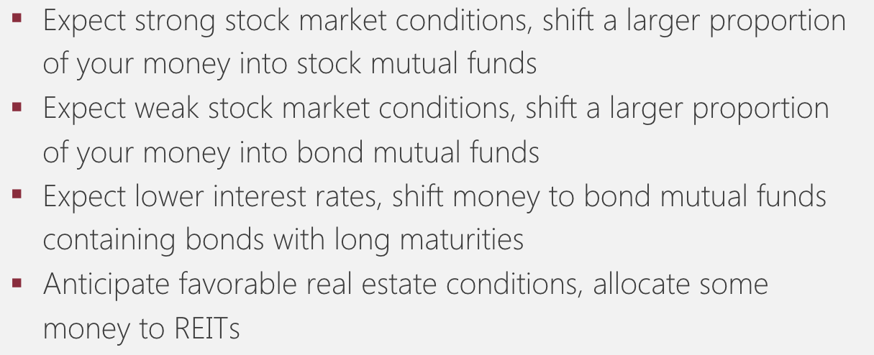

Change the composition of your investment portfolio in response to changes in your market expectations, investment goals, and life circumstances

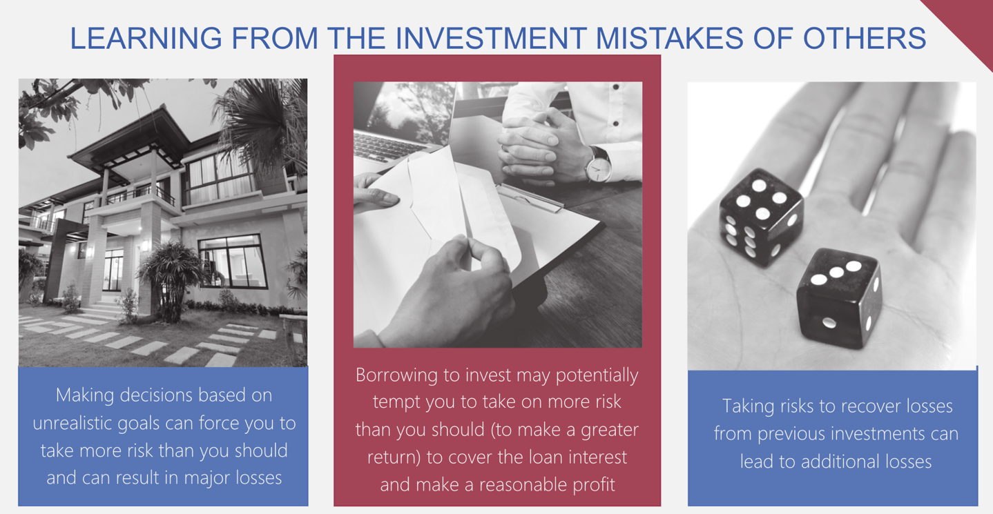

- Focus on ethic
Insider Information: Non-public information known by employees and other professionals that is not known by outsiders

- Avoid making any investment decisions until you have the fact in hand (Annual Report, Credible new sources, check with a trusted financial adviser)
- It can be difficult to tell the difference between legitimate and fraudulent investment opportunities

Def l’I.A, expliquer pourquoi c’est “le mythe de notre siècle” (GAFA investissent, s’installe de plus en plus dans notre vie quotidienne. Thus, artificial intelligence will take the place of customer service representative jobs in the workforce within the next two to three decades.

The artificial intelligence. Moreover, it seems to be the next main revolution of the Century. Indeed, the GAFA for instance are investing hundreds of millions in this technology in order to get the leadership in this crucial field.

