International Business

Chapter 1 – Globalization
- Globalization
  - The merging of previously domestic spaces and issues into one multifaceted and interconnected global village
  - The growing interdependence of people around the world with regard to societal influence, economies, and cultural exchanges
  - The increasing economic integration and interdependence of countries
  - A global movement to increase the flow of goods, services, people, real capital, and money across national borders in order to create a more integrated and interdependent world economy

- Globalization – interconnected interdependence, integration, and transformation of market, production, consumers

- Globalization of markets into one huge market:
  - Facilitated by:
    - Low-cost transportation
    - Low-cost global communications networks such as the World Wide Web are helping to create electronic global marketplaces

- Globalization of production:
  - The sourcing of goods and services from locations around the world to take advantage of national differences, costs, and quality of factors of production.

- Globalization of customers
  - The merging of separate national markets into one huge global marketplace

- Globalization: Key Drivers
  - Market
    - New markets
    - Strategic alliances
      - American cars, are they really American
    - Demand for products
  - Cost
    - Source of inexpensive labour
    - Cheaper raw materials
    - New sources of capital
  - Competition
    - Competition is producing similar goods of equal or better quality at lower cost
    - Competition can come from anywhere
      - Local and other global comp
  - Government
    - Trade liberalization policies
    - Industry deregulation
    - Privatization
    - Participation in globalization institutions
  - Technology
    - Advances in information and communication technologies facilitate:
      - Coordination of business activities from anywhere
      - Cross-border banking
    - Homogenization of many enabling technologies

- Globalization emerging themes

  - Interconnectedness
  - Interdependence
  - Integration
  - Complexity
  - Competition
  - Risk
  - Ethical dilemmas
  - Civil society
  - Social Responsibility
  - Culture
  - Laws

- Globalization: Good or Bad
  - For:
    - Increases economic growth rate, prosperity and opportunity for all participants
    - Private corporations and open markets provide better goods and services to society
    - Increases civil liberties and reduces inequalities
    - Leads to lower prices, higher employment in developing countries and better standards of living
    - Facilitates the transfer of technology, capital, intellectual property and skilled labour
    - A cleaner world environment
    - Rising standard of living in developing countries
    - Limits on international behaviour
  - Against
    - Increases the wealth of giant corporations and leaves developing countries poorer
      - Holding the state at ransom
    - Harms the environment

    - Increases unemployment in developed countries
    - Reduces standards (manufacturing, health, quality, environmental)
    - Periodic financial crises are caused, disrupting the economies of many countries
    - Intellectual property is not respected
    - Homogenizes cultures
    - Fuels income inequality between nations
    - Increases the gap between haves and have-nots
    - Causes problems that cannot be resolved by single nations
    - Globalization institutions run by developed countries

- Films on Demand: The Cost of Clothes: Ethical Textile
  - Low cost labour
  - Government not to disturb the textile industry
  - Fair trade is about making long term relationships with buyers and sellers

LECTURE 2 – Country Differences in Political Economy
Country Differences in Political Economy
- Differences:
- Political systems
  - Two dimensions of political systems:
  - Collectivism (the needs of society as a whole are more important than individual freedoms)
  - Individualism (the interests of the individual should take precedence over the interests of the state)
  - Individualism and democracy go hand in hand
  - Democracy: a political system in which government is by the people, exercised either directly or through elected representatives (representative democracy)
    - Economist intelligence unit democracy index 2017
          - Graded on:
            - Electoral process and pluralism
            - Civil liberties
            - The functioning of government
            - Political participation
            - Political culture
          - Country classification ranking
            - Full democracies
            - flawed democracies
            - hybrid regimes
            - authoritarian regimes
  - Collectivism and totalitarianism also go hand in hand
  - Totalitarianism: a form of government in which one person or political party exercises absolute control over all spheres of human life and opposing political parties are prohibited
- Economic systems
  - Market Economy – all productive activities are privately owned – production is determined by the interaction of supply and demand and there is no restriction on supply (no monopolies)
  - Command Economy – the goods and services that a country produces, the quantity in which they are produced, and the prices at which they are sold are all planned by the government
  - Mixed Economy – certain sectors of the economy are left to private ownership and free market mechanisms while others have significant state ownership and government planning
- Legal systems
- Common Law – based on tradition, precedent and custom
  - Tradition – a country’s legal history
  - Precedent – to cases that have come before the courts in the past
  - Custom – to the ways in which laws are applied in specific situations
- Judges have power to interpret the law so that it applies to the unique circumstances of the individual case
- Civil Law – based on a very set of detailed laws organized into codes
- Judges have power only to apply the law and therefore have less flexibility than those judges under common law
- Theocratic Law – a legal system based on religious teachings
- Contract Law
  - Common Law – relatively ill-specified so contracts drafted under a common law framework tend to be very detailed
  - Civil Law – many issues typically covered in a common law contract are already covered in a civil code, so contracts tend to be much shorter and less specific
- Property Rights
  - Property rights – the bundle of legal rights over the use to which a resource is put and over the use made of any income that may be derived from that resource
  - Violation of Property Rights:
    - Private Action – theft, piracy, blackmail by private individuals or groups
    - Public Action – when public officials extort income or resources from property holders
- Intellectual Property – property that is the product of intellectual activity (e.g., software, chemical formula)
- Ownership is established through:
  - Patents – grants the inventor exclusive rights for a defined period to the manufacture, use or sale of that invention
  - Copyrights – exclusive legal rights of authors, composers, playwrights, artists and publishers to publish and disperse their works as they see fit
  - Trademarks – designs and names by which merchants or manufacturers designate and differentiate their products
- Product Safety and Product Liability
  - Product Safety Laws – set certain safety standards to which a product must adhere
  - Product Liability – holding a firm and its officers responsible when a product causes injury, death, or damage

The Shift Toward a Market-Based Economic System
- Requirements:
  - Deregulation – removing legal barriers to the free play of markets, establishing private enterprises
  - Privatization – transferring state ownership into the hands of private individuals
  - Legal Systems – that protect property rights with associated machinery to enforce that system

International Business and Political Economy
- Countries are different in terms of:
  - Political systems (democracy vs. totalitarianism)
  - Economic systems (market economy vs. command economy vs. mixed economy)
  - Legal systems (common law vs. civil law) which raises issues of:
    - Contract law
    - Property rights
    - Intellectual property
    - Product safety and product liability

Implications for International Business
- How attractive is a country to export to, or to develop a physical presence?
  - Benefits:
    - Potential profitability (new revenue source, inexpensive labour costs)
    - Possible first-mover advantage
    - Building brand loyalty
- How attractive is a country to export to, or to develop a physical presence?
  - Costs and Risks:
    - Political stability – could the investment be “nationalized”
    - Prevailing local business practices (bribes?)
    - If the country is underdeveloped is there still a business case?
    - Does the prevailing legal system protect your area of business?
    - Is economic mismanagement a real risk (currency fluctuations, inflation, social unrest)

Potential exam question:
- Lecture 2
  - What is the significance of the political system to a company operating internationally?
  - Does it matter that the country in which you wish to sell your product or service is “democratic” or “totalitarian”
  - What’s the significance of the prevailing economic system to a company operating internationally
  - For a company operating internationally, what is the relationship between risk and; property right, intellectual property, product safety

Lecture 3 – The Cultural Environment
Cultural – WHY IS CULTURAL SENSITIVITY IMPORTANT?
- Some thematic facts:
  - Cultural diversity is a fact of organizational life in the global economy
  - To succeed firms must recognize the influence of culture and take cultural considerations into account when formulating strategies
  - Modern management principles may not be uniformly applied to all employees across the globe, as management practices are largely influenced by cultural dimensions

CULTURE – WHAT IS IT?
- A system of values and norms that are shared among a group of people, and that when taken together constitute a design for living
- Values – abstract ideas about what a group believes to be good, right, and desirable (shared assumptions about how things ought to be)
  - Broad preferences concerning appropriate courses of action or outcomes...[reflecting] a person’s sense of right and wrong or what “ought” to be (Jacob, Fink and Schuchman (1962) Values and Their Function in Decision Making, American Behavioural Scientist 5, suppl. 9, pp 6—38)
  - Abstract ideals that relate to proper life goals and methods for reaching those goals (Hitt, Miller & Colella: Organizational Behavior, Third Edition, Wiley, 2011)
- Norms – social rules and guidelines that prescribe appropriate behaviour in particular situations
  - Folkways – routine conventions of everyday life
  - Mores – norms that are seen as central to the functioning of a society
- Society – a group of people who share a common set of values and norms

Terminal Values vs. Instrumental Values
- Terminal Values
  - The “ends” to be achieved – the goals and individual would like to achieve during his/her lifetime
- Instrumental Values
  - The “means” for achieving desired ends – how you might go about achieving your important end states depending on the relative importance you attach to the instrumental value

Allport’s Six Value Categories
- Theoretical – interest in the discovery of truth through reasoning and systematic thinking
- Economic – interest in usefulness and practicality, including the accumulation of wealth
- Aesthetic – interest in beauty, form and artistic harmony
- Social – interest in people and love in human relationships
- Political – interest in gaining power and influencing other people
- Religious – interest in unity and in understanding the cosmos as a whole

Cultural Dimensions

- Who am I?
- How do I see the world?
- How do I relate to other people?
- What do I do?
- How do I use time and space?

Cultural Orientations
- Kluckhohn and Strotbeck – Five Basic Dimensions of the cultural orientation of societies
  - How people see themselves
    - How people conceptualize human nature (a mixture of good and bad, with the propensity to change from one to the other; or intrinsically good or bad, remaining in that state in perpetuity)
  - How people see the world
    - Dominant over nature ( a “can do” culture); or dependent on nature
  - How people relate to other people
    - Individual freedom and goals (individualism)
    - Societal rights and the “common good” take precedence (collectivism)
  - Dominant Behaviour
    - “Doing”: action, controlling to achieve outcomes measured by criteria, time-conscious; vs.
    - “Being”: greater harmony with nature; less time conscious; not outcome-driven
  - Use of Time and Space
    - Past-conscious: respectful of history, traditions, customs (e.g. Vietnamese)
    - Present-conscious: live in the present (e.g. Australians)
    - Future-conscious: an orientation toward the future (North Americans)
    - Space: the value of privacy

Determinants of Culture
Cultural norms and value systems
- Religion
  - Religion is defined as a system of shared beliefs and rituals that are concerned with the realm of the sacred
  - Most of the world’s ethical systems are the product of religions
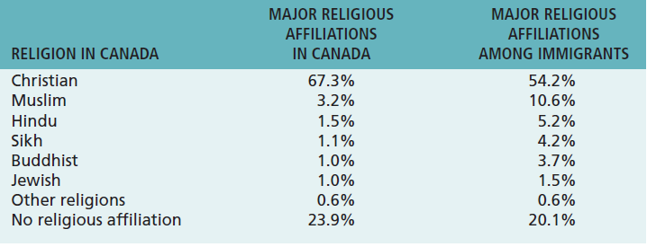
  - There are thousands of religions in the world today, but in terms of number of adherents, four dominate—
    - Christianity with about 1.9 billion,
    - Islam with about 1.2 billion,
    - Hinduism - about 750 million,
    - Buddhism - about 350 million
  - Economic Implications Proposed:
    - Protestant work ethic and the “spirit of capitalism” – hard work and wealth creation
    - Islam – supportive of free enterprise
    - Hinduism – the perception of the pursuit of material well-being as making the attainment of nirvana more difficult
    - Buddhism – not the same kind of historical cultural stress on entrepreneurial behaviour, but the lack of support for the caste system and extreme ascetic behaviour may represent a more fertile ground for entrepreneurial activity than a Hindu culture
  - Key message: religion plays an important role in international business
- Political philosophy
- Economic philosophy
- Education
  - Competitiveness
    - One important aspect of education is its role as a determinant of national competitive advantage
    - The availability of skilled and educated workers seems to be a major determinant of the likely economic success of a country
- Language
  - The nature of a language structures the way we perceive the world
  - Communication can be verbal and non-verbal
    - Communication is the ability to share ideas and feelings
    - Communication … is a two-way process by which information is exchanged between individuals, including and behaviour, verbal or nonverbal that is perceived by another
    - Communication is a two-way process in which the communicators try to achieve a shared meaning
  - Characteristics of Communication
    - No direct mind-to-mind contact, so we must share feelings and experiences through a physical process
    - Only inference is possible, so we never know for sure
    - Communication is a dynamic process – no obvious beginning and end, and a means through which we bring definition to the world around us
    - Communication is interactive, a reciprocal process
    - Communication is inevitable
    - Communication permits the transmission of knowledge between persons, and also between generations
    - Communication is symbolic, expressing things, processes, ideas
    - Communication does not mean understanding
    - Communication has consequences
    - Communication is self-reflective, rooted in our ability to think about ourselves and to reflect on our past, present and future
    - The brain is an open system – we can learn and we never stop learning
    - Communication is contextual – time, place, and prescriptive regarding the type of behaviour preferred or prohibited
  - Importance of Communication
    - Management is getting things done through other people
    - Everything a manager does involves communication (managers spend 75% of their time on communicating)
    - For the manager, communication facilitates control, motivation, the expression of emotions and the transfer of information/meaning
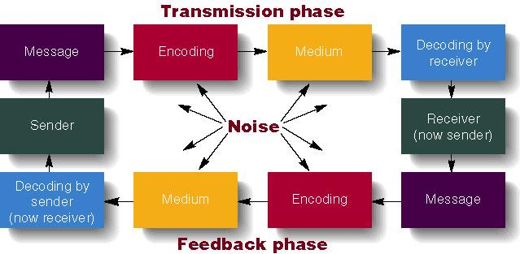
  - Nonverbal Communications
    - In a normal two-way conversation, verbal components carry less than 35 percent of the social meaning of the situation
    - We believe nonverbal messages over verbal messages when the two contradict each other
    - Nonverbal communication is often the foundation for our first impressions
    - Communication in any form other than words that can produce shared meaning and elicit a response
    - Embraces the intentionality and ‘unintentionality’ of messages during the encoding and decoding stages
  - Verbal vs. Nonverbal
    - Verbal Communication
      - Based on culturally agreed upon set of symbols
      - usually deliberate
      - Learned later in life
      - Come in an orderly sequential way
      - Has a definite ending point
    - Nonverbal Communication
      - Based on culturally agreed upon set of symbols
      - Often governed biologically/involuntarily
      - Learned earlier in life
      - Do not come in an orderly sequential way, but simultaneously from a multiple of channels
      - Continuous process, never ending
  - Categories on Nonverbal Communications
    - Chronemics
      - The use of time – in this context, in the midst of communication
    - Proxemics
      - The use of space –
    - Paralanguage
      - Voice quality
      - Volume
      - Pitch variation
      - tempo
    - Material Possessions
      - Style of dress
        - Clothes, Jewelry, trinkets
    - Chromatics
      - Communication through colours – send intended or unintended messages in some cultures
    - Smell
      - Cologne – a sign of respect or disrespect?
    - Oculesics
      - The role of eyes in non-verbal communication
      - Can convey trust or aggression
    - Haptics
      - Touch – conveys intimacy of the relationship (Brazil vs. North America differ in the respect!)
    - Kinesics
      - Body language
      - Fidgeting, gestures, facial expressions, posture
- Social structure
  - Individual
    - Definition: In Western societies, the individual is the basic building block of social organization and the value system of many Western societies emphasize individual achievement.
  - Group
    - Definition: Group is the association of two or more individuals who have a shared sense of identity and who interact with each other in structured ways on the basis of a common set of expectations about each other’s behavior – one central value of some Asian cultures is the importance attached to group membership
  - Social Strata
    - Societies stratified on a hierarchical basis into social categories or social strata defined on the basis of characteristics such as family background, occupation, and income. Individuals are born into a particular stratum

Culture and the Workplace
- How a society’s culture affects the values found in the workplace is of considerable importance to an international business with operations in different countries.
- Hofstede isolated five dimensions that he claimed summarized different cultures:
    - Power distance – how a society deals with the fact that people are unequal in a social and status sense
      - A low rating characterizes societies that stress equality and opportunity
    - Uncertainty avoidance – how society copes with uncertainty and deals with risk
      - A low rating characterizes societies that are more accepting of ambiguity, less rule-oriented, take more risks, and more readily accept change
    - Individualism – collectivism – the relative closeness of the relationship between one person and others
      - Collectivism emphasizes a tight social framework in which people expect others in groups of which they are a part to look after them and protect them
    - Masculinity – femininity – the sexuality of roles in society and the degree to which society allows overlap between the roles of men and women
      - A high femininity rating means the culture sees little differentiation between male and female roles and treats women as the equals of men in all respects
    - Long-term vs. Short-term Orientation
      - A low score means that the culture prefers to maintain time-honoured traditions and norms while being suspicious of societal change

CHAPTER 4 – ETHICS IN INTERNATIONAL BUSINESS
COUNTRY DIFFERENCES: ETHICS
- What is “ethics”?
- Business Ethics
- 6 Environments Affecting Ethics and Influences on Ethical Behaviour
- Ethical Issues
- Determinants of Ethical Behaviour
- Models of Ethical Decision-MakinG

BUSINESS ETHICS
- Business Ethics:
  - “the application to business activity of ethics, the study of morals or principles of what is right or wrong in human behaviour” (Edmund Marshall, “Business and Society”, Routledge, 1993)
  - “…concerned with the beliefs that determine what is acceptable (and what is not) in business” (Wheelen, Hunger and
  - Wicks, “Concepts in Strategic Management”, Canadian Edition, Pearson Prentice Hall, 2005)
  - “applies a group’s standards of right and wrong to the decisions and actions of business organizations, managers, and employees” (Marian Burk Wood, “Business Ethics in Uncertain Times”, Prentice Hall, 2004)
  - The accepted principles of right or wrong governing the conduct of business people (Hill, Hult, McKaig)

COMMON THEMES EMERGING FROM DEFINITIONS OF BUSINESS ETHICS
- Right and wrong
- Moral standards
- Value judgements

MORAL STANDARDS
- The means by which individuals judge their actions and the actions of others based upon accepted behaviour in society

VALUE JUDGEMENTS
- Subjective evaluations of what is considered important, based on how managers intuitively feel about the goodness or rightness of various goals

INFLUENCES ON ETHICAL BEHAVIOUR

- Individual morals
- National and ethnic cultures
- Government legislation and regulation
- The legal system
- Religion
- Colleagues or peers
- Education
- Media
- Corporate mission, vision, and values statements
- Union contracts
- Competitive behaviour
- Activist or advocacy groups
- Business or industry organizations
- Professional associations

6 Environments Affecting Ethics

- Political
- Socio-cultural
- Technological
- Economic
- Competitive

Ethical Issues in International Business
- Changing Political Environment
  - People elected to run government in one jurisdiction are affected by political results in other national and international circumstances
  - Corruption and perception of corrupt politicians
  - Human rights
- Changing Socio-Cultural Environment
  - Normal practice in one culture may be considered unethical in another
  - Gift-giving vs. bribery
- Changing Technological Environment
  - New technology can create ethical issues
    - Fake news
    - Video streams and social media
- Changing Economic Environment
  - Hiding investment in tax-saving havens
  - Corporations not paying taxes
- Changing Competitive Environment
  - Employee practices
  - Outsourcing
  - Environmental Pollution

Ethical Dilemmas
- Situations in which none of the available alternatives seem ethically acceptable;
- Situations where a decision must be made between two equally valid but mutually exclusive courses of action

Determinants of Ethical Behaviour
- Personal Ethics
- Organizational Culture
- Unrealistic Performance Goals
- Leadership
- Decision-Making Processes

Making Ethical Judgements: Deciding What is Ethical
- What approaches exist to help make defensible ethical decisions
  - Otto Bremer: Four Questions
  - Josephson: Bell, Book, Candle
  - Nash
  - Pagano
  - Integrated Ethical Decision Model

Otto Bremer: 4 Ethics Questions
Source: Karakowsky, Carroll, Bucholtz: Business and Society – Ethics and Stakeholder Management, First Canadian Edition: Thomson Nelson
- What is (descriptive ethics)?
    - What is actually going on in an ethical sense (what is the real situation)
- What ought to be (normative ethics)?
    - What managers should do
- How do we get from What Is to What Ought to Be?
    - How is the gap closed? May actually not be able to fully close the gap!
- What is Our Motivation?
    - What is the motive for being ethical?

Making Ethical Decisions – Josephson’s “bell, book, candle” Approach
Three tests:
- “Listen for the bells warning you of an ethical decision (the ‘bell’);
- Check to see if there are any laws, regulations or rules which restrict your choices (the ‘book’); and,
- How will your decision look in the light – could a reasonable, fair-minded person conclude you acted improperly? (the candle).”[1]
[1] Michael Josephson cited in West, Andrew. 2007. Sartrean Existentialism and Ethical Decision-Making in Business. Journal of Business Ethics, Springer 2007.

Nash: Some Plainly Worded Questions
- Have you defined the problem accurately?
- How would you define the problem if you stood on the other side of the fence?
- How did this situation occur in the first place?
- To whom and to what do you give your loyalty as a person and as a member of the corporation?
- What is your intention in making this decision?
- How does this intention compare with the probable results?
- Whom could your decision or action injure?
- Can you discuss the problem with the affected parties before you make your decision?
- Are you confident that your position will be as valid over a long period of time as it seems now?
- Could you disclose without qualm your decision or action to your boss, your CEO, the Board of Directors, your family, society as a whole?
- What is the symbolic potential of your action if understood? If misunderstood?
- Under what conditions would you allow exceptions to your stand?

The Pagano Model
- Is it legal?
- The benefit cost test (the greatest good for the greatest number?)
- The categorical imperative (Do you want this action to be a universal standard?)
- The light of day test (What if your actions appeared on TV?)
- Do unto others (Do you want the same to happen to you?)
- The ventilation test (Get a second opinion from someone with no investment in the outcome)

An Integrated Ethical Decision Model
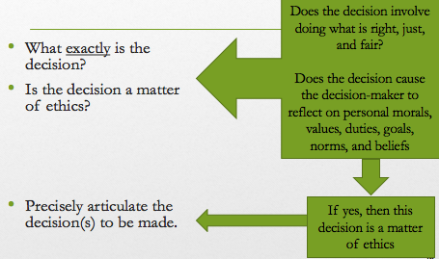

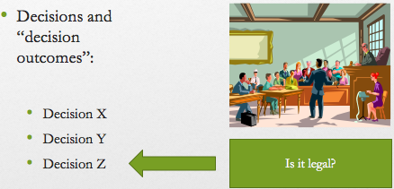

- Who are the key stakeholders impacted by this decision?
- Do you believe the decision is right, just and fair for the majority of key stakeholders?
- Deontological Test: Is the decision consistent with my ideals for behaviour, the behaviour others have a right to expect of me, and my sense of duty?
- Teleological Test: Does the decision produce the best outcome for the greatest number, or the worse outcome for the fewest number?

Chapter 5 – International Trade Theories

International Trade Theory
- International trade theory has shaped the economic policy of many nations for the past 50 years.
  - It was the driver behind the World Trade Organization and regional trading blocs such as
      - the European Union
      - the North American Free Trade Agreement (NAFTA)

International Trade Theory
- Mercantilism
  - The first theory of international trade
  - Mercantilists believed:
    - It was in a country’s best interests to maintain a trade surplus (to export more than it imported)
    - Government intervention to achieve a surplus in the balance of trade was welcomed and recommended policies to maximize exports and minimize imports
      - Subsidize exports & apply tariffs and quotas to imports
  - The flaw: a “zero-sum game” in that a gain in one country results in a loss by another since in the long term no country could sustain a surplus on the balance of trade (David Hume)
- Absolute AND COMPARATIVE advantage
  - Absolute
    - A country has an absolute advantage (Adam Smith) in the production of a good when it is more efficient than any other country in producing it (for Canada, for example, several raw materials)
    - The absolute advantage could be natural (natural resources, climate, available labour resources) or acquired (product or process technology)
  - Comparative
    - A country has a comparative advantage (David Ricardo) when it is comparatively more efficient at producing one good over another
    - The theory of comparative advantage proposes that it is sensible for a country to specialize in the production of those goods that it produces most efficiently and to buy the goods that it produces less efficiently
    - The pattern of international trade therefore arises from differences in productivity
- The Heckscher–Ohlin theory
  - The Heckscher–Ohlin Theory predicts that countries will export those goods that make intensive use of factors that are locally abundant, while importing goods that make intensive use of factors that are locally scarce.
  - Also referred to as the Factor-Proportions Theory in some texts
  - The pattern of international trade is therefore determined by differences in factor endowments
  - The Leontief paradox
    - Leontief tested the Heckscher–Ohlin theory and found the result was at variance with the predictions of the theory
    - Since the United States was relatively abundant in capital compared to other nations, it would be an exporter of capital-intensive goods and an importer of labour-intensive goods (according to the Heckscher–Ohlin theory)
    - Leontief found that United States exports were less capital-intensive that its imports – this became known as the Leontief Paradox
- The Product Lifecycle
  - The location of production of certain kinds of products shifts as they go through their life cycles (Daniels, Radebaugh & Sullivan: International Business, Environments & Operations, Pearson 2007)
  - 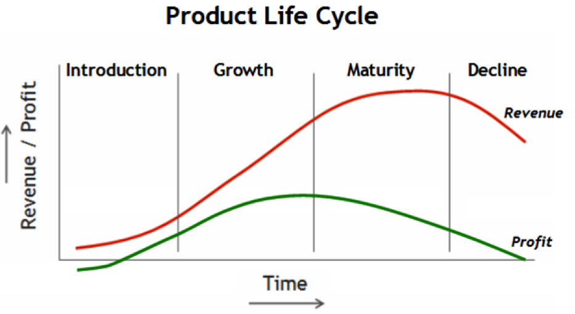
- New Trade Theory
  - The New Trade Theory began to emerge in the 1970s when a number of economists were arguing that increasing returns to specialization might exist in some industries.
  - Economies of scale:
    - Represent one particularly important source of increasing returns.
    - Economies of scale are unit cost reductions associated with a large scale of output.
  - Important Trade Points
  - Through economies of scale, trade can increase the variety of goods available to consumers and decrease the average costs of those goods (allowing for favourable prices and higher profits)
  - In industries where the output required to attain economies of scale represents a significant proportion of the entire world demand, the global market may be able to support only a small number of enterprises possibly dominated by countries whose firms were first movers in their production
  - First mover advantage: The US dominates in the export of commercial jet aircraft because American firms such as Boeing were first movers in the world market, building a competitive advantage that is difficult for firms in other countries to challenge
- National Competitive Advantage
- Demand conditions
- Relating and supporting industries
- Factor endowments
- Firm strategy, structure, and rivalry
  - Michael Porter’s Theory (The Competitive Advantage of Nations, 1990) determines that four broad attributes of a nation shape the environment in which local firms compete, and these attributes promote or impede the creation of competitive advantage.
  - 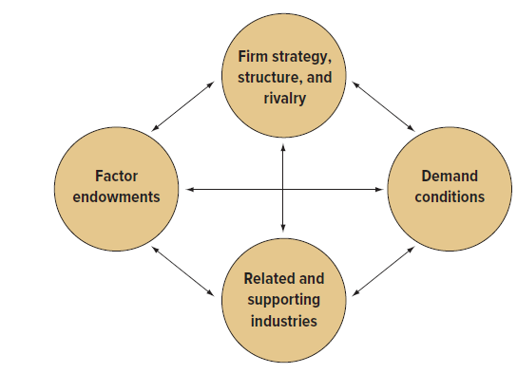
- Implications for International Businesses
  - Location Implications
    - different countries have particular advantages in different productive activities
    - it makes sense for a firm to disperse its productive activities to those countries where, according to the theory of international trade, they can be performed most efficiently
  - First-mover Implications
    - firms that establish a first-mover advantage with regard to the production of a particular new product may subsequently dominate global trade in that product
    - it pays to invest substantial financial
resources in trying to build a first-mover, or early-mover, advantage, even if that means several years of substantial losses before a new venture
becomes profitable
  - Policy Implications
    - The theories of international trade also matter to international businesses because firms are major players on the international trade scene.
    - Because of their pivotal role in international trade, businesses can influence government trade policy, lobbying to promote free trade or trade restrictions

Trade theory question:
A strong Australian demand to ensure a continuing market?
- Relating and supporting industries – is there: A presence of internationally competitive supplier industries?
- Factor Endowments – is there: A well developed infrastructure and sufficient skilled labor?
- Firm strategy, Structure and Rivalry – is there: Domestic rivalry that encourages high quality and competitiveness? A strong demonstration of company management and approach to organization?
- If the answer to these questions is “yes”, then there is a strong likelihood for success.

Trade Theory Question: Selling Electrical equipment to Australia
- What is Australia’s general position on international trade?
  - They are open to international trade
- Are there any trade restrictions relating to electrical equipment?
  - Australia does not ban or restrict the import of electrical equipment

Electrical Equipment Questions
- Does Australia have an absolute natural advantage? Absolute acquired advantage? A comparative advantage?
- Would exporting electrical equipment to Australia follow to the product lifestyle?
- Would you have an economy of scale?
- Would you have first mover advantage in Australia;

Chapter 6 – International Trade Policy

Instruments of Trade Policy
- Tariffs
- Subsidies
- Import Quotas & Voluntary Export Restraints (VER)
- Local Content Requirement
- Administrative Policies
- Antidumping Policies

Instruments of Trade Policy
- Tariff – a tax levied on imports
  - Specific Tariff – levied as a fixed charge for each unit of a good imported ($3 per barrel of oil, for example)
  - Ad Valorem Tariff – a charge levied as a proportion of the value of the imported good (a percent by value on the first 2.5 million tonnes, for example)
- A tariff raises the cost of imported products to protect domestic producers from foreign competition
- Subsidy – a government payment to a domestic producer
  - Cash grants
  - Low-interest loans
  - Tax breaks
  - Government equity participation in domestic firms
  - Subsidies lower production costs
  - Can grow so large as to disrupt the normal pattern of international trade
    - Shipping, wheat and butter industries are notorious
  - Bug losers: efficient producers in countries that lack large scale subsidies
    - Australia’s wheat industry
    - New Zealand’s dairy industry
- Import Quota – a direct restriction on the quantity of a good that may be imported into a country – usually enforced by issuing import licences
- Voluntary Export Restraint (VER) – a quota on trade imposed by the exporting country, typically at the request of the importing country’s government
- Local Content Requirement – demands that some specific fraction of a good be produced domestically (in physical terms or value terms)
  - e.g., what does “Swiss Made” on a wristwatch actually mean?
  - e.g., what constitutes an “American product”?
- Administrative Policies
  - Bureaucratic rules designed to make it difficult for imports to enter a country
- Antidumping Policies
  - Dumping – selling goods in a foreign market at below their cost of production, or at below their “fair” market value
  - Unloading excess production in foreign markets
  - If dumping is proven an antidumping duty can be imposed (countervailing duties)

Other non-tariff barriers
- Products & testing standards
- Restricted access to distribution networks
- Public sector procurement policies
- Regulatory controls
  - Health and safety
- Currency controls
  - Forcing importers to purchase foreign currency at the central bank
- Investment control
  - Determines stock ownership

The Case for Government Intervention
- One consistent message has been that the implication of applying any of the instruments of trade policy is detrimental to the consumer – so why do it??
- There are both political arguments and Economic Arguments
- Political Arguments
- Protecting Jobs and Industries from unfair foreign competition
- National Security
- Retaliation – using the threat to intervene in trade policy as a bargaining tool to force trading partners to play by the rules
- Protecting Consumers from “unsafe” products
- Furthering Foreign policy objectives – granting preferential trade terms to certain countries
- Protecting Human Rights – using trade policy to improve the human rights policies of trading partners
- Economic Arguments
- Infant Industry – temporary government support for new industries (using tariffs, import quotas, and subsidies) until they have grown strong enough to meet international competition
- Strategic Trade Policy:
  - if a government can help a firm gain first-mover advantage, national income will rise;
  - Government intervention might help domestic firms overcome barriers to entry created by foreign firms that have already established first-mover advantage

The WTO
- The WTO acts as an umbrella organization that encompasses the following bodies:
    - GATT
    - GATs (General Agreement on Trade in Services)
    - TRIPs (Trade Related Aspects of Intellectual Property Rights)
- WTO has taken the responsibility for arbitrating trade disputes and monitoring the trade policies of member countries
- Simple basics of the WTO:
  - When two countries have a trade dispute, the WTO looks at the various trade agreements these countries have had over the years, and rules which is the best outcome of a current situation
    - Like a global UFC “trade” referee
- Three unresolved issues at the forefront of the WTO agenda:
  - The rise of antidumping policies
  - The high level of protectionism in agriculture
  - The lack of strong protection for intellectual property rights

The Heart of the WTO Video

Lecture 7 – Foreign Direct Investment
FDI Described
- FDI occurs when a firm invests directly in facilities to produce or market a product in a foreign country – two main forms:
  - Greenfield investment (establishing a wholly new operation in a foreign country); or,
  - Acquiring or merging with an existing firm in the foreign country

Form of FDI – Acquisitions vs. Greenfield Investments
- Acquiring existing foreign assets is apparently preferred over greenfield investments – why?
  - Mergers and acquisitions are faster to expedite
  - Acquired foreign firms have valuable strategic assets (brand loyalty, customer relationships, trademarks, patents, distribution systems, production systems, strategic alliances)
  - A belief that the transfer of capital, technology, or management skills can increase the efficiency of the acquired enterprise

WHY FDI??
- FDI is more risky than exporting (producing goods at home and then shipping them to the receiving country for sale) or licensing (granting a foreign entity (licensee) the right to produce and sell the firm’s product in return for a royalty fee on every unit the foreign entity sells)
- FDI is also more expensive – a firm must bear the costs of establishing production facilities in a foreign country or of acquiring a foreign enterprise
- So the perceived “preference” of FDI must be anchored in limitations of exporting and licencing
- Note the following definition of “profit”:
  - Profit = reward for assuming a risk; the greater the risk, the greater the associated potential profits
- Is FDI more profitable, or is exporting and licensing less profitable??
- Therefore, what are the limitations of exporting and licensing?

Capitalizing on Foreign Market Opportunities
- Limitations of Exporting
  - Potential constraints imposed by trade barriers (import tariffs, quotas) and transportation costs
  - Trade barriers could either exist or threatened to be imposed
  - Transportation costs depend on the nature of the product – low value-to-weight ratio products that can be produced anywhere may render exporting unprofitable
- Limitations of Licensing
  - Risk of giving away valuable technological know-how to a potential foreign competitor
  - Lack of tight control over marketing, manufacturing, and strategy in a foreign country
  - Competitive advantage based on management, marketing and manufacturing instead of the actual product

Political Ideology of FDI – The Driver of Government Policy Toward FDI
- The Radical View:
  - Marxist political and economic theory
  - Argues that the multinational enterprise (MNE) is an instrument of imperialist domination
  - They see the MNE as a tool for exploiting host countries to the exclusive benefit of their capitalist-imperialist home countries
  - They argue that MNEs extract profits from the host country and take them to their home country
- The Free Market View:
  - argues that international production should be distributed among countries according to the theory of comparative advantage:
    - countries should specialize in the production of those goods and services that they can produce most efficiently
- The Pragmatic Nationalism View:
  - In practice, many countries have adopted neither a radical policy nor a free market policy toward FDI, but instead a policy that can best be described as pragmatic nationalism.
    - The pragmatic nationalist view is that FDI has both benefits and costs.
    - FDI can benefit a host country by bringing capital, skills, technology, and jobs, but those benefits often come at a cost.

Benefits of FDI to the Nation State: Host-Country Benefits
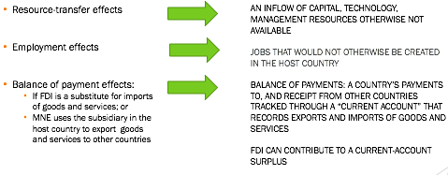

Benefits of FDI to the Nation State: Home-Country Benefits
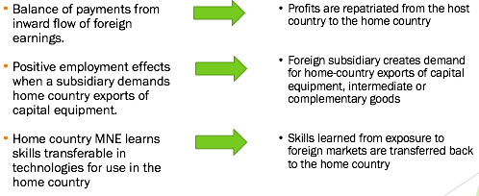

Costs of FDI to the Nation State: Host-Country Costs
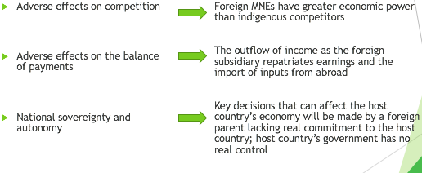

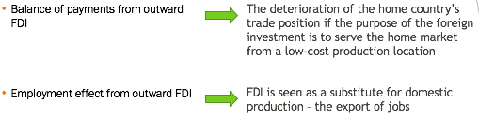
Costs of FDI to the Nation State: Home-Country Costs

Government Policy Instruments and FDI Home Country Policies
- Home Country Policies
  - Encouraging Outward FDI
    - Government-backed insurance programs
    - Government loans
    - Tax concessions
    - Political influence to persuade host countries to relax their restrictions on inbound FDI
- Restricting Outward FDI
  - Limit capital outflows
    - Tax concessions for firms to invest at home
    - Formal or informal restrictions on firms from investing in certain countries for political reasons

Government Policy Instruments and FDI Host Country Policies
- Host Country Policies
  - Encouraging Inward FDI
    - Tax concessions, low-interest loans, grants or subsidies to encourage foreign firms to invest
  - Restricting Inward FDI
    - Ownership restraints (foreign companies excluded from specific fields; a requirement for a significant proportion of the equity of the subsidiary to be owned by local investors; national security concerns)
    - Performance requirements (local content, exports, technology transfer, local participation in top management – all intended to control the behaviour of the MNE’s local subsidiary)

Foreign Direct Investment – Implications for Business
- Would you acquire a similar company already in your selected country if one exists?
  - What are issues?
    - Degree of urgency
    - Extent of strategic assets in the acquired firm
    - Potential to increase the acquired firm’s efficiency using the skill, technology and capital transferred
  - What are the risk factors applicable to the acquisition of a company in the selected country?
    - Stability of government
    - History of mergers and acquisitions
    - Political ideology prevailing in the selected country, as well as the home country
  - What are the prevailing policy instruments at play in both the host and home country?
- Would your FDI take a greenfield approach?
  - What are issues?
    - Significant investment
    - Longer time period to establish the company
    - Source of expatriates, training, local workers
    - Dealing with country differences
- What are the risk factors applicable to the acquisition of a company in the selected country?
  - Stability of government
  - History of mergers and acquisitions
  - Political ideology prevailing in the selected country, as well as the home country
- What are the prevailing policy instruments at play in both the host and home country?

Lecture 9 – The Global Monetary System

The Journey Continues….
- Globalization -> Country difference -> Cross-border trade & investment -> global money system
- The international monetary system: the institutional arrangements that countries adopt to govern exchange rates
  - Evolution of the system

    - Gold Standard
    - Bretton Woods
    - Floating Exchange Rate Regime

  - Impact on international business

The Global Monetary System
- Exchange rates are a critical consideration for international business, in particular, the volatility of exchange rates
- Consider FDI – the subject of an earlier lecture: whether ‘greenfielding’ or acquisition/merger the money required is greatly affected by exchange rates
- The demand and supply of currencies is influenced by their respective countries’ relative inflation rates and interest rates

The Global Monetary System: Foreign Exchange Market
- Foreign Exchange Market - where currencies are bough and sold and their value determined
- Exchange Rate – the rate at which one currency is exchanged for another. The rate depends on:

  - Size of the transaction
  - Trader
  - General economic conditions
  - Government mandate

- Significance?
  - This market facilitates international transactions
  - Companies typically must convert to local currencies when undertaking FDI; and,
  - Convert the profits earned in local currency back to home currency when the profits are repatriated

The Global Monetary System: Foreign Exchange Market
- International business have four main uses for foreign exchange markets:
  - Conversion of payments received for exports, income received from foreign investments, or income received from licensing agreements into home country currency;
  - Conversion of home currency into foreign currency to pay a foreign company for its products or services in its country’s currency;
  - Investing spare cash for short periods in money markets;
  - Currency speculation – the short-term movement of funds from one currency to another in the hope of profiting from shifts in exchange rates

The Global Monetary System: Exchange Rates’ Influence on Business
- Managers must consider the potential impact of currency fluctuations on international business activities and therefore should undertake some form of forecasting
  - Fundamental analysis – using statistical models based on fundamental economic indicators to forecast exchange rates;
  - Technical analysis – using charts of past trends in currency prices and other factors to forecast exchange rates

The Global Monetary System
- Historically:
  - Gold standard
  - Fixed Exchange Rates (Bretton Woods)
  - Floating Exchange Rates
- Gold standard: pegging currencies to gold and guaranteeing convertibility
- Fixed exchanged rate: all countries fixed the value of their currencies in terms of gold but were not required to exchange their currencies for gold – only the dollar remained convertible into gold
- A floating exchange rate is when the foreign exchange market determines the relative value of a currency
  - The exchange rate for converting one currency into another is continuously adjusted depending on the laws of supply and demand
- Pegged Exchange Rate
  - Many developing nations fix the value of their currency relative to a reference currency (Euro, US dollar)
- Currency Board
  - Country commits itself to converting its domestic currency on demand into another currency at a fixed exchanged rate
- Dirty-float system
  - The value of the currency is determined by market forces, but the central bank of a country will intervene in the foreign exchange market to try to maintain the value of its currency if it depreciates too rapidly against a reference currency

The Global Monetary System – Exchange Rate Regimes in Practice
- Governments around the world pursue a number of different exchange rate
policies
  - 21 percent of the IMF’s members allow their currency to float freely.
  - Another 23 percent intervene in only a limited way (the so-called managed float)
  - 43 percent use more inflexible systems, including a fixed peg arrangement

The Global Monetary System: The Case for Floating Exchange Rates
- Monetary Policy Autonomy:
- Removing the obligation to maintain exchange rate parity would restore monetary control to a government and remove the inherit limitation in a government’s ability to use monetary policy to expand or contract their economies found in a fixed exchange rate policy
- Adjustment mechanisms would function more smoothly

The Global Monetary System: The Case for Fixed Exchange Rates
- Monetary Discipline
  - Ensures that governments do not expand their money supplies at inflationary rates – lower influence of political pressures to expand the money supply too quickly
- Speculation
  - Speculation (foreign exchange dealers) can cause fluctuations in exchange rates that distort export and import pricing
- Uncertainty
  - Unpredictable exchange rate movements has made business planning difficult and increase the risk associated with exporting, importing and FDI

The Global Monetary System
- The world’s four major trading currencies:

  - U.S. dollar
  - European Union’s euro
  - Japanese yen
  - British pound

- The are all free to float against each other
- Their exchange rates are determined by market forces and fluctuate against each other.
- A central bank is the generic name given to a country’s primary monetary authority, such as the Federal Reserve System in the United States, or the Bank of Canada in Canada
- A central bank usually has the responsibility for
  - issuing currency,
  - administering monetary policy,
  - holding members banks’ deposits,
  - and facilitating the nation’s banking industry
- The International Monetary Fund and the World Bank: two multinational institutions established through the Bretton Woods agreement
- Role of the IMF:
  - Economic Surveillance
  - Lending
  - Capacity Development(1)
    - The World Bank:
  - Consists of a group of five institutions
    - International Bank for Reconstruction and Development (the World Bank’s official name)
    - International Development Association
    - International Finance Corporation
    - Multilateral Investment Guarantee Agency
    - International Centre for Settlement of Investment Disputes

The Global Monetary System: the IMF
- Economic Surveillance:
  - Bilateral Surveillance – the appraisal of and advice on the policies of each member country
  - Multilateral Surveillance – oversight of the world economy
- Capacity Development:
  - To enable governments to provide better services (schools, roads, hospitals), foster a stable economic environment, and improve growth and create jobs
- Lending:
  - IMF loans are meant to help member countries tackle balance of payment problems, stabilize their economies, and restore sustainable economic growth
- All IMF loan packages come with conditions attached
- Until very recently, the IMF has insisted on a combination of:
  - Tight macroeconomic policies including cuts in spending, higher interest rates and tighter monetary policy
- Criticisms of the IMF:
  - “one-size-fits-all” approach to macroeconomic policy is inappropriate for many countries
  - Rescue efforts are exacerbating “moral hazard” – people behave recklessly because they know they will be saved if things go wrong
  - Accountability

Lecture 10 – Global Strategy
International Strategy
Multidomestic Strategy
Global Strategy
Transnational Strategy
Global Strategy – Principles
- Value Creation
- Strategic Positioning
- Experience Effects
- Core Competencies
- Subsidiary Skills
- Cost Reductions & Local Responsiveness

What is a strategy?
- Strategy – the actions that managers take to attain the goals of the firm
- Planning – the process of identifying and selecting an organization’s objectives and deciding how the organization will achieve those objectives (1)
- Strategy formulation requires both planning and strategy (2)
- Strategy Formulation Process (3):
1.Identify Company Mission and Goals
  - Identify Core Competencies and Value Creating Activities

    - Unique Abilities
    - Primary Activities
    - Support Activities
    - National & International Business Environments

  - Formulate Strategies

Global Strategy
- Going global is intended to generate profits
- One definition of profit: reward for assuming a risk, therefore:
  - >risk; >potential profit (think: Canada Savings Bonds)
- Accounting definition of profits (simplified):
  - Total Revenues – Total Costs
- Conditions determining profits:
  - Perceived value of a firm’s goods or services
  - Costs of production
- Value Creation: the difference between
  - The value of a product to a consumer; and,
  - The cost of production
- Michael Porter: superior profitability is associated with the creation of superior value and the way to do this is:
  - Decrease costs and/or
  - Differentiate the product so consumers value it more and will pay a higher price

Global Strategy – Value Chain: Distinct Value Creating Activities
- Primary Activities – examples: Research & Development, Production, Logistics, Service, Distribution, Marketing & Sales, Service
- Support Activities – examples: Company infrastructure, Human Resources, Information Systems, Materials Management,
- “The value chain represents a framework that lets managers deconstruct the general idea of “create value” into a series of discrete activities that their company actually does to create value”(4)

Global Strategy: Configuring the Value Chain
- Several factors influence the way the activities of the value chain are arranged (5)
  - Cost factors (manufacturing costs – wages, inflation)
  - Business environments (level of risk, government policy and regulation)
  - Cluster effects (industry clustering of increasing related value creation in a specific location (e.g., Silicon Valley as a technology cluster)
  - Logistics (how goods and services are transferred)
  - Economies of scale
  - Customer needs

Global Strategy Competitive Pressure: Local Responsiveness
- Differences in Consumer Tastes and Preferences
  - Product and/or marketing messages must be customized to appeal to the tastes and preferences of local consumers
  - Pressure is created to delegate production and marketing functions to national subsidiaries
- Differences in Infrastructure and Traditional Practices
  - The product may need to be customized to the distinctive infrastructure and practices of different nations
  - This may necessitate the delegation of manufacturing and production functions to foreign subsidiaries
- Differences in Distribution Channels
  - Sales forces
  - Retail chains
  - Delegation of marketing functions to national subsidiaries may be necessary
- Host Government Demands
  - Economic and political demands
  - Threats of protectionism
  - Local content rules
  - International business may be required to manufacture locally

Global Strategy: Four Basic Approaches

- International
- Multidomestic
- Global
- Transnational

International Strategy
- The creation of value by transferring valuable skills and products for foreign markets where indigenous competitors lack those skills and products
- Leveraging core competencies and unique products
- Local subsidiaries operate business as instructed by headquarters – an ethnocentric orientation
- Examples: McDonald’s, Kellogg, Wal-Mart
- Is appropriate when the firm is faced with:
  - low cost pressures
  - low pressures for local responsiveness
  - low pressures for global integration

Multidomestic Strategy
- An orientation toward achieving maximum local responsiveness with extensive customization of product offering and marketing strategy to match different national conditions
- The establishment of a complete set of value creation activities:
  - Production, marketing, research and development in each major national market
- The subsidiary is virtually a stand-alone operation
- Example: Proctor and Gamble
- Is appropriate when the firm is faced with:
  - low cost pressures
  - high pressures for local responsiveness
  - low pressures for global integration

Global Strategy
- The focus is on increasing profitability by reaping the cost reductions associated with experience curve effects and location economies
  - Experience curve effects – systematic reductions in production costs that have been observed to occur over the life of a product
  - Location economies – performing a value creating activity in the optimal location for that activity
- Market a standardized product worldwide and tightly controls global operations from headquarters
- Examples: Intel, Motorola
- Is appropriate when the firm is faced with:
  - high cost pressures
  - low pressures for local responsiveness
  - high pressures for global integration

Transnational Strategy
- The flow of skills and product offerings should be from foreign subsidiary to home country, and from foreign subsidiary to foreign subsidiary: global learning
- Simultaneously trying to achieve cost efficiencies, global learning, and local responsiveness – exploit location economies, leverage core competencies, deal with pressures for local responsiveness
- Differentiation of capabilities and contributions from country to country
- Example: General Electric
- Is appropriate when the firm is faced with:
  - high cost pressures
  - high pressures for local responsiveness
  - high pressures for global integration

Strategic Alliances
- Cooperative agreements between potential or actual competitors
- Range from formal joint ventures to short-term contractual arrangements
- Advantages:
  - Facilitation of entry into foreign markets
  - Share fixed costs of developing new products or processes
  - Bring together complementary skills and assets that neither company could easily develop on its own
  - Help the firm establish technological standards for the industry that will benefit the firm

VIDEO: Building Strategic Alliances
- Management and how to complement each other differences
- Clause to protect the company if anything changes
  - Ownership
- Top 3 tips
  - Be clear with your strategy and the fit
  - Their business must be sound
  - Ensure you can work together to meet expectations

Lecture 11 – Entering Foreign Markets
Entering Foreign Markets
- Some Basic Decisions
- Which markets?
    - What is the profit potential based on an assessment of a nation’s long-run profit potential?
      - Economic and political factors
      - Cost-Benefit-Risks
      - Size of market; present and future wealth of consumers; future economic growth rates
- When will you enter the market?
    - Before or after other international firms?
      - Pioneering costs; changes to regulations
- What is your scale of entry?
    - Strategic Commitment?
- What is your level of risk tolerance?
- Factors:

  - Exporting
  - Turnkey Projects
  - Licensing
  - Franchising
  - Joint Ventures
  - Wholly Owned Subsidiaries

Entering Foreign Markets
- Exporting – the most common form of international business activity (1)
- Indirect exporting – selling a product to a domestic customer, who in turn exports the product
- Direct exporting – selling a product to customers located outside the company’s home country
- Intracorporate transfer – selling a product by a firm in one country to an affiliated firm in another country
Exporting: Advantages
- Avoids significant costs of establishing manufacturing operations
- Can help a firm achieve experience curve and location economies
Exporting Disadvantages
- Not appropriate if there are lower-cost locations for manufacturing the product abroad (location economies can be realized by moving production elsewhere)
- High transportation costs can make exporting uneconomical (bulk products)
- Tariff barriers
- Delegation of marketing to foreign agents who might carry products of competing firms

Entering Foreign Markets
- Turnkey Projects
  - A contractor agrees to handle every detail of the project – e.g., fully design, construct and equip a facility, then turn the project over to the purchaser the foreign client is ‘handed the key’ to a plant that is ready for full operation
- Turnkey Projects: Advantages
  - Generate revenues from the knowledge base necessary to run technologically complex projects
  - Useful when FDI is limited by the host country’s government and less risky than FDI
- Turnkey Projects: Disadvantages
  - No long-term interest in the foreign country
  - Inadvertent creation of a competitor
  - Selling technology, if a source of competitive advantage, is selling the competitive advantage to potential and/or actual competitors

- Licensing Agreement – an arrangement whereby a licensor grants the rights to intangible property to another entity for a specified period, in return for a royalty fee
- Intangible Property – patents, inventions, formulas, processes, designs, copyrights, trademarks
- Advantages:
  - Licensee puts up most of the necessary capital – the home firm does not have to bear the developmental costs and risks associated with the foreign market
  - An approach to develop intangible property with business applications but home company does not want to develop the applications itself
- Disadvantages:
  - Absence of tight control over the factors necessary for realizing experience curve and location economies
  - Coordination of strategic moves across countries may require the use of profits in one country to offset competitive attacks in another country
  - Loss of competitive advantage to foreign companies

Franchising
- A specialized form of licensing in which the franchisor sells intangible property to the franchisee and insists the franchisee abides by strict rules as to how it does business
- Franchisor receives a royalty payment
- Franchising is a special form of licensing
- Franchising Advantages:
  - Firm relieved of many of the costs and risks of opening in a foreign market on its own
  - Establish a global presence quickly
- Franchising Disadvantages:
  - Quality control
  - Revenue sharing

Joint Venture – establishing a firm that is jointly owned by two or more otherwise independent firms
- Advantages:
- Firm benefits from a local partner’s knowledge of the host country’s competitive conditions
- Risks are shared
- Political considerations in many countries make a joint venture the only option
- Disadvantages:
- Risk of giving control of its technology to its partner
- Lack of tight control over subsidiaries
- Shared ownership/management can lead to conflicts

Wholly Owned Subsidiaries
Wholly Owned Subsidiaries – the parent company owns 100 percent of the stock/shares in the subsidiary
- Set up a new operation in the host country (greenfield) or
- Acquire an established firm in the host country
- Advantages:
  - Reduces risk of losing control over technological competence
  - Tight control
- Disadvantages:
  - The most costly method of serving a foreign market with parent company bearing full costs and risks of setting up

Selecting an Entry Mode
- Core competencies and entry mode
  - Technological know-how
      - if a firm’s competitive advantage (its core competence) is based on control over proprietary technological know-how, licensing and joint venture, arrangements should be avoided if possible to minimize the risk of losing control over that technology
  - Management know-how
      - The competitive advantage of many service firms is based on management know how (e.g., McDonald’s).
      - For such firms, the risk of losing control over the management skills to franchisees or joint-venture partners is not that great.
      - These firms’ valuable asset is their brand name, and brand names are generally well protected by international laws pertaining to trademarks
- Pressures for cost reductions and entry mode

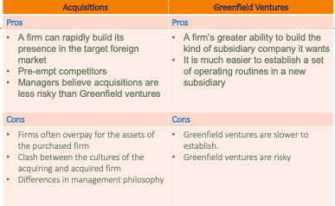

Why do acquisitions fail?
- Acquisitions fail for several reasons.
    - First, the acquiring firms often overpay for the assets of the purchased firm.
      - The price of the target firm can get bid up if more than one firm is interested in its purchase, as is often the case.
    - Second, many acquisitions fail because there is a clash between the cultures of the acquiring and acquired firm.
      - After an acquisition, many acquired companies experience high management turnover, possibly because their employees do not like the acquiring company’s way of doing things

FINAL
- 100 multiple choice
- 77 general knowledge 1,2,3,4,5,6,7,10,11,12
- 12 based of videos
    - look over transcript to save time
    - true and false concepts
- 11 applications questions

