Lesson 2: The Training and Development Process

Learning Objectives
- Define the meaning of human resource management, performance management, training and development.
- List the organizational, employee and societal benefits of training and development (T&D).
- Describe the state of T&D in Canada and Quebec.
- Understand the context of T&D and high performance work systems.
- Explain the meaning of strategic human resources management and strategic T&D.
- Recognize the instructional systems design model of T&D.
- Identify resources for learning about trends and practices within the field of T&D.

Introduction
Performance Management: Process of establishing performance goals and designing interventions and programs to develop employees and improve their performance.
- Performance goals: stem from organizational goals
- Feedback: informal
- Performance evaluation: rate behavior + performance against goals
- Employee development: training and development programs to help reach goals
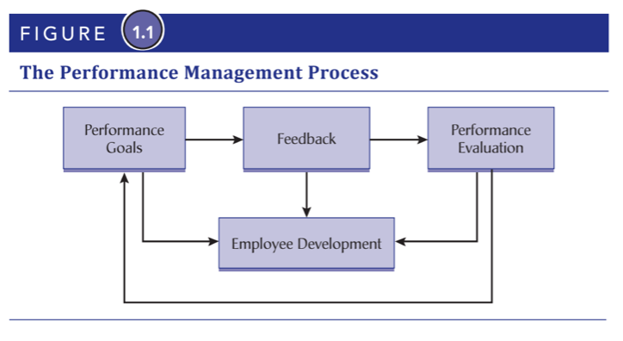
Human resource development (HRD): Systematic and planned activities designed to provide employees with opportunities to learn skills to meet current and future demands. Includes 1) Training and 2) Development.
- Training: Formal and planned efforts to help employees acquire knowledge, skills, and ability to improve performance in current job. Short term, focused on acquiring skills to complete a given task.
  - Ex: Workshop on how to use a machine
- Development: Formal and planned efforts to help employees acquire knowledge, skills, and ability to perform future job responsibilities. Long term, focused on achieving career goals and organizational goals.
  - Ex: Leadership development program

Benefits
- Organization: Helps sustain a competitive advantage
  - Facilitates strategy: tie T&D to strategy to help org. Survive and prosper
  - Increases effectiveness: better work, less supervision, less attrition, better morale
  - Improves recruitment and retention: lowers turnover rates, especially under 30
- Individual: builds the employee too
  - Intrinsic benefits: greater confidence, self-efficacy, morale
  - Extrinsic benefits: salary, marketability, job security, possibility for promotion
- Society: skilled population = better economy and standard of living
  - Educated and skilled population: more autonomous and marketable
  - Economy and standard of living: better skills = better productivity = better economy

T&D in Canada
- Canada doesn’t rank high compared to other countries
- Spending less and less on T&D per employee over the years
- Quebec spends most, Atlantic Canada spends least
- SMEs spend more, larger orgs spend less
- New industries like TMT spend more, traditional industries spend less

Is T&D an Investment or Expense?
- For those who think expense: it’s the first thing to cut, spend is already low, very low priority
- For those who think investment: ROI-based, tied to strategy
  - Training bond: A contract between employee and employer wherein employer agrees to pay for T&D provided that the employee stays with company for a certain amount of time upon completion.
- Quebec instituted 1% payroll law and has spurred adult learning, T&D a lot
  - If payroll is > $1M, employers must spend at least 1% on T&D
  - If not spent, a tax is levied for equivalent amount
  - Emploi QC offers grants to incentivize and offset costs

Context of T&D
T&D is only a segment of the HR system which itself is influenced by environmental (external) and organizational (internal) factors.
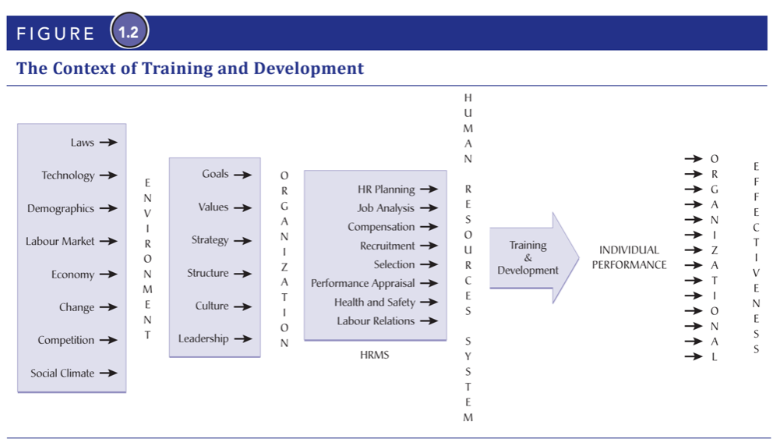
Environmental context (external)
- Global competition: global marketplace = cross-cultural training
- Technology: new tech = new skills needed
- Labour market: lack of skilled labor in market = need for internal development
- Change: change mgmt = intrinsic T&D
Organizational context (internal)
- Strategy: important to tie HRM & T&D to strategy
  - Strategic human resource mgmt (SHRM): Alignment of HR practices with an org’s business strategy
  - Strategic T&D (ST&D): Alignment of org’s training needs and programs with org’s strategy and objectives
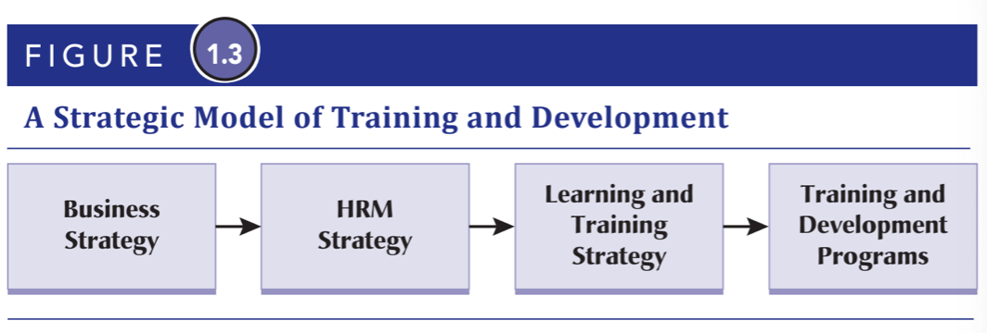
- Structure: flatter orgs require employees to have more managerial skills
- Culture: Shared beliefs, values, and assumptions that exist in an org

The HR System
High-performance work system (HPWS): An interrelated system of HR practices and policies that usually includes rigorous recruitment and selection procedures, performance contingent incentive compensation, performance mgmt, a commitment to employee involvement, and extensive T&D programs.

Instructional Systems Design (ISD) Model of T&D
ISD Model: A rational and scientific model of the T&D process that consists of a needs analysis, training design and delivery, and training evaluation.

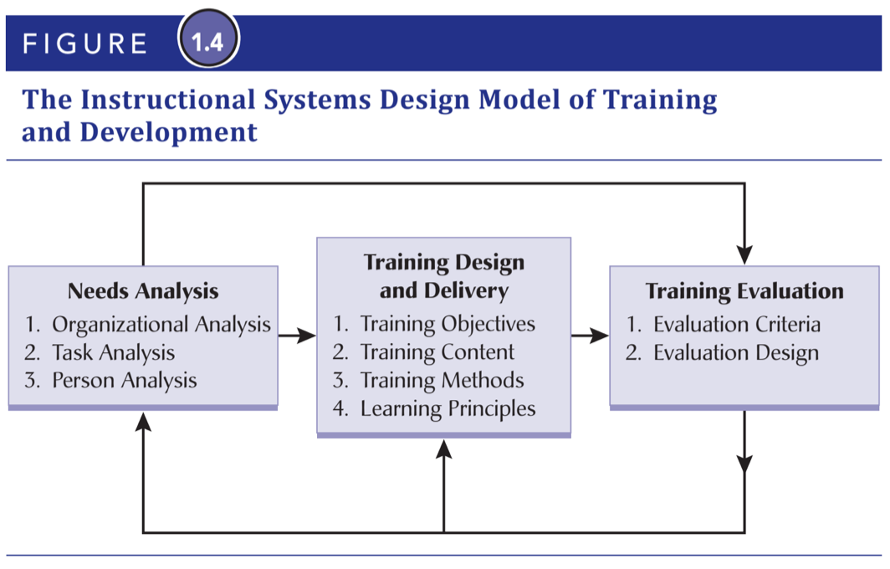

Lesson 3: Organizational Learning

Learning Objectives
- Define organizational learning and describe a learning organization along with its disciplines and principles.
- Discuss the four dimensions critical for creating and sustaining a learning organization.
- Explain what knowledge is and give examples of explicit and tacit knowledge.
- Describe and explain intellectual capital, knowledge management and informal learning.
- Describe the multilevel systems model and explain how learning is related to training and development.

Introduction
Organizational learning: The process of creating, sharing, diffusing, and applying knowledge in organizations. Focuses on systems used to create and distribute new knowledge on an organizational-wide basis.
- Before: train for deficiency of skills or knowledge on short-term, as-needed basis
- Now: develop learning systems to train and learn faster

The Learning Organization
Learning organization: Creates, acquires, organizes, shares, and retains information and knowledge, and uses new info and knowledge to change behavior in order to achieve objectives.

- Peter Senge: The 5th discipline: Art and Practice of Organizational Learning
  - 1) Personal mastery: Individuals must be able to learn
  - 2) Building shared vision: Collectively shared vision of future
  - 3) Mental models: Images and assumptions about ourselves and world
  - 4) Team learning: Dialogue and discussion leads to learning together
  - 5) Systems thinking: Understanding of how individual parts of org influences org as a whole

Principles of Learning Organization
Learning culture: Attitudes and practices within an org associated with organizational learning ppl development. 4 pillars:

- Vision: clear vision of desired future + how learning is part of that vision
- Culture: supports risk taking, experimentation, learning - formal and informal
- Learning dynamics and systems: expected and encouraged to manage own learning and development but also provided with formal and informal learning opportunities. Also coached and mentored by senior managers.
- Knowledge mgmt and infrastructure: system to acquire, code, store, and distribute important info and knowledge so it’s readily available

Knowledge in Organizations
Knowledge: Sum of truths, information, and principles known by employees or orgs
- Explicit knowledge: Can be bought and traded - easily transferable
- Implicit knowledge: Learned from experience and insight - not as transferable

Intellectual Capital
Intellectual capital: an orgs knowledge, experience, relationships, process discoveries, innovations, market presence, and community influence. 4 types:
- Human capital: knowledge, skills, and abilities of employees
  - Intelligence: ability to reason
  - Interpersonal skills: ability to communicate and work with others
- Renewal capital: intellectual property
- Structural capital: formal systems and informal relationships that allow employees to communicate, solve problems, and make decisions
- Relationship capital: an org’s relationship with suppliers, customers, and competitors
  - Customer capital: value of an org’s relationships with customers

Knowledge Management
Knowledge mgmt: creation, collection, storage, distribution, and application of compiled “know-how” and “know-what”. 4 processes:
- Knowledge acquisition
  - Internal sources
  - External sources
- Knowledge interpretation
  - Mental models: assumptions, generalizations, opinions that influence how we learn and how we see the world
- Knowledge dissemination
  - Knowledge sharing: providing task info to help other solve problems
- Knowledge retention
  - Knowledge repositories: place to compile, store, and retrieve knowledge

Communities of Practice
Communities of practice: informal groups of employees who share similar issues and collectively try to find new approaches for solving problems. Defined by 3 characteristics:

- Domain: must share domain of interest
- Community: sharing of info and reciprocal assistance between members
- Practice: must be practitioners in domain

Informal Learning
Workplace learning: Acquiring job-related skills and knowledge informally and formally
- Informal learning: spontaneous, specific, and immediate
- Formal learning: clearly defined goal and process, sponsored by org

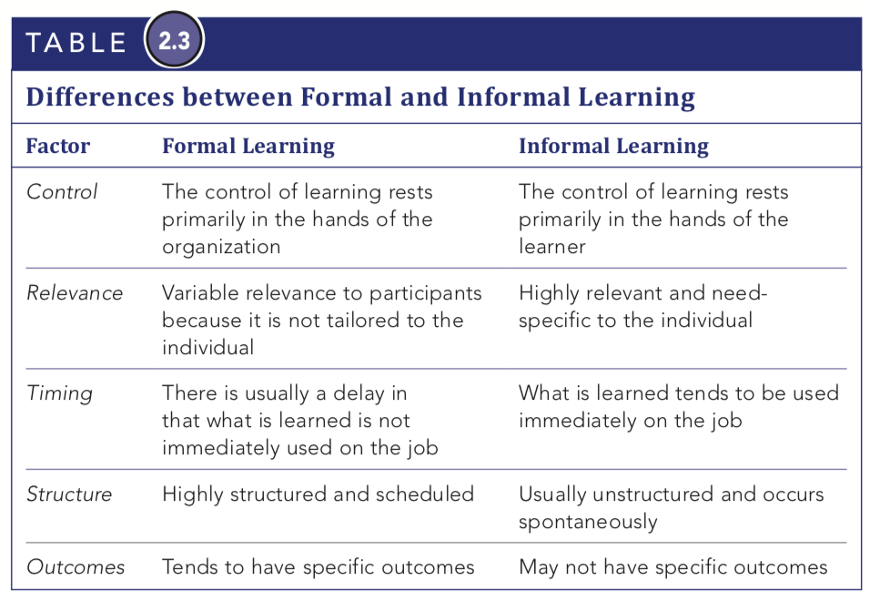

Multilevel systems model of organizational learning
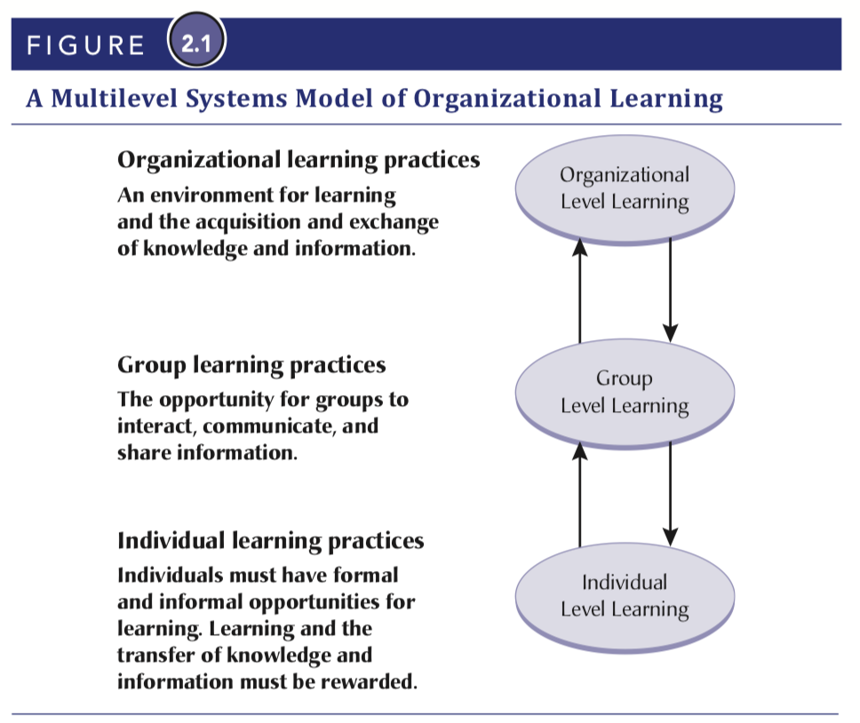
- Organizational level: leadership, culture, vision, strategy, and structure
- Group level: climate, culture, norms, dynamics, and processes
- Individual level: must learn, share knowledge, and be rewarded for learning and applying it to job

Links between levels: Organizations cannot learn if individuals and groups do not learn, and individuals and groups cannot learn if organizations do not provide opportunities for learning and the sharing and exchange of knowledge and information.

