- Neurons: cells in the nervous system that communicate with one another to perform information-processing tasks
- Late 1880s: Santiago Ramón y Cajal used Golgi stain to highlight the appearance of neurons. His technique revealed that the neurons came in different shapes and sizes.
- 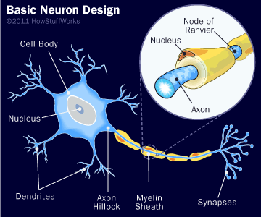
- Cell body: the largest component of the neuron that coordinates the information-processing tasks and keeps the cell alive. Functions: protein synthesis, energy production, metabolism. Cell body is surrounded by a porous cell membrane that allows molecules to flow into and out of the cell.
- Nucleus: a structure that houses chromosomes that contain DNA, the genetic blueprint.
- Dendrites: neuron’s cell membrane that receive information from other neurons and relay it to the cell body.
- Axon: neuron’s cell membrane that transmits information to other neurons, muscles, or glands.
- Myelin sheath: an insulating layer of fatty material composed of glial cells (support cells found in the nervous system)
- Synapse: the junction or region between the axon of one neuron and the dendrites or cell body of another

- Neuron types:
- Sensory neurons: receive information from the external world and convey this information to the brain via the spinal cord. Have specialized endings on their dendrites that receive signals for light, sound, touch, taste and smell.
- Motor neurons: carry signals from the spinal cord to the muscles to produce movement. Often have long axons that can stretch to muscles at our extremities.
- Interneurons: connect sensory neurons, motor neurons and perform a variety of information processing functions within the nervous system. Perform together in small circuits to perform simple tasks, e.g. identifying the location of a sensory signal, and complicated tasks, e.g. recognizing a familiar face.

- Mirror neurons are found in the frontal lobe (near the motor cortex) and in the parietal lobe.
- Mirror neurons activate when animal performs a behavior or another animal observes this animal performing the behavior
- The same set of neurons involved in action recognition are also involved in understanding the intentions of others.
- Activity of brain regions containing mirror neurons relate to recognizing the goal someone has in carrying out an action and the outcome of the action.
- Suggest a possible innate neural basis for empathy.

- Resting potential: the difference in electric charge between inside and outside of a neuron’s cell membrane (about -70millivolts). Excess K⁺ inside, excess Na⁺ outside. K⁺ flow freely across the cell membrane, Na⁺ kept out, creating difference in electric charge between the inside and outside of neuron’s cell membrane.
- Action potential: an electric signal that is conducted along a neuron’s axon to a synapse (about +40millivolts). Shuts down K⁺ channels, opens up Na⁺ channels, thus Na⁺ rushes into the membrane, causing an increase in positive charge inside the axon relative to the outside.
- Refractory period: time following an action potential during which a new action potential cannot be initiated. Extra Na⁺ inside, extra K⁺ inside right after action potential. Pump in the cell membrane moves Na⁺ out and K⁺ inside restoring resting potential, thus enabling another action potential to be initiated.
- Action potential will only happen if the shock reaches a threshold. BUT increase in strength of the shock after threshold does not increase strength of action potential. Action potential is all or none.
- Myelin: increases speed of signal transmission. Breakpoints between myelin: nodes of Ravier. Electric current jumps from node to node: salutatory conduction.

- Presynaptic neurons end with terminal buttons that are filled with vesicles containing neurotransmitters: chemicals that transmit information across the synapse to a receiving neuron’s dendrites
- Dendrites on postsynaptic neurons contain receptors: parts of the cell membrane that receive neurotransmitters and either initiate or prevent a new electric signal.
- The action potential traveling down to terminal buttons stimulates the release of neurotransmitters from vesicles into the synapse.
- The neurotransmitters float across the synapse and bind to receptor sites of the postsynaptic neuron.
- A new electric potential is initiated in that neuron and the process continues down that neuron’s axons to the next synapse…
- Synaptic transmission: communication between neurons that underlie your thoughts, emotions and behavior
- Different neurotransmitters are prevalent in different areas of the brain
- Neurotransmitters and receptor sites act as a lock and key system. Receptors are neurotransmitter specific.
- Neurotransmitters leave the synapse by 1) reuptake (go back to presynaptic neuron), enzyme deactivation (specific neurotransmitters broken down by specific enzymes), 3) autoreceptors (receptors on the presynaptic neuron detecting amount of released neurotransmitters and signaling to stop release).

- Neurotransmitter types:
- Acetylcholine: involved in number of functions including voluntary motor control. Activates muslces to initiate motor behavior, also contributes to dreaming, sleeping, learning, attention and memory
- Dopamine: regulates motro behavior, motivation, pleasure and emotional arousal. High levels link to schizophrenia, low levels link to Parkinson’s
- Glutamate: primary excitatory neurotransmitter involved in information transmission throughout the brain. Too much can overstimulate brain and cause seizures.
- GABA: primary inhibitory neurotransmitter in the brain. Stops firing of neurons. Too little GABA can overstimulate brain.
- Norepinephrine: influences mood and arousal, involved in states of vigilance, heightened awareness of dangers in environment
- Serotonin: regulates sleep and wakefulness, eating, and aggressive behavior.
- Endorphins: act within the pain pathways and emotion centers of the brain. Natural analgesic and causes euphoria, calming and pleasurable effect.

- Agonist: increase production of neurotransmitters, increase release of neurotransmitters, bind to autoreceptors and block their inhibitory effect, block the deactivation or reuptake, bind to postsynaptic receptors and activate the, increase neurotransmitter effect
- Antagonist: block the production of neurotransmitters, deplete neurotransmitters in vesicles, block the release of neurotransmitters, activate autoreceptors so that they inhibit release of neurotransmitters, bind to receptors and block binding
- Recreational drug use can have an effect on brain function. Brain structure of cocaine users show decrease in size of amygdala.

- 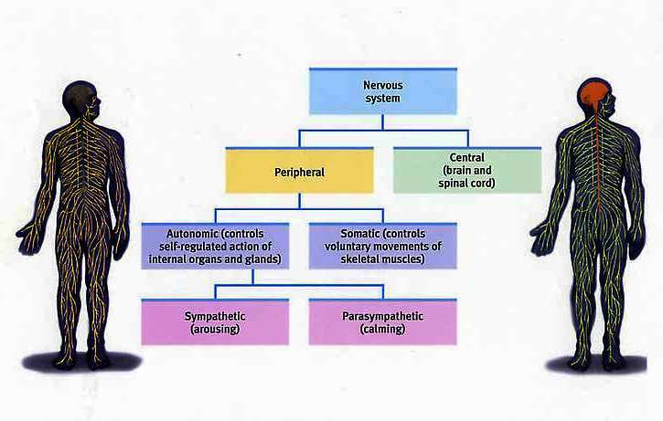
- Central: brain and spinal cord
- Peripheral: connects the CNS to the body’s organs and muscles
- Somatic: voluntary
- Automatic: involuntary
- Sympathetic: arousing (alarming state / escaping)
- Parasympathetic: calming (go back to original state)
Sympathetic | Parasympathetic
- dilate pupils  - relaxes bronchi  - accelerates heartbeat  - inhibits digestive activity  - stimulates glucose release  - stimulates secretion of epinephrine / norepinephrine  - relaxes bladder  - ejaculation in male | - contracts pupils  - constricts bronchi  - decelerates heartbeat  - stimulates digestive activity  - stimulates gallbladder  - contracts bladder  - allows blood flow to sex organs

- Spinal reflexes: simple pathways in the nervous system that rapidly generate mucle contractions
- Pain Withdrawal Reflex: don’t require the brain’s input. Reflexive activity is controlled by the spinal cord.

- Brain:
- Hindbrain: spinal cord is continuous with the hindbrain: area of the brain that coordinates information coming into and out of the spinal cord.
- Controls respiration, alertness and motor skills
- Medulla: extension of the spinal cord into the skull that coordinates heart rate, circulation and respiration
- Reticular formation: small cluster of neurons inside the medulla that regulates sleep, wakefulness, and levels of arousal
- Cerebellum: controls fine motor skills, fine tuning of behavior
- Pons: relays information from the cerebellum to the rest of the brain

- Midbrain: contains two structures: tectum and tegmentum
- Tectum: orients an organism in the environment. Receives stimulus input from the eyes, ears and skin and moves the organism in a coordinated way toward the stimulus.
- Tegmentum: involved in movement and arousal. Helps to orient organism toward sensory stimuli.
- Midbrain: central location of neurotransmitters involved in arousal, mood, and motivation, and the brains structures that rely on them

- Forebrain: highest level of the brain, literally and figuratively. Controls complex cognitive, emotional, sensory, and motor functions
- Cerebral cortex: outermost layer of the brain, visible to the naked eye, and divided into two hemispheres.
- Subcortical structures: areas of the forebrain housed under the cerebral cortex near the very center of the brain.

- Subcortical structures: thalamus, hypothalamus, pituitary gland: located in the center of the brain. Relay signals to and from these structures and also help to regulate them.
- Thalamus: relays and filters information from the senses and transmits the information to the cerebral cortex. (All major senses except smell)
- Hypothalamus: located below thalamus, regulates body temperature, hunger, thirst, and sexual behavior. Messages from your cerebral cortex about sex are sent to the hypothalamus to trigger the release of hormones.
- Pituitary gland: major gland of the body’s hormone producing system, releases hormones that direct the functions of many other glands in the body. Hypothalamus sends hormonal signals to the pituitary gland, which sends hormonal signals to other glands to control stress, digestive activities, reproductive processes.

- The limbic system: where the subcortical structures meet the cerebral cortex a group of forebrain structures including hypothalamus, amygdala and hippocampus: involved in motivation, emotion, learning and memory
- Hippocampus: creating new memories, integrating them into a network of knowledge so that they can be stored indefinitely in other parts of the cerebral cortex.
- Amygdala: located at the tip of each horn of the hippocampus, central role in emotional processes, particularly the formation of emotional memories. Attaches significance to previously neutral events associated with fear, punishment, or reward. Encoding events as fearful. Help you to laugh, weep, or shriek in fright depending on the circumstance.
- Basal Ganglia: set of subcortical structures that direct intentional movements. Located near the thalamus and hypothalamus, receive input from the cerebral cortex and send outputs to the motor centers in the brain stem. Striatum: involved in control of posture and movement.
- Parkinson’s: dopamine-producing neurons in the substantia nigra (in the tegmentum) have become damaged affecting the striatum in the basal ganglia causing visible behavioral symptoms

- Cerebral Cortex: highest level of the brain, responsible for the most complex aspects of perception, emotion, movement and thought
- Smooth surfaces of the cortex: gyri (plural of gyrus)
- Indentations/fissures: sulci (plural of sulcus)
- Wrinkles and fold: holds a lot of brainpower in a relatively small package that fits comfortably inside the human skull
- Three levels: 1) separation of cortex into two hemispheres, the functions of each hemisphere and the role of specific cortical areas

- Contralateral control: each hemisphere (right, left) controls the functions of the opposite side of the body.
- Cerebral hemispheres are connected to each other by commissures: bundles of axons that make possible communication between parallel areas of the cortex in each half.
- The largest commissure: corpus callosum: connects large areas of the cerebral cortex on each side of the brain and supports communication of information across the hemispheres.
- Each hemisphere is divided into four regions/lobes: 1) occipital lobe 2) parietal lobe 3) temporal 4) frontal

- Occipital lobe: processes visual information.
- Sensory receptors thalamus occipital lobe where simple features of the stimulus are extracted (location, orientation of an object’s edges) processed into a complex map of the stimulus onto the occipital cortex comprehension of what’s being seen
- Parietal lobe: processes information about touch.
- Contains somatosensory cortex: strip of brain tissue running from the top of the brain down to the sides
- Each part of the somatosensory cortex maps onto a particular part of the body
- Motor cortex: located directly in front of somatosensory cortex, in the frontal lobe. Initiates voluntary movements and sends messages to the basal ganglia, cerebellum, spinal cord
- Temporal lobe: responsible for hearing and language
- Primary auditory cortex is analogous to the somatosensory cortex and the primary visual areas of the occipital lobe
- It receives sensory information from the ears based on the frequencies of sounds
- Secondary areas process the information into meaningful units (speech, words)
- Also houses visual association areas that interpret the meaning of visual stimuli and help us recognize common objects in the environment
- Frontal lobe: specialized areas for movement, abstract thinking, planning, memory and judgment
- Coordinate thought processes to manipulate information and retrieve memories to plan our behaviors and interact socially
- Association areas: composed of neurons that help provide sense and meaning to information registered in the cortex
- Neurons in the primary visual cortex: highly specialized, some detect features of the environment that are in a horizontal orientation, others detect movement and others process information about human versus nonhuman forms.
- Association areas of the occipital lobe interpret the information extracted by these primary areas, shape, motion, and so on to make sense of what is being perceived
- Neurons in the primary auditory cortex register sound frequencies but it’s the association areas of the temporal lobe that allow you to turn those noises into the meaning.
- Neurons in association areas: less specialized and more flexible than neurons in the primary areas.
- They can be shaped by learning and experience to do their job more effectively: allows brain flexibility, “plasticity”.

- Gene: the unit of hereditary transmission
- Chromosomes: strands of DNA wound around each other in a double-helix configuration
- Heritability: a measure of the variability of behavioral traits among individuals that can be accounted for by genetic factors

