Chapter 2: Personality & Learning

What defines a personality?
- It is the relatively stable set of psychological characteristics that influence the way you interact with your environment. It can also affect how people react in a situation
  - Some people react differently to different situations and perceive situations differently
Person-situation debate
- Dispositional approach
  - Their traits/attributes or characteristic influence their attitudes and behaviors – Individuals are predisposed to behave in certain ways
- Situational approach
  - Characteristics of the organizational setting such as rewards and punishment influence people’s feelings, attitudes and behavior (environment)
- Interactionist approach
  - Organizational behavior (individuals’ attitudes & behavior) is a function of both disposition and situation
    - To predict and understand OB, we need to know individuals’ personality & the work setting
    - Managers need to appreciate the advantages of employee diversity
- Trait activation theory
  - Traits lead to certain behaviors only when the situation makes the need for the trait
- WEAK SITUATIONS
  - Roles are VAGUELY defined, few rules and few reinforcement and punishment contingencies – personality has the STRONGEST effect
- STRONG SITUATIONS
  - The extent to which personality affects people’s attitude and behavior depends on the situation
Five-Factor Model of Personality OCEAN
- Openness
- Conscientiousness
- Extraversion
- Agreeableness
- Neuroticism/ Emotional Stability

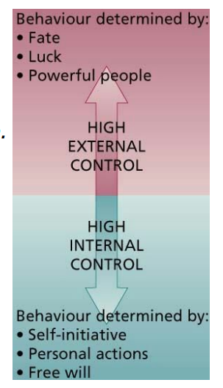
Lotus of Control
Set beliefs about whether one’s behavior is controlled mainly internal or external factors
- Internals believe that opportunity to control their own behavior, resides within themselves. They are more satisfied with their jobs, more committed to their organization, earn more money, and achieve higher organizational positions
- SELF INITIATIVE
- Externals believe that external forces determine their behavior. High “externals” see their behaviors controlled by factors like fate, luck & powerful people.
- SELF-MONITORING:
  - Observe and regulate how they appear and behave in social settings and relationships
- SELF-ESTEEM – degree to which a person has a positive self-evaluation
  - Low esteem reacts badly to negative feedback
    - According to behavioral plasticity theory, people with low self-esteem tend to be more susceptible to external & social influences that those who have high self-esteem
Learning
This occurs when practice or experience leads to relatively permanent change in behavior potential. It is the practice or experience that prompts/produce learning stems/arises from an environment that provides feedback concerning the consequences of behavior.
- Practical Skills: job specific skills, knowledge, technical competence
- Intrapersonal Skills: problem solving, critical thinking, alternative work processes
- Interpersonal Skills: Interactive skills
- Cultural awareness: Social norms of organizations, company goals, business operations, expectations and priorities
How do people learn? Operant leaning and social cognitive theory
- Operant learning theory
  - Operate on the environment to achieve certain consequences – learning by doing, by operating in the situation you learn to do the task better
Reinforcement is the process by which stimuli strengthen behavior. It is a stimulus that follows some behavior and increases or maintains the probability of that behavior
- Positive Reinforcement: increase or maintains the probability of some behavior by the application or addition of a stimulus to the situation in question
- Negative Reinforcement: increases or maintains the probability of some behavior by the removal of a negative stimulation
  - Occurs when a response prevents some event or stimulus from occurring.
    - Removes an impediment to someone’s performance – restricted workspace, noisy environment – The removed or prevented stimulus is a negative reinforcer
Errors involving reinforcement
- Confusing rewards with reinforcers – rewards fail to serve as reinforcers when they are not made contingent/possible on some specific desired behavior **
- Neglecting important sources of reinforcement
  - Performance feedback
  - Social recognition
- Neglecting diversity in preferences for reinforcers
When to use immediate versus delayed reinforcement + when to use continuous versus partial
- Fast acquisition = continuous + immediate
- Behavior tends to be persistent = partial + delayed
Strategies that reduce the probability of learned behavior
- Extinction
  - Gradual dissipation of behavior following the termination of reinforcement
  - Works best when coupled with the reinforcement of some desired substitute behavior
- Punishment
  - Application of an aversive stimulus following an unwanted behavior = to decrease probability of that behavior
  - Problems using punishment
    - It does not demonstrate which behaviors should replace to punish response
    - Punishment indicates only what is not appropriate
    - Temporarily suppresses the unwanted behavior
    - Can provoke a strong emotional reaction
  - Using it effectively
    - Limit the emotions involved in the punishment
    - Provide an acceptable alternative response for the punished response
    - Make sure the punishment is truly aversive
    - Punish immediately or reinstate the circumstances surrounding the problem behavior at a more appropriate time
SOCIAL COGNITIVE THEORY (emphasize the role of cognitive processes in regulating people’s behavior) learn by observing
- Observation
  - Seeking the consequences others experience
  - Thinking what may happen if they act the way others do
  - Imitating the behavior if we expect favorable consequences
- Self-efficacy
  - Beliefs that people have about their ability to successfully perform a specific task
- Self-regulation
  - Involves observing your own behavior, comparing it to a standard model and rewarding oneself (self-reinforcement) when behavior meets the standard

    - Discrepancy reduction: motivates one to modify their behavior to attain the goal (difference between u and ur goal self)
    - Discrepancy production: once one attains their goals, they are likely to set higher and more challenging goals (you want to keep doing better
  - Self-regulation involves the following activities
    - Collect self-observation data
    - Observe models
    - Set gals
    - Rehearse
    - Reinforce oneself

Chapter 3 – Perception, Attribution, and Diversity
Perception
The process of interpreting the messages of our sense to provide order and meaning to the environment.
- People base their actions on their interpretation of reality that their perceptual system provides rather than what’s actually going on
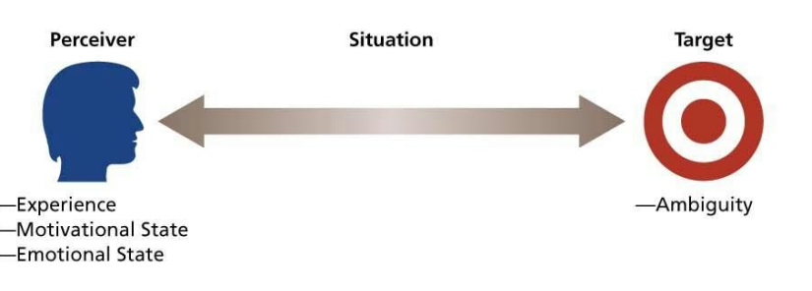
Perceiver: Past experiences lead the perceiver to develop expectations that affect current perceptions. Emotions can influence our perceptions.
- Tendency for the perception system to defend the perceiver against unpleasant emotions
- People often “see what they want to see and hear what they want to hear”
Situation: Add info about the target. The perception of the target can change when the situation changes but the perceiver and target remain the same
Target:
- Ambiguous targets are especially susceptible to interpretation and the addition of meaning
- The perceiver does not or cannot use all the info provided by the target
Bruner’s Model of perceptual process
- Unfamiliar target = perceiver is very open to informational cues (senses) in the target and situation
- The perceiver will actively seek cues to resolve ambiguity
- As the perceiver encounters some familiar cues, a crude categorization of the target made.
- The search for cues becomes less open and more selective
- The perceiver will search for cues that confirm the categorization of the target
- As the categorization becomes stronger, the perceiver will ignore or even distort cues that violate initial perceptions
Three important characteristics
- Perception is selective
- Perceptual constancy: once we see a target one way it hard to change the perception even in another situation
- Perceptual consistency: we want things to be the same. Tendency to select, ignore and distort cues so that they fit the mold we have pictured
Biases
Primacy and Recency Effects
- Primacy: first impressions lasts
- Recency: last impression lasts (recent cues)
- Reliance on central traits
  - Physical appearance
  - Personal characteristics of a target person that are of interest to a perceiver
    - Look for people that are similar to you “type”
  - Hot people book more jobs
  - Overweight is negatively evaluated vs. height is perceived as successful, good job performance, and appealing
Implicit personality theory:
- Personal theories that people have about which characteristics go together
  - i.e. we expect had working people to also be honest
Projection:
- Attributing your own feelings and thoughts to others
Stereotyping:
- The tendency to generalize about people in a social category and ignore variations among them
  - We distinguish some category of people
  - We assume that the individuals in this category have certain traits
  - Generalization
    - Ex. All Italians have a short temper
Attribution Theory
Attribution is the process by which we assign causes or motives to explain people’s behavior. An important goal is to determine whether some behavior is cause by dispositional or situation factors
Dispositional attributions:
- Personal acts a certain way because of internal characteristics
  - Personality, values, intelligence, desires
Situational attributions:
- Person acts a certain way because of a situation or the environment
  - Bad weather, good luck, poor advice
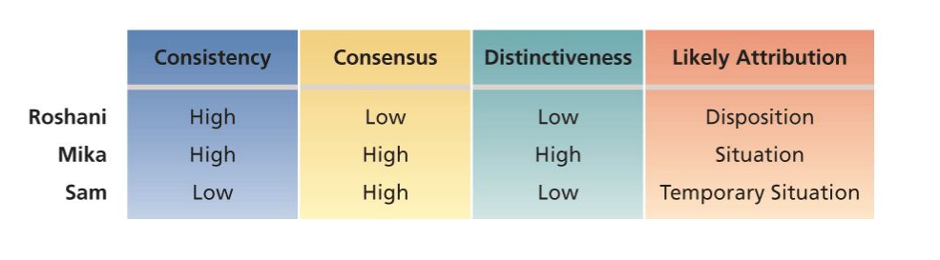
Biases in attribution:
Fundamental attribution error: the tendency to overemphasize dispositional explanations for behavior at the expense of situational explanations
Actor vs Observer effect: the tendency for actors and observers to view the causes of the actor’s behavior differently. Actors are prone to attribute much of their own behavior to situational factors while observers are more likely to invoke dispositional causes **
Self-serving biases: is the tendency to take credit for successful outcomes and deny responsibility for failures
Workforce diversity
Refers to differences among employees or potential recruits in characteristics such as race, gender, age, religion, cultural backgrounds, physical ability, and sexual orientation
Valuing diversity
- A critical motive for valuing diversity is the basic fairness/equity of valuing diversity, in addition, there is increasing awareness that diversity
  - Its proper management that can yield strategic and competitive advantages
  - Organizations with more gender-diverse management teams have superior financial performance

Chapter 4 – Values, Attitudes & Work Behavior
Values
There are broad tendencies to prefer certain states of affairs/events over others. What we consider good or bad?
- Values are motivational – how we believe, we should or not behave
- Values are very general; they do not predict behavior in specific situations very well
- Ex. Power, achievement, autonomy, conformity, tradition, and social welfare
Generational stereotypes and differences in values: **
Cultural differences in values:
- A lack of understanding of cross-cultural differences can cause foreign assignments to terminate early and business negotiations to fail
Work Centrality:
- Work is valued differently across cultures
- There are cross-national differences in the extent to which people perceive work as a central life interest
HOFSTEDE BASIC DIMENSIONS WORK-RELATED VALUES
- Power distance: unequal distribution of power is accepted by society members
  - Small power distances – superiors are accessible and power distances are downplayed
  - Large power distances – superiors are inaccessible and power distances are highlighted
- Uncertainty avoidance
  - Strong – stress rules and regulations, hard work, conformity and security
  - Weak – don’t stress rules, conformity, and security and hard work is not seen as a virtue
- Masculinity/Femininity
  - Masculine cultures – differentiate gender roles, support dominance of men and stress economic performance
    - Ex. Japan
  - Feminine cultures – accept fluid gender roles, stress sexual equality and quality of life
    - US or Canada
- Individualism/ Collectivism
  - Individualism – stress independence, individual initiative, and privacy
  - Collectivism – stress interdependence and loyalty to family
Implications of cultural variations**
Attitude
Fairly stable evaluative tendency to respond consistently to some specific object, situation, person, or category of people
Values + Beliefs (can change) Attitude Behavior
Job Satisfaction:
Collection of attitudes/feelings that workers have about their jobs. It results from an evaluation of the job in general
- Facet satisfaction
  - Tendency to be more or less satisfied with various facets such as the work itself, compensation, recognition, supervision, benefits
- Overall satisfaction
  - Summary indicators of a person’s attitude toward his/her job that cuts across various facets
What determines job satisfaction
- Discrepancy theory – what you think you should receive vs what you receive
- Fairness: issues of fairness affect what people want and how they react to the inevitable discrepancies
  - Distributive fairness – when people receive the outcomes, they think they deserve from their jobs
  - Equity theory – job satisfaction stems from a comparison of your inputs and outputs vs those of others
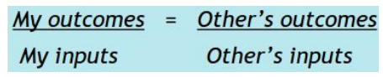

- Procedural fairness – occurs when the process to determine work outcomes is seen as reasonable
- Interactional fairness – when people feel they have received respectful and informative communication about an outcome
- Mood/temper are less intense than emotions
- Emotions are intense, short-term feelings resulting from a particular event such as bad performance evaluation/appraisal
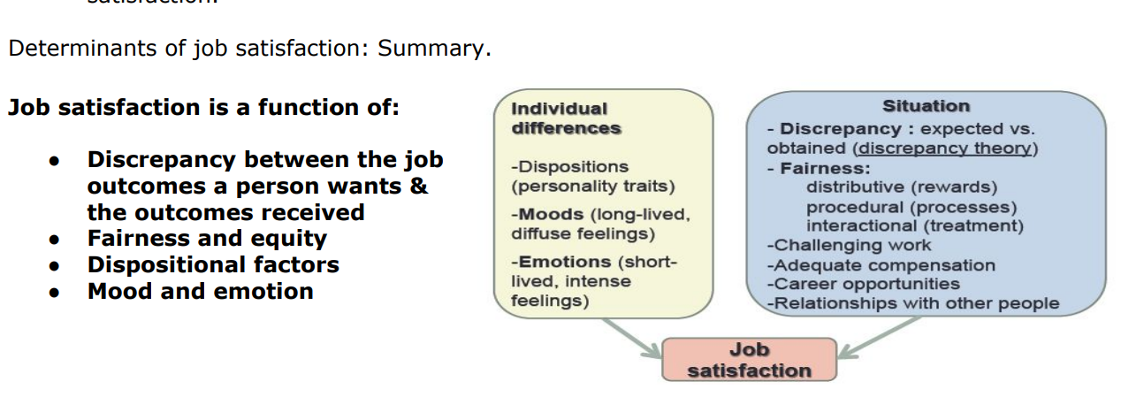
Job satisfaction on absenteeism/turnover/performance
- Higher job satisfaction lower absenteeism and lower turnover and most likely higher performance
Key contributions to Job Satisfaction
- Mentally challenging work
- Adequate compensation
- Career opportunities
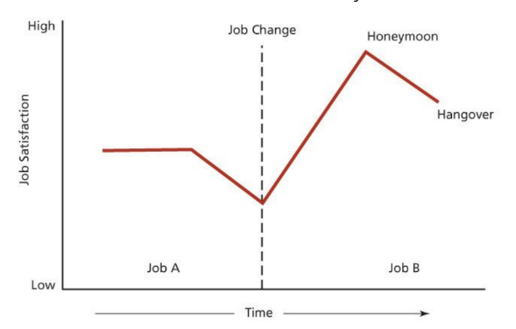
- People (colleagues)
Consequences of Job Satisfaction
- Absence from work
- Turnover
Honeymoon- Hangover effect

Organizational Citizenship Behavior
- Individual’s behavior that is voluntary – not explicitly recognized by the formal reward system, it promotes the effective functioning of the organization
  - Voluntary
  - Spontaneous
  - Contributes to organizational effectivess
  - Unlikely to be explicitly picked up and rewarded by the performance evaluation system
    - EX. Helping co-workers, being friendly, volunteer for extra work
Commitment
Organizational commitment – attitude that reflects the strength of the linkage between an employee and an organization. This linkage has implications for whether someone tends to remain in an org
- Affective commitment – based on a person’s identification and involvement with an organization. People with high affective commitment stay with an org because THEY WANT TO
- Continuance is based on the costs that would be incurred in leaving in org (you have to be there
- Normative commitment – feeling obligation to an organization (you feel you should be there) they stay because they think they should do so

Chapter 5 – Theories of Work Motivation
Motivation
Is the extent to which persistent effort is directed toward a goal?
- The amount of effort the person exhibits in the job
- The persistence
- The extend to which worker’s channel their persistence effort in a direction that benefits the organization = working smart and hard
- All motivated behavior has some goal or objective
  - High productivity, good attendance, or creative decisions
  - Employee goals are sometimes contrary to the objectives of the org
Intrinsic
Stems from the direct relationship between worker and task, usually self-applied
- Achievement, accomplishment, challenge, and competence derived from performing one’s job, and the interest in the job itself
Extrinsic
Stems from the work environment external to the task usually applied by others
- Pay, policies
Self-determination theory
A theory of motivation that considers whether people’s motivation is autonomous or controlled.
Intrinsic and extrinsic motivation are used to explain what motivates people and whether motivation is autonomous or controlled.

Performance
Factors that predict performance
- General cognitive ability
  - A person’s basic information-processing capacities and cognitive resources.
  - An individual’s overall capacity and efficiency for processing information.
  - It includes a number of cognitive abilities (e.g., verbal, numerical, spatial) that are required to perform mental tasks.

- Emotional Intelligence
  - The ability to understand and manage one’s own and others’ feelings and emotions.
  - It involves the ability to:
    - Perceive and express emotion.
    - Assimilate emotion in thought.
    - Understand and reason about emotions.
    - Manage emotions in oneself and others.
  - The four skills represent sequential steps that form a hierarchy:
    - Perceiving emotions accurately in oneself and others.
    - Using emotions to facilitate thinking.
    - Understanding emotions, emotional language, and the signals conveyed by emotions.
    - Managing emotions so as to attain specific goals.

Motivation- Performance Relationship
- It is possible for performance to be low even when a person is highly motivated.
- In addition to personality, general cognitive ability, and EI, poor performance could also be due to:
  - Poor understanding of the task.
  - Luck and chance factors.

McClelland’s Needs Theory
- Need for achievement
  - Desire to perform challenging tasks well
- Need for affiliation
  - Desire to establish and maintain friendly, compatible interpersonal relationships
- Need for power
  - Desire to influence others, making a significant impact or impression.
Managerial Implications of Need Theories
- Need theories have several implications for managerial attempts to motivate employees:
  - Appreciate diversity
  - Appreciate intrinsic motivation

Expectancy Theory
Basic components
- Outcomes
  - The consequences that may follow a certain work behavior
    - 1st level outcomes are of particular interest to the org
      - High vs avg productivity
    - Expectancy theory is concerned with specifying how an employee might attempt to choose one 1st level outcome
      - High vs avg productivity
    - 2nd level outcomes are consequences that follow the attainment of a particular first level outcome
      - They are of particular interest to the individual worker and involve things such as
        - Pay, sense of accomplishment, acceptance by peers, etc.
- Instrumentality
  - The probability that a particular 1st level outcome will be followed by a particular 2nd level outcome
- Valence
  - The expected value of outcomes, the extent to which they are attractive or unattractive
- Expectancy
  - Effort Performance link
    - The probability that the worker can actually achieve a particular 1st level outcome
- Force
  - End product of other components of the theory
    - The relative degree of effort that will be directed toward various 1st level outcomes
Managerial Implications of Expectancy Theory
- The motivational implications of expectancy theory involve “juggling the numbers” that individuals attach to expectancies, instrumentalities, and valences.
  - Three implications:
    - Boost expectancies
    - Clarify reward contingencies
    - Appreciate diverse needs

Equity Theory
Explains people’s job satisfaction through a comparison process of inputs and outcomes
When workers perceive equity, they experience job satisfaction and vice versa
Gender and Equity
- Both men and women tend to choose same-sex comparison persons
Managerial Implications of Equity Theory
- Perceived underpayment will have a variety of negative motivational consequences for the organization (e.g., low productivity, low quality, theft).
- Understand that feelings about equity stem from a perceptual social comparison process.
- Understanding the role of comparison people is especially crucial.

Goal
Objective or aim of an action, personal performance goals are vague or nonexistent for many organizational members
Goal Setting Theory
Specific
- Goals that specify an exact level of achievement for people to accomplish in a particular time frame
Challenging
- Goal challenge is more of a personal matter than goal specificity
  - When it is pegged to the competence of individual workers and increased as the particular task is mastered
Commitment
- Individuals must be committed to specific, challenging goals if the goals are to have effective motivational properties
Factors that might affect commitment to challenging, specific goals
- Goal feedback
  - Most effective goals are when they are accompanied by ongoing feedback that enables the person to compare current performance with the goal
- Participation
  - Improve goal commitment and facilitate performance in some situations
    - When a climate of distrust exists between management and employees
    - When participation provides info that assists in the establishment of fair, realistic goals
- Rewards
  - Monetary incentives are not needed to increase goal accomplishment
- Management support
  - Supervisors must demonstrate a desire to assist employees attain their goals and behave supportively if failure occurs
Cross-cultural limitations of theories of motivation
- Equity theory will be constrained by what is considered “fair” in a particular culture in terms of how to allocate rewards
- Expectancy theory is very effective when applied cross-culturally
- Setting specific and challenging goals should be motivational when applied cross-culturally

Chapter 6 – Motivation in Practice
Money as a motivator
- Money can be a motivator to the extent that is satisfies a variety of needs, is highly valent, and it is clearly tied to performance (extrinsic motivator)
Job design as a motivator
- The use of job design as a motivator represents an attempt to capitalize on intrinsic motivation. The goal of a job design is to identify what characteristics of a certain tasks will promote motivation within its employees (Intrinsic motivation)
  - Job score is the breadth and depth of a job
    - Breadth is the # of diff. activities performed on a job
    - Depth is the degree of discretion or control a worker has over how tasks are performed
Scientific Management
- Extreme division of labor
- Careful standardization and regulation of work activities and rest pauses
  - Are not intrinsically motivating
  - Motivating strategies consist of close supervision and piece-rate pay
  - Simplification helped workers achieve a reasonable standard of living
Job Characteristics Model
*USE MODE BEFORE CONDUCTING JOB ENRICHMENT
- Skill variety
  - Degree a job provides the opportunity to do a variety of different activities using various skills and talents
- Task identity
  - Job involves doing a complete piece of work (beginning end)
- Task significance
  - Job has a substantial impact on others
- Autonomy
  - Job freedom degree to schedule one’s own work activities and decide work procedures
- Feedback
  - Information about the effectiveness of one’s work performance
Job Enrichment
- The design of jobs to enhance intrinsic motivation, quality of working life, and job involvement
- Involves increasing the motivating potential of jobs via the arrangement of their core job characteristics (how can work suck less?)
Job Involvement
- Cognitive state of identification with one’s job and the importance of work to one’s total self-image
- All the core job characteristics are positively related to job involvement

Job Enrichment Procedures
- Combining tasks
- Establishing external client relationships
- Establishing internal client relationships
- Reducing supervision or reliance of others
- Forming work teams
- Making feedback more direct
Potential Problems with Job Enrichment
- Poor diagnosis
- Lack of desire or skill
- Demand for rewards
- Union resistance
- Supervisory resistance
Management by Objectives
Elaborate, systematic, ongoing program designed to facilitate goal establishment, goal accomplishment, and employee development
MBO Process
- Objectives for the org as a whole are developed by top management and diffused down through the org
  - These are translated into specific behavioral objectives for individual members
  - Nature of the interaction between managers and individual workers in an MBO program is important
Alternative Working Schedules
- Some of the most common alternative working schedules:
  - Flex-time
    - Arrival and quitting times are flexible
    - Meeting the needs of a diverse work force
  - Compressed workweek
    - An alternative work schedule in which employees work fewer than the normal five days a week but still put in a normal number of hours per week.
  - Job and work sharing
    - Job sharing is an alternative work schedule in which two part-time employees divide the work of a full-time job.
    - Work sharing involves reducing the number of hours employees work to avoid layoffs when there is a reduction in normal business activity.

  - Telecommuting
    - A system by which employees are able to work at home but stay in touch with their offices through the use of communications technology, such as a computer network, voice mail, and electronic messages.
    - Distant staffing enables employees to work for a company without ever having to come into the office or even be in the same country.

Chapter 7 – Groups & Teamwork
Groups
2 or more people interacting interdependently to achieve a common goal.
Formal Groups
- Established by organizations to facilitate the achievement of organization goals
  - Project: (temporary) groups that meet to achieve particular goals or solve particular
  - Committees: (permanent) group that handle recurrent assignments outside the usual work group structures
Informal Groups
- Emerge naturally in response to the common interests of organizational members. They are seldom authorized by the organization, they can either help or hurt an organization, depending on their norms for behavior.

Stages of Group Development
Forming
- Group members “test the waters”. The situation is often ambiguous, and members
Storming
- Confrontation and criticism occur as members determine whether they will go along with the way the group is developing – roles, responsibilities
Norming
- Members resolve the issues that provoked the storming – consensus
  - Compromise
  - Norms are agreed on + cohesiveness
  - Information and opinions flow freely
Performing
- The group devotes its energy toward accomplishment – achievement, creativity and mutual assistance are prominent themes at this stage
Adjourning
- Rites and rituals that affirm the group’s previous successful development are common – members often exhibit emotion support for each other

Punctuated Equilibrium
Phase 1
- Starts with the 1st meeting & continues until the midpoint
  - Sets agenda and tone for the phase until the midpoint.
  - The group gathers info & holds meeting but makes little visible progress toward the goal.
Midpoint transition
- Occurs at almost exactly the halfway point in the time before the deadline
  - The transition marks a change in the group’s approach.
  - This transition crystalizes the group’s activities for Phase 2

Project deadline (Phase 2)
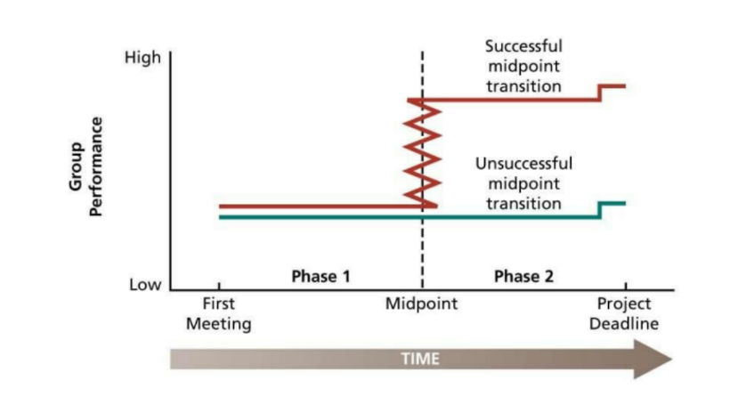
- Decisions & approaches from midpoint are applied. It concludes with a final meeting that reveals an eruption of activity and concern for how outsiders will evaluate the product

Group Structure
Characteristics of the stable social organization of a group – group norms, roles, status & cohesiveness

Group Size:
- Consequences caused by group size depends of the type of task (additive, disjunctive, conjunctive)
Group size and satisfaction
- Large groups = less satisfaction with group membership
- Size increases = chance to develop friendships decreases
- Larger groups might cause conflict and disagreements
- Increase size = decrease verbal participation from each group member
Group size and performance
- Additive tasks = all group members are necessary in the sum of the final project
- Disjunctive = group performance relies on the strongest group member
- Conjunctive = group performance relies on the weakest group member
PROCESS LOSSES = performance difficulties that stem from the problems of motivating and coordinating larger groups
ACTUAL PERFORMANCE = POTENTIAL PERFORMANCE – PROCESS LOSSES
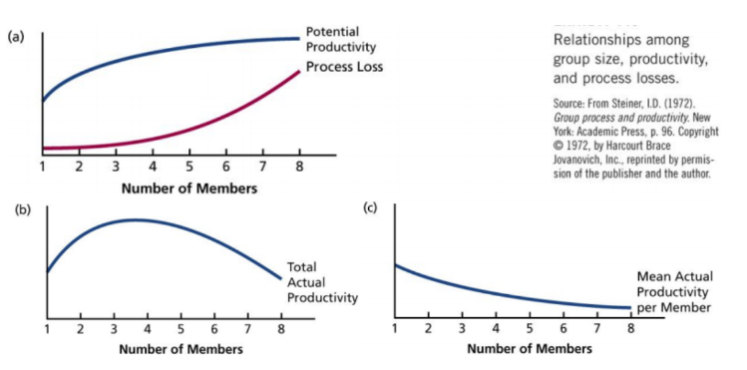
Diversity:
- More diverse groups will have more problems of communication and cohesiveness + take longer to develop as a team (unity)
Norms and roles
Social Norms
- Collective expectations that members of social units have regarding the behavior or each other
  - Good behavior vs. bad behavior = all subjective to one’s norms
Roles
- Position in a group that have a set of expected behavior attached to them.
  - Most consistent consequences of role conflict are job dissatisfaction, stress reactions, lowered commitment, turnover intentions
- Assigned roles: formally prescribed by an organization to divide labour and responsibilities to get the task done
- Emergent roles: roles develop natural to meet the social-emotional needs of group members or to assists in formal job accomplishment
Status
- Consequences of Status Differences
  - Status affects the ways in which people communicate with each other. Most people like to communicate with people of equal or higher status rather than those of lower
Cohesiveness
Group cohesiveness
- If group members especially want to remain in that specific group setting
  - Member Diversity – if groups are in agreement that their goal is to accomplish a task, its success will outweigh the dissimilarities of a group
  - Success – people want to be part of a winning team
  - Threat a competition- these factors force the members to work together when the group goals are in ganger.
  - Size – Larger groups have more difficulty becoming one and have more problems of communicating and coordinating efforts
  - Toughness of initiation – groups that are more exclusive are more attractive
Consequences of cohesiveness
- More participation will lover turnover and absenteeism
- More conformity – members will be motivated to engage in activities that will keep the group cohesive and respect group norms
- More success
  - Cohesiveness contributes to the group’s success
PARTICIPATION AND COMMUNICATION + CONFORMITY = AGREEMENT = GOALS
Social Loafing
The tendency to withhold physical or intellectual effort when performing a group task as there is lower sense of motivation (one of the process losses in large groups)
- Free rider effect: people lower their effort to get a free ride at the expenses of other group members
- Sucker effect: people lower their effort because of the feeling that others are free riding

Virtual Teams
Work groups that use technology to communicate and collaborate across time, space and organizational boundaries
- Advantages: accessible all the time, reduced travel time and cost – larger talent pool
- Challenges: trust is difficult to develop between virtual team members due to lack of physical contact, miscommunication, isolation, high costs, management issues
  - Recruitment
  - Training
  - Personalization
  - Goals and ground rules

Chapter 8 – Social Influence, Socialisation & Culture
Organizational culture
Consists of shared beliefs, values, & assumptions that organization
Characteristics of organization culture:
- It represents a true “way of life” for an organizational culture
- It tends to be stable over time and once established it can persist despite turnover among organizational members, providing social continuity
- Culture can have a strong impact on both organizational performance and member satisfaction
Subcultures
- Subcultures are smaller cultures developed within a larger organizational culture that are based on differences in training, occupation, or departmental goals
Assets of strong cultures
Coordination
- Overarching values & assumptions that facilitate the coordination of different parts of the organization. Different parts of the organization can learn from each other and can coordinate their efforts
Conflict resolution
- Sharing core values is a powerful mechanism that can facilitate conflict resolution

Financial success
- Strong cultures contribute to financial success when the culture supports the mission, strategy and goals of the organization
Liabilities of strong cultures
- Resistance to change can damage a firm’s ability to innovate
- Culture clash/conflict: can mix badly when a merger or acquisition pushes two of them together under the same corporate banner
- Pathology: cultures based on beliefs, values & assumptions that support friction, secrecy, paranoia
How cultures are built & maintained? 2 key factors that contribute to the foundation & continuation of organizational cultures:
Founder’s role:
- Strong cultures, reflect the values of an organization’s founders
- Top management strongly shapes an organization’s culture
- Sometimes the culture begun by the founder can cause conflict when top management wishes to see an organization change direction
Socialization
- Socialization is one of the primary means by which individuals can learn the culture’s beliefs, values, and assumptions
- IMPORTANT PROCESS FOR ORG WITH STRONG CULTURES
- Selecting employees
- Debasement (undoing) and hazing
- Training “in the Trenches”
- Reward and Promotion
- Expose core culture
- Reinforcing folklore
- Role models
How to diagnose an organizational culture
Examine the symbols, rituals and stories that characterize the organization’s way of life
Symbols
- Corporate motto or mascot = common meaning and reinforce cultural values
Rituals
- Parties, recognition award events and employee nights = define and build culture

Stories
- The folklore of organizations
  - Stories about past org events – is a common aspect of cultures
    - Stories = communicate “how things work”

Chapter 9 – Leadership
Leadership
The influence that individuals exert on the goal achievement of others is an organizational context. Leadership is about motivating people and gaining their commitment
Effective leadership exerts influence in a way that achieves organizational goals by enhancing the productivity, innovation, satisfaction, and commitment of the workforce.
Strategic leadership: ability to anticipate, envision, maintain flexibility think strategically, & work with others to initiate changes that will create a viable future for the organization
Formal leadership: manager, executive superior & department head occupy formal or assigned leadership roles – hold a position of authority
Informal leadership: They do not have a formal authority within the organization. Leaders that emerge to occupy informal leadership roles.
Trait theory of leadership
- Traits associated with leadership
  - Intelligence
    - Leadership effectiveness
  - Energy and drive
  - Self-confidence
  - Dominance
  - Motivation to lead
  - Emotional stability
  - Honest and integrity
  - Need for achievement
  - Sociability
- “Big Five”
  - Extraversion and conscientiousness
Limitations
- It is difficult to determine whether traits make the leader or whether the opportunity leadership produces the traits
- Does not tells us what they do to be leaders
- It does not take into account the situation in which leadership occurs
- It can lead to bias discrimination when it comes to evaluating a leader’s effectiveness and decisions about promoting people to leadership positions
Leadership Behaviors
Consideration: the extent to which leader is approachable and shows personal concern and respect for employees. The considerate leader is seen as friendly and egalitarian, expresses appreciation and support, and is protective of welfare group
Initiating structure: the degree to which a leader concentrated on group goal attainment – less focused on people
Consequences of consideration and structure
- Consideration and initiating structure both contribute positively to employees’ motivation, job satisfaction, and leader effectiveness
- Consideration = follower satisfaction, motivation and leader effectiveness
- Initiating = leader job performance and group performance
- Not all circumstances will work with these two structures
- Initiating structure increases satisfaction and performance when employees are under a high degree of pressure
- Consideration should promote employee’s satisfaction while structure would promote dissatisfaction when goals and methods of performing a job is very clear
  - If things are clear people want someone who motivates them and calms them
  - And will not appreciate someone up their ass
Situational theory of leadership
- The characteristics of the employees
- The nature of the task they are performing
- Characteristics of the organization
A leader who is effective in one situation might not be as effective in another situation
House’s path-goal theory (the manager defines the path to various goals)
- The most important activities of leaders are those that clarify the paths to various goals of interest to employees
- The opportunity to achieve such goals should promote job satisfaction, leader acceptance, & high effort
- The effective leader forms a connection btwn employee goals and organizational goals
- Employees must trust in the leader’s ability to give immediately satisfying or as leading to future satisfaction
- To promote employee effort, leaders must make rewards dependent on performance and ensure that employees know how they can achieve these awards

Specific kinds of leader behavior
- Directive behavior – directive leaders schedule work, maintain performance standards, and let employees know what is expected of them. It is identical to initiating structure.
- Achievement-oriented behavior – leaders encourage employees to exert high effort and strive for a high level of goal accomplishment
- Supportive behavior – friendly, approachable, and concerned with pleasant interpersonal relationships. Identical to consideration.
- Participative behavior – consult with employees on work issues and consider their opinions
Situational factors
The impact of leader behavior on employee satisfaction, effort, and acceptance of the leader depends on nature of the employees and the work environment
- Employee characteristics
  - High need achievers should work well under achievement-oriented leadership
  - Employees who prefer to be told what to do respond best to directive leadership
  - When employees have low task abilities, they will appreciate directive leadership
**EFFECTIVE LEADERS should take ADVANTAGE of the motivating and satisfying aspects of jobs while OFFSETTING OR COMPENSATING for those job aspects that demotivate or dissatisfy**
Participating leadership
- Leaders can vary in the extent to which they involve employees in decision making
- Minimally, participation involves obtaining employee opinions before making a decision
- Maximally, it allows employees to make their own decisions within agreed-on limits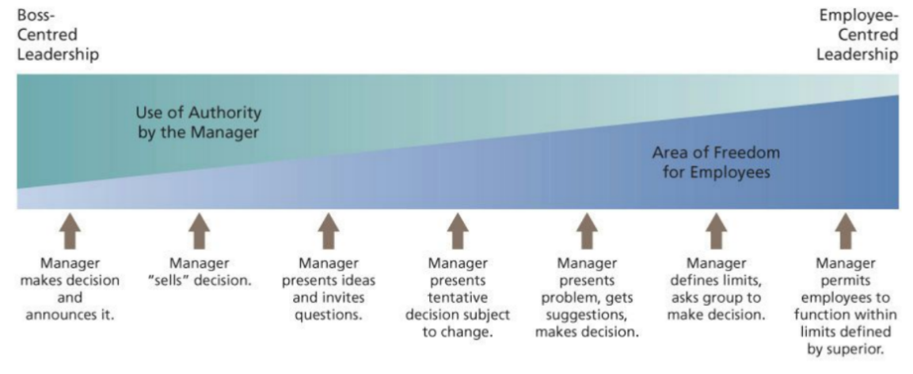
- Participation can involve individual or the entire group of employees that reports to the leader
- The choice of an individual or group participation strategy should be tailored to specific situation

Potential advantages of participative leadership
- Motivation
- Quality
- Acceptance

Potential problems of participative leadership
- Loss of power
- Lack of receptivity or knowledge

Transactional leadership
Based on straightforward exchange relationship between leader and followers
- Contingent reward behavior gives rewards based on employee performance
- Management by exception:

Chapter 11 – Decision Making
Decision Making
The process of developing a commitment to some course of action – aka problem solving
- Making a choice among several actions’ alternatives
- Making a commitment of resources (time, money or personnel
A problem exists when a gap is perceived between some existing state and some desired state
Well-structured problems: The existing state and desired states are clear, and how to get one state to the other is fairly obvious (solutions arouse little controversy)
Ill-structured problems: The existing and desired states are unclear, and the method of getting the desired state is unknown (often risky decisions)
- They are unique and unusual problems that have not been encountered before
- They tend to be complex and involve a high degree of uncertainty

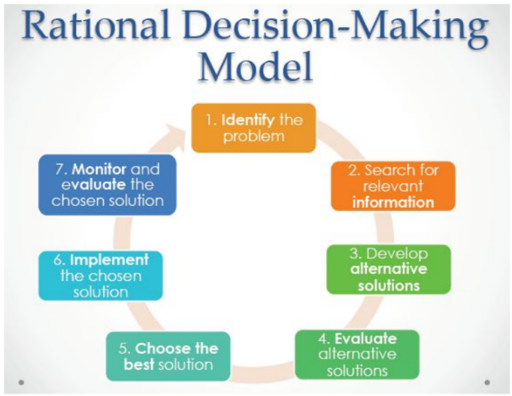
Perfect vs Bounded rationality

Perfect rationality
- Completely informed, logical, and oriented toward economic gain
  - Economic person
    - Gather info without cost and is completely informed.
    - Perfectly logical and has only one criterion for decision making: economic gain
Bounded rationality
- The rational characteristics of Economic Person do not exist in real decision makers. Administrators use bounded rationality rather than perfect rationality. While they try to act rationally, they are limited in their capacity to
  - Acquire and process info
  - Time constraints
  - Political considerations
Framing
Refers to aspects of the presentation of information about a problem that are assumed by decision makers – how problems and decisions are framed can have a powerful impact on resulting decisions
- Cognitive biases: tendencies to acquire and process info in a particular way that is prone to error
- They involve assumptions and shortcuts that can improve the efficiency of the problem solving but can frequently have serious errors in judgement

Problem Identification and Framing
- Bounded rationality can lead the following difficulties in problem identification
  - Perceptual defense
  - Problem defined in terms of functional specialty
  - Problem defined in terms of solution
  - Problem diagnosed in terms of symptoms
  - When a problem is identified it is framed in some way
  - A $10,000 expenditure can be framed as a cost or an investment
  - Different decision frames can lead to very different decisions
- Rational decision makers should be very self-conscious about HOW they framed problems
Information Search
- The perfectly rational decision maker has free and instantaneous access to all info necessary to clarify the problem and develop alternative solutions
- Bounded rationality can suggest info search that is slow and costly
- Decision makers can have too little or too much info
Too little info
- When they use info that is readily available and the tendency to be overconfident which is exacerbated by confirmation bias
- Confirmation bias refers to the tendency to seek out info that conforms to one’s own definition of or solution to a problem
Too much info
- Informed overload is the reception of more info than needed to make effective decisions
- People have a cognitive bias to value advice for which they have paid over free advice = quality
Alternative Development, Evaluation, and Choice
- The perfectly rational decision maker exhibits maximization – the choice of the decision alternative with the greatest expected value
- For the decision maker working under bounded rationality, all alternative solutions and probabilities of success are not all know (we don’t know which solutions the best is, or if we found it yet)
- The anchoring effect illustrates that decision makers do not adjust their estimates enough from some initial estimate that serves as an anchor
  - It is possible to reduce some of these cognitive biases by making people more accountable for their decisions
  - The perfectly rational decision maker can evaluate alternative solutions against a single criterion – economic gain
  - Decision maker (bounded reality) might have to factor in other criteria such as the political acceptability of the solution to other organizational members

Satisficing
- The decision maker working under bounded rationality frequently “satisfices” rather than maximizes
  - This means that the decision maker establishes an adequate level of acceptability for a solution to a problem and then screens solutions until he or she finds one that exceeds this level
  - When this occurs, evolution of alternative ceases, and the solution is chosen for implementation
  - AKA there is a benchmark or characteristics that the solution must be, they search until it meets or exceeds the standards, and stops after this – although this might not be the best decision it is good enough
Risky business
- When people view a problem as a choice between losses, they tend to make risky decisions
- When people frame the alternatives as a choice between gains, they tend to make conservative decisions
- This is an example of framing
Solution implementation
- Decision makers are often dependent on others to implement their decision, and it might be difficult to anticipate their ability or motivation to do so – decision makers and the implementations are not the same person (people need to take the solutions of the decision makers and implement it into their work)
- Cross-functional teams can help prevent these kinds of implementation problems
Solution evaluation
The perfectly rational decision maker should be able to evaluate the effectiveness of a decision with calm, objective detachment – The bounded decision maker might encounter problems at this stage of the process
- Justification
  - People are overconfident about the adequacy of their decisions
  - Substantial dissonance can be aroused when a decision turns to be faulty
  - To prevent such dissonance, decision makers avoid careful tests of the adequacy of the decision
  - The decision maker may devote his or her energy to trying to justify a faulty decision
- Hindsight
  - Tendency to review the decision-making process that was used to find what was done right or wrong
  - Tendency to take personal responsibility for successful decisions outcomes while denying responsibility for unsuccessful outcomes

Escalation of commitment
The tendency to invest additional resources in an apparently failing course of actions. Groups are more prone than individuals to escalate commitment
Reason for escalation of commitment
- Dissonance reduction
- Social norms for consistent behavior
- Motivation to not appear wasteful
- The way the problem is framed
- Personality, moods, and emotions
Preventing escalation of commitment
- Encourage continuous experimentation with reframing the problem. Shift the frame to saving rather than spending
- Set specific goals for the project in advance that must be met if more resources are to be invested
- Place more emphasis in evaluating managers on HOW they made the decisions and less on decision outcomes
- Separate initial and subsequent decision making
How do emotions and moods affect decision making?
- Strong emotions frequently figure in the decision-making process
  - Emotion can help decision making but strong emotions can be a hindrance
- Moods can affect what and how people think when making a decision
- Mood has the greatest impact on uncertain, ambiguous decisions of the type that are especially crucial for the organizations
- Research shows
  - People in a positive (negative) mood tend to remember positive (or negative) info
  - People in a positive (negative) mood tend to evaluate people, objects and event more positively (negatively)
  - People in a good mood tend to overestimate the likelihood that good events occur and underestimate the occurrence of bad events and people in a bad mood do the opposite
  - People in a good mood adopt simplified, shortcut decision-making strategies, more likely violating the rational model
Group Decision Making
Many organizational decisions are made by groups, especially when problems are ill structured
Why use groups for decision-making?
- Decision quality
  - Groups Are more vigilant
  - Can generate more ideas that are better
  - HIGHER WUALITY DECISION MAKING
- Decision acceptance and commitment
  - More chances of getting a decision implemented
- Diffusion of responsibility
  - Share the burden if there are negative consequences of a poor decision
  - No one is singled out
Groups Decision = Higher quality
- The group members differ in relevant skills and abilities
- Some division of labor can occur
- Memory for facts in an important issue
- Individual judgements can be combined by weighting them to reflect the expertise of the various members
Disadvantages of Group Decision Making
- Time
- Conflict
- Domination
- Groupthink
  - Illusion of invulnerability
    - Members are overconfident and willing to assume great risks
  - Rationalization
  - Illusion of morality
  - Stereotypes of outsiders
  - Pressure for conformity
  - Self-censorship
  - Illusion of unanimity
  - Mind guard
Strategies to Prevent Groupthink
- Leaders must avoid exerting undue pressure for a particular decision outcome and concentrate on a good decision process
- Leaders should establish norms to encourage and reward responsible dissent
- Outside experts should be brought in to challenge the group’s views
How Do Groups Handle Risk?
- Risky shift – the tendency for groups to make riskier decisions than the average risk initially advocated by their individual members
- Conservative shift – the tendency for groups to make less risky decisions than the average risk initially advocated by their individual members
- A key factor of risk is the initial positions of the group members prior to discussing the problem as a group
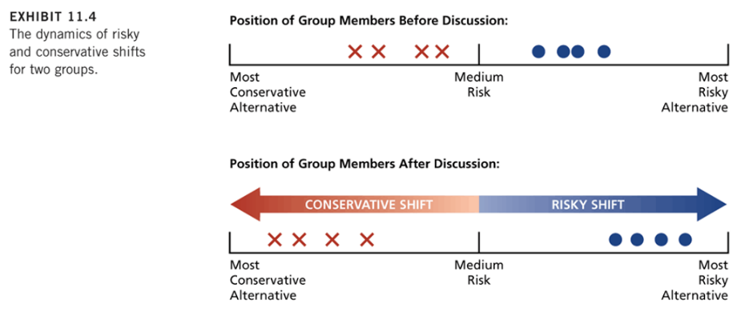

Chapter 12 – Ethics
Ethics
Systematic thinking about the moral consequences of decisions. Moral consequences are framed in terms of the potential for harm to any stakeholders in the decision
** stakeholders are people inside or outside of the organization who have the potential to be affected by org decisions
Effects in organizations
- Top managers tend to see their org as being very ethical than do those lower in the hierarchy
Nature of ethical dilemmas
- Common themes
  - Honest communication
  - Fair treatment
  - Special consideration
  - Responsibility to org
  - Corporate social responsibility
  - Respect for the law
Causes of unethical behavior
Gain
- The role of temptation
- If you feel like a positive outcome will come out of an unethical action, with no punishment expected
- Compensation systems

Role conflict
- Conflict when bureaucratic role as an org employee is at odd with one’s role as member of a profession
Strong organizational ID
- Lead to people making poor unethical decisions for “the organization” (help)
Competition
- When competition is high, and resources are scarce
Personality
- Cynical and those with external locus of control are less tuned in to ethical matter
- High need for personal power
- Strong economic values
- Not morally engaged
Organizational and industry culture
- How your peers and supervisors act
- Corporate culture to reward or punish unethical actions
**Whistle-blowing: when a current/former org member discloses illegitimate practice to someone or org that may be able to take action to correct these practices
Sexual Harassment
- Many org pretend to not know about the complaints of sexual harassment or are slow to take action – deaf ear syndrome
Why do organizations fail to respond?
- Inadequate org policies and procedures for managing harassment complaints
- Defensive managerial reactions

Responding to sexual harassment
- Examine the characteristics of deaf ear org
- Encourage management support and education
- Stay vigilant
- Take immediate action
- Create a perfect policy
- Establish clear reporting procedures

Organizations that are responsive to complaints of sexual harassment have
- Top management commitment
- Provide comprehensive education programs
- Continuously monitor the work environment
- Respond to complaints in a thorough and timely manner
- Have clear policies and reporting procedures

Chapter 13—Conflict & Stress
Interpersonal conflict
Process that occurs when one person, group, or organizational subunit frustrates the goal attainment of another
Causes of interpersonal conflict
- Group identification & intergroup bias:
  - Tendency of people to like people in their “own group” and not like the “out-groups”
- Interdependence
  - This can be an issue when people are interdependent of each other
- Differences in Power, Status and Culture
- Ambiguity
  - Ambiguous goals, jurisdictions, or performance criteria can lead to conflict
- Scarce resources
  - Differences in power are magnified when common resources are short in supply
Types of conflict
- Relationship related
- Task related
- Process related
Managing Conflict
- Competing
- Accommodating
- Compromise
- Avoiding
- Collaborating
Positive effects of stimulating conflict:
Conflict Change Adaptation Survival

Stressors
Environmental events or conditions that have a potential to induce stress
- Stress
  - Psychological reaction to the demands inherent in a stressor that has the potential to make a person feel tense or anxious because the person does not feel capable to manage these demands
- Stress reactions
  - Behavioral, psychological, and physiological consequences of stress
Personality and stress
Personality can affect both the extent to which potential stressors are perceived as stressful and the types of reactions that will occur
- Three key personality traits are
  - Lotus of control
  - Type A behavior pattern
  - Negative affectivity
Sources of stress encountered by various organizational role occupants
Executive and Managerial Stressors
They make ley org decisions and direct work for others which leads them to experience special forms of stress
- Role overload
  - Perform too many tasks in a short period of time
Operative-level stressors
- Operatives are individuals who occupy nonprofessional & nonmanagerial positions. The occupants of operative positions are sometimes exposed to a special onset of stressors
  - Job demands-job control model is a model that asserts that jobs promote high stress when they make high demands while offering little control over work decisions
Boundary Role Stressors, Burnout, and Emotional Labor
- Boundary roles are positions in which org members are required to interact with members of other organizations or with the public. Occupants of boundary role positions are especially likely to experience stress as they straddle the imaginary boundary between the org and its environment
General Stressors
Stress that probably everyone equally experiences

Interpersonal Conflict
The entire range of conflict, from personality clashes to intergroup strife, is especially likely to cause stress when it leads to real or perceived attacks on our self-esteem or integrity
Ex. Bullying
Reactions to stress
Behavioral reactions
- To stress over activities that the stressed individual uses in attempt to cope with stress and include problem solving, performance, withdrawal and use of addictive substances
Psychological reactions
- To stress that primarily involves emotions and thought processes, rather than obvious behavior, although these reactions are frequently revealed in the individual’s speech and actions
- Common defense mechanisms
  - Rationalization
    - Attributing socially acceptable reasons or motives to one’s actions so that they appear reasonable and sensible
  - Projection
    - Attribution one’s own undesirable motives and ideas to other so that they seem less negative
  - Displacement
    - Is directing feelings of anger at a “Safe’ target rather than expressing them where they may be punished
  - Reaction formation
    - Expressing oneself in a manner that is directly opposite to the way one truly feels, rather than risking negative reactions to one’s true position
  - Compensation
    - Applying one’s skills in a particular area to makeup for failure in another area
Physiological reactions –
- There is evidence that work stress is associated with electrocardiogram irregularities and elevated levels of blood pressure, cholesterol, and pulse
- Work place stress can double the risk of heart attack
- Stress has also been associated with the onset of diseases such as respiratory and bacterial infections

