Project management

Project: Unique, large, one-time operation designed to accomplish a specific objective in a limited time frame.
Performance Goals: For a project: Keep the project within schedule, budget and quality guidelines

Deciding which projects to implement is called project portfolio selection. This involves factors such as budget, availability of personnel with knowledge and skills necessary, cost benefit considerations, financial benefits, etc.
Steps for project selection:
- Establish a project council
- Identify some project categories and criteria
- Collect project data
- Assess resources availability
- Prioritize projects within categories
- Select projects to be funded
- Communicate the results to stakeholders and provide reason for the selections

Project planning determines how a project will be undertaken. It includes; breaking down the job into smaller components, determining the resources needed and estimating their cost, scheduling activities, planning risk management, planning material purchases.

Project execution involves; purchasing materials, using team members and subcontractors to perform the tasks.

Matrix Organization: An organizational structure that temporarily groups together specialists from different departments to work on special projects.

Project Manager: The person responsible for planning, scheduling, executing and controlling a project from inception to completion. Meeting the project requirements and ensuring completion on time within the budget and quality standards. Skills of a project manager are also motivating, direct and build a team, make trade off decisions, deal with obstacles and budget.
Responsible for the following:
- The work
- The human resources
- The communication
- The quality
- The time
- The costs

Ethical Issues: Often arise in connection with projects. Examples include the temptation to understate costs or to withhold information in order to get a project approved, pressure to alter or make misleading statements on status reports, falsifying records, compromising workers' safety, and approving substandard work.

Project Planning: Analyzing the project into work packages and activities, estimating resources needed and durations, scheduling, etc.
Quality Planning: Determining how much product quality is to be assured and controlled. It includes deciding the quality policy, objectives, responsibilities, metrics and tools.
Communication Planning: Determining the nature of information needed by stakeholders an how to satisfy these needs. It includes plans for information collection/storage, the technology and media used, nature of information distributed and methods for accessing and updating the information.
Purchase Planning: Determining what to purchase, the statement of work or the specification of the item, supplier evaluation and selection, and the award of contract.

Project Phases:
- Initiation → conception, feasibility and selection
- Planning and Scheduling → activity breakdown, determine resources/costs/risks, and scheduling
- Execution and Control → purchase, monitor and adjust
- Closeout → ensure completion, paperwork and review

Risk Management Planning
Risks are inherent in projects. There can be delays, increased costs, or an inability to meet technical specifications. In some cases the risks associated with a project can cause it to be terminated. Risks are the highest when the project first begins and lower the closer the project comes to completion. However the cost associated with risk is the lowest when it first begins and raises as the project approaches completion. This is because the longer a project is in existence the higher the cost of the project.

Once risks have been identified, each risk must be evaluated to determine its probability of occurrence and the potential consequence if it does occur.
Risk response include:
- Redundant (backup) systems, example emergency generators
- Using less complex process or more stable supplier
- Frequent monitoring of critical project aspects with the goal of catching and eliminating problems
- Transferring risks, for example by outsourcing
- Risk-sharing, for example as in an oil and gas consortium
- Extending the schedule, creating contingency funds, reducing project scope, clarifying the requirements, obtaining information and improving communications

Gantt Chart
Scheduling chart that can be used as a visual aid for scheduling and control of activities.

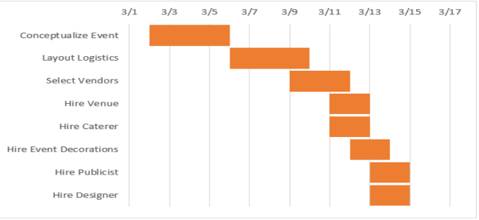
Work Breakdown Structure (WBS): A hierarchical listing of what must be done during a project
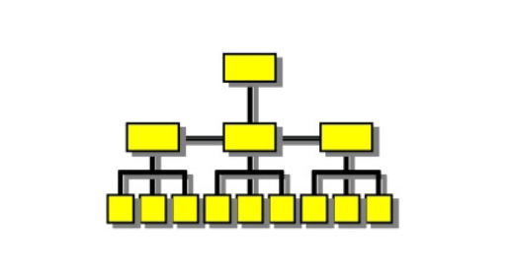
Project Scheduling
Involves determining the timing of activities/tasks of the project. It starts with the identification of activities in the WBS → Then any sequential dependencies of every pair of activities should be identified → Then the resources needed for each activity need to be identified → Then the duration of each activity can be estimated using information on the availability of resources → Finally the scheduling development using the activity duration estimates and the sequential dependencies of activities by the PERT/CPM technique

PERT/CPM Technique
PERT: Program Evaluation and Review Technique, used for scheduling and control of large projects
CPM: Critical Path Method, used for scheduling and control of large projects
- A graphical display of project activities and their sequential relationship
- An estimate of how long the project will take
- An indication of which activity are most critical to timely project completion
- An indication of how long any activity can be delayed without delaying the project

Precedence Network: A diagram of project activities and their sequential relationships by use of nodes and arrows
One of the main features of PERT/CPM is its use of a precedence network to depict project activities and their sequential relationships by use of arrows and nodes.
(AON): Activity on Node
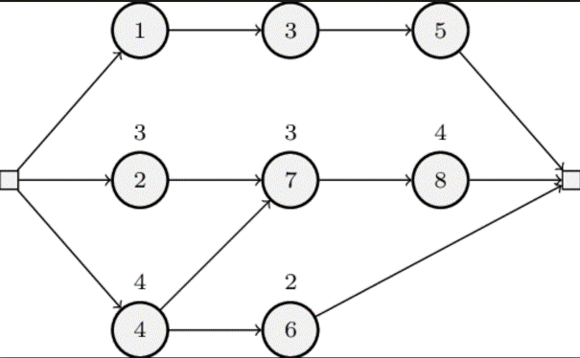

Path: A sequence of activities that leads from the start node to the end node
Critical Path: The longest path from start to finish, determines the expected project duration
Critical Activities: Activities on the critical path
Path Slack Time: Allowable slippage for a path; the difference between the length of the path and the length of the critical path
Deterministic Durations: Durations that are fairly certain
Probabilistic Durations: Durations that allow for variations
3-point Estimates Method:
- Optimistic duration: The length of time under the best conditions
- Pessimistic duration: The length of time under the worst conditions
- Most likely duration: The most probable length of time
Beta Distribution: A family of continuous positive distributions used to describe the inherent variability in activity durations

Procedures
→ Forward pass calculations are used to determine the "Early Schedule" (ES) for each activity, and the project duration.
In forward pass computations if an activity has 2 or more preceding activities, the bigger Early Finish (EF) of all proceeding activities sets the Early Start time of that activity because an activity cannot start before all preceding activities are finished.
→ Backwards pass calculations are used to determine the "Late Schedule"(LS) and the critical path
In backwards pass computations if an activity has 2 or more successors the smaller late start time of all successors sets the late finish (LF) time of that activity, because we cannot delay the start time of any successor on a late schedule

Calculation of activity slack times: LS - ES or LF -EF

Path Mean: Ʃ(expected duration of activities on the path)

Determining Path Probabilities:
z= (Specified length of time - Expected path duration)/Standard deviation of path duration

Project Crashing
Estimate of an activity's duration is usually made for given level of resources. In many situations it is possible to reduce the length of a project/ "crash" the project, by using additional resources. The impetus to shorten projects may reflect efforts to avoid late penalties, to take advantage of monetary incentives for timely or early completion of a project, or to free resources for use on other projects.
The general procedure for crashing is:
- Obtain estimates of regular and crash durations and crash cost per period for each activity, and indirect projects cost per period
- Determine the lengths of all paths
- Determine the critical activities
- Crash critical activities, starting from the cheapest, as long as crashing cost per period does not exceed the benefits of crashing. Note that two or more paths may become critical as the original critical path shortens.

Project Execution: Involves the actual performance of the activities that were planned in project planning.
Project Control: Involves assessing a project's progress against plans and taking corrective actions, if necessary, in order to bring the project on track. Forecasts of costs and completion time are generated using trend analysis to determine the need for action.

Project Management Software
Example Microsoft Project
Advantages:
- It imposes a methodology and common project management terminology
- It provides a logical planning structure
- It enhances communication among team members
- It flags the occurrence of a problem
- It automatically formats reports
- It generates multiple levels of summary reports and detailed reports
- It enables "what-if" scenarios
- It generates various charts, including basic schedule/control Gantt chart.

