VERSION 02

Lecture L01 / L02 Department _________________

Name ______________________________ Student ID __________________

University of Calgary
Schulich School of Engineering
Winter 2018
ENGG 407 - Numerical Methods

Midterm

March 6 (Wednesday)
6:30-8:30 PM
ST140 / ST148

- Please check the VERSION of your exam (01 or 02) and mark it on the bubble sheet (it is at the center of bubble sheet, below the course number).
- Your name and ID will be required on both bubble sheet and the exam sheet.
- We will collect both bubble sheet, exam sheet, and formulae sheet.
- The exam consists of 25 multiple-choice questions
- Same mark for each question.
- Examination is closed book/notes.
- Only SSE calculators allowed.
- No wireless devices or earphones are allowed during the exam.
- All angles are in radians.
- Notations and symbols follow those used during the class specified otherwise.
- Formulae sheet is provided with the exam.
- No mark will be given if there is no derivation/calculation in the box below question.
- Exam starts at 6:40 and ends at 8:20 (100 minutes).

- The absolute value of the machine epsilon in a floating point representation with 15 bits in the mantissa and 10 bits in the exponent is approximately
a) 2⁺¹⁵ b) 2⁻¹⁵ c) 2⁺¹⁰ d) 2⁻¹⁰
e) None of the above

- Given a system of linear equations Ax=b , according to the LU decomposition method,
where A= L U, what is the procedure for finding x ?
a) one back-substitution operation of A to find x directly
b) one forward-substitution operation of A to find x directly
c) forward-substitution of L followed by back substitution of U
c) back-substitution of U followed by back substitution of L
e) None of the above

- The Gauss Seidel method for solving a linear system of equations Ax = b
a) Requires a pre-decomposition stage followed by a back substitution
b) Converges quickly when the magnitude of the diagonal components of A are large in comparison with all of the off diagonal terms
c) Is an efficient way of performing the Gaussian elimination of A.
d) Does not converge when the dimension of A is too large
e) None of the above

- Given two bytes for machine representation of float point numbers. Assume each byte (8 bits) is allocated for the mantissa and exponent, respectively, where the most significant bits are reserved for representing their signs. What is the range of number representation using this scheme?
a) $±2^{8}∙{10}^{±2^{8}}$ b) $±2^{7}∙{10}^{±2^{7}}$ c) $±{10}^{8}∙{10}^{±2^{8}}$ d) $±2^{7}∙2^{±2^{7}}$
e) None of the above

- It is guaranteed that a root of a continuous nonlinear functionexists in [a, b] when f(a) • f(b) < 0. However, when f(a) • f(b) > 0, there would be N roots existing in [a, b]. In this case, which of the following possibilities may be ruled out?
a) N = 0
b) N = 1
c) N ≥ 2 and are even numbers
d) N > 3 and are odd numbers
e) None of the above

- Among the numerical methods for solving nonlinear equations and at least a solution is in the initial bracket, which of the following statements is NOT true?
a) Bisection method does not need to know the derivative of the given function
b) Newton’s method may diverge
c) Regula falsi method may diverge
d) Secant method may leads to Newton’s method when Δx → 0
e) None of the above

- The convergent condition for solving root(s) for a nonlinear function f(x) in [a, b] is determined by the following, except:
- (b-a)/2 < tolerance
- f(x_{i}) = 0
- f′(x_{i}) = 0
- f(x_{i}) < tolerance
- None of the above

- What is(are) the possible eigenvector(s) of the matrix $A=\left[\begin{matrix}3 & 0 \\ 0 & 3\end{matrix}\right]$
a) $\left[\begin{aligned}1 \\ 1\end{aligned}\right]$ b) $\left[\begin{aligned}1 \\ 0\end{aligned}\right]$ c) $\left[\begin{aligned}3 \\ 3\end{aligned}\right] d) \left[\begin{aligned}0 \\ 4\end{aligned}\right]$
e) All of the above
A = 3 * I. Therefore, all but zero vectors are possible eigenvectors
- Crout’s method of LU decomposition is applied to the matrix $A=\left[\begin{matrix}2 & 3 \\ 1 & 2\end{matrix}\right]$. What are L and U matrices?
a) $L=\left[\begin{aligned}2 \\ 1 \end{aligned}\begin{aligned} 0 \\ 0.5\end{aligned}\right], U=\left[\begin{aligned}1 \\ 0 \end{aligned}\begin{aligned} 1.5 \\ 1\end{aligned}\right]$ b) $L=\left[\begin{aligned}1 \\ 0 \end{aligned}\begin{aligned} 1.5 \\ 1\end{aligned}\right], U=\left[\begin{aligned}2 \\ 1 \end{aligned}\begin{aligned} 0 \\ 0.5\end{aligned}\right]$

c) $L=\left[\begin{aligned}1 \\ 0 \end{aligned} \begin{aligned} 0 \\ 1\end{aligned}\right], U=\left[\begin{aligned}2 \\ 0 \end{aligned}\begin{aligned} 3 \\ 1\end{aligned}\right]$ d) $L=\left[\begin{aligned}1 \\ 0.5 \end{aligned} \begin{aligned} 0 \\ 1\end{aligned}\right], U=\left[\begin{aligned}2 \\ 0 \end{aligned}\begin{aligned} 3 \\ 0.5\end{aligned}\right]$

e) None of the above
Crout’s U matrix must have 1’s in the diagonal term.

- Which sentence is correct? “If a system of equation Ax=b, and matrix A are ill-conditioned,”
a) small changes in b or in the elements of A will result in small changes in x.
b) when Cond(A) is large (>> 1), small residuals will indicate large errors.
c) large changes in b or in the elements of A will result in small changes in x.
d) when Cond(A) is large (>> 1), small residuals will indicate small errors.
e) None of the above

- After applying Gauss-Jordan method on the following linear system of equations ($A= \left[\begin{matrix}0 & 2 & 1 \\ 1 & 1 & 2 \\ 2 & 1 & 1\end{matrix}\right] and b=\left[\begin{matrix}4 \\ 6 \\ 7\end{matrix}\right] )$, what is the vector $b^{'} (A^{'}x= b^{'} ,{ A}^{'}=\left[\begin{matrix}1 & 0 & 0 \\ 0 & 1 & 0 \\ 0 & 0 & 1\end{matrix}\right])$ ?

$$\left[\begin{matrix}0 & 2 & 1 \\ 1 & 1 & 2 \\ 2 & 1 & 1\end{matrix}\right]\left[\begin{matrix}x_{1} \\ x_{2} \\ x_{3}\end{matrix}\right]=\left[\begin{matrix}4 \\ 6 \\ 7\end{matrix}\right]$$

$a) \left[\begin{matrix}\frac{7}{5} \\ \frac{11}{5} \\ \frac{8}{5}\end{matrix}\right]$ b) $\left[\begin{matrix}\frac{11}{5} \\ \frac{7}{5} \\ \frac{6}{5}\end{matrix}\right]$ $c) \left[\begin{matrix}\frac{11}{5} \\ \frac{7}{5} \\ \frac{6}{5}\end{matrix}\right]$ $d) \left[\begin{matrix}\frac{11}{5} \\ \frac{6}{5} \\ \frac{7}{5}\end{matrix}\right]$ $e) \left[\begin{matrix}\frac{8}{5} \\ \frac{7}{5} \\ \frac{11}{5}\end{matrix}\right]$

$E_{1}^{'}=E_{2}$ $\left[\begin{matrix}1 & 1 & 2 \\ 0 & 2 & 1 \\ 2 & 1 & 1\end{matrix}\right] \left[\begin{matrix}6 \\ 4 \\ 7\end{matrix}\right]$
$E_{2}^{'}=E_{1}$
(2) $\left[\begin{matrix}1 & 1 & 2 \\ 0 & 2 & 1 \\ 0 & -1 & -3\end{matrix}\right] \left[\begin{matrix}6 \\ 4 \\ -5\end{matrix}\right]$
$$E_{3}^{"}=E_{3}^{'}-2E_{1}^{'}$$
(3) $\left[\begin{matrix}1 & 0 & \frac{3}{2} \\ 0 & 2 & 1 \\ 0 & 0 & -\frac{5}{2}\end{matrix}\right] \left[\begin{matrix}4 \\ 4 \\ -3\end{matrix}\right]$
$$E_{1}^{‴}=E_{1}^{"}-\frac{1}{2}E_{2}^{"}$$
$$E_{3}^{‴}=E_{3}^{"}+\frac{1}{2}E_{2}^{"}$$
(4) $\left[\begin{matrix}1 & 0 & 0 \\ 0 & 2 & 0 \\ 0 & 0 & -\frac{5}{2}\end{matrix}\right]$ $\left[\begin{matrix}\frac{11}{5} \\ \frac{14}{5} \\ -3\end{matrix}\right]$
$$E_{1}^{⁗}=E_{1}^{‴}+\frac{3}{5}E_{3}^{‴}$$
$$E_{2}^{⁗}=E_{2}^{‴}+\frac{2}{5}E_{3}^{‴}$$
(5) $\left[\begin{matrix}1 & 0 & 0 \\ 0 & 1 & 0 \\ 0 & 0 & 1\end{matrix}\right] \left[\begin{matrix}\frac{11}{5} \\ \frac{7}{5} \\ \frac{6}{5}\end{matrix}\right]$
$$E_{2}^{"""}=E_{2}^{""}*\frac{1}{2}$$
$$E_{3}^{"""}=E_{3}^{""}*\frac{-2}{5}$$
- The system below has true solution as $x_{1}=1 , x_{2}=2.$what are the true error and residual vector for the given numerical solution?

$$x_{1}+ x_{2}=3$$
$$4x_{1}-2x_{2}=0$$
$$\tilde{x}= \left[\begin{matrix}{\tilde{x}}_{1} \\ {\tilde{x}}_{2}\end{matrix}\right]=\left[\begin{matrix}1.004 \\ 1.998\end{matrix}\right]$$

- $\left[\begin{matrix}-0.004 \\ 0.002\end{matrix}\right], \left[\begin{matrix}0.002 \\ 0.02\end{matrix}\right]$
- $\left[\begin{matrix}-0.004 \\ 0.002\end{matrix}\right], \left[\begin{matrix}0.002 \\ 0.001\end{matrix}\right]$
- $\left[\begin{matrix}0.002 \\ -0.004\end{matrix}\right], \left[\begin{matrix}0.02 \\ 0.04\end{matrix}\right]$
- $\left[\begin{matrix}0.002 \\ -0.004\end{matrix}\right], \left[\begin{matrix}0.001 \\ 0.003\end{matrix}\right]$
- None of the above

$e=x- \tilde{x}= \left[\begin{matrix}e_{1} \\ e_{2}\end{matrix}\right]= \left[\begin{matrix}-0.004 \\ 0.002\end{matrix}\right]$

$r=A\tilde{x}-b= \left[\begin{matrix}1 & 1 \\ 4 & -2\end{matrix}\right] \left[\begin{matrix}1.004 \\ 1.998\end{matrix}\right]- \left[\begin{matrix}3 \\ 0\end{matrix}\right]= \left[\begin{matrix}r_{1} \\ r_{2}\end{matrix}\right]= \left[\begin{matrix}0.002 \\ 0.02\end{matrix}\right]$
a) is correct

- What are the eigenvalues and eigenvectors of the matrix below?

$$A= \left[\begin{matrix}0 & 1 \\ -2 & -3\end{matrix}\right]$$

$a)-1,-2, \left[\begin{matrix}+2 \\ -1\end{matrix}\right], \left[\begin{matrix}+1 \\ -2\end{matrix}\right]$ $b) 1,2, \left[\begin{matrix}+2 \\ -1\end{matrix}\right], \left[\begin{matrix}+1 \\ -2\end{matrix}\right]$

$c) -1,-2, \left[\begin{matrix}+2 \\ -2\end{matrix}\right], \left[\begin{matrix}+1 \\ -2\end{matrix}\right]$ $d) 1,2, \left[\begin{matrix}+2 \\ -2\end{matrix}\right], \left[\begin{matrix}+2 \\ -1\end{matrix}\right]$

$$e) None of the above$$
$$\left|\begin{matrix}- λ & 1 \\ -2 & -3- λ\end{matrix}\right|=0 ⇒ λ^{2}+3λ+2=0 ⇒ λ_{1}=-1 λ_{2}=-2$$

$\left[\begin{matrix}- λ & 1 \\ -2 & -3- λ\end{matrix}\right]\left[\begin{matrix}x_{1,1} \\ x_{2,1}\end{matrix}\right]=\left[\begin{matrix}0 \\ 0\end{matrix}\right]$

- $λ_{1}=-1$

$\left[\begin{matrix}1 & 1 \\ -2 & -2\end{matrix}\right]\left[\begin{matrix}x_{1,1} \\ x_{2,1}\end{matrix}\right]=\left[\begin{matrix}0 \\ 0\end{matrix}\right]$

$x_{1,1}+x_{2,1}=0$ ${ -2x}_{1,1}-2x_{2,1}=0$ so $x_{1,1}=-x_{2,1}$

$\left[\begin{matrix}x_{1,1} \\ x_{2,1}\end{matrix}\right]=k*\left[\begin{matrix}+1 \\ -1\end{matrix}\right]$ $k=±1,±2,….$

- $λ_{2}=-2$

$\left[\begin{matrix}2 & 1 \\ -2 & -1\end{matrix}\right]\left[\begin{matrix}x_{12} \\ x_{2,2}\end{matrix}\right]=\left[\begin{matrix}0 \\ 0\end{matrix}\right]$

$2x_{1,2}+x_{2,2}=0$ $2x_{1,2}=-x_{2,2}{ -2x}_{1,2}-x_{2,2}=0$ so

$\left[\begin{matrix}x_{1,1} \\ x_{2,1}\end{matrix}\right]=k*\left[\begin{matrix}+1 \\ -2\end{matrix}\right]$ $k=±1,±2,….$

- Consider the linear system of equation $Ax=b$ as $A= \left[\begin{matrix}2 & -4 \\ 6 & 2\end{matrix}\right]and b=\left[\begin{matrix}4 \\ 10\end{matrix}\right],$ using LU decomposition with Crout’s method, what is the solution of $Ly=b$?

- $\left[\begin{matrix}4 \\ -\frac{1}{7}\end{matrix}\right]$ b)$\left[\begin{matrix}2 \\ -\frac{1}{7}\end{matrix}\right]$ c) $\left[\begin{matrix}2 \\ -\frac{1}{14}\end{matrix}\right]$ d) $\left[\begin{matrix}4 \\ -\frac{1}{14}\end{matrix}\right]$
- None of the above

$$l_{11}=a_{11}=2, l_{21}=a_{21}=6,$$
$$u_{11}=u_{22}=1$$
$u_{12}=\frac{a_{12}}{l_{11}}=-\frac{4}{2}= -2$

$$l_{22}=a_{22}-l_{21}u_{12}= 14$$

$$L=\left[\begin{matrix}2 & 0 \\ 6 & 14\end{matrix}\right],$$

$$y_{1}=\frac{b_{1}}{l_{11}}=2$$

$$y_{2}=\frac{b_{2}-l_{21}y_{1}}{l_{22}}=\frac{10-12}{14}=-\frac{1}{7}$$

$$y=\left[\begin{matrix}2 \\ -\frac{1}{7}\end{matrix}\right]$$

- What is the solution of linear system of equation below after second iteration using Jacobi iteration method starting from $x_{1}=x_{2}=x_{3}=0$?
$${5x}_{1}-2x_{2}+3x_{3}=-1 \\ -{3x}_{1}+9x_{2}+x_{3}=2 \\ {2x}_{1}-x_{2}-{7x}_{3}=-2$$

- $\left[\begin{matrix}0.146 \\ 0.203 \\ -0.517 \end{matrix}\right]$ b) $\left[\begin{matrix}-0.200 \\ 0.222 \\ -0.429\end{matrix}\right]$ c) $\left[\begin{matrix}0.157 \\ 0.149 \\ -0.612\end{matrix}\right]$ d) $\left[\begin{matrix}-0.220 \\ 0.202 \\ -0.435\end{matrix}\right]$

- None of the above

$$x_{1}^{1}=-\frac{1}{5}+\frac{2}{5}\left(0\right)-\frac{3}{5}\left(0\right)=-0.2 \\ x_{2}^{1}=\frac{2}{9}+\frac{3}{9}\left(0\right)-\frac{1}{9}\left(0\right)=0.222 \\ x_{3}^{1}=-\frac{3}{7}+\frac{2}{7}\left(0\right)-\frac{1}{7}\left(0\right)=-0.429$$
$$x_{1}^{1}=-\frac{1}{5}+\frac{2}{5}\left(0.222\right)-\frac{3}{5}\left(-0.429\right)=0.146 \\ x_{2}^{1}=\frac{2}{9}+\frac{3}{9}\left(-0.2\right)-\frac{1}{9}\left(-0.429\right)=0.203 \\ x_{3}^{1}=-\frac{3}{7}+\frac{2}{7}\left(-0.2\right)-\frac{1}{7}\left(0.222\right)=-0.517$$
- Which method does the following Matlab code implements

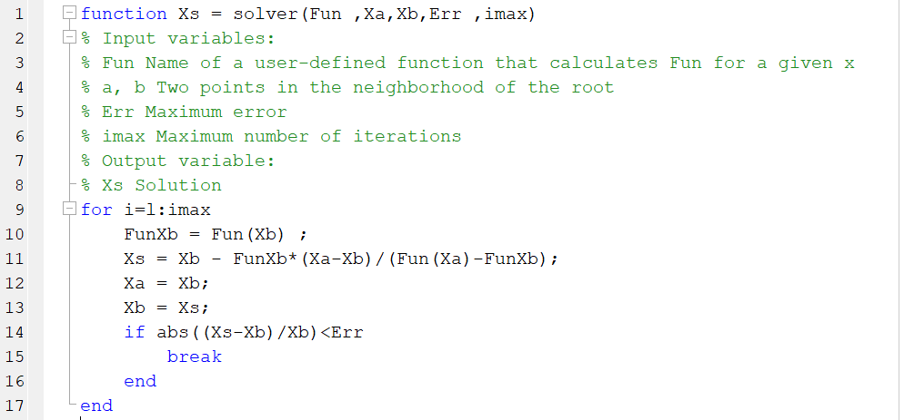

- Regula Falsi Method
- Secant Method
- Newton-Raphson Method
- Bisection Method
- None of the above

- Which method does the following Matlab code implements

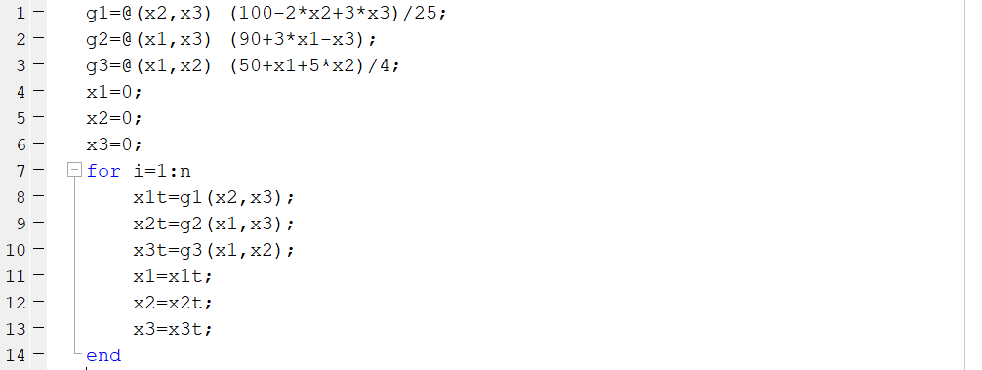

- Gauss-Seidel Method
- Secant Method
- Jacobi Method
- Fixed-Point SNLE
- None of the above

- Which method does the following Matlab code implements

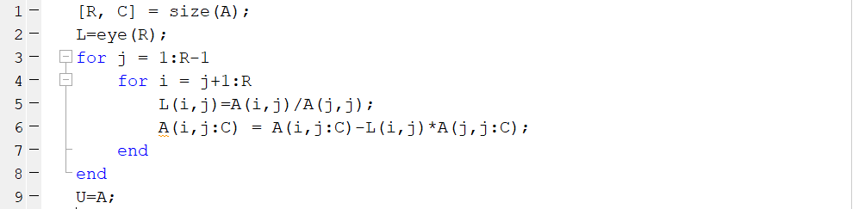

- Doolittle LU Decomposition Method
- Court’s LU Decomposition Method
- Bisection Method
- Secant Method
- None of the above

- Which method does the following Matlab code implements

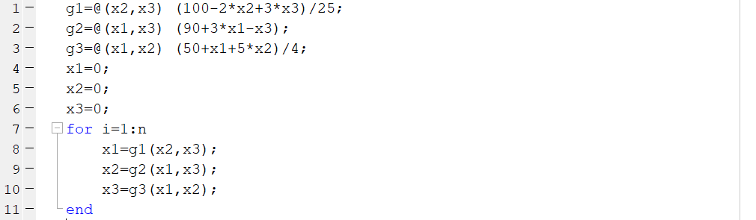

- Jacobi Method
- Gauss-Seidel Method
- Doolittle LU Decomposition Method
- Fixed-Point SNLE Method
- None of the above

- Which method does the following Matlab code implements

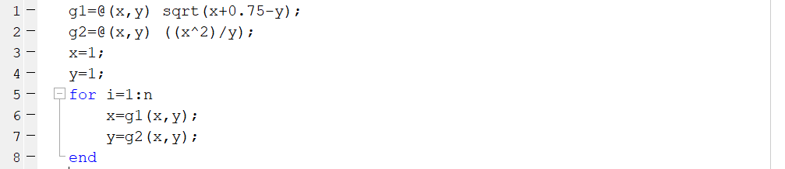

- Jacobi Method
- Doolittle LU Decomposition Method
- Gauss-Seidel Method
- Fixed-Point SNLE Method
- None of the above

- $\sum_{n=0}^{∞}{{(-x)}^{n}}$ is the Taylor series for which function?
a) sin(x) b) cos(x) c) $\frac{1}{1-x}$ $d) \frac{1}{1+x} e) e^{x}$
The Taylor series of $\frac{1}{1+x}$with center 0 is: 1-x + x² -x³+x⁴

- Find the Taylor series about x=0 for $f\left(x\right)=\frac{1}{{(1-x)}^{2}}$
$a)\sum_{n=0}^{∞}{(n+1)x^{n}}$ $b)\sum_{n=0}^{∞}{ {(-1)}^{n}(n+1)x^{n}}$
$c)\sum_{n=0}^{∞}{nx^{n}}$ $d)\sum_{n=0}^{∞}{x^{2n}} e)\sum_{n=0}^{∞}{{-x}^{2n}}$

The Taylor series of $\frac{1}{{(1-x)}^{2}}$with center 0 is: 1+2x+3x²+4x³+5x⁴+…

- Given $f\left(x\right)=ln⁡(\cos\left(x\right))$, calculate the value of $ln⁡(\cos\left(\frac{π}{2}\right))$.
a) -1.741 b) 1.741 c) 1.563 d) -1.563 e) 1.293
Explanation: Given f(x) = ln(cos(x)), f(0) = 0
Differentiating it f'(x) = – tan(x), f'(0) = 0
f⁽²⁾(x)=-sec²(x), f⁽²⁾(0) = -1
f⁽³⁾(x)=-2sec²(x) tan(x), f⁽³⁾(0) = 0
f⁽⁴⁾(x)=-2(f⁽³⁾(x) f⁽¹⁾(x)+( f⁽²⁾(x))²), f⁽⁴⁾(0) = -2

f(x)=ln(cos(x))=0+0- x²/2! +0 – x⁴/12
therefore:
f(x)= - x²/2! – x⁴/12

- Expand for the function $f(x)= \frac{1}{\sin{x}}$ with Taylor series up to three non-zero terms around $x_{0}=\frac{π}{3}$. Find the value of $\frac{1}{\sin{\frac{π}{4}}}$ using the formula you obtain with Taylor series. Use your calculator to find the true value of $\frac{1}{\sin{\frac{π}{4}}}$ . What is the true relative error of $\frac{1}{\sin{\frac{π}{4}}}$ that you have obtained with Taylor series?

- 0.0135
- 0.0115
- 0.0121
- 0.0108
- None of the above

The Taylor series of $\frac{1}{\sin{x}}$ with center $\frac{π}{3}$ is : $\frac{2}{\sqrt{3}}-\frac{2}{3}\left(x-\frac{π}{3}\right)+\frac{5}{3\sqrt{3}}{(x-\frac{π}{3})}^{2}$
Taylor: T(x)=T($\frac{π}{4})$= 1.3952
True value = f($\frac{π}{4})$=$\frac{1}{\sin{\frac{π}{4}}}$= 1.4142
Relative error=(1.4142- 1.3952)/ 1.4142=0.0135

a) is correct

- If all derivatives of f(x) are less than 1.0, what is the minimum number of terms of the Taylor series centered at x =1 necessary to approximate f(1.2) with an error less than 0.00001?
- 2
- 3
- 4
- 5
- None of the above
x0=1
x=1.2
$$Rn\left(1.2\right)<\frac{f^{n+1}}{\left(n+1\right)!}{(1.2-1)}^{n+1}$$
It is given that $f^{n+1}<1$
$$Rn\left(1.2\right)<\frac{1}{\left(n+1\right)!}. {(0.2)}^{n+1}$$
Using calculator:
n=1 Rn=0.02
n=2 Rn= 0.00133
n=3 Rn= 0.000066
n=4 Rn= 0.00000266
Thus, at least four terms are necessary to approximate f(1.2) with error less than 0.00001

- End of Exam –

