NAME:
STUDENT NUMBER:

MCG2130: Thermodynamics I
Quiz 10
Instructions: 110 minutes. Closed book. Non-programmable calculators allowed.
Use methodology shown in class for full marks.
Q1 (Short Answer) (2 marks):
- Write out the second law of thermodynamics for open systems and identify all of the components. 1MARK

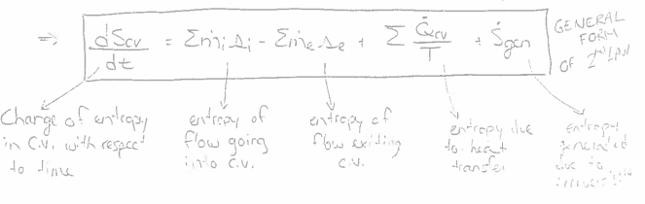
- What is the general simplified equation for work for a reversible steady state process (such as a pump, compressor, or turbine)? 0.5 MARKS

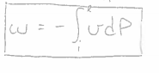

- What is the equation for work for reversible pump? 0.5 MARKS
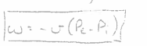

Q2 (2 Marks):
An industrial process requires a steady 0.75 kg/s supply of compressed air at 500 kPa at a maximum temperature of 30°C. This air is to be supplied by installing a compressor and an after cooler. Local ambient conditions are 100 kPa, 20°C.
Using a reversible compressor, determine:
- The power required to drive the compressor
- The rate of heat rejection in the after cooler.

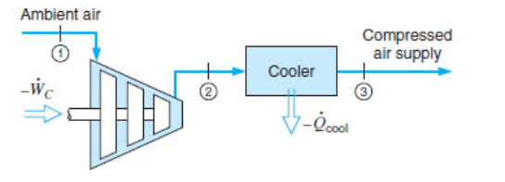

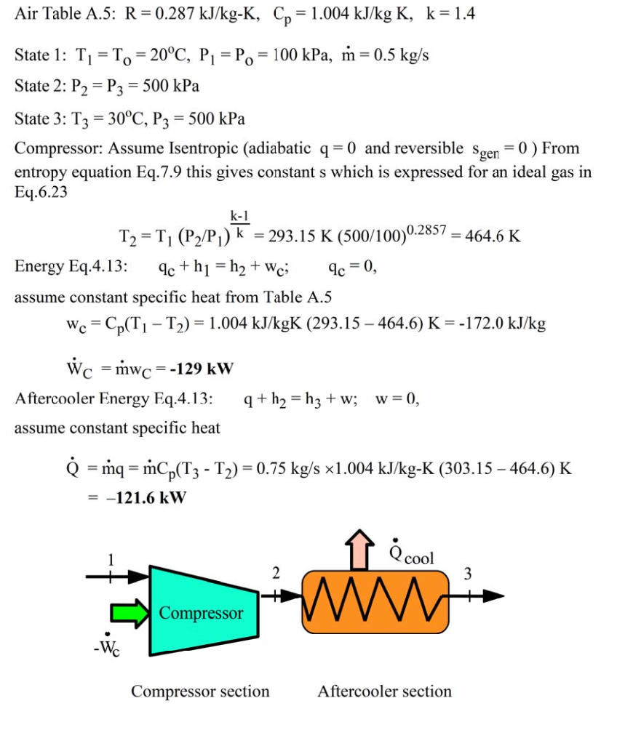

Subtract 0.5 per mistake.

Q3 (4 marks):
A steam power plant (shown below) has P1 = P4 = 20 kPa, T1 = 40°C and P2 = P3 = 15MPa, T3 = 600°C.
- Draw a T-s diagram of the cycle.
- Find the specific work and exit state for the pump.
- Find the specific work and exit state for the turbine.
- Find the specific heat transfer in the boiler.
- Find the specific heat transfer in the condenser.
- What is the cycle’s efficiency?

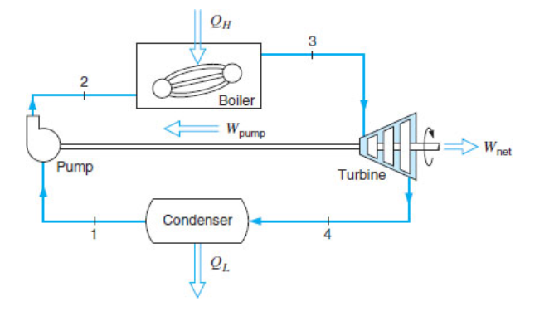
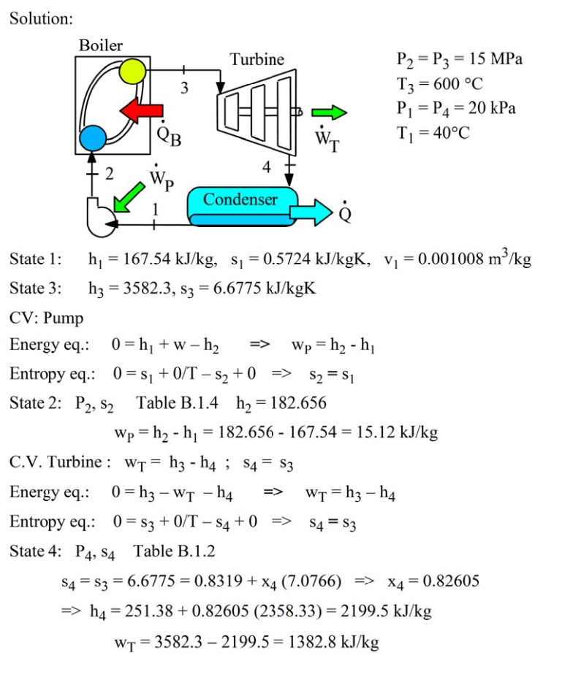

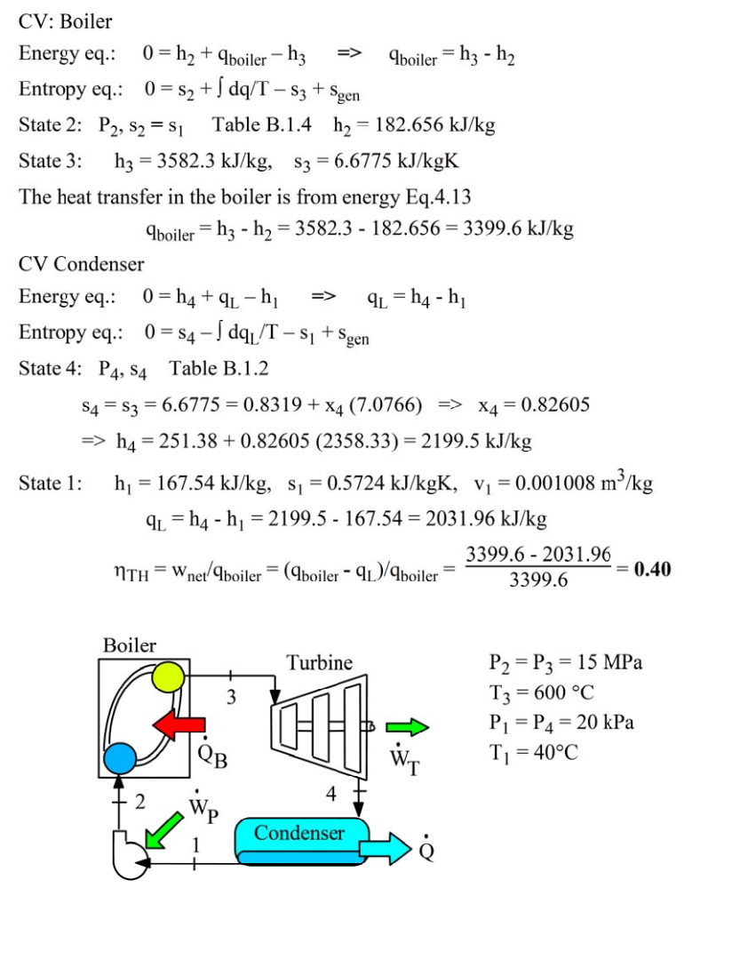
Subtract 0.5 per mistake.

Q4 (2 marks): Two flows of air are both at 200 kPa; one has 2 kg/s at 400 K, and the other has 1 kg/s at 290 K. The two flows are mixed together in an insulated box to produce a single exit flow at 200 kPa.
- Find the exit temperature of the air.
- Find the total rate of entropy generation.
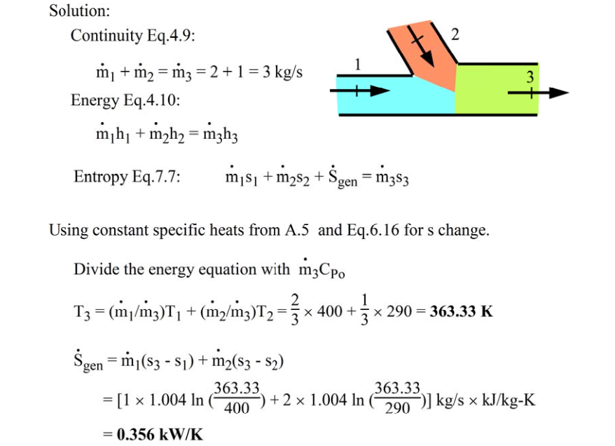
Subtract 0.5 per mistake.

