Lecture 1: Human Resources Management

Human Resources Management (HRM)
- the process of managing human talent to achieve an organization's objectives
  - human resources
  - human capital
  - intellectual assets
  - talent management
- used to be called “personnel"

Products and Services
- tangible actions
  - people: airlines, health, hotels, gyms
  - possessions: repair, cleaning, retail, landscaping
- intangible actions
  - people: radio, consulting, training
  - possessions: accounting, banking, insurance, lawyers

Management
- defined as the art and science of getting things accomplished through others in organizations
- different roles of management:
  - first level- mobilization (ex. manager)
  - second level - coordination
  - third level - strategic (ex. where is your business in the economy)

Traditional Management

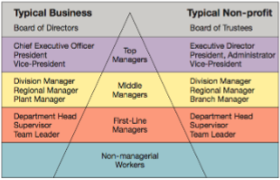

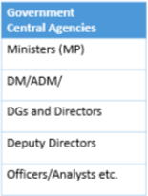

Human Capital and HR Management
- human capital:
  - the knowledge, skills and capabilities of individuals that have economic value to an organization
- intangible inimitable and idiosyncratic
- cannot be management the way organizations manage jobs, products, and technologies
- valuable because capital is:
  - based on company-specific skills
  - gained through long-term experience
  - can be expanded/ increased through development

Stairway Model

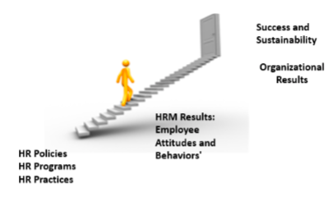

HRM Responsibilities
- what are the core responsibilities of Human Resource Management?
  - employee recruitment and selection
  - employee training and performance evaluation
  - employee compensations and benefits
  - employee separation
  - planning for staffing needs
- competitive issues - what are these?
  - 1. Responding Strategically to Changes in the Global/ Local Marketplace
  - 2. Setting and Achieving CSR and Sustainability Goals
  - 3. Advancing HR Management with Technology
  - 4. Costs, Top Talent, and Productivity
  - 5. Demographic and Diversity Workforce Challenges
  - 6. Adapting to Educational and Cultural Shifts Affecting the Workforce

Trend 1: Changes in the Global/ Local Marketplace
- Six Sigma
  - a set of principles and practices whose core ideas include understanding customer needs, doing things right the first time, and striving for continuous improvement
- Total Quality Management (TQM)
  - a process used to translate customer needs into a set of optimal tasks that are performed in concert with one another
- Reengineering
  - the fundamental rethinking and radical redesign of business processes to achieve dramatic improvements in cost, quality, service, and speed
- Downsizing
  - planned elimination of jobs (“headcount”)
  - layoffs
- Outsourcing
  - contracting outside the organization to have work done that formerly was done by internal employees
- Offshoring (Global Sourcing)
  - the business practice of sending jobs to other countries
- Globalization
  - approx. 70-85% of the Canadian economy today is affected by international competition
- Impact of Globalization
  - “anything, anytime, anywhere” markets
  - partnerships with foreign firms
  - lower trade and tariff barriers
  - “trump twitter” effect

Trend 2: CSR and Sustainability Goals
- Corporate Social Responsibility
  - the responsibility of the firm to act in the best interests of the people and communicate affectively by its activities
  - sustainability is closely related to CSR - refers to a companys ability to produce a good or service without damaging the environment or depleting a resource

Trend 3: Advancing HRM with Technology
- impact of Technology on HRM
  - operational
    - automation of routine tasks, lower administrative costs, increased productivity and faster response times; self-service access to information and training for managers and employees
  - relational:
    - online recruiting, screening, and pretesting of applicants
  - transformational:
    - training, tracking and selecting employees based on their record of skills and abilities; organization-wide alignment of “cascading” goals
  - collaborative software allows workers anywhere anytime to interface and share
  - information with one another have changed how and where people and companies do business
  - from “Touch” Labour to Knowledge Workers
  - Knowledge Workers:
    - workers whose responsibilities extend beyond the physical execution of work to include planning, decision-making, and problem-solving
  - Human Resources Information System (HRIS)
    - a computerized system that provides current and accurate data for purposes of control and decision-making

Trend 4: Costs, Talents, Productivity
- organizations take many approaches to lowering labour-related costs, including:
  - carefully managing employees benefits
  - downsizing
  - outsourcing
  - offshoring, nearshoring, homeshoring
  - employee furloughing and leasing
- hidden costs of a layoff:
  - severance and rehiring costs
  - accrued vacation and sick-days payouts
  - pension and benefit payoffs
  - potential lawsuits from aggrieved workers
  - loss of institutional memory and trust in management
  - lack of staffers when the economy rebounds
  - survivors who are risk averse, paranoid, and political
- benefits of a no-layoff policy:
  - a fiercely loyal, more productive workforce
  - higher customer satisfaction
  - readiness to snap back with the economy
  - a recruiting edge
  - workers who aren’t afraid to innovate, knowing their jobs are safe

Trend 5: Demographic and Diversity Challenges
- almost half of the organizations surveyed reported that the biggest investment challenge facing them over the next 10 years is obtaining human capital and optimizing their human capital
- demographic changes
  - more diverse workforce
  - aging workforce
  - more education workforce
- managing diversity
  - being aware of characteristic common to employees, while also managing employees as individuals
- other factors
  - cultural and societal changes affecting the workforce
  - employee rights
  - privacy concerns of employees
  - changing nature of the job
  - changing attitudes toward work
  - balancing work and family

Trend 6: Adapting to Educational and Cultural Shifts Affecting the Workplace
- other factors
  - cultural and societal changes affecting the workforce
  - employee rights
  - privacy concerns of employees
  - changing nature of the job
  - chaining attitudes toward work
  - balancing work and family

Lecture 2: Equity and Diversity in Human Resource Management

Strategy and Human Resource Planning (read in textbook)

Strategic Planning and Human Resources
- strategic planning
  - set of procedures for making decisions about the organizations long-term goals and strategies
- Human Resource Planning (HRP)
  - process of anticipating and providing for the movement of people into, within, and out of an organization
- Strategic Human Resources Management (SHRM)
  - the pattern of human resources deployments and activities that enable an organization to achieve its strategic goals

Strategic Planning and Human Resources (just know the names)

Step 6: Evaluation and Assessment
Step 5: Strategy Implementation
Step 4: Formulating Strategy
Step 3: Internal Analysis
Step 2: External Analysis
Step 1: Mission, Vision, and Values

Forecasting: A Critical Element of Planning

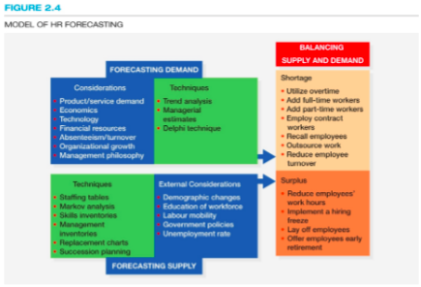

Forecasting a Firms Demand For Employees
- quantitative methods —> forecasting demand —> qualitative methods

Quantitative Methods
- forecasting labour demand based on an organizational index (such as scales)

Forecasting Future HR Needs (Demand)
- Quantitative Approaches:
  - Trend Analysis: review past employees levels
  - Ratio Analysis: ratio of business activity (ex.scales) and number of employees needed
  - Scatter Plot: used to determine whether two factors (business activity and staffing levels) are related
  - Regression Analysis: examines the statistical relationship between business activity and employees
- Forecasting Based On:
  - projected turnover
  - quality and nature of employees relative to needs
  - decisions regarding product quality and new markets
  - plans for technological and administrative changes to increase productivity and reduce headcount
  - financial resources available
- Qualitative Approaches:
  - 1. Nominal Group Technique
    - decision making technique that involves a group of experts meeting face to face
    - steps to include independent idea generation, clarification and open discussion, and private assessment
  - 2. Delphi Technique
    - judgemental forecasting method used to arrive at a group decision, typically involving outside experts as well as organizational employees
  - 3. Managerial Judgement

Forecasting the Supply of Employees: Internal Labour Supply
- staffing tables
- Markov analysis
- Skill/ Management inventories
- replacement charts
- succession planning

Staffing Tables
- a pictorial representation of all jobs within the organization, along with the number of current incumbents and future employment requirements (monthly or yearly) for each

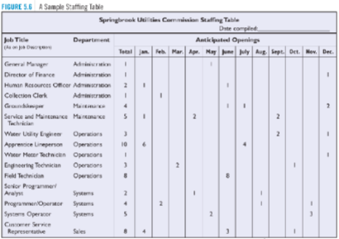

Markov Analysis
- a method of forecasting internal labor supply that involved tracking the pattern of employee movements though various jobs and developing a transitional probability matrix
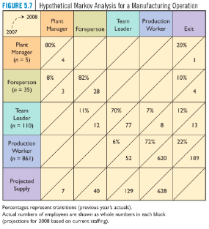

AKA Transitional Matrix:

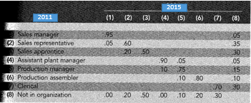

Forecasting Tools:
- Skill inventories
  - files of personnel education, experience, interests, and skills that allow managers to quickly match job openings with employee backgrounds
- replacement charts
  - listing of current jobholders and people who are potential replacements if an opening occurs
- succession planning
  - the process of identifying, developing, and tracking key individuals for executive positions
- includes:
  - analysis of the demand for managers and professionals in the company
  - audit of existing executives and projection of likely future supply
  - planning of individuals career paths based on objective estimates of future needs, performance appraisal data, and assessments of potential
  - career counselling and performance-related training and development to prepare individuals for future roles
  - accelerated promotions, with development targeted at future business needs
  - planned strategic recruitment, aimed at obtaining people with the potential to meet future needs, as well as at filling current openings

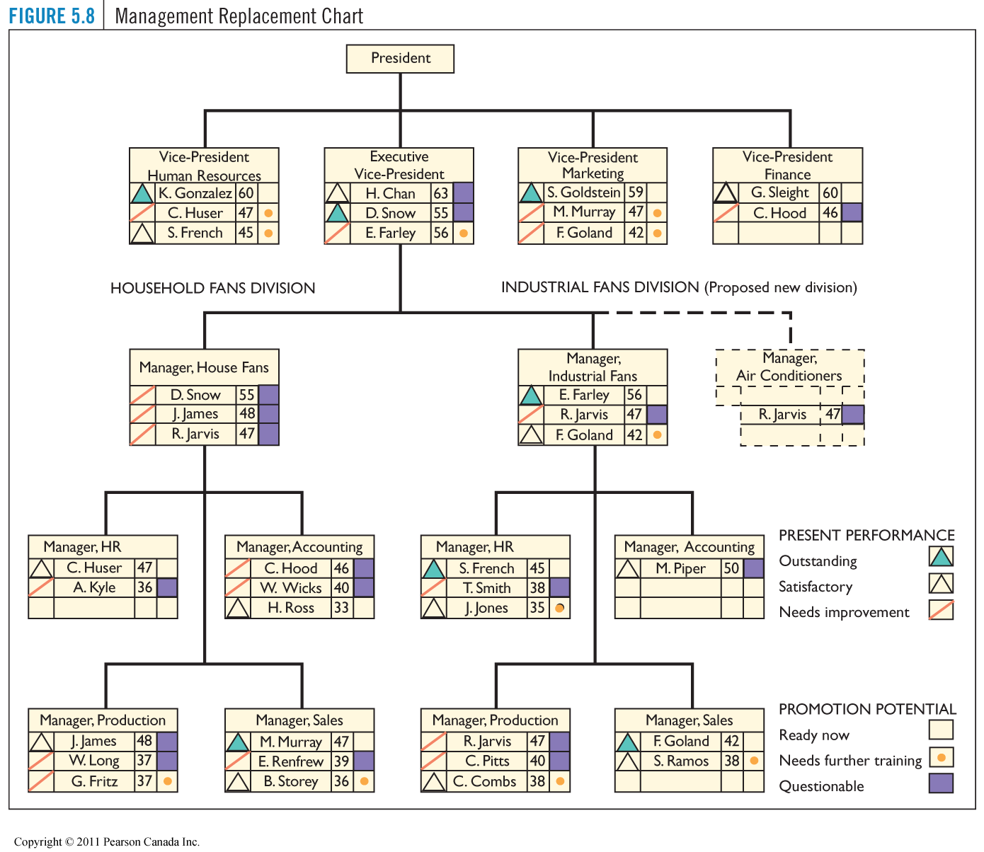

Measuring a Firms Strategic Alignment
- Balanced Scorecard (BSC):
  - a measurement framework that helps managers translate strategic goals into operational objectives
- financial
- customer
- processes
- learning

NOTE: Balanced Scorecard - Harvard business review (important)

Ensuring Strategic Flexibility for the Future
- organizational capability
  - capacity of the organization to continuously act and change in pursuit of sustainable competitive advantage
- coordination flexibility
  - the ability to rapidly reallocate resources to new or changing needs
- resource flexibility
  - having human resources who can do many different things in different ways

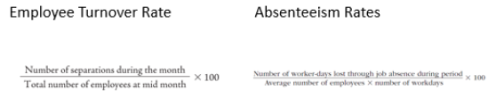

Equity and Diversity in HRM

The Legal Framework
- The Canadian Charter of Rights and Freedoms
- The Canadian Human Rights Act (CHRA)
- Provincial and Territorial Laws

Issues
- discrimination: intentional / systematic
- sexual harassment
- duty to accommodate
- bona fide occupational qualification/ requirement (BFOQs BFORs)
- pay equity
- employment equity

Sexual Harassment
- unwelcome advances, requests for sexual favours, and other verbal or physical conduct of a sexual nature in the working environment

The Enforcement of Human Rights Laws
- file a written complaint
- investigation and submission of report
- if complaint is substantiated, settlement
- if no agreement, then a tribunal

Exemptions
- Bona Fide Occupational Qualification (BFOQ)
  - a justifiable reason for discrimination based on business reasons of safety or effectiveness

The Employment Equity Act (1995)
- organizations regulated under Canada Labour Code
- more than 100 employees
- Federal Contractors Program
- status of designated groups:
  - woman
  - aboriginal people
  - visible minorities
  - people with disabilities

The Implementations of Employment Equity in Organization

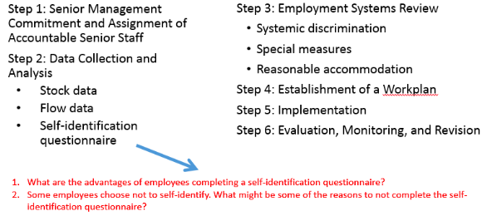

Pay Equity
- illegal to discriminate on the basis of job context
- equal pay for work of equal value

Managing Diversity
- diversity management: the optimization of an organizations multicultural workforce in order to reach business objectives

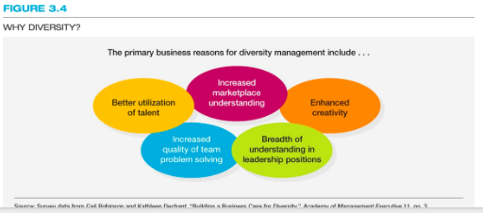

Business Benefits for Diversity Management
- better utilization of talent
- increased marketplace understanding
- enhanced creativity
- increased quality of team problem solving
- greater understanding in leadership positions

Lecture 3:

Job Requirements
- job
  - a group of related activities/ duties for one or more employees
- job family
  - a group of individual jobs with similar characteristics
- position
  - a collection of tasks/ responsibilities performed by one person
- occupation
  - a collection of jobs that share some or all of a set of main duties
- job description
  - a statement of the tasks, duties, and responsibilities of a job to be performed
- job specification
  - a statement of the needed knowledge, skills, and abilities of the person who is to perform the job

Relationship of Job Requirements and HRM Functions
- Strategic HR planning
- recruitment
- selection
- training and development
- performance management
- compensation management
- legal compliance

Job Analysis
- the process of obtaining information about jobs by determining the duties, tasks, or activities of jobs
- a job analysis should also outline the tools needed to do the job, the environment and times at which it needs to be done, the people with whom it needs to be done, and the outcome or performance level it should produce

Uses of Job Analysis Information

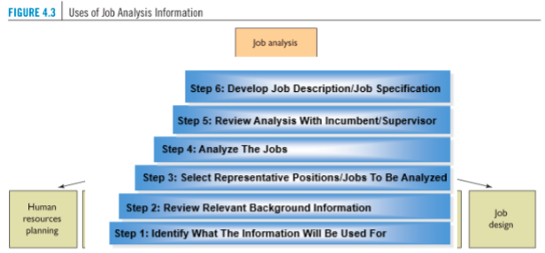

Steps in Job Analysis (complete)

Methodology
- job information
  - interview
  - questionnaires
  - observation
  - diaries
- approaches
  - 1. The Position Analysis Questionnaire system (PAQ)
  - 2. The Critical Incident method
  - 3. A Task Inventory analysis
  - 4. A Competency- based analysis

Methods of Collecting Job Analysis Information
- functional job analysis
  - quantitative method for classifying jobs based on types and amounts of responsibility for data, people and things
  - performance standards and training requirements are also identified
- Fleishman Job Analysis System
  - SME (job incumbents) evaluation of abilities to perform the job
- National Occupational Classification (NOC)
  - reference tool for writing job descriptions and job specifications
  - compiled by the federal government contains comprehensive, standardized descriptions of about 30,000 occupations and the requirements of each
  - NOC and its counselling component, The Career Handbook, both focus on occupations rather than jobs

Process Chart for Analysis a Jobs Workflow

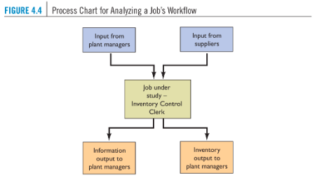

Methods of Collecting Job Analysis Info - Qualitative

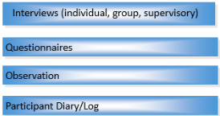

Popular Approaches (PAQ)
- Position Analysis Questionnaire:
  - questionnaire used to collect quantifiable data concerning the duties and responsibilities of various jobs
  - very structured job analysis questionnaire which contains 194 items
  - provides quantitative job score on six dimensions of job requirements:
    - information input
    - mental processes
    - work output (physical activities and tools)
    - relationships with others
    - job context (physical and social environment)
    - other job characteristics (pace and structure)
- Critical Incident:
  - involved the identification of job tasks that are essential for job success
  - focuses on behaviours
- Task Inventory Analysis
  - job oriented
  - organization-specific list (tailor-made) of
  - identify - with employees and managers - tasks and their descriptions used as a basis to identify components of jobs
  - survey instrument of task statements including importance and frequency
- competencies
  - demonstrable characteristics of a person that enable performance of the job
- Competency-Based Job Analysis
  - describing a job in terms of the measurable, observable behavioural competencies an employee must exhibit to do a job well
- Competency Framework
- Competencies the entire organization requires to be successful

Human Resource Information System (HRIS)
- one of the most important Management Information Systems
- contributes to human resource administration functions of an organization
- Kavangah et al., (2007), HRIS is a computer system used to acquire, store, manipulate, analyze, retrieve and distribute information related to human resources
- besides hardware and software, it also includes people, forms, policies, procedures, and data. Modern HRIS can help organizations by automating most HR planning functions
- HRIS becomes an important strategic tool since it collects, manages and reports information for decision-making g
- fully integrated organizational HRIS ought to interface with other systems enabling and enhancing the communication between departments such as payroll system with accountancy system

Job Descriptions
- job title
  - indicated job duties and organizational level
- job identification section
  - distinguished job from all other jobs
- job duties, or essential functions, section
  - indicate responsibilities entailed and results to be accomplished
- job specification section
  - skills required to perform the job and physical demands of the job

Problems with Job Description
- if they are poorly written, using vague rather than specific terms, they provide little guidance to the jobholder
- they are sometimes not updated as job duties or specifications change
- they may violate the law by containing specifications not related to job success
- they can limit the scope of activities of the jobholder, reducing organizational flexibility

Job Design
- an outgrowth of job analysis that improves jobs through technological and human considerations to enhance organization efficiency and employee job satisfaction
- Behavioural Concerns
  - the job enrichment model and the job characteristics model: two methods designed to increase the job satisfaction of employees

Job Design Considerations (FIGURE 4.3: PAGE 141)
- Job specialization (industrial engineering)
  - work simplification
  - industria engineering
- behavioural aspects
  - job enlargement, job rotation, job enrichment, team based job design
- ergonomic aspect
  - physical needs of workers
- increasing job flexibility
  - cognitively complex, more team-based, more dependent on social skills and technological competence, time pressured, mobile, and less dependent and geography

Job Enrichment
- different from job enlargement (extension or rotation)
- increasing the level of difficulty and responsibly of the job
- allowing employees to retain more authority and control over work outcome s
- providing unit or individual job performance reports directly to employees
- adding new tasks to the job that require training and growth
- assigning individuals specific tasks, enabling them to use their particular competencies or skills

Job Characteristic Model: Designing Job to Motivate Employees

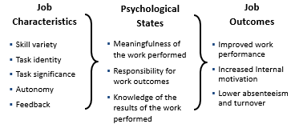
Job Design
- Industrial Engineering Considering
  - a field of study concerned with analyzing work methods and establishing time standards
- Ergonomic Considerations
  - an interdisciplinary approach to designing equipment and systems that can easily and efficiently used by human beings
- Designing Work for Groups and Teams
  - an outgrowth of job analysis that improves jobs through technological and human considerations to enhance organization efficiency and employee job satisfaction
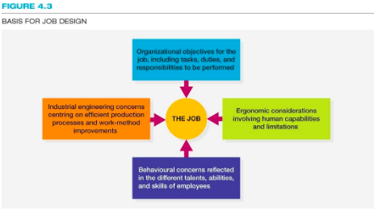
Basis for Job Design

Designing Work for Groups and Teams
- Employee Involvement Groups (Eis)
  - groups of employees who meet to resolve problems or offer suggestions for organizational improvement
  - also known as quality circles (QCs)
  - success with EIs requires:
    - comprehensive training for group members
    - recognition of the groups contributions
    - continuing input and encouragement by management
    - use of a participative/democratic leadership style

Types of Employee Teams

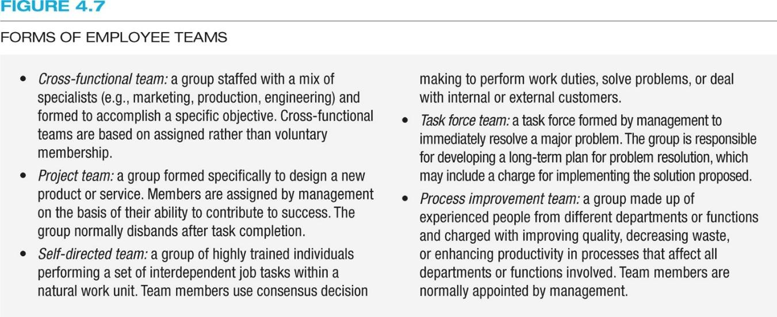

Characteristics of Successful Teams
- a commitment to shared goals and objectives
- motivated and energetic team members
- open and honest communication
- shared leadership
- clear role assignments
- a climate of cooperation, collaboration, trust, adn accountability
- the recognition of conflict and its positive resolution

Benefits of Employee Teams
- increased integration of individuals skills
- better performance (quality and quantity) solutions to unique and complex problems
- reduced delivery time
- reduced turnover and absenteesim
- accomplishments among team members

Flexible Work Schedules
- compressed workweek
  - shortening the number of days in the workweek by lengthening the number of hours worked per day
- flextime
  - working hours that permit employees the option of choosing daily starting and quitting times, provided that they work a set number of hours per day or week
- job sharing
  - the arrangement whereby two part-time employees perform a job that otherwise would be held by one full-time employee
- telecommunicating
  - the use of personal computers, network, and other communications technology to do work in the home that is traditionally done in the workplace

Strategic Assets of Recruiting

Strategic Issues
- decision about talent
- the board factors that can affect a firms recruiting strategy include a firms recruiting abilities

Who is responsible?
- HR recruiters or generalists (large firms)
- managers and/or supervisors (smaller firms)
- work teams
- Recruiting Process Outsourcing (RPO)
- the practice of outsourcing an organizations recruiting function to an outside firm

Internal and External

Internal
- most managers try to follow a policy of filling job vacancies above the entry-level position through promotion and transfers
- there are advantages and disadvantages to both. What are they?

External/ Global
- to develop better products via a global workforce
- to attract the best talent wherever it may be
- international recruiting issues
- local, national, and international laws
- different labour costs
- different pre-employment and compensation practices
- cultural difference
- security
- visas and work permits

Labour Markets
- area from applicants are to be recruited:
  - tight market: high employment, few available workers
  - loose market: low employment, many available workers
- what are the factors determine relevant labour markets?

Internal vs. External
- internal job postings
- identifying talent through performance appraisals
- skills inventories and replacement charts
  - BRANDING: an organizations efforts to help existing and prospective workers understand why it is a desirable place to work. Create a compelling, differentiating, and engaging employer brand
    - https://www.youtube.com/watch?v=RInuBNwjeOQ
  - advertisements
  - walk-ins, unsolicited applications, and resumes
  - the internet, social networking, and mobile recruiting
  - job fairs
  - employees referrals
  - re-recruiting
  - executive search firms
  - educational institutions
  - professional associations
  - labour unions
  - public employment agencies
  - private employment and temporary agencies
  - employee leasing

Improvement the Effectiveness of Recruiting

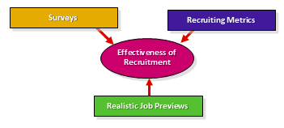

Recruiting Metrics
- quality-of-fill statistics
- quality of hire = (PR + HP + HR) / N
  - PR = average job performance rating of new hires (3.5/5 = 70%)
  - HP = % of new hires reaching acceptable productivity with acceptable time frame (75%)
  - HR = % of new hires retained after one year (80%)
  - N = number of indicators = 3
  - (70 + 75 + 80) / 3 = 75%
- Time to Fill (pg. 179)
- the number of days from when a job opening is approved to the date the candidate is selected
- yield ratios
- the percentage of applicants from recruitment source that make it to the next stage of the selection process

Cost of Recruitment (Per Employee Hired):



- SC = source cost
- AC = advertising costs, total monthly expenditure (ex. $32,000)
- AF = agency fees, total for the month (ex. $21,000)
- RB = referral bonuses, total paid (ex. $2600)
- NC = no-cost hires, walk-ins, nonprofit agencies, etc. (ex. $0)
- H = total hires (ex.119)
- cost to hire one employee = $467.23

Career Management Developing Talent Over Time
- goal
- to match individual and organizational needs
- the employee role
- the organizational role
- identification of opportunities and requirements
- begin with a competency analysis
- identify job progressions and career paths
- track career stages

Recognizing Career Paths
- recognize different career paths
  - promotion
  - transfer
  - consider dual career paths for employees
  - consider the boundaryless career
  - help employees progress beyond career plateaus
- career development initiatives
  - career planning workbooks and workshops
  - career counselling
  - mentoring
  - networking
  - career self-management training

Lecture 4: Employee Selection

EXAM:
CH 1-7
6 short answer w/ multiple parts
15-20 MC
40 points overall

Overview of the Selection Process
- selection
  - process of choosing individuals who have relevant qualifications to fill existing or projected job openings
- selection considerations
  - person-job fit
  - person-organization fit
- job analysis
  - job description
  - job specifications
- the goal is maximizing hits (Table 6.1 pg. 210)
  - what are the costs of a miss?
    - it depends on type of miss
    - one type implies an opportunity cost (someone who would have been successful did not get the chance)
      - Beta error or Type II
    - other implies the wrong person was hired for the job (someone was hired when they should not have been hired)
      - alpha error or Type I
        - an expensive error to replace or retrain

The Selection Process
- obtaining reliable and valid information
  - reliability:
    - the degree to which interviews, tests, and other selection procedures yield comparable data overtime
  - validity:
    - the degree to which a test or selection procedure measures a persons attributes
    - ex. giving a test that has nothing to do with the job
- avoiding costly errors

Initial Screening
- cover letters and resumes
- internet checks and phone screening
- application forms
- online applications

Employment Interviews
- non-directive interviews
  - the applicant is allowed the maximum amount of freedom in determining the course of the discussion, while the interviewer carefully refrains from influencing the applicants remarks
- situational interview
  - application is given a hypothetical incident and asked how he/she would respond to it
- structured interview
  - set of standardized questions with an established set of answers is used
- behavioural description interview (BDI)
  - applicant is asked questions about what he/she did in a given situation
- panel interview
  - board of interviewers questions and observes a single candidate
- technology
  - video and phone interviews
  - computer-administers (automated) interviews
- sequential interview
  - formate in which candidate is interviewed by multiple people, one right after another

Guidelines for Employment Interviewers
- guidelines for interviewing
  - variables in the employment interview
  - interviewer training
  - employment equity: are your questions legal?
- post interview screening
  - reference checks
  - background checks
  - credit checks
  - additional security screening

Pre-employment Tests
- job knowledge test
- work sample test
- assessment centre
- cognitive ability
- biodata tests
- personality and interest inventories
- polygraph tests
- honesty and integrity tests
- physical ability tests
- medical examinations
- drug testing

Determining the Validity of Tests
- criterion-related validity
  - the extend to which a selection tool predicts, or significantly correlates with, important elements of work behaviour
- two types
  - concurrent: the extend to which test scores (or other predicts information) match criterion data obtained at about the same time from current employees
  - predictive: the extent to which applicants test scores match criterion data obtained from those applications/employees after they have been on the job for an indefinite period
- content validity
  - the extend to which a selection instrument, such as a test, adequately samples the knowledge and skills needed to perform a particular job
  - ex. typing tests, drivers test
- construct validity
  - the extend to which a selection tool measures a theoretical construct or trait

Reaching a Selection Decision
- selection process
  - summarizing information about applicants
  - decision-making strategy
  - approaches to decision making
- selection consideration s
  - should individuals be hired according to their highest potential or according to the needs of the organization?
  - start the individual at what grade or wage level?
  - should selection be for employee-job match, or should advancement potential be considered?
  - should those not qualified but qualifiable be considered?
  - should overqualified individuals be considered?
  - what effect will a decision have on meeting equal opportunity plans and diversity

Clinical and Statistical Approaches

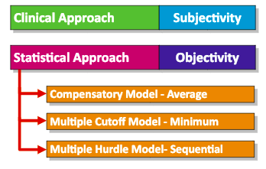

Selection Process
- selection ratio
  - the number of applicants compared to the number of people to be hired
- cutoff score
  - the score that the applicant must achieve
- final decision
  - selection of applicant by departmental or immediate supervisor to fill vacancy
  - notification of selection and job offer by the human resources department

