Experiment 4: Stereochemical Analysis of the Reduction of Benzil

Dr. Rashmi Venkateswaran
Department of Chemistry
CHM1321

Introduction
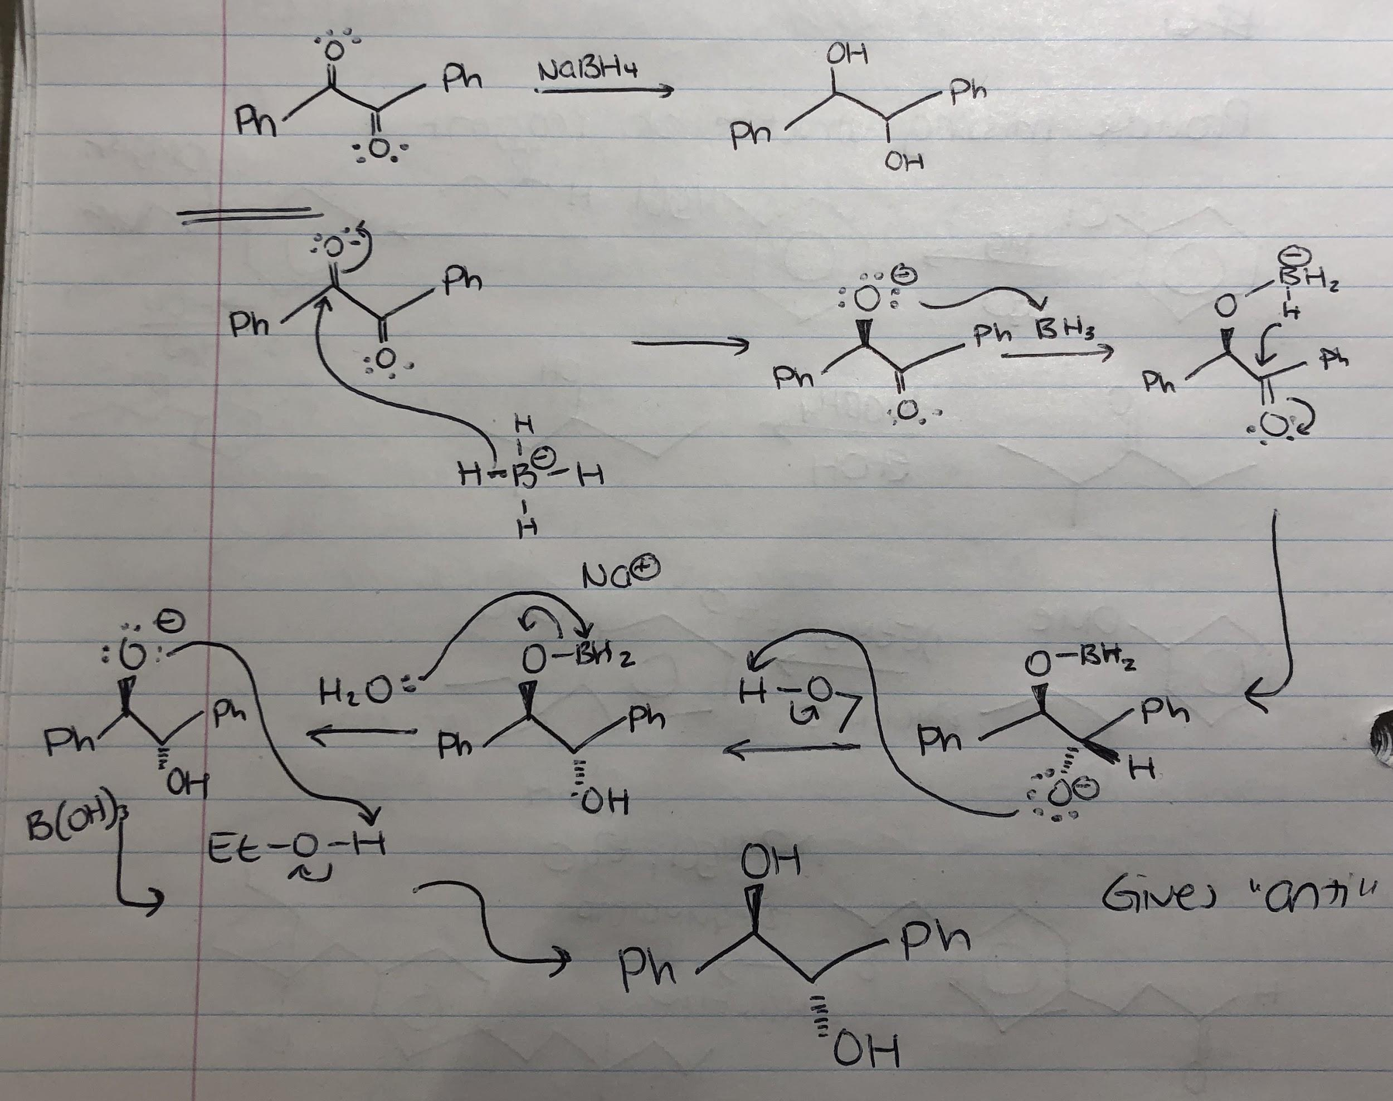

Procedure
Follow procedure as described in the laboratory manual (Experiment 4: Stereochemical Analysis of the Reduction of Benzil, 2014 pp. 7).

Observations
Part A
-benzil is a solid. It was a yellow crystal-like powder.
-dichloromethane was a colourless, viscous liquid.
-ethanol was a colourless, viscous liquid.
-combination of the three above makes yellow, translucent solution with a slight odour.
-sodium borohydride was a fine white powder.
-w the addition of sodium borohydride, the colour began to lighten to a fainter translucent yellow. Ppt was formed.
-when added heat, solution cleared up and was a pale yellow. Bubbling intensified and then stopped. Bubbles formed was hydrogen gas.
-the addition of more of water resulted in white gel-like precipitate.

Table 1. Table of Reagents for Reduction of Benzil with Sodium Borohydride.
Compound | Amount (g or mL) | Molecular Weight (g/mol) | Density (g/mL) | Moles (mol) | Millimoles (nmol)
Benzil | 1.0 | 210.232 | N/A | 0.0048 | 4.76
NaBH4 | 0.3 | 37.83 | N/A | 0.0079 | 7.93
Ethanol | 5 | 46.07 | 0.789 | 0.0856 | 85.63
Dichloromethane | 5 | 84.93 | 1.33 | 0.0783 | 78.30

Table 2. Table of Results of Reduction of Benzil with Sodium Borohydride.
Product | Amount (g) | Molecular Weight (g/mol) | Moles (mol) | % Yield
Hydrobenzoin | 1.17 | 214.26 | 0.0055 | 115

Figure 1. TLC 1
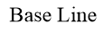
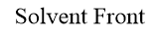
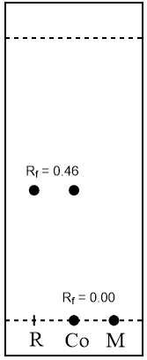
ds=4.8cm
di=2.2cm and 0.0cm
Rf=0.46 and 0.00
Solvent System: 1:9 ethyl acetate:hexanes
Reference: benzil dissolved in dichloromethane
Reaction Mixture: hydrobenzoin

Figure 2. TLC 2
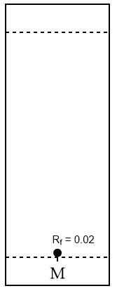
ds=4.9cm
di=0.1cm
Rf=0.02
Solvent System: 1:9 ethyl acetate:hexanes
Reaction Mixture: hydrobenzoin precipitate with a few drops of dichloromethane
Part B
Legend: Blue marker balls indicate -OH group. White marker ball indicates hydrogen atom. Grey bonds indicate sp2 hybridization. Black bonds are sp3 hybridization.
Note: S centres mean the priority of the atoms is in a counterclockwise direction. R centres have the atoms going in a clockwise direction. The priority goes as follows, from highest to lowest; -OH group, phenyl group, the carbon chain with the second phenyl group, and lastly, hydrogen.

Figure 7. Relationship between the products of hydrobenzoin.
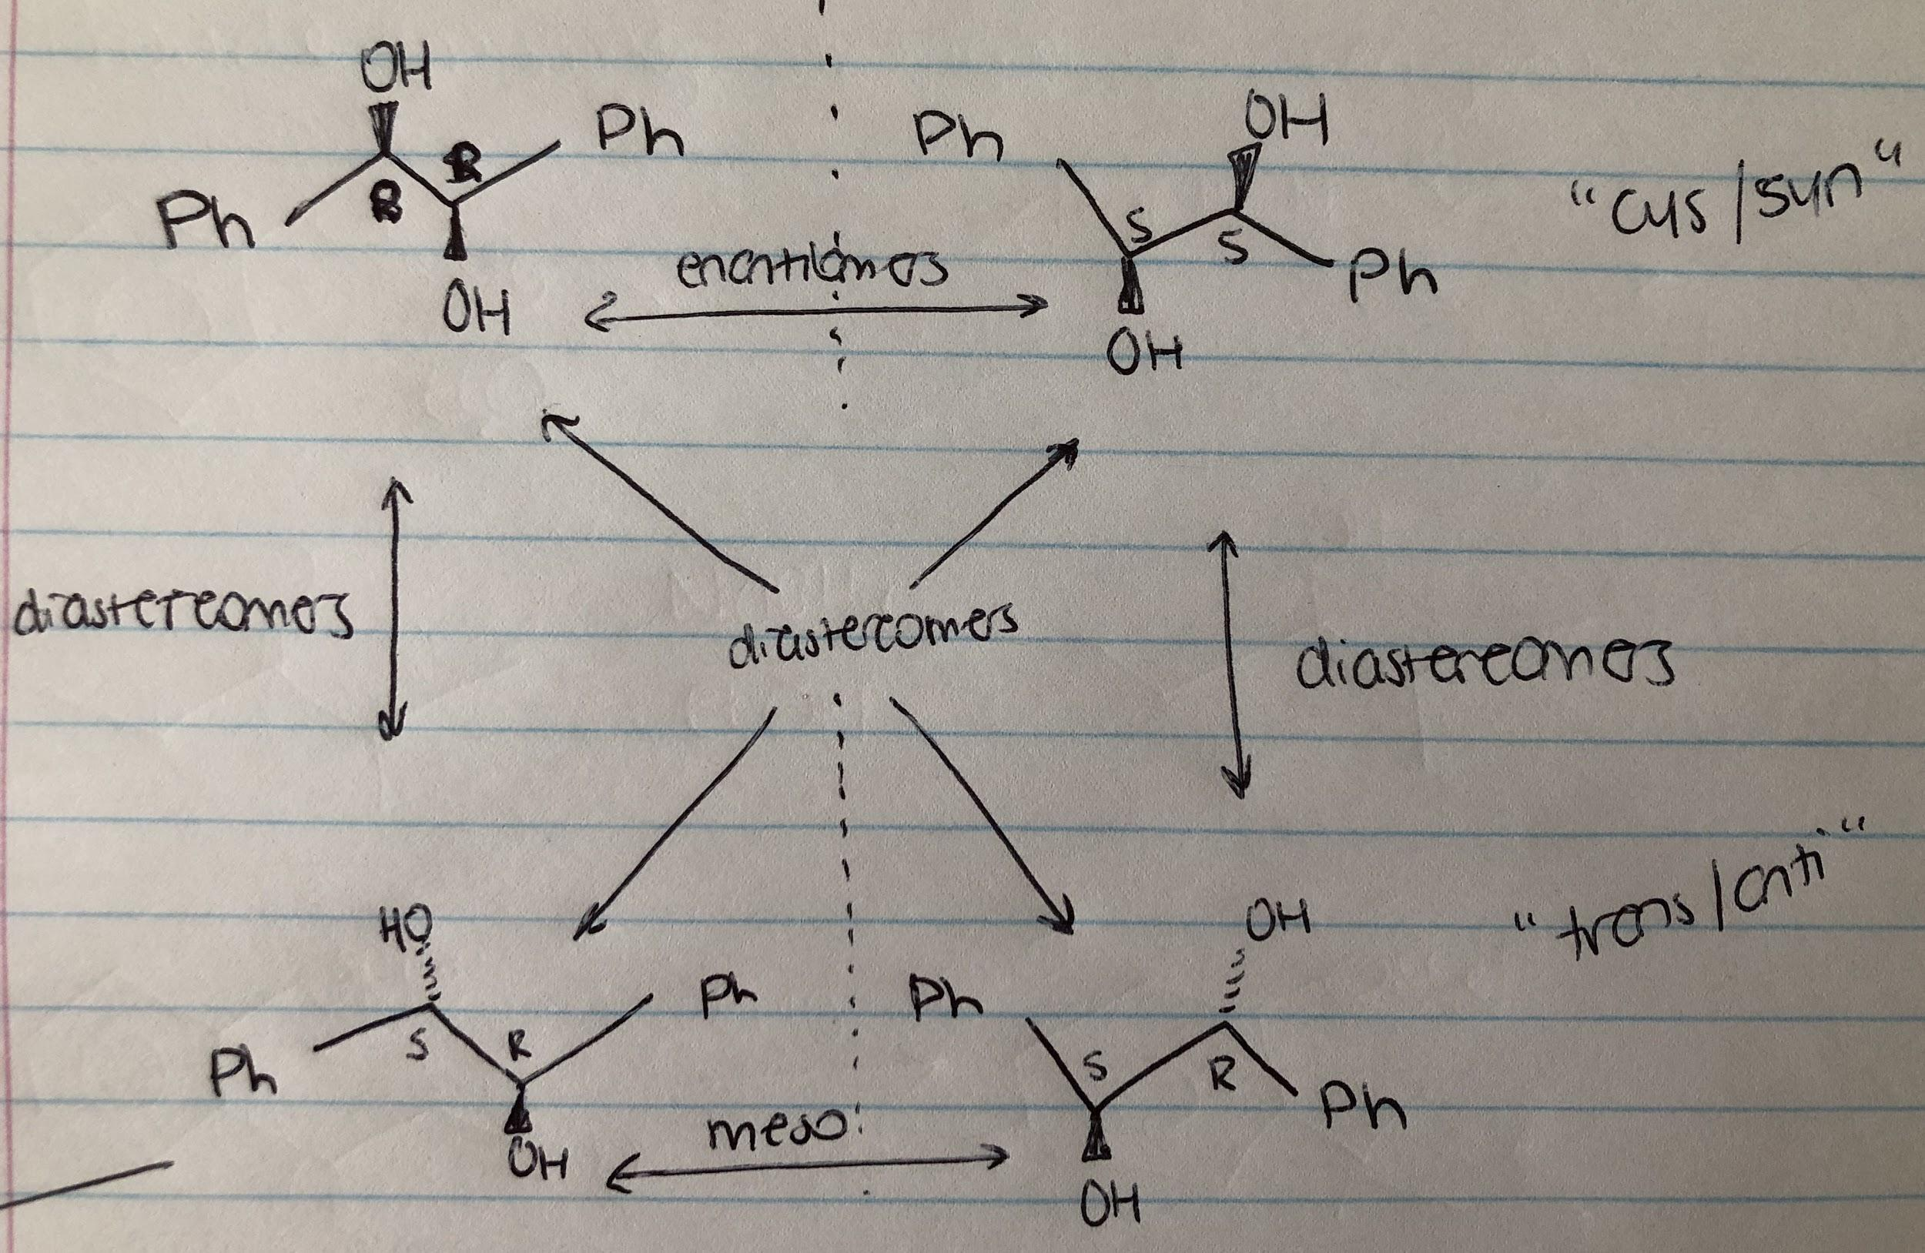

Calculations
Calculating Moles
=1.0g x mol/210.232g
=0.00475665
=0.0048 mol

Retention Factor (Rf)
=di/ds
=2.2cm/4.8cm
=0.4583
=0.46

Percent Yield
=empirical mass (g) / theoretical mass (g) x 100%
=1.17 / 1.019 x 100%
=115% yield

Discussion
The purpose of this experiment was to reduce benzil’s two ketone functional groups to alcohol groups, making hydrobenzoin, a white crystalline product. Reduction can be explained by a gain of electrons, a gain of protons, or a loss of oxygen.
At the beginning of the experiment, the reducing agent, sodium borohydride, was added in small portions. If this was not respected, overheating and explosion could have occured due to the solid being exothermic. This was the purpose of the ice bath. Then, the addition of hot water after the cooling resulted in more vigorous bubbling. This suggested a chemical reaction and the presence of colour change and gas, which in this case was hydrogen gas. NaBH4 can react any acidic proton to form an acidic gas. The addition of the water was to hydrolyze the remaining BH3 and NaBH4 into boric acid, B(OH)3. Since boric acid is soluble in water, recrystallization can be done with ease. The reaction mixture was then quenched. An important point to note was when washing the crystals with cold water, if the water was not cold enough, the crystals have the ability to dissolve in warmer water resulting in a diminished yield.
Benzil contains two ketone groups. The oxygen acts as a proton acceptor, which increase the polarity of the compound. When the first oxygen has been reduced to an alcohol, the benzoin now has both proton donors as well as acceptors. It is more polar than the previous compound. Finally, when the second ketone is reduced to an alcohol, there are now two sites of donors as well as acceptors. This compound has the highest polarity of the three.
In figure 1, four spots were seen. The two spots that moved up and had Rfs of 0.46 represented the starting reactant, benzil. The low polarity of benzil explains the higher Rf value compared to the hydrobenzoin in the reaction mixture, which is the final product. The two spots with Rfs of 0.0 in the mixture column were the final products. The absence of the spot associated with the reactants in the reaction mixture indicates that the reaction has gone to completion. Its polarity results in interaction with polar silica, therefore less movement on the plate. If another spot in the reaction mixture was present in the middle of the two Rfs, this would suggest an incomplete reaction, indicating that benzoin is present and has not undergone full reduction.
In figure 2, the Rf value is 0.02 for the crystals. A low Rf value means the compound is polar, which is expected considering it is hydrobenzoin. This can be explained with the addition of the -OH group, which now has both proton donors as well as acceptors. The second TLC plate was done to assess the purity of the crystals. Seeing only one spot on the plate indicates that there was only one isomer present. More than one spot would have indicated the presence of other isomers with different polarities, and therefore different Rf values. The TLC plate however does not dictate the amount of water present in the formed crystals after the filtrations, therefore its purity is difficult to tell.
The percent yield of hydrobenzoin was 115%. A yield greater than 100 indicates that there are impurities. This is most likely due to improper filtration and the presence of water in the precipitate. Water was added during the process, and considering both the product and water are polar molecules, they tend to exhibit hydrogen bonding with each other resisting separation. Presence of water can be confirmed with the crystals looking clumpy, and not powdery. The melting point of the product can be analyzed to assess purity by comparing it to the theoretical melting point of hydrobenzoin.
An improvement would be to use suction filtration for a greater period of time to ensure there is no water left. Another thing would be to use a thermometer for greater accuracy in order to ensure the boiling point of the reaction is not met, and oiling out does not occur. During recrystallization it would have been more effective to cool the content in an ice bath after heating rather than cooling to room temperature. The greater the temperature difference, the more precipitate would be forced out during recrystallization, thus increasing the yield.

Conclusion
In conclusion, the percent yield of hydrobenzoin is 115%. The greater than 100% yield indicates impurities in the mixture.

Questions
1. This statement is true. Oiling out occurs when the compound has a low melting point or when the molecular structure makes crystals difficult to form. Oiling out can sometimes be avoided by choosing a solvent with a low boiling point, or by cooling the solution very slowly. If the boiling point of the recrystallization solvent is larger than the melting point of the compound, the crystals will separate from the solution as liquids. As a result, it will be difficult for recrystallization to occur.
2. The difference of solubility came out of solution as a precipitate.
39.1-35.6 = 3.5g
The yield is 3.5g/39.1 x 100% =9% yield.
3. The yield in the experiment can be increased by starting the experiment at a higher temperature. At higher temperatures, the solute solubility in solvents increase. This would therefore result in recrystallization to occur. Another point is using a solvent with a higher boiling point as opposed to methanol, to allow for a greater difference in temperatures.
4. a) sodium borohydride is a mild reducing agent, and is not strong enough to reduce carboxylic acids. This is due to the proton from the carboxylic acid reacting with the hydride agents. Butanol will therefore not be obtained.
b) bubbling and heating suggests there is a chemical reaction. The product of the reaction will be hydrogen gas, since the carboxylic acid will deprotonate.
5. The methyl group is located on top of the ring. As a result, the attack will be from the bottom, since it is less sterically hindered. Equimolar amounts of DIBAL and substrate are required because unlike NaBH4 that has 4 hydrogens available, DIBAL only has one. Therefore the ratio of DIBAL and substrate must be 1:1.


