Experiment 5: Preparation of Benzoic Acid using a Grignard Reagent

Dr. Rashmi Venkateswaran
Department of Chemistry
CHM1321

Introduction
Mechanism for formation of benzoic acid using a Grignard reagent.
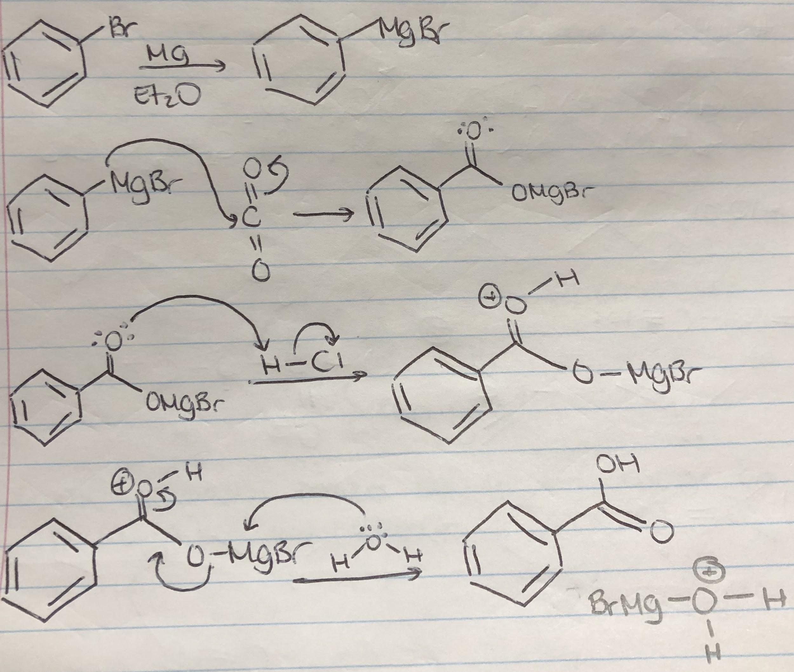

Procedure
Follow procedure as described in the laboratory manual (Experiment 5: Preparation of Benzoic Acid using a Grignard Reagent, 2008 pp. 4-5).
A change was made to step 5. The solution was added all at once, instead of half of it at a time.
A change was made to step 12. Solid carbon dioxide was in pellets, therefore 4-5 pellets of dry ice were added.
A change was made to step 14. 28.81g of ice water was added, of which most was water.

Observations
-CaCl2 for drying tube was a small, white, spherical solid. It was kept in a brown glass jar.
-Magnesium turnings were silver, solid metallic thin strips. It was kept in a brown glass jar.
-Iodine was blackish grey solid small chunks. It was kept in a brown glass jar.
-Bromobenzene was a colourless, viscous liquid with an odour.
-Anhydrous diethyl ether was a colourless, viscous liquid with an odour. It was kept in a metallic bottle.
-Addition of bromobenzene and anhydrous diethyl ether briefly formed white precipitate.
-The combination of the solutions with the solids in the round-bottom flask resulted in a brown colour. Bubbling was seen, and the flask became warm. Magnesium settled at the bottom of the flask. After a few minutes, the content in the flask became colourless, followed by reverting back to translucent brown, and vigorous bubbling which soon subsided. The total time the solution was left to react was 30 mins.
-Combining the reaction in the flask with the dry ice pellets in the beaker resulted in steaming. A brownish grey sticky opaque mass began accumulating. Mass had a strong smell. Frost was seen on the beaker.
-HCl was a colourless, viscous solution.
-Diethyl ether was a colourless, viscous solution.
-Water was a colourless, viscous, odourless solution.
-With the addition of HCl, diethyl ether, water, and the sticky mass along with the dry ice, the content became a yellow slush.
-When transfered to separatory funnel, the content was left to warm up for better separation. Two phases were evidently seen. The bottom aqueous layer was a slightly foggy solution. The top organic layer was a translucent yellow solution.
-1:9 EtOAc:Hexanes was a colourless, viscous, liquid with a strong odour.
-NaOH was a colourless, viscous solution.
-The content in the separatory funnel had a translucent colourless aqueous phase on the bottom, and a yellowish translucent organic phase at the top.
-Addition of HCl to the aqueous phase resulted in white precipitate. The blue litmus became red.
-The precipitate dried into white crystals. The mass of the solid was obtained by taking the mass of the weighing paper and subtracting it from the mass of the solid on the weighing paper.
-White crystals were melted for melting point of 121 degrees celsius.

Table 1. Table of Reagents for Benzoic Acid preparation with Grignard Reagents.
Compound | Amount (g or mL) | Molecular Weight (g/mol) | Density (g/mL) | Moles (mol) | Millimoles (mmol) | Equivalence
Bromo-  benzene | 3.0 | 157.01 | 1.50 | 0.0287 | 28.7 | 1
Anhydrous diethyl ether | 20.0 | 74.12 | 0.71 | - | - | -
Magnesium | 0.8 | 24.31 | - | 0.0329 | 32.9 | 1.15
Iodine | - | 126.9 | - | - | - | -
Solid Carbon Dioxide | - | 44.01 | - | Excess | Excess | -

Table 2. Table of Results for Benzoic Acid.
Product | Amount (g) | Molecular Weight (g/mol) | Moles (mol) | Millimoles (mmol) | Percent yield (%) | Melting Point (°C) | Percent Error (%)
Benzoic Acid | 2.14 | 122.12 | 0.0175 | 17.52 | 61% | 121 | 0.82

Figure 1. TLC of Reaction Mixture.
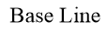
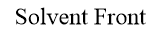
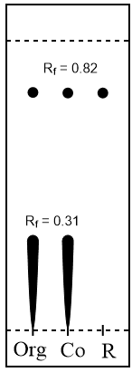
ds=4.9cm
di=4.0cm and 1.5cm
Rf=0.82 and 0.31
Solvent System: 1:9 ethyl acetate:hexanes
Reference: bromobenzene
Reaction Mixture: organic phase from separation

Figure 2. TLC of Final Reaction Mixture.
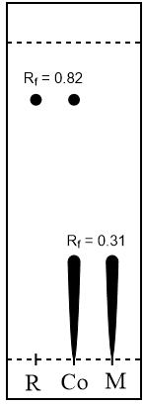
ds=5.0cm
di=4.1cm and 1.55cm
Rf=0.82 and 0.31
Solvent System: 1:9 ethyl acetate:hexanes
Reference: bromobenzene
Reaction Mixture: benzoic acid

Flow Chart
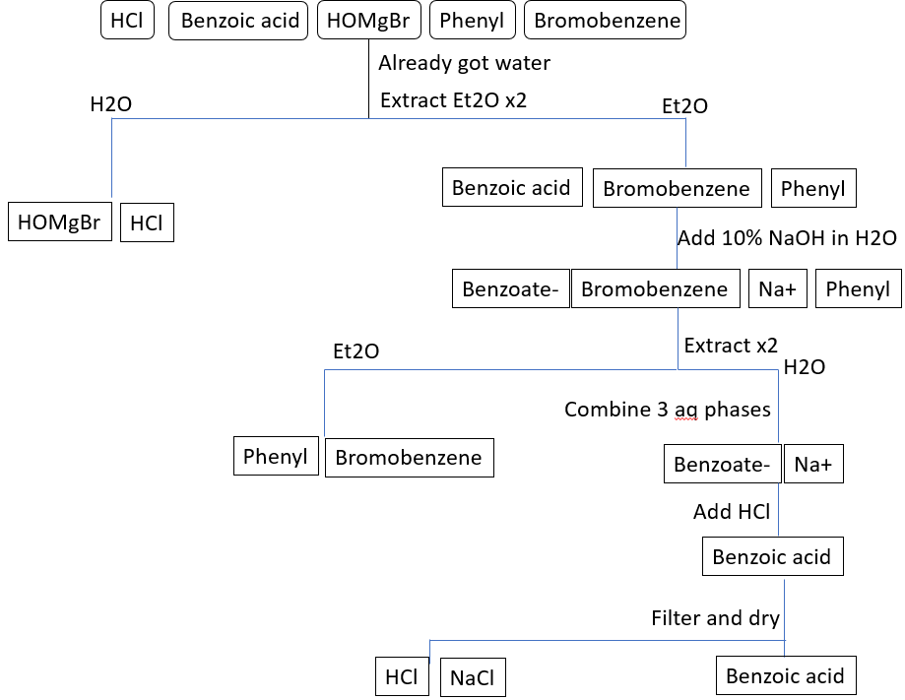

Calculations
Retention Factor (Rf)
=di/ds
=1.5cm / 4.9 cm
=0.306
=0.31

Calculating moles Equivalence
=mass used x molecular weight =mol excess / mol limiting
=3.0g x (24.31g / mol) =0.0329 mol / 0.0287 mol
=0.0329 mol =1.15

Percent yield Percent error
= (mol product / mol starting material) x 100% =|(ev-tv)/tv| x 100%
= (0.0175mol / 0.0287mol) x 100% = (121-122) / 122 x 100
=61% =0.82%

Discussion
The purpose of this experiment was to prepare benzoic acid with a Grignard reagent, and test the purity of the product by taking its melting point and comparing it to the theoretical melting point.
To produce the Grignard reagent, magnesium is exposed to iodine, which acts as a catalyst and activates the reaction. Magnesium metal can react with oxygen, coating it with a layer of magnesium oxide. The purpose of iodine is to remove the magnesium oxide layer and allow for more exposure of the magnesium. With the addition of anhydrous ether, the magnesium attacks the bromide group of bromobenzene, which forms a benzene ring with a negatively charged carbon atom. The electrons allow for the carbon to form a bond with the magnesium ion, resulting in phenylmagnesium bromide. The presence of water would interfere with this bonding. Since Grignard reagents are nucleophiles, and nucleophiles are bases, there would be an acid/base interaction with the Grignard and the water. Water would protonate the base, detaching the phenyl group. This was reduced with the use of a drying tube with CaCl2. The calcium chloride pellets absorb any moisture flowing through the apparatus. During the combination of the reagents, the bubbling indicates the formation of the Grignard. The bubbles are the solvent itself boiling, and not a gas being produced. The formation of the Grignard is exothermic, confirmed by the heating of the flask. It is able to begin its own reaction; however, a hot water bath is required shortly after to ensure collision rate is still fairly high. Having the content be stirred would also increase the rate of collision. Next, with the addition of solid carbon dioxide, the phenyl group bonds with one of the carbonyl groups of carbon dioxide. Electrophiles have a carbonyl functional group, and carbon dioxide has two. By drawing dipoles, we can determine that the carbon is electrophilic, having a delta positive charge. Another bond can form with the negatively charged oxygen atom and a phenylmagnesium bromide. As a result, the phenyl group is transferred. Lastly, the hydronium ion from the protonation of water molecule by HCl results in the acidic proton to attack the oxygen. The result is an unstable, positively charged oxygen atom. For the stability to increase, a bond must be made between oxygen and the magnesium ion. Magnesium bromide therefore no longer has bonds with the oxygen, and an alcohol group is the result.
When performing the first separation with the funnel, the aqueous phase contains magnesium as well as HCl. The remaining compounds, benzene, bromobenzene, and benzoic acid, of which all contain benzene rings, separate into the organic phase. The first TLC, Figure 1, demonstrates that benzoic acid and bromobenzene is present in the organic phase. The addition of NaOH separates the benzoic acid from the benzene and bromobenzene by forming benzoate ions, which become soluble in water, or the aqueous phase. Taking the aqueous phase and adding HCl to it protonated the benzoate back to benzoic acid, and forms a salt, NaCl, as well. NaCl and HCl is easily filtered out, considering their solubility is higher than that of benzoic acid causing it to precipitate out, leaving the white benzoic acid crystals. The acidity of the product was tested with a blue litmus paper, which turned pink, confirming that the content in the beaker was an acid. The second TLC, Figure 2, was taken after washing the solid with NaOH. The result indicates that there was no starting product, benzophenone, in the reaction mixture by the absence of the spot with an Rf of 0.82, associated with bromobenzene. Bromobenzene was effectively separated and the reaction mixture contained only benzoic acid. This was associated with the spot having an Rf of 0.31.
The TLCs do not consider any water that is present in the final product. The purity can be determined by taking the melting point. It was recorded to be 121 °C. Compared with the theoretical melting point of benzoic acid, which is 122 °C, the empirical value deviates by only one degree celsius, or a percent error of 0.82%. The preparation was fairly successful. Water has a lower boiling point of the product, being 100 °C. Having the temperature lower than theoretical confirms the presence of water in the final product. NaCl on the other hand has a melting point of 801 °C. If the boiling point was higher than the theoretical, this would indicate presence of the salt.
The carboxylic acid functional group of benzoic acid increases its polarity. It has both proton donors as well as acceptors, allowing for hydrogen bonding. Benzoic acid would therefore make hydrogen bonds with the polar silica on the TLC plate. The resulting Rf would be low, since there is little movement up the plate. This was confirmed with both TLCs having an Rf of 0.31. Considering bromobenzene consists of a non-polar phenyl ring and the bromine, which does not add much polarity, it is unable to interact with the polar silica to the same extent. It is therefore expected that the reference spot associated with bromobenzene has a significantly higher Rf value than that of benzoic acid. This was also confirmed with both TLCs with an Rf of 0.82.
A factor that could have improved yield was having the content in the round-bottom flask to boil for a greater period of time, swirling, as well as having a warmer water bath under it, allowing for a longer reaction, greater rate of collision, and more of the product to be formed. Next, as an improvement, it is important to work quickly once the apparatus is taken out of the oven. If not working quickly enough, yield decreases due to interaction of Grignard with water and air. When transferring content from apparatus, some of the content was left behind. Additionally, during filtration, there was leftover product on the filter paper that was difficult to scrape off and transfer onto a weighing paper. It would be ideal if more time was allotted allowing for the original filter paper to dry, for a minimum amount of crystals lost due to transferring. Lastly, when referring to the equivalence, the magnesium is not that much in excess. This means that it is easy to lose it and not have enough for the reaction, which would therefore result in a decreased yield since there is nothing for interaction.

Questions
- The benzene is formed with the interaction of water. The bond to MgBr is broken, forming the benzene, and the remaining of the water interacts with the MgBr to form HOMgBr.
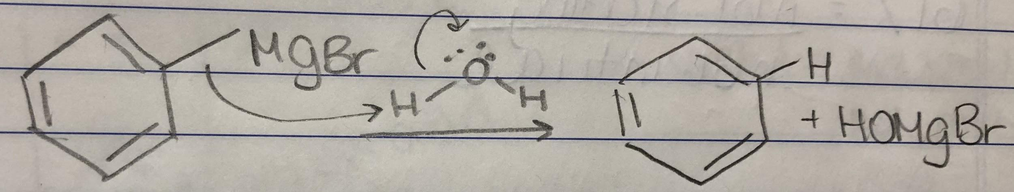
- The Grignard reagent acts as a nucleophile to the phenyl bromide. The two are combined. The carbocation is unstable and therefore makes a double bond, which breaks the bond with the bromine. The result is biphenyl.
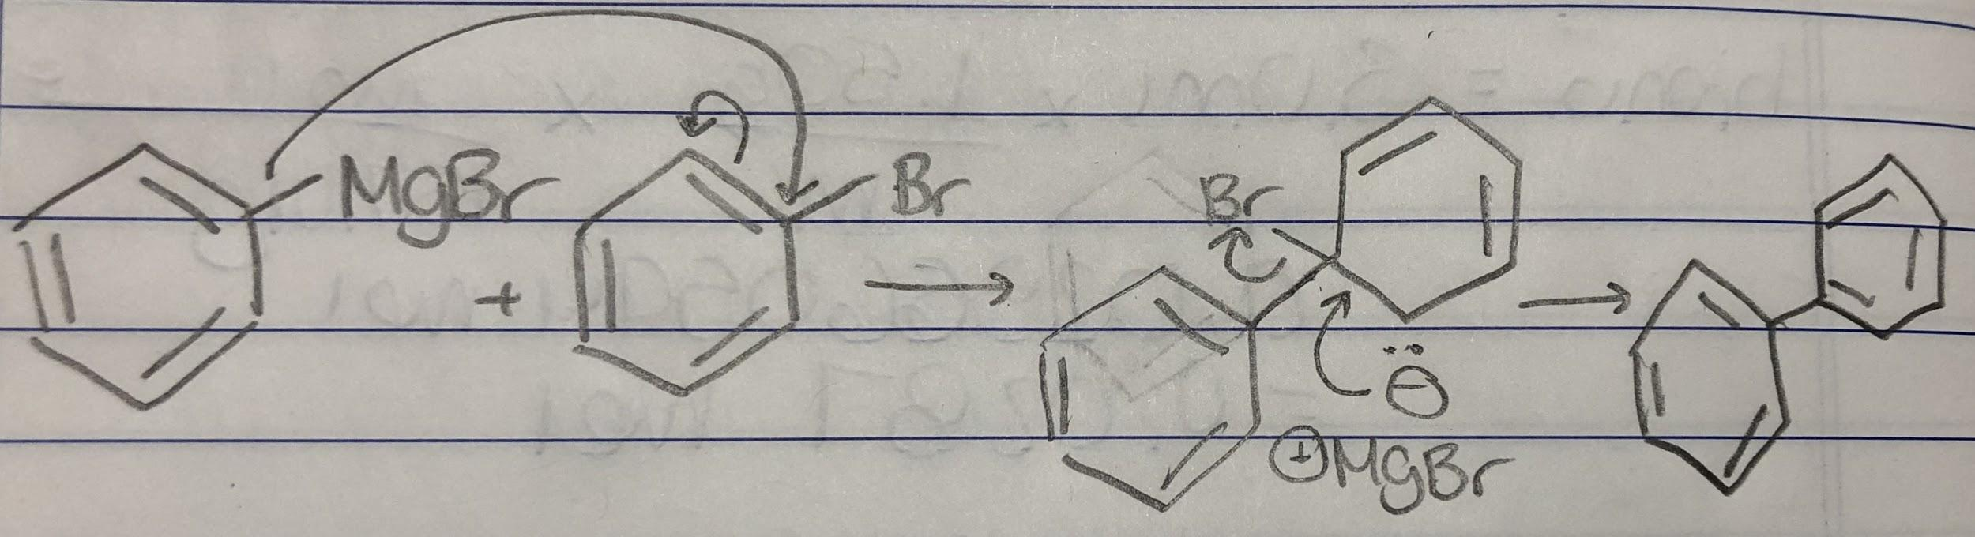
- The volume of water can be found stoichiometrically. Bromobenzene was the limiting reagent. 0.0287 moles of bromobenzene was used. Bromobenzene and phenylmagnesium bromide are in a 1:1 ratio. Calculation is done to determine moles of water needed, and multiply by water’s density to get the volume in mL.
(0.0287 mol) x (18.02 g/mol) x (1.00g/mL) = 0.517 g
Therefore, 0.517 g of water is required to destroy phenylmagnesium bromide.
- The reaction is very exothermic, which means heat is given off during the combination of the reactants. An increase in heat accelerates the reaction. The addition in portions keeps the reaction under control. The silica gel contains multiple -OH groups and is very acidic. This would protonate the Grignard reagent, forming benzene. The two spots in the starting material column and the Grignard column that match up on the plate would be the bromobenzene, and the spot closest to the solvent front in the Grignard column would be the benzene, considering it is even less polar than bromobenzene, since it has no functional groups and is a simply a hydrocarbon. SM is starting material, Grig means Grignard reagent.


